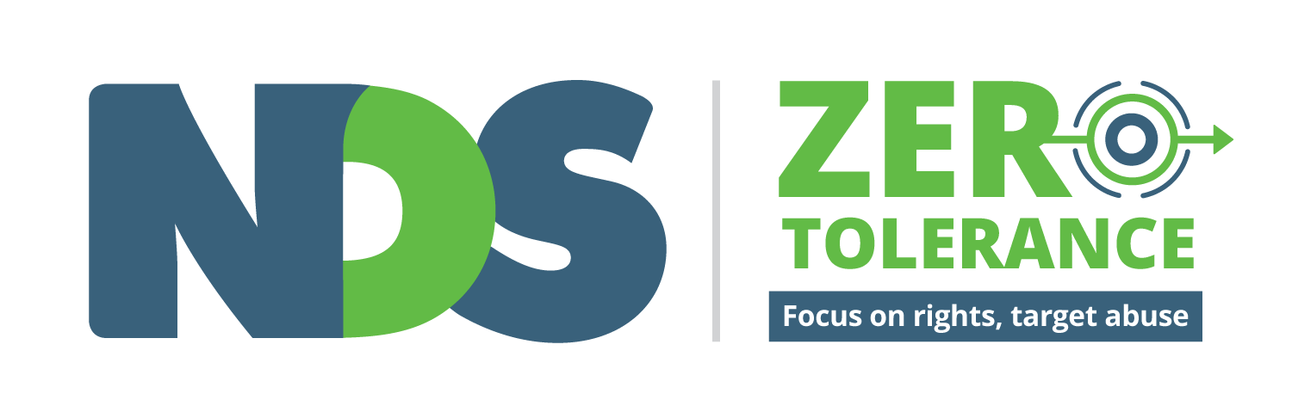
Positive Cultures
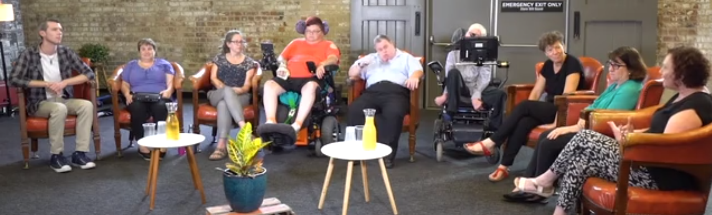

A guide to use with the Zero Tolerance Positive Cultures films

Disclaimer
The information provided in this guide and accompanying films is intended for general use only. It is not a definitive guide to the law and best practice. It does not constitute formal advice, and does not take into consideration the particular circumstances and needs of your organisation.
Every effort has been made to ensure the accuracy and completeness of this document at the date of publication. NDS cannot be held responsible and extends no warranties as to the suitability of the information in this document for any particular purpose and for actions taken by third parties.

Copyright
This publication is copyright. All intellectual property rights vests in NDS. Material which is reproduced from this publication must include an acknowledgement of the source. Prior permission should be sought from NDS.

Acknowledgements
National Disability Services would like to acknowledge the funding from the Victorian Government which allowed these resources to be developed.
© National Disability Services 2019
We would like to express our gratitude for the insight, experience and time of the people that contributed to these films:
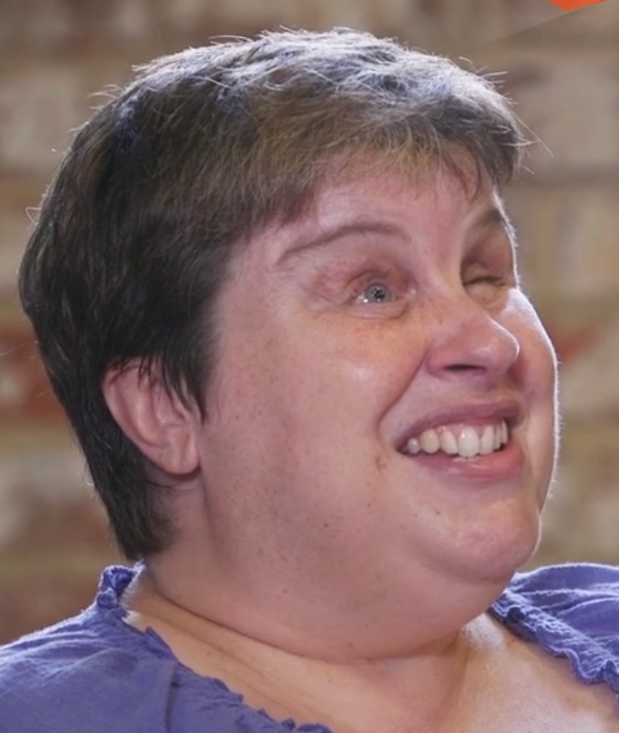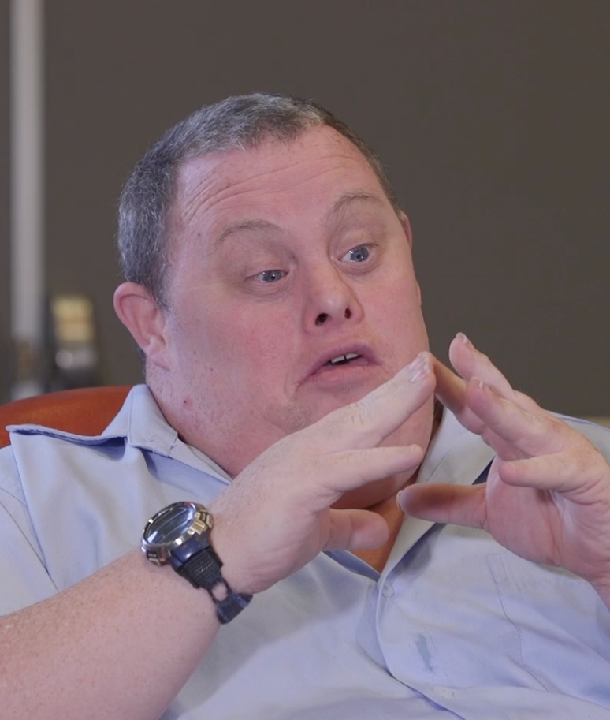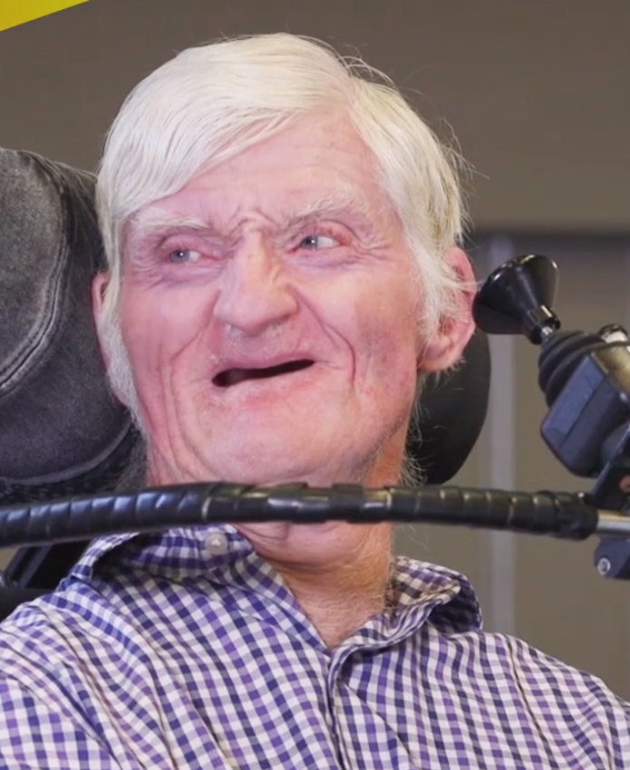
Cath – Peer worker Leigh – Peer worker Rob – Peer worker
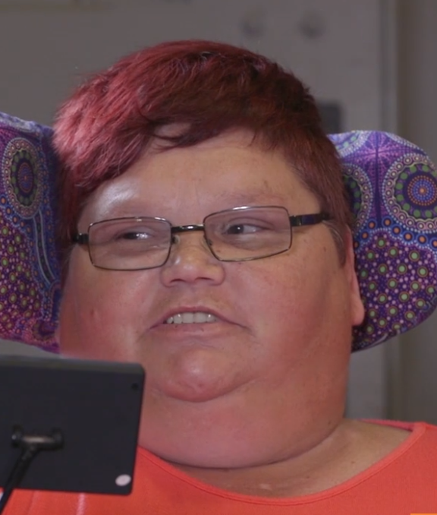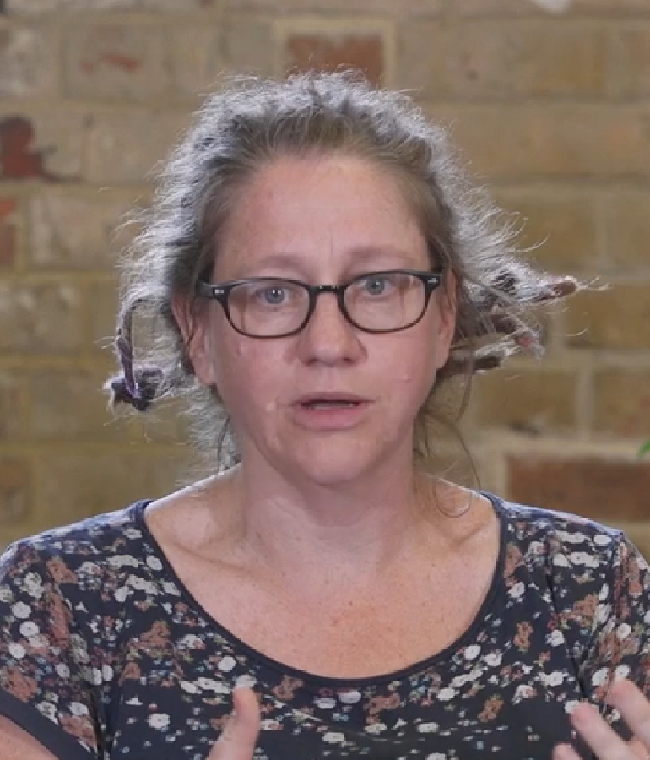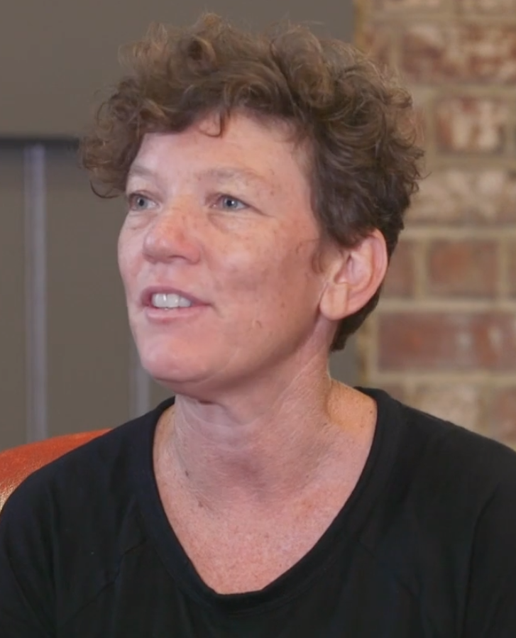
Tania – Peer worker Jess – Support worker Jen – Advocate
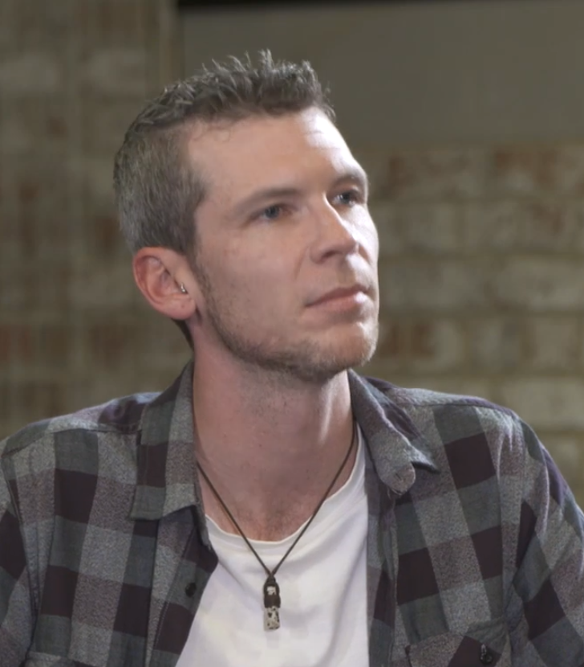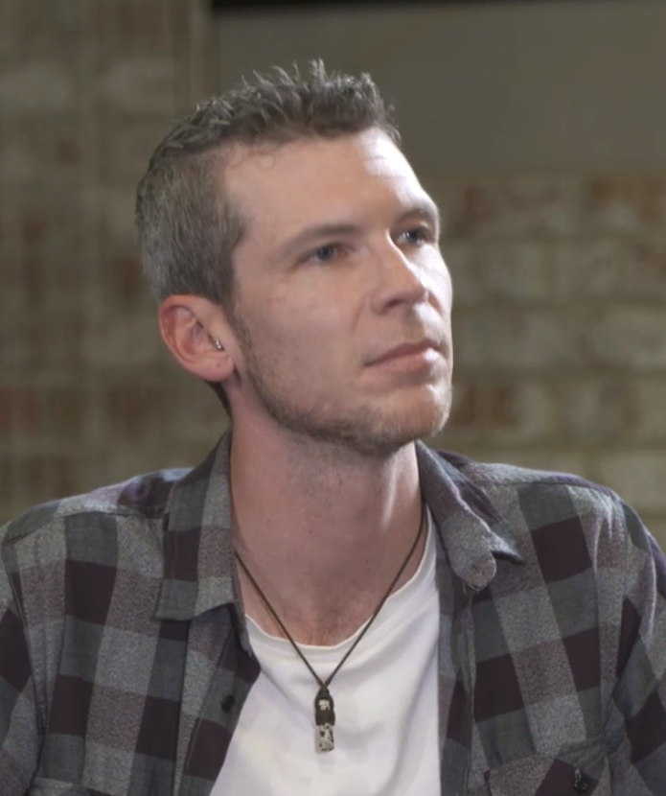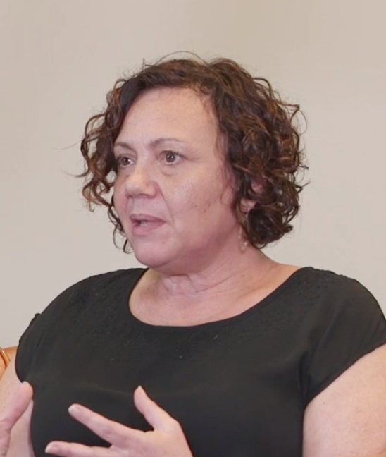
Dave – Manager Hayley – COO Christine - NDIS Commission
Matt Cartwright Director, Production Management, Maitree House
Leigh Bramall Cinematographer, Editor, Maitree House
Peta Khan Senior Producer, Maitree House
Martin Demian Sound Technician
Liz Collier Zero Tolerance Project Lead, NDS

About the Zero Tolerance Initiative
Zero Tolerance is an initiative led by National Disability Services (NDS) in partnership with the disability sector. Using a human rights approach, Zero Tolerance outlines actions for service providers to improve prevention, early intervention and responses to abuse, neglect and violence experienced by people with disability. Put simply, Zero Tolerance means abuse is never OK. It asks service providers to focus on rights and target abuse to create safer, more empowering environments for people they provide services to.
An expanding range of Zero Tolerance tools and resources for the disability sector is available to support safeguarding approaches for people with a disability. See the NDS website for more information: https://www.nds.org.au/resources/zero-tolerance.

Getting the support you need
Some of the things that are talked about in the films or that you talk about together might bring up feelings for people. This may be because of things you have experienced or seen in your work or personal life. Please talk to someone you trust if you need to discuss any of the issues covered in these films. This may include a family member or friend, or a supervisor or manager.
You can also call Lifeline on 13 11 14 for confidential 24-hour telephone crisis support.

Quote
“A positive culture allows people, and knows that people, need to speak up in their own way.” Cath, Peer worker
About the Positive Cultures films
The Positive Cultures films have been developed for everyone in your organisation.
A positive culture is one where every person feels valued, listened to and safe to speak up.
Every person in an organisation is important in creating a positive culture.
The films show a conversation between nine people with different ideas and experiences. These people came from different roles including:
- Peer workers
- Support worker
- Manager
- Chief Operating Officer
- Advocate
- Representative from the NDIS Commission
The films will show you how you can have these conversations together in your organisation. They can help you to open up conversations between people with disability, workers, managers, CEOs, boards and families so that everyone can play a part in creating a positive culture.

There are eight 4-6 minute films which cover:
- Positive Cultures
- Power and Control
- Speaking Up
- Listening Well
- Everyday Opportunities
- Structured Opportunities
- The Right Supports
- The Way We Use Language
Each film includes questions that you can use to start the conversation in your own team or organisation.
Some of the ways the Zero Tolerance films are being used include:
- During meetings and team discussions
- With people with disability, families and carers
- With staff as part of supervision and training
- As part of induction
- In board meetings
- In personal reflection
Some tips for positive conversations:
- Think about where and when you will have the conversation so that everyone is comfortable and free from distraction.
- Make sure you allow enough time so that everyone has the opportunity to speak and be heard.
- Think about what follow-up might be needed. Let people know how they can keep the conversation going and where they can get support if needed.
- Consider who you would like to facilitate the conversation.

About this guide
This guide accompanies the NDS Zero Tolerance Positive Cultures films. It will help you to use the films in conversation with people in your organisation. It will also give you some links to other information you might find useful.
You can use this guide to work through the films for self-reflection, in meetings or as part of supervision and training. Use the guide and films in the context of your organisation’s policies and procedures.

You can choose how to use the questions in the guide.
The first set of questions in the guide match the questions on screen at the end of each film. Use them to start the conversation about what people have seen in the film and how it relates to their own experiences.
If you have more time you may also like to use the personal reflection and commitment questions in the guide.
A good way to start the conversation is to ask people what stood out for them in each film.
You can also pause the films at the end of each topic for a more in-depth conversation.

Positive Cultures
A positive culture in a workplace is one where:
- Every person is listened to and knows they will be listened to
- Every person knows that they are equal
- Every person feels valued and like their opinions matter
- Every person in the organisation feels safe, comfortable and confident to speak up about everything

Watch the film together and answer these three questions:
- When have you experienced a positive culture?
- What are some of the best things about the culture in your organisation?
- How do you celebrate what you do well?

Personal reflection
- Did people have very different ideas about what makes a positive culture?

Commitment
- What will you do to improve the culture in your team or organisation?
- How will you check back in with each other to see how you’re going?

Quote
“The example that I had has been when I've gone to visit organisations or services where the people doing the supporting and the people there to be supported are just treated the same. Everyone's valued. But they're treated the same. And there's no difference between them.” Christine, NDIS Quality & Safeguards Commission

Power and Control
- Power can be used in good and bad ways.
- Some people have more power than others and this is true in every part of our lives.
- When we talk about having a positive culture in a workplace, we need to think about what we can do so everyone can use their own personal power.

Watch the film together and answer these two questions:
- How can you recognise where power is not shared equally?
- What can you do about it?

Reflection
- We know that power imbalances exist in all areas of our lives.
- Can you think of an example of a power imbalance you have experienced or observed?
- What did you do or what could you have done to address this imbalance?

Commitment
- What is one change you will make to address power imbalances that you are involved in?

Quote
“It’s a process. You don’t just… learn how to use power in a positive, constructive, mutual kind of way. I think it takes practice.” Cath, Peer worker

Speaking Up
- We might want to speak up because we are passionate about something.
- We might want to speak up because we have experienced or witnessed something that isn’t OK.
- Feeling safe to speak up is so important.
- We know that there are things that make it easier and things that make it harder.

Watch the film together and answer these three questions:
- Do you feel confident to speak up about things you are passionate about?
- Do you feel confident to speak up when you see something that is not OK?
- What helps you to speak up?

Reflection
- Were there things people said in the film or in your conversation that you hadn’t thought of before?

Commitment
- What will you do to support others to feel confident to speak up?

Quotes
“We work together as a team to help each other to speak up.” Rob, Peer worker
“We’re really interested, genuinely interested in giving each other feedback because we want to see each other succeed.” Jen, Advocate

Listening Well
- Really listening to people well involves all of your senses, all of the time.
- Being listened to is also a really important part of feeling and being safe.

Watch the film together and answer these three questions:
- When has someone listened to you well? What did they do?
- How did it feel?
- How can you show people you are ready to listen?

Reflection
- What might you need to consider if a person does not use words to communicate?
- What might you need to consider if English is not someone’s first language?

Commitment
- What will you change about the way you listen to people?

Quotes
“Sometimes... listening means asking different questions and powerful questions and questions that people haven’t really considered asking before. What is it that you love about working with … everyday? What does … bring to your working day?” Jen, Advocate
“If you’re pretending you understand me, you’re being completely dismissive of me and you’re not actually listening to me and therefore I can’t speak up.” Jess, Support worker
“If somebody has had the courage to actually want to say something to you, the least we can do, anyone, it to give the respect of listening” Hayley Dean, Chief Operating Officer

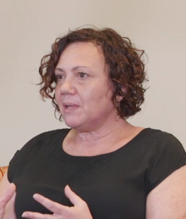
Everyday Opportunities
Part of creating a culture where people know they will be listened to and supported is recognising and creating opportunities to do this every day.

Watch the film together and answer these questions:
- What are some everyday opportunities to check in with people that are important to you?
- How do you let people know what’s important to you?
- How do you check in with other people in your organisation throughout the day?

Reflection
- What are some of the ways that you have seen other people check in that you would like to try?
- How can you create opportunities every day for people to speak up and let you know what is important to them?

Commitment
- What is one thing you will do every day to check in?

Quotes
“Everyday opportunities are those little moments that we take when we check in with each other, where we get feedback, where we build rapport, where we build trust. They’re those little moments where we get a sense of what people like and what people don’t like.” Dave, Manager
“I like it when people show me that they are really interested in how I am, and want to work out what to do to make things better for me.” Rob, Peer worker
“I’ll always say “You want to yarn? How are you doing? Can I help you out?” Tania, Peer worker

Structured Opportunities
- Structured opportunities include things like meetings, feedback forms and complaints processes.
- There are lots of ways to make these opportunities more positive and inclusive for everyone

Watch the film together and answer these three questions:
- How are people with disability involved in decision-making processes in your organisation?
- What do you do to make sure meetings work for everyone?
- How do people make complaints or give feedback

Reflection
- What is your role in supporting people to participate in meetings and decision making processes?
- Think about a meeting you have been in recently. What could you have done better?

Commitment
- How will you make your next meeting more inclusive?

Quotes
“Let’s not talk about moving motions and seconding motions if that’s not going to mean anything and that’s going to be a barrier to a person’s participation in the meeting.” Cath, Peer worker
“We have a responsibility to ensure that systems are flexible, and enable to positive culture of speaking up.” Hayley, Chief Operating Officer

Voice At the Table – Top Ten Tips for Inclusive Meetings
You can find films and guides to help you run inclusive meetings here: https://voiceatthetable.com.au/resources/

The Right Supports
- People need to know what supports are available to them in their organisation.
- They also need to know about other supports including:
  - Peer support
  - Advocacy
  - Counselling and other specialist support
  - Family and community
  - The Police.

Watch the film together and answer these two questions:
- What supports are available to people in your organisation?
- How do people know where and how to access other supports?

Reflection
- How confident do you feel that if someone needed extra support you would know what to do or who they could speak to?

Commitment
- How will you look out for signs that other support may be needed?
- How will you find out about supports that are available?

Quotes
“…we don’t expect our support workers to be all things for us, and… our support workers don’t expect that” Cath, Peer worker
“It’s good to debrief and I’m lucky I have got people I can debrief with” Tania, Peer worker
“How do we as a community make sure that information is accessible to people?” Jess, Support worker

The way we use language
- Sometimes the language used in disability services can hurt people and change the way others see them.
- We need to think about the words we use.

Watch the film together and answer these two questions:
- What are some of the words you use or hear used that may be upsetting for people?
- How can you work together to make changes to the language you use?

Personal reflection
- Are there other words that upset you personally? Be aware that it may be best not to share these with the group if you think they may upset others.
- How do you let people know when words upset you?

Commitment
- Will you let people know when they use words that could hurt people?
- Will you let people know that you would like them to tell you when you use words that could hurt people?

Quote
“We’re all learning how to work with support workers in a way that’s right for both of us… I think that it’s really important to keep that conversation open.” Cath, Peer Worker

