Zero Tolerance Initiative Overview – Facilitator Guide to Slide Set

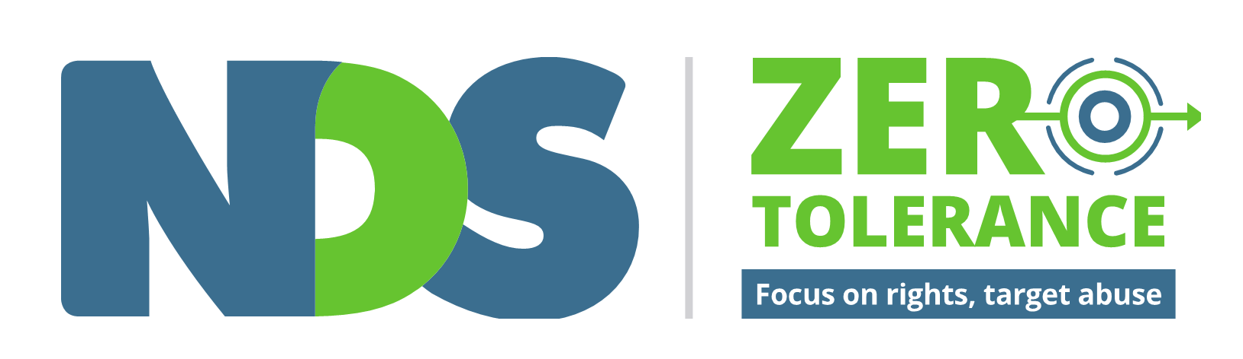

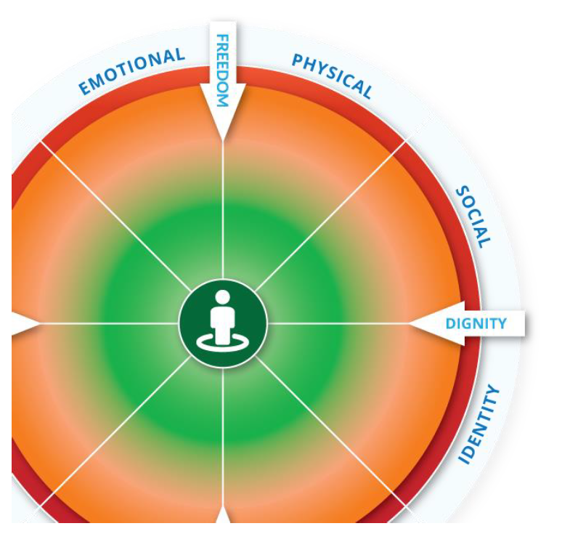

Contents
- Slide 1 - Zero Tolerance Initiative Overview Cover Page
- Slide 2 - When we talk about abuse, neglect and violence
- Slide 3 - Zero Tolerance Framework
- Slide 4 - Speaking Up About Safety
- Slide 5 - Zero Tolerance Resources
- Slide 6 - How to use Zero Tolerance resources
- Slide 7- Abuse and neglect can be
- Slide 8 - The Empowerment Circle
- Slide 9 - The Zero Tolerance Commitment
- Slide 10 - Contact Us

Things to Consider
Spend some time familiarising yourself with the slides and the Zero Tolerance website before your presentation
- Contact NDS is you have any questions before you present
- Allow enough time for questions
- Think of some relevant examples to share throughout the presentation
- Use Zero Tolerance films to encourage conversation

Disclaimer
The information provided in this guide and accompanying films is intended for general use only. It is not a definitive guide to the law and best practice. It does not constitute formal advice, and does not take into consideration the particular circumstances and needs of your organisation. Every effort has been made to ensure the accuracy and completeness of this document at the date of publication. NDS cannot be held responsible and extends no warranties as to the suitability of the information in this document for any particular purpose and for actions taken by third parties.

Copyright
This publication is copyright. All intellectual property rights vests in NDS. Material which is reproduced from this publication must include an acknowledgement of the source. Prior permission should be sought from NDS.
© National Disability Services 2019

Slide 1
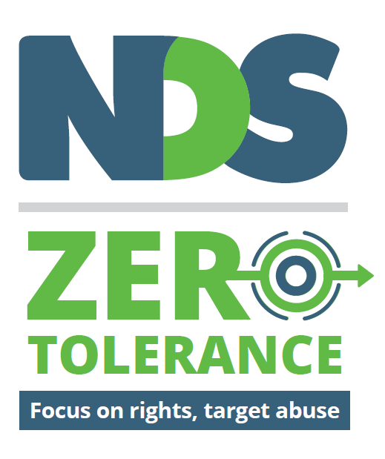

Zero Tolerance Initiative overview

Facilitator notes:
- Zero Tolerance is an initiative led by NDS in partnership with the disability sector.
- You might have heard the term ‘Zero Tolerance’ before, so it’s good to clearly define what we are talking about when we use it here.
- We know that there is widespread abuse, neglect and violence towards people with disability and that people are affected by this in all settings.
- Zero Tolerance is not a punitive term. It is a call to refocus on the rights of people with disability.
- Zero Tolerance means a commitment to take action on anything:
  - That doesn’t support human rights
  - That might make people feel or be unsafe
  - That you could be doing better

Useful links:
Zero Tolerance website

Slide 2

When we talk about abuse, neglect and violence
Some of the things we talk about might make you feel uncomfortable. It’s OK to have a break if you need to. Think about who you can talk to if you extra support.

Beyond Blue:
1300 22 4636
Website

Lifeline:
13 11 14
Website

1800 Respect:
1800 737 732
1800 Respect website

Facilitator notes
- This is an important place to start when we talk about abuse, neglect and violence
- Talking about these things can be hard for some people
- We don’t know what people’s personal experiences have been, what they have seen in their work, or what these conversations might bring up
- Feelings may come up during the session, later today, in a week, in a month
- These sessions are not the place to talk about personal experiences of abuse but it is important that you know who you can talk to
- That may be a supervisor or manager, friend, partner or family member
- Remind people about Employee Assistance Program, Beyond Blue or Lifeline
- Have this conversation EVERY time you address this topic of recognising and responding to abuse; and remind people of the support services available
- Think about what follow up conversations may be needed

Useful Links:
- Beyond Blue – 1300 22 4636, Website
- Lifeline – 13 11 14, Website
- 1800 Respect – 1800 737 732, website
Decorative image omitted.

Slide 3

The Zero Tolerance Framework
- Understanding Abuse
- Promote and apply human rights
- Understand causes of abuse
- Recognise risk factors and signs of abuse
- Practices and safeguards which can help prevent abuse
- Implement policy and practice that protect people’s rights
- Support empowerment of people with disability
- Create the right organisational cultures
- Addressing risk for specific groups and service settings
- Targeted approaches for groups at increased risk of abuse
- Target service features and settings that increase risk
- Reducing and eliminating restrictive practices
- Responding to abuse
- Early intervention and response
- Supporting the person
- Meet legal and organisational requirements
- Analysis, Learning and Improvement
- Maintain and analyse records
- Continuous improvement
- Support initiatives to reduce abuse

Facilitator notes
- Zero Tolerance is an approach for disability service providers to prevent and respond to abuse of people with disability.
- NDS developed the Zero Tolerance Framework in 2014 in consultation with people with disability, advocacy organisations, service providers, government and statutory bodies and academics
- As the peak body for non-government disability services, NDS saw that it had a responsibility to do something about abuse, neglect and violence towards people with disability in services
- The Framework is similar to prevention frameworks used in other sectors, with the addition of:
  - recognition that we didn’t have a clear consistent understanding of what we mean by abuse
  - that while most actions are universal, there are also risks for specific groups and service settings that need more targeted approaches
- It uses a framework with five levels so everyone in an organisation is clear on things they can be doing, from frontline workers to the board.
  - Understanding Abuse – why, and how and what we are talking about
  - Preventing Abuse – through empowerment of people with disability, and organisational cultures
  - Considering Additional Risk for people and places that are most at risk
  - Responding to abuse to ensure safety and justice for victims
  - Learning from Abuse so it doesn’t happen again

Useful links:
- Detailed version of the Framework with actions for organisations
Decorative images omitted.

Slide 4

‘Speaking up about safety’
In the 2014 report ‘Speaking Up About Safety’, people with disability said that they feel safe when service providers:
- Listen
- Respect people’s choices and decisions
- Involve people with disability in planning their services
- Make sure that staff can do their job properly
- Get to know people and treat them as an individual
- Support contact with services like police or advocacy
- Ensure respect for personal space and privacy
- Offer choice about who people live with
Speaking Up about Safety summary and full Report
Decorative image omitted.

Facilitator notes
- In 2013-2014 NDS worked with advocacy organisations to have focus groups with people with disability from across Australia
- This included:
  - people with intellectual disability
  - people from culturally and linguistically diverse backgrounds
  - people from remote Aboriginal communities
  - women with disability
  - people who require communication support.
- People were asked about feeling safe at home, in the community, and what they wanted from service providers in order to feel safe.
- The most frequent response across all groups was “Listen to me”.
- We recognise that not everyone chooses who they live with, and this is an important conversation to keep having as we work to ensure people feel and are safe.

Useful links:
Speaking Up About Safety summary report and full report

Slide 5

Zero Tolerance Resources
- Understanding abuse
- Human Rights and You: 30 minute eLearning program and guide
- Understanding Abuse: 40 minute eLearning program, set of eight films, workbook and guide for supervisors
- Empowerment Circle
- Practices and safeguards which can help prevent abuse
- Practice advice: Safer Recruitment and Screening, Supervision and Safety
- Positive Cultures: set of eight films and guide
- Addressing risk for specific groups and service settings
- Recognising Restrictive Practices: seven pairs of films and guide
- Responding to abuse
- Responding to Abuse: set of eight films and guide
- Analysis, Learning and Improvement
- Safeguarding for Boards guide

Facilitator notes
- NDS have developed a range of resources to support the implementation of the Zero Tolerance Framework
- They are all free and are designed to be used flexibly in the context of your organisation’s policies and procedures
- Look at the Zero Tolerance Framework and what you are currently doing in your organisation, and use the Zero Tolerance resources that are most relevant to you
- NDS continues to work with people with disability, support workers, government, advocacy and specialist services to develop new resources
- These are some of the things that are available: (read from screen)

Useful links:
- Understanding Abuse webpage
- Preventing Abuse webpage
- Considering Additional Risk webpage
- Responding to Abuse webpage
- Learning and Improvement webpage
Decorative image omitted.

Slide 6

How to use the Zero Tolerance resources
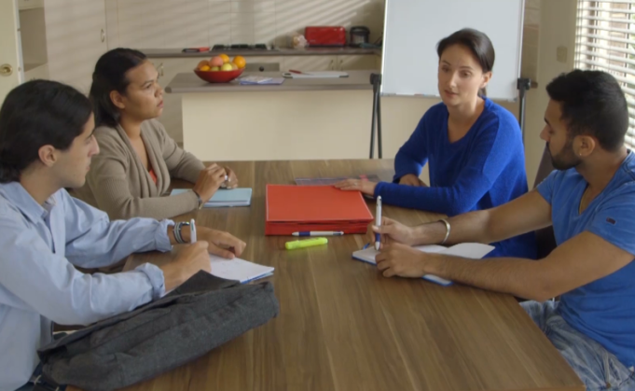
- In board meetings
- As part of induction
- During ongoing staff training
- As part of supervision
- During staff meetings or team discussions
- In personal reflection
- With people with disability, families and carers

Facilitator notes
- These are some of the ways that the NDS Zero Tolerance resources are being used
- Some of the resources are also being used in research, training and online tools by government
- NDS would like to hear from you about how you are using the Zero Tolerance resources.
Decorative image omitted.

Slide 7

Abuse and neglect can be:

Deliberate
- perpetrators target people with disability
- people seek to harm or take advantage of others
- exploit vulnerability of systems and people
- cutting corners, rushing activities and supports.

Accidental
- prioritisation of routine over personal choice
- staff don’t realise their actions are abuse
- staff don’t understand the impact of their actions
- actions indirectly impact on someone else.

Systemic
- staff not trained or supervised properly
- staff don’t have the resources to do their job
- insufficient staff due to high sick leave / turnover
- people forced to live with others who pose a risk.

Facilitator notes
- It doesn’t matter what the cause is
- The person who experiences something is probably not wondering whether the cause is deliberate, accidental or systemic.
- What matters is the impact. This is where our focus needs to be.
- When you consider examples for each of these, it is useful to consider the Zero Tolerance Framework and where your response will fit within the Framework
Decorative images omitted.

Slide 8

The Empowerment Circle
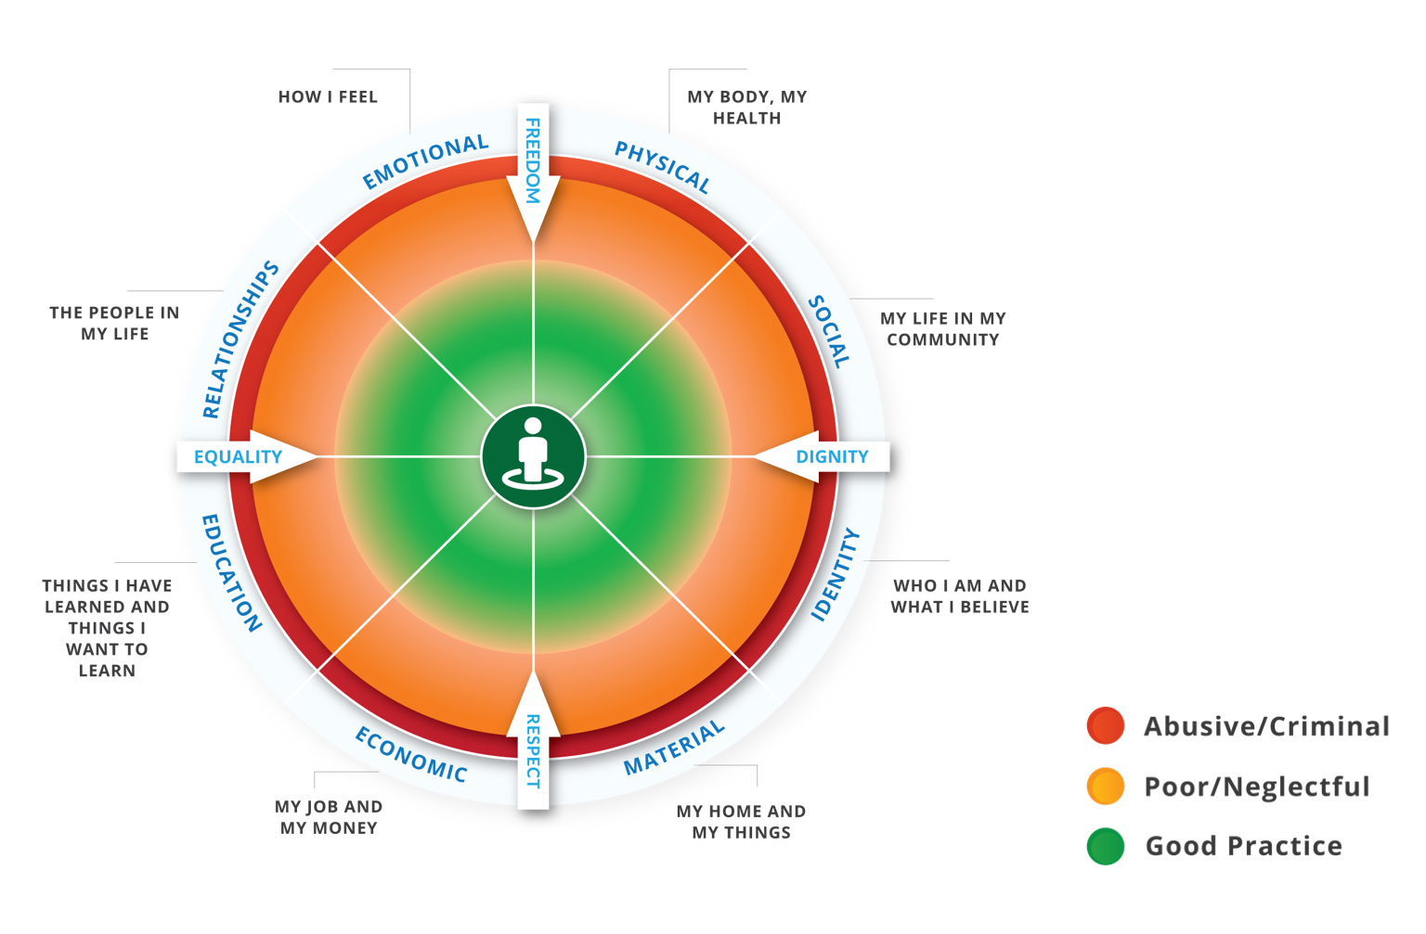

Facilitator notes
- We know that abuse, neglect and poor practice can happen in every area of a person's life.
- The Empowerment Circle will help you think about ways to support people to be more empowered in each of these areas through good practice.
- When we think about abuse, neglect and violence towards people with disability, we must not only consider criminal and reportable incidents, but also all of the everyday experiences of poor practice, neglect and misuse of power that people experience.
- The Empowerment Circle is a visual representation of this
- The red outer edge of the circle represents abusive and criminal practice.
- The orange shading represents layers of poor practice and disempowerment.
- The green area represents good practice, with the person in the middle representing empowerment and control overall areas of their own life.
- The arrows of freedom, respect, equality and dignity are human rights markers that remind us to keep working to achieve these rights

Useful links
Understanding Abuse downloadable worksheets and Guide for supervisors

Slide 9

The Zero Tolerance Commitment
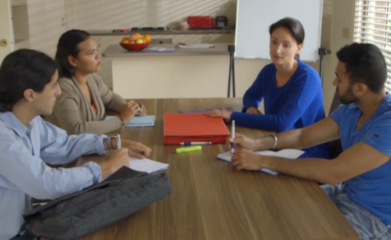

A commitment by organisations and people to speak up and take action on:
- anything that does not support a person’s rights
- anything that might make a person feel or be unsafe
- anything they could be doing better

Facilitator notes
- The Zero Tolerance Commitment is a commitment you can make with your team or organisation to speak up and take action on anything
  - that doesn’t support human rights
  - that might make people feel or be unsafe
  - that you could be doing better
- This can start with a conversation about what is OK and not OK, and a commitment to let each other know when you see these things
- It can sometimes feel uncomfortable, but it about recognising that some things are more important than our own feelings of discomfort
- It doesn’t replace your complaints and reporting procedures but works together with them
- Question for the group: Do you give each other permission to let each other know when you see things that are not OK?

Useful links:
Understanding Abuse eLearning program
Decorative image omitted.

Slide 10

Contact us
NDS Zero Tolerance Website
Mary Lou McPherson – email here.
Dave Relf – email here
Decorative image omitted.
End of document.

