Workforce Planning in a Nutshell:

A simple handbook for disability organisations

Key terms

Workforce planning
Workforce planning looks at what an organisation needs to accomplish in a given period of time; what knowledge, skills, and experience are required to get the job done; and how large and what type of workforce is required to provide that mix of skills, knowledge, and experience. It defines the activities necessary to have ‘the right people with the right skills in the right place at the right time’.

Functional requirements
Are the key functions that need to be performed in order to accomplish the direction set out in the Strategic Plan. Remember: functional requirements focus on the job function not on the people needed to do the job.

Gap analysis
The difference between what is needed and what is available. It also represents the difference between where you are and where you want to be.

Strategic planning
Is an organisation’s process of defining its strategy, or direction, and making decisions on allocating its resources to pursue this strategy.

Workforce profile
Is a collection of confidential data about your employees. It can include age, gender, employment status (permanent part-time, casual), tenure, remuneration and qualifications.

Succession planning
A process designed to ensure the continued effective performance of an organisation by making provision for the development and replacement of key people over time. Succession planning is generally considered to be a strategy of workforce planning.

Performance measures
Common measures for evaluating performance include outputs, outcomes, and efficiency. Performance measures answer the question, ‘How is the organisation doing at the job of meeting its strategic objectives?’
Milestone
Is a key achievement at a specific stage in a project. A milestone is typically an important project event, such as the achievement of a key deliverable.
Deliverable
Measurable outputs, services, items or change produced by a given project or activity.

Introduction

What is workforce planning?
Workforce planning is an organised process for:
• Identifying the number of employees and the types of employee skill sets required to meet your organisation’s goals, strategic objectives and service delivery requirements
• Developing a plan of action to ensure that the appropriate workforce will be available to provide quality services to your disability service clients.

Why is it important?
In the disability sector there are a number of factors that are contributing to the challenge of managing the workforce. Some significant factors are:
• Changing demographics of the workforce
• Changing policy and funding landscape as the National Disability Insurance Scheme (NDIS) is implemented
• Increased competition for skilled and capable employees
• Increasing demand for disability services
• Continuing financial challenges
To address these factors, organisations will benefit from developing useful workforce plans to ensure they have the right number of people in the right jobs at the right time to meet their goals and objectives, and to plan for future growth.
Many industries and organisations have developed models for workforce planning. Except for variations in terminology and the order of the processes, most approaches are similar. The model documented in this guide has attempted to take into account the unique operating cultures and needs of the disability services sector.
It is simple, flexible and can be modified to address your organisation’s specific and distinctive needs.

Stages of workforce planning & development
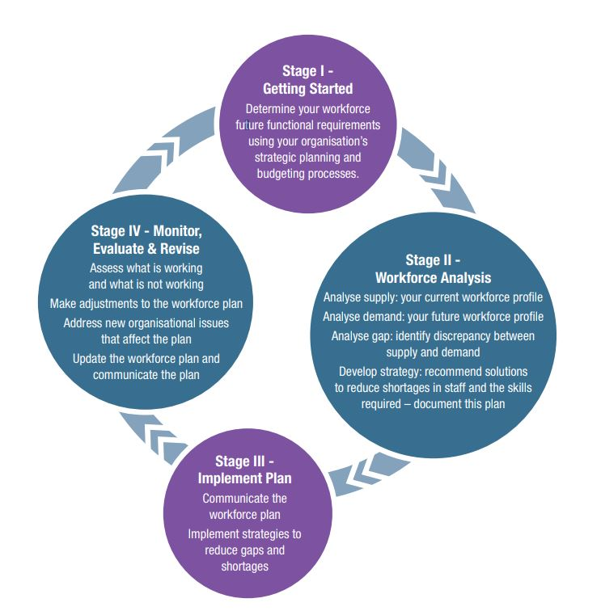

Stage 1 - Getting started

Determining your organisation’s strategic direction
Strategic planning sets an organisation’s direction and defines its goals and measurable objectives. These goals and objectives not only provide the basis for determining necessary financial resources, but they also provide the basis for determining workforce needs.
Workforce planning complements and is a follow-up to strategic planning. A workforce plan translates strategy into action to identify workforce staffing and training needs. It attempts to answer the following questions:
• How many and what types of jobs and skills are needed to meet the mission and strategic goals of the organisation?
• What strategies should the organisation use to hire, retain, or teach these skills?
To understand your organisation’s direction and future workforce needs, a summary of the mission, strategies, and goals over the next five years will need to be documented and analysed. Usually the most valuable workforce planning information can be found in your organisation’s strategic plan and budget.
Starting Place | Actions to Consider
Strategic plan | - Analyse your organisation’s strategic plan  - Identify mission, key strategies, goals and workforce issues  - Determine whether there are pending changes to the organisation’s mission that would affect your workforce now or in the future
Budget information | - Analyse your budgets and forecasts  - Determine whether there will be budget issues affecting your current or future workforce
Decide scope | Determine whether your workforce plan will cover your entire workforce or a more limited scope, such as:  • Focusing only on occupations delivering key services  • Focusing only on occupations that are difficult to recruit to or retain people in  • Focusing on a particular strategy outlined in the strategic plan to ensure that the right people are available to get the work done in one specific area

Stage 2 - Conducting your workforce analysis
Analysis of workforce data is the key element in the workforce planning process. Workforce analysis frequently considers information such as occupations, skills, experience, retirement eligibility, diversity, turnover rates, education, and trend data. Using the NDS Workforce Wizard to document your organisation’s profile is an easy way to track and document these trends.
There are four key steps to the workforce analysis phase of the planning model. These steps are illustrated below.

Step 1: Analyse supply
Supply analysis focuses on an organisation’s existing and future workforce supply. It answers the question, ‘What is the existing profile of the current workforce, and what does it need to be in the future to accomplish our goals and objectives?’
To assist with this process see the Current Workforce Profile spreadsheet.
Starting Place | Actions to Consider
Determine supply factors | Determine and document the workforce profile:  - Identify the ages, gender, language and cultural background (if relevant), education levels and length of service  - Determine the skill profile of your workforce. You may want to compare the best, average, and poor performers. What knowledge, skills and abilities do high performers use to achieve success?  - Identify any workforce management issues that affect your workforce  - Ask your frontline managers to identify segments of the workforce that are currently or potentially vulnerable  - Review retention, turnover, promotion patterns and leave usage  - Consider whether your organisation’s turnover rate affects its ability to deliver services  - Review staff retirement plans and patterns  - Project what the skill and experience level of the current workforce needs to be in the future  - How have and will retirements affect your organisation and ability to deliver service?  - What other challenges might affect the organisation’s ability to recruit and retain important skills?

Step 2: Analyse demand
Demand analysis identifies the future workforce needed to carry out your organisation’s mission. The focus of this step should be on the work the organisation must perform and on the staff needed to perform that work. To assist with this process refer to the PESTLE analysis and future Workforce Requirements Templates.
Note that you can assess the environmental context of your organisation at an earlier stage in the process if this makes sense.
Starting Place | Actions to Consider
Examine internal and  external environmental factors | Demographic  - Identify significant external demographic issues that are likely to influence the demands placed on the organisation, such as the aging population  Technological  - Investigate how technology can and will be used to enhance service provision  - Identify jobs that will be affected by technological enhancements  - Determine whether any changes in technology will affect the number of employees needed to do the work or the type of skills needed  Economic  - Are there funding and economic considerations that have particular relevance to the organisation and its provision of programs and services?  Labour market  - Identify labour trends in the localities and regions you work in  - Examine student information available from educational institutions  - Assess where you might get staff from both internally and externally  - Identify issues associated with the use of non- permanent staff, including cost and supply  Summary  - Will the way the work is being done need to change?  - Will programs/services be added or deleted?  - Will current employees have the necessary skills to do the work in the future?  - What types of employees/skills are needed for the future?  - Will the workload change?  - Will more or fewer employees be needed?

Step 3: Gap analysis
Gap analysis involves comparing the workforce supply projection (Step 1) to the workforce demand forecast (Step 2) and attempting to answer the following questions:
• What new skills will the organisation need to accomplish its goals and objectives?
• Does the organisation’s workforce currently have the anticipated needed skills?
• What job functions or skills will no longer be required?
The organisation will establish workforce strategies based on the results of this analysis. Analysis results may show one of the following:
• A gap (when projected supply is less than forecast demand), which indicates a future shortage of workers or skills. It is important to know what critical jobs will have gaps so the necessary training or recruiting can be anticipated.
• A surplus (when projected supply is greater than forecast demand), which indicates a future excess in some categories of workers and may require action. The surplus data may represent occupations or skills that will not be needed in the future or at least will not be needed to the same extent.
Benchmark results that allow you to compare your organisation with others in the disability or broader sectors can help inform this analysis.

Step 4: Strategy development
The final step in Stage 2, the workforce analysis phase, involves the development of strategies to address future gaps and surpluses. Strategies include the programs, policies, and practices that assist an organisation in recruiting, developing, and retaining the critical staff needed to achieve its mission and strategic goals.
Strategies can fall into the broad categories of:
• role redesign or organisational development strategies that ecourage new ways of working (eg team work) or support clients in new ways
• recruitment strategies to find trainees and/or qualified candidates from your traditional or new labour pools, such as recent immigrants or carers
• selection strategies to help you find, recognise and select the best possible candidates in what is often a very competitive marketplace
• retention strategies to encourage employees to stay in the organisation
• staff development strategies to build capacity by shaping and developing staff capabilities and prepare employees for new roles or responsibilities (see templates to help you document and manage this process)
• succession planning strategies to ensure that there are qualified people capable of filling critical positions, and knowledge transfer strategies to capture the knowledge of experienced employees before they leave your organisation.
Remember: Strategies should be kept to a manageable number so they can be achievable, and they should be prioritised to allow your organisation to focus its resources on the most important strategies first. To assist with this process see the Sample Gap Closing template.

Stage 3 – Implementing your workforce plan
Before implementing the plan, you should consider how you will implement your strategies, including gaining the organisational support and resources you need. An organisation may need a separate action plan to address the implementation of each strategy in your workforce plan.
Strategies can fall into several broad categories as follows:
• ensuring that there is executive and board support for the workforce strategies
• allocating necessary resources to carry out identified workforce strategies
• clarifying roles and responsibilities in implementing the strategies
• establishing timelines
• defining performance measures, milestones and expected deliverables
• communicating the plan.
Remember: Your workforce plan should be implemented in connection with the requirements of organisation’s strategic plan. If the strategic plan changes due to unanticipated funding, leadership or even legislative changes then adjustments to workforce plan strategies may be necessary.

Stage 4 - Monitor, evaluate and revise
Ongoing evaluation and adjustments are important in workforce planning and are key to providing a usable process that works for the disability services sector.
Workforce plans should be reviewed at least annually. If an organisation does not regularly review its workforce planning efforts, it risks failing to respond to unanticipated changes and challenges.
Consequently, you should establish a process that allows for a regular review of your workforce planning efforts to:
• review performance measurement information
• assess what is working and what is not working
• adjust the plan and strategies as necessary
• address new workforce and organisational issues that occur.
Organisations should ask the following questions to determine whether the plan needs revision:
1. Have organisation strategies changed?
2. Are the assumptions used in both the demand and supply models still valid?
3. Have there been changes that would require a review of the strategies?

Workforce planning templates
Below is a brief description of each of the templates with instructions on how to complete them.
1. Current Workforce Profile – See separate spreadsheet here.
This template provides you with the ability to document your current staff profile. Payroll data should be used to populate the spreadsheet.
2. Future Workforce Requirements Profile – See separate spreadsheet here.
This template provides you with the ability to analyse your current workforce profile (Supply Analysis), future staff requirements (Demand Analysis) and the resulting Gap Analysis to give you information regarding current and future workforce requirements.
The template is based on a single spreadsheet that requires you to enter the following information:
• Existing workforce. Enter a separate line for each position type within each location.
• Future workforce. This is based on your future staff requirements to meet changing business needs and requires you to enter the total number of staff you will require in each position/location in the year in which you will require them.
3. Sample Gap closing template – See separate spreadsheet here.
This template provides an example of a stategy plan drawn up to address a specific workforce gap.
4. Skills Profile – Word document, page 13
This template details the required skills to perform specific job roles within your organisation. Each job classification within your organisation should have an appropriate skills profile. An example Skills Profile with sample data is provided for your guidance.
5. Individual Learning and Development Plan – Word document, page 14
This template allows you to build and record development plans for each individual within your workforce. It also provides the ability to track progress against the plan. An example Individual Learning & Development Plan with sample data is provided for your guidance.
6. Workforce Plan Template – Word Document, available here.

Skills Profile template
Job title
Core organisational competencies
What will be the core competencies required for our organisation?
Job family competencies
What will be the common competencies required for this function, team or job type?

Job specific competencies
What will be the specific competencies required for this job role?

Individual Learning and Development Plan template
Name:
Date:
Job role:
Department/team:
Line Manager:
Process: Identify assessment method (self, evidence based, Line Manager verification) of individual against the skills profile for the job role, linked to performance management cycle.
Strengths
Learning needs
Development required (priority)
Continuous improvement areas

Contact details
Caroline Alcorso
National Manager, Workforce Development National Disability Services
Level 19, 66 Goulburn Street
Sydney, NSW, 2000
Phone: 02 9256 3111
Email: caroline.alcorso@nds.org.au
This handbook was developed by Talent Consortium as part of an NDS project funded in Western Australia by the Disability Services Commission. December 2016 ©
This publication is copyright. All rights reserved. Except as provided in the Copyright Act 1968 (Commonwealth), no use of this work, which is within the exclusive right of the copyright owner, may be made.

