AUSTRALIAN DISABILITY WORKFORCE REPORT
fEBRUARY 2018

Contents

Executive summary 2
1 Introduction 3
2 How are workers employed? 6
Overview 7
Does organisational size make a difference? 8
Is there a gender story? 9
The growth in the workforce 10
Workforce turnover 13
Another look at growth in the workforce 15
How does the sector compare? 17
3 What hours are worked by disability workers? 18
Overview 19
Does organisational size make a difference? 19
Average hours worked by each worker 20
Gender and hours of work 22
Hours of work and workforce growth 23
How does the sector compare? 24
4 Spotlight topic: absences 25
Introduction 25
Personal and carers’ leave and leave without pay 25
Industrial instruments covering the workforce 27
5 What are workers looking for? 31
What interests job seekers? 32
Job applications 33
6 What does the allied health workforce look like? 36
Demographic aspects 36
Forms of employment 37
Hours of work 37
Spotlight topics 38
Appendix 39

Executive summary

The second edition of Australian Disability Workforce Report revisits the issues first identified in our mid-2017 edition. The richness of nine quarters of Workforce Wizard data covering between 35,000 and 38,000 people each quarter significantly deepens our understanding of front-line disability and allied health professional work.
The analysis presented confirms the distinctive character of the of the disability workforce: a majority female, mainly part-time group of workers, over two-fifths of whom are casually employed.
Trends and features that appear to be associated with the way the sector is responding and adapting to the National Disability Insurance Scheme are also becoming clearer as the rollout gathers pace.

Changes in support worker employment as the NDIS rolls out
Since 2015, casual work has been increasing slightly, and now accounts for 42 per cent of all workers. Most employment gains appear to be coming from casual employment growth. This trend is mainly driven by small and medium organisations, where casual employment at the end of 2017 formed close to half of their workforce.
Two potential downsides to this high casual employment, however, are revealed elsewhere in the data analysis. First is the very high turnover rate of casual workers – a two-year average of nearly 9% per quarter (equal to 35% per annum). This is a significant cost and administrative burden for providers. Second, detailed investigation of NDS carecareers job board data shows job applicants have a clear preference for permanent over casual roles. In the competition for talented people, offering casual jobs only or mainly is likely to be a liability. Part-time work has also been growing; but unlike casual employment large organisations are also contributing to this tendency. It appears that both large and small/medium organisations are seeking to achieve flexibility in their staffing, but have chosen different strategies. Again, the NDS carecareers job board data offers useful insights. Most job applicants want part-time rather than full-time work, so this growth in the sector is partly driven by worker preferences.

Allied health professionals facing an uncertain environment
Allied health professional employment offers a stark contrast to that of disability support workers. Instead of being majority part-time, the allied health workforce is split almost evenly between people who work full and part time. Three-quarters are permanent workers. But around 16% of applied health professionals were employed as fixed term (on short term contracts) over the last two years and this rose to above 20% during some quarters.
Again, different strategies to minimise risk in an uncertain environment are being used with this young, mainly female professional workforce.
Spotlight topics of interest suggested by Workforce Wizard users
The two spotlight topics featured in this edition of Australian Disability Workforce Report are staff absences and industrial instrument coverage.

This is the first time we have reliable data on the use of personal and carers’ leave in disability: well over ten days per year. The data is important to achieving fair prices since these figures run counter to the figures assumed by the NDIA.
The disability sector also has an above-average proportion of workers on enterprise agreements than the labour market average, although we know that many of these are due to be renegotiated.

Workforce Wizard and carecareers data continue to fill a major gap
Despite government’s legitimate concern about the sector’s capacity to scale up as quickly as NDIS participants need, no publicly funded workforce data collection process exists. ABS classifications continue to merge disability workers with other groups, making it impossible to obtain regular labour force analysis.
NDS thanks the many regular Workforce Wizard users whose quarterly data entries allow us to fill this pressing information gap.

1 Introduction
This is the second edition of the Australian Disability Workforce Report, an NDS publication that documents current trends in the disability workforce. The features of this workforce is a key question for the sustainability of the National Disability Insurance Scheme (NDIS), and the disability sector as a whole.
Disability’s key workforce metrics are reported and discussed in this and every edition. A primary focus is how the workforce is changing (or not) with the introduction of the NDIS.
Australia’s capacity to provide a workforce that is of sufficient quantity and quality to meet the increasing workload that the NDIS demands will be crucial to the success of the scheme.
Where does the data come from?
Since ABS labour force data is not classified in a way that allows us to pinpoint the disability workforce, the Australian Disability Workforce Report relies on data from NDS’s purpose-built two-way workforce metrics application, Workforce Wizard.
Workforce Wizard http://www.workforcewizard.com.au/ is a free online tool into which disability service providers enter data quarterly. An important design element of Workforce Wizard is that it is short and simple, making it convenient for users. Once the data period closes, benchmark reports are quickly generated showing the organisation’s workforce characteristics benchmarked against the sector.
Organisations enter data based on workforces of their own defining. For the purposes of this report, if an organisation entered data for more than one workforce, those workforces were consolidated into one organisational result. This is to avoid multiple counts of a single organisation with more than one (and sometimes duplicate) workforces. When the unit ‘organisation’ is used in this report, it needs to be understood that the real life organisation may have other streams of activity, such as aged care, plus other staff (eg back office staff) who are not included in our analysis.

The data sample used in this report is nine quarters of data entered up to the end of the September quarter in 2017. Roughly 35,000 to 38,000 disability support workers and allied health professionals data were entered each quarter, from across Australia. Considering the significant coverage of the sector that Workforce Wizard provides, aggregate results have been mainly used.
A longitudinal ‘balanced panel’ has also been created of organisations that have entered data across the seven consecutive quarters between March 2016 and September 2017. The longitudinal nature of this panel means the disability support worker results from each quarter are more truly comparable to each other, and can confirm trends.
There is no separate longitudinal analysis for the allied health workforce, as most participants of this sample are consistently engaged with Workforce Wizard and therefore constitute a longitudinal panel.

Data on jobseekers
The second major source of data used in this report comes from carecareers https://www.carecareers.com.au/. This is NDS’s job board where employers advertise for disability sector and aged care staff. The data from this job board spans about five years, from the end of 2012 to the beginning of 2018, and is a rich source of information on what is happening in the disability job market. Around one million people use this site every year to find disability and aged care jobs.
A more detailed discussion of Workforce Wizard and carecareers data and our methodology can be found in the first edition of the Australian Disability Workforce Report, which can be found at https://www.nds.org.au/workforce-hub

What’s in this report
In the next three chapters, the Report presents data on the key metrics Workforce Wizard collects about disability support workers:
/ types of employment
/ organisation growth
/ turnover rates
/ working hours; and
/ age and gender distribution.
Chapter Six analyses these same workforce trends among allied health workers.
Chapter Four reports on our newly introduced special topics, so-called Spotlight Topics, which shed light on important policy issues in the sector. These issues are generated by users and reflect their concerns and interests. One or two additional questions are asked each quarter about these subjects, on a one-off basis.
In this edition, the topics covered are:
/ Number of staff absences
/ Industrial instrument use in the organisation.
carecareers data analysed in Chapter Five concerns the number of views and applications made by jobseekers for each advertisement.
Throughout the report there are hyperlinks (in blue) to various other parts of the text, to all the figures, and to the tables in the appendix. These tables provide the data which sit behind all the figures. Clicking on these links will take you directly there, and clicking on the Back Button in your PDF Reader will take you back to where you were reading.

2 How are workers employed?

The disability workforce is quite distinctive. About 70% of disability support workers are women, compared to a figure of 46% in the wider Australian workforce.¹ Disability support workers are also slightly older than the Australian workforce: some 44% are aged 45 years or more. In the workforce more generally, the figure is 39%.
Over time, as the disability sector grows strongly, these features may change. More men and more younger workers may enter the sector. At present these features pose challenges that many services are overcoming as they broaden their recruitment targets. On the other hand, there are two areas where the characteristics of the sector pose considerable ongoing challenges. These arise around the forms of employment—whether workers are permanents or casuals—and the hours of work.² The disability sector is quite unique in both these areas and the steady growth of casual employment and the increased use of part-time hours raises important issues about the viability of the sector’s workforce. Will the disability workforce of the future be a stable, highly-skilled and well-motivated workforce? Or will we see the emergence of pockets of heavily casualised and part-time work, where high turnover, low morale and inconsistent standards prevail?
It is still early days in the rollout of the NDIS, but the sector needs to be alert to developments in the disability workforce which may undermine the positive outcomes promised by the scheme. By focusing on changes in forms of employment and hours of work, NDS is drawing attention to issues that industry, government and service users need to solve collaboratively.

- It is important to stress that this gender characteristic is shared by other community sector workers, such as carers and aides (the group which includes child-care aged-care workers) where the proportion is 85%.
- See the discussion of these concepts in the Appendix, on page A1.

Overview

The largest group in the disability workforce are permanent workers but casual workers make up two-fifths of the workforce, a share which has been increasing over the last 18 months
Most disability support workers are employed as permanent or casual workers. Very few are fixed-term workers.³ In September 2017 the proportion of permanent workers in the disability workforce was 55%; the proportion of fixed-term workers was 3%; and the proportion of casual workers was 42%. Figure 1 shows these proportions in each of the quarters over last two years.

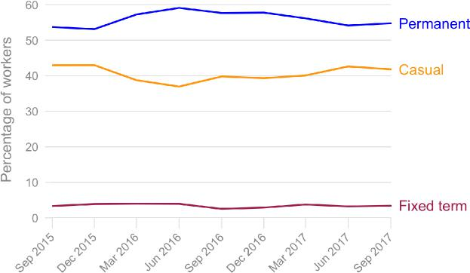

The figures for September 2017 are close to the overall averages for this two-year period, though the permanent proportion is somewhat lower and the casual proportion somewhat higher, suggesting that the share of casual employment may be slowly increasing. The analysis of workforce growth (page 14 onward) does indeed suggest that casual employment is increasing in the sector.
3. Permanents are employed with an expectation of on-going employment; fixed-term workers have a termination date in their contracts; and casuals have no expectation of any ongoing employment and can, in theory, be terminated at short notice.

Does organisational size make a difference?
Permanent employment is increasingly the preserve of large organisations and casual employment is becoming dominant in small and medium size organisations
While the overall trend towards increased casualisation is only slight, when we look more closely at the different organisational sizes in the disability sector, it becomes apparent that small and medium organisations are definitely engaging more casuals. This is shown in Figure 2. In both cases, the proportion of casuals among their disability support workers is now greater—or about to become greater—than the share of permanents. Only for large organisations is the gap between the share of casuals and permanents not closing.⁴

In the September 2017 quarter the proportion of permanent disability support workers in large organisations was 57%, while the proportion of casuals was 40%. By contrast, in small organisations permanents made up just 44% and casuals had reached 47%, while in medium organisations the figures were 49% permanents to 48% casuals.

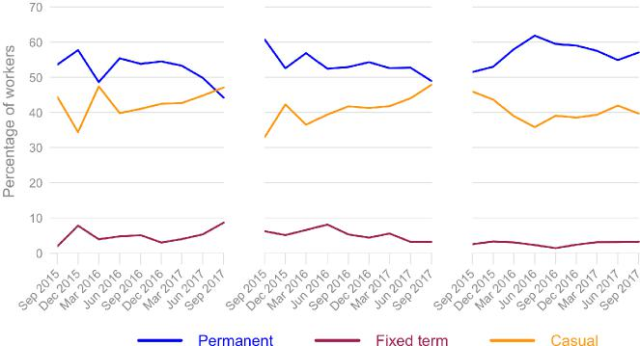
4. We categorise organisational size on the basis of the number of disability support workers in the organisation: Small: less than 50 workers; Medium: 50 to 199 workers; and Large: 200 or more workers.

Is there a gender story?
There is also a striking pattern according to the gender of the workforce. We saw in the last chapter that women make up the majority of the workforce—averaging around 70 percent—so this makes it difficult to define organisations by their gender proportion. Nevertheless, by pooling the data from all quarters, we have a sufficient number of observations to define four categories based on the ratio of female to male staff, that is, the percentage of women within each organisation’s workforce.⁵
As the proportion of women increase in organisations, so too does the proportion of casuals

By comparing the forms of employment across these four categories we find a distinctive result: organisations with higher female-to-male ratios have higher levels of casual employment and lower levels of permanent employment. Indeed, there is an almost linear relationship: as the proportion of women increase in organisations, so too does the proportion of casuals (see the red line in Figure 3.)
Figure 3: Forms of employment by the proportion of women employed
Notes: Note that data is pooled over all quarters. Details in Table A12.

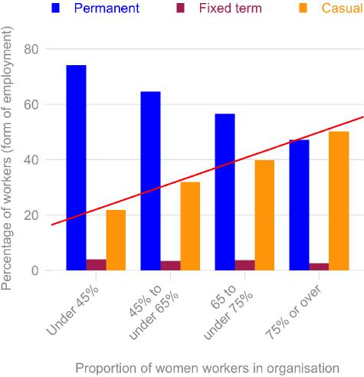
5. These categories are: Under 45% women; 45% to under 65% women; 65% to under 75% women; 75% or over women.

Permanent employment is dominant in organisations where there are a large majority of male workers
In organisations which are clearly majority male—that is, where male workers make up 55% or more of the staff—the proportion of permanents in those organisations is 74% and the proportion of casuals is just 22%. By way of contrast, in organisations where women make up three quarters of the staff—only slightly above the overall average—we find almost equal proportions of permanents (47%) and casuals (50%).

The growth in the workforce
One of the most striking aspects of the disability workforce is the strong growth taking place. As the NDIS rollout proceeds, new organisations have arisen and existing organisations have expanded their staff to cope with the increased demand for services. During 2016 the Australian workforce as a whole increased by about 1.6% per year, but the workforce in the broader social assistance / personal assistance / residential care sectors grew much more strongly, by 9.5% per year.⁶ In the case of the disability sector the growth, as measured by Workforce Wizard, has been even stronger: 11.1% per year (averaged over the two year period).
It is possible to examine workforce growth in the disability sector by analysing the numbers of workers who leave an organisation and the numbers who are recruited in each quarter. The difference between these is a measure of ‘net change’ in the workforce. These figures are collected by Workforce Wizard for permanent and casual staff, and an overview of these data are shown in Figure 4.
Employment losses come from permanent workers leaving and the gains come from increased recruitment of casuals
It appears that employment losses in the sector tend to come from permanent workers departing and that most of the employment gains are, in absolute terms, from increased employment of casuals. Given that casuals make up just under half of the disability support workforce one might expect that the net change would also reflect a similar ratio. Clearly, this is not the case, and the increased propensity for organisations to recruit more casuals is evident in Figure 4.
If we want to look at this in percentage terms, the permanent growth rate was 1.3% per year. The casual growth rate, on the other hand, was 26% per year.⁷
- Figures from Australian Bureau of Statistics, Characteristics of Employment, 2016, Cat. No. 6333.0.
- There is considerable quarterly variability in these percentages, so the figures given here are averaged over the two year period. A different approach to calculating growth rates, based on a balanced panel, is discussed below on page 20.

Figure 4: Net change in permanent and casual staff
Notes: Details in Table A13

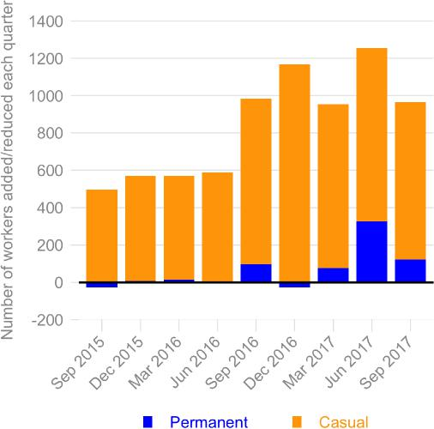
In large organisations permanent and casual employment are growing at the same rate but in medium organisations casual employment is growing strongly while permanent employment is declining
We saw earlier (page 12) that in both small and medium size organisations the proportion of casual staff was growing strongly, and becoming the dominant form of employment. For medium size organisations, this picture is confirmed in Figure 5, which shows the net change in permanent and casual staff across medium and large organisations (with trend lines shown in black). In large organisations the ratio between permanent and casual net changes in staff appears reasonably stable over time—both are growing together at the same rate. By contrast, in medium size organisations, the net change in casual staff is growing rapidly, while the net change in permanent staff shows a downward trend.

Figure 5: Net change in permanent and casual staff, by organisational size
Notes: Details in Table A14

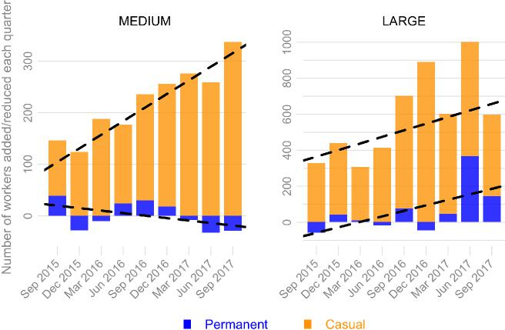
What do these changes mean? Essentially, over time a downward trend in the net change of permanent staff means that the sector is diluting its permanent workforce, and that in the long term the share of jobs in the sector held by casual workers will steadily increase. While large organisations are ‘holding the line’ and not contributing to this potential problem, the drivers of this transition lie in the medium size organisations.
Another perspective on these changes in employment entails categorising organisations by how their permanent and casual staffing profile changed during the quarter. We can define three categories: where a particular type of workforce is declining, where it is stable, and where it is increasing. (The definitions of these categories, and the detailed data for them, are shown in the appendix, see Table A17).
25% of all organisations experienced an increase in their casual workforce but the majority of organisations maintained a stable permanent workforce
Looking first at the casual staffing profile, about 71% of organisations have had a stable casual workforce in each quarter. Only a small proportion of organisations—an average of 3%—had seen their casual workforce decline during the quarter. By contrast, 25% of all organisations experienced an increase in their casual workforce.

In the case of permanent workers, about 85% of organisations had a largely stable workforce during the quarter. Another 7% of organisations had seen their permanent workforce decline. The remaining 8% of organisations had seen their permanent workforce increase. This organisational approach to the issue of forms of employments is important because it emphasises the stability, as well as the changes, in the sector.
As the sector grows rapidly, more of the increased recruitment of workers takes place through the creation of casual jobs
While the losses in employment which do take place are largely in permanent jobs—as we saw earlier—the magnitude of this is relatively small. The strong growth in casual employment may not represent a ‘conversion’ of permanent work into casual work. Rather, it suggests that as the sector grows rapidly, more of the increased recruitment of workers takes place through the creation of casual jobs.

Workforce turnover
Workforce turnover is an important measure of the amount of ‘churn’ in an organisation. High levels of labour turnover lead to instability, as experienced workers with good organisational knowledge depart and are replaced with less experienced workers. High labour turnover can signal problems with the organisation, such as low worker morale, or uncompetitive wages or working conditions. On the hand, turnover rates which are too low may leave an organisation without fresh ideas, and the organisations may suffer from routines which reflect old habits no longer suited to the organisation. For the clients, turnover which is too high disrupts continuity in their access to supports; turnover which is too low may leave them deprived of the new ideas which new recruits might bring.

About one quarter of the disability workforce changed jobs every year

The turnover rate is measured as the number of workers who leave an organisation during a quarter, expressed as a percentage of the average total number of workers for that quarter and the previous quarter. Thus the all-worker turnover rate, shown in Figure 6, was 6.5% in the September 2017 quarter; the permanent turnover rate was 4.9% and the casual turnover rate was 8.6%. In annual terms, about one quarter of the disability workforce changed jobs every year.

Figure 6: Quarterly turnover rates by forms of employment
Notes: Details in Table A18
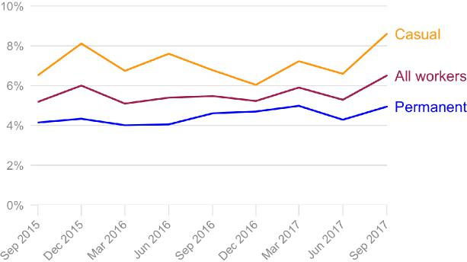

Casual workers have 1.6 times the turnover rate of permanent workers
The turnover rate for all workers averaged 5.6% per quarter over the last two years, so the 6.5% figure for September 2017 represents a small rise. The turnover rate for permanent workers has fluctuated between 4.1% per quarter and 5% per quarter over the last two years, and has averaged 4.4% per quarter for the period. In the case of casuals, the turnover rate has been even more erratic, ranging from a low of 6% per quarter through to a high of 8.6% per quarter, with the average for the last two years being 7.1% per quarter. The rate for the last quarter—at 8.6%—is above this longer-term average.
In summary, the turnover rate for casuals has averaged about 1.6 times as high as the permanent rate over the last two years and appears to be increasing. This reinforces the observation made at the start of the chapter: organisations gain apparent flexibility by employing more casual staff but the cost is a greater increase in labour turnover in their workforce, and a consequent drop in the quality of the service provision for their clients.

Another look at growth in the workforce
The information provided by Workforce Wizard on departures and recruitment is valuable in looking at growth and turnover rates. There is, however, an issue around compositional change in the Workforce Wizard sample. As new organisations join the Workforce Wizard, and others drop out, the composition of the workforce represented by all these organisations may change. To capture a more enduring picture of the workforce we can create what is called a ‘balanced panel’, a longitudinal sample made up of the same organisations.⁸
Using this balanced panel, we look at where the growth in the workforce came from with respect to forms of employment (see Table A15 for details). In overall terms, most quarters saw growth in numbers (with the exception of the March 2017 quarter) with the strongest growth taking place in the June and December quarters of 2016 (Figure 7).
We can also look at these data in terms of growth rates, that is, the percentage change in numbers in each quarter. Figure 8 shows that the quarterly growth rate for the permanent workforce is consistently lower than the growth rates for casuals (except for the last quarter). In annual terms, and averaging across all quarters, the growth rate for permanents was about 4% percent and for casuals it was 15.2%. The growth in the workforce overall was 8.4%.⁹

- In this case, we have selected only those organisations with complete data in Workforce Wizard for all of the seven previous quarters. While this reduces the size of the sample considerably, the numbers are still adequate for our analysis.
- Growth rates for fixed-term workers are not shown because they are so erratic, based as they are on very small counts. The average growth rate across all quarters for fixed-term workers is 1.1%.

Figure 7: Growth in disability support workforce by forms of employment (counts)

Notes: Details in Table A15
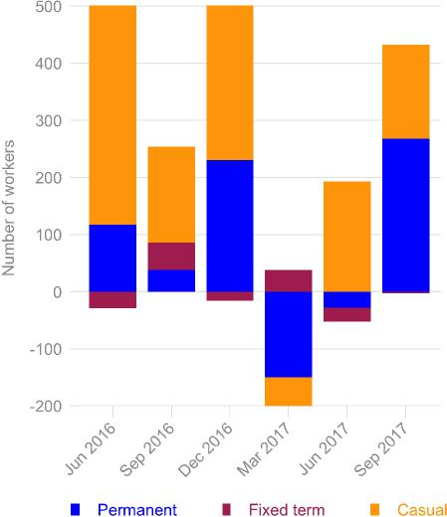

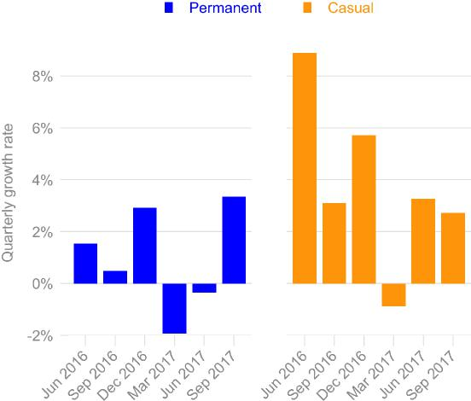 | Figure 8:  Growth in disability support workforce by forms of employment (quarterly growth rates)  Notes: Details in Table A16

Casual employment has driven employment growth but permanent employment has begun to fare better
Both these figures show that the majority of the growth in the sector’s workforce was through the increased employment of casuals, with only the most recent quarter breaking from this pattern. This analysis confirms the overall picture shown earlier: that casual employment is overwhelmingly driving employment growth in the sector but that in the last quarter (September 2017) permanent employment fared much better. Additional quarters of Workforce Wizard will indicate if this is the beginning of a new trend.

How does the sector compare?
In 2016 the proportions of casuals, permanents and fixed-term workers in disability, compared with the labour market more generally were as follows:
Permanent: 58% (disability) to 67% (in general); Casual: 40% (disability) to 23% (in general); Fixed term: 3% (disability) to 10% (in general).
Casual employment in disability is much higher than in the labour market more generally
This comparison shows that casual employment in the disability sector is considerably higher than in the labour market more generally. At the same time, fixed-term employment is much lower.
If we look at the ABS category of ‘carers and aides’—which includes child care, aged care and disability—this difference in casualisation rates shrinks considerably: some 33% of carers are casuals. The full details of these comparisons can be found in the appendix (Table A6).
In summary, casual employment is much higher in the disability sector than in the Australian workforce more generally. But if we compare the sector to other similar sectors, then the comparison is less stark, though these higher casualisation rates are still exceptional.

3 What hours are worked by disability workers?

Overview
Flexibility in the hours of employment is important for both employers and workers. The former often need to manage varying demand for staff, while workers often need flexibility to juggle their work and non-work lives. In this chapter we look at the hours patterns in the permanent workforce: mainly the split between part-time (under 38 hours per week) and full-time (38 hours or more). We also look at the average hours worked each week.
The disability sector shares in what has been a national trend towards increased part-time work. Within the disability sector, part-time work is dominant and also increasing (see Figure 9). In the September 2017 quarter, the proportion of the permanent workforce who worked part-time was 81%. Full-time workers made up the remaining 19%.
Figure 9: Full-time and part-time workers: overview (%)
Notes: Details in Table A19
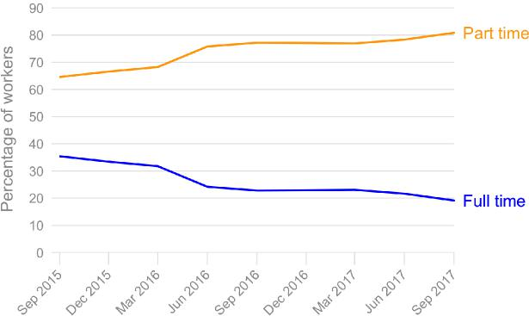

The permanent workforce is dominated by part-time work, and this is growing strongly
Over the last two years part-time work has grown strongly among permanent disability support workers. In September 2015 part-time workers made up 65% of this workforce (with full-timers making up the remaining 35%). The part-time workforce (among permanent workers) has thus grown by 16 percentage points in just two years.

Does organisational size make a difference?
Large organisations have increased their part-time workforce and now have the highest proportion of part-time workers
Over the last two years large organisations have been steadily increasing their part-time workforce. As Figure 10 on page 25 shows, at the start of the period part-timers made up 62% of their workers. By the end of the period the figure was 83%, an increase of 21 percentage points. From being behind small and medium organisations in their employment of part-timers back in 2015, by late 2017 large organisations now have the highest proportion of part-timers.
In both small and medium organisations the proportion of part-timers has remained reasonably stable over the period (with more volatility in small organisations). By the end of the period medium organisations had slightly higher proportions of part-timers than did small organisations (74% to 68%).
Both large and small/medium organisations aim for workforce flexibility but have chosen different strategies

Because the analysis discussed here applies to the permanent workforce, a number of inferences can be drawn. First, this high proportion of part-timers in large organisations is predominantly permanent part-time. Secondly, the slightly lower proportion of part-timers in small and medium organisations needs to be seen in the context of higher levels of casual workers in those organisations. In other words, both large and small/medium organisations have sought to achieve flexibility in their staffing, but have chosen different strategies.

Figure 10: full-time and part-time workers by size of organisation

Notes: details in table A20
Figure 10:
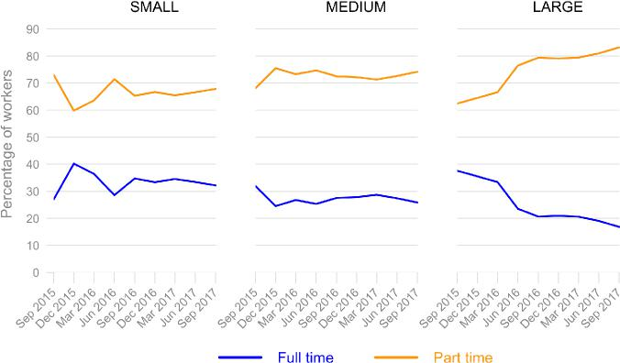 | Full-time and part-time  workers by size of organisation  Notes: Details in Table A20

Average hours worked by each worker
There is a long-term downward trend in average hours of work .and this is most pronounced in medium and large organisations
Does the increased use of part-time workers also mean a reduction in the average hours worked by each worker within the disability sector? In general, the answer appears to be yes. There is a downward trend over the last two years in overall average hours of work, as shown by the red line in Figure 11.
Figure 11: Average hours of work per week per worker
Notes: Details in Table A21

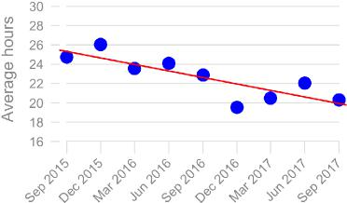

If we look at the size of the organisations we can see that this is driven by the medium and large organisations (see Figure 12). In small organisations, average hours of work are stable whereas in both medium and large organisations they are declining steadily. This last result is not surprising: given the increased use of part-time workers by large organisations, it follows that their average hours per worker will be declining.
Figure 12: Average hours of work per week per worker by organisational size
Notes: Details in Table A22

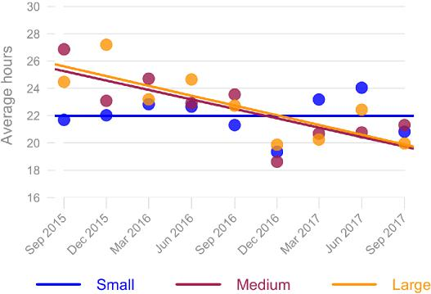
Both the level and the decline in average hours worked are a cause for concern. The decline appears unusual, and departs from the general pattern in the labour market. The level—averaging 22.6 hours per week over the last two years—is considerably lower than elsewhere in the labour market. For example, in workforces with similarly large proportions of part-time workers the figure is closer to 26 hours per week.¹⁰ In the last quarter, the average hours worked by disability support workers had actually fallen to just 20 hours per week. Such low average hours raise important questions about sustainable growth for the sector’s workforce: how does one earn a living wage without taking on a second job, or leaving the sector for a better paid position elsewhere?

Gender and hours of work
Is there a gender effect with full-time and part-time work, as there is with forms of employment? Using the same definitions as before, we look at whether organisations with higher concentrations of female disability support workers are also more likely to have higher proportions of part-time workers.

There is no clear linear relationship between gender and hours of work
Figure 13 suggests that unlike forms of employment, there is no clear linear relationship. Until one looks at those workplaces with the highest concentrations (three quarters or more women) the proportion of part-time workers shows no distinct pattern. However, in those organisations with these large concentrations of women, there is a distinctly higher proportion of part-time workers: some 84% working part-time compared with an average of about 75% across the other categories.
Figure 13: Full-time and part-time workers by the gender composition of the organisation
Notes: Note that data is pooled over all quarters. Details in Table A23.

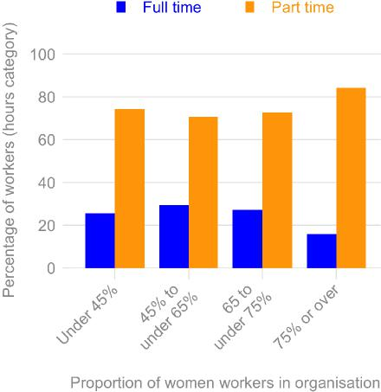

10. This is a ten year average for the general category of ‘carers and aides’, which includes aged-care workers as well as disability workers. Based on HILDA data.

Hours of work and workforce growth
Employment gains come from increases in part-time workers job losses are from declines in full-time workers
We saw earlier that workforce growth was strongly driven by an increased employment of casual workers. Using the same approach, with a balanced panel (see page 14), we analyse the composition of workforce growth according to the full-time and part-time status of the workers entering and leaving organisations. While the totals are smaller—because this full-time / part-time analysis is restricted to the permanent workforce—it seems clear that the growth in employment is largely driven by the increased employment of part-time workers. At the same time most of the job losses have been for full-time workers. Only in the September 2016 quarter did growth in full-time workers exceed growth in part-time workers. Figure 14 illustrates these findings.

Figure 14: Growth in disability support workforce by full-time and part-time work (counts)

Notes: Details in Table A24

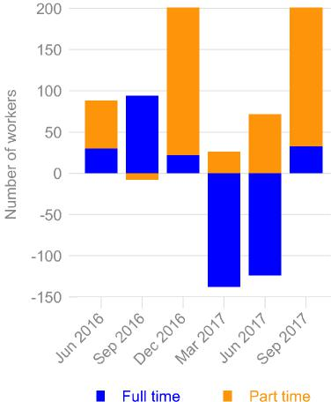

How does the sector compare?
We conclude this chapter by looking at how disability support workers compare with other workers. A more detailed comparison is in the appendix (see Table A7). It needs to be kept in mind that the population here is the permanent workforce and the comparisons are for September 2016.
The high levels of part-time employment in disability appear exceptional
In the September quarter of 2016 about 23% of disability workers within the permanent workforce were full-time; the remaining 77% were part-time. By comparison, the figures for the labour market as a whole are vastly different: 69% full-time and 31% part-time. In other words, in its use of part-time employees, the disability sector appears quite exceptional. However, this seems to be a feature of this type of sector, since the occupational category of ‘carers and aides’—which includes the aged-care sector—has similar proportions: here some 30% are full-time and 70% part-time.
The strong growth of part-time work in disability over the last two years is a departure from the general trend
Is the growth in part-time employment which this chapter has illuminated part of a wider development in the labour market, or is it somewhat unique to the disability sector? Over the last 15 years, part-time employment has grown steadily among permanent employees, rising from 26% of the workforce in 2001 to 30% in 2016. However, this growth has been uneven: and the figure of 30% has been largely stable since 2011 suggesting that the strong growth of part-time work in disability over the last two years is a departure from the general trend, and is likely to be NDIS-related.
If we again look at the broad category of ‘carers and aides’ keeping in mind that it includes aged-care workers as well as disability support workers—the 15 year-trend is largely static: 72% were part-time in both 2001 and 2016. However, in the period since 2011, the proportion has been dropping, from a high of 75% down to 72%. While these figures need to be treated with caution (given the small sample size on which they are based), they confirm the earlier impression: the increasing use of part-time work in the disability sector is not shared more widely in the labour market.

4 Spotlight topic: absences

Introduction
Each quarter the Workforce Wizard contains an additional ‘spotlight topic’, a topic which throws light on important policy issues within the sector. It is not essential that these topics be collected every quarter. They will be repeated every two years and thereby provide the sector with a long-term perspective on these crucial issues.
In the March 2017 quarter the topic was recruitment trends and difficulties, and the results for this topic were discussed in the previous Australian Disability Workforce Report. In June 2017 the topic was workforce absences, specifically personal and carers’ leave and leave without pay. Since these conditions were only available to the permanent workforce, they were only collected by Workforce Wizard for workers engaged as permanent or fixed term.

Personal and carers’ leave and leave without pay
The Workforce Wizard collected the actual number of days workers were absent, but to take account of the fact that large organisations have a larger numbers of workers, we need to analyse leave as a ratio: the number of days taken per worker per quarter. Using this figure we compare averages across the states (with some of the smaller areas grouped with their neighbour to make the numbers adequate for analysis).
Workers took an average of about 6 days of personal and carers’ leave per person per year
During the June quarter of 2017 disability support workers took an average of 1.8 days of personal and carers’ leave per person during the quarter (see Table 1). Using the median, which removes more extreme values, the average was 1.2 days. Based on these figures, an annual estimate is that workers took about 6 days of personal and carers’ leave per person per year.¹¹
11. This is based on multiplying by 4 the mid-point figure of 1.5 days.

Personal and carers’ leave was highest in Victoria / Tasmania (2.9 days per quarter) and Queensland (2.5 days per quarter), and lowest in South Australia / NT (0.8 days per quarter) and in organisations that were spread across states (1 day per quarter).
Workers took an average of 2 days of leave without pay per person per year
Leave without pay was much less common. The national average was 0.5 day, which in annual terms equated to 2 days of leave without pay. The highest figures were just 0.7 day per quarter in Queensland and South Australia / Northern Territory. The lowest figures (0.3 day per quarter) were again in the multi-State organisations.
While there is no discernible pattern in the leave without pay figures according to the size of the organisation, there is when it comes to personal and carers’ leave. Those disability support workers employed by large organisations accessed about half of the amount of leave compared to those employed by small and medium organisations. Those in large organisations took 1.1 days per quarter, while those in small organisations took 2 days and those in medium organisations took 2.1 days.
Table 1: Average number of days per worker per quarter, personal and carers’ leave and leave without pay, by State

State | Personal and carers’ leave |  | Leave without pay |  | n
 | Mean | Median | Mean | Median
Queensland | 2.5 | 1.3 | 0.4 | 0.0 | 33
Multi-state | 1.0 | 1.1 | 0.5 | 0.2 | 47
Victoria/Tasmania | 2.9 | 1.8 | 0.7 | 0.0 | 31
Western Australia | 1.3 | 1.2 | 0.7 | 0.0 | 30
New South Wales / ACT | 1.6 | 1.2 | 0.4 | 0.0 | 34
South Australia / NT | 0.8 | 0.4 | 0.3 | 0.0 | 18
National average | 1.8 | 1.2 | 0.5 | 0.0 | 193

Notes: Population is permanent and fixed term workers only. n is number of organisations in the sample. Source: Workforce Wizard
The National Employment Standards for a full-time employee provide for 10 days per year for personal and carers’ leave. This minimum figure feeds into the pricing assumptions of the NDIS. Yet the disability sector figure of 6 days for each worker, in a workforce where over 80% of workers are part time, equates to a much higher number, over 10 days. While it is well-known that workers in stressful and emotionally demanding jobs have higher sickness rates, this is the first time we have data on the actual use of personal and carers’ leave entitlements in disability.

Industrial instruments covering the workforce
In the September quarter of 2017 the spotlight topic was the type of industrial instrument which covered the workforce for which that organisation was entering data. The industrial instrument provided the basis for wages and conditions for a defined group of employees. There were two main instruments:
- Awards: which are negotiated by trade unions and often operate at an industry level. They usually provide a ‘floor’ to both wages and conditions in that industry, though individual organisation may sometimes provide ‘over-award’ pay or conditions.
- Enterprise agreements: these are based on bargaining outcomes within the organisations between the union or workers and the management. They usually provide better pay and conditions than the award, but may also involve ‘trade-offs’ on the part of the workers in return for these advantages.
Traditionally, many disability organisations have undertaken enterprise bargaining, but this may be changing in the new market environment and this spotlight topic will assist in monitoring such changes.
Nearly 60% of organisations were covered by awards, about 40% by enterprise agreements
Overall about 59% of organisations were covered by awards and the remaining 41% were covered by agreements. However, the variation across states was considerable. As Table 2 shows, the coverage of awards was much higher in New South Wales / ACT and Queensland: 87% and 73% respectively. It was lowest in South Australia / NT (just 25%) and somewhat lower in Victoria / Tasmania (49%).

Table 2: Industrial instruments operating in organisations, by state (%)

State | Award | Agreement | Total | n
New South Wales / ACT | 87 | 13 | 100 | 30
Victoria/Tasmania | 49 | 51 | 100 | 37
Queensland | 73 | 27 | 100 | 22
South Australia/NT | 25 | 75 | 100 | 16
Western Australia | 54 | 46 | 100 | 26
Multi-state | 56 | 44 | 100 | 16
Total | 59 | 41 | 100 | 147
Notes: Population is organisations and coverage refers to disability support workers. n is number of organisations in the sample. Source: Workforce Wizard
These figures for industrial coverage are for organisations in the disability sector, but it is also possible to calculate coverage for the workforce by taking account of the number of workers in each organisation. Table 3 shows the patterns in industrial coverage for some 31,000 disability support workers in Australia.
Workers are split evenly between award coverage and enterprise agreements
Overall, workers are split almost evenly between award coverage (51%) and enterprise agreements (49%). The state patterns, however, are quite diverse. New South Wales / ACT and
Queensland are again the States with the highest proportion of workers under the award (82% and 63%), and South Australia / NT is again much lower. An interesting difference is evident in the figures for Victoria / Tasmania. Award coverage for organisations is 49%, but for the workforce the figure is half this at 25%.
Table 3: Industrial instruments for the workforce, by state (%)

State | Award | Agreement | Total | n
New South Wales / ACT | 82 | 18 | 100 | 6,658
Victoria/Tasmania | 25 | 75 | 100 | 5,008
Queensland | 63 | 37 | 100 | 2,911
South Australia/NT | 17 | 83 | 100 | 3,429
Western Australia | 44 | 56 | 100 | 5,999
Multi-state | 58 | 42 | 100 | 6,819
Total | 51 | 49 | 100 | 30,824

Notes: Population is the disability support workforce. n is number of workers covered by the organisations in the sample. Source: Workforce Wizard
Historically, enterprise bargaining has been more common in large organisations, while smaller organisations have often stayed on the award. To some extent, this pattern is confirmed in the Workforce

Wizard data, particularly for the workforce figures. In the case of organisational coverage, some 46 percent of large organisations have enterprise agreements, slightly higher than the average (41%) but considerably higher than small organisations (35%). Turning to workforce coverage, some 53% of workers in large organisations are covered by enterprise agreements compared with just 35% of the workforce found in small organisations.
Table 4: Industrial instruments for organisations and for the workforce, by organisational size (%)

 |  | Organisations |  |  |  | Workers
Org size | Award | Agreement | Total | n | Award | Agreement | Total | n
Small | 65 | 35 | 100 | 40 | 65 | 35 | 100 | 1,083
Medium | 59 | 41 | 100 | 66 | 61 | 39 | 100 | 6,757
Large | 54 | 46 | 100 | 41 | 47 | 53 | 100 | 22,984
Total | 59 | 41 | 100 | 147 | 51 | 49 | 100 | 30,824

Notes: Population in first panel is organisations; in second panel the workforce. n in first panel is number of organisations; in second panel, number of workers covered. Source: Workforce Wizard
The disability sector has a higher proportion of workers on enterprise agreements than the labour market average
How do these figures compare with the industrial relations situation more generally? The Australian Bureau of Statistics collects workplace information on methods of setting pay and it’s data for May 2016 provides an overall estimate of 37% of employees¹² on enterprise agreements, with the balance split between award coverage and individual arrangements.¹³ This suggests that the disability sector has a higher proportion of workers (49%) on enterprise agreements than in the labour market more generally.
However, if we look at the broad industry category of ‘health care and social assistance’, the figures are much closer to the disability sector figures in Workforce Wizard. These ABS estimates show that 53% of employees were employed on enterprise agreements. This industry finding mirrors the findings in other chapters, where if we focus more closely on occupational groups such as carers and aides, the disability sector appears much less exceptional.
- The data come from ABS, Employee Earnings and Hours, Australia, May 2016, Cat.No. 6306.0 (Spreadsheet: 63060DO007_201605). Note that the population for these estimates is full-time non-managerial employees. The all-employee data combines awards and collective agreements and is therefore of no use in this particular comparison.
- The ABS has always distinguished between award coverage and individual arrangements but this overlooks two issues. First, individual arrangements are ‘underpinned’ by the award, so the low figures given for award coverage are misleading. Secondly, the number is further reduced because ‘over-award’ payments are also classified as individual arrangements. For these reasons, it is best to just focus on the figures for enterprise agreements, which the ABS terms collective agreements.

5 What are workers looking for?

The job market is where employers in the disability sector look for workers and where people interested in working in the sector seek out jobs. The carecareers website which is run by NDS accepts advertisements for jobs (‘job ads’) from employers where they currently have vacancies. People who land on the website scan this ‘job board’ looking for suitable employment, and when they find a position which interests them, they may click on the ‘view details’ button and continue by clicking on an ‘apply’ button.
The data from this job board spans about 5 years, from the end of 2012 to the beginning of 2018, and is a rich source of information on what is happening in the disability jobs market. In this chapter we look at the job applications posted by individuals who transact with the carecareers job board. These people—termed ‘job seekers’—may be already working, and looking around for a different job; they may be unemployed; or they may be outside the labour force and contemplating entering or returning to the workforce. We don’t have information on their situation, but we can look in some detail at the kinds of jobs for which they are looking.
We use the data from 2013 to 2017 because it is complete for each year. Through to end of June 2016 NSW employers (accounting for over 50% of the total advertiser base) were able to list ads for free, so there is a steady growth in jobs over the period. However, during 2017—once employers were required to pay a (modest) amount for listing ads—the number of job ads declined. It is important to keep this decline in mind. It does not imply a decline in the availability of work in the sector and the decline in ads does not weaken the useful of the various comparative measures used here.
All the jobs examined here are only those applying to the disability sector (carecareers posts a much larger range of jobs in other areas of the community sector) and we also analyse the occupational groupings which apply to these jobs.¹⁴
14. The definitions of the occupational groupings used here are to be found in the appendix. See Table A26. The combined disability sector jobs include some health professional, and allied health professional jobs, but for sampling reasons the occupational groupings omit all of the health jo
What interests job seekers?
One measure of what people look for when they transact on the jobs board of carercareers is whether they click to find out more details about the job. We calculate the ratio of views to each listing to gauge the ‘popularity’ of listings over the period from 2013 to 2017. These data are shown in Figure 15 and suggest that in the first full year of operation, each listing on the jobs board for direct support workers was ‘viewed’ on average by more than 450 potential workers.¹⁵
These popularity ratios fell in 2014, but then grew steadily from then on, and the pattern was generally repeated across most occupational groups. One interpretation of these data is that the initial year represented heightened interest in a new job-seeking platform available on the internet, and that subsequent years reflected the underlying growth of interest in these jobs. What seems particularly notable about the listings for direct support workers is the reduction in listings during 2017 did not lead to a diminishing level of interest by job seekers. The ratio (of over 400) held up during 2017, despite fewer jobs on offer on the platform.
Figure 15: Views of job listings for direct support workers
Source: carecareers job board
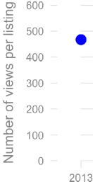
 | 2014 | 2015 | 2016 |  |  | 2017

15. We need to keep in mind that actual job listings were only shown for a month, so this figure is an average based on dividing the total number of views in a year by the total number of listings, broken down by the occupational grouping.

Job applications
A much stronger measure than viewing the details for job ads is making an application. While there are some difficulties in knowing whether job seekers follow through completely with their online applications, there is no reason to assume that systematic patterns will influence this outcome. With this in mind, we examine information on forms of employment and hours of work to see what kinds of jobs disability workers are looking for. We plot the data as monthly counts and then fit trend lines to illuminate the overall pattern. As we did in earlier chapters, we focus on both forms of employment (permanent and casual jobs) as well as hours of work (full time and part time jobs). The latter distinction is only applicable to job ads for permanent positions.

Most job seekers preferred permanent over casual jobs but workers preferred part-time jobs over full-time jobs
As Figure 16 shows, most job seekers preferred permanent jobs over casual jobs. The growth in the latter category remained almost flat from 2016 onward, whereas growth in applications for permanent jobs grew strongly until early 2017, when applications began to fall.
Figure 16: Monthly applications for disability jobs, by forms of employment
Source: carecareers job board

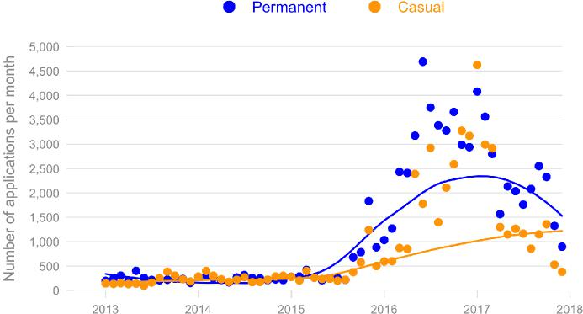

Because 80% of the applications were for direct support workers, the occupational breakdown for this group closely matched the overall patterns. That is, direct support workers had a much stronger preference for permanent jobs over casual jobs (see Figure 17). This carried through to the other occupational groups with some minor variations. For example, while casual jobs barely featured in administration, they were more common in the management occupations, with applications split evenly between permanent and casual jobs during the middle of 2016.
Figure 17: Number of job applications per month, by forms of employment and by occupational grouping (Source: carecareers job board)
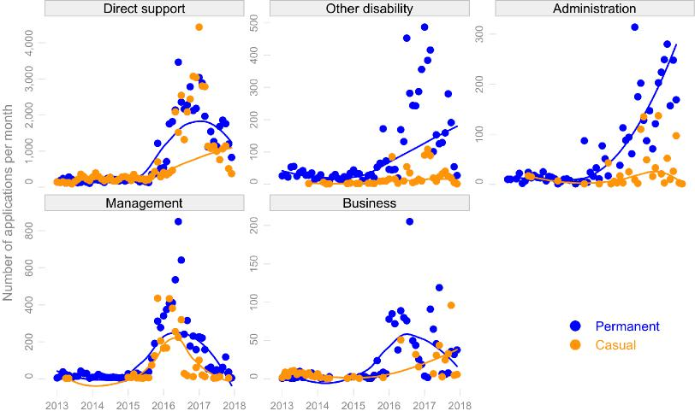
When we turn to hours of work, a very different picture emerges. Not only did part-time applications outnumber full-time applications across the period, but they continued to grow strongly during 2017 when full-time applications were falling away (Figure 18). This is quite a striking difference to the picture which emerges with forms of employment. Again, because of the dominance of direct support workers in this population, the breakdown by occupational groups reinforces this general pattern of a strong preference for part-time work. There is, however, is one interesting variation. While full-time applications were more common than part-time ones in administrative occupations, the numbers were very close and there was strong growth in both during 2017 (Figure 19).

Figure 18: Monthly applications for disability jobs, by hours of work.

Source: carecareers job board
Figure 18:
Monthly applications for disability jobs, by hours of work
Source: carecareers job board
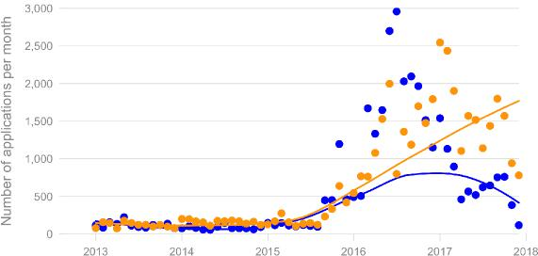

Figure 19: Number of job applications per month, by hours of work and by occupational grouping (Source: carecareers job board)
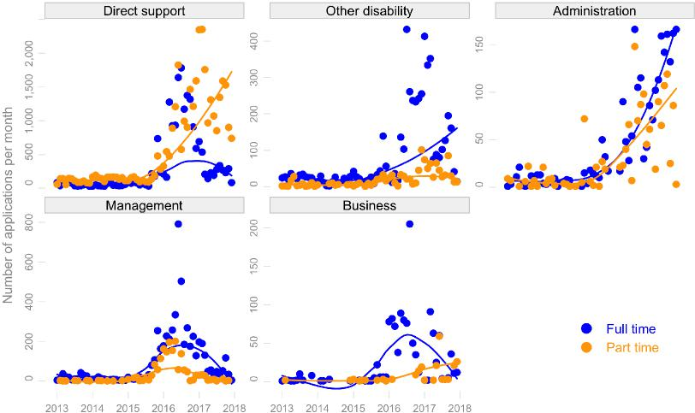

One of the enduring questions posed by the growth of part-time employment in the Australian labour market is whether this growth is mainly driven by what employers offer, or by what workers are looking for. The high levels of underemployment¹⁶ in some sectors of the labour market suggests that many of the part-time jobs are all that is on offer. Nevertheless, some sectors have large numbers of female workers and students who seek out part-time work because of its suitability for work-life balance.
16. This is where part-timers wish to work more hours than are provided by their employees

The job applications data for the disability sector provides some insights into this enduring question. When it comes to offering jobs for direct support workers, carecareers employers appear to be offering both permanent and casual jobs in roughly comparable numbers. Similarly, when it comes to whether the permanent jobs on offer are full-time or part-time jobs there is some variability over the period, but the overall pattern in the proportions are also close to even.
Most job seekers want permanent jobs in preference to casual jobs, and part-time jobs in preference to full-time jobs
However, when we turn to look at the data on what interests job seekers, we find that workers are more interested in applying for the permanent jobs. And within those permanent jobs, they are more interested in the part-time positions. This is particularly so among workers looking for direct support jobs and for jobs in administration.

6 What does the allied health workforce look like?

Demographic aspects
The allied health workforce in the disability sector is much smaller than the disability support workforce, but is quite a distinctive group of workers. It is made up of allied health professionals such as occupational therapists, physiotherapists and speech pathologists, as well as nurses.
The workforce is overwhelmingly made up of women. In the September quarter of 2017, 92% of allied health professionals were women. In very few organisations (about 12%) is the female-to-male ratio of the allied health workforce less than 80%. Indeed, in more than one fifth of disability organisations, the whole of their allied health workforce is female. These figures compare starkly with the disability support workforce, where the female proportion in the September quarter of 2017 was 70%.
Similarly, the age profile of allied health workers stands out: they are a much younger workforce. Some 65% were in the middle years of 25 to 44, compared with a figure of 44% among disability support workers. As we saw earlier, the latter group had more older workers—about 21% were older than 55 years—whereas in the allied health workforce only 11% were in this age group.

Forms of employment
Three quarters of the allied health workforce were permanent workers
Unlike disability support workers, an important aspect of employment among allied health workers is the dominance of permanent employment and the relatively larger role played by fixed-term appointments. Whereas casual employment is a striking feature of the disability support workforce, among allied health workers it is insignificant: only about 7% of workers were employed in this way over the period.¹⁷ By contrast, some 16% were employed as fixed-term and this figure had moved above 20% during some quarters. Most importantly, an average of three quarters of the allied health workforce were employed as permanent employees.
If we look at this in terms of workforce density within organisations, we see that both casual and fixed-term employment is not prominent. As Table 5 shows, 47% of organisations with allied health workers employ none of these worker as casuals, and 44% employ none as fixed-term workers. Only about 10% of organisations had densities of more than 30% for these forms of employment, and these were overwhelmingly the smaller organisations.
Table 5: Organisations by casual and fixed-term density: allied health workers
 | Casual employment |  | Fixed-term employment
Density | No. | % | No. | %
None | 91 | 47 | 85 | 44
10% or less | 46 | 24 | 31 | 16
Between 10% and 30% | 35 | 18 | 58 | 30
More than 30% | 23 | 12 | 21 | 11
Total | 195 | 100 | 195 | 100
Notes: Data has been pooled over all quarters. Source: Workforce Wizard
Hours of work
The allied health workforce is split almost evenly between full-time and part-time workers.¹⁸ In the September quarter of 2017 49% were employed full-time and 51% were employed part-time. This situation is, however, the culmination of a steady increase in part-time workers over the two year period. At the start of the period part-time workers made up 45% of the workforce.
Consistent with this development, the average hours of work seem to have been declining over the period. As Figure 20 shows, despite The fluctuations, the longer-term trend appears to be downward.¹⁹
- The data for the last quarter shows a threefold increase in the proportion of casuals (from 6.6% to 18.7%), but because of the small number of organisations in the Workforce Wizard sample, one needs to treat this figure with considerable caution. The average of 7% for the period excludes this outlier. Including it only moves the average higher by one percentage point.
- The population for this is both permanent and fixed-term workers. Unlike the situation with disability support workers, fixed-term employment is significant in allied health, and is thus included in the analysis.
- One needs to be cautious with these quarterly figures for the allied health workforce because the number of observations are quite small. See Table A25 for these counts.

Figure 20: Average hours per week: allied health professionals

Notes: Details in Table A25

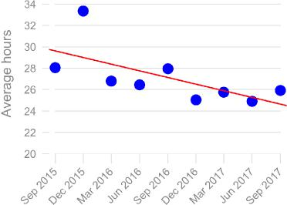

Spotlight topics
Like the disability support workers, the allied health professionals also answered question about absences and industrial relations. In the case of personal and carers leave, allied health professional took an average of 2 days leave per person during the quarter. This was a slightly higher figure than that taken by disability support workers (1.8 days).
Allied health workers use of leave without pay was low: 0.7 days per quarter. Again, this figure was slightly higher than the comparable figure for disability support workers (0.5 days).
In nearly two-thirds of organisations the industrial coverage for allied health professionals was an industrial award, with the remainder of organisations using enterprise agreements (63% to 37%). This figure for award coverage was slightly higher than for organisations with disability support workers (59%).

Appendix

Important concepts
Workers may be engaged by employers as permanent, fixed term, or casual, a mode of engagement referred to as the form of employment. The first two categories are characterised by the workers having access to holiday and sick leave, while those in the third category have neither of these. Permanents are also employed with an expectation of on-going employment; fixed-term workers have a termination date in their contracts; and casuals have no expectation of any ongoing employment and can, in theory, be terminated at short notice.²⁰
Fixed term workers are often used to fill a gap, such as when staff are on parental leave or long service leave. Because the number of fixed-term disability support workers is very small, we mostly combine permanent and fixed-term workers and refer to them as the permanent workforce. Only in Chapter 2, the chapter which deals with forms of employment, do we report on all three categories.
One of the key issues for workforce planning in the disability sector is the extent of casualisation. As we will see, the sector has a higher proportion of casual workers than most other sectors in the workforce and it is growing over time. There are a number of important policy issues raised by this development. While casuals offer apparent flexibility to employers in meeting their staffing needs, the downside is the higher staff turnover which results, and a more uneven mix in their workforce when it comes to quality (such as skills, experience and qualifications). For workers, these jobs offer a ‘casual loading’ in their wages, which they may be reluctant to forgo in favour of the increased security which permanent jobs might bring. The main downside for workers is that casual employment is insecure: there is no guarantee of the job continuing, nor how much income they may earn and institutions such as banks will often not make large loans to those in casual employment.
20. The casual category is a complicated one, since industrial tribunals have modified the rights of employers to terminate casuals at short notice. The labour market is also characterised by large numbers of ‘permanent casuals’ who have worked in that form of employment with the same employer over many years.
The hours an employee works, whether full-time or part-time, is a different matter to the form of employment, but in popular usage the term ‘casual’ is often taken to mean part-time. In the case of the disability workforce, we distinguish full-time and part-time only for the combined permanents category (that is, permanents and fixed term workers). In the case of casuals, disability services do not systematically record data on their hours of work, so we are not in a position to discuss levels of part-time work among the casual workforce.
Comparisons
In this section of the appendix we look in more detail at how disability support workers compare with other workers, and how the Workforce Wizard data compare with other data sources (in this case the HILDA data).²¹ The comparison for forms of employment is summarised in Table A6. We need to keep in mind the difficulties of lining up disability support workers with occupational and industry categories available in other data sources.²² There is no clear one-to-one correspondence. The occupational category which is the closest analogy for these workers is carers, so this comparison is the best one for comparing the data as such.²³ The other comparisons in this table illuminate how the workforce in this sector differs from other workforces.
Table A6: Comparisons for forms of employment (%)
Category Casual Fixed term Permanent
Disability service workers (Workforce Wizard) 40 3 58
Carers (HILDA) 33 9 58
Community Sector (HILDA) 19 11 70
All males (HILDA) 20 9 70
All females (HILDA) 25 11 64
All persons (HILDA) 23 10 67
Notes: The data for Workforce Wizard come from the September quarter of 2016, the closest period in time to when the HILDA data was collected. Source: Workforce Wizard and unpublished data from HILDA, Release 16
- The Household, Income and Labour Dynamics in Australia (HILDA) Survey is a longitudinal survey of Australian households which has been conducted annually since 2001. It is carefully sampled to be representative of the Australian population and collects information on households, and on individuals living in those households. It is managed by the Melbourne Institute of Applied Economic and Social Research.
- For more details see NDS and Windsor and Associates 2014, Roadmap to a Sustainable Workforce: Improving the quality of disability workforce data, Report for DSS Project Report 1, Sydney: National Disability Services.
- Carers are defined asANZSCO [42] Carers and Aides. This category also includes childcare workers, education aides and aged care workers.

The most notable difference shown here is the remarkably high incidence of casual employment among organisations in the Workforce Wizard. The comparison with carers has the smallest gap: 40% compared to 33%. Compared to the community sector as an industry category,²⁴ the difference is stark: 40% compared to 19%. A similar gap is evident for the workforce more generally: 40% to 23%.
However, part of the explanation for these differences lies with the category of fixed-term employment. What is notable about the occupational comparison is that the incidence of permanent employment is identical between Workforce Wizard and carers, at 58%. The difference in casualisation is solely due to the differences in fixed-term employment: Workforce Wizard organisations have a far smaller proportion of fixed-term workers than is the case for carers. A similar difference is evident with the community sector. Here the gap in permanent employment between that sector (70%) and the disability sector (58%) is narrower than is the gap in casual employment between that sector (19%) and the disability sector (40%).
Turning now to a comparison with hours, Table A7 summarises the results. It needs to be kept in mind that the population here is the permanent workforce, and this applies to the HILDA data as well as to the Workforce Wizard figures.
Table A7: Comparative split between part-time and full-time permanent workers (%)

Category | Part time | Full time
Disability service workers (Workforce Wizard) | 77 | 23
Carers (HILDA) | 70 | 30
Community Sector (HILDA) | 56 | 44
All males (HILDA) | 16 | 84
All females (HILDA) | 47 | 53
All persons (HILDA) | 31 | 69

Notes: Population is non-casual workforce for both Workforce Wizard and HILDA data. The data for Workforce Wizard come from the September quarter of 2016, the closest period in time to when the HILDA data was collected. Source: Workforce Wizard and unpublished data from HILDA, Release 16
As with forms of employment, Workforce Wizard organisations are closer to the category of carers: about 7 percentage points difference in the incidence of part-time workers: 77% to 70%. As noted earlier this occupational category is probably the closest match for disability support workers so these similar figures suggest the Workforce Wizard data is reasonably representative of the sector.

The broader comparison is quite stark. For all the other comparisons in this table the gap is particularly large. There is a 21 percentage point gap with the community sector more broadly, and a 46 percentage point gap with the general workforce. Given the high incidence of female employment in the sector, a fairer comparison for the latter would be with the female workforce more generally and the gap here is 30 percentage points: 77% to 47%. Clearly, the incidence of part-time employment within the permanent workforce in the disability sector is remarkable.
24. The community sector is defined as ANZSIC [86] Residential Care Services and [87] Social Assistance Services.

Acknowledgements
This report uses unit record data from the Household, Income and Labour Dynamics in Australia (HILDA) Survey. The HILDA Project was initiated and is funded by the Australian Government
Department of Families, Housing, Community Services and Indigenous Affairs (FaHCSIA) and is managed by the Melbourne Institute of Applied Economic and Social Research (MIAESR). The findings and views reported in this report, however, are those of the author and should not be attributed to either FaHCSIA or the MIAESR.
Additional tables
Table A8: Age profile of staff of disability support workers (%)

Quarter | Under 25 year | 25 to 44 years | 45 to 54 years | 55 years and  over | n
Sep 2015 | 10.1 | 42.2 | 25.7 | 22.0 | 123
Dec 2015 | 9.7 | 42.0 | 25.3 | 23.1 | 132
Mar 2016 | 10.2 | 42.6 | 24.7 | 22.5 | 157
Jun 2016 | 11.5 | 43.6 | 24.0 | 20.9 | 167
Sep 2016 | 10.3 | 42.9 | 24.2 | 22.6 | 182
Dec 2016 | 10.6 | 43.6 | 24.0 | 21.8 | 183
Mar 2017 | 10.9 | 43.5 | 23.7 | 21.9 | 189
Jun 2017 | 11.2 | 44.3 | 22.9 | 21.5 | 193
Sep 2017 | 11.5 | 44.2 | 22.9 | 21.4 | 165

Notes: n is number of organisations in the sample. Source: Workforce Wizard
Table A9: Gender profile of disability support workers (%)

Quarter | Female | Male | n
Sep 2015 | 71.0 | 29.0 | 123
Dec 2015 | 71.5 | 28.5 | 132
Mar 2016 | 70.5 | 29.5 | 157
Jun 2016 | 66.6 | 33.4 | 167
Sep 2016 | 70.6 | 29.4 | 182
Dec 2016 | 70.8 | 29.2 | 183
Mar 2017 | 70.6 | 29.4 | 189
Jun 2017 | 70.2 | 29.8 | 193
Sep 2017 | 69.8 | 30.2 | 165

Notes: n is number of organisations in the sample. Source: Workforce Wizard

Table A10: Forms of employment: overview (%)

Quarter | Permanent | Fixed term | Casual | n
Sep 2015 | 53.7 | 3.3 | 43.0 | 123
Dec 2015 | 53.1 | 3.9 | 43.0 | 132
Mar 2016 | 57.3 | 4.0 | 38.8 | 157
Jun 2016 | 59.1 | 3.9 | 37.0 | 167
Sep 2016 | 57.7 | 2.5 | 39.8 | 182
Dec 2016 | 57.8 | 2.9 | 39.3 | 183
Mar 2017 | 56.2 | 3.8 | 40.1 | 189
Jun 2017 | 54.2 | 3.2 | 42.6 | 193
Sep 2017 | 54.8 | 3.4 | 41.8 | 165

Notes: n is number of organisations in the sample. Source: Workforce Wizard.

Table A11: Forms of employment by organisational size (%)

Quarter | Size | Permanent | Fixed term | Casual | n
Sep 2015 | Small | 53.6 | 1.9 | 44.4 | 50
Sep 2015 | Medium | 60.8 | 6.2 | 33.0 | 44
Sep 2015 | Large | 51.5 | 2.5 | 46.0 | 29
Dec 2015 | Small | 57.7 | 7.8 | 34.4 | 46
Dec 2015 | Medium | 52.6 | 5.1 | 42.3 | 51
Dec 2015 | Large | 53.0 | 3.3 | 43.7 | 35
Mar 2016 | Small | 48.6 | 4.0 | 47.4 | 53
Mar 2016 | Medium | 56.9 | 6.6 | 36.5 | 66
Mar 2016 | Large | 58.0 | 3.1 | 39.0 | 38
Jun 2016 | Small | 55.4 | 4.8 | 39.8 | 55
Jun 2016 | Medium | 52.4 | 8.1 | 39.4 | 75
Jun 2016 | Large | 61.9 | 2.3 | 35.8 | 37
Sep 2016 | Small | 53.8 | 5.1 | 41.0 | 56
Sep 2016 | Medium | 52.9 | 5.3 | 41.7 | 78
Sep 2016 | Large | 59.5 | 1.4 | 39.1 | 48
Dec 2016 | Small | 54.5 | 3.0 | 42.5 | 53
Dec 2016 | Medium | 54.3 | 4.4 | 41.3 | 83
Dec 2016 | Large | 59.0 | 2.4 | 38.6 | 47
Mar 2017 | Small | 53.3 | 4.0 | 42.7 | 55
Mar 2017 | Medium | 52.6 | 5.6 | 41.8 | 87
Mar 2017 | Large | 57.5 | 3.1 | 39.3 | 47
Jun 2017 | Small | 49.8 | 5.3 | 44.8 | 55
Jun 2017 | Medium | 52.8 | 3.2 | 44.0 | 92
Jun 2017 | Large | 54.9 | 3.1 | 42.0 | 46
Sep 2017 | Small | 44.2 | 8.7 | 47.1 | 44
Sep 2017 | Medium | 49.0 | 3.2 | 47.9 | 75
Sep 2017 | Large | 57.1 | 3.2 | 39.7 | 46

Notes: Size of organisation is based on the number of employees: Small = Less than 50; Medium = 50 to 199; Large = 200 or over. n is number of organisations in the sample. Source: Workforce Wizard
Table A12: Forms of employment by the gender composition of the organisation (%)

Female % of workforce | Permanent | Fixed term | Casual | n
Under 45% | 74.1 | 4.0 | 21.8 | 54
45% to under 65% | 64.6 | 3.4 | 32.0 | 372
65 to under 75% | 56.5 | 3.8 | 39.8 | 542
75% or over | 47.2 | 2.6 | 50.2 | 519
Notes: Data has been pooled over all quarters. n is number of organisations in the sample. Workforce refers to all disability support workers in that organisation.Source: Workforce Wizard

Table A13: Net change in permanent and casual staff
 | Permanent staff |  |  |  | Casual staff
Quarter | Depart | Recruit | Net | Depart | Recruit | Net | n
 |  |  | change |  |  | change
Sep 2015 | 458 | 431 | -27 | 559 | 1,054 | 495 | 123
Dec 2015 | 603 | 611 | 8 | 891 | 1,452 | 561 | 132
Mar 2016 | 635 | 651 | 16 | 704 | 1,258 | 554 | 157
Jun 2016 | 702 | 697 | -5 | 801 | 1,389 | 588 | 167
Sep 2016 | 892 | 990 | 98 | 877 | 1,763 | 886 | 182
Dec 2016 | 1,000 | 972 | -28 | 839 | 2,005 | 1,166 | 183
Mar 2017 | 995 | 1,071 | 76 | 1,000 | 1,878 | 878 | 189
Jun 2017 | 824 | 1,151 | 327 | 976 | 1,902 | 926 | 193
Sep 2017 | 912 | 1,034 | 122 | 1,179 | 2,022 | 843 | 165

Notes: Population is all organisations.
n is number of organisations in this sample. Source: Workforce Wizard
Table A14: Net change in permanent and casual staff by organisational size

Quarter | Size | Permanent staff |  |  |  | Casual staff |  | n
 |  | Depart | Recruit | Net  change | Depart | Recruit | Net  change
Sep 2015 | Small | 26 | 19 | -7 | 35 | 96 | 61 | 50
Sep 2015 | Medium | 131 | 170 | 39 | 93 | 200 | 107 | 44
Sep 2015 | Large | 301 | 242 | -59 | 431 | 758 | 327 | 29
Dec 2015 | Small | 31 | 25 | -6 | 20 | 59 | 39 | 46
Dec 2015 | Medium | 147 | 119 | -28 | 147 | 271 | 124 | 51
Dec 2015 | Large | 425 | 467 | 42 | 724 | 1,122 | 398 | 35
Mar 2016 | Small | 27 | 42 | 15 | 36 | 106 | 70 | 53
Mar 2016 | Medium | 204 | 194 | -10 | 177 | 365 | 188 | 66
Mar 2016 | Large | 404 | 415 | 11 | 491 | 787 | 296 | 38
Jun 2016 | Small | 34 | 23 | -11 | 57 | 77 | 20 | 55
Jun 2016 | Medium | 165 | 189 | 24 | 271 | 424 | 153 | 75
Jun 2016 | Large | 503 | 485 | -18 | 473 | 888 | 415 | 37
Sep 2016 | Small | 41 | 33 | -8 | 41 | 95 | 54 | 56
Sep 2016 | Medium | 178 | 208 | 30 | 249 | 455 | 206 | 78
Sep 2016 | Large | 673 | 749 | 76 | 587 | 1,213 | 626 | 48
Dec 2016 | Small | 26 | 26 | 0 | 44 | 82 | 38 | 53
Dec 2016 | Medium | 193 | 211 | 18 | 232 | 470 | 238 | 83
Dec 2016 | Large | 781 | 735 | -46 | 563 | 1,453 | 890 | 47
Mar 2017 | Small | 52 | 89 | 37 | 59 | 107 | 48 | 55
Mar 2017 | Medium | 209 | 201 | -8 | 244 | 520 | 276 | 87
Mar 2017 | Large | 734 | 781 | 47 | 697 | 1,251 | 554 | 47
Jun 2017 | Small | 26 | 18 | -8 | 62 | 96 | 34 | 55
Jun 2017 | Medium | 235 | 202 | -33 | 301 | 560 | 259 | 92
Jun 2017 | Large | 563 | 931 | 368 | 613 | 1,246 | 633 | 46
Sep 2017 | Small | 23 | 30 | 7 | 41 | 94 | 53 | 44
Sep 2017 | Medium | 165 | 136 | -29 | 248 | 585 | 337 | 75
Sep 2017 | Large | 724 | 868 | 144 | 890 | 1,343 | 453 | 46

Notes: Size of organisation is based on the number of employees: Small = Less than 50; Medium = 50 to 199; Large = 200 or over.
n is number of organisations in this sample. Source: Workforce Wizard

Table A15: Growth in disability support workforce by forms of employment (counts)
Quarter | Permanent | Fixed term | Casual | Total | n
Jun 2016 | 117 | -29 | 467 | 555 | 64
Sep 2016 | 38 | 48 | 168 | 254 | 64
Dec 2016 | 231 | -16 | 329 | 544 | 64
Mar 2017 | -150 | 38 | -50 | -162 | 64
Jun 2017 | -28 | -24 | 193 | 141 | 64
Sep 2017 | 268 | -3 | 165 | 430 | 64

Notes: Counts refer to the change in the number of employees from the previous quarter. Sample is longitudinal sample limited to seven quarters where each organisation is present in every quarter (a balanced panel). n is number of organisations in this sample. Source: Workforce Wizard
Table A16: Growth in disability support workforce by forms of employment (quarterly growth rates %)

Quarter | Permanent | Fixed term | Casual | Total
Jun 2016 | 1.5 | -6.0 | 8.9 | 4.1
Sep 2016 | 0.5 | 9.0 | 3.1 | 1.9
Dec 2016 | 2.9 | -3.1 | 5.7 | 3.8
Mar 2017 | -1.9 | 6.8 | -0.9 | -1.2
Jun 2017 | -0.4 | -4.5 | 3.3 | 1.0
Sep 2017 | 3.3 | -0.6 | 2.7 | 2.9
Average | 1.0 | 0.3 | 3.8 | 2.1
Annual average | 4.0 | 1.1 | 15.2 | 8.4

Notes: Sample is longitudinal sample limited to seven quarters where each organisation is present in every quarter (a balanced panel). Number of organisations in this sample is the same as for Table A15. Source: Workforce Wizard

Table A17: Categorisation of organisations according to workforce changes, by forms of employment
Percentages in each category

Quarter | Forms emp | Decline | Stable | Increase | n
Sep 2015 | Permanent | 7 | 89 | 4 | 123
Dec 2015 | Permanent | 8 | 83 | 8 | 132
Mar 2016 | Permanent | 7 | 85 | 8 | 157
Jun 2016 | Permanent | 7 | 86 | 7 | 167
Sep 2016 | Permanent | 8 | 81 | 11 | 182
Dec 2016 | Permanent | 9 | 83 | 8 | 183
Mar 2017 | Permanent | 8 | 85 | 7 | 189
Jun 2017 | Permanent | 4 | 89 | 8 | 193
Sep 2017 | Permanent | 7 | 83 | 10 | 165
Sep 2015 | Casual | 2 | 72 | 25 | 123
Dec 2015 | Casual | 3 | 76 | 21 | 131
Mar 2016 | Casual | 6 | 73 | 21 | 157
Jun 2016 | Casual | 5 | 76 | 19 | 167
Sep 2016 | Casual | 3 | 71 | 26 | 182
Dec 2016 | Casual | 1 | 70 | 29 | 183
Mar 2017 | Casual | 3 | 67 | 30 | 189
Jun 2017 | Casual | 3 | 70 | 26 | 193
Sep 2017 | Casual | 4 | 67 | 29 | 165

Notes: These definitions are based on: decline: where the net change in staff (in each form of employment) in that organisation has fallen by more than 5 workers during the quarter; stable: where the net changes lie between a fall in 5 workers and a rise in 5 workers; and increase: where the net changes are greater than 5 workers increasing.
n is number of organisations in the sample. Source: Workforce Wizard
Table A18: Turnover rates: all workers, permanents and casuals

Quarter | Permanent | Casual | All workers | n
Sep 2015 | 4.1 | 6.5 | 5.2 | 123
Dec 2015 | 4.3 | 8.1 | 6.0 | 132
Mar 2016 | 4.0 | 6.7 | 5.1 | 157
Jun 2016 | 4.1 | 7.6 | 5.4 | 167
Sep 2016 | 4.6 | 6.8 | 5.5 | 182
Dec 2016 | 4.7 | 6.0 | 5.2 | 183
Mar 2017 | 5.0 | 7.2 | 5.9 | 189
Jun 2017 | 4.3 | 6.6 | 5.3 | 193
Sep 2017 | 4.9 | 8.6 | 6.5 | 165

Notes: Turnover rate is the number of workers in organisations who leave during the quarter, expressed as a percentage of the average total number of workers for that quarter and the previous quarter. All workers refers to the sum of permanents and casuals (ie. excludes fixed-term workers). n is number of organisations in the sample. Source: Workforce Wizard.

Table A19: Full-time and part-time workers: overview (%)

Quarter | Full time | Part time | n
Sep 2015 | 35.4 | 64.6 | 123
Dec 2015 | 33.4 | 66.6 | 132
Mar 2016 | 31.8 | 68.2 | 157
Jun 2016 | 24.2 | 75.8 | 167
Sep 2016 | 22.8 | 77.2 | 182
Dec 2016 | 22.9 | 77.1 | 183
Mar 2017 | 23.1 | 76.9 | 189
Jun 2017 | 21.7 | 78.3 | 193
Sep 2017 | 19.2 | 80.8 | 165

Notes: Population is the non-casual workforce. n is number of organisations in the sample. Source: Workforce Wizard.
Table A20: Full-time and part-time workers by size of organisations (%)

Quarter | Size | Full time | Part time | n
Sep 2015 | Small | 27.0 | 73.0 | 50
Dec 2015 | Medium | 31.9 | 68.1 | 44
Mar 2016 | Large | 37.6 | 62.4 | 29
Jun 2016 | Small | 40.2 | 59.8 | 46
Sep 2016 | Medium | 24.5 | 75.5 | 51
Dec 2016 | Large | 35.5 | 64.5 | 35
Mar 2017 | Small | 36.4 | 63.6 | 53
Jun 2017 | Medium | 26.8 | 73.2 | 66
Sep 2017 | Large | 33.4 | 66.6 | 38
Sep 2015 | Small | 28.6 | 71.4 | 55
Dec 2015 | Medium | 25.3 | 74.7 | 75
Mar 2016 | Large | 23.5 | 76.5 | 37
Jun 2016 | Small | 34.7 | 65.3 | 56
Sep 2016 | Medium | 27.5 | 72.5 | 78
Dec 2016 | Large | 20.6 | 79.4 | 48
Mar 2017 | Small | 33.3 | 66.7 | 53
Jun 2017 | Medium | 27.8 | 72.2 | 83
Sep 2017 | Large | 20.9 | 79.1 | 47
Sep 2015 | Small | 34.5 | 65.5 | 55
Dec 2015 | Medium | 28.7 | 71.3 | 87
Mar 2016 | Large | 20.6 | 79.4 | 47
Jun 2016 | Small | 33.4 | 66.6 | 55
Sep 2016 | Medium | 27.4 | 72.6 | 92
Dec 2016 | Large | 19.0 | 81.0 | 46
Mar 2017 | Small | 32.2 | 67.8 | 44
Jun 2017 | Medium | 25.8 | 74.2 | 75
Sep 2017 | Large | 16.8 | 83.2 | 46

Notes: Population is the non-casual workforce. Size of organisation is based on the number of employees: Small = Less than 50; Medium = 50 to 199; Large = 200 or over. n is number of organisations in the sample. Source: Workforce Wizard.

Table A21: Average hours of work per week per worker

Quarter | Average hours | n
Sep 2015 | 24.7 | 97
Dec 2015 | 26.0 | 109
Mar 2016 | 23.6 | 128
Jun 2016 | 24.1 | 149
Sep 2016 | 22.9 | 165
Dec 2016 | 19.5 | 161
Mar 2017 | 20.5 | 166
Jun 2017 | 22.0 | 172
Sep 2017 | 20.3 | 147

Notes: n is number of organisations in the sample. Source: Workforce Wizard.
Table A22: Average hours of work per week per worker by organisational size

Quarter | Organisational size | Average hours | n
Sep 2015 | Small | 21.7 | 40
Sep 2015 | Medium | 26.9 | 32
Sep 2015 | Large | 24.5 | 25
Dec 2015 | Small | 22.0 | 41
Dec 2015 | Medium | 23.1 | 40
Dec 2015 | Large | 27.2 | 28
Mar 2016 | Small | 22.8 | 45
Mar 2016 | Medium | 24.7 | 53
Mar 2016 | Large | 23.2 | 30
Jun 2016 | Small | 22.7 | 54
Jun 2016 | Medium | 22.9 | 63
Jun 2016 | Large | 24.6 | 32
Sep 2016 | Small | 21.3 | 53
Sep 2016 | Medium | 23.5 | 70
Sep 2016 | Large | 22.7 | 42
Dec 2016 | Small | 19.3 | 50
Dec 2016 | Medium | 18.6 | 74
Dec 2016 | Large | 19.9 | 37
Mar 2017 | Small | 23.2 | 49
Mar 2017 | Medium | 20.7 | 76
Mar 2017 | Large | 20.2 | 41
Jun 2017 | Small | 24.0 | 52
Jun 2017 | Medium | 20.8 | 81
Jun 2017 | Large | 22.4 | 39
Sep 2017 | Small | 20.8 | 41
Sep 2017 | Medium | 21.3 | 67
Sep 2017 | Large | 20.0 | 39

Notes: Size of organisation is based on the number of employees: Small = Less than 50; Medium = 50 to 199; Large = 200 or over. n is number of organisations in the sample. Source: Workforce Wizard

Table A23: Full-time and part-time workers by the gender composition of the organisation (%)

Female % of workforce | Full time | Part time | n
Under 45% | 25.7 | 74.3 | 54
45% to under 65% | 29.3 | 70.7 | 372
65 to under 75% | 27.2 | 72.8 | 542
75% or over | 15.9 | 84.1 | 519
Notes: Data has been pooled over all quarters. n is number of organisations in the sample. Workforce refers to all disability support workers in that organisation. Source: Workforce Wizard
Table A24: Growth in disability support workforce by full-time and part-time work (counts)

Quarter | Full time | Part time | Total | n
Jun 2016 | 30 | 58 | 88 | 64
Sep 2016 | 94 | -8 | 86 | 64
Dec 2016 | 22 | 193 | 215 | 64
Mar 2017 | -138 | 26 | -112 | 64
Jun 2017 | -124 | 72 | -52 | 64
Sep 2017 | 33 | 232 | 265 | 64

Notes: Population is the non-casual disability service workforce. Counts refer to the change in the number of employees from the previous quarter. Sample is longitudinal sample limited to seven quarters where each organisation is present in every quarter (a balanced panel). n is number of organisations in this sample. Source: Workforce Wizard
Table A25: Average hours of work per week per worker: allied health professionals

Quarter | Average hours | n
Sep 2015 | 28.0 | 15
Dec 2015 | 33.3 | 14
Mar 2016 | 26.8 | 14
Jun 2016 | 26.4 | 17
Sep 2016 | 28.0 | 20
Dec 2016 | 25.0 | 21
Mar 2017 | 25.8 | 24
Jun 2017 | 24.9 | 23
Sep 2017 | 25.9 | 19

Notes: n is number of organisations in the sample. Source: Workforce Wizard.

Table A26: Definitions of occupational groups
Occupational group Detailed occupation
Direct support Professional Support Workers
Direct support Support Workers
Other disability Case Manager
Other disability Service Co-ordinators
Other disability Employment Consultant
Administration Accounting & Finance
Administration Administration
Administration Facilities & Maintenance
Administration Legal
Administration Payroll
Administration Trades & Services
Administration Transport
Management Executive
Management Human Resources
Management Management
Management Service Managers
Business Business Development
Business Call Centre & Customer Service
Business Education & Training
Business Fundraising & Marketing
Business Graduate
Business Hospitality, Tourism & Travel
Business Information Technology
Business Marketing & Communications
Business Sales
Omitted Occupational Therapist
Omitted Physiotherapist
Omitted Speech Pathologist
Source: carecareers job board

