Australian Disability Workforce Report
3rd edition

July 2018

Contact details
Caroline Alcorso
National Manager, Workforce Development
National Disability Services
Level 19, 66 Goulburn Street Sydney NSW 2000
Phone: 02 9256 3180
caroline.alcorso@nds.org.au

Acknowledgements
NDS gratefully acknowledges the expert advice and guidance of Dr Ian Watson in the development of Workforce Wizard, and the innovative work of software company Mozzler.

This data for this report was collected in part through the NDS Disability Workforce Innovation Network project 2014-16 which took place with the assistance of funding provided by the Australian Government. NDS also recognises the significant contribution of the industry in embracing Workforce Wizard, helping shape it and making it the successful tool it is today.

About this report
This is the third edition of a twice yearly publication. It was prepared by Adrian Lui and Caroline Alcorso, NDS. The next edition will be published in February 2019.

© This publication is copyright
All rights reserved. Except as provided in the Copyright Act 1968
(Commonwealth), no use of this work, which is within the exclusive right of
the copyright owner, may be made.

About National Disability Services
National Disability Services (‘NDS’) is the peak body for non-government disability services. Its purpose is to promote quality service provision and life opportunities for people with disability. NDS’s Australia-wide membership includes more than 1000 non-government organisations, which support people with all forms of disability. NDS provides information and networking opportunities to its members and policy advice to state, territory and federal governments.
Contents
Introduction 3
Chapter 1: The latest trends in the disability support workforce 4
Employment type 4
Small and medium organisations — where casualisation takes place 5
Employment growth 5
Employment gains and losses by organisational size 6
Workforce turnover 8
Working hours 8
Summary 10
Chapter 2: The disability workforce in the states and territories 11
Workforce casualisation — a converging trend 11
Western Australia charts a different course on forms of employment 11
Workforce turnover 13
Working hours variability 14
Consistent gender and age disparities 14
Chapter 3: The profile of the allied health professionals 16
Forms of employment 16
The age and gender profile of allied health professionals 17
Chapter 4: Spotlight topics 19
Introduction 19
Spotlight Topic 1: The qualifications of newly recruited disability workers 19
How many new recruits are formally qualified? 19
How states vary in the level of qualified new recruits 20
Spotlight Topic 2: Recruitment difficulty 20
Level of recruitment activity 20
Were employers successful in filling their vacancies? 21
Reasons for unfilled vacancies 22
Recruiting allied health professionals 23
Summary 24
Appendix: Sample size, Workforce Wizard users each quarter 25

Introduction

This midyear update is part of NDS’s on-going tracking of disability workforce trends using data from Workforce Wizard, the sector’s quarterly workforce data collection. Eleven quarters of ‘Workforce Wizard data, now covering some 45,000 workers nationally, are presented.

The update examines whether the patterns comprehensively analysed in our February 2018 Australian Disability Workforce Report (available through the NDS website) are continuing, stalling or reversing.

In addition, it discusses state-level features which highlight the challenges faced by the sector in different parts of the country. Finally, the results of the two latest ‘spotlight topics’ are included, providing new information about topics providers report on a one-off basis.

This report does not give a detailed account of our methodology, nor does it present all the data behind trends. For methodology, please read the February 2018 Australian Disability Workforce Report available at the NDS Workforce Hub, on the Knowing Your Workforce page.
As always, we are keen to hear your suggestions about reports, and what you would like Workforce Wizard to tackle next. Workforce Wizard is your workforce data tool, built for convenience, rigour and maximum usefulness for the sector.

Chapter 1: The latest trends in the disability support workforce

Workforce Wizard data over the last two years has shown that the majority of disability support workers in Australia are employed either as permanent or casual employees, with very few people on short-term contracts. Permanent employment has been more common, but a gradual trend towards increased casual employment has been emerging. Has this trend continued during 2018?

Employment type

The latest data shows that most (48%) disability support workers are still employed on a permanent basis, whether part-time or full-time. However, the proportion continues to fall. Casual employment, alternatively, is rising and in March 2018 accounted for nearly half of the total workforce (see Figure 1).

Key points
- In September 2015, permanent workers made up 56% of the disability support workforce
- In March 2018, permanent workers made up 48% of the disability support workforce
- Casual employment as a proportion of the total increased from 40% in September 2015 to 46% in March 2018

Increased use of casual workers has been particularly notable in the last four quarters.

Figure 1: Forms of employment
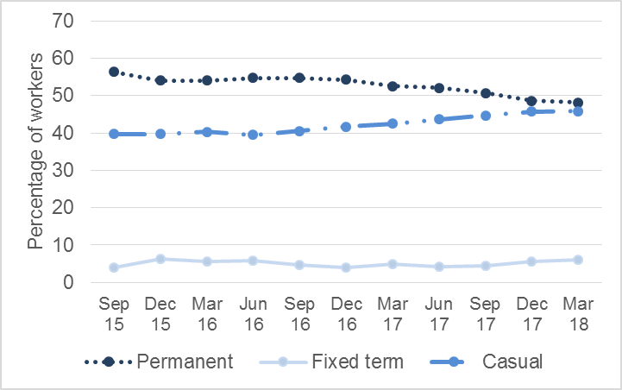

Small and medium organisations — where casualisation takes place

The casualisation trend, however, is not universal. In the February 2018 Australian Disability Workforce Report (available at the NDS workforce hub www.nds.workforce-hub/knowing-your-workforce), we observed that casualisation is more prevalent in small and medium organisations, with the trend absent in large organisations. This pattern has held.

In small organisations, the gap between permanent and casual employment shares has been closing since September 2017. In medium organisations, casual employment has already become the most common form of employment. Only in large organisations does a notable preference for permanent workers remain (see Figure 2).

Figure 2: Forms of employment by organisation size

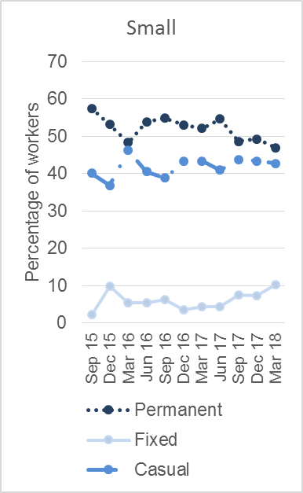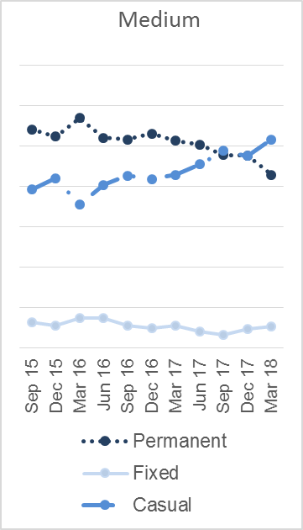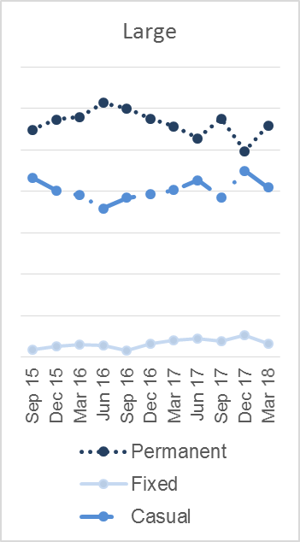

Employment growth

The disability workforce has been growing strongly. According to NDS’s February 2018 report, the disability support workforce growth rate was 11.1% per year (averaged over a two-year period between September 2015 and 2017). This compares with growth of just 1.6% for the Australian workforce as a whole at the time.

This remarkable growth rate came overwhelmingly from the recruitment of casual workers. The average permanent workforce growth rate was just 1.3% per year, while the casual growth rate was 26% per year.

Figure 3: Quarterly workforce growth rate by form of employment
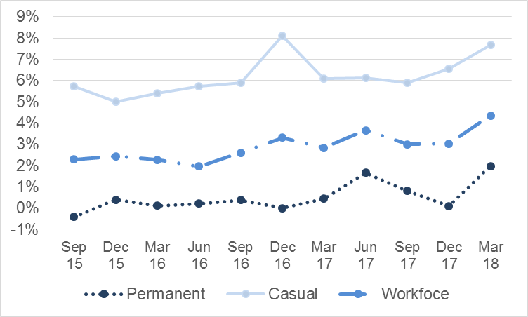

During the December 2017 and March 2018 quarters, net workforce growth continued to be strong. Both the permanent and casual workforces grew at a stronger pace than in the earlier periods.

This is consistent with faster employment growth across the Australian economy, albeit not as fast as in disability. National employment growth (trend) was 2.6% between May 2017 to May 2018.

Key points
- Overall, the disability support workforce grew by 13.8% in the 2017-18 financial year
- This reflected an average growth rate of 3.8% for the permanent component and 26.8% for the casual component.

Employment gains and losses by organisational size

Of note is that in March 2018, Workforce Wizard data indicated a large net increase in permanent employment. This was due to one large organisation acquiring services previously provided by a public sector agency, as part of the NSW Government’s divestment program.
Figure 4 shows the ‘net component change’ in the disability workforce. Employment losses in the sector tend to come from permanent workers departing while most of the gains are from increased recruitment of casuals.

Figure 4: Net change in permanent and casual staff
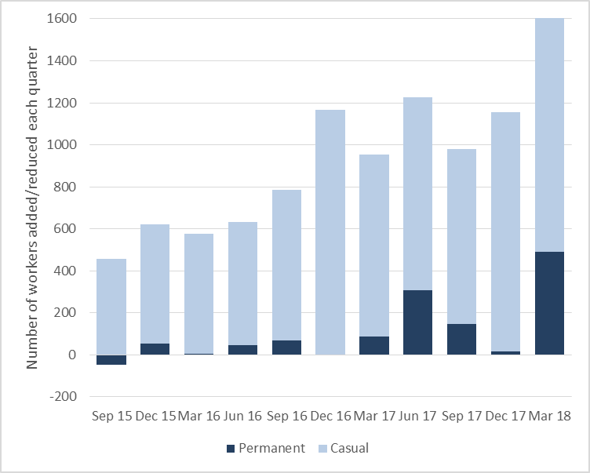

The gain in permanent employment in March 2018 came mainly from large organisations, continuing the pattern described earlier. In medium size organisations, the proportion of casual workers also grew, sometimes at the expense of permanent employment, while in large organisations, both workforces grew, albeit at different speeds (see Figure 5).

Figure 5: Net change in permanent and casual workers, by organisational size
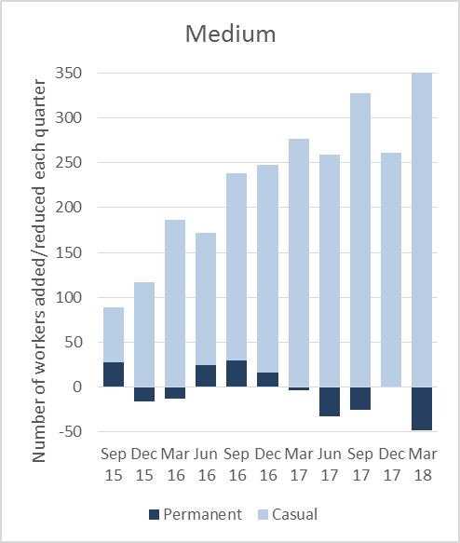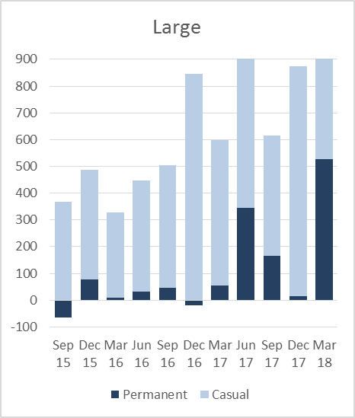

Workforce turnover

Workforce turnover is inevitable as the personal circumstances of workers alter, and also organisations need different staff to adapt to changing environments.

However, high workforce turnover can reflect lower employee engagement, and also disrupt continuity of care, leaving clients less satisfied with the quality of service. Rapid turnover means more expenditure on recruitment and training.

Workforce Wizard has consistently shown casual workers to have considerably higher turnover rates than permanent workers. Historically, this has been a difference of four percentage points/quarter, or 16 percentage points/year.

In the last two quarters, both casual and permanent workforce turnover are trending upwards, as shown in Figure 6 below. This could be related to the more buoyant labour market and the accelerating NDIS rollout.

Figure 6: Quarterly turnover rates by form of employment
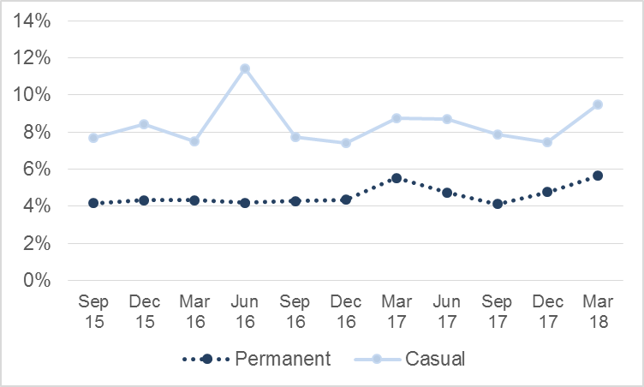

Key points
- In the two most recent quarters workforce turnover for permanent disability support workforce has averaged: 5.2% per quarter
- Casual workforce turnover in the same period has been: 8.5% per quarter

Working hours

In the February 2018 Australian Disability Workforce Report, we observed that the disability sector displays an intensified version of the part-time employment profile characteristic of the health care and social assistance sector.
In the past two years, the proportion of permanent workers who worked part-time increased from 65% in September 2015 to 83% in September 2017.

In the most recent two quarters this trend reversed (see Figure 7) with part-time employment falling back to 79%.

Figure 7: Full-time and part-time work: employment shares (%)
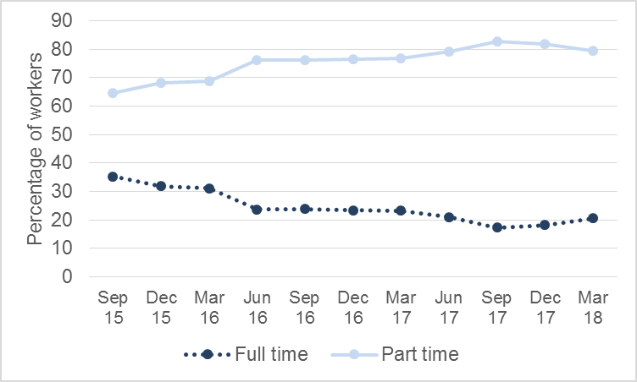

In addition, the average hours worked by a disability support worker increased for the March 2018 quarter to 22 hours/week. This compares to 21 hours/week in the preceding two quarters. It remains to be seen whether this is a reversal of the previous falling hours trend, or simply a one-off variation.

Previously, average hours have trended downwards from 24 hours per week in September 2015 to 21 hours per week at the end of 2017. The data shows some volatility which is likely due to the changing nature of the sample, and seasonal factors.

Recent ABS data indicates that while employment growth has been relatively strong, utilisation rates have changed little. In the health care and social assistance industry, average hours per job remained lower at the end of 2017 than in 2010. This industry had the second lowest hours per job of the 19 ABS industry categories.

Figure 8: Average hours of work per week per worker
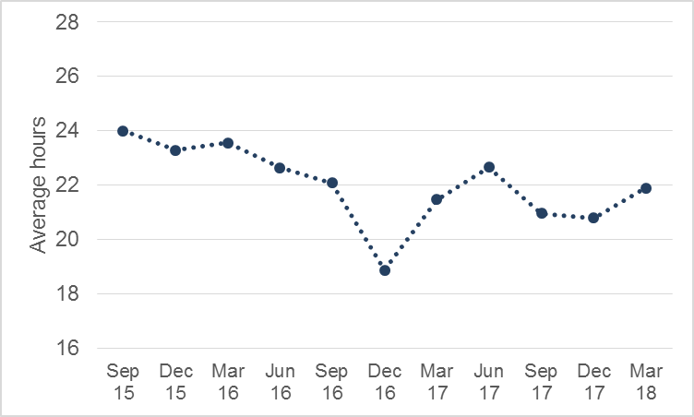

Key points
- Full-time work, which has been falling in the disability support workforce has recovered slightly in the March 2018 quarter
- Average working hours also rose slightly, to 22 hours/week.

Summary

In this mid-year analysis, trends observed in previous reports are again evident. The casual workforce has grown strongly. Casual workers continue to have a higher turnover than permanent workers. The different strategies employed by organisations of different sizes to cope with flexible demands appear to persist.

The March 2018 quarter has however been a period of strong sustained growth, more rapid even than in the past. Perhaps as a result, we see two new trends:

- a substantial net increase in the permanent workforce; and
- a minor reversal of the trend of increasing part-time work, coupled with declining working hours

It is not yet clear if the longer term trajectory of the disability workforce is shifting or if these are one-off reversals. However, it is undoubtedly the case that disability providers are experimenting with their workforce strategy, switching between forms of employment and approaches to employee engagement to obtain the best balance between client, worker and financial imperatives.

In the following chapter, we will examine the patterns of disability workforce in the states and territories.

Chapter 2: The disability workforce in the states and territories

Workforce casualisation — a converging trend

The analysis in Chapter 1 shows that there is a slow but steady trend towards casualisation in Australia. Is this trend universal in each state and territory?

In fact casualisation has risen substantially in most states, including Western Australia and NSW/ACT, which employed fewer casual workers in the beginning of the period. Casual employment growth tended to be lower in states where the employment of casuals was already high, such as Victoria. Note that Tasmania shows fluctuations which are probably due to the small sample size.

Key point
- Casualisation appears to be a converging trend; states where fewer casuals were employed have been catching up with states which had higher rates of casual employment in the first place.

Figure 9: The proportion of casual workers by state
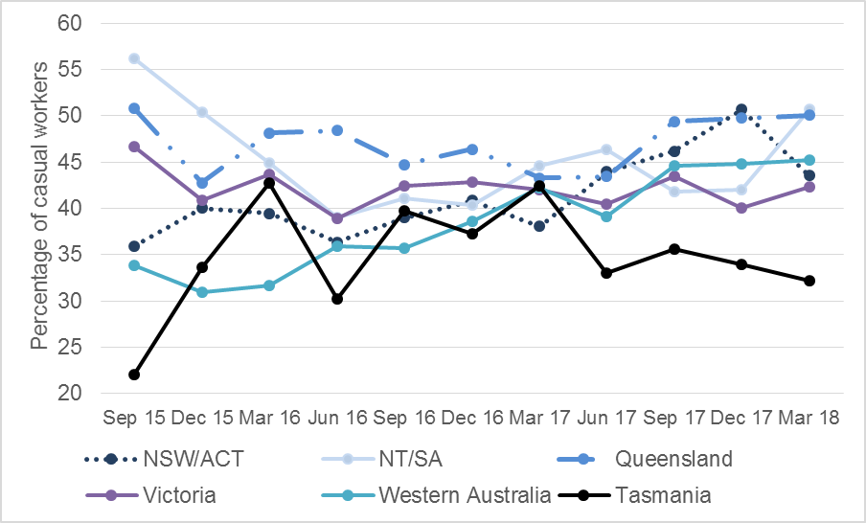

Western Australia charts a different course on forms of employment

The changing share of full-time and part-time employment work however is not standard across the states and territories.

The decline in full-time work is only marked in Queensland, NT/SA and to a certain extent, Victoria. Western Australia has maintained a relatively high proportion of full-time workers, compared to the rest of the country. Tasmania, on the other hand, has a much lower proportion of full-time workers throughout the period. Recently, Queensland overtook Tasmania as the state with the lowest proportion of full-time workers in the permanent disability workforce (See Figure 10).

Figure 10: The proportion of full-time employment in the permanent disability workforce
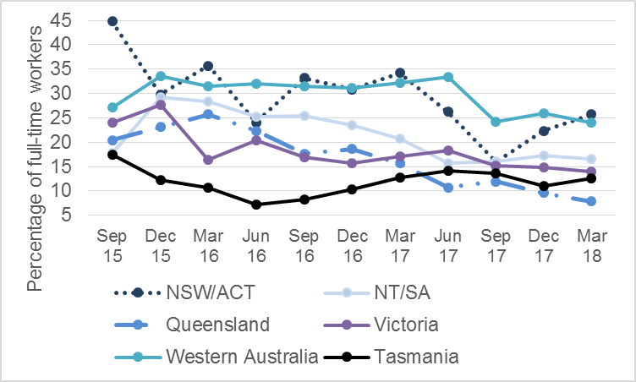

In Figure 11, the net change in permanent workers shifts between positive and negative growth in all states, with the exception of Western Australia. In Western Australia, the permanent workforce has grown in all quarters except December 2015. Tasmania, on the contrary, has negative growth of permanent workers in all but one quarter.

Figure 11: Net change in permanent workers, by state
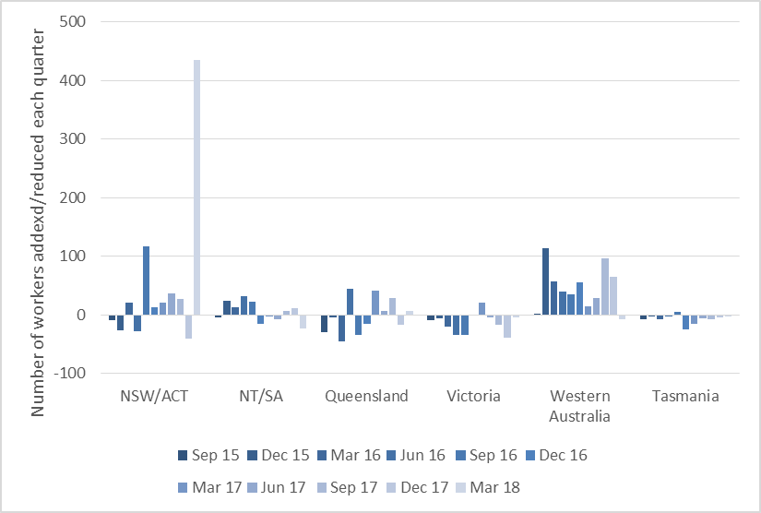

Workforce turnover

The 11-quarter average turnover rate for permanent workers in Australia is about 4.6% per quarter. This rate remains reasonably stable across states and quarters. Casual turnover at nearly 8.5% per quarter, on average, which is higher and more volatile. Western Australia has the highest casual workforce turnover rate, with double digit rates in three of the last 11 quarters. This could be linked to Western Australia’s lower reliance on casual workers than other states.

Figure 12: Quarterly turnover rates of permanent workers, by state
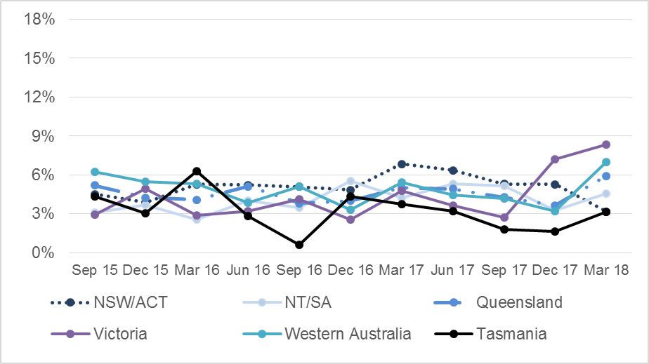

Figure 13: Quarterly turnover rates of casual workers, by state
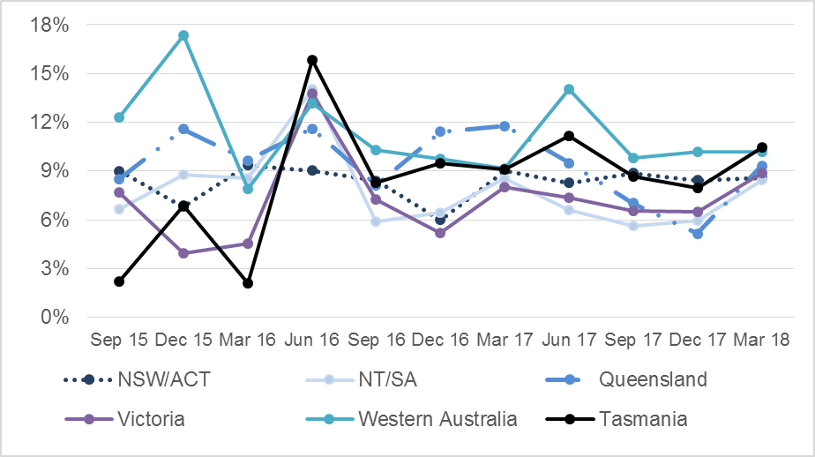

Working hours variability

The average permanent disability worker works 22 hours per week. As
Figure 14 shows, there is some variation between states and considerable volatility.

Key points
- Victoria has the lowest working hours, with average hours dropping to 21 hours or below in seven out of the past eleven quarters

- In contrast, workers in NT/SA and Queensland, on average, worked 22 hours or more in all quarters except December 2016

- There appears to be a declining trend in working hours in NSW/ACT and Western Australia, but this trend is not clear in other states.

Figure 14: Average hours of work per week per worker
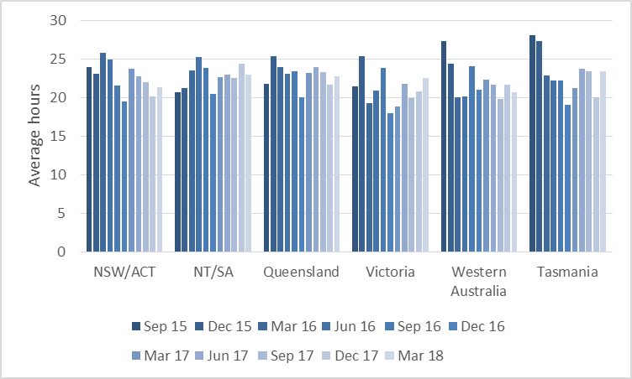

Consistent gender and age disparities

The female-to-male ratio in the disability support workforce is 7:3.

Key point
- The gender ratio is roughly the same in all states and has been stable for the past eleven quarters.

Similarly, the disability support workforce is older than the Australian workforce as a whole across the country.

Key points
Australian workers over 45 years old make up around 34% of the total workforce. By comparison,

- the ‘youngest’ state is Western Australia where disability workers over 45 years old made up 40% of the workforce in March 2018

- in Queensland, which has the oldest disability workforce, workers of this age group made up of nearly half of the workforce (49%) in March 2018.

Chapter 3: The profile of the allied health professionals

Forms of employment

Unlike disability support workers, casual employment is uncommon among allied health workers. Fixed-term employment has risen in recent years - from 8% in September 2015 to 17% in March 2018. However, permanent employment remains the dominant form of employment for allied health workers.

Figure 15: Forms of employment
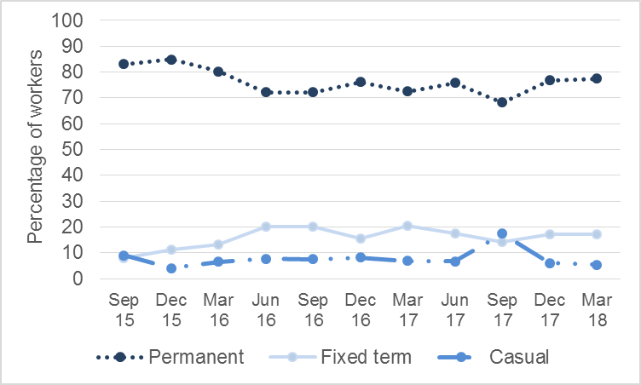

Part-time work has been increasing among allied health professionals as in the support workforce, although the rate of increase has been much less.

In September 2015, full-time employment was a little more common than part-time, making up 55% of the permanent workforce. More recently, the shares of full-time and part-time employment have equalised (see Figure 16).

Figure 16: Full-time and part-time allied health professionals: employment shares (%)
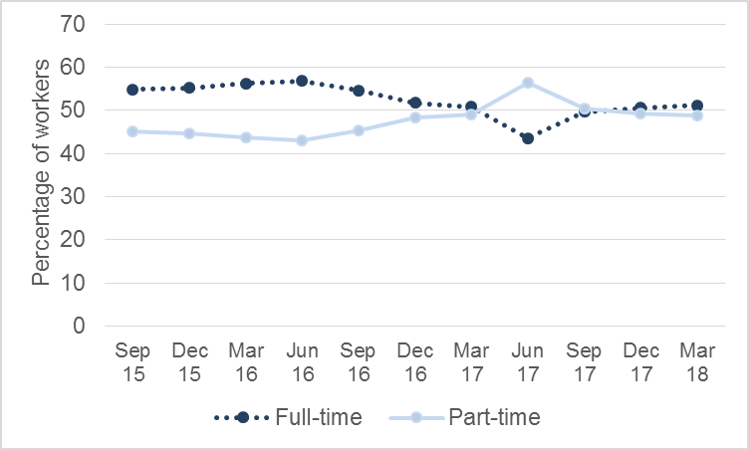
More positively, Figure 17 indicates that the long-term downward trend in working hours among allied health workers has reversed in the last three quarters.

Key point
- In March 2018, allied health professionals worked on average 28 hours per worker per week – the same amount as in September 2015.

Figure 17: Average hours of work per week per worker
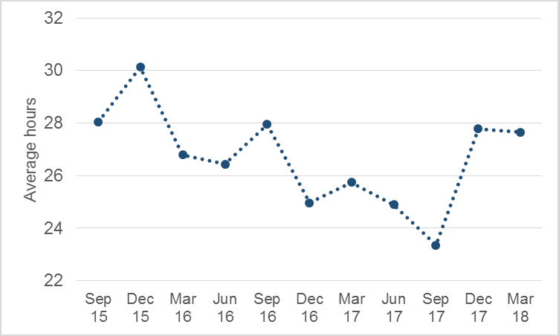

Workforce turnover

The turnover rate of the permanent allied health workforce is lower than that of the direct support workforce in the period between September 2015 and June 2016. However, workforce turnover trends upwards after June 2016, as shown in Figure 18. Allied health professionals appear to be changing jobs more frequently as the NDIS rolls out.

Since they are an expensive workforce to recruit, on-board and induct, and may take clients with them when they move, workforce instability can have a negative impact on providers.

Figure 18: Quarterly turnover rate of permanent allied health workforce
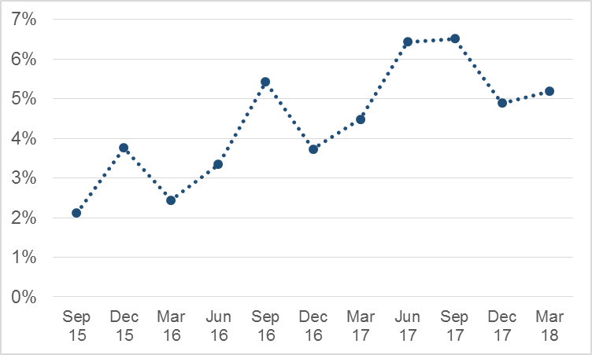

The age and gender profile of allied health professionals

The allied health workforce is overwhelmingly female. In March 2018, 93% of allied health professionals were women.

It is also a remarkably young workforce. In March 2018, 70% of allied health workers were in the middle years of 25 to 44. Only 21% of the workers were older than 45 years, relatively fewer than the Australian workforce generally (34%) and the disability support workforce (45%).

Chapter 4: Spotlight topics

Introduction

Each quarter the Workforce Wizard ‘Spotlight Topic’ shines a light on an issue of importance to the sector but not suitable for quarterly tracking. Some of these topics are repeated every one or two years to provide the sector a long-term perspective on them. NDS is particularly grateful to disability organisations for providing answers to these occasional questions, as they require extra effort to complete.

In December 2017, the qualifications of new recruits was the Spotlight Topic, while in the March 2018 quarter it was recruitment difficulty. The results are summarised below (reporting is also provided to Workforce Wizard users on closure of the data entry period).

Spotlight Topic 1: The qualifications of newly recruited disability workers

Nearly two-thirds of all users (65%) responded to the December 2017 questions asked about the qualifications of newly recruited disability support workers.

How many new recruits are formally qualified?

Providers reported that approximately one in five new recruits had a disability-related qualification (Certificate III and above). Among 3,246 newly recruited disability support workers, around 660 people had a disability-related qualification.

This appeared to be at least in part a matter of employer policy. In a sizable portion of workforces all new recruits had a disability-related qualification (24%). On the other hand, an equally substantial portion (20%) did not recruit any new workers with formal qualifications. See Table 1.

Table 1: Disability workforces by new recruits with a disability-related qualification

New workers who had a disability related qualification | Disability workforces (%)
All new recruits | 24
75% - 99% of new recruits | 4
50% - 74% of new recruits | 18
25% - 49% of new recruits | 18
1% - 24% of new recruits | 15
No new recruits | 20

Small organisations were more likely to recruit people with a disability-related certificate qualification. A third of workforces in small organisations (33%) had all new recruits with a disability-related qualification, while only 14 per cent of medium to large organisations and none of the large organisations had this level of formally qualified new recruits.

How states vary in the level of qualified new recruits

Most states and territories are in line with the national average, 21%. Victoria has the highest level of formally qualified workers (30%), while Queensland has the lowest (15%).

Table 2: Newly recruited workers with a disability-related qualification, by state and territory

State or territory | Formally qualified new workers (%)
Victoria | 30
Northern Territory | 24
NSW/ACT | 23
South Australia | 22
Tasmania | 21
Western Australia | 20
Queensland | 15
Multi-state | 14
Total | 21

Spotlight Topic 2: Recruitment difficulty

The same three recruitment difficulty questions were asked as Spotlight Topics in the March 2017 and March 2018 quarters. Over 90 per cent of users who entered data on their disability support workforce also responded to these questions. In 2018 there were 176 valid responses.

Level of recruitment activity

Nearly fourth-fifths of organisations (79 per cent) indicated that they advertised to fill at least one disability support worker position in the March 2018 quarter, a little higher than 12 months before (76 per cent).

Organisations in every state except NSW had become more active in recruitment in the March 2018 quarter. In 2017, NSW was the most active state in recruiting direct support workers (88% of organisations advertised to recruit in the March 2017 quarter). However, NSW was the least active state in the March 2018 quarter (71% of organisations advertised to recruit). Not surprisingly, multi-state organisations were most active in recruitment, with almost all organisations advertising to fill a position (94%).

Table 3: Recruiting organisations, by state, March 2018 & 2017 quarters

State | Yes, we recruited to fill DSW roles (%) |  |  |  | Number of organisations responding
 |  | March 18 | March 17 | March 18 |  | March 17
Multi-state |  | 94 | 75 | 16 |  | 12
South Australia |  | 89 | 75 | 18 |  | 20
Western Australia |  | 86 | 82 | 29 |  | 33
Queensland |  | 82 | 70 | 28 |  | 33
Victoria |  | 74 | 68 | 35 |  | 44
New South Wales |  | 71 | 88 | 35 |  | 33
Other states and territories |  | N/A | N/A | 15 |  | 17
Total |  | 79 | 76 | 176 |  | 192

Were employers successful in filling their vacancies?

Seven out of ten organisations (70 per cent) were able to fill all disability support positions advertised in the March 2018 quarter. Recruitment has become a little easier than a year before when 65 percent of organisations were able to fill all advertised positions.

The level of difficulty varied across the states. For example, Western Australia, which had the lowest rate of filled vacancies (56%) in the March 2017 quarter, became the state with the highest rate (75%) this quarter. Queensland, alternatively, had the highest rate (79%) in the March 2017 quarter but dropped to below the national average (67%) in 2018. South Australia had the lowest rate of filled vacancies in the March 2018 quarter, with only 53% of organisations saying they had filled all advertised positions.

A handful of organisations (3.6%) indicated that direct support worker positions are advertised all year around and that they have no recruitment limit, rather taking all suitable candidates.

Table 4: Organisations with advertised positions filled/unfilled, March 2018 and 2017 quarters, by state (%)
State | Filled (%) |  |  | Unfilled (%) |  | n
 | Mar 18 | Mar 17 | Mar 18 |  | Mar 17 |  | Mar 18 | Mar 17
Multi-state | 80 | N/A | 20 |  | N/A |  | 10 | N/A
Western Australia | 75 | 56 | 25 |  | 44 |  | 24 | 25
Victoria | 73 | 62 | 27 |  | 38 |  | 26 | 29
Queensland | 67 | 79 | 33 |  | 21 |  | 21 | 19
New South Wales | 65 | 67 | 35 |  | 33 |  | 23 | 27
South Australia | 53 | 64 | 47 |  | 36 |  | 15 | 14
Other states and territories | N/A | N/A | N/A |  | N/A |  | 9 | 19
Total | 70 | 65 | 30 |  | 35 |  | 128 | 133
Note: n is the number of organisations in the sample. A small proportion (7 per cent) of users did not answer whether or not their advertised positions were filled.

The ratio of filled positions to unfilled vacancies in the March 2018 quarter was 12.3. This was higher than March 2017 quarter (11.4), consistent with earlier results, suggesting organisations are now more able to fill their advertised positions than a year ago. Since there has not been a significant change in unemployment or underemployment rates, this result may reflect improved recruitment techniques learned through experience.

Reasons for unfilled vacancies

The reasons given for unfilled vacancies are similar in the March 2018 and the March 2017 quarters:

- the lack of suitable or qualified candidates was the most cited reason (43%), followed by
- candidates being unable or unwilling to meet specific job requirements (29%)
- geographical factors (13%)
- poor employment conditions and/or job prospects (9%).

Similar to the results a year ago, a number of responses advised that the advertised roles required one or more of the following:

- specific job skills or experiences (e.g. behaviour support for clients with complex needs)
- personality or demographic characteristics that match customer preferences
- ability to work flexible hours in order to fit shifts that align with client needs.

Some organisations (13% in 2017 and 9% in 2018) mentioned poor employment conditions, especially the lack of permanent full-time roles, short working hours and low rates of pay as possible reasons for unfilled vacancies.

Table 5: Reasons positions were unfilled at the end of the recruitment round
Reason given | % |  | n
 | Mar-18 | Mar-17 | Mar-18 | Mar-17
Lack of suitable/qualified candidates | 43 | 29 | 24 | 20
Candidates unable/unwilling to meet job requirements | 29 | 22 | 16 | 15
Geographical factors | 13 | 13 | 7 | 9
Poor employment conditions and/or job prospects | 9 | 13 | 5 | 9
Organisational factors | 2 | 9 | 1 | 6
Limited labour supply for the expanding vacancies | 2 | 7 | 1 | 5
Seasonal factors | 0 | 3 | 0 | 2
Total (including other) | 100 | 100 | 57 | 69
Notes: n is the number of times the reason was cited. This was an open-ended question so a respondent could mention more than one factor.

It is important to note that the success rate of filled vacancies is only one way of measuring recruitment difficulty. Indeed, a number of organisations remarked that even though they were successful in filling all advertised positions, they did so reluctantly by recruiting unqualified staff just to meet the growing demand. In other words, there are ‘hidden recruitment difficulties’ not picked up through this data.

Recruiting allied health professionals

Twenty five out of 26 organisations which entered data on allied health professionals responded to the Spotlight Topics on recruitment difficulty (96 per cent). Of these, 20 respondents indicated that they advertised to fill an allied health professional position in the March 2018 quarter (80%). This was more than in the March 2017 quarter, when only 62 per cent of organisations did so.

While more organisations advertised, a smaller proportion of them were successful in filling all the vacancies. Only eight out of eighteen organisations (44%) were able to fill all advertised positions, compared to 64% in the March 2017 quarter.

An estimated 27 allied health professional positions were unfilled (from 9 organisations reporting unfilled vacancies) in the March 2018 quarter, while 88 permanent and casual allied health positions were filled. In the March 2017, an estimated 10 positions were unfilled (from 4 organisations reporting unfilled vacancies), while 64 permanent and casual positions were filled. Note the sample size of allied health workforces is small in both quarters, hence, a direct comparison on the number of filled and unfilled positions between these the quarters is not recommended.
Some of the challenges in recruiting allied health professionals are similar to those faced by organisations recruiting disability support workers. They include the lack of suitable/qualified candidates, poor pay and rural and remote locations. A number of responses mentioned that the salary they can offer is unattractive when compared with the private sector or the adjacent aged care sector.

Unlike disability support workers, increasing specificity in job requirements was not mentioned as a problem for organisations employing allied health professionals. A number of organisations did look for allied health professionals with specific professional skills which were an ongoing problem for them to locate.

Summary

The results indicate the difficulty experienced by organisations in the disability sector in employing allied health professionals.

This result echoes the NDS Market Survey 2017, which found that organisations ranked allied health employees as the most difficult group to recruit. Providers reported ‘extreme difficulty’ in recruiting specific allied health professions, with the following percentages saying this about:

- psychologists (41%)
- physiotherapists (36%)
- occupational therapists (27%)
- speech therapists (25%)

The NDIS rollout and state government divestment of services previously provided by public sector agencies means the disability sector is an industry growing quickly, rich with new jobs. It is not surprising that recruitment is a key focus for most services, with many experimenting with new ways to creatively source and attract workers.
Workforce Wizard Spotlight Topic data highlights the volume of recruitment activity occurring, and the relative success providers are having with front line workers. Attracting allied health professionals to the sector is a different story, despite the fact that the number of registered professionals in Australia has been growing at a healthy rate in recent years.
As disability providers become more used to the NDIS and the pace of change eases, it will be important for them to focus as strongly on techniques to keep workers as to recruit them. The next Australian Disability Workforce Report will address this issue in more depth.

Appendix: Sample size, Workforce Wizard users each quarter

Table A: Number of organisations (direct support workforce), by state
 | NSW/ACT | NT/SA | Queensland | Victoria | Western Australia | Tasmania | Total
Sep 15 | 47 | 10 | 16 | 20 | 9 | 8 | 110
Dec 15 | 39 | 16 | 26 | 21 | 15 | 5 | 122
Mar 16 | 47 | 14 | 28 | 26 | 24 | 5 | 144
Jun 16 | 52 | 22 | 35 | 30 | 16 | 10 | 165
Sep 16 | 49 | 23 | 37 | 38 | 21 | 7 | 175
Dec 16 | 40 | 26 | 36 | 38 | 28 | 10 | 178
Mar 17 | 34 | 26 | 34 | 46 | 31 | 8 | 179
Jun 17 | 37 | 30 | 32 | 41 | 33 | 11 | 184
Sep 17 | 33 | 23 | 29 | 40 | 29 | 9 | 163
Dec 17 | 37 | 25 | 35 | 39 | 29 | 8 | 173
Mar 18 | 43 | 24 | 28 | 41 | 32 | 8 | 176

Table B: Number of organisations (allied health workforce)
 | Australia
Sep 15 | 10
Dec 15 | 9
Mar 16 | 11
Jun 16 | 9
Sep 16 | 10
Dec 16 | 10
Mar 17 | 11
Jun 17 | 14
Sep 17 | 8
Dec 17 | 8
Mar 18 | 11

Organisational size is classified on the basis of the number of disability support workers in the organisation, as follows: Small = less than 50 workers; Medium = 50 to 199 workers; and Large = 200 or more workers.
ABS, Labour Force Australia, Cat no. 6202.0, May 2018.
We measure workforce turnover as follows: the number of workers who leave an organisation during a quarter, as a percentage of the total number of workers, averaged over two recent quarters.
Part-time workers refer to workers who work less than 38 hours, while full-time workers refer to workers who work 38 hours or more.
ABS, Labour Account Australia, Quarterly Experimental Estimates, Cat no. 6150.0.55.003, Sept 2018.
ABS, Labour Force, Australia, Detailed, Quarterly, May 2018. Cat. No. 6291.0.55.003.
Due to the small sample size of allied health workforces, the quarterly workforce turnover rates of permanent allied health workforces using the organisational average tend to be volatile. Hence, a different measure is used. The turnover rates presented here are measured by the aggregate number of permanent workers who left the workforce as a proportion of all permanent workers in a quarter. The trend of increasing turnover rates is notable in both measurements of workforce turnover. measure is used. The turnover rates presented here are measured by the aggregate number of permanent workers who left the workforce as a proportion of all permanent workers in a quarter. The trend of increasing turnover rates is notable in both measurements of workforce turnover.
ABS, Labour Force, Australia, Detailed, Quarterly, May 2018, Cat. No. 6291.0.55.003.
Small organisations are those with less than 50 disability support workers. Medium organisations are those with 50 to 199 disability support workers. Large organisations are those with more than 200 disability support workers.
The figures for large organisations need to be used with caution. Only 6 workforces from large organisations provided data on this question. The numbers of workforces in small, small-to medium, medium to large organisations which provided data are 42, 46 and 43 respectively.
NDS State of the Disability Sector 2017, Figure 20, page 49.

