Project exploring implications of NDIS Separation of Housing & Support
Author: Joseph Connellan, MC Two Pty Ltd
2016
Note: NDS funded the Separation of Housing and Support Project in 2016. This presentation was developed by Joseph Connellan of MC Two Pty, Ltd. and the information is accurate as at October 2016

Separation of Housing & Support for NDIS Participants – overview
- Introductions
- The NDS Separation of Housing & Support Project
- Background
- Key Issues
  - 4.1 NDIS Development Process
  - 4.2 NDIA Separation of Housing & Support Policy
  - 4.3 Current SSA/SDA in Victoria
  - 4.4 NDIS Specialist Disability Accommodation (SDA)
  - 4.5 Growth Options
  - 4.6 Housing Manager Role
  - 4.7 Multi Provider Sites & Vacancy Allocation
  - 4.8 The Victoria Government’s Possible Future Roles
- Next Steps
- Acronyms

1. Introductions

Joseph Connellan (MC Two Pty Ltd)
- 25 years in not for profit housing & disability advocacy
- Ex CEO of Supported Housing Ltd – 1,000 tenants with disability
- 9 years+ consulting to NGOs/Government
- Working with Russ Wood, Bedrock Social Co
  - 10 years as strategy consultant to NFP organisations
  - Adviser to Federal Government & State Cabinet Ministers
  - Property development advisory – clients across local government, aged care, seniors’ living, affordable housing

2. The NDS Separation of Housing & Support Project

Purpose
- Document current arrangements
- Identify transition issues & opportunities:
  - for current disability support providers
  - for NDIS recipients, especially for those eligible for Specialist Disability Accommodation (SDA)

Project Structure
- Review of published & unpublished material
- Consultation with providers, Victorian Government & NDIS representatives
- Meeting presentations
- Completion of a Report and Practical Guide

Questions being asked:
- What is current practice? (& what is most common?)
- What other options exist? (What challenges & mechanisms are embedded in them?)
- Which of these options are consistent with NDIA policy?
- What challenges & opportunities may arise in the transition (recognising diversity of acceptable responses)?
- What practices & mechanism exist that can be used or adapted to smooth the transition?

3. Background - Stakeholders’ Aspirations

Aspirations of decision-makers
- Can be shared such as “More & better housing for people with a disability in Victoria”
- Aspirations typically overlap but are not the same
- Will evolve over time

Decision-makers & possible aspirations for housing:
Who | Aspirations
People with a disability | Access & sustain housing that supports life aspirations
Families of People with a Disability | Ensure people with a disability are securely housed with appropriate supports
NDIA | Successfully rollout a sustainable NDIS
Victorian Govt | Ensure Victorians with a disability are well housed & Govt assets well used
Affordable Housing Providers | Grow housing for disadvantaged people sustainably
Housing Developers | Deliver a profit on housing developments
Housing Investors | Provide better return (for same or less risk) than other investments
Disability Support Provider | Facilitates efficient & effective support provision

Sample of Feedback to Date:
- It is important to define roles & intent as there are more, new & different players at or about to join the table

3. Background: Housing for people with a disability (& the NDIS)

People with a disability live in diverse housing settings, typically with a small number with higher needs live in more specialised stock
- Specialist Disability Accommodation (SDA) 6%
  - Community Residential Units (CRUs)
  - Specialist residential units for people with high needs
  - Young People in Residential Aged Care
  - Institutions
- Social Housing 15% +/-
  - Public housing
  - Community & affordable housing
- Private Rental & Ownership 80% +/-
  - Family home
  - Own or buying house
  - Supported Residential Services (SRS)
  - Private Rental
  - NDIS will fund Home Mods 1% to 6%

Sample of Feedback to Date:
- COAG (of which Victoria is a part) decided that NDIS will fully fund SDA housing & only SDA Housing
- NDIS, via increased & portable support, is generating huge demand for housing, mainly for social housing.

4. Key issues

The project raises a number of key issues around the following areas:
- 4.1 NDIS Development Process
- 4.2 NDIA Separation of Housing & Support Policy
- 4.3 Current SSA/SDA in Victoria
- 4.4 SDA
- 4.5 Growth Options
- 4.6 Housing Manager Role
- 4.7 Multi Provider Sites & Vacancy Allocation
- 4.8 The Victoria Government’s Possible Future Roles

4.1 NDIS Development Process
- NDIS is combining development & rollout
- Process is very ambitious & is hitting some impediments e.g. portal, Board changes
- Urgent issues can overwhelm important issues (which are often slow to resolve) in short term
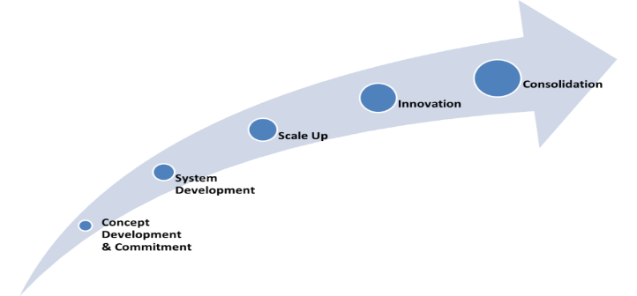
- Housing is just coming onto agenda now
2012
2022
We are here

Sample of Feedback to Date:
- NDIA moves from Aspirational (Control & Choice) to Pragmatic (Necessary & Reasonable) over time
- NDIA learns more through experience & less from practitioner advice
- Things change: “Stay close (to the NDIA), relaxed & flexible”

4.2 NDIA Separation of Housing & Support Policy

Broadly funding & policy have been moving:
- Ownership: Away from Government/NGO ownership to Private/NGO ownership
- Management: Away from combined housing & support management to separated arrangements
- Also Govt funding of Housing moving to recurrent from capital grants (eg NRAS, SDA)

Sample of Feedback to Date:
- There is well developed practice separating housing & support in Victoria & in other States

4.2 NDIA Separation of Housing & Support Policy

NDIA is requiring separation of housing & support as part of commitment to choice & control with each contracted & funded separately:
- Specialist Disability Accommodation (SDA) refers to accommodation for participants who require specialist housing solutions to assist with the delivery of supports that cater for their significant functional impairment and/or very high support needs
- Supported Independent Living (SIL) is defined as including personal care & other assistance to enable a participant to live in a secure, independent environment in the community. SIL incorporates assistance with and/or supervising tasks of daily life in a shared living environment or other domicile

NDIA expects SDA & SIL to be separable & ultimately separately provided
- The current NDIA separation policy only applies to funded SDA.
- On one extreme of the continuum is the principle of choice & control, characterised by unlimited continuous choice. On the other extreme is the principle of necessary and reasonable, characterised by free market with limited choice

NDIA expects that there will be a transition period in which:
- Where the SDA provider (or a related party) also provides SIL services they will need to provide participants with separated contracts for each service at no cost
- Conflict of Interest (COI) provisions required to manage any real or perceived conflict of interest between SDA & SIL services

NDIA Separation of Housing & Support Policy (cont.)

Sample of Feedback to Date:
- Coverage & Impact:
  - NDIA have confirmed that this policy only applies management (not ownership) of SDA that is NDIS funded
  - There is advocacy pressure to extend it to ownership
  - Timeframes for the interim arrangement are yet to be determined
  - SDA & SIL are interrelated & will impact each other’s efficiency & effectiveness
  - SDA & SIL are currently tied together in the Victorian Disability Act
- Opposition to policy:
  - Limited opposition to date cites poor quality & responsiveness of existing housing providers
  - Also identifies forced separation as a market distortion
- Mechanisms:
  - Separate contracts are being developed through modified residential statement (By some NGOs & Vic Govt)
  - COI provision do not typically exist & consequently a number of agencies are developing them
- Policy Process:
  - Full clarity about NDIA Separation of Housing & Support Policy will only occur when the regulations finalised
  - Provider awareness & understanding of SDA is limited (detail, implications & options) but increasing
  - NDIS recipients & family awareness of SDA generally is very low

4.3 Current SSA/SDA in Victoria

Current Victorian stock of Shared Support Accommodation (SSA) includes:
- 1,000+ group homes (with 5,150 beds) mostly registered as Community Residential Units (CRUs)
- DHHS advises all group homes provide “integrated housing and support” in Victoria under the Disability Act
- Mainly 4 or 5 bedroom but some 8 bedroom
- 75% are Vic Govt owned (with a Govt equity held in most of the rest)
- 50% have support provided by Govt in combined Housing & Support
- Victorian Govt has committed to exit SSA/SDA support provision at unspecified date
- NGO ownership is split between Disability NGO & Housing NGOs
- In some cases Govt & Housing NGOs headlease properties to Disability NGOs who combine housing & support

4.4 NDIS Specialist Disability Accommodation (SDA)

Definition, Reach & Growth:
- SDA is a new definition including both existing & new stock for people with high support needs
- NDIS will fund new & existing properties
- The current national supply supports 14,000 people with a projected growth by 2022 to 28,000 people
- 6% of all NDIS participants eligible for SDA
- National growth is 500 units p.a. rising to 900 in 2019 & back below 500 in 2022

Segmentation (with impact on pricing):
- There will be 5 design categories
  - Basic, Improved Accessibility, Fully Accessible, Robust & High Physical Needs
- There will be 4 building types
  - Apartment, Villa / Duplex / Townhouse, House & Group home
- Price will adjust for geography & for additional features e.g. sprinklers

4.4 More points about SDA

Funding
- NDIS Annual Base Price:
  - New housing - will range from $12,730 p.a. to $105,030 p.a. per person
  - Existing housing - will range from $4,410 p.a. to $77,213 p.a. per person
- A “reasonable rental contribution” 25% of DSP plus CRA similar to social housing
- NDIA will deduct market rental to property headleased from Govt at peppercorn rates to NGOs

Acceptable Configurations (balance to become legacy stock)
- No more than 5 people can reside in a single SDA dwelling
- A single parcel of land can have no more than 10 residents if there are more than 2 in a single dwelling
- SDA properties may have the greater of either 15 residents or 15 per cent of the total residents, if there are 2 or fewer in each dwelling on single parcel
- There is an “Intentional communities” exemption

4.5 Growth Options
- Growth will be significant; 14,000 to 28,000 people in SDA nationally
- Growth will be mainly in Villa/Apartments rather than Group Houses
- Group Houses will remain dominant form
- Growth in Victoria may be less than other states due to higher than level of existing SSA

NDIS SDA Growth Estimates
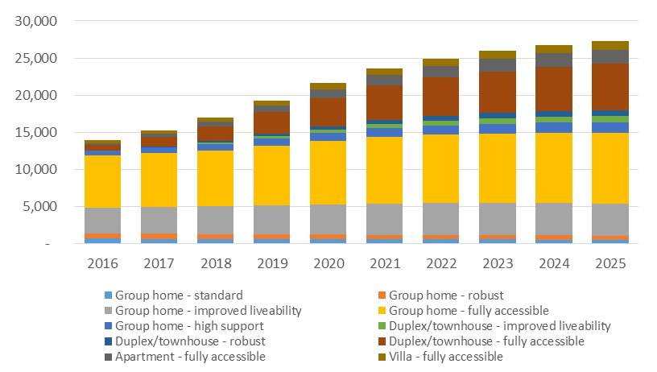

SDA growth in NSW, Vic & QLD from SSA to Proposed SDA

Sample of Feedback to Date:
- Without redeveloping existing stock Victoria could end up with oldest & poorest SDA stock in country
- Redevelopment could be partly funded by New SDA rate & could meet some of non SDA NDIS housing demand

4.5 Growth Options (Cont.)

Developing and managing new SDA requires four roles which, in some cases, are undertaken by the same organisation

Sample of Feedback to Date:
- The growth funding will generate diversity… the challenge is to deliver best possible diversity
- The lack of clear functional briefs may lead to inefficient stock being constructed
- There are good possible returns but also many, diverse and significant risks for developers & owners
- There are under-resourced family funded/driven developments under way that are at risk of creating inappropriate and/or overly expensive or unsustainable housing
- Disability NGOs have capital they wish to contribute to housing

4.6 Housing Manager Role
- Existing housing management & support roles are either combined or governed by agreements e.g. nomination rights
- Nomination rights typically trade housing access to housing for support provision

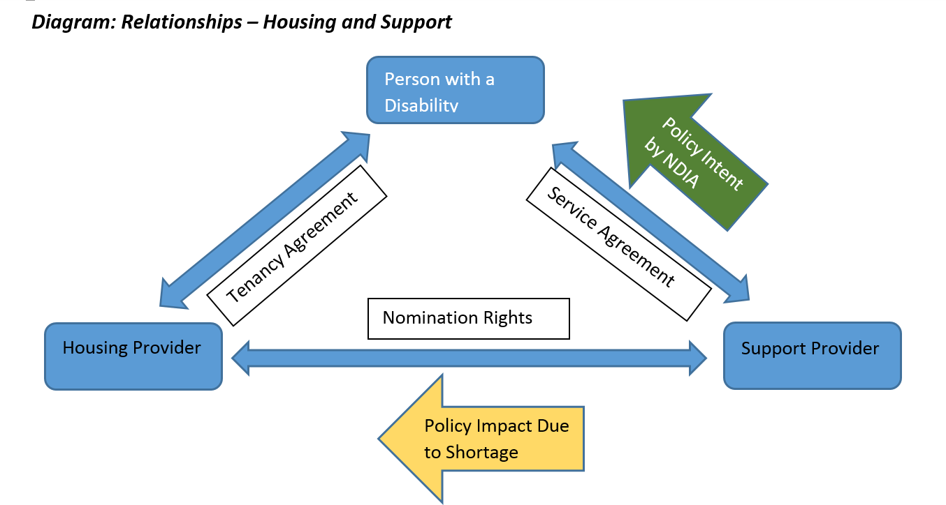Sample of Feedback to Date
Residential Statement
SDA Service Agreement
SIL Provider
- NDIA policy intent is to shift power to participants but the shortage of housing may transfer control to housing provider in medium term

4.6 Housing Manager Role (Con’t)
- The introduction of choice of provider (or limited tenure) will change the housing & support provider relationship
- Housing providers may become more engaged with tenants & support providers
- There may be a site co-ordination/facilitating role emerging beyond the traditional housing management role
- Change will impact on practice such as vacancy allocation
Diagram: Existing Housing, Site Co-ordination & Support
Support Provider role under Collaboration Agreement

Sample of Feedback to Date
- Housing agency may be happy to allow support provider to continue to fill vacancy even though recipient could select another support provider over time
- The higher the support required & the increasing rate of challenging behaviours, the less capacity an NDIS participant has to exercise their tenancy rights
- Review of the Residential Tenancies Act (RTA) & the tenancy provisions in the Disability Act is an important opportunity

4.7 Multi Provider Sites & Vacancy Allocation
Two issues that may impact on housing management & separation of housing & support are:

Support Selection in Multi Provider Sites:
- In shared housing regular collective decision making may be acceptable indeed required due to SIL
- There is a continuum of participant choice and type of housing. On one side, there is dispersed housing characterised by multiple providers and increase participant choice; in the middle are multi-unit sites; and on the other side there are group homes characterised by a single provider and limited choice

Vacancy Allocation may be allocated by one or more of the following:
- Housing agency
- Support provider
- Government (DHHS in NEMA?)
- Activist Property Owner (e.g. Summer Foundation) and/or
- A panel of some or all of the above

Sample of Feedback to Date:
- Some service providers may seek to restrict support choice in the housing they control
- Some housing agencies may continue to seek nominations from a single support provider
- There are concerns about equity of access
- Panels may emerge to meet choice & risk management requirements

4.8 The Victorian Govt Possible Future Roles
- Vic Govt is supportive of separation policy but is dealing with issues such as Disability Act
- Vic Govt is committed to transfer out of SIL
- Vic Govt has made no statements regarding the future ownership & /or management of the Vic Govt properties
- Unmet housing (“the Other 94%”) is Federal & Vic Govt responsibility (not NDIA)
- Vic Govt could consider a number of conflicting priorities when looking at the future of its SSA including maximising return, strengthening NGO sector (Housing or Disability) and/or producing more social housing
- Depending on the above Vic Govt could hold (& possibly redevelop), transfer to NGOs (Housing or Disability) and/or sell SSA/SDA into private market (via PPP)

Sample of Feedback to Date:
- Victorian Govt will define practice because of scale
- Redeveloping old, large and underdeveloped SSA could deliver additional social housing
- Timing of Victorian action will impact on opportunities for stock redevelopment

Questions/Feedback and Project Next Step

Questions/Comments
- Frame discussion:
  - Fundamental Issues (the policy)
  - Clarity of Detail (what is acceptable)
  - Practice Guidance & Examples (what is OK from a providers & NDIA point of view including examples & pro forma)

Project Contacts:
- Joseph Connellan, MC Two Pty Ltd
  - Mobile: 043 8388 444 or joseph.connellan@gmail.com

6. Acronyms
COAG | Council of Australian Government
COI | Conflict of Interest
CRU | Community Residential Unit
DHHS | Victorian Department of Health & Human Services
NEMA | NDIS North East Melbourne Area
NGO | Non Government Organisation
NDIA | National Disability Insurance Agency
NDIS | National Disability Insurance Scheme
OH&S | Occupational Health & Safety
OOA | On-site Overnight Assistance
RTA | Residential Tenancy Act
SDA | Specialist Disability Accommodation
SSA | Shared Supported Accommodation

