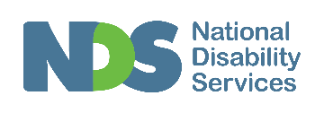

The Business of Allied Health in the NDIS and Beyond

Report on Workshop Training Series
May 2018
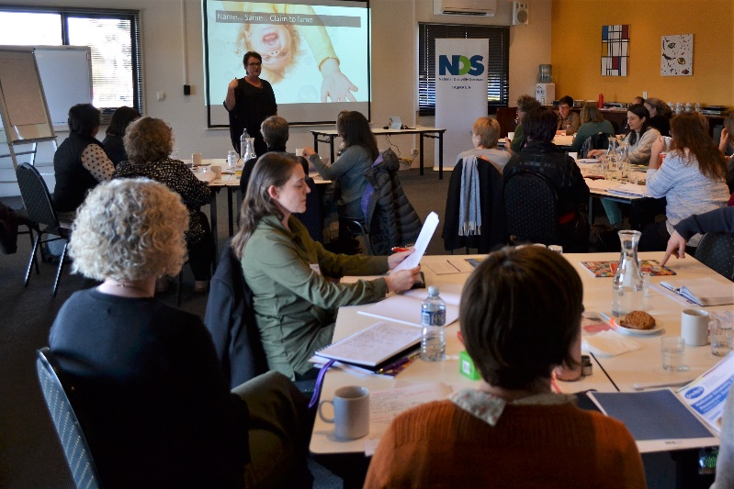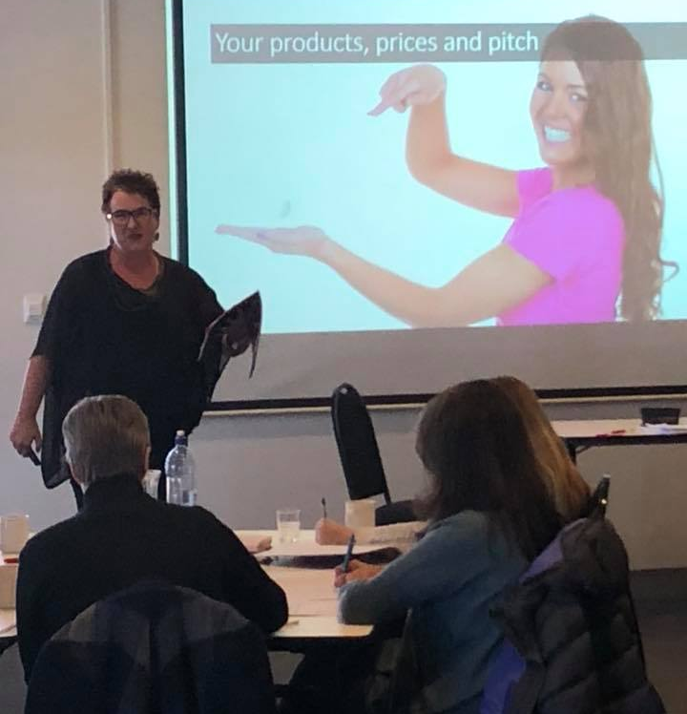
Supported By:
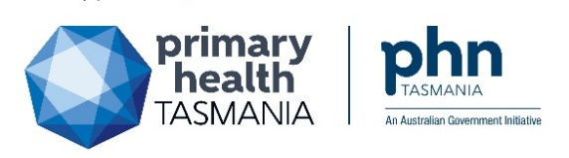

Background
This training series aimed to strengthen the business capability of current and future Tasmanian National Disability Insurance Scheme (NDIS) registered allied health professionals (AHPs), so that they may work more effectively in the context of the NDIS.
The training was informed by the Tasmanian Allied Health Disability Workforce Strategy and Action Plan (action area 1.1.D, see full document for details), which was developed by the Tasmanian Disability Allied Health Workforce project. The project is delivered by National Disability Services (NDS) and is supported by Tasmanian Department of Health and Human Services via NDIS Sector Development Funding until the end of June 2018.
Project engagement activities identified a significant risk that many existing AHPs may be lost to the allied health workforce providing services for people with a disability, unless they receive support to develop their business capability. This meant that training on business capability was prioritised during project timeframes.

Training Delivery
The training was funded and delivered through collaboration between NDS, Primary Health Tasmania (PHT), and Occupational Therapy Australia (OTA). Cathy Love of Nacre Consulting was engaged to deliver the training series. Cathy is an allied health business coach, occupational therapist, and speaker of Nacre Consulting. The training consisted of a pre workshop webinar, face to face workshop and post workshop webinar. A detailed breakdown is provided below:
Pre workshop webinar: Tuesday 8 May 6 pm – 7 pm
The interactive webinar provided a high level overview of planned topics and gathered feedback to refine workshop subject matter.
Face to Face Workshop: Saturday 19 May 2018 10 am – 3 pm (Campbell Town)
The following content was covered, with a focus on interactive discussions throughout.
- Building Business Foundations:
- NDIS core concepts (with reference to audits), business purpose and lifecycle, risk and safety (with reference to audits), and business plans.
- It takes a team to raise a business
- Advisors, recruitment/retention, performance development, and billable hours.
- Your products prices and pitch
- Service delivery model (link to profits), innovation, value proposition, diverse income streams, and business dashboard.
- Systemise your business for success
- Standard operating procedures, practice management software, leveraging technology, quality and Safeguard audit.
- Ethical and effective marketing
- Online and offline marketing tips
A representative of the NDIA provider engagement team attended to provide an update on the NDIS and to respond to any questions arising about NDIS processes. PHT provided an update about My Health Record.
Post workshop webinar: Tuesday 29 May 6 – 7 pm
The interactive webinar provided a review of key subject matter and active reflection for attendees.

Attendees
There were a total of 32 attendees from all regions of the state. Details on attendee’s work role, service type, and NDIS registration status are provided in Figures one, two and three on the following page.
Figure 1 Attendance by work role
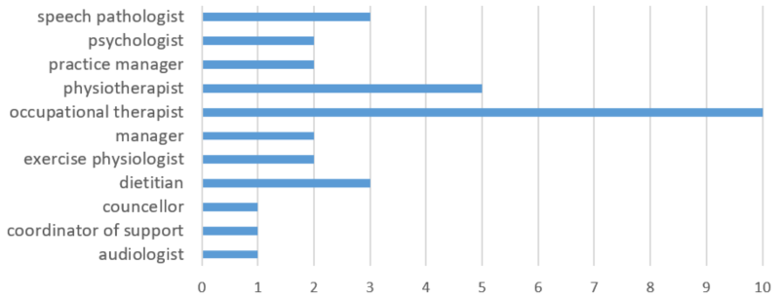
Figure 2 Attendance by service type
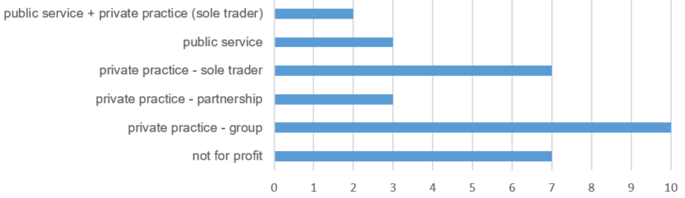
Figure 3 Attendance by NDIS registration status
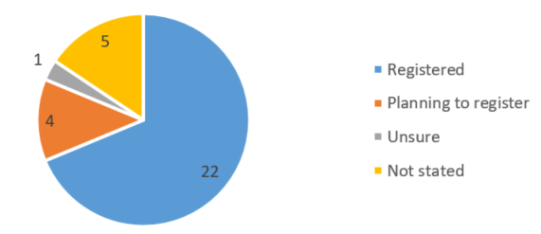

Feedback Summary
Feedback received by attendees was largely positive.
“Great to have a workshop delivered in a format that is engaging! Real life examples have been helpful. Presenter was great at keeping people focussed and reframing questions and comments as needed”
“Being used to my own professional aspect and learning it is refreshing to see a business seminar for related professions. This session was valuable but a bit challenging”
Attendees were asked to rate their agreement against the following statement:
“Events such as this support me to continue or start working within the NDIS”
Attendees rated strong agreement with this statement, with an average score of 4.5 out of 5 (where 1 = strongly disagree, and 5 = strongly agree).

Implementation of Changes to Services at a Result of Workshops
Most attendees were able to identify practical changes they planned to make as a result of these introductory workshops. A brief summary of responses is provided below.
Twelve attendees reported a resolve to review NDIS background documents and disability standards in order to better prepare for pending auditing processes; six attendees reported they would review and update their business plan based on content covered in the workshop; and three reported they would be reviewing their policies and procedures.
Several attendees reported plans to review their technology and systems in order to streamline their business and maximise billable hours.
“(I will) Invest in clinical software and financial planning for better processes and less unbillable time”
A number of attendees reported that this workshop had provided them with ideas to get started on their business plan or setting up their practice in preparation for becoming an NDIS registered provider.
“I am about to register to be NDIS provider - this workshop will guide many of my future work practices”
A number of attendees reported a shift in thinking following the workshop.
“(I will) Start thinking like a business team leader rather than just a clinical leader”

Further Supports
Attendees were asked what further support they would need in order to continue or start working within the NDIS. Most responses related to support for navigating the NDIS administration requirements.
“Overall - we need the payment side of things to start working better we have cash flow struggles with all the delays”
“How to successfully use the NDIS reporting templates”
“Practical assistance with using the portal”
“Reduce the admin requirements, they are phenomenal!”
“More detailed training on service agreements and portal access/registration”
Many attendees reported they required further support and clarity around auditing requirements for providers, including quality and safeguard frameworks.
“Ongoing clarity about audits, requirements”
“More Quality & Safeguards info sessions”
Other attendees spoke to the need for better communication and updates from the NDIS
“Forums and updates on NDIS - very hard to get to these as they are advertised a few weeks out from event and during the week”
Some attendees indicated they would like further support with business processes in relation to the NDIS.
“More practical discussions about business processes - quoting, service delivery models, tips for successful interaction with NDIS etc.”
“Need more info on how to get started as a business specifically catering for NDIS and making it as successful as possible - what services can I offer and target market development etc.”

Summary & Future Recommendations
This training initiative successfully reached the target audience of AHPs who are already registered, or planning to register from the NDIS, including those who are making the move from government funded services.
The training objectives were met. Attendees provided feedback indicating that the workshop had assisted them to work within the context of the NDIS, and most were able to identify how their work practices would change as a result.
The collaborative approach taken in planning and delivering this training meant that a broad range of AHPs from all over the state were in attendance. Future initiatives targeting the allied health workforce working in the NDIS would benefit from this collaborative approach.
Attendees have clearly identified a need for ongoing information sharing, networking and supports in order for existing AHPs to continue their work in the NDIS. This will also assist in attracting more AHPs to become registered providers.

