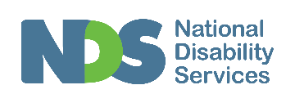

Clinicians Working in the NDIS Network Pilot

Report on Regional Network Events
Events held at:
Burnie - 4th June 2018, 6 – 8pm
Launceston - 5th June 2018, 6 - 8 pm
Hobart - 6th June 2018, 6 – 8 pm
Supported by:
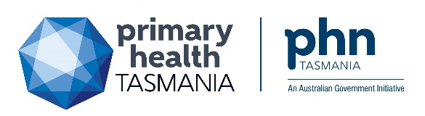

Background
The Clinicians Working in the NDIS (CWIN) regional network aims to build the capability of the allied health workforce by:
- Strengthening local connections between current and future Tasmanian National Disability Insurance Scheme (NDIS) registered allied health professionals (AHPs) and associated work roles
- Providing a conduit for information sharing and support to strengthen work practices within the context of the NDIS
This pilot initiative was informed by the Tasmanian Allied Health Disability Workforce Strategy and Action Plan (action area 3.1.A, see full document for details), which was developed by the Tasmanian Disability Allied Health Workforce project. The project is delivered by National Disability Services (NDS) and is supported by DHHS via NDIS Sector Development Funding until the end of June 2018.
Project engagement activities had identified an immediate need for improving connections between AHPs (and associated work roles) in order to address perceived workforce fragmentation, as well as improved pathways for information sharing, support and updates relating to the NDIS.
Additionally, the CWIN network is a potential lynch pin for the delivery many of the activities included in the Workforce Strategy and Action Plan, it may be used as a conduit through which to direct and/or deliver many other allied health workforce support initiatives.
As a result, this pilot CWIN network event series was prioritised before project end.

Event Delivery
The events were funded and delivered through collaboration between NDS and Primary Health Tasmania (PHT). NDS coordinated and facilitated the events. PHT helped coordinate the events and provided funding and administrative support to manage registrations, venues and catering.
The NDIA provider engagement team were formally invited to attend all three events in order to provide updates from the NDIS and participate in Q&A with event attendees.
The use of telepractice to improve the reach of therapy supports for people with disability and developmental delay was an area of focus in the allied health workforce project. National Disability Services commissioned Therapy Connect, an NDIS registered private practice delivering all therapy supports via telepractice, to develop a fit for purpose webinar for these events.

Overview of event activities
All three events were delivered in the evening (from 6 – 8pm), with a meal provided upon arrival. The NDS allied health project coordinator facilitated all events, incorporating the following activities:
- Allied Health workforce project update
- NDIA engagement team - NDIS update
- My Health Record – what’s in it for me and my clients?
- Facilitated ‘speed dating’ style networking between attendees
- Pre-recorded telepractice webinar & Q&A
- Wrap up and follow up (further information and resources)
Following the events, all attendees were emailed with a copy of the resources and information discussed during the events including a link to the telepractice webinar.

Attendees
A total of 62 people attended across the 3 locations, out of 97 who registered their interest (64 % attendance rate). Figure one below breaks down registrations and attendees by location.
Figure 1 CWIN network event registrations and attendees
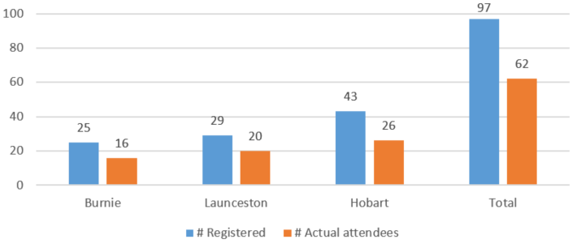
The majority of those who attended worked in a private practice. Figure two provides a breakdown between service types for all attendees.
Figure 2 Attendee breakdown by service type
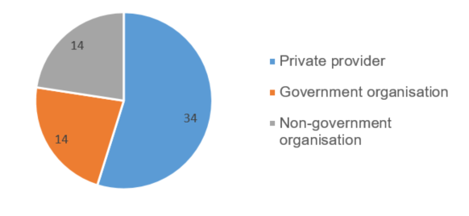
The CWIN network events attracted a broad range of professional roles, the majority of attendees were of an allied health background, with the highest numbers registering from those that are prevalent in the disability sector; Occupational Therapists, Speech Pathologists, Physiotherapists and Psychologists.

Feedback Summary
Feedback was invited via an online survey which was emailed to attendees following the events. Of the 62 attendees, 40 completed the survey, resulting in a very high response rate of 65%. Of those attendees who provided feedback, approximately 80% reported they are NDIS registered, and a further 15% reported they plan to register.

Feedback received on the events
Feedback received from attendees, both during the events and following the events via the online survey, was largely positive.
“I was happily surprised by the number of contacts I made and very pleased to have the info re. telehealth which I am a bit nervous, but excited to attempt after this video”
“I highly valued the opportunity to discuss concerns with other AHPs and workers working within the NDIA/Mission (NDIS parters) in NW Tas. Great way to continue the great collaboration between services that already exists in NW Tas and ensure that services are all working together and have the same understanding. The rollout of the NDIS has been stressful/ confusing and any opportunities (such as this event) is needed and greatly appreciated by service providers”
“Great venue, excellent facilitation and great networking”
“Discussions were facilitated well. Great that the event was free!”
“The event helped me to understand more about the NDIS. Our support organisation needs to be proactive in supporting members transitioning to the NDIS in the most appropriate and effective way. The presentations and the networking with AHP from a variety of disciplines very much assisted”
“(It was) very useful to meet and hear about the breadth of service began provided, as it is so isolating working in the new private model, and I want to be able to refer participants on to person with the best skills to help them”
“Well organised, helpful, relevant”
“Excellent evening. I think they are essential to maintain allied health professionals in private practice to continue working within the NDIS”
“It was very good having (name of the NDIA representative present to answer direct questions”
A number of attendees indicated they would have liked more unstructured time to network with colleagues, and to participate in Q&A/discussion with the NDIA provider engagement team representative.
“Some more time for questions / answers about NDIS in this face to face setting would have been useful”
“I felt that the session was too structured and didn't allow an opportunity to discuss issues and seek the expertise of the group”
“The "speed dating" cut some really useful conversations off too short, so perhaps a visual timer for each "partner" conversation could be helpful next time”
Attendees were asked to rate their agreement against the following statement:
“Networking events such as this support me to work more effectively in the context of the NDIS”
Thirty seven out of 40 attendees who responded to the survey agreed with this statement. Figure three provides a breakdown.
Figure 3 Attendee agreement ratings
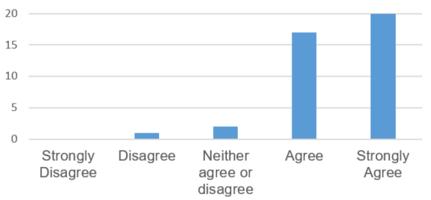
Attendees were given a number of pre-determined options to select in response to the question:
“What was the most useful part of the event for you?”
Networking with colleagues was rated the most useful on average, followed by NDIS updates and meeting the engagement team, telepractice webinar and discussion, and the My Health Record update. Figure four provides a percentage breakdown of responses.
Figure 4 Attendee response to question about most useful aspect of event
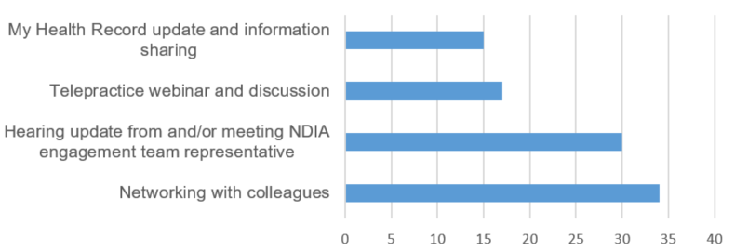

Feedback for future events
All 40 survey responders indicated they would be interested in attending similar events should they be held in the future. When asked what frequency is preferred, 28 out of 40 indicated quarterly events would be ideal. Figure five provides a breakdown of responses.
Figure 5 Attendee preference for future event frequency
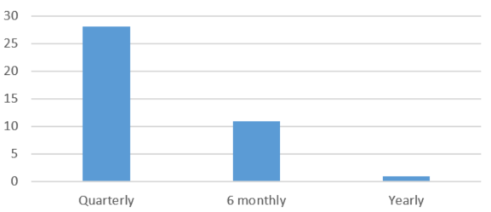
When asked what future events should focus on, NDIS information sharing and updates rated most highly (36 out of 40), followed by networking with allied health professionals in the region (32 out of 40), networking with other NDIS related roles (29 out of 40) and professional development activities (28 out of 40). Figure six provides a summary of responses.
Figure 6 Attendee preference for future network event focus
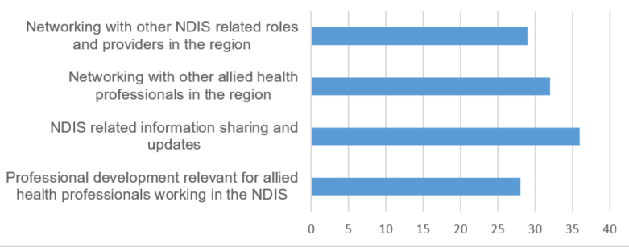
Survey responders also suggested a number of other ideas and areas for focus in future events, these are provided below:
“Panel type Q & A - various people / themed questions”
“Exploring role of planners”
“Develop training opportunities in Tasmania”
“PD especially around the new quality standards & audits coming up for Tassie in 2019”
“Would be useful to have a presentation from NDIS and reputable/successful Support Coordinators about the role and expectations of the Support Coordinator role”
“Discussions about issues, solutions others have come up with, ways to navigate the system. Perhaps questions/issues sought and shared with the people that have RSVP’d in advance so that people can bring resources and other information to assist each other (e.g. quoting pro forma, report templates etc.)
Finally, survey responders were asked if they would be interested in a steering group to help direct future activities, 10 people provided their contact details for this (25% response rate). Three are based in the North West, two in the North and five are based in the South.

Summary and Recommendations
This pilot network event series has provided strong evidence to support the continuation of the Clinicians Working in the NDIS initiative. Events were very well attended, and successfully reached the target audience of NDIS registered AHPs and associated work roles in all three regions of the state. Of those who completed the survey, almost all felt that these events support them to work more effectively in the context of the NDIS, and all expressed they would like the network events to run in the future.
A number of areas of need and ideas for future inputs have been identified, and significant interest in providing support to continue this initiative has been garnered. This should be leveraged off when planning future events.
The collaborative approach taken in planning and delivering these events was crucial to their success. Future events should involve the NDIA provider engagement team, PHT and NDS in order to share resources and maximise reach.

Next Steps
Following the events representatives from PHT, the NDIA engagement team, and NDS have agreed to a follow up meeting in early August to plan the coordination and implementation of future network activities.
Those who have expressed interest in the steering group will be invited to provide input. Several other key stakeholders have been approached and a number have already agreed to participate in future events. Feedback from these events should be used to plan and guide upcoming events.
The Allied Health Disability Strategy and Action Plan developed during the allied health workforce project is a key document that should be used to help guide future initiatives to support the allied health workforce, including the CWIN network. This plan will be made available to the coordinators of the network and steering group, and to project funders along with recommendations regarding further supports in allied health workforce development.

