WA Disability Services Sector Industry Plan

Highlights

Introduction
National Disability Services WA (NDS WA) is excited to present the WA Disability Services Sector Industry Plan (The Industry Plan). It provides a clear picture of where the sector is now, and how it can best make the transition to where it must be at full roll out of the National Disability Insurance Scheme (NDIS). The Industry Plan provides effective support for the NDIS transition.
This overview provides a summary of key findings, an analysis of service capability, strategies for transition and a plan for implementation. A full version of the WA Disability Services Sector Industry Plan is available on the NDS website, www.nds.org.au.

About the Industry Plan
NDS commissioned ACIL Allen Consulting in July 2016 to research and establish a knowledge base on the contribution and potential of the WA disability sector under the NDIS – the Industry Plan.
The Industry Plan will form the centrepiece for the effective implementation of the NDIS in WA, highlighting priorities and outlining a range of measures that require strong investment by the State Government.
The Plan clearly articulates that the NDIS will stimulate significant economic and jobs
growth for the State, but that smooth transition and delivery of high-quality disability
services in all parts of our vast state will require significant investment by the State
Government in an Industry Plan. This has been the case with other jurisdictions such
as Victoria ($36M) and NSW ($30M) to assist with sector NDIS readiness and building a
sustainable supply of disability services into the future.
The Plan highlights the importance of the WA disability sector working in close partnership with the State Government to improve the lives of people with disability in our State. This
will assist in building a strong disability sector that provides increasing and diverse choice
for people with disability across WA, including regional and remote locations.

Why an Industry Plan is needed
A well-functioning NDIS will improve the lives of people with disability and their families
and create a sustainable disability support system. However, without a coordinated
strategic approach to change management, there is a risk that growth in demand will
outpace supply and that service innovation will be impeded.
The Industry Plan provides a clear, solid framework for a coordinated and comprehensive
approach to NDIS transition and is relevant for all levels of government and all sectors
of the community. The Industry Plan is expected to evolve over the next three years in
2
response to the external drivers that influence and shape the sector. The Industry Plan is an evidence-based strategic data asset that creates a line of sight between organisational and market outcomes and quality of life outcomes for people with disability. It demonstrates
cause and effect between the interests of consumers, government policy settings and the
sustainable supply of services.

How the Industry Plan was developed
The Industry Plan was developed through extensive engagement within the disability
sector and analysis of new and existing data and information. The compressed timeline for
the full roll out of the NDIS in WA was considered, as was the experience of other states
and territories. Interstate experiences demonstrate the importance of engaging people
with disability, their families and carers, as well as service providers in the design of the
Scheme and its implementation. It is critical that the significant problems experienced in
other jurisdictions are avoided in order to keep the NDIS implementation on track in WA.

Profile of the WA disability sector
To inform the development of the Industry Plan, ACIL Allen developed a separate,
stand-alone Industry Profile of the WA disability services sector. It provides a snapshot
of the sector’s performance and outlook, as well as its overall strengths, weaknesses,
opportunities and any threats to its success.

The Industry Profile is based on the SWOT analysis undertaken on the sector and other
reports already developed by ACIL Allen, including the WA Disability Sector Economic
Impact Assessment report and the WA Disability Sector Survey report.

The SWOT summary, shown in Figure 2, depicts the overall performance and outlook for
the WA disability sector. It provided an important starting point in the development of the
Industry Plan. Figure 1 provides a snapshot of key opportunities and challenges identified
by the WA Disability Services Sector as the transition to the NDIS occurs.

The SWOT analysis also provided valuable insights for sector organisations in the
development of their own strategic plans as the sector moves towards full implementation
of the NDIS in WA.

Critical information sourced from the SWOT analysis has informed the Three Strategic
Themes of the Industry Plan.
Figure 1. WA disability services sector opportunities and challenges

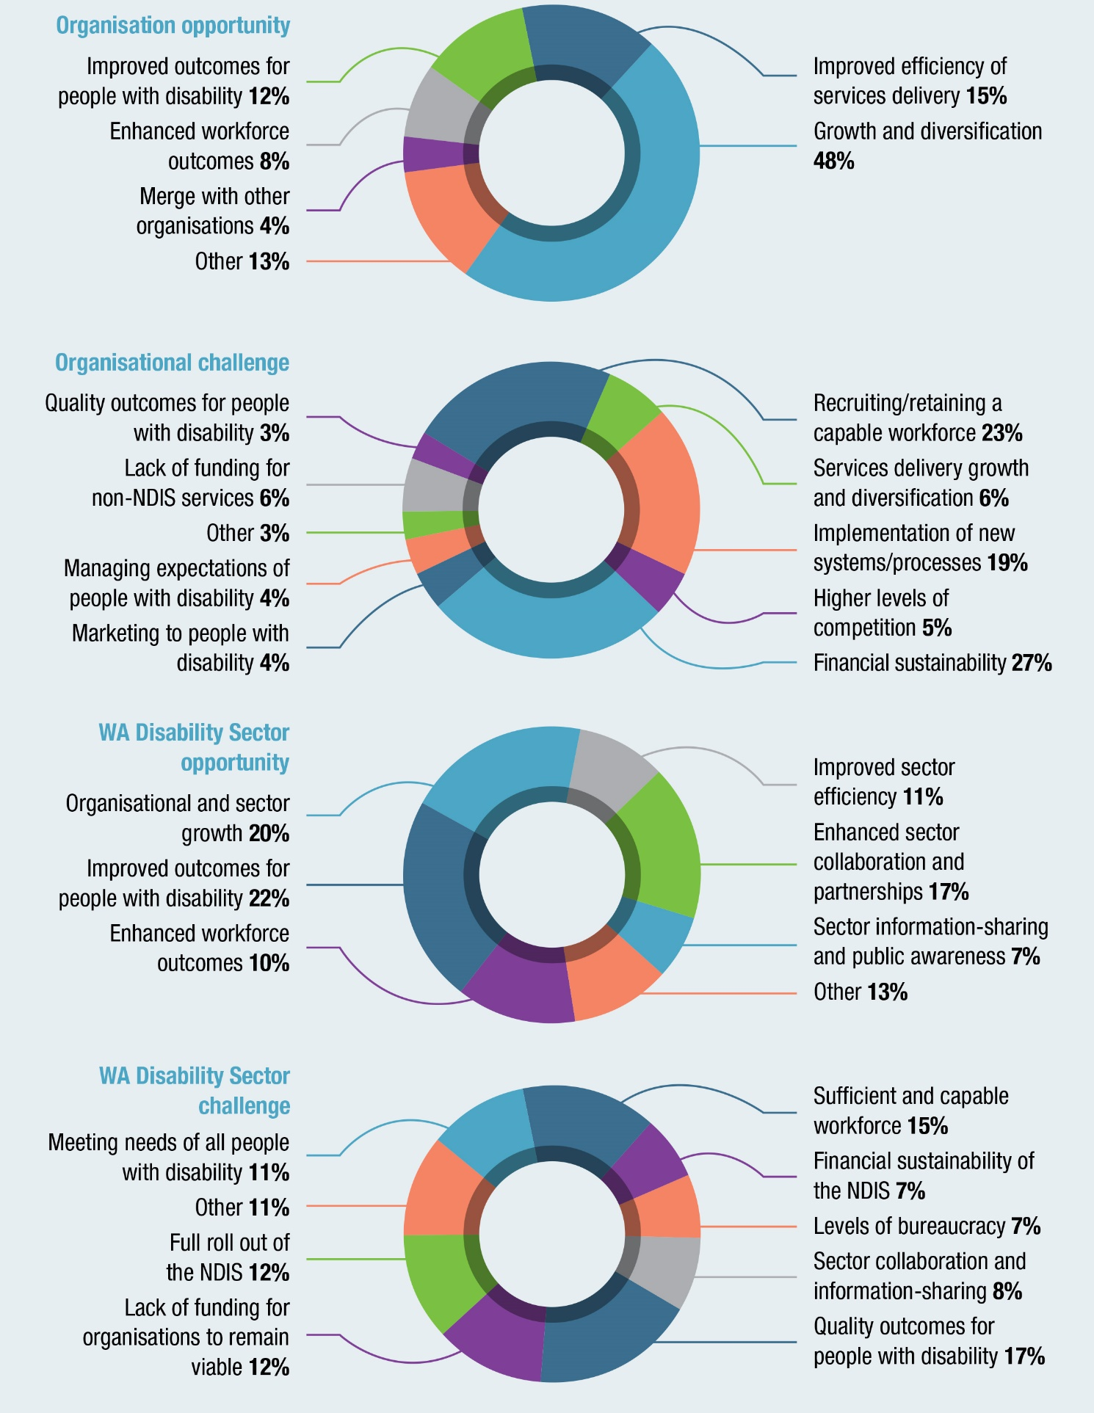

Figure 2. WA disability services sector SWOT summary
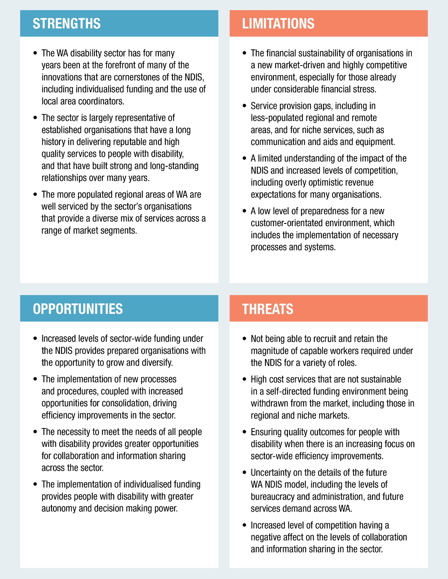

What is the Industry Plan?
The Industry Plan includes:

- An NDIS snapshot of the experiences of all states and territories with the roll-out of the NDIS and any transitional strategies implemented.
- A profile of the WA disability sector including an overview of its current strengths, limitations, opportunities and threats to its success; the current and future economic impact; and anticipated workforce growth.
- Three strategic themes recognising the need for comprehensive systemic and strategic planning to ensure the long-term social and economic gains of the NDIS are fortified.
- Seven strategies and 24 actions and initiatives to ensure the sector is well-prepared for the full implementation of the NDIS in WA.
- Recommended next steps to successfully implement the Industry Plan.

Figure 3. WA Disability Services Sector Industry Plan
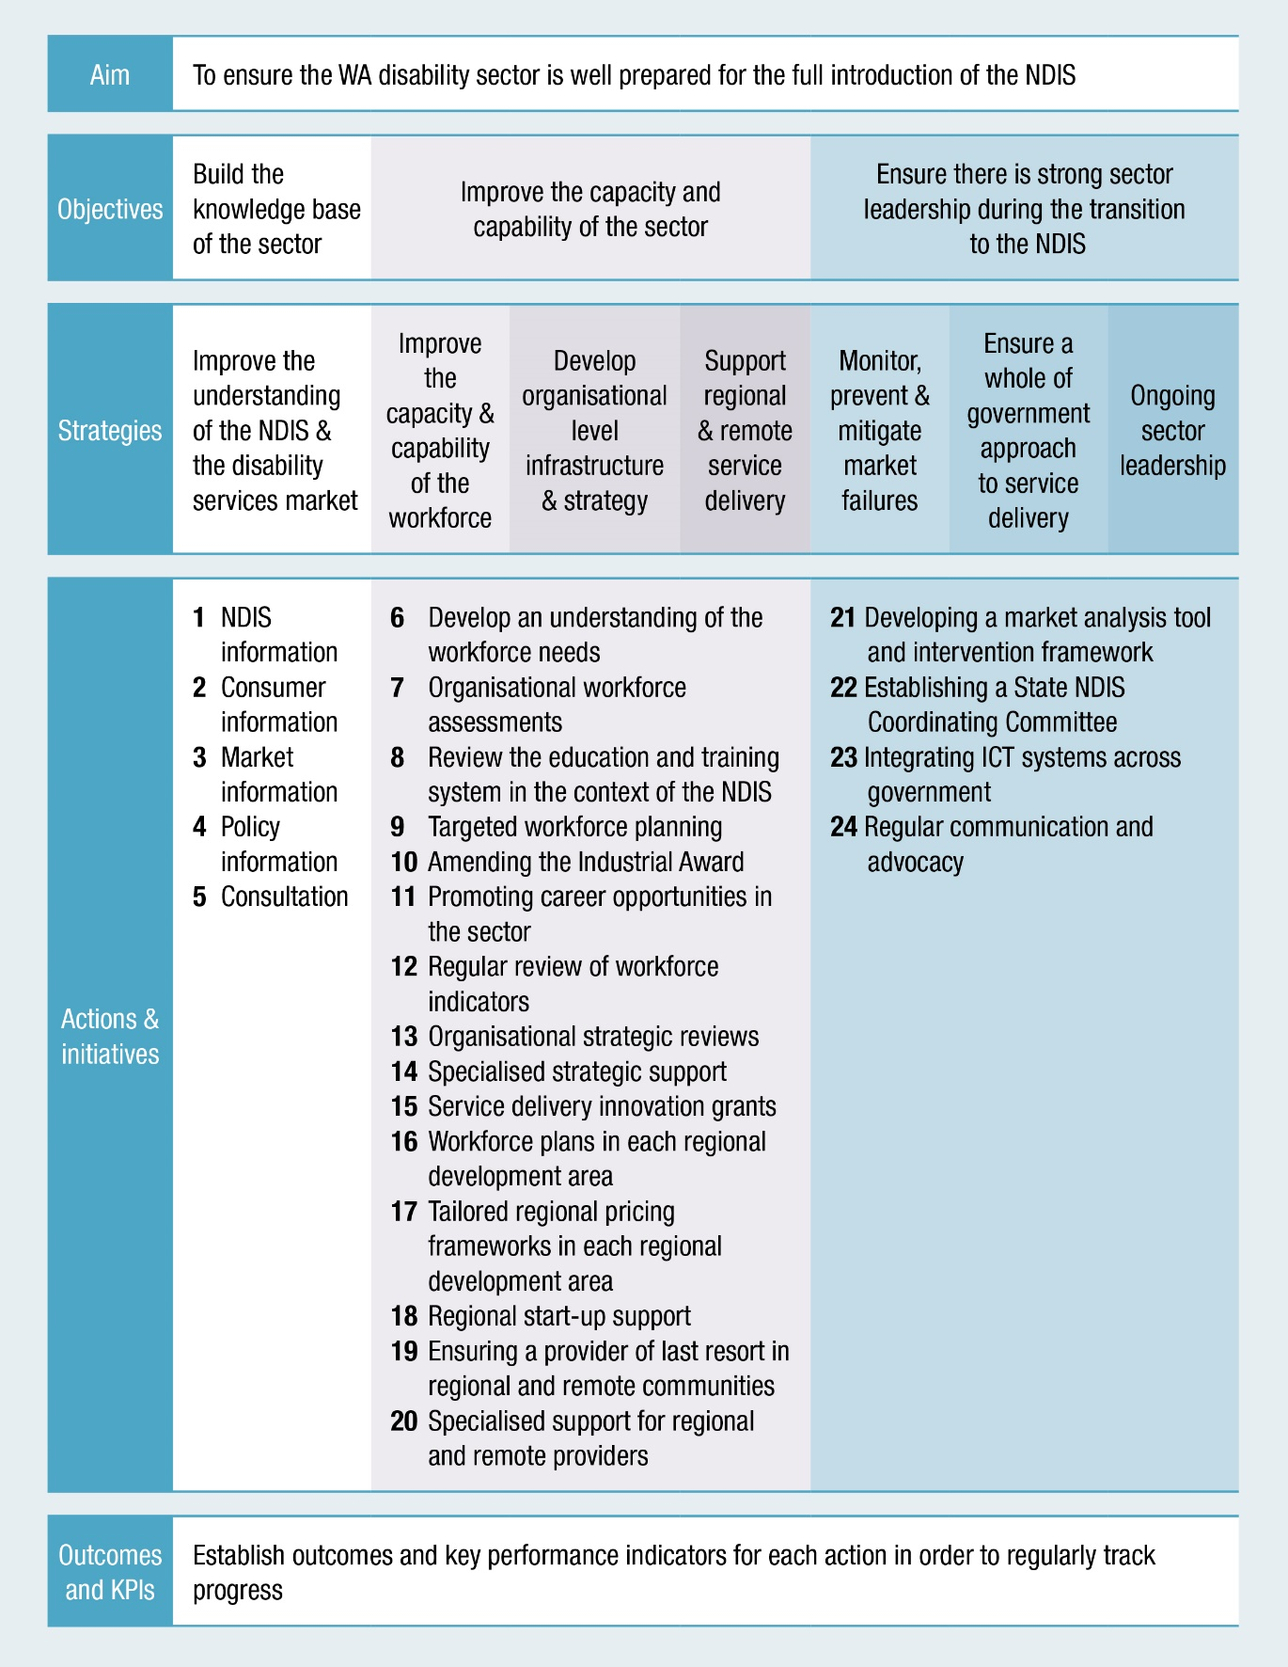

The Industry Plan identifies critical issues that must be addressed to ensure that sector
growth from the NDIS is improving service choice, availability, and creating better
outcomes for people with disability.

The critical issues include fostering and maintaining a workforce that is productive,
inclusive, efficient and mobile and that can be supported by ongoing market intelligence
and stewardship that monitors and prevents service failure.

This will require better preparedness, sophistication and financial resilience among service
providers, as well as access to more integrated and user-friendly information systems.
Greater collaboration with and across government is necessary to provide the leadership
required to drive policy and legislative change.

Key Industry Plan Facts and Figures

Figure 4. Industry Plan economic and service projections
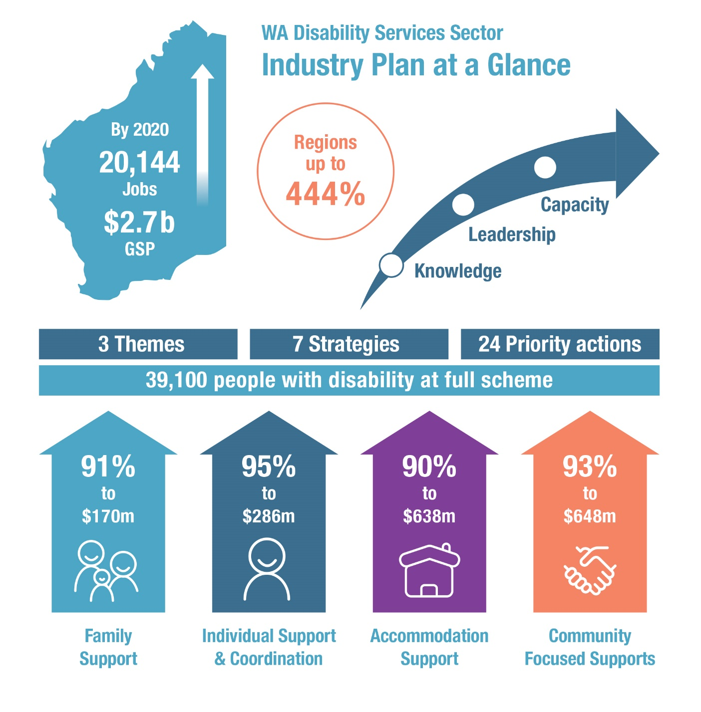

2020 Projections
- Significant economic growth
$2.7B contribution to the state’s economic activity (Gross State Product), up from $1.4B in 2015-16
- Income growth
$1.8B in incomes, up from $941M in 2015-16
- Strong jobs growth
20,144 direct and indirect jobs, up from 10,507
The NDIS will provide a significant opportunity for WA, with potential to trigger large-scale
economic growth and job creation in the state. Industry Plan modelling identified that the
total economic contribution of the disability sector in WA and the number of jobs generated
by the sector will double over the next three years.

By 2020, the disability sector in WA is forecast to generate a total of $2.7 billion worth of
economic activity in the state. This includes $1.8 billion in income and the equivalent of
20,144 direct and indirect full-time jobs. Metropolitan and regional areas are all expected
to see significant growth.
Figure 5. Projected impact of NDIS
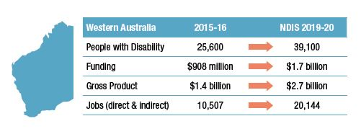
The availability of the NDIS will see increased demand for a wider range of services in WA. Total funding in the state for disability supports and services is expected to increase by 92 per cent to $1.7 billion across four core service types:
- Coordination and individual support up 95 per cent to $286 million
- Community-focused support up 93 per cent to $648 million
- Family support up 91 per cent to $170 million
- Accommodation support up by 90 per cent to $638 million
Figure 6. Future funding arrangements by service area
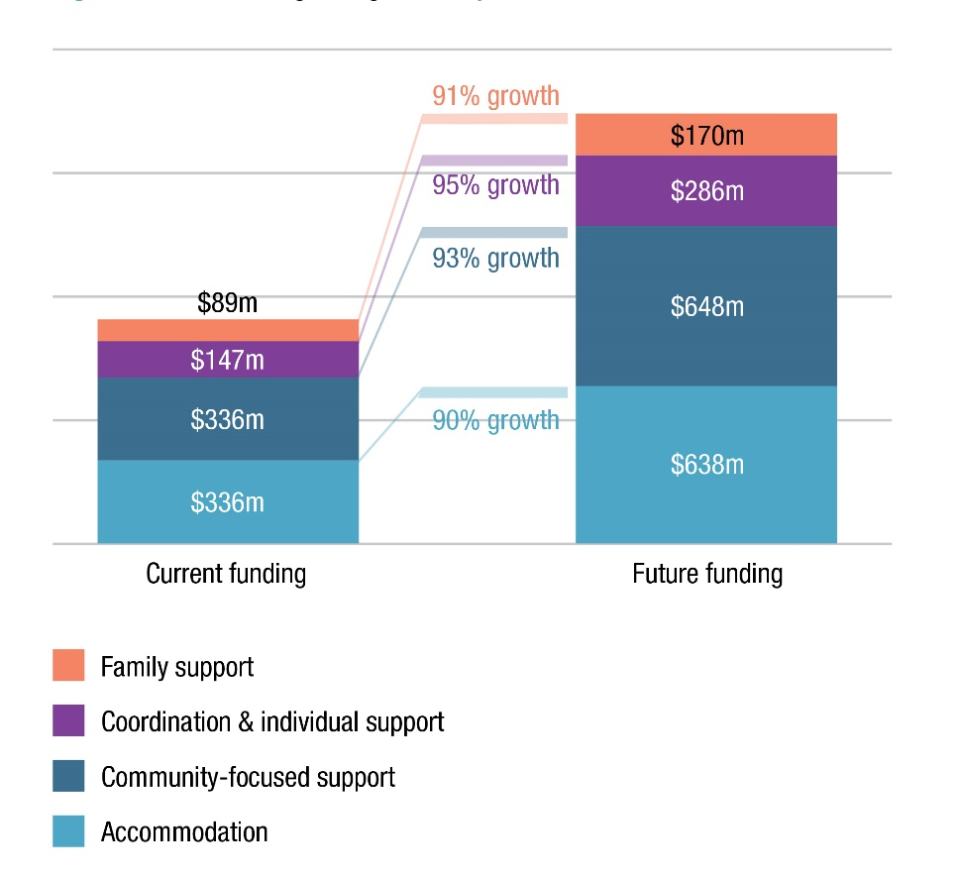

Workforce and jobs growth
WA needs a contemporary, adaptable and high-performing disability workforce to implement the NDIS effectively.
Figure 7. Employment impact full implementation
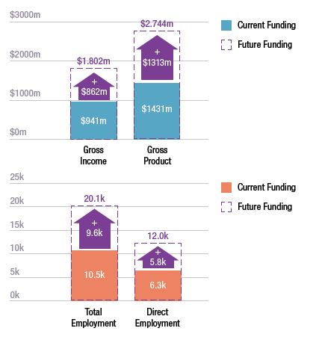
The WA disability sector has grown significantly over the past decade in line with increased
funding directed to the sector. In 2015-16, total expenditure for specialist disability
supports and services was $908 million. The sector generated an estimated $1.4 billion in
economic activity through $941 million in incomes and the equivalent of 10,507 full-time,
direct and indirect jobs. At full scheme, the NDIS is expected to boost employment by more
than about 9,600 jobs, including 5,800 new positions directly employed in the disability
sector.
Organisations estimate that their workforces will significantly increase from an average of
125 full time equivalent (FTEs) positions to 150 FTEs in 2019-20. Allied health staff, direct
support workers and volunteers are expected to be the most difficult to source.

The Industry Plan identified a range of factors that discourage people from working in
regional settings, including:
- Higher wage costs or supports to attract workers
- Lack of training in rural settings
- Perception of limited professional development
- Perception of isolation arising from with working in a rural setting
- Lack of infrastructure (such as communications) in regional and remote towns
Action is required to minimise projected skill shortages so that people with disability
can access high-quality supports and services provided by a skilled and contemporary
workforce.

The Industry Plan puts forward the sector’s view that a high-quality disability workforce
will strengthen safeguards and provide greater choice for people with disability. It outlines
the need for targeted attraction and retention initiatives to build a contemporary, adaptable
and high-performing workforce. This means recruiting and retaining committed individuals
who are able to implement the changes required while maintaining the highest standards
of care and support. Education and training requirements need to be considered and
supported. Effective transition to the NDIS depends on the capacity of government and the
sector to work together to get the right people into the right jobs.

Growing disability services in the regions
The size of WA and the provision of services to regional and remote communities pose
unique challenges in the context of implementing the NDIS state-wide. Integrated
strategies are required in regional and remote communities to realise improved outcomes
for people with disability living outside of the metropolitan area. People with complex needs
will need integrated but highly-specialised services wherever they live.

The Industry Plan research found an increasing number of disability service providers
intend to provide services across most areas by 2019-20. There is particular interest in
expanding daily living services, behaviour support and specialist care services, wellbeing
services, episodic coordination of support services and therapy and specialist support
services. All regional areas are forecast to experience increases in the number of service
providers, with the strongest growth expected in the more-populated regions of Peel, South
West, Wheatbelt and Goldfields-Esperance.

Demand for services is expected to increase significantly as more people access services
through the NDIS. Individualised funding in the disability sector will increase in all regions. The projected increases on current rates of funding range from 70 per cent in the
metropolitan area to 444 per cent in the Gascoyne.
- Metropolitan Perth region up 70 per cent to $1.2 billion
- South West up 78 per cent to $139 million
- Great Southern region up 145 per cent to $59 million
- Peel region up 152 per cent to $104 million
- Pilbara region up 194 per cent to $21 million
- Goldfields-Esperance region up 221 per cent to $41 million
- Kimberley region up 224 per cent to $26 million
- Mid-West region up 318 per cent to $60 million
- Wheatbelt region up 355 per cent to $90 million
- Gascoyne region up 444 per cent to $8 million
In regional and remote centres, choice and control need to be considered in the context
of the small market for services where often a single provider (or no provider) services a
small or remote community. This requires a significant cultural shift in thinking about the
delivery of human services.

The Industry Plan recommends targeted workforce planning at a local level, and
start-up support in regional and remote areas where service delivery gaps are identified.
Consideration also needs to be given to suitable intervention strategies and responses,
including a provider of a last resort mechanism in regional and remote areas.

Government will need to take decisive action on the social and economic imperatives that
underpin its commitment to people with disability. This includes investment in monitoring
and measuring outcomes, and providing for tangible progress actions in disability and
across the justice, housing, education and transport sectors.
Regional Economic Impact

Figure 8. Regional impact of NDIS
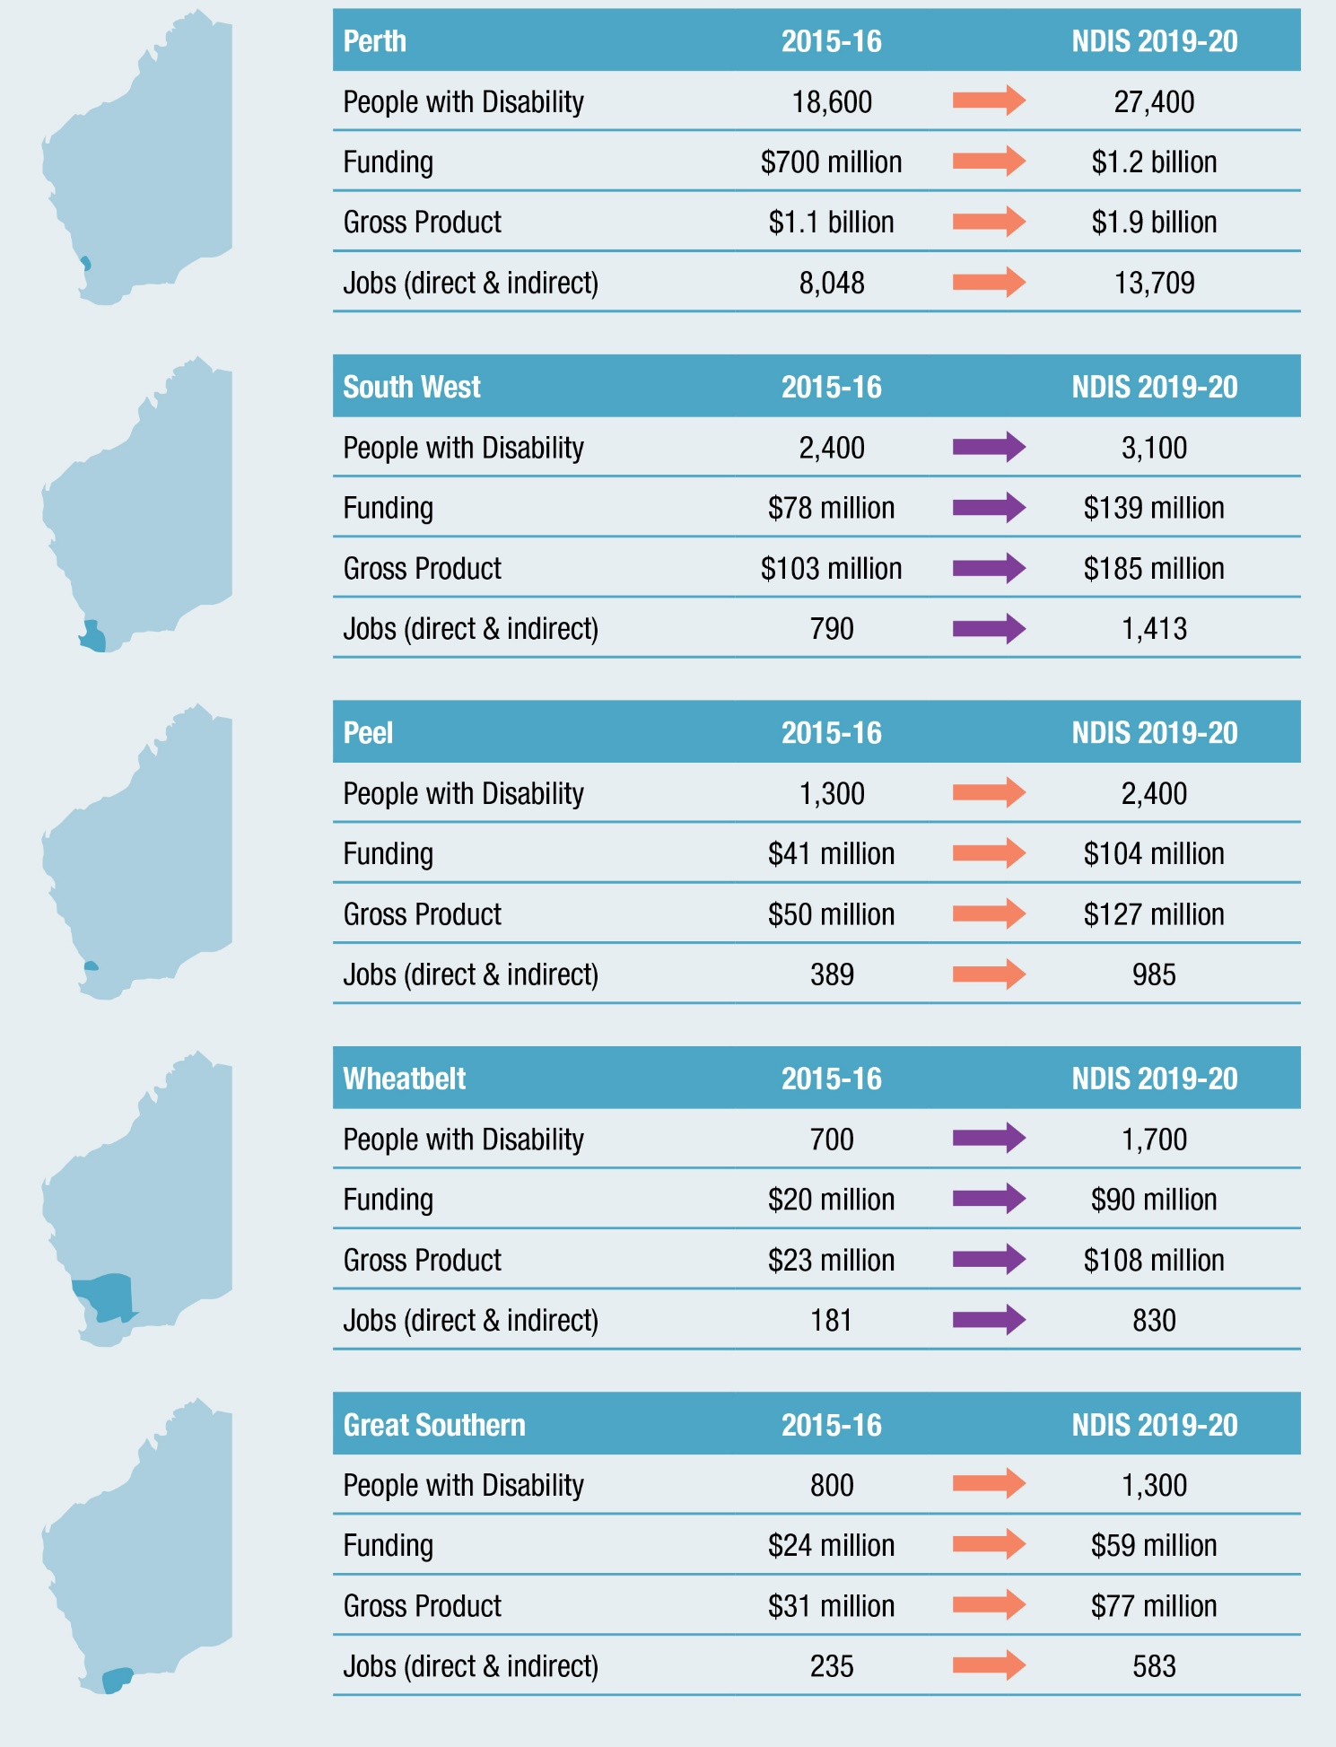

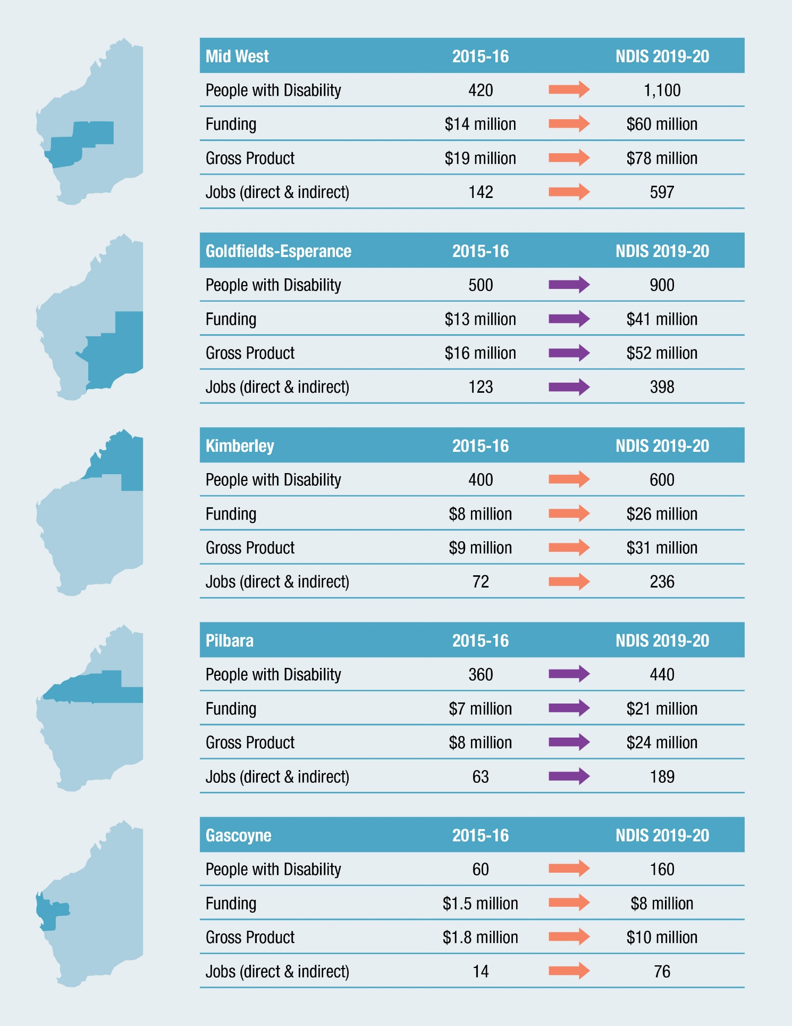

A different marketplace and the need for more integrated services
The Industry Plan identified the transition period as a critical time that will require
appropriate stewardship and intervention to ensure market availability, particularly for
people needing services in regional and remote communities.

In some parts of the sector, there is limited understanding of the impact of the NDIS and
subsequent increased competition. Organisations require a greater understanding of the
broader WA disability services market, including operational policies, supply gaps and
demand trends, in order to make informed decisions about their future operations.

There is a risk that high cost services may be withdrawn, particularly in thin or remote
markets. There are also concerns that the sector will not be able to collectively recruit or
retain the amount of skilled, capable staff required to fulfil the promise of the scheme. The
Industry Plan research found that in small to medium disability organisations, there is a low
level of preparedness for the new customer-orientated environment and the systems and
processes to implement it.

The Industry Plan shows that organisations require improvements to their existing
strategies, structures, planning, systems, processes and business models to better align
with the individualised funding framework and person-centred principles of the NDIS, and
to be financially sustainable in a more competitive market.

The research also found that many service providers are optimistic about challenges that
present opportunities for them to grow and diversify. The implementation of new processes
and procedures are expected to drive efficiencies. The absolute requirement to shift to
individualised and person-centred approaches is expected to better support people with
disability as well as boost collaboration and information-sharing within the sector.

A more competitive and deregulated market environment will not in itself address
market failures. A stronger understanding of the NDIS and the broader market will ensure
efforts to build capacity and capability are relevant, functional and efficient. Market
failures must be addressed and future policy and legislative changes must be based on
ongoing engagement and dialogue between people with disability, service providers and
government. There is potential for negative unintended outcomes for people with disability,
service providers and government.

Harnessing these opportunities and resolving existing and emerging issues is expected
to require significant investment, resourcing and commitment to strengthen community
capacity to best support people with disability.

Activating change
The NDIS should be about providing maximum benefit to people with disability, their
families and careers, and building a strong, diverse and sustainable disability services
sector.

The Industry Plan recognises the well-documented potential of the NDIS to better meet
the needs of people with disability, and that individualised funding provides for greater
autonomy and decision-making. It confirms the view that, for many years, WA has been
at the forefront of many of the changes underpinning the NDIS, such as individualised
funding and the use of local area coordinators. It also confirms that there are service gaps,
particularly in less-populated areas.

The NDIS in WA must also interface more effectively with other state-controlled service
delivery systems and be designed so that decision-making and accountability are
maximised for the people it impacts. Individuals’ needs can be complex. Complementary
services from other service delivery systems such as housing, child protection, public
transport, education and mental health need to be coordinated.

It is in the interests of people with disability and the broader community to build the
business intelligence of disability sector organisations by improving access to data and
information pertaining to the NDIS and the broader disability services market. This should
include good consumer and market information that is readily accessible.

People with disability will benefit from a more robust marketplace with more options,
better customer information, and a service provision environment built on the strength of
customer service and value for money. Facilitation of this kind of sustainable marketplace
and integrated approach requires a sound knowledge base and appropriate control of the
economic and other levers to create the right conditions.

While the NDIS will significantly increase funding for disability care and support, it will not
replace nor include the traditional responsibilities of other state-based service delivery
systems. A greater level of integration is required across the NDIS and relevant state-based
service delivery systems to ensure that there are minimal duplications and gaps in service
delivery, and that the provision of social services is cost-effective.

Investment is needed to ensure that the sector can meet the expected increase in
consumer demand and respond effectively to its changing nature. Close cooperation,
collaboration and partnership between government and key stakeholders - including
people with disability and service providers - is needed to ensure that NDIS transition in WA
is successful for people with disability, service providers and government.

Implementation
The Industry Plan maps out an evidence-based plan of action to ensure the WA disability sector is well-prepared for the full introduction of the NDIS.
Three key themes of continued leadership; building capacity and capability; and expanding the knowledge base underpin seven targeted strategies to create higher quality and more efficient services for people with disability in WA.
Twenty-four priority actions and transition initiatives have been identified to ensure the NDIS in WA is effective and delivers on the promise of a better life for people with disability and their families and carers.
Figure 9. The Industry Plan key strategic themes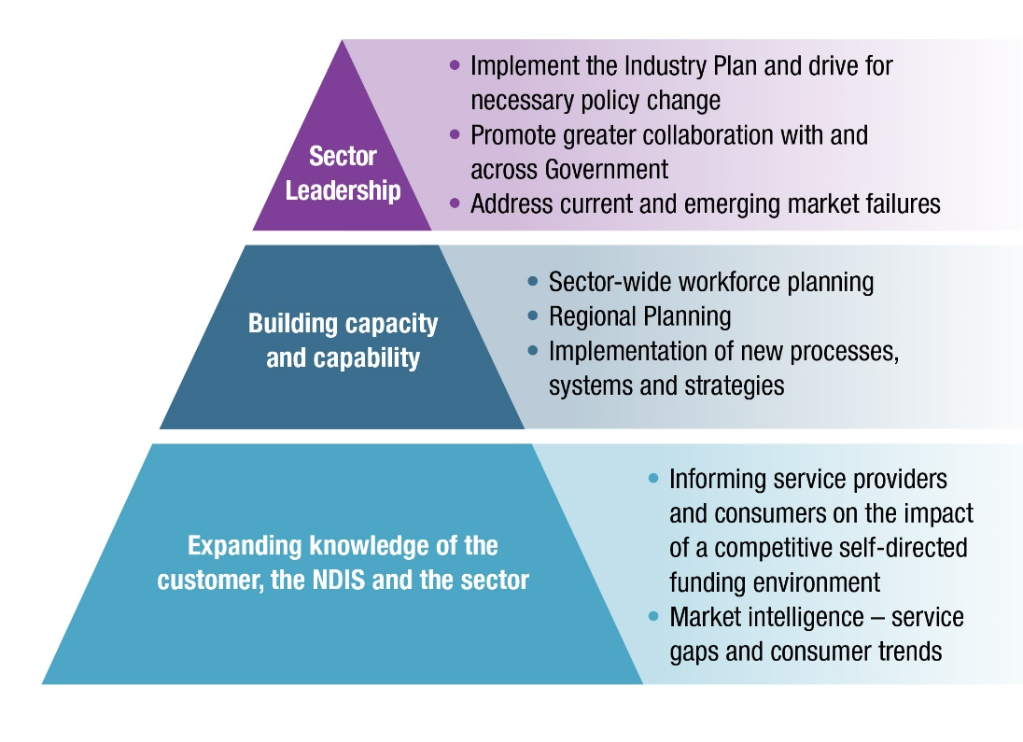
The three key themes recognise the need for comprehensive systemic and strategic planning in order to fortify the long-term social and economic gains of the NDIS. The associated strategies provide a way forward to ensure a smooth transition and effective implementation of the scheme. The strategies are:
- Understand the NDIS and the disability services market
Build the business intelligence of disability sector organisations by improving access to data and information about the NDIS, people with disability and the broader disability services market.
- Build the capacity and capability of the workforce
Develop and implement a state workforce plan for the disability services sector to address capacity and capability requirements.
- Improve organisational level strategy and infrastructure
Develop and improve the organisational level strategy and infrastructure of service providers in the sector.
- Support regional and remote service delivery
Develop regional and remote NDIS plans for each of WA’s nine regional development areas to support local communities that are at risk of market failure under the NDIS.
- Monitor, prevent and mitigate market failures
Develop capacity to ensure that market failure risks are monitored, and that market failures are prevented and mitigated.
- Ensure a whole-of-government approach to service delivery
Develop a holistic, whole-of-government approach to delivering services to people with disability.
- Ongoing sector leadership
Ensure the successful implementation of the NDIS in WA; based on a policy of co-design.
The Industry Plan will support the state to achieve its social and economic goals with
regards to the NDIS, including the primary objective of supporting the goals of people with
disability and their individual plans.

The Industry Plan provides strategic direction for a comprehensive whole-of-sector,
whole-of-state approach to NDIS implementation. It offers evidence-based, practical
solutions that can be implemented in collaboration with organisations, the sector and
government in support of people with disability. It provides a solid pathway for a smooth
transition to a statewide NDIS in WA.

About NDS
National Disability Services (NDS) is Australia's peak body for non-government disability service organisations. In WA, NDS represents over 100 not-for-profit disability services organisations. It provides services to tens of thousands of people with disability, their families and carers in the state. Services range from home support, respite and therapy to community access, employment and more.
NDS and its members in WA are committed to providing high standards of care and supports and better outcomes for people with disability. It is well recognised that to do this, service providers will have to completely adjust their operations and way in which they provide services to people with disability.

Contact
Julie Waylen
State Manager
Western Australia

Phone: 08 9208 9805
Fax: 08 9242 5044
Email: julie.waylen@nds.org.au
Web: www.nds.org.au

12 Lindsay Street
Perth WA 6000
PO Box 184 Northbridge WA 6865

