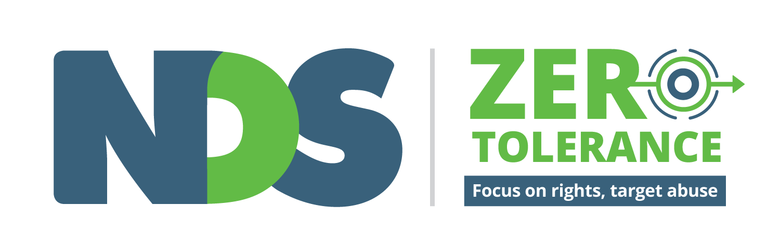
Feedback and Complaintsfd
Feedback and Complaints
Positive complaints cultures are a critical part of promoting human rights and preventing abuse of people with disability. When people feel comfortable speaking up, providing feedback and making complaints they are more likely to report poor practice, as well as acts of abuse, neglect and violence.

The right to speak up is identified in Standard 4 of the National Standards for Disability Services (2013) Feedback and Complaints. Standard 4 provides six indicators of practice as a basis for any organisational complaints management processes, including.

- Individuals, families, friends, carers and advocates are actively supported to provide feedback, make a complaint or resolve a dispute without fear of adverse consequences.
- Feedback mechanisms including complaints resolution, and how to access independent support, advice & representation are clearly communicated to individuals, families, friends, carers and advocates.
- Complaints are resolved together with the individual, family, friends, carer or advocate in a proactive and timely manner.
- The service seeks and, in conjunction with individuals, families, friends, carers and advocates, reviews feedback on service provision and supports on a regular basis as part of continuous improvement.
- The service develops a culture of continuous improvement using compliments, feedback and complaints to plan, deliver and review services for individuals and the community.
- The service effectively manages disputes.
Organisations should also seek to maximise privacy and confidentiality for people making complaints, and take steps to ensure that there are no reprisals or repercussions for people speaking up. This includes any staff speaking up about disclosed, observed or reported abuse and neglect.
Most states and territories have statutory bodies responsible for overseeing the management of complaints in the disability sector. In many cases these bodies have developed advice for people with disability and families about how to make complaints, and resources for service providers on how to manage complaints.

 | Complaints Body  Who manages complaints | Making a Complaint: Information for people with disability, families/carers | Responding to Complaints: advice for providers on responding to complaints
ACT | Disability and Community Services Commissioner | ‘How to Make a Complaint’ | ‘About the complaints process – providers’
NSW | Deputy Ombudsman – Community and Disability Services | ‘Making a Complaint?’ | ‘Complaint Handling Toolkit for Community Service Organisations’
NT | Health and Community Services Complaints Commission (HCSCC) | ‘Making a Complaint’ | ‘Helpful Hints for Handling Complaints’

QLD | Complaints and Review Area - Department of Communities, Child Safety and Disability Services | ‘A Guide to Making a Complaint’ | ‘Complaints Management Policy and Procedure’
SA | Health and Community Services Complaints Commissioner (HCSCC) | ‘Make a complaint to HCSCC’ | ‘For Service Providers: Addressing Complaints’
TAS | Department of Health and Human Services | ‘Compliments and Complaints’ | -
VIC | Disability Services Commissioner | ‘Making a Complaint’ | ‘Everything You Want to Know About Complaints…’
WA | HADSCO: Health and Disability Services Complaints Office | ‘Disability Service Complaints’ | ‘Tips and Advice on effective complaint management’

There are also several national bodies ready to respond to and/or manage disability-related complaints

 | Complaints Body  Who manages complaints | Making a Complaint: Information for people with disability, families/carers
National | Department of Social Services | ‘Feedback, Compliments, Complaints and Enquiries’
National | National Abuse and Neglect Hotline | “Report Abuse or Neglect of People with Disability’
CRRS | Complaints Resolution and Referral Service | ‘Complaints and Report Abuse’
Rights | Australian Human Rights Commission | https://www.humanrights.gov.au/our-work/disability-rights
NDIS | National Disability Insurance Agency  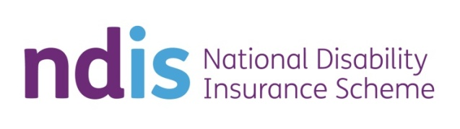 | ‘Feedback and Complaints’

Health | Australian Health Practitioner Regulation Agency | ‘Do You Have a Complaint or Concern?’
National | Commonwealth Ombudsman | http://www.ombudsman.gov.au/
Consumer | Australian Competition and Consumer Commission (ACCC) | www.accc.gov.au  Information about buying disability-related products and services

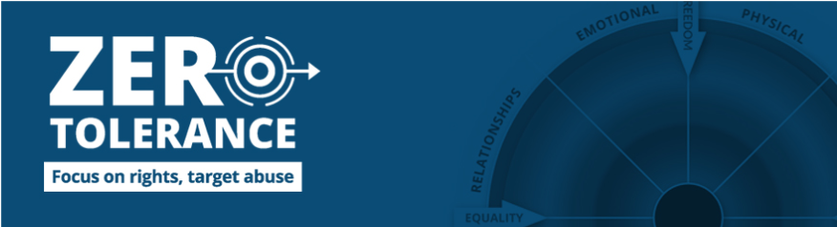
For more information, visit the NDS Zero Tolerance web pages: https://www.nds.org.au/zero-tolerance

