National Disability Services (NDS) WA Annual Report 2015-2016
12 Lindsay Street, Perth WA 6000
PO Box 184, Northbridge WA 6865
Phone: 9242 5544
Fax: 9242 5044
www.nds.org.au
Twitter - @nds_wa

Contents
Contents 2
Chairperson and State Manager Report 4
Supporting our Members 6
Policy and Advocacy 8
Sector Development 12
Access and Inclusion 18

Chairperson and State Manager Report
The past year has continued to be one of profound change for the disability sector in Western Australia (WA). 2015-16 saw the passing of the much-needed Motor Vehicle (Catastrophic Injuries) Bill 2016 in State Parliament. National Disability Services (NDS) WA campaigned tirelessly for many years for a no-fault insurance scheme and applauds the State Government and appreciates the bipartisan support in taking this step to introduce the Catastrophic Injuries Support Scheme (CISS) on 1 July 2016. We look forward to working collaboratively with the State Government and the Insurance Commission of WA as the CISS is implemented.
Another significant milestone in 2015-16 was the Commonwealth and State Government’s joint commitment to the expansion and extension of the National Disability Insurance Scheme (NDIS) in WA. The agreement gave much needed certainty for people with disability and service providers involved in the WA trials of the scheme and for those waiting to participate.
Under the agreement, 10,900 current and future trial participants will benefit from the NDIS while the details of the full scheme are finalised before a State-wide rollout in July 2017. Trial sites of the WA NDIS (formerly My Way) are being expanded to include Armadale, Murray and Serpentine-Jarrahdale, while the Commonwealth-run National Disability Insurance Agency (NDIA) trial will grow to include Bayswater, Bassendean, Chittering, Toodyay, York and Northam.
NDS WA welcomes the State Government’s continuing commitment to supporting people with disability through initiatives funded in the 2016-17 State Budget. The State Government committed $944.9 million to the disability sector in the 2016-17 State Budget, representing a 118 percent increase since 2008.
NDS WA has contributed to policy development and advocacy at both a National and State level, with the centrepiece for State level advocacy being our annual Pre-Budget Submission (PBS). The PBS is one of our most important policy documents and continues to highlight priorities. It outlines a diverse range of measures that require strong investment by the State Government with a focus on delivering priority recommendations in the National Disability Strategy. NDS WA is committed to driving initiatives that address areas of critical need and pave the way for a comprehensive service system for people with disability in WA.
NDS WA was proud to be recognised publicly for its outstanding partnership with the Disability Services Commission (DSC). DSC received a prestigious award from the Institute of Public Administration Australia WA for best practice collaboration between Government and Non-Government Organisations for the development of the $2 million Changing Places Network across the State. This important project was the culmination of a successful partnership between DSC, NDS WA, the WA Local Government Association and the Metropolitan Redevelopment Authority. The Changing Places Network was a key recommendation in the NDS WA PBS over the past four years and NDS WA played a vital role in facilitating consultations between people with disability, carers and service providers to provide recommendations on setting up a network, along with the type and location of the facilities.
We would like to acknowledge the support of DSC, Department of the Premier and Cabinet, Department of Finance and the NDIA Perth Hills, with whom NDS WA has worked closely throughout the year.
We also acknowledge the important part that Lotterywest plays in supporting the disability sector in this State. Lotterywest is the only lottery in Australia in which money raised is given back to the community.
Around one third of all money raised is distributed to nearly 1,000 different community organisations in WA including many of our member organisations.
We sincerely thank and recognise the invaluable work and commitment of Tony Vis for his time as Chairperson of NDS WA and as a member of the NDS WA State Committee. During this time, Tony saw a period of unprecedented change and major reform in the disability sector and played a key role in ensuring there was a strong focus on improving outcomes for people with disability in WA.
NDS WA continues to appreciate the active involvement and participation of our member organisations in the work we do. This relationship deeply connects us to the needs of people with disability and enables us to strongly represent the disability sector in WA. We look forward to continuing to work for and with you, our members, over the coming year.

Supporting our Members
NDS is Australia’s peak industry body representing non-government disability service organisations. Our purpose is to promote high quality service provision and life opportunities for people with disability. This is achieved by influencing government at all levels and supporting members with information and advice, networking opportunities and business support.
NDS represents more than 1,100 non-government disability services organisations across all states and territories in Australia. As at June 2016, NDS WA had 106 members.
Collectively, these members provide services to thousands of West Australians with disability and their families and carers. The reach of NDS WA is further extended through our Access and Inclusion services: ACROD Parking, Companion Card, Changing Places Network and the Community Living and Participation Grants.

New NDS WA office
Ms Andrea Mitchell MLA, the then Parliamentary Secretary to the Minister for Disability Services, officially opened the new NDS WA Office on 13 November 2015. The move to the office in Northbridge represented a significant milestone for NDS WA and is a fantastic asset for the WA disability sector. The new office enables NDS WA to provide an accessible, inclusive facility and services to better respond to the future requirements of the growing disability services sector in WA.
The landmark building was previously Moores Bakery, one of the largest bakeries supplying Perth in the first half of the 20th century. It was substantially renovated by the Metropolitan Redevelopment Authority in 2006, with many of the bakery’s original features conserved. Thanks to generous Lotterywest funding with support from Metier and Richard Potts, NDS WA made additional modifications to ensure the fit-out included best-practice gold standard accessibility features.

2016 Annual Member Survey
The annual Member Survey was conducted in February 2016. All respondents rated the following roles as either important or highly important for NDS WA to undertake on behalf of its members:
- Advocating with Government;
- Developing and promoting sound policy for disability services in WA; and
- Keeping members informed of sector issues.
Members considered that NDS WA is performing best at:
- Keeping members informed of sector issues;
- Promoting a positive image for the disability services sector; and
- Developing and promoting sound policy for disability services in WA.

Media Coverage
To raise the profile of its members and showcase the work they do to the wider public, as well as promote positive stories regarding people with disability and the disability sector, NDS WA proactively works to secure media coverage across a range of outlets. Media campaigns effectively highlighted the significance of International Day of People with Disability, the 2016 Disability Support Awards and the NDS WA State Conference, with a range of stories featured in The West Australian, community and regional newspapers, radio and social media. Additionally NDS WA has positioned itself as a recognised voice for comment on issues facing the disability sector.

Policy and Advocacy
NDS WA continued to have a critical role in shaping policy and acting as a strong advocate for member organisations, people with disability and the broader disability sector over the past twelve months. Our consistent policy and advocacy work has helped to support and strengthen the disability sector in an environment of transitional change and monumental reform at a National and State level, generated by the implementation of the NDIS.

Pre-Budget Submission (PBS)
The development of the annual PBS is the centrepiece of NDS WA’s policy and advocacy work. This document articulates to the State Government the priority disability issues that should be funded in the next State Budget as identified by our members. The NDS WA PBS is recognised by Government as an important and comprehensive piece of work that provides evidence-based recommendations and priorities to improve the outcomes and opportunities for people with disability in WA.
Presented to the Deputy Under Treasurer Mr Michael Court on 4 November 2015, the 2016-17 Submission advocated strongly for State Government commitment to the rollout of the NDIS in WA with local decision making at its core. Additionally, an investment to develop a Disability Services Industry Plan, including the establishment of a Sector Innovation Fund to build a strong disability services sector was also highlighted as a significant budget priority.
The ten priorities and recommendations identified in the 2016-17 PBS directly aligned with the six policy areas articulated in the National Disability Strategy 2010-2020:
- Inclusive and accessible communities;
- Rights protection, justice and legislation;
- Economic security;
- Personal and community support;
- Learning and skills; and
- Health and wellbeing.
The PBS urged the State Government to continue to meet the challenge to improve services for people with disability across the whole spectrum of Government and to honour its commitment to the National Disability Strategy.
The NDS WA PBS has been a powerful mechanism in influencing State Government decision making to create meaningful change for people with disability, including:
- The prompt commencement of no-fault insurance in WA by 1 July 2016 with the passing of the Motor Vehicle (Catastrophic Injuries) Bill 2016 through Parliament. The Bill provides peace of mind and a fairer model of lifetime care and support for people who receive catastrophic injuries in a motor vehicle accident regardless of whether anyone is to blame. NDS WA is keen to ensure that WA implements the most effective and efficient model possible and that the associated Regulations adequately provide coverage, compensation, lifetime care and support for those in our community injured catastrophically in motor vehicle accidents. To assist in the implementation process, NDS WA has continued to advocate for the State Government and the Insurance Commission of Western Australia to establish an advisory group to guide the practical design of the scheme. NDS WA has highlighted that the scheme’s ongoing design and development is particularly important, given a National Injury Insurance Scheme (NIIS) in WA will be introduced into a new disability services environment that is being developed through implementation of the NDIS.
- NDS WA is delighted that the Changing Places Network initiative was announced as the winner of the Institute of Public Administration Australia WA Best Practice in Collaboration between Government and Non-Government Organisations award. WA is the first State to develop a Changing Places Network initially driven by the State Government’s investment of $2 million to fund the first 14 Changing Places. NDS WA has been a strong advocate for the establishment of the network through our PBS, since 2012.
- The construction and opening of WA’s first Disability Justice Centre in August 2015 costing $8.5 million was a significant step forward for people with an intellectual or cognitive disability who have been charged with an offence. The new Bennett Brook Disability Justice Centre in Caversham provides a safe placement option for a small group of people deemed unfit to plead and stand trial due to their disability. The opening marked the end of a four-year campaign to create a declared place, where people accused of a crime but considered unfit to plead could be housed and supported.
NDS WA is also pleased that our PBS continues to influence the State Government’s ongoing investment across its agency portfolio areas through a diverse range of measures demonstrated through its commitment of $944.9 million to the disability sector in the 2016 State Budget. This is a 118 percent increase since 2008-09 and paves the way for the future development of a comprehensive and contemporary service system for people with disability based on entitlement, choice and control.
The PBS strongly recommended the State Government commit to the transition and rollout of the NDIS. This included securing funding for full implementation, resolution of outstanding design issues and an ongoing commitment to co-design, investment in transition support and a sustainable disability support workforce. NDS WA has advocated to the State Government that a full transition to a NDIS across WA should be based on the principles of a local decision making and governance model supported by a national framework.
The provision of additional funding of $26 million to extend the current NDIS trials to July 2017 and expansion to additional trial sites in WA is welcome and will give much needed certainty for people with disability and service providers.
It was also pleasing that the 2016-17 State Budget provided an increase of $50 million to meet growth in demand for existing services where NDIS trial sites are not operating.
Despite the challenging fiscal and budget environment faced by the State Government, it is very pleasing that our 2016-17 PBS successfully highlighted critical disability issues which helped shape budget decisions and investment in improving the economic and social participation of people with disability in our community. The WA disability sector has a strong record of achieving quality outcomes for people with disability and we welcome the opportunity to work with the State Government to build the best NDIS in WA. NDS WA looks forward to the Commonwealth and State Government commitment to working collaboratively toward the signing of a NDIS bilateral agreement by October 2016 to enable the full rollout of the NDIS.
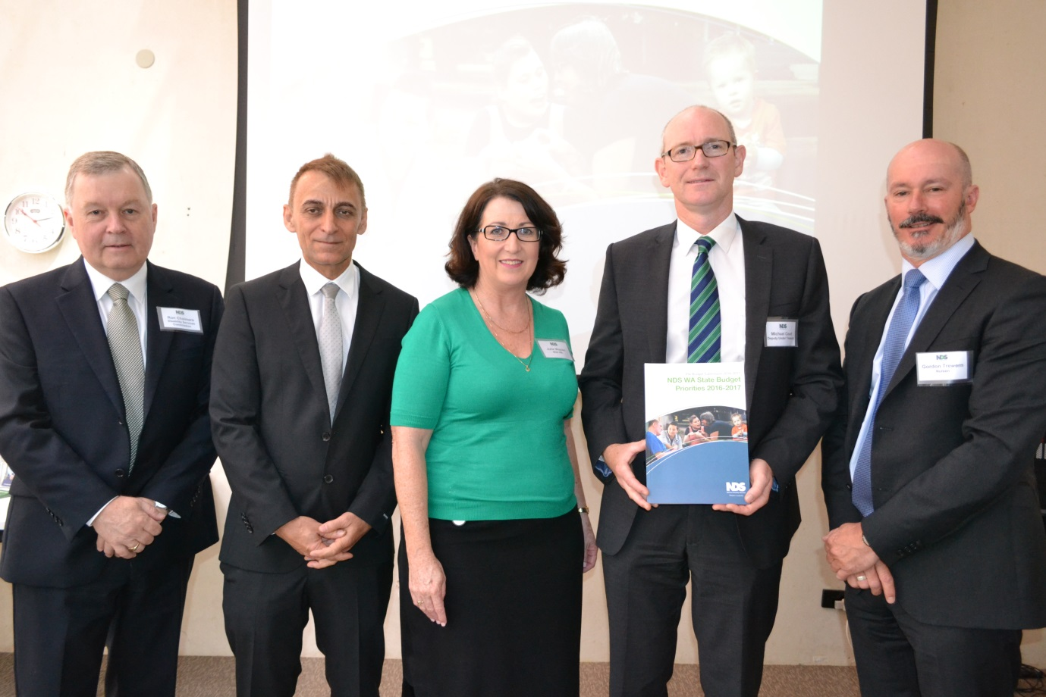
Photo caption: 2016-17 PBS Launch.
L to R: Dr Ron Chalmers, Director General, DSC; Jim Vanopoulos, State Policy Manager, NDS WA; Julie Waylen, State Manager, NDS WA; Michael Court, Deputy Under Treasurer; and Gordon Trewern, Deputy Chairperson, NDS WA.

Policy Papers and Submissions
NDS WA contributed to a number of national and State policy submissions and papers during the course of 2015-16, including:
- Information Linkages and Capacity Building Commissioning Framework Consultation;
- Royal Commission into Institutional Child Sexual Abuse Out-of-Home Care Consultation Paper;
- Royal Commission into Institutional Child Sexual Abuse Complaints Handling Consultation Paper;
- Disability Employment Framework;
- Review of the National Disability Advocacy Framework;
- Specialist Disability Accommodation Pricing and Payments Framework;
- Senate Committee Indefinite detention of people with cognitive and psychiatric impairment in Australia;
- Personal Care and Community Participation Price Reviews; and
- Western Australian Government Indexation Policy for Community Services.

Policy Forums
NDS WA continued to conduct a number of policy forums, briefings and consultations in 2016 aimed at disability sector CEOs, senior management and member organisations. These forums provided information and networking opportunities and gave participants the opportunity to shape policy advice around critical issues such as specialist disability accommodation, WA NDIS Pricing Frameworks, block funding and Information, Linkages and Capacity Building.

Research Seminar
NDS WA partnered with DSC and the NDS Centre for Applied Disability Research (CADR) to deliver a one-day disability research seminar in August 2015.
The focus of the seminar was to develop disability sector evidence based action research to support informed policy decision making.
Following the seminar, a range of facilitated sessions and individual consultations were held to inform the development of a business plan for the WA Disability Research Network (DRN). This included input from people with disability, disability sector organisations, DSC Local Area Coordinators (LACs) and mainstream government agencies (Departments of Education, Health, and Premier and Cabinet).
Research priorities, likely partners and stakeholders, potential business and governance models and resource/funding/revenue streams have been identified through the consultation process.

NDIS Essential Briefing
NDS hosted an NDIS Essential Briefing in October 2015, which provided information on the transition to the full NDIS. The briefing focused on the national policy environment and the need-to-know facts and data for organisations including updates on pricing, housing, transfer of business, LACs, workforce, the Modern Award, quality and safeguards and more.
It was an opportunity to explore what is and is not working since the NDIS began and highlighted the operational challenges of the NDIS faced by participants and providers.
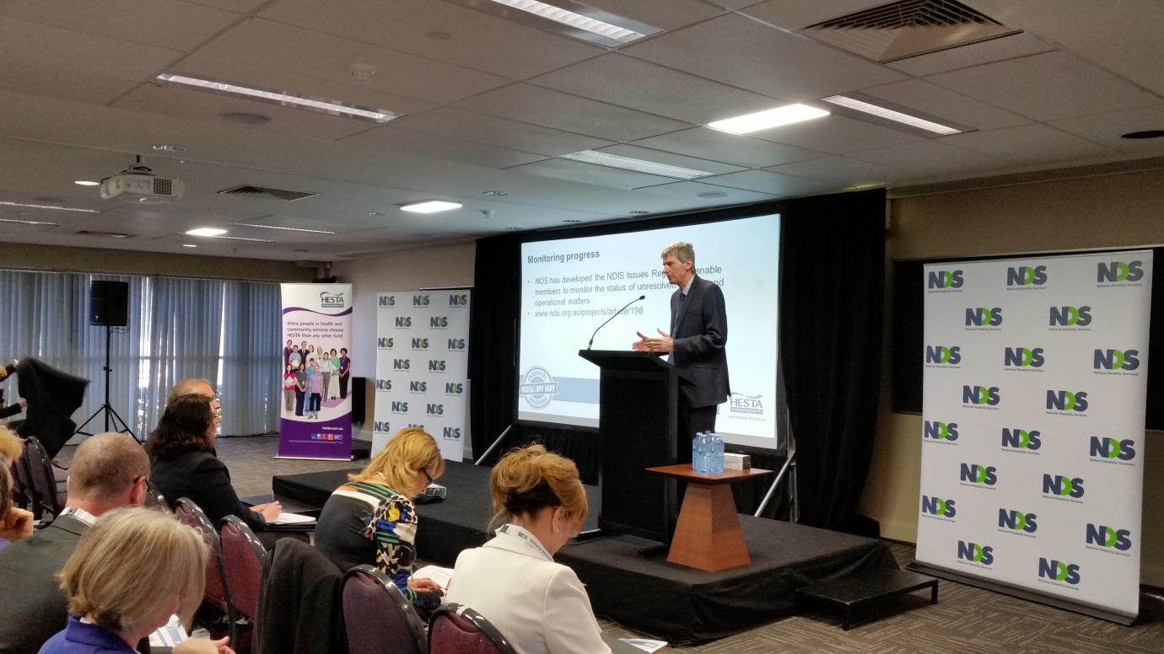
Photo caption: NDIS Essential Briefing. Dr Ken Baker AM, NDS Chief Executive.

Sector Development
During 2015-16, NDS WA has been active in supporting the development and sustainability of the disability services sector, through targeted activities that enhance member organisations’ capacity to respond to policy reform and build on the quality of service delivery.

Quality and Safeguarding

Enhancing service quality and safeguarding
A number of initiatives were delivered to NDS WA members aligned with the NDS Zero Tolerance framework. These initiatives not only delivered tools and resources for providers to improve their individual safeguarding and risk mitigation practices, but also to monitor the quality of services, meet compliance requirements and support continuous service improvement.
The Quality, Individual Safeguarding and Strengthening Safer Services initiatives assist disability sector organisations to develop a positive culture of safeguarding by developing an understanding of:
- Measuring and monitoring service quality, at the individual and whole-of organisation level, including responding to identified gaps or areas for improvement;
- Developing an organisational commitment to quality, whereby quality is embedded in organisational systems and workforce practices;
- Best practice in assessing and responding to individual vulnerability and risk; and
- Supporting or empowering people with disability, their families and carers to lead or shape the development, review and monitoring of services, including safeguarding strategies (if and when they are required). In metropolitan and regional areas 46 workshops and forums were delivered to over 600 participants.

Outcomes Recording and Reporting Project
Resources and training were provided to the disability sector to help service providers effectively measure and record individual outcomes and meet State Government reporting requirements. NDS WA facilitated a targeted workshop with sector representatives to identify specific challenges with the reporting process and develop recommendations about how this process could be streamlined or better communicated in the future. These recommendations were tabled with DSC and sector feedback is used to assist with continuous improvement and reporting.

Safer Services Research Project
NDS WA has partnered with Curtin University for the Safer Services Research Project. The project aims to identify safeguarding concerns for people with disability in various circumstances and across different services, and to understand the practices WA disability service organisations have developed in order to keep people safe from abuse, neglect, harm and exploitation. The first phase of the project has seen:
- The recruitment of over 140 research participants, including people with disability, people with complex communication needs, families and carers, members of the disability services sector workforce and Government representatives;
- Analysis of qualitative data gathered through interviews and focus groups;
- Reviews of academic and grey literature; and
- A targeted survey to understand the existing policies, procedures and practices within disability service organisations.
Curtin has commenced work on the development of practical resources that can be adopted by disability service organisations to improve their ability to keep people with disability safe from abuse, neglect and exploitation. Resources will be shaped by the research findings gathered to date and align with the Zero Tolerance tools and resources.

Employment
NDS WA has delivered a range of training programs and resources to support the delivery of new opportunities created by the NDIS which allow more people to access employment-related supports.

Ticket to Work
Two ‘Ticket to Work’ networks, using a local community partnership model which brought together disability and representatives from education, training, youth, business and local government, commenced during the year. The objective of the network is to improve the transition to employment for young people with disability.

Supporting Young People with Disability to Transition to Employment
A ‘Supporting Young People with Disability to Transition to Employment’ learning program was delivered to service providers to challenge thinking and broaden the design of bespoke work-related supports for participants ineligible for Disability Employment Services (DES). The program includes pathways for skill development, work practice and job creation and is delivered through a combination of workshops and mentoring.
Feedback revealed that 90 percent of service providers and parents strongly agreed that the initiative would improve their ability to support young people with disability to transition towards or into work of their choice, including increased innovation in self-employment and micro-enterprise opportunities.
A number of events and resources for school leavers have been developed in partnership with peak bodies and Local Governments, including the Essentials Guide for Graduates, Local Work for Local Youth and the Connections - Your Next Step Forum.
In response to the lower than anticipated number of young people with disability including employment goals within their NDIS plans across WA trial sites, NDS WA developed a short animation video for participants. The aim of the video was to encourage higher job-related expectations in the NDIS planning process and to identify the support and guidance available through WA NDIS. This has been accompanied by employment goal planning presentations to planning personnel and pre-planning resources for families. The video can be viewed in the resources section of the NDS website.

Liaison with Government
NDS WA worked with planning personnel from the NDIA and DSC to support the inclusion of work-related goals in NDIS plans, particularly for participants who are not eligible or unable to obtain services from Disability Employment Services (DES) or Australian Disability Enterprises (ADE).

Workforce

Attracting Workers to the Sector
Frontline staff are the heart of disability work, with quarterly reports from June 2014 – April 2016 from the WA NDIS and the Australian Government indicating supports provided by staff in frontline roles represent close to 80 percent of the total NDIS spend in WA. To help the sector build a sustainable and diverse workforce to meet the needs of people with disability, NDS WA has conducted 36 career information and sector linkage forums to schools, community groups, tertiary education organisations and job support agencies in conjunction with participating member organisations reaching over 850 people.
In addition, the NDS WA Training and Skill Development Incentive provided subsidies to 192 new sector support staff to obtain a full Certificate III in Disability qualification, or, a skill set of six units of competence from the Certificate III. More than 40 percent of participating trainees were from regional or remote based services.

Disability Support Awards
The 2016 Disability Support Awards showcased the impact of quality support on the lives of people with disability and raised the profile of the sector as an employer of increasing significance. Attracting almost 150 nominations across the sector, the Awards culminated in a gala dinner attended by a record number of 760 people.
A communications campaign in the lead-up to the Disability Support Awards highlighted the careers and achievements of support workers who had achieved excellence in their fields by promoting nominees/finalists and winners in the various Award categories in both mainstream and social media.
NDS WA proudly hosts the Awards in partnership with DSC. Sponsorship was provided by Curtin Not-for-profit Initiative, HESTA, Intework, RAC, Ability Centre, Healthcare Australia and Zenith Insurance Services. In addition, Lotterywest supported 100 people with disability and their companions to attend the event.
2016 Disability Support Award winners:
- Excellence in Personal and Community Support Award.
Stephen Cathie, Ability Centre.
- Excellence in Improving Participation Award.
Susie Waller, Nulsen Disability Services.
- Emerging Leader Award.
Ayesha Patterson, Youth Disability Advocacy Network.
- Excellence in Improving Employment Opportunities Award.
Renae Hartmann, Enable Southwest.
- Excellence in Regional Support Award.
Annie Ryder Team: Tammy Mickle, Slade White-Dunn, Odette Askew and Jocelyn Frearson, Avivo.
- Excellence in Advocacy and Rights Promotion Award.
Jenny Au Yeong, Ethnic Disability Advocacy Centre.
- Lifetime Achievement Award.
Helen Payne, My Place.
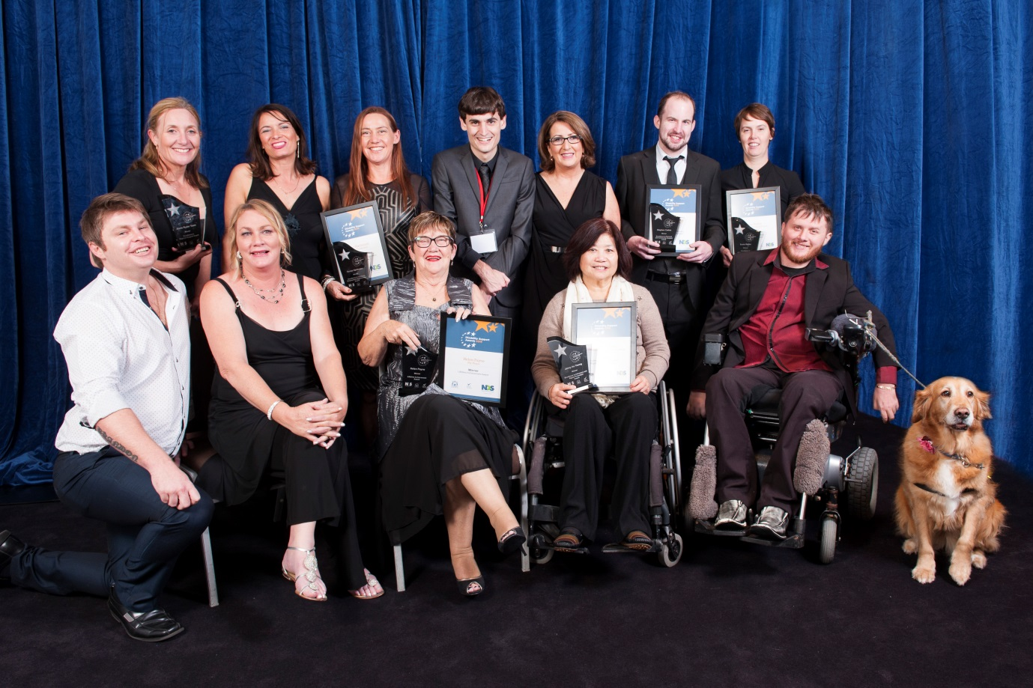
Photo caption: 2016 Disability Support Awards. Back row, left to right: Jocelyn Frearson, Nicki Dyson, Renae Hartmann, Ben Cox, Julie Waylen, Stephen Cathie, Susie Waller. Front (L-R): Slade White-Dunn, Tammy Mickle, Helen Payne, Jenny Au Yeong, Peter Darch, Phoebe.

Learning and Development

A Skilled Workforce
NDS WA has delivered 105 workshops and forums to 2,221 participants this year. These events aim to help sector staff build capacity, skills and knowledge required to work alongside people with disability in designing and tailoring services that reflect individual needs, choice and control. Evaluation of feedback conducted six months post training demonstrated a sustained increase in knowledge in relation to NDIS concepts including financial sustainability, staff development, client and market focus, choice and control.

Sector Support toward NDIS Transition
NDS WA delivered regular provider forums across all three WA trial locations which explored and identified issues. In addition, 27 NDIS transition related workshops targeting direct support, middle management and executive managers have been delivered throughout the year in metropolitan and regional areas.

Managing the Cost of Services
An extension on the NDS WA Costing and Pricing, this project offered a range of resources to support organisations identify and develop cost efficiencies, conduct due diligences of activity and carry out financial planning with a focus on cost management in an NDIS pricing environment.

NDS WA Conference
The 2016 NDS WA Conference, Shaping the Future – Preparing for Change, was held on 17 and 18 March. It was the largest NDS WA Conference ever with 550 attendees, representing a 39 percent increase on the 2014 Conference.
The conference was based around three streams designed to bring together topics of importance and relevance at this time of unprecedented change and major reform within the disability services sector:
- Quality and Safeguarding;
- Sustainable Services; and
- Workforce and Employment.
The 2016 NDS WA Conference combined contemporary evidence, research and theory with practical information and attracted an impressive group of local and national speakers, all experts in their field, to share their knowledge and experience and to showcase innovation and best practice.
Sponsorship was provided by Curtin Not-for-profit Initiative, Australian Red Cross, Nulsen Disability Services, RAC, Rise Network and Senses Australia. In addition, Lotterywest supported 50 people with disability and their companions to attend the conference and DSC provided a grant to support regionally governed organisations with travel and accommodation expenses.
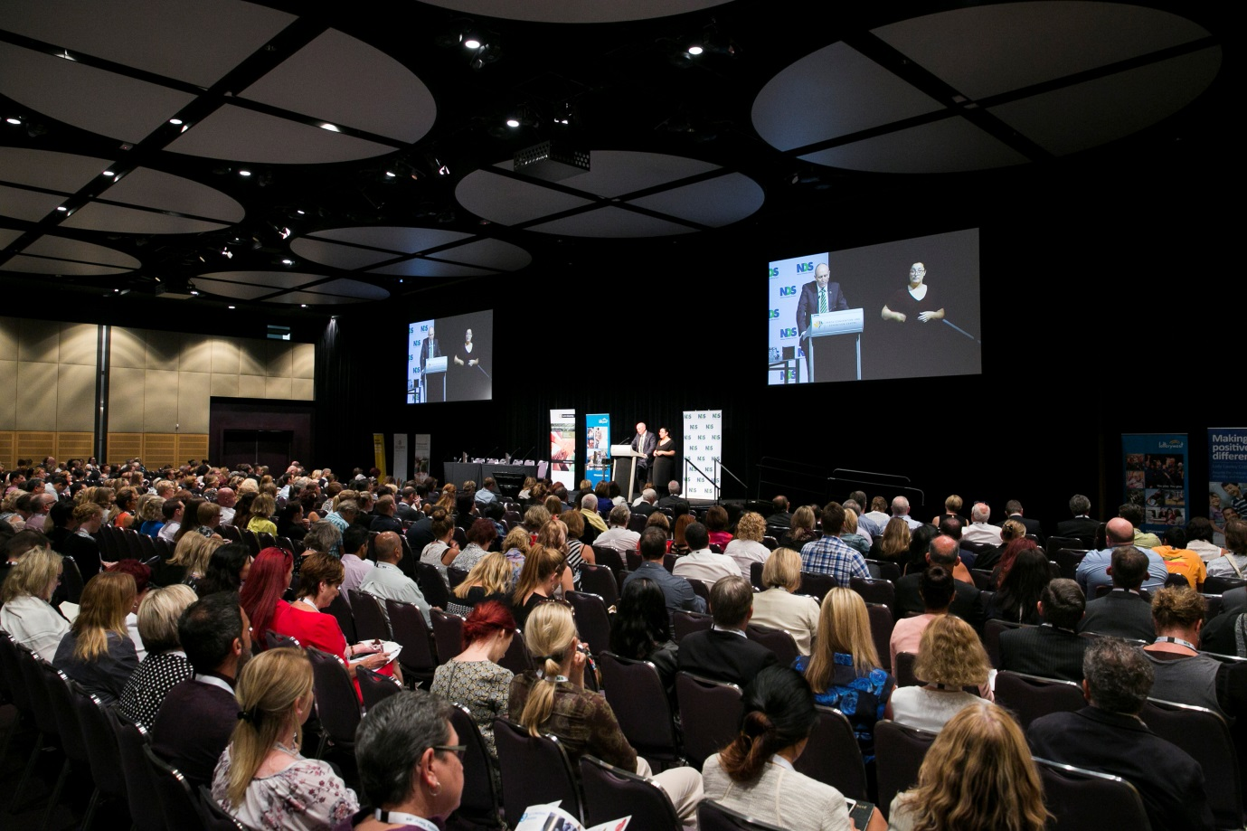
Photo caption: 2016 NDS WA Conference

Access and Inclusion
The Access and Inclusion services provided by NDS WA deliver the Community Living Participation Grants, Companion Card, support for the Changing Places Network and ACROD Parking. These services provide both an extensive information source and direct connection with over 77,000 people with disability in WA.

Supporting Inclusion
This year NDS WA has:
- Acquitted $500,000 of small grants through the Community Living and Participation Grants program to support people with disability and local community groups;
- Supported over 12,000 people with disability through the Companion Card program; and Issued 45,000 new and renewed Australian Disability Parking Permits, bringing the total to 77,200 WA permits in circulation.
The Companion Card program celebrates ten years of operation in 2016, and planning is underway to showcase the benefits and achievements of the program since its inception. In addition to the annual cardholder newsletter Your Companion and Facebook page, Companion Card WA now offers cardholders a quarterly e-newsletter.
Analysis of the latest e-newsletter indicates that over 50 percent of recipients opened the e-newsletter and various links to events and information were well utilised. Work has commenced on development of the new database and website that will provide NDS WA with improved data analysis capacities, offering cardholder’s more up-to-date information regarding affiliated businesses and organisations, including a Google maps function.
A review of infrastructure for the ACROD Parking Program has identified technology upgrade requirements and the following is planned for 2016-17:
- Update application forms to be compatible with the two main GP software packages (Best Practise and Medical Director);
- Investment in a new database;
- Investment in an upgraded/new website; and
- Online applications to be available through the new website interfacing with the new database and GP software packages.

Changing Places
In partnership with State and Local Governments, NDS WA facilitated the development of the Changing Places Network, a series of secure specialised facilities for people with disability who need space and assistance to use the bathroom when out in the community. State Government investment in a Changing Places Network had been a NDS WA PBS recommendation for the past four years.
During 2015, NDS WA facilitated a community consultation regarding the initiative which reached over 75,000 people, and has an ongoing advisory role in the development of this network throughout the State as 28 facilities are built over the next two years.

Lunch in celebration of International Day of People with Disability
Almost 500 people attended the sold-out NDS WA Lunch in celebration of International Day of People with Disability on 3 December 2015 at Crown Perth. Previously a Breakfast, NDS WA changed the timing of this event to make it more inclusive and accessible.
The theme of the Lunch was Inclusion Matters: access and empowerment for people of all abilities. This was linked to the overarching United Nations theme and the State Government’s Count Me In vision that all people live in welcoming communities that facilitate citizenship, friendship, mutual support and a fair go for everyone.
As its major focus, the Lunch showcased and celebrated the abilities and achievements of West Australians with disability. Key highlights included: Ben Cox as emcee alongside Geraldine Mellet; Greg Barr playing the didgeridoo as part of the Welcome to Country by Shaun Nannup and a fun fashion parade showcasing Daniel Pavlovic’s unique t-shirt designs.
Sponsorship was provided by Ability Centre, DSC, Life Without Barriers, Nulsen, RAC and Senses Australia. In addition, Lotterywest supported 150 people with disability and their companions to attend the event.
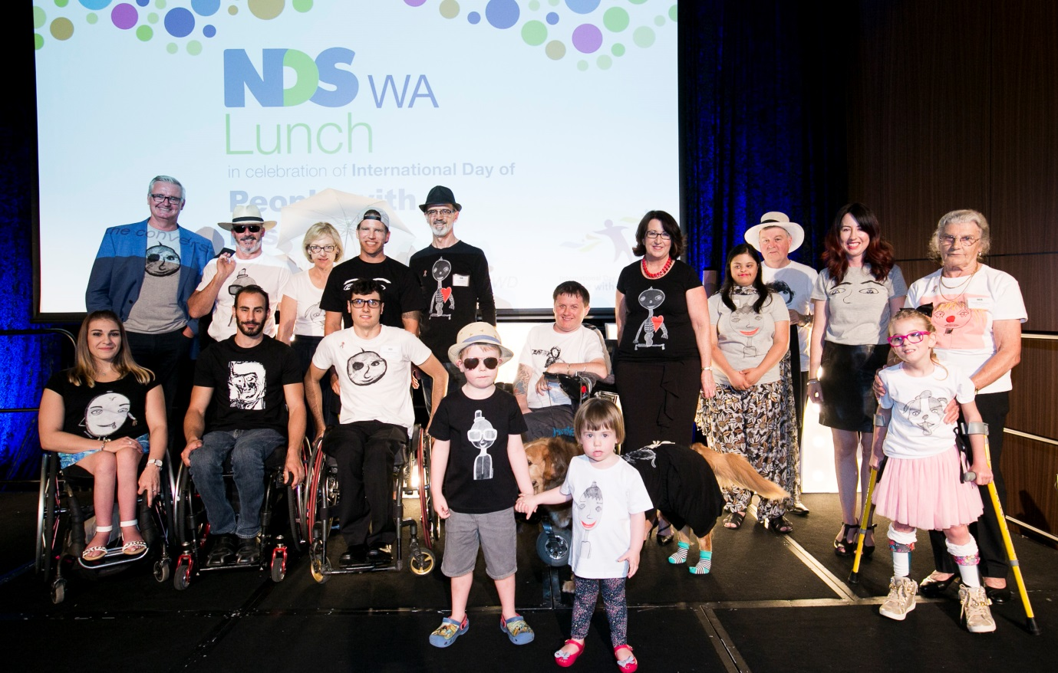
Daniel (Ink.) models after their debut at the NDS WA Lunch in Celebration of International Day of People with Disability. Back row (L-R): Tim Gossage, Gordon Trewern, Debbie Karasinski, Brant Garvey, Ivan Pavlovic, Peter Darch and Phoebe the dog, Julie Waylen, Shanthi Fielding, Dr Ron Chalmers, Melissa Kent, Tonka Pavlovic. Front row (L-R): Sarah Vinci, Andrew Liddawi, Daniel Pavlovic, Leo Butler, Annabel Butler, Emily Prior.

2015-16 NDS WA State Committee Members
- Debbie Karasinski (Chairperson) Senses Australia
- Joan McKenna Kerr (Deputy Chairperson) Autism Association of WA
- Gordon Trewern (Deputy Chairperson) Nulsen Disability Services
- Fiona Beermier Intework Inc.
- Justine Colyer Rise Network
- Marcus Stafford MS Society
- Marina Re Identitywa
- Matt Burrows Therapy Focus
- Michael Tait Rocky Bay
- Rob Holmes Enable Southwest
- Sue Ash UnitingCare West
- Tony Vis (Chairperson – retired March 2016) Activ
2015-16 Chairs of NDS WA Sub-committees
- Michelle Crook Access and Inclusion
- Janet Wagland Accommodation and Housing
- Kelly Gurr Clinical and Allied Health
- Chris O’Brien Employment
- Rob Gotti Finance and Sustainability
- Phil Simich Workforce
NDS WA Staff
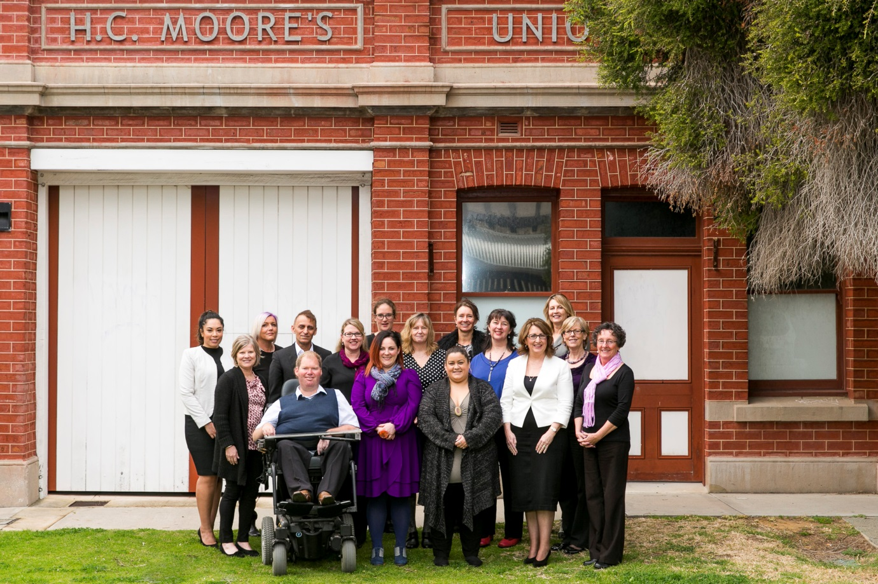
Left to right: Jess Fuimaono, Jill Bailey, Jacqueline Vernon, Jim Vanoploulos, Jeremy Barrett-Lennard, Sandra Banicek, Sarah Morrison, Anne-Marie Rich, Shona Campbell-Brown, Sian Evripidou, Jane Cousins, Alison Wood, Julie Waylen, Frances Buchanan, Jacqui Sim and Lynelle Sanders.
Absent:
Bronwyn Harmsen, Colin Archibald, Cora-Lee Godden, David Rogers, Frances Thomas, Gabriela Di Perna, Gaelen Williams, Helen Moorhead, Jackie Breasley, Jenny Gleeson, Linley Jones, Matthew Mostyn, Melissa Kent, Merissa Van Der Linden, Natalie Forrest, Peter Darch, Rebekah Millar.

