Risk Incidents and Complaints Management

Risk Management Policy Checklist – Certification
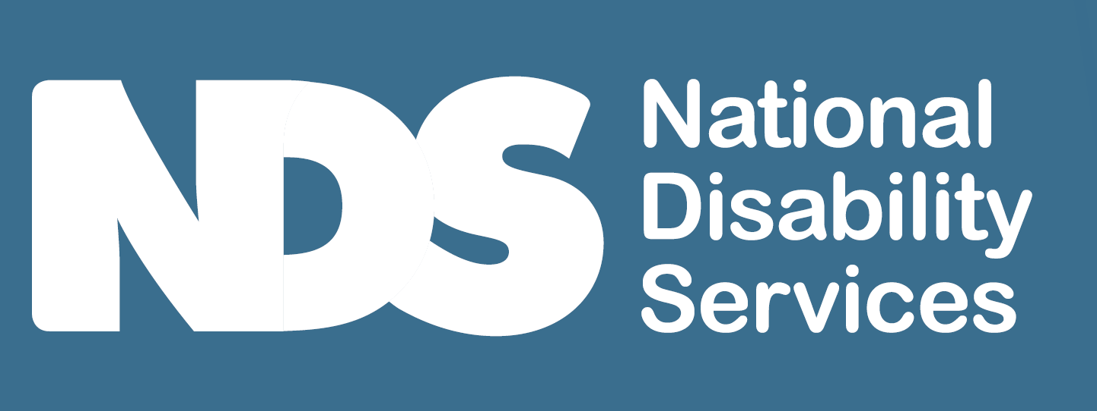
[Decorative images omitted]

Instructions
Certification is for all providers delivering higher risk, more complex service and support.
This checklist is designed for services that require certification, to understand the elements of a risk management policy that meets NDIS Commission requirements. It can be used to check against what you may already have and be adapted and customised to suit your circumstances.
Tick when your policy includes the following elements.
[Decorative images omitted]

Risk Management Policy Checklist – Certification
Tick when your policy includes these elements.

Definition of Risk and Risk Management
- You identify risk as an event or circumstance that may have a negative effect on your organisation and/or operations (for example, the risk of COVID-19 infections spreading due to poor infection control procedures).
- Risk management is about what you do to ensure you understand the risks your organisation faces and then make informed decisions about how to manage these to minimise/avoid their impact. It involves a process of identifying, assessing, and judging risks, assigning responsibilities, and taking action to mitigate (reduce) or anticipate them and then monitoring and reviewing progress. It seeks to identify potential problem areas before they occur and creates a safer environment.

Approach to Risk Management
- You use a risk management plan to minimise foreseeable injury and harm to individuals, disruption to your operations including plans to source and induct a workforce in the event that a workforce disruption occurs as a result of emergency or disaster and damage to the environment and property that fits the needs of your organisation.
- You foster a culture that supports good risk management; that includes a focus on participant safety and outcomes, clear understanding of behaviour expectations, staff and participants trust each other, staff and participants are encouraged to share concerns or ideas.
- Incidents, hazards, and complaints are seen as opportunities to learn and improve/innovate and contribute to risk identification.
- You train and communicate with staff to implement risk management effectively.
- You strive to continually improve your risk management practices.
- Your risk management system is documented and leads risk management practice, which may include policy and procedures, risk management plan, compliance register, risk register, risk assessments and a risk analysis matrix.
- You ensure all insurance requirements that apply to your risk management, including professional indemnity, public liability and accident insurance are up to date.
- You adopt good risk management to:
  - reduce the likelihood and/or consequences of potential adverse events
  - maximise the results of positive events
  - provide decision makers with information to assess risks in your business operations
  - ensure that the application of risk management practices adds value to your organisation
  - ensure that your organisation implements strategies that are cost effective.
All of this means that the organisation will increase the likelihood of success in its business operations.
- Your risk management system includes operational management, financial management, information management and governance, WHS and emergency and disaster management and where relevant, measures for prevention and control of infection and outbreaks.
- Participants are informed of your arrangements in relation to risk management (for example, via Service Agreement).

Allocation responsibility
- You determine responsibility for implementing the risk management processes; risk assessment, management, monitoring and reporting. This may be kept in a risk management plan. You also ensure the responsibility for ensuring risk management procedures below are delegated.
- All staff are responsible for maintaining an awareness of potential risks in their area of responsibility. They are also responsible for notifying a manager of any potential or actual risk.
- Your key personnel are responsible for managing risks in their area.
- Staff with specific capabilities are identified to assist in responding to emergencies or disasters (for example, contingency planning and infection control).
- You have a documented plan that explain the steps you take to minimise and deal with actual and potential risks.
- Maintenance of a annual compliance plan (by which an organisation will conform to specific regulations to achieve and maintain compliance) is designated.
- Workers with capabilities that are relevant to assisting in the response to an emergency or disaster such as contingency planning or infection prevention or control are identified.
End of document

