Risk Incidents and Complaints Management – What good complaint management looks like?
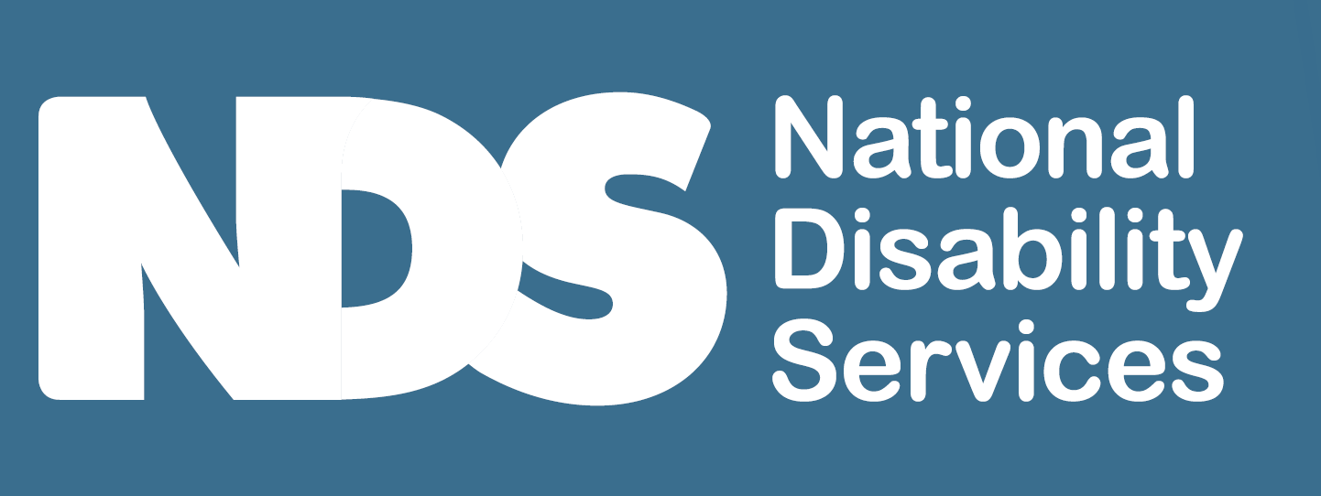
[Decorative image omitted]

Instructions
Complaint management is important for any sized service to respond to and
prevent future complaints, safeguard participants and continually improve.
Very small services don’t need complex systems to achieve good complaint
management.
This infographic can assist you to identify what needs improvement in the way you
manage incidents and can be displayed as a prompt and reminder to staff and
encourage good practice.
[Decorative image omitted]

What good complaint management looks like?
- You welcome and encourage complaints and view them as an opportunity to improve
- Actively promote the rights of people with disability
- You consult with participants and staff when developing your complaints management system
- You train staff in your approach to managing complaints
- You encourage a speaking up culture and address any barriers
- You ensure participants know how to and are supported to access an advocate
- You have a way to record and manage complaints
- You identify the person responsible for investigating complaints
- You involve participants at every step during the investigation of complaints and determining actions and outcomes
- You respond to complainants based on findings of the investigation
- You learn from complaints and make necessary changes to systems and the way you work for improvement
- You check the effectiveness of your complaints process and adjust to improve its use
[Decorative images omitted]
End of document.

