Standard 6 (Easy Read) template

Making services better

This information is written in an easy to read way.
We use pictures to explain some ideas.

Some words are written in bold. We explain what these words mean.

You can ask for help to read this information.

A family member, friend, or support person may be able to help you.

Let us know if you need us to help you.

This Easy Read information is a shorter version of another document.

You can ask us for a copy of the longer document.

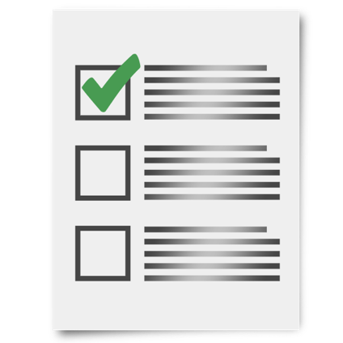

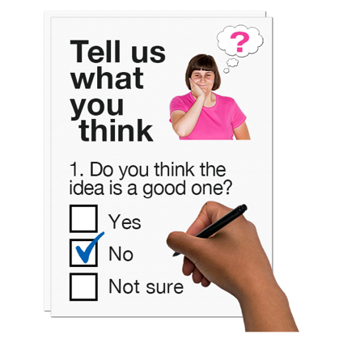

This document is about continuous improvement.

Continuous improvement means we want ideas on how to make our services better and we try to learn from our mistakes.

We ask people who use our services and also our staff for their ideas on how we can make our services better. We do this in different ways.

We might talk to you about things we could do to make our services better.

We might ask you questions about your experience and what you think in a survey.

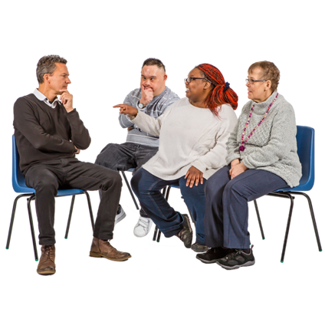

We might ask you ‘how can we make our services easier to use?’

We might invite you to be in a group to talk about things we could improve.

If you decide to leave and go to another disability organisation, we might ask why you are leaving and what could be done better.

We also ask any staff that leave us.

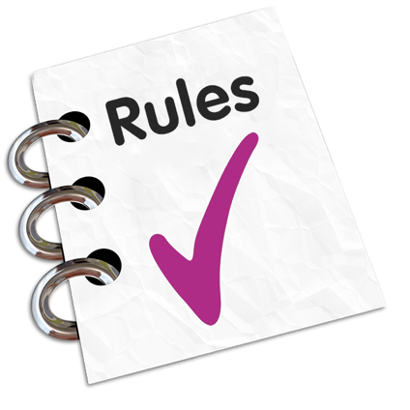

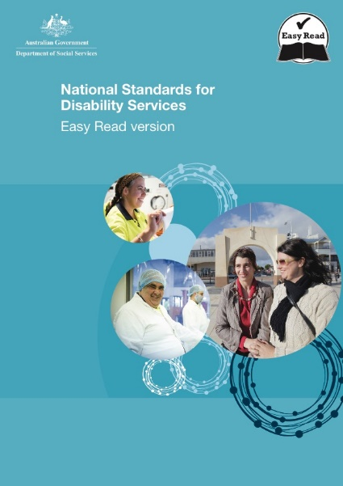

Sometimes, experts come to check up on our services. This is called an evaluation.

An evaluation is a kind of test to see if we are meeting service standards.

Service standards are rules made by the government to protect your rights, make sure you are included, can access services, that services are run well and you know how to complain when things go wrong.

All disability organisations must follow the service standards.

Please ask a staff person for a copy of the standards if you would like more information on the service standards. You can get the service standards in Easy Read.

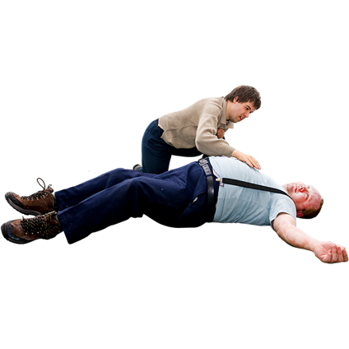

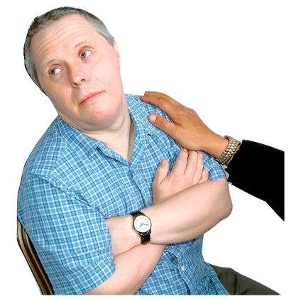

If there is an accident or other serious problem, we look into it.

We will find out how we can stop the same problem happening again.

Please let us know at any time if you have any ideas on how we can support you better.

Please contact [insert name, position and contact details] to tell us your ideas.

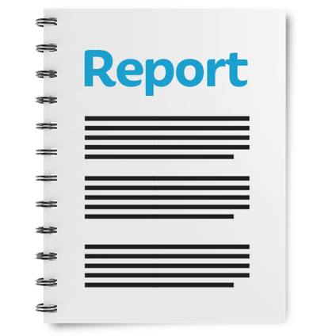

Our managers write a report every year on what we have done to improve services.

That report goes to our Board.

The Board is a committee of people in charge of making sure the organisation does everything the right way.

The Board makes sure we keep trying to make our services better all the time.

