Standard 6 (Easy Read) template

Code of conduct

This information is written in an easy to read way.
We use pictures to explain some ideas.

Some words are written in bold. We explain what these words mean.

You can ask for help to read this information.

A family member, friend or support person may be able to help you.

This Easy Read information is a shorter version of another document.
You can ask us for a copy of the longer document.

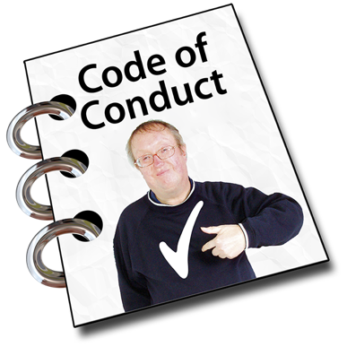

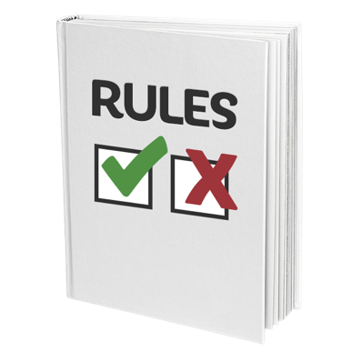

This information is about our code of conduct.

The code of conduct is the set of rules that tell our staff how they must act and behave at work.

The code of conduct tells our staff what is ok and what is not ok.

The code of conduct helps us provide good services that keep everyone safe.

Our code says
- staff must do their job well
- staff must be fair and respect you
- staff are not allowed to hurt you or make you feel bad
- staff must follow your plan
- staff must only do jobs they know how to do
- staff must tell the truth and follow the law
- staff must not take your money or things for themselves

We teach all our staff about the code of conduct. If we do not teach staff properly, we can get in trouble.

If staff do not stick to the code of conduct they can be told off, or moved to a different job.

If staff break the rules, staff might have to stop their job.

You can complain if we do not follow the rules or staff do not follow the rules.

Please contact [insert name, position and contact details] if you want to make a complaint about a staff person.

