Risk Matrix and Risk Register Template

Introduction

Risk assessment and risk management are requirements of the WA Quality System which will apply in Western Australia until July 2020, when the national Quality and Safeguarding Framework will come into effect in WA. The national system also requires [Organisations] to identify and mitigate risks.

This template has been developed in support of sole traders seeking to assess and mitigate risk and evidence the application of National Standards for Disability Services Standard 6 in their business. This risk template may be a useful starting point for small to medium [Organisations] with more than one employee.

The template consists of two Excel worksheets. Part A is a Risk Matrix which could be used to identify and record risks related to the sole providers knowledge, experience, processes and practice. You can insert additional rows if there is more than one risk in any particular area. There is more information about the headings which is visible when you roll over the heading with your mouse. You can see all descriptions by clicking the ‘show all comments’ button in the ‘Review’ tab. You can adapt the headings to suit your business. Where drop down menus have been included, they can be easily adapted to suit your [Organisation] by editing the relevant list in the ‘Data Set’ worksheet.

Part B is a Risk Register which could be used to document anticipated risks. It can also then be used to document the actions you have taken to
- remove a risk,
- reduce the likelihood of a risk occurring, or
- reduce the impact of a risk.
Mitigation strategies should be recorded for all risks. You can insert additional rows if there is more than one risk in any particular area. Risks that are most likely to occur and /or have serious consequences require urgent attention.
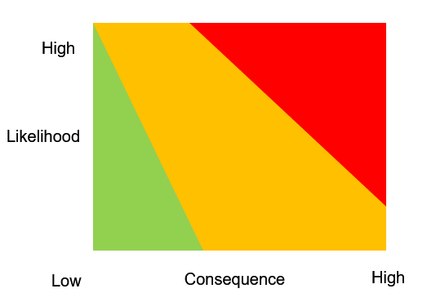
Part A - Risk Matrix Template

Use the following four steps to complete the Risk Matrix Template worksheet.

Step 1: Describe the risk to your business in your own words.

Step 2: Use the drop-menu to answer the next three questions about your business capability and capacity.
- Do you have personal competency in this area?
- Do you have documented processes on how you have undertaken particular activities?
- Do you have evidence of good practice in the way you undertake your business?

Step 3: In the next column use the drop-down menu, select how likely it is that a risk might become a reality.

Step 4: In the last step, identify the potential consequences/level of harm for any risks.

Part A - Risk Matrix Template
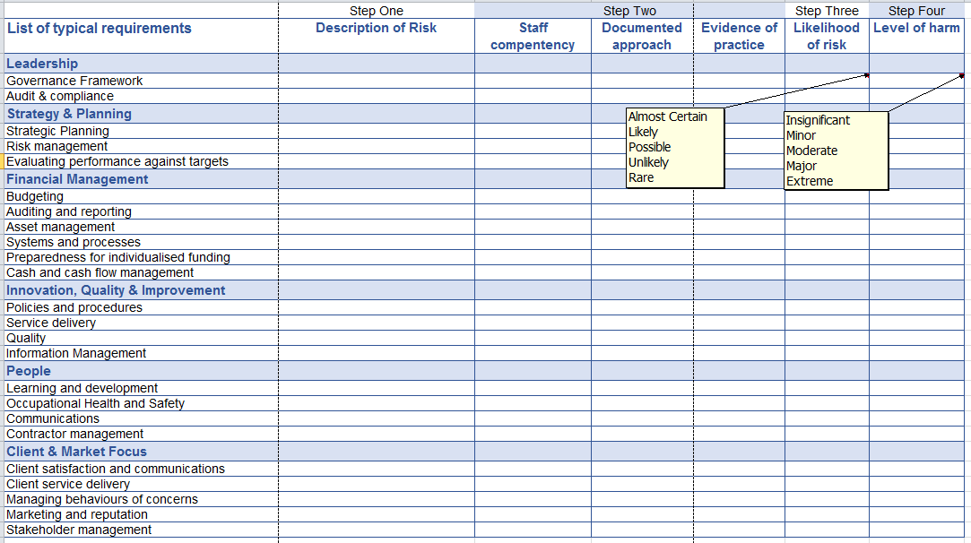

Part B - Risk Register Template
The Risk Register Template is a worksheet that is provided for [Organisations] to record their risks and their plans to mitigate identified risks.

Step 1: Using the information from the Risk Matrix to describe each risk. You can insert additional rows if there is more than one risk in any particular area.

Step 2: Using the drop-down menu to identify the cause of each risk. You can also enter your own description.

Step 3: Think about ways you can prevent the risk from occurring, or ensure the risk is less likely to occur. Enter the information in the column ‘Actions to reduce risk.’

Step 4: Think about ways you might respond if a risk was to occur. This might include risk of harm to yourself, your customer, visitors, your premises or your business. What action is needed to reduce the severity of the consequences or harm associate with the risk?

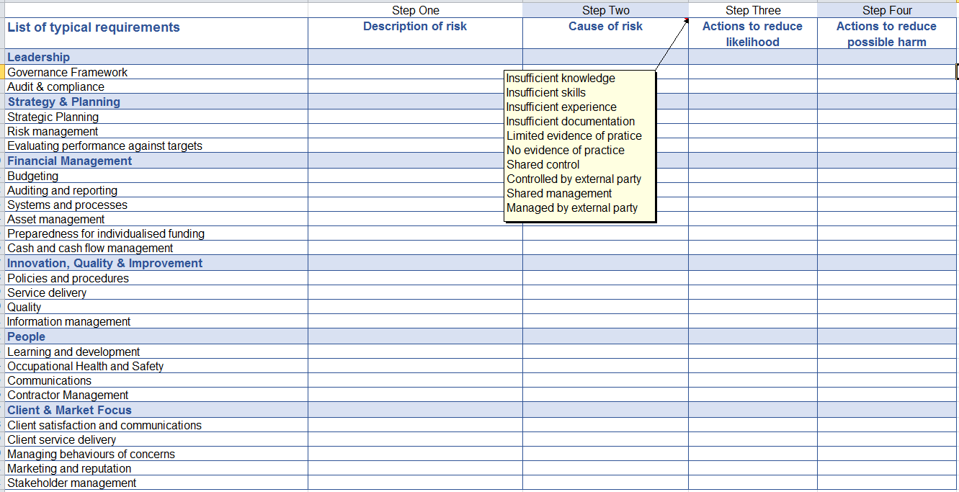

Disclaimer

The tool is intended for general use only and doesn’t consider the needs or circumstances of individual providers or their business. This document does not constitute legal advice and NDS cannot be held responsible and extends no warranties as to the suitability of the information in this document for any particular purpose and for actions taken by third parties.

References

Risk Management and Controls Model for Disability Services, National Disability Services, Department of Human Services, Victorian Managed Insurance Agency 2010, 2011 (accessed 18 September 2018).

Registered provider responsibilities, NDIS Commission website accessed online 18 September 2018.

Quality System: Quality Evaluation. Types of Evidence and sample questions for service providers. Department of Communities- Disability Services Version 2.1 May 2017.

Six Simple Steps to Standard 6: Service Management compliance. Disability Services Provider Panel - Request for Registration DSC0702016. Department of Communities- Disability Services 2016.

