Action Learning Network -
Individual project reports
June 2018

  - Acknowledgements
Funded by the Australian Government Department of Social Services 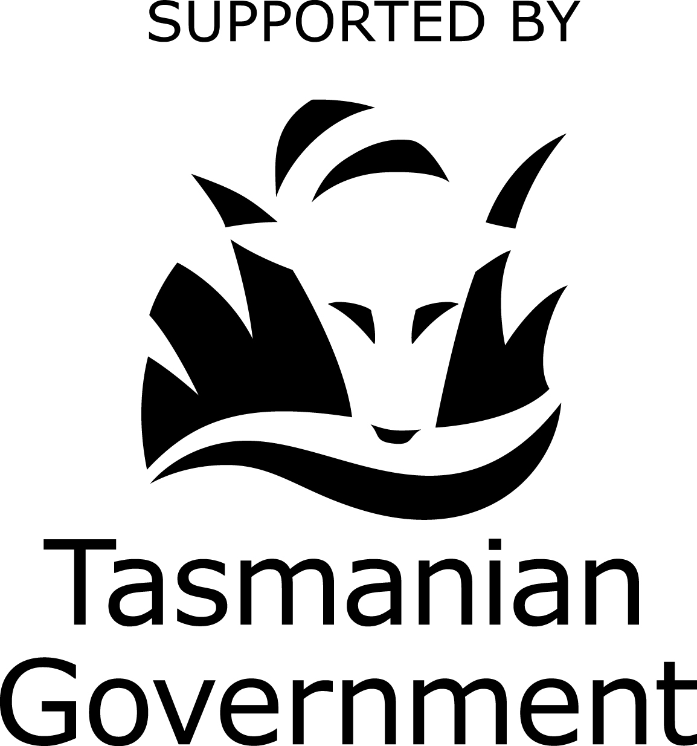
The Tasmanian Disability Action Learning Network:
- Anya Carnell, Dean Pitt, Margaret Lockley – Langford Support Services
- Lisa Sheppard, Ange Evans, Roz Loveless – Montagu Community Living
- Lynette Deacon, Mark Anderson, Jarrod Lorring – Multicap Tasmania
- Stephanie Van Brecht, Sharlene Knight – Eskleigh Foundation
- Angelique Halloran – The Parkside Foundation
- Donna Coetzee – St Vincent Industries
- Cath Ralston – NDS
You can find more information about this project at the NDS Person-centred, Outcomes-focused Project Design (POPD) webpage.
URL: https://www.nds.org.au/resources/person-centred-outcomes-focused-project-design
  - Contact
Caroline Alcorso
National Manager (Workforce Development)
Phone: 02 9256 3180
Email: caroline.alcorso@nds.org.au
  - About National Disability Services
National Disability Services is the peak body for nongovernment disability services. Its purpose is to promote quality service provision and life opportunities for people with disability. NDS’s Australia-wide membership includes more than 1050 non-government organisations, which support people with all forms of disability. NDS provides information and networking opportunities to its members and policy advice to state, territory and federal governments

Table of Contents

Introduction 1
St Vincent Industries 2
Multicap Gardening Group 5
Multicap Outdoor Water-based activities 8
Montagu Community Living 10
Langford 12

Introduction
In September 2017, with funding from Tasmanian Department of Health and Human Services through the Sector Development Fund, National Disability Services convened a group of staff from disability service Providers to form the Action Learning Network (ALN).
The Network attracted people interested in implementing contemporary approaches to disability service delivery and committed to strengthening the quality of service delivery in their workplace and the sector more broadly. An action learning approach was used to find out more about co-design and measuring outcomes.
Each Provider involved in the ALN designed and implemented a project to solve a workplace problem. Most of the projects were not completed within the life of the broader ALN project, but were continuing to unfold.
This document compiles the project reports generated to reflect progress on these projects as part of the network activities. A part of this was a focus on the use of Plain English. There were another two projects started as part of the Action Learning Network, however the reports for these were not completed by the end of the project.
The group further developed a framework for person-centred, outcomes-focused project design. This is available for download along with this document from the NDS Person-centred, Outcomes-focused Project Design (POPD) webpage.
ALN members are keen to continue to work together using an action learning approach subsequent to the end of the funded project. Information about how to become involved is available on the webpage.

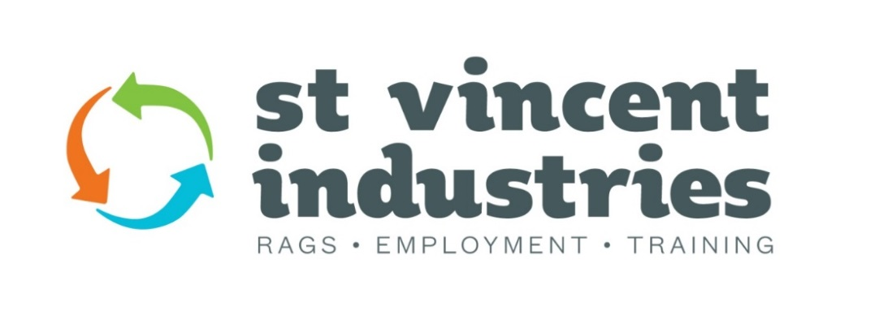

St Vincent Industries

Background
St Vincent Industries (SVi) is currently evaluating ways to increase awareness to all stakeholders of the value of working in supported employment for people with disability.
Since the rollout of the National Disability Insurance Scheme (NDIS) SVi and at least two other Disability Enterprises have not had any referrals from the agency and current NDIS participants have advised us that it is quite a lengthy process to get supported employment onto their NDIS plans. It is the intention of this project to ensure that SVi informs stakeholders about the value of supported employment prior to the participants’ planning meetings.

The problem and design question
The main problem SVi encountered was how to quantify the value of supported employment to supported employees from the perspective of supported employees, their families and/or support people. The first challenge was to ensure that what the organisation (SVi) valued was aligned with what the supported employees, their families and/or support people value. The strategic goal for this project was for SVi to demonstrate the value of supported employment to people with disability and the design question became, “What do we value about the work that St Vincent Industries does, how do we measure it and how do we share it with the people who need to know what we do?”

The response
The first step taken was to develop a “4+1 questionnaire”. This was circulated to all supported employees, staff, family members and/or support people and the SVi Committee of Management (COM). This questionnaire was designed to encourage all stakeholders the opportunity to share the following information with us:
- what do people value about SVi in all areas: work, training, social and life skills,
- what goals (work, training and social) does SVi support people to achieve,
- how do they see SVi supporting people to achieve these goals,
- how they would like us to gather and share this information, and
- what additional services would people like to see SVi offer.
Several focus sessions were held with the supported employees to make sure everyone had the opportunity to contribute. These sessions were facilitated by the SVi Training Coordinator and provided a comfortable, familiar environment for the employees to share their thoughts.
A focus session was held with the parents and support people, the SVi staff, and a COM representative. This session was extremely well attended. This session was directed towards measuring outcomes for SVi. It was facilitated by an experienced trainer in this area.
An information session for several Baptcare Local Area Coordinators was held at SVi to discuss what supported employment in 2018 is, and what SVi offers to their employees.

Outcomes
Through this process, SVi has confirmed that the current strategic direction it is taking is highly valued by the supported employees, their families and/or support people as well as the current staff members.
The development of improved feedback mechanisms will ensure the currency and accuracy of information shared with all stakeholders.
The development of an SVi Wordle provides a visual display of what the SVi community values about the work and training achieved at SVi.

Reflection
The most effective means of attracting potential employees to SVi is direct contact through the schools, colleges, other organisations aligned with disability support and positive word of mouth.
Networking directly with other Disability organisations adds value to the sharing of information for all people who may choose to work at SVi.

Recommendations
SVi continues their excellent work and training programs.
Face to face meetings with potential employees has proven to be the best promotion of the SVi workplace and a continued presence at schools and colleges including attendance at Beyond the School Gate sessions and the Gearing Up Expos is essential.
Continuation and expansion of work experience opportunities and workplace trials.
SVi continues to develop networks to ensure information is readily available to all potential supported employees and their families and/or support organisations.
To further develop SVi’s printed information packages, more regular posts on the SVi Facebook account and an increase of employee stories and activities on the SVi website. SVi actively seeks opportunities to distribute information about our workplace into the community.
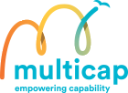

Multicap Gardening Group

Background
Multicap Tasmania has provided services for people with a disability since 1971. We have extended from the Burnie region to Launceston and most recently the Devonport area. We provide a number of services including:
- Respite and emergency stays,
- Residential services, and
- Community tenancy support, where people live with minimal support provided as required.
Multicap also provides day service programs and community access services. People using these services have the opportunity to build their skills in a learning environment. Staff use active support to enable people to choose and participate activities that interest them.
Multicap recognises the need to re-shape some of our services to strengthen the way we support people with NDIS plans. To do this we are committed to listening to what the people we support want and making their choices possible.
The NDS Action Learning Network presented an opportunity to join with a number of disability organisations from across the state to exchange, support and challenge each other in action and learning. We chose our own organisational challenge/opportunity and committed ourselves to act and help each other through the problems, creating options and learning from the experience of taking action.

The problem and design question
When questioned, a number of the people supported by Multicap voiced that they wanted a “proper paid job”. We realised that these people needed to develop their job readiness skills to achieve their goal.
We identified the problem we wanted to look at as “people are not job ready and they want employment”. Multicap also recognised a valuable resource in our garden facility in Burnie, which might be useful in addressing this problem. To help us identify appropriate activities we asked ourselves:
“How might we develop a horticultural program so that people can develop workplace skills to enter the workplace?”

The response
We identified the activities we needed as part of a project logic statement. The core activities can be grouped in the following way:
- Infrastructure – we needed to maintain and repair some existing infrastructure, and expand the number of beds in the facility.
- Operations – we needed to develop a budget and apply for additional funding to support the activities available at the garden. Additionally we needed to develop safe operating procedures for the use of machinery and equipment.
- Skills development for staff - we needed to develop the horticultural skills of staff as well as their understanding of job readiness skills.
- Ongoing activity of staff and group members – we need to continually work with individuals to strengthen their individual plans. We also need to align the activities in the garden to support progress toward meeting these goals. Staff and group members will carry out activities in the garden on a weekly basis.
We also identified the outcomes the project targeted, and developed a framework to evaluate these. This entailed looking at outcomes for NDIS participants, Multicap employees, the organisation and the broader Burnie community.

Outcomes
The expected outcomes from this project are:
- Gardening Group member’s value being part of the Group.
- Gardening Group members have skills and knowledge in gardening and job readiness.
- Gardening Group members who have employment goals are working.
- Staff have strong skills to support engagement with Gardening Group members.
- Multicap recognises the Gardening Group as a viable and valuable arm of the enterprise.
- Other organisations participate in Multicap community garden. This may include, but is not limited to TasTAFE farm, Burnie Community House/farm and Produce to the People.

Reflection
We need to continue to take into consideration what goals participants are wishing to work towards. By identifying their goals (which may continually change), our activities should then be based around supporting these goals. A balance of a person centred learning environment as well as one that has an opportunity for leisure based activities should be made available. By having an outcome focused approach we may then be able to measure what is and isn’t working for the best interests of our participants.
Open communication within any organisation is a major component to their success. We all need to feel valuable and that our opinion is valued. CEOs cannot be expected to ensure effective, efficient and appropriate management of an organisation if not kept up to date with the working environment they oversee. We are all accountable for the impact our services will have on current and future NDIS participants.
When we ask the people we support open ended questions about they want, it stops us closing the door on opportunity. If we had asked “do you want a job?” I anticipate that the majority would have replied “no”. However by asking “If you could have a job what would that be?” we have opened up an endless opportunity.
Talking to other members of the ALN group shows us that all disability organisations experience the same problems. By sharing a problem, that problem may well then be halved. When more than one person has experienced the same problem, we can then get ideas of how best to solve that problem.

Recommendations
- Continue to roll-out the planned activities of the project (see project logic statement attached).
- The Gardening Group program needs to be evaluated as per the evaluation plan (attached). There is still some work to do to prepare the measurement tools for this.
- Update the activity plan on the basis of the evaluation findings

Multicap Outdoor Water-based activities

Background
Multicap Tasmania is a not-for-profit organisation that started in 1971. We provide a variety of services for people living with disability. The services include community tenancy support, respite, residential and day services on the North West Coast and Launceston.
I am employed as a Support Worker at day services where participate in activities like bike riding, walking, gardening, woodwork, art and craft, ten pin bowling and other community access activities.
In Burnie, on the North West coast of Tasmania, water sports are a popular pastime. My life skills include being a current surf Lifesaver with training and assessing, patrolling and ski paddling skills. Due to the popularity of sit on top kayaks, I felt there may be interest from the people I support to use this equipment.
The opportunity to be supported to use a design approach to developing and running the program came about in September 2017 as part of the Action Learning Network.

The problem and design question
I thought that it would be good for people with disability to have the opportunity to also participate in their community through water-based activities. This was in keeping with Multicap being keen to introduce new activities for NDIS participants.
The problem I identified was that people with disability do not have sufficient community engagement through water activities.
This translated to my design question, which was, “How might we offer community-based water activities for people with disability?

The response
Part of the action learning network training was to brainstorm with my ALN workgroup to get all the parts of the activity outlined. Then develop a plan to enable the program to be used in the workplace.
Consultation with prospective participants uncovered some problems such as: a fear of sharks in one person (made okay by explaining the very low incidence of attacks in Tasmania), and getting a lifejacket to fit a bigger person. There were also some nice surprises, such as finding out that one person already regularly paddles.
My management was happy to allow me to develop this program. After research of costs of equipment I purchased kayaks, paddles, lifejackets and necessary other items.
The safety aspect has taken a lot of planning. The activity requires one worker with one participant until a certain capability level is reached. We have also identified some other safety strategies such as: remaining in water up to waist level as a maximum, practice in a swimming pool, using a tow rope, and using a double kayak. A safety checklist is also being developed with input by the program participants.
The plan is that over time, participants will learn to paddle while sitting on top of kayaks in a capable and safe manner according to their capabilities. Paddlers will also have the chance to learn to:
- Be aware of weather and tide conditions
- Load and unload equipment using correct lifting procedures, such as two man lifts
- Recognise safety problems like waves and currents
- Wear safety equipment
- Sit safely on and get off craft
- Cope and recover when things go wrong by practicing in safe areas

Outcomes
We have ascertained that the project has the support of the workplace, other workers and some people using Multicap’s services.
During the winter months, when it is too cold to be on the water, people are practicing their dry land skills. Also, Marine and Safety Tasmania has agreed to run a course at the local swimming pool on the use of lifejackets with a small boat. We hope to have a practice with the kayaks as well.
The outdoor water-based program will start again in October

Reflection
I underestimated the amount of time to plan and use co design skills. I feel the ALN program has been of great benefit to me.

Recommendations
I recommend that Multicap continue to support the implementation of this program. During winter we can get participants to learn dry land skills such as safe lifting, tide and weather forecasts, loading and tying on craft and to become familiar with a paddling checklist.

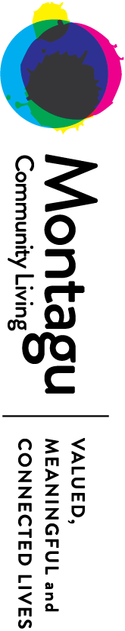

Montagu Community Living

Background
Montagu Community Living (Montagu) is a community based, not-for-profit organisation established in 1990, we specialise in the provision of support for people with a disability. We exist to provide quality services so that people can live a valued and meaningful life and remain connected to their chosen community.
In September 2017-National Disability Services invited organisations to be a part of an extended learning group-Action Learning Network (ALN).
ALN provided us with the knowledge and skills to work on a project; to work collaboratively using the co-design principles with service users, staff and other interested parties. Unlike traditional “project management” techniques this has pushed our boundaries to think differently. We recognised that we weren’t involving service users in the recruitment process, and we needed to make changes to this.

The problem and design question
Montagu prides itself on providing a quality service, and valuing the input and feedback from service users, family, friends, staff and other stakeholders. We had been considering involving service users in the recruitment process.
As such, we recognised our problem as “Montagu’s service users are not involved in our recruitment process”. From this we identified our design question as: How might we involve service users to recruit to maintain a stable workforce?
This needed to be:
- Non-tokenistic
- Have value and meaning for all involved stakeholders
- Empowering for everyone Involved (service users, staff, prospective staff, etc)
- Educational and Inclusive for all

The response
Our plan was rather simple:
Service User Engagement | Employee Engagement
All service users to be invited to participate in a co-design workshop to look at how they can be meaningfully participate in recruiting Montagu staff | All employees to be invited to participate in a survey and a design workshop to look at how service users can meaningfully participate in recruiting Montagu staff
- Seek involvement of an advocacy organisation to plan the running of co-design workshop  - Send a letter to everyone Montagu supports inviting feedback and participation  - Coordinate and run the co-design workshop | - Develop a survey for all staff to contribute ideas  - Invite employees to complete survey and participate in a staff design workshop  - Analyse survey responses  - Coordinate and run the staff design workshops

The new recruitment process will be designed around the feedback from the co-design workshops with the people we support and existing employees. We recognise that we will need to update internal policies, procedures and other documentation as required.
Due to organisational constraints our project was placed on hold in late November.

Outcomes
Due to operational requirements within Montagu, our project has been put on hold until the first week in September. This ensures that we will be able to dedicate the project the allocated time it requires. Once we recommence the process, we will be meeting fortnightly to ensure traction of our schedule.

Reflection
The main benefits we experienced from participating in the Action Learning Network were associated with networking with other services. We value the opportunity to have met staff from other organisations, and to learn more about the work they do.
We were pleasantly surprised to find that Montagu are already using co-design concepts for some of our processes.

Recommendations
Moving forward with our Project, it will be important that we:
- Adhere to our meeting and outcome times, as per our project schedule
- Develop an evaluation plan.

Langford

Background
In 2016 Langford started on a journey towards a new organisational structure based on self-managing teams. This new direction was a response to the greater individual focus of the National Disability Insurance Scheme (NDIS) and associated business pressures. It was developed with the advice of influential staff and external consultants. The willingness to try new things has resulted in remarkable success in other aspects of the organisation. As a result, Langford has a reputation for thinking outside the box and taking the lead.
Langford was changing to be more person-centred and designed a structure to match this. The organisation would no longer have a traditional Management team, but would operate within a Coaching model. Support teams would have a Coach to support them to work with participants to design and deliver their support services.
Langford conducted numerous forums and consultations to ensure a smooth transition. Important steps during 2017 were:
- The re-design of Langford’s team purpose and values,
- Several well received readiness training sessions on topics such as team work, values-based support and the NDIS, and
- New values were developed in a positive process.
However, it was recognised that the new change and direction was inadvertently creating hostility and tension within the organisation. There did not appear to be a “how” of moving forward.
Three coaches took on a project to move things forward as part of the Action Learning Network (ALN) conducted by National Disability Services (NDS). The intention was to redesign Langford’s approach to implementing self-managed teams. By arrangement, NDS conducted interviews with a cross-section of Langford staff and the people we support. The resultant report from NDS confirmed that ‘People are overall committed to the innovative approach and have expended effort and creativity in making it work. Most people accept that the NDIS is bringing change, and that Langford are adapting to the change’.

The problem and design question
After some analysis, the project team recognised that we were concerned by the threat of the new organisational structure and its implementation negatively impacting service delivery. In order to design our approach to resolving this problem, we formulated the following focus question, which became our purpose.
‘How might we continue to implement self-managed teams so that the people we support have access to and experience high quality person centred supports?’

The response – activities to date
The first thing we learned was that we had to go backwards to go forwards. We needed to reflect on where we were at, and reset our direction. We realised that our project design and the planning process needed to be more organic and adaptive in order to respond to our complex environment.
We sought expert advice from NDS which resulted in a whole of organisation consultation. The review report was released in January 2018. The recommendations of report were accepted by The Chief Executive Officer
The Chief Executive Officer and the Chief Financial Officer joined the team as members and key advisors. The group committed to meet regularly to build and maintain momentum. Together we defined our vision, as follows:
The focus of decision-making will shift from management to workers and the participants we support.
The operating model will transform from a management structure to a flatter coaching model.
Executive and Senior team members will build a culture of trust by modelling the new guiding principles.
The coaching framework needs to sit well with the self-managing direction to enable and support shared decision-making.
The coaching framework will enable staff in all parts of the organisation to:
- Provide and receive constructive input, and
- Support a culture where such input is openly worked through.
The framework will be interwoven with the purpose, values and behaviours of the organisation

We have established two key groups to inform the project team:
- An Expert Advisory Team comprising service users from across the organisation. This group has been working with Speak Out Advocacy to develop skills in relation to providing feedback and awareness of Rights.
- A Focus Group comprising support workers, invited through an expression of interest process.
We have designed an in-principle model and a road map involving elements such as:
- Lead teams
- Focus Group
- Modules of self-management
- Trickle-down effect
- Policy redesign
- Systems change
- Decision making protocols
- Delegations, and
- The groundwork for cultural shift.
Together we have identified our intended outcomes from implementing the new structure. We have also developed a framework to evaluate how well we achieve these.
We are in the process of engaging a consultant with expertise in coaching. They will work with teams at all levels to co-create the coaching framework. They will then support us to implement the framework within the whole organisation

Outcomes
What we and others experienced as a result of the project activity
- We felt secure, we set guidelines as a team as a way of testing our own self-management. We adopted an open-source mindset about our sharing and understanding about the progress of the project and became very clear in how we communicated with others.
- We developed an overview of a way forward which is underpinned by collaboration at all levels and sound project design and evaluation.
- We identified the elements and attributes of a Langford self-managing model.
- Langford became committed to a purpose-driven approach to our whole-of-organisation change.

Reflection
We have become clearer about the scope of the model and the centrality of co-design as driving the process for planning and trialling. This ensures we keep the person at the centre. Yet as the project grew in scope and intention, we realised through the Action Learning Network that we needed to integrate the disciplines of both traditional project management, action learning and co-design.
We understood definitively the need to strengthen trust, commitment and accountability within and between all layers of the organisation and to establish clarity, around responsibility and decision-making scope at all levels.
We recognised that strong project design needs everyone it impacts on board, and that regular evaluation is vital. We realised the centrality of valuing and building a great culture of communication to demonstrate this.

Recommendations
After consultation with senior and executive teams Langford now has the approval and go ahead from the CEO, to move ahead and implement the actions of the in-principle model and a road map. This will involve multiple interlocking phases, creating a dynamic unique to Langford as we move forward toward self-management with our purpose held close and our desired impact in sight.

