Disability Employment Confident
Improving employment outcomes for people with disability
  - Agency Self-Assessment and Action Plan

Building Public Sector Disability Employment Confidence
The following five steps assists agencies to build disability employment confidence by providing a comprehensive, organisation-wide approach:
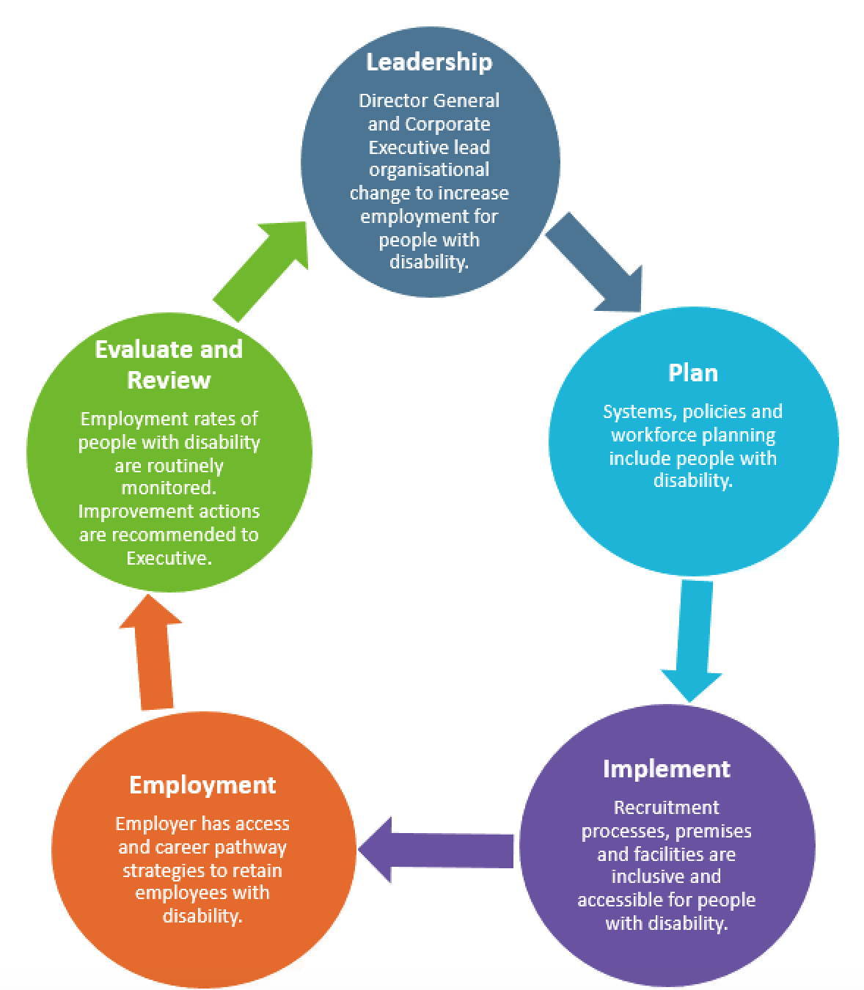
The diagram above shows the process of building public sector disability employment confidence.
- Leadership – Director General and Corporate Executive lead organisational change to increase employment for people with disability.
  - Leadership leads to Plan.

- Plan – Systems, policies and workforce planning include people with disability.
  - Plan leads to Implement.

- Implement – Recruitment processes, premises and facilities are inclusive and accessible for people with disability.
  - Implement leads to Employment.

- Employment – Employer has access and career pathway strategies to retain employees with disability.
  - Employment leads to Evaluate and Review.

- Evaluate and Review – Employment rates of people with disability are routinely monitored. Improvement actions are recommended to Executive.
  - Evaluate and Review leads back to Leadership, and the cycle continues.

Disability Employment Confidence – WA Public Sector Self-Assessment and Action Plan

Context
- Currently 53% of people with disability are in employment, compared to 83% of people without disability.
- The Western Australian Public Sector is WA’s largest employer. However in 2019 the WA public sector’s rate of employment of people with disability was 1.5%. This has been decreasing over the past few years.
- In 2019 the WA State Government set a target of 5%, by 2025, to improve Western Australia public sector employment outcomes for people with disability (People With Disability: Action Plan to Improve WA Public Sector Employment Outcomes 2020-2025)
- Two significant factors are needed to increase the rate of employment of people with disability:
  - Agency Executive leadership and support
  - planning strategic changes through an agency-wide self-assessment.
A disability confident employment agency has:
- a staffing equity index demonstrating employees with disability working across all levels in the agency
- inclusive and accessible recruitment practices in place
- a variety of entry pathways to employment
- processes and provisions for workplace adjustments for both recruitment and retention
- disability awareness training
- inclusive and accessible practices and facilities to retain employees with disability
- linkages with disability employment providers for information and support.

Step 1: Leadership
Objective: Director General and Corporate Executive lead organisational change to increase employment for people with disability.
Outcome | Strategies | Yes or No | Resources | Responsibility | Timeframe
Disability employment is driven at the Executive level. | - Corporate Executive direct/complete Self-assessment and action plan.  - Corporate Executive prioritise areas for implementation.  - Director General quarterly monitoring of self-assessment and action plan by placing on Corporate Executive agenda.  - Director General to send out communication(s) to all staff. |  | - Self-Assessment and Action Plan  - Template: Sample Communication to Staff
 | - Agency is aware of their current rate of employment of people with disability (a baseline to measure achievement).  - Employment rates published in annual report. |  | - Template: Sample Staff Survey  - WA Public Sector annual reporting guidelines
 | - Executives / Managers mentor employees with disability for career development. |  | - Mentoring Program
 | - Executive network established across WA public sector agencies. |  | - Australian Public Service Disability Champions Network
Agency has a culture of inclusion. | - Staff undertake disability awareness training and mental health awareness.  - Disability awareness training is incorporated into Agency’s induction program. |  | - Online training module: Disability Awareness  - Factsheet: Inclusive Language and Engagement  - Factsheet: Myths and Facts  - A range of organisations across WA offer Mental Health First Aid training – contact directly
 | - Disability awareness information, links and resources are available on the agency’s intranet. |  | - Accessible information guidelines
 | - Participating in or holding awareness events (e.g. International Day of Disability – 3rd December). |  | - International Day of People with Disability resources
People with disability are represented on Agency Boards, working groups, reference groups, etc. | - Link with the disability sector to seek representation on Boards, working groups, policy development etc. |  | - On Board with Me - Delivering Board Disability Diversity
 | - Advertise and communicate vacancies for roles at all levels, including working groups, using a range of tools e.g. social media. |  | - Checklist: Advertising Positions, JDFs and Recruitment Material
Employees with disability are equally represented in leadership and senior roles. | - Appointments of employees with disability to leadership roles and provide leadership development opportunities.  - Provide secondment and acting opportunities to grow capacity of employees with disability. |  | - Checklist: Managers, Supervisors and Retention of Employees with Disability  - Mentoring Program
 | - Career pathways developed for employees with disability. |  | - Factsheet: Careers Pathways  - Mentoring Program
Senior HR Manager and HR staff understand legal requirements and promote an inclusive workplace. | - Senior HR Manager and HR staff trained in accessible and inclusive recruitment and processes |  | - Online training module: Disability Awareness  - Factsheet: Inclusive Language and Engagement  - Factsheet: Myths and Facts  - Factsheet: Application of s66 of the WA Equal Opportunity Act  - Checklist: Advertising Positions, JDFs and Recruitment Material  - Checklist: Managers, Supervisors and Retention of Employees with Disability  - Information on disability types

Step 2: Plan
Objective: Systems, policies and workforce planning include people with disability.

Governance
Outcome | Strategies | Yes or No | Resources | Responsibility | Timeframe
The Agency’s Workforce and Diversity Plan is current and includes the requirements for employing people with disability. | - Update Agency’s Workforce and Diversity Plan to allow the Agency to allocate resources and to increase employment rates of people with disability. |  | - Factsheet: Application of s66 of the WA Equal Opportunity Act  - Public Sector Commissioner’s Circular, Equal employment opportunity management plans and workforce planning in the public sector  - Disability & Accessibility
The Agency has an Equal Employment Opportunity management plan to assist the Agency to address the issues of employees who belong to diversity groups that may not have experienced equitable access to public employment in the past. | - Agency completes and must lodge their Equal Employment Opportunity management plans with the Director of Equal Opportunity in Public Employment (DEOPE).  - Provisions included for employment of people with disability. |  | - Factsheet: Application of s66 of the WA Equal Opportunity Act  - Public Sector Commission – Workforce and Diversity Planning
Disability employment is linked with relevant organisational strategic plans and documents. | - Processes are identified to link relevant strategic and organisational documents and plans with disability employment.  - Senior Manager ensures DAIP is linked to Disability Employment Confident Action Plan. |  | - Disability Access and Inclusion Plan Resources  - Implementing your Disability Access and Inclusion Plan
Governance and HR policies and procedures are developed and reviewed to ensure disability employment confidence. | - NDS Disability Employment Confident checklists are incorporated into the development and review of governance and recruitment policies and processes.  - People with disability are consulted on policy development. (Links to DAIP outcome 6). |  | - Checklist: Governance  - Checklist: Accessible Interviewing  - Checklist: Advertising Positions, JDFs and Recruitment Material  - Communicate and consult with people with a disability
The Agency promotes the availability of disability policies and programs to all staff. | - Relevant policies are promoted regularly, centrally located on the intranet and are available in accessible formats. Alternative formats upon request. |  | - Guidelines for accessible printed information checklist

Workforce Composition
Outcome | Strategies | Yes or No | Resources | Responsibility | Timeframe
Agency promotes job  re-design and customised employment options. | - Agency is connected to a disability employment provider. |  | - Factsheet: Working with Disability Employment Providers  - Factsheet: Customised Employment for the Public Sector
People with disability are included when working out the staffing requirements of the Agency. | - Different pathways and options for employment of people with disability are used (e.g. targeting positions, customised employment, job analysis).  - Links to disability employment providers are utilised. |  | - Factsheet: Application of Section 66 of the WA Equal Opportunity Act  - Factsheet: Working with Disability Employment Providers
There are different opportunities for people with disability including traineeships, internships and graduate programs. | - Traineeships, internships and graduate programs are funded through annual budget processes.  - Partnerships with tertiary organisations developed. |  | - Checklist: Managers, Supervisors and Retention of Employees with Disability  - Factsheet: Application of s66 of the WA Equal Opportunity Act

Step 3: Implement
Objective: Recruitment processes, premises and facilities are inclusive and accessible for people with disability.

Premises and Facilities
Outcome | Strategies | Yes or No | Resources | Responsibility | Timeframe
Buildings, facilities and outdoor spaces are accessible. (Links to DAIP outcomes 1 and 2) | - Undertake an initial access audit.  - Annual accessibility assessment of buildings, facilities and outdoor spaces is incorporated into annual OH&S audits.  - Incorporate adjustments into forward budgets (if required). |  | - Accessible events checklist  - JobAccess - Workplace modifications made easy  - Employment Assistance Fund
 | - External venues used for work purposes (e.g. events) are accessible. |  | - Accessible events checklist

Recruitment
Outcome | Strategies | Yes or No | Resources | Responsibility | Timeframe
The Agency has an established relationship with a disability employment provider. | - Link with a disability employment provider. |  | - Factsheet: Working with Disability Employment Providers
Job advertisements are inclusive and accessible. (Links to DAIP outcome 3). | - Utilise the NDS Disability Employment Confident checklists for advertising positions.  - Utilise the checklist for accessible information. |  | - Checklist: Advertising Positions, JDFs and Recruitment Material  - JobAccess - Design and advertise your job  - Guidelines for accessible printed information checklist
Agency targets some vacancies/positions for people with disability. | - Application of Section 66 of the WA Equal Opportunity Act  - Link with a disability employment provider. |  | - Factsheet: Application of Section 66 of the WA Equal Opportunity Act  - Factsheet: Working with Disability Employment Providers
‘Guaranteed interviewing’ is considered for candidates with disability. | - Policy and processes are in place for ‘guaranteed interviews’.  - The policy is promoted to Managers. |  | - Factsheet: Application of Section 66 of the WA Equal Opportunity Act  - Example of ‘guaranteed interview’ program - Australian Government’s Recruitability
Workplace adjustments policy is in place. | - Workplace adjustments are offered at all stages of the recruitment process. |  | - Checklist: Accessible Interviewing  - Factsheet: Sharing Information Regarding Disability
Contracted recruitment agencies work towards the Agency’s set target to increase rates of employees with disability. | - Contractors apply inclusive and accessible practices, and are provided with relevant resources as part of their contract conditions.  - Contractors report the number of enquiries, applications and interviews of people with disability as part of contract reporting. |  | - DAIP agents and contractor requirements

Step 4: Employment
Objective: Employer has access and career pathway strategies to retain employees with disability.
Outcome | Strategies | Yes or No | Resources | Responsibility | Timeframe
Disability awareness is a part of staff induction training. | - The Agency’s induction program includes disability awareness training. |  | - Online training module: Disability Awareness
Induction programs accommodate workplace adjustments. | - Induction material is accessible and available in alternative formats if requested.  - Support workers / external trainers are welcomed.  - Implement a peer system for induction and/or the beginning of employment. |  | - Accessible information checklist  - Checklist: Managers, Supervisors and Retention of Employees with Disability
The Agency has a workplace adjustments policy and procedures. | - HR develop an Agency Workplace Adjustments Policy and Procedures.  - Managers access the Employment Assistance Fund, where eligibility is met, for reasonable adjustments. Disability Employment Services can assist with the application process. |  | - National Employment Standards: Flexible working arrangements  - JobAccess - Reasonable Adjustment Policy template  - JobAccess - Making physical workplace adjustments  - JobAccess - Sourcing assistive technology  - Employment Assistance Fund  - Factsheet: Working with Disability Employment Providers
Agency work events are accessible (for example social functions, off-site events, group meetings). (Links with DAIP outcome 1) | - Managers have processes in place for inclusion and access of staff at events.  - Access requirements are included on event invites (e.g. access and dietary requirements). |  | - Accessible Events checklist
Standard privacy and workforce policies and practices incorporate provisions to support people with disability and are accessible and inclusive. | - Privacy policies, procedures and guidelines include provisions regarding an individual sharing information (disclosing) about disability. |  | - Factsheet: Sharing Information Regarding Disability
Staff surveys include questions relating to disability access and inclusion. | - HR incorporates disability access and inclusion related questions into general staff surveys. |  | - Template: Sample Staff Survey
The Agency has a mentoring program for supporting and advancing employees with disability. | - HR puts into place a mentoring program. |  | - Mentoring Program
Employees with disability have equal opportunities for career progression and skills development. | - Managers incorporate strategies into employees’ annual performance review to identify workplace adjustments, career opportunities etc. |  | - Factsheet: Career Pathways  - JobAccess - Managing an employee with a disability

Step 5: Review and Evaluation
Objective: Employment rates of people with disability are routinely monitored. Improvement actions are recommended to Executive.
Outcome | Strategies | Yes or No | Resources | Responsibility | Timeframe
When due for review and update, Governance and HR policies include the requirements of people with disability. | - NDS Checklists are incorporated into review processes. |  | - Checklist: Governance
 | - Co-design is used to review policies.  - Establish an internal Diversity Advisory Group (including people with disability), as a consultation mechanism. |  | - Co-design Guide tool
There is an increase of employees with disability at the Agency. | - Disability employment statistics are recorded and reported quarterly and in annual report. |  | - WA Public Sector annual reporting guidelines
 | - Results for DAIP outcomes are reported in DAIP progress reports. |  | - Implementing your Disability Access and Inclusion Plan
 | - Quarterly monitoring of the actions and outcomes of the assessment is undertaken.  - Improvement actions are recommended to Corporate Executive. |  | - Self-Assessment and Action Plan

