National Disability Services Webinar: Safer and Stronger accessible slides
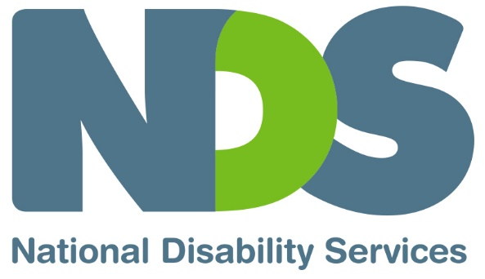
Document in English language

Slide 1

National Disability Services: Safer and Stronger – Disability Services and Covid-19 Vaccine webinar
Friday 26th February 2021, 10:00am – 11:00am (AEDT)

Slide 2

Welcome and Introductions
Sarah Fordyce – Victorian State Manager, National Disability Services

Slide 3

Agenda

Victorian Department of Health: Vaccine Efficacy
Professor Ben Cowie, Executive Director, Covid-19 Response, State Department of Health

Health and Community Services Union Update
Paul Healey, Branch Secretary, H.A.C.S.U.

Commonwealth Department of Health: Implementation and Communications Plan
Maddison Behringer, Simon De Sousa, Paula Nesci. Vaccine Taskforce, Commonwealth Department of Health

Office of the Public Advocate: Decision Making Capacity and Consent
Sonia Gardiner, Senior Medical Treatment Decision Officer, Office of the Public Advocate

Provider Perspective
Rohan Braddy, C.E.O., Mambourin

Q&A
Facilitated by Sarah Fordyce, N.D.S.

Slide 4
Victorian Department of Health

Prof. Ben Cowie

Executive Director, Covid-19 response

State Department of Health

Slide 5

Health and Community Services Union
Paul Healey
Branch Secretary
H.A.C.S.U.

Slide 6
Commonwealth Department of Health
Simon De Sousa, Maddison Behringer, Paula Nesci
Vaccine Taskforce
Commonwealth Department of Health

Slide 7
Office of the Public Advocate
Sonia Gardiner
Senior Medical Treatment Decision Officer
Office of the Public Advocate

Slide 8

Consent (or refusal) for the vaccine
- if a person has decision-making capacity, they consent to or refuse the vaccine
- if they are assessed as lacking capacity (by a health practitioner, such as a G.P. or registered nurse), and there is no advance care directive, their medical treatment decision maker can consent or refuse
  - the consent or refusal must be based on the person’s preferences and values
  - if the person's values and preferences can’t be determined, the decision must be based on what best promotes their personal and social wellbeing
- if there is no medical treatment decision maker, a health practitioner needs to decide if the vaccine administration is significant or routine treatment
  - if routine treatment, the health practitioner can make the decision but must record the details in their notes
  - if significant treatment, for example if the injection will cause the person distress or there is a risk of significant side effects, the health practitioner must request the Public Advocate to make the decision (by completing the s.63 for COVID-19 vaccine online form)

Slide 9

Consent (or refusal) for the vaccine
For more information or advice:
Public Advocate webpage
- Guideline on the administration of the Covid-19 vaccine
- ‘Medical decisions’ tab
- s.63 forms
Telephone Advice Service
1300 309 337

Slide 10
Provider Perspective
Rohan Braddy
C.E.O.
Mambourin

Slide 11

The vaccine rollout in Victoria: a provider perspective
Rohan Braddy
Chief Executive Officer

Slide 12

The position we took
Q: Will the vaccine be made mandatory for Mambourin staff (or customers)?
A: No. (unless)
- Mambourin will not unilaterally make any vaccine mandatory*. Our position will be the vaccine is strongly encouraged.
- *We would be obliged to follow any government direction.
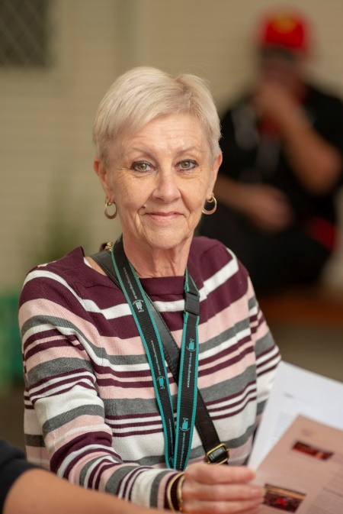

Slide 13

The position we took
Explained to staff:
- We respect any person’s fundamental human right to make their own choices about their health care including what is put into their bodies
- Subject to government directive and customer choice, health profile and/or capacity for infection control methods to be effective, we may not be able to allow an unvaccinated staff member to do some work they are currently doing
- Consequence of this might be redeployment or, where that is not possible, reduction in hours or redundancy
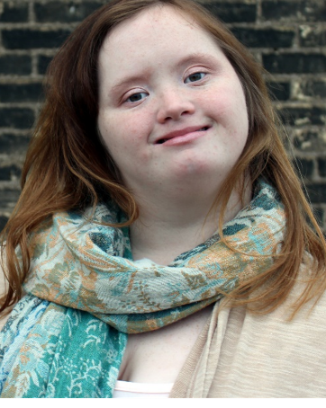

Slide 14

National Disability Services’ position
The Board endorsed an Industry Policy on Covid-19 Vaccination:
- mandated via Public Health Orders of T.G.A. approved vaccines
- for disability support workers providing face to face support to people with disability
- subject to legislated exemptions
- with a strong public education campaign to promote universal uptake of the Covid-19 vaccines in the sector
N.D.S. is advocating for these outcomes to all Australian Governments, their departments and agencies
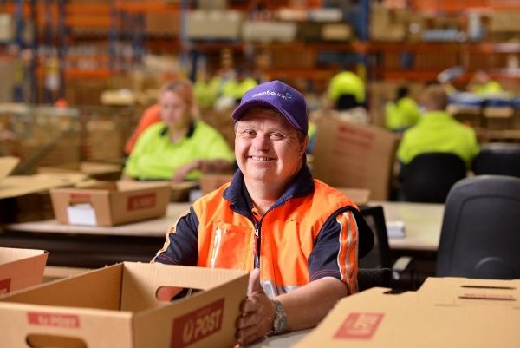

Slide 15

One provider’s experience so far
- 24 vaccinations at one site in one day
- Consents obtained prior by the service provider
- Vaccinated person observed for 15 minutes
- Total time per person around 20 minutes
- Staff administering the vaccine stay for half an hour after last person vaccinated to monitor for reactions/adverse side effects
- Similar to having the flu vaccine

Slide 16

Issues we need to grapple with
- Need clear definition of the ‘disability sector’
- A multitude of workforce issues
- Timely advice regarding when vaccines to be allocated to specific sector groups
- Need communication in appropriate formats for sector participants
- Logistical challenge: vaccine that requires two doses/visits, increased workload
- Need general vaccines information

Slide 17

Q&A
Questions from Q&A box and those submitted in advance to N.D.S.

Slide 18

Thank you
End of document.

