National Disability Services Webinar: Responding to Covid-19 accessible slides
Document in English language

Slide 1

National Disability Services: Responding to COVID-19: Lessons from 2020 as we plan ahead webinar
Friday 19 February 2021

Slide 2

Agenda
Welcome and Introductions
Reflection and Resetting: Why we are here – Sarah Fordyce, State Manager (VIC) National Disability Services
Setting The Scene – David Moody, National Disability Services C.E.O
2020 Reflections – Graeme Kelly, Project Advisor, Safer and Stronger
2020 Workforce Reflections - Yumi Stamat, Purpose at Work
Provider Perspectives:
- Kate MacRae, Able Australia (VIC)
- Jennifer Luff, Sunnyfield (N.S.W.)
- Jo Jessop, Multicap (Q.L.D.)
- Breakout Sessions – Issues and opportunities sharing
- Report back and discussions

Slide 3

Why we are here
Sarah Fordyce – State Manager (VIC), National Disability Services

Slide 4

Setting The Scene
David Moody, C.E.O., National Disability Services

Slide 5

Hot issues for our sector in 2021
- Covid-19
- S.I.L./S.D.A./Housing & Living Options
- Workforce
- Disability Royal Commission
- Disability employment
- Pricing
- Support Coordination
- Quality and Safeguards
- Tune Review implementation
- N.D.S. Review
- Federal Election?

Slide 6

Reflecting on 2020 and what we have learnt
- How to be more agile and deal with adversity more effectively
- Staff can work from home productively
- Government support makes a difference
- The value of having a great team who had the knowledge, capability and initiative to make a difference
- The true value of collaboration and support between organisations
- The value of leadership demonstrating resilience

Slide 7

Learning how to work with Covid in 2021
- Covid is not going away any time soon so we should be prepared for some disruption and more challenges ahead
- Look at 2021 as a year of opportunity to lift and grow with better outcomes for providers and their clients
- It’s another year to learn from others and collaborate with partners who can add real value
- Enhance our staff engagement and productivity to achieve our goals and objectives
- Providers to invest in their businesses and in their staff to achieve greater outcomes

Slide 8

Key lessons from 2020
Graeme Kelly

Slide 9

C-19 Lessons – Highlights from Report to N.D.S. Victoria February 2020
Graeme Kelly – Optimate Consulting
Decorative image omitted.

Slide 10

Safer Stronger and maybe Smarter – Introduction
- Report for key stakeholders
- Best Practice captured
- Methodology used multiple sources
- Primary source C.E.O. Interviews
- Inquiry directed to:
  - What worked well?
  - What could be improved?
  - What should be changed?
- Five key themes emerged

Slide 11

Infection Prevention and Control and Business Continuity
What worked
- Initial sector preparations/response – mostly “without a safety net”
- Effective response to positive cases
- Collaboration stood out before ramped up support over last six months
- Finally, some agreed quality I.P.C. training

Slide 12

I.P.C. and Business Continuity
Recommendations
- Keep the momentum going/“Make it stick”
- Develop further logistical support i.e. infrastructure and business continuity approaches that have proven successful
- Continue to develop good practice

Slide 13

2. Business Sustainability and Innovation
What worked
- Improved balance between operational and strategic
- Opened eyes for future opportunities and risks
- “Never waste a crisis to shake up thinking”

Slide 14

Business Sustainability and Innovation
Recommendations
- Seek support from good practice organisations
- Consolidate learnings for better financial reporting and scenario development
- Employ strategic adaptation to emerge stronger

Slide 15

3. Workforce and Wellbeing
What worked
- Finding new ways of working at the front line and in support functions
- Stronger focus on staff wellbeing

Slide 16

Workforce and Wellbeing
Recommendations
- Consideration should be given to appropriate recognition
- Use C-19 as a launching pad for a new work force strategy
- Confirm and simulate the surge work force response
- Work force strategy must address W.H.S.

Slide 17

4. Governance and Leadership
What worked
- More responsive governance and risk management frameworks
- Taking responsibility early and maintaining oversight
- Fast tracked revised K.P.I. reporting to a small number of agreed indicators
- Use of existing resources

Slide 18

Governance and Leadership
Recommendations
- Formalise your governance approach/contingency planning
- Look for opportunities to share and collaborate not just on C-19
- Be proactive and don’t wait for the “establishment” to respond
- Reflect on your lessons learned/good practice

Slide 19

5. Collaboration and Communication
What worked
- Moving from alarm to support action
- Leadership provided through Able Australia
- Activating local connections based on existing relationships
- Clear, correct and consistent leadership communications

Slide 20

Collaboration and Communication
Recommendations
- Strengthen NDS capability to consolidate improvement
- Strengthen existing collaborations that align well with new actions
- Integrate co-design and greater involvement of customers in the C-19 normal future
- Increase engagement with customers with diversity needs
- Explore recent improvements in communications technology

Slide 21

Conclusion
“Nobody does pandemic well but we did better than most”

Slide 22

Workforce lessons from Covid-19
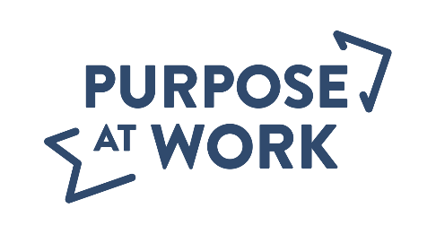
Yumi Stamet, Director Purpose at Work
19 February 2021

Slide 23

Purpose of this session
What lessons can be drawn in the area of workforce development and management from Covid-19?
Content:
- Workforce issues during the Covid-19 crisis
- How did providers respond?
- What lessons can we draw?
Decorative image omitted.

Slide 24

Workforce size issues during Covid-19
- Staff mobility restricted
- Drop in demand
- Staff going into isolation
- Lack of surge workforce
- Staff with multiple employers
- Workforce shortage
- Casuals and sole traders
- Low pay rate
- Mostly female staff

Slide 25

Workforce skills issues during Covid-19
- Infection control
- Lack of time/resources for training
- Literacy and language

Slide 26

Work environment issues during Covid-19
- Lack of emergency planning
- Manager exhaustion
- Additions to workload and stress
- Access and use of P.P.E.
- Border issues
- Job stress, fatigue, and mental health issues amongst workforce
- Lack of supervision
- Lack of frontline autonomy
- Lack of workforce planning

Slide 27

Providers response to Covid-19
- Recognition of importance of support work
- Increase use of technology
- Adoption of new ways of working
- Stronger focus on staff wellbeing
- Providers working together to face the crisis

Slide 28

What lessons can be drawn?
- Start improving your work environment
- Align your workforce practices to the new times
- Increase your planning capability
- Collaborate to address systemic issues

Slide 29

More information
- NDS session with two providers on how their self-organising teams responded to Covid-19
- Article by Corporate Rebels on how progressive organisation respond to crisis
- National Skills Commission Report: The shape of Australia’s post Covid-19 workforce
- Social policy Research Centre: The disability workforce and Covid-19
- University of Melbourne: Disability support workers: the forgotten workforce in Covid-19

Slide 30

Yumi Stamet, Purpose at Work
Mobile: 0428 824 634
Yumi Stamet email
Purpose At Work webpage
LinkedIn page
Decorative images omitted.

Slide 31

Provider Perspectives
Kate MacRae – Able Australia (VIC)
Jennifer Luff – Sunnyfield (N.S.W.)
Joanne Jessop – Multicap (Q.L.D.)

Slide 32

Covid-19 Reflections
Kate MacRae C.E.O. Able Australia
Chair of C.E.O. Covid Collaboration

Slide 33
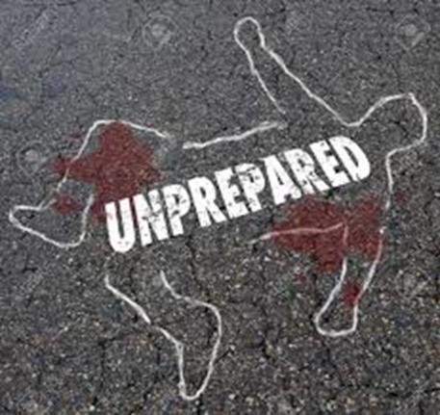

Slide 34

Invisible

Slide 35

Health/Disability

Slide 36
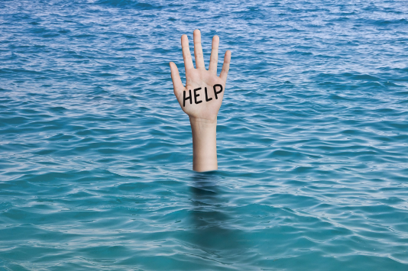

Slide 37

Collaboration

Slide 38

What next

Slide 39

Vulnerable Workers
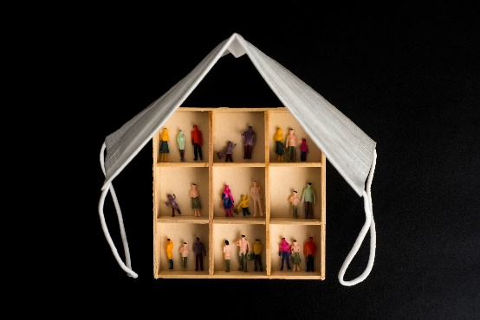

Slide 40

Mental Health and Well Being

Slide 41

Literacy and Health Literacy

Slide 42

Administrative Burden

Slide 43

Financial Viability

Slide 44
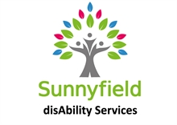
- Communication
- Infection Protocols
- Business systems and support
- Response Plans
- External stakeholders
- Client and Staff Welfare

Slide 45

Short Break

Slide 46

Breakout rooms
What lessons will you take from operating during the COVID-19 environment that you can build upon in your organisation into the future?
End of document.

