**NDIS Basics**

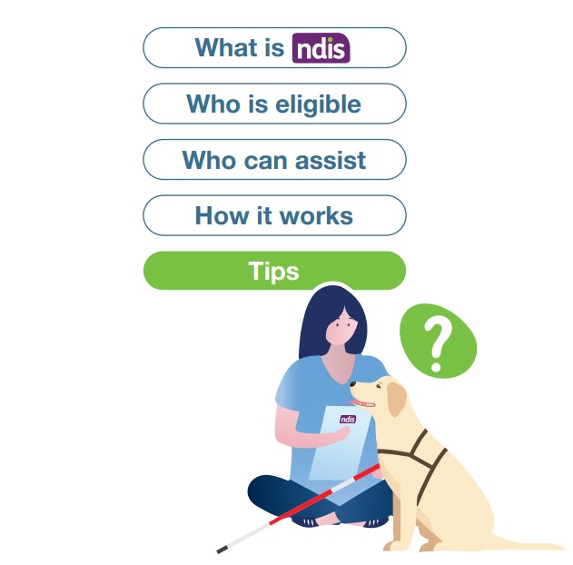

Applying to access the National Disability Insurance Scheme (NDIS) can be overwhelming.

If you are applying to access NDIS while in hospital, your health team may help with the NDIS Access Request and planning process.

**What is NDIS**

NDIS provides funding for supports and services to help people, eligible for the scheme, achieve their goals and live their best life. The scheme gives the participant ‘choice and control’ over who will provide their services, and where and when they are delivered. The agency that manages the NDIS is National Disability Insurance Agency (NDIA).

**Who is eligible for NDIS?**

You may be eligible for the NDIS if you:

* Are aged between 0 and 65
* Are an Australian citizen, resident or Protected Special Category Visa holder
* Have a permanent and significant disability.

**Who can assist**

### Completing a NDIS Access Request

If you are in hospital your health team may assist with your access Request.

A NDIS Access Request is the form you complete to apply for the NDIS.

You can also talk to a Local Area Coordinator (LAC). A LAC can explain how the NDIS works and help with your Access Request. If you need support for a child younger than seven years, talk to an Early Childhood Partner.

To find a Local Area Coordinator or Early Childhood Partner visit [www.ndis.gov.au/contact/locations](http://www.ndis.gov.au/contact/locations)

**Gathering evidence**

It is important to gather comprehensive evidence to support your Access Request. If you are in hospital, your health team may collect and prepare your evidence. Evidence can be collected from your doctor, specialists, therapists and your support network (family, carer, friends).

### Creating a plan

### If access to NDIS is approved, you will create a NDIS plan with your LAC.

Your goals are an important part of a NDIS plan. Think about what you would like to achieve in life. For example: recreational activities, becoming more independent at home and finding a job.

Your plan will include:

* Your goals
* The supports and services that will help you achieve your goals. For example: therapy services, a mentor, a support worker, community activities and assistive technology
* A budget to pay for your supports and services
* How your plan will be managed.

**How it works**

**Contact a Local Area Coordinator (LAC) for help**

**If you are in hospital, your health team can assist with Steps 1-2**

**Step 1** **Submit a NDIS Access Request**



Gather medical and supporting evidence

Collect evidence of disability (from doctors and specialists)

Collect evidence of how your daily living is affected (from therapists, specialists, doctors and your support network)

Complete and submit the NDIS Access Request form. A LAC and your support network can help

NDIA will make an access decision or request more information within 21 days

**Step 2 Make a NDIS plan**



Identify your goals and the supports you need to achieve your goals

Attend a NDIS planning meeting with your LAC. Have someone you trust with you when you create your plan

Work with your LAC to develop a plan

Your plan is submitted to the NDIA for assessment.

Your LAC can help

NDIA approves your plan or requests more information within 60 days

**Step 3 Use your NDIS plan: you have the option to use one or a mix of self-manage, plan manager, NDIA managed**



**Self-manage your NDIS plan**

* Research and confirm services and supports to use
* Sign service agreements
* Manage invoices

**and or**

**Use a plan manager**

* You research services and supports to use
* A plan manager organises your service agreements and invoices

**and or**

**NDIA manages your plan**

* You research and confirm services and supports to use
* NDIA manages service agreements and invoices

**NDIS Plan review**

* Your plan will be reviewed
* When your plan will be reviewed can vary from six months to 24 months

**If your Access Request or NDIS plan is not approved**



**1. Internal NDIA review**

You have three months to request an internal review. A decision can take up to 60 days

**2. Administrative Appeals Tribunal**

If you are unhappy with the NDIA decision, you have 28 days to lodge a tribunal appeal

**3. Federal Court**

If you are unhappy with the tribunal appeal, you have 28 days to lodge a court appeal

**Tip 1**

**Graphic: light bulb with number 1 in it**

**Read the NDIA booklets available at** [**http://www.ndis.gov.au/participants**](http://www.ndis.gov.au/participants)



Booklet 1 Applying for the NDIS covers eligibility criteria, applying for the NDIS and what the NDIS funds.

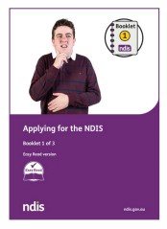

Booklet 2 Creating your NDIS plan covers how to develop goals, prepare for a planning meeting and create a plan.

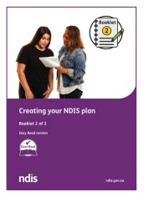

Booklet 3 Using your NDIS plan covers what is in a plan, how to use a plan and the plan review process.

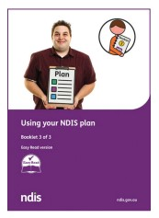

For more information phone NDIS National Contact Centre on 1800 800 110

**Tip 2**

**Graphic: light bulb with number 2 in it

**

**Before applying to access NDIS**

Talk to people with similar health conditions. Join a support group. You might find a local support group on Facebook.

Research types of supports you might be able to use and the services available in your community.

Think about how you would like your plan to be managed. Consider each option carefully and talk to people who are NDIS participants.

**Tip 3**

**Graphic: light bulb with number 3 in it**

**Be prepared for delays**

The application and planning process may take longer than expected. You might be asked to provide more information which can take extra time.

If the NDIS plan you receive is not what you expected, you are entitled to have the decision reviewed.

If delays occur, talk to your LAC about short term supports that you may be eligible for.

The Ready to Go Home project is funded by the Australian Government Department of Social Services. Go to [www.dss.gov.au](http://www.dss.gov.au/) for more information.

