Your hospital guide 6
After your hospital stay
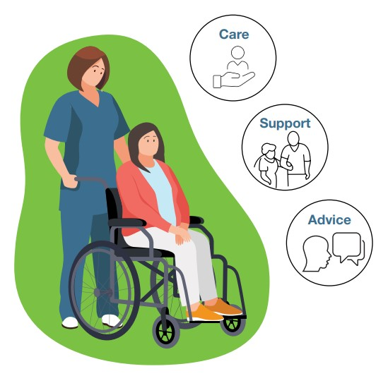
Leaving hospital can be accompanied by a range of emotions. You may feel excited and relieved, or you might be worried, afraid and overwhelmed.
Many people feel this way for different reasons, such as learning to manage a health change or a new living arrangement.
After leaving hospital you may have to make changes to your daily routine or reach out for assistance.
Care
Take extra care with your physical and emotional health
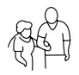
Supports
Find additional supports to help you adjust
Advice
Seek advice on matters such as your rights, legal and financial issues
Take extra care
- Taking care of your health is important to prevent a return to hospital.
- Appointments and ongoing treatment: Try your best not to miss any of your medical and therapy appointments. If you are unable to make an appointment, call the service to reschedule. If you have any concerns about your health, contact your GP.
- Falls and hazards: Falls, slips and trips might result in an injury that sends you back to hospital. Keep walkways clear, make sure you have good lighting, wear appropriate footwear and let your support networks know if you feel unwell.
- Infections: Simple things to avoid infection when you leave hospital include: washing your hands, using hand sanitiser regularly, wound care, cleaning household surfaces and ensuring you have good ventilation by opening windows to let air circulate.
- Medication and exercises: Follow the instructions given to you in hospital about your medications and any exercises. Ensure all your medications are securely stored.
Your emotional wellbeing is as important as your physical health. If you start to feel sad, lonely, anxious or depressed
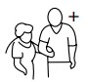
Finding Additional Support
You may be leaving hospital with all or most of your supports and services organised. If this is not the case you might need to search for additional services.
To help with your search: the following user-friendly websites may assist
Ask Izzy provides information on support services. You can search by postcode across 16 categories, such as housing, food, health, technology, etc.
Visit www.askizzy.org.au
Concessions WA has information about more than 100 rebates, concessions and subsidy schemes provided by the Government of Western Australia.
Visit concessions.communities.wa.gov.au
Disability Gateway features information and services covering 10 categories, such as aids and equipment, employment, education and leisure.
Visit www.disabilitygateway.gov.au
Mappa helps people to find health services close to home, family and country across WA. Mappa features strong aspects of cultural safety and appropriateness through the information provided.
Visit www.mappa.com.au
My Services provides information on mental health services across three areas – immediate help, mental health support and advice, alcohol and drug support.
Visit www.myservices.org.au
WA Connect provides information on community services and emergency relief supports across WA, such as housing, family support, furniture, transport, etc.
Visit www.waconnect.org.au
Seeking Advice
You may not find all the supports you feel you need. If so, there are a number of organisations that can provide advice and guidance on personal and practical matters.
Do not be afraid to ask questions.
Citizen’s Advice Bureau of WA can assist with legal and mediation advice.
Phone (08) 9221 5711
Visit www.cabwa.com.au
Financial Counsellors’ Association of WA can direct you to counsellors who can provide information, support and advocacy on financial matters.
Phone 1800 007 007
Visit www.financialcounsellors.org
Health and Disability Services Complaints Office can deal with complaints you have about health, disability and mental health services.
Phone 1800 813 583
Visit www.hadsco.wa.gov.au
Health Consumers Council provides independent advice on your healthcare rights.
Phone (08) 9221 3422
Visit www.hconc.org.au
Legal Aid WA offers free and low-cost advice on legal matters.
Phone 1300 650 579
Visit www.legalaid.wa.gov.au
Local Area Coordinators (LACs) can direct you to services and supports available to people with disability.
Phone 1800 800 110
Consumers of Mental Health WA can direct you to advocacy services and peer support groups.
Phone (08) 9258 8911
Visit comhwa.org.au
Council on the Aging WA provides useful information, resources and programs to support aging West Australians.
Phone (08) 9472 0104
Visit www.cotawa.org.au
Advocacy organisations can link you with a professional advocate to help you resolve a problem, address unfair treatment and find support options. Search Ask Izzy for disability advocacy services.
Visit www.askizzy.org.au
The Ready to Go Home project is funded by the Australian Government Department of Social Services. Go to www.dss.gov.au for more information.

