Your hospital guide 5
Your discharge summary
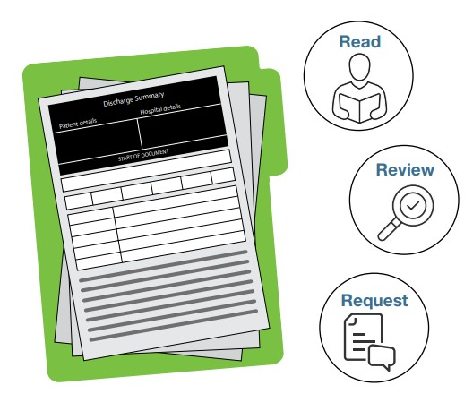
As a patient you can expect to receive a discharge summary before leaving hospital. A discharge summary is prepared by your hospital health team.
A good discharge summary is important because it:
- Provides the medical information to support a smooth and well coordinated transition from hospital
- Reduces the likelihood of readmission.
Before you leave hospital, it is important to:
- Read your discharge summary
- Review your discharge summary - it is recommended you have a support person or an advocate with you during the review
- Request a copy of your discharge summary before leaving hospital.
Read
A discharge summary is a brief document covering the clinical information about your hospital experience.
Discharge Summary headings | What the heading means
Problems/Diagnoses | Why you were admitted to hospital
Clinical interventions performed | What medical or surgical procedures were performed
Clinical Synopsis or Clinical Summary | Overview of your medical condition/s while in hospital
Management - Progress | Therapy and programs completed while in hospital
Diagnostic Investigations | The tests completed while you were in hospital
Health Profile – adverse reactions | Any allergies or bad reactions you experienced while in hospital
Medications – current medications on discharge | Current medications you are taking on discharge
Medications – ceased medications | Medications you no longer need to take
Recommendations and information | Instructions about services and appointments which have been arranged for you or you need to make
Review

Review your discharge summary with your health team, a support person and or advocate.
Things to think about include:
Do I understand what happened to me in hospital?
Do I understand what treatment I need now and in the future? Do I know which medications to take and when?
I’m I aware of any allergies or bad reactions during my hospital stay and what to do to avoid a repeat episode? Do I know what to do if any health issues reoccur?
Do I know when my follow-up appointments are?
Does my support network (family, carer, friends) understand my discharge summary?
Request

Before leaving hospital, request a copy of your discharge summary for your records. You may wish to share it with your support network and service providers.
It is a good idea to confirm with your health team:
- When your discharge summary will be uploaded to your My Health Record (if you use My Health)
- When your discharge summary will be sent to your GP and or Specialist.
After leaving hospital, if you have concerns about the accuracy of the information provided in your discharge summary you can:
- Contact the hospital Patient Liaison Officer and ask they raise your concerns with your health team
- Talk to your GP and or Specialist.
For complex concerns which are not resolved, you can request a copy of your patient file under the Freedom of Information Act.
The Ready to Go Home project is funded by the Australian Government Department of Social Services. Go to www.dss.gov.au for more information.

