Your hospital guide 4

Discharge planning checklist

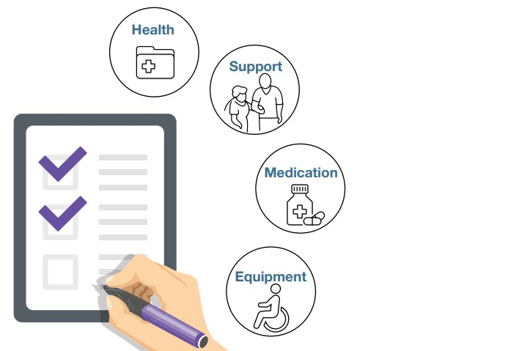
During your hospital stay, your health team will work with you to create a plan for your discharge. Preparing to leave hospital is important because it assists in a smooth transition from hospital and helps prevent readmission.
Things to consider when planning for your discharge are:
Your health
Your health records
Your transport
Your support needs
Your medications
Your equipment
Your appointments.
Start planning for your discharge early in your hospital stay.
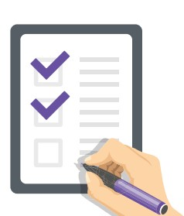

Your Health
Have all your questions about the health condition that brought you to hospital been answered?
Do you know what symptoms to watch for when you go home? It is important to understand when you might need medical assistance.
Are there dietary requirements you need to prepare for?
What exercises do you need to continue at home?
Do you have all the information you need to stay safe when you leave hospital? For example: preventing falls.
Is there any education or training to prepare you for your return home?
Do you have any concerns about how you and your family are coping with your health? If you do, ask your health team for information about support groups and other resources you may be able to access.

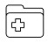

Your Health Records
Ask for a copy of your discharge summary.
Ask for a copy of your Patient Medication List.
Ask for copies of any x-rays, scans and or test results.

Your Transport
Have you confirmed transport from hospital to your destination?
Are there any transport costs you need to prepare for?
If you live in a regional area, do you need to access the Patient Assisted Travel Scheme?
Will you need to organise transport to get to appointments, collect medications and other essential items?

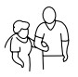

Your Support Needs
Have you confirmed with your support networks (family, carer, friends) who can help with daily tasks when you return home?
Are you connected with the appropriate services?
Have your support networks and service providers been trained by hospital staff to:
- use any new equipment you will require at home?
- assist with daily health-related tasks? For example: changing a bandage, giving an injection and wound care.
Are you eligible for any outpatient or at-home programs provided by the hospital?

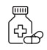

Your Medications
Do you have any questions about the medications on your Patient Medication List? This includes any changes to medications, vitamins and or supplements you were taking before your hospital stay.
If you need assistance with your medications when you leave hospital, has the person assisting you been properly trained?
Will you be provided with any medications on discharge?
How will your medications be packaged and stored when you leave hospital?
For example: Webster pack or an automated dispensing kit.
Ensure you have prescriptions and or referrals for medications and supplements before you leave hospital.
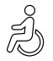
Your Equipment and Home Modifications
Your equipment and home modification needs should be assessed as early as possible, as there may be delays.
Ask your health team when your equipment and home modification needs will be assessed.
Ask for an equipment and home modification schedule:
- What is needed?
- When will it be provided?
- What are the costs?
- How will any equipment and home modifications be funded?
- Who will organise hire and or purchase of the equipment?
- How will any new equipment be transported to your home?
- Who will be coordinating any home modifications?
Where National Disability Insurance Scheme funding is not available, the hospital may have information about other funding options.
Your Appointments
Do you have a list of appointments and referrals scheduled after you leave hospital? What is the appointment, who is the appointment with and where is the appointment?
Make sure any referrals for outpatient services have been made. Confirm where your outpatient services will be provided?
Download the Manage My Care App
This is a free app that can track public outpatient appointments and referrals in WA. For more information visit www.healthywa.wa.gov.au/Managemycare
Final Checks Before Leaving Hospital
I have been involved in planning for my discharge.
I understand and am happy with my discharge plan.
I feel ready to leave hospital.
I am confident all the supports, equipment and home modifications I need to leave hospital are in place.
My occupational therapist has checked that my home is safe to move to.
My support networks (family, carer, friends) and service providers are prepared for my discharge.
I understand my health condition and know what warning signs to look for.
I understand what I can do to manage my health condition.
I know what my medications are, how to obtain them and how they will be administered.
I understand the potential side effects of my medications and who I should call if I have complications.
I am confident using my new equipment (if applicable) or I have training scheduled to learn how to use it.
The Ready to Go Home project is funded by the Australian Government Department of Social Services. Go to www.dss.gov.au for more information.

