Your hospital guide 2
Your hospital stay
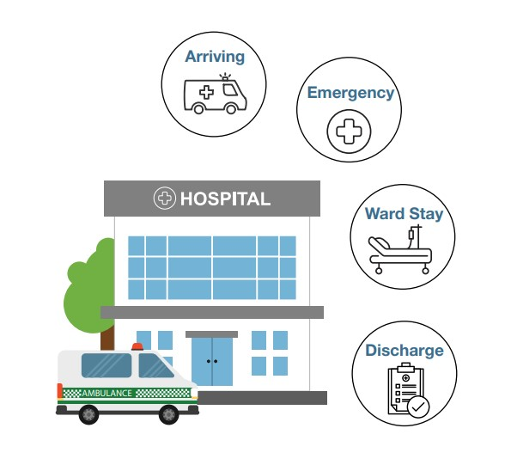
Understanding what your hospital stay might be like may reduce stress and improve your hospital experience.
It can be helpful to have an idea about:
- what might happen
- who you might talk to
- how you might feel.
Arriving at hospital

What might happen
- If you travel to hospital by ambulance, you might be taken to one hospital then to another hospital
- When a hospital is busy you may have to stay in the ambulance until the hospital has space to treat you
- Where special assistance is required, police officers might take you to hospital
- You may be transported to hospital by air

Who you might talk to
- Ambulance team
- Emergency paramedics
- Police officers
- Flight crew
- Doctors
- Nurses

How you might feel
You may feel comfortable and relieved, or you might feel:
- Anxious
- Frightened
- In pain
- In shock

Tips
- Try to stay calm and respectful
- Let the professionals do their job they are there to help you with no judgement
- If you are not sure what is happening, then ask questions
Emergency Department

What might happen
- If you go to the Emergency Department, you will be seen by someone from the triage team. Triage is where patients are prioritised for treatment based on their needs
- If you have private health insurance, it is your choice whether you choose to go public or private
- Critical patients go straight through for treatment
- If you are not critical and the hospital is busy, you may need to wait
- You might need some emergency medications, procedures and or medical tests which may involve special equipment. For example: x-rays and scans
- You may be transferred to another hospital
- A nurse will complete medical observations and paperwork
- The nurse and doctor have other patients, so you may be left alone sometimes
- After your assessment is complete, you will either be discharged or admitted to a ward
- If you are admitted, you will be taken to a ward

Who you might talk to
- Admission clerk
- Customer relations
- Admin staff
- Triage nurses
- Doctors
- Interpreters
- Social workers
- Occupational therapists
- Psychologists
- Specialists. For example: surgeons
- Orderlies
- Police

How you might feel
You may feel fine and not concerned, or you might feel:
- Uncomfortable
- Frustrated
- Worried
- Traumatised
- Not listened to or forgotten
- Confused
- Very unwell and in pain

Tips
- It is good to have a support person with you where possible
- Be aware it will be noisy – lots of beeping and alarms – and you may have to wait a long time to be seen
- It’s okay to ask questions about your condition and the process
- Be kind to and patient with hospital staff
- If you are a National Disability Insurance Scheme participant, let staff know and provide them with your essential information
- If you have sensory sensitivities, let someone know you need a quiet place and explain why
- Ask the nurse to show you the call button and how to use it
- If you feel your condition is getting worse, go to the triage station or call out for help
- If you have aids or equipment, ask for a patient label to stick on each item
- If you are admitted, make sure all your clothes, shoes and personal items are bagged and go with you to the ward
- If you feel you need advice and or someone to speak on your behalf – get an advocate
Ward Stay

What might happen
- A ward is the area you are allocated for your hospital stay
- You may be moved around to different wards depending on your health needs
- You will be asked to fill out a menu. Make sure you are clear if you have any dietary requirements and or food allergies
- If you are assessed as needing help to shower, assistance will be provided
- Doctors, nurses and other members of your health team will visit you to discuss your health and discharge plan
- You may be given new medications
- You may have different types of tests taken
- You may be referred to therapy, such as speech, occupational and physiotherapy
- You may need a procedure or surgery
- Your health team will work with you to prepare your discharge plan for you to leave hospital

Who you might talk to
- Nurses
- Doctors
- Specialists
- Allied health professionals. For example: psychologist
- Other service providers who may help during your stay or with your discharge plans

How you might feel
- You might enjoy your hospital stay, but you also might be feeling
- Lonely
- Isolated
- Tired
- Anxious
- Down
- Bored
- Very unwell and in pain
- Scared
Tips
- Some hospitals have an information folder that explains how the hospital works
- Be aware your sleep may be disturbed
- Staff can change and you might not see the same people all the time
- If you would like to practise your faith while in hospital, talk to the Patient Liaison Officer
- If discharge planning hasn’t begun, ask why and when it will begin
- If you feel you need advice and or someone to speak on your behalf – get an advocate
Discharge

What might happen
- Discharge planning meetings are coordinated with your health team and services
- You and your support networks (family, carer, friends) can be involved in discharge planning meetings
- A discharge date is decided but may change depending on your progress and circumstances
- If you have had a long hospital stay, you may go home for a few days at a time until you are ready to go home full-time
- You may have to go to rehabilitation or temporary accommodation
- You may need help from your support networks (family, carer, friends), as well as service providers

Who you might talk to
- Allied health professionals. For example: social worker, dietician, occupational therapist
- Nurses
- Doctors
- Community service providers

How you might feel
- You may be excited and relieved to be moving on from hospital, but it is okay to feel like you are not ready
- Leaving hospital can be overwhelming and it is not unusual to feel anxious
- You might feel uncertain or apprehensive
- You may still feel unwell and in pain
Tips
- If you feel you need advice and or someone to speak on your behalf – get an advocate
- If you get new assistive technology, ask about training on how to safely use any new equipment or aids
- Ask about any at-home rehabilitation services that you may be eligible to receive
- Talk to your social worker about any concession programs
The Ready to Go Home project is funded by the Australian Government Department of Social Services. Go to www.dss.gov.au for more information.

