Recognising Restrictive Practices: Guide

Contents
Recognising Restrictive Practices: Guide 1
Contents 1
Acknowledgements 2
Cast and Crew 3
Disclaimer 4
Copyright 4
Introduction 5
About the films 5
What are restrictive practices? 7
Chemical restraint 9
Restricted access/Environmental restraint 11
Mechanical restraint 13
Physical restraint 16
Seclusion 18
Power control 20
Consequence control 22
Find out more 24
References 25

Acknowledgements
National Disability Services would like to acknowledge the funding from the Victorian Government which allowed these Recognising Restrictive Practices resources to be developed.
We would also like to express our gratitude for the time and expertise given in the development of these resources by:
- Kerrie Hancox, Krysia Birman, Katie White and Bonnie O’Leary from the Department of Health and Human Services, Office of Professional Practice
- Associate Professor Paul Ramcharan and Dr Raelene West, RMIT University
- David Relf, Senior Positive Behaviour Support Practitioner, Yooralla
- Hayley Dean, Chief Operating Officer, Melba Support Services
- Dr Hilary Johnson, Strategic Research Project Advisor, Scope
- Jean-Marie Cadby, Actor, Fusion Theatre Company
- Greg Muir , Actor and Advocate, Weave Movement Theatre
- Members of the Recognising Restrictive Practices Project Reference Group
- Members of the Northern Territory Zero Tolerance Working Group and staff from Somerville Disability Services
- Duy Huynh and the beyondedge team (www.beyondedge.com)
- NDS Learn and Develop: Nicole Jenkins
- NDS Zero Tolerance: James Bannister, Liz Collier and Sarah Nicoll(update)

Cast and Crew
We would also like to say a very special thankyou to all the actors who brought these characters and ideas to life on screen. Thank you!
Emma Jean-Marie Cadby
Ray Greg Muir
Kim Kevin Stanton
Lesley Lisa Dezfouli
Tom Alex Litsoudis
Jai Benjamin Oakes
Jordan Adam Balales
Penny Maria Thu Fampidi
Director Duy Huynh, Beyond Edge

Disclaimer
The information provided in this guide is intended for general use only. It is not a definitive guide to the law and best practice, does not constitute formal advice, and does not take into consideration the particular circumstances and needs of your organisation.
Every effort has been made to ensure the accuracy and completeness of this document at the date of publication. NDS cannot be held responsible and extends no warranties as to the suitability of the information in this document for any particular purpose and for actions taken by third parties.
All stories used throughout this guide and these films are fictional and are for educational purposes only.
We'll also map our learning to the Convention on the Rights of People with Disability and the PBS Capability Framework.

Copyright
This publication is copyright. All intellectual property rights vests in NDS. Material which is reproduced from this publication must include an acknowledgement of the source. Prior permission should be sought from NDS.
© National Disability Services 2017, Updated 2021

Introduction
We all need to be able to recognise when restrictive practices are being used.
People with disability who are subject to restrictive practices are more at risk of abuse, neglect and exploitation.
This guide and accompanying short films have been developed as part of the Zero Tolerance Initiative to help explore restrictive practices from a human rights perspective.
The Zero Tolerance Initiative outlines strategies for service providers to improve prevention, early intervention and responses to abuse, neglect and violence experienced by people with disability. It urges all of us to focus on rights and target abuse to create safer, more empowering environments for people you support. Put simply, Zero Tolerance means abuse is never OK.
Restrictive practices can be a significant breach of a person’s human rights. Restrictive practices can have a serious impact on the health and wellbeing of people with disability. These are some of the reasons Australia has made a commitment to reducing and eliminating the use of restrictive practices for people with disability. Reducing and eliminating restrictive practices is an obligation we all have under the Convention of Rights of People with Disability (CRPD).

About the films
This collection of Recognising Restrictive Practice films will talk about the ways restrictive practices are used with people with disability.
We hope they help you to recognise restrictive practices when you see or use them and start conversations about how to do things differently.
In the first part of the film you will see a scenario where restrictive practices are used. In the second part of the films people from different parts of the disability sector discuss the scenarios. They talk about the impact of the practice on the person, what alternatives to restrictive practices might be and how the practice may impact people. They will help you to explore less restrictive ways to support people safely.
Important: Please note these films are NOT illustrating the use of authorised regulated restrictive practices.
However, we do hope the films also help teams and practitioners to think about ways to reduce and eliminate any restrictive practices that may be authorised for use with the people you are working with.
About this guide
This guide accompanies the NDS Zero Tolerance Recognising Restrictive Practices films. You can use this guide:
- to work through the films on your own,
- with your team; or
- if you are a supervisor – in supervision and training.
These films will assist your team start conversations about restrictive practices and how people might be supported in different ways.
You might also find it helpful to have a copy of the Empowerment Circle (NDS) with you as you work through the films. The Empowerment Circle gives a way to see if a practice is good (green zone), poor (orange zone) or abusive (red zone) and how to shift those practices.
The films and guide should be used with:
- your organisation’s policies and procedures;
- advice and guidelines of any other expert bodies in your state or territory;
- specific policy and legislation relevant to the state or territory you provide support in, in particular about prohibited practices and authorising regulated restrictive practices;
- the NDIS Commission’s Regulated Restrictive Practices Guide

What are restrictive practices?
A Restrictive Practice is ‘any practice or intervention that has the effect of restricting the rights or freedom of movement of a person with disability’¹.
Restrictive practices can have a serious impact on the health and wellbeing of people with disability. Using restrictive practices can significantly limit a person’s human rights.
Australia has made a commitment to reduce and eliminate the use of restrictive practices for people with disability. This is part of our commitment under the Convention on the Rights of People with Disabilities (CRPD).
Five of these films relate to the types of restrictions that may be identified as restrictive practices regulated by the NDIS Quality and Safeguards Commission:
- Chemical restraint
- Restricted Access (Environmental restraint)
- Mechanical restraint
- Physical restraint
- Seclusion

Restrictive practices can be overused or misused
What we see in these films is that restrictive practices can be overused or misused. They might be used:
- without knowing that something is restricting a person’s human rights
- without teaching new ways to get needs met
- without using proactive strategies to reduce the risk
- for too long at one time
- for too long over time and without being regularly reviewed
- for reasons other than keeping people safe
- to control people or to make people act in a certain way
- as a form of abuse and neglect (intentional or unintentional)
- due to a lack of training, knowledge or reflection about less restrictive alternatives
- without the proper authorisation.

Questions to think about
- What are restrictive practices?
- How are restrictive practices used and misused?
- What is the impact of restrictive practices?
- What can we do to reduce and eliminate the use of restrictive practices?

Finding different ways to do things and speaking up
In many situations, you might feel that the way a person is being supported is not right, but not be sure about what other options are available. The reflection videos may give you new ideas. Talk with your team and make a plan.
Share ideas and knowledge within your team and think about where else you can go for support and information.

Chemical restraint
Quotes from the film:
- “he’s just acting up and I’m way behind on my cleaning.’
- ‘But he’s not due for his meds until 9pm’

“Penny and Kim” - In this scenario we see
Kim is using his computer whilst Penny is cleaning. Penny accidentally turns the Wi-Fi off. Kim tries to let her know and get her attention but Penny thinks he is just ‘acting up’. Penny gets a phone call from someone who suggests she give Kim his night medication early which she does. Kim falls asleep and Penny carries on with her cleaning.

Watch the scenario
- What did you observe?
- What impact do you think this has on the people involved?
- What would you question about this scenario?
- What could be done differently?

Watch the reflection
Listen to what others have observed. Think about how the points raised in the films relate to the people you support and discuss anything that might be done differently in the future.

Things to talk about
- What would you do in Penny’s situation? Is this OK? Are there times when this is OK?
- Do you know what medication people are taking and why? What are the side effects?
- What is in place to ensure medication is only used as prescribed?
- How are your observations of side effects collected to give to medical professionals?
- Is this a reportable incident? An unauthorised restrictive practice?

More about chemical restraint
The NDIS (Restrictive Practices and Behaviour Support) Rules 2018 define chemical restraint as:
‘the use of medication or chemical substance for the primary purpose of influencing a person’s behaviour. It does not include the use of medication prescribed by a medical practitioner for the treatment of, or to enable treatment of, a diagnosed mental disorder, a physical illness or a physical condition’.
The use of chemical restraint as a regulated restrictive practice must be a part of a positive behaviour support plan. A positive behaviour support plan will introduce skills and strategies to work towards reducing the regulated restrictive practice. All staff should be aware of possible side effects of medications that may be prescribed.
Some misuses of medication include:
- Use of psychotropic medications when behaviours may not be occurring.
- Over-medication or misuse of medication.
- Giving medications differently to how they are prescribed.
- Long term use of medication without a review to reduce the use of medication for the purposes of behaviour management.
- Menstruation suppression.

Restricted access/Environmental restraint
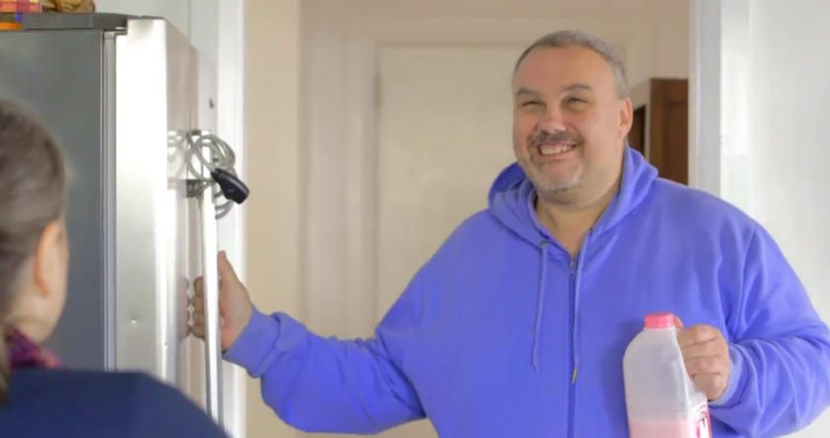
Quotes from the film:
- “The fridge stays locked. That's the house rules.”
- “Why? That's weird.”

“Tom moves in” - In this scenario we see
Tom moves in to his new house. He tries to put his milk away in the fridge but finds it is locked. Lesley (the house supervisor) explains that the fridge is locked because another person who lives in the house has a history of hiding food under her bed. Lesley tells Tom if he wants the fridge open, he just needs to ask. Tom’s access to his food and drink has been restricted (and so is his housemates). This is called ‘environmental restraint’, you may have also heard it called restricted access, or environmental control. Later, we see Tom packing food and kitchen items into a box to take back to his room.

Watch the scenario
- What did you observe?
- What impact do you think this has on the people involved?
- What would you question about this scenario?
- What could be done differently?

Watch part two - reflections
Listen to what others have observed. Think about how the points raised in the films relate to the people you support and discuss anything that might be done differently in the future.

Things to talk about
- How do you think Tom feels about his new home? How would you feel?
- Are there any similar ‘house rules’ in place for anyone you support? Why?
- How comfortable are you to question restrictions that you don’t understand?
- How do you work with people to reduce the use of restrictions like this?
- How do you ensure that restrictions placed on one person do not impact on other people?
- Is this a reportable incident? An unauthorised restrictive practice?

More about environmental restraint
The NDIS (Restrictive Practices and Behaviour Support) Rules 2018 define environmental restraint as a practice:
“which restricts a person’s free access to all parts of their environment, including items or activities”.
The use of environmental restraint as a regulated restrictive practice must be a part of a positive behaviour support plan. A positive behaviour support plan will introduce skills and strategies to work towards reducing the regulated restrictive practice.
A locked fridge is only one example of environmental restraint. Environmental restraint might look like:
- The front door being locked, and only staff have the key.
- Restricting access to household items or food in locked cupboards or fridges.
- Not being able to access your own possessions without asking or getting permission.
- Rooms that are locked and can’t be accessed without asking or getting permission.
- Not being able to access the community.
- Not being able to come and go freely in your yard.

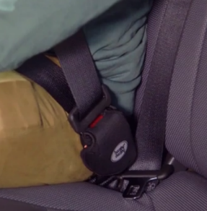
Mechanical restraint
Quotes from the films
- “Come on, we’ll take you to the bus”
- “He’s got ants in his pants”

“A day out” - In this scenario we see
Tom, Emma and Jordan are planning a day out. Jai tries to get Jordan’s attention but Jordan tells him to go away. Jai tries to get Jordan’s attention again so Jordan asks Lesley for support. She decides that Jai can wait in the bus. She clips Jai into his seat using a seatbelt lock and returns to the group. Later, when the group return from their trip, Jordan tells Jai he will come back to get him once they have unpacked the van.

Watch the scenario
- What did you observe?
- What impact do you think this has on the people involved?
- What would you question about this scenario?
- What could be done differently?

Watch part two - reflections
Listen to what others have observed. Think about how the points raised in the films relate to the people you support and discuss anything that might be done differently in the future.

Things to talk about
- Why does Lesley lock Jai in the van? What would have been a better way for her to support Jai?
- Can you think of any examples of mechanical restraint for people you support?
- Why are they used? Is there an alternative?
- What is in place to make sure that therapeutic devices or devices like seatbelt locks are not used outside of their prescribed use?
- Is this a reportable incident? An unauthorised restrictive practice?

More about mechanical restraint
The NDIS (Restrictive Practices and Behaviour Support) Rules 2018 define mechanical restraint as a practice:
“the use of a device to prevent, restrict, or subdue a person’s movement for the primary purpose of influencing a person’s behaviour but does not include the use of devices for therapeutic or non behavioural purposes.”
The use of mechanical restraint as a regulated restrictive practice must be a part of a positive behaviour support plan. A positive behaviour support plan needs to say when and for how long the mechanical restraint can be used. The positive behaviour support plan will introduce skills and strategies to work towards reducing the regulated restrictive practice.
Mechanical restraint might look like:
- Clothing which limits someone’s movement and which the person cannot remove.
- Velcro straps and belts.
- Seatbelt locks.
- Putting on a person’s wheelchair brakes so they can’t move if they want to.
- Mechanical restraint is the use of a device to limit someone’s movement or control behaviour.
The NDIS Commission has identified devices that cause harm to a person with disability can be identified as abuse and be against the law³. This includes but is not limited to: hand cuffs in any form; devices that stop a person’s legs/feet from moving; ropes used to tie hands or other body parts. Any device intended to cause harm or hurt a person with disability is considered abuse, must be stopped immediately and reported to the NDIS Commission within 24 hours.

Physical restraint
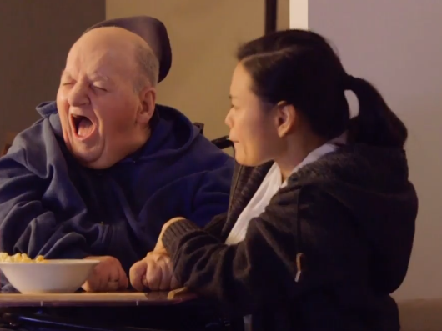
Quotes from the film:
- ‘I’ve never seen him like this before.’
- “He’s being doing this a lot lately. I just have to hold his hands until he calms down’

“Movie night” - In this scenario we see
Kim and Penny are visiting Tom in his new house. Whilst the group watch a movie Kim seems to hit himself in the face repeatedly. Tom and Jordan worry about Kim. Penny tells them that he has been doing this a lot lately, and that she just holds his hand down until he feels better. Penny pushes Kim’s arm down and holds it on his tray.

Watch the scenario
- What did you observe?
- What impact do you think this has on the people involved?
- What would you question about this scenario?
- What could be done differently?

Watch part two - reflections
Listen to what others have observed. Think about how the points raised in the films relate to the people you support and discuss anything that might be done differently in the future.

Things to talk about
- What are some of the reasons why Kim might be hitting himself?
- Is Penny helping or making things worse?
- How do you decide how to support someone who tries to harm themselves?
- What systems do you have in place to record changes in behaviour and share this information with staff and other relevant professionals?
- Is this a reportable incident?

More about physical restraint
The NDIS (Restrictive Practices and Behaviour Support) Rules 2018 define physical restraint as a practice:
“the use or action of physical force to prevent, restrict or subdue movement of a person’s body, or part of their body, for the primary purpose of influencing their behaviour. Physical restraint does not include the use of a hands-on technique in a reflexive way to guide or redirect a person away from potential harm/injury, consistent with what could reasonably be considered the exercise of care towards a person”
The use of physical restraint as a regulated restrictive practice must be a part of a positive behaviour support plan. There are many risks for the person and the staff when using physical restraint. Physical restraint should only be used as a last resort. This will be considered in the assessment and development of the positive behaviour support plan.
It is physical restraint when:
- A person’s hand is held down to prevent them from hitting themselves.
- Taking someone’s arm and pulling them in a direction they don’t want to go.
- Holding down a part of someone’s body to address a behaviour of concern.
Some physical restraints are prohibited practices, they must never be used. They can cause serious harm or death. The NDIS Commission lists the prohibited practices in the Regulated Restrictive Practices Guide.

Seclusion
Quote from the film:
- “Jai get out of the way or you’ll have to go back inside”

“Working in the garden” In this scenario we see
Tom, Emma, Jai, Greg and Jordan are in the garden, working and talking. Jai approaches Tom and stands in front of him. Tom is not sure what Jai wants so he asks Jordan, the support worker, to intervene. Jai takes holds of the rake that Tom is using. Jordan tells Jai he needs some time out and takes him inside away from the others. Later we see Jai looking through the window as everyone else carries on with the day.
Watch the scenario
- What did you observe?
- What impact do you think this has on the people involved?
- What would you question about this scenario?
- What could be done differently?

Watch part two - reflections
Listen to what others have observed. Think about how the points raised in the films relate to the people you support and discuss anything that might be done differently in the future.

Things to talk about
- What do you think is happening for Jai?
- How do you think he is feeling?
- What could have been done differently?
- Do you ever call ‘time out’ with people you support? Why does this happen?
- Are there people you support who don’t use words to communicate?
- What could you and your team do to better support people with different communication needs?
- Is this a reportable incident?

More about seclusion
The NDIS (Restrictive Practices and Behaviour Support) Rules 2018 define seclusion as the:
“sole confinement of a person with disability in a room or a physical space at any hour of the day or night where voluntary exit is prevented, or not facilitated, or it is implied that voluntary exit is not permitted”.
Like all restrictive practices seclusion should only be used when other strategies have not worked and as a last resort to keep people safe. The use of seclusion as a regulated restrictive practice must be a part of a positive behaviour support plan.
Seclusion might look like:
- being locked in a room or area, such as your home or backyard, and being unable to leave
- being left alone in a room and believing you can’t leave
- being unable to leave a room or area due to inaccessible door handles.
In some states and territories seclusion is prohibited for people under 18 years of age.

Power control
Power control is where a person uses their position of power or authority to control another person’s behaviour or make them do something.
Examples of power control include:
- being told not to move or to speak
- being told to sit down
- treating adults like they are children.

“Dinner time”
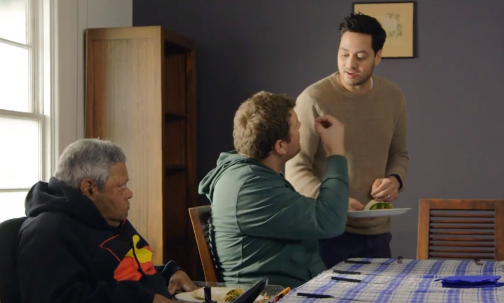
Quotes from the film:
- “Hands on your laps, everyone”
- “We are not kindergarten people.”

In this scenario we see
Tom has made souvlaki for his new housemates. Everyone sits down to eat at the table. Tom is about to start eating but Emma stops him. Jordan explains that they must wait until everyone is ready to start eating. Lesley tells everyone to put their hands in their laps. Tom is surprised at the way everyone is being treated but Emma is used to it.

Things to talk about
- How do you feel watching this film?
- Who do you think makes the rules in this house?
- Have you even seen any power imbalances like this in your job? How did you feel? What did you do?
- How do you support people to choose how they want their lives to be?
- Where do these practices sit on the Empowerment Circle: good, poor or abusive?
- If you were a new worker in this home how would you feel? What would you do? What would help you?

Consequence control
Consequence control is when someone uses warnings, threats or intimidation to make someone do what they want them to do.
Consequence control often involves threats about things, people or activities that are important to the person.
Examples include:
- personal threats involving relationships or possessions
- coercion or bribery
- punishment or implication of punishment

“Out for lunch”
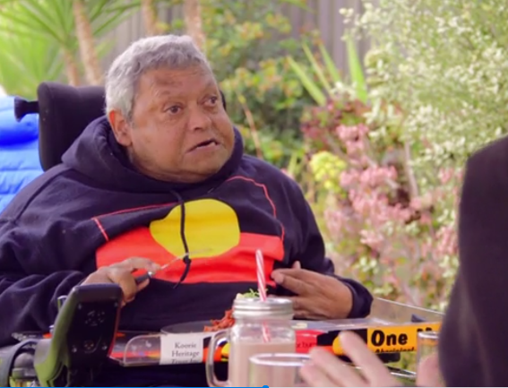
Quotes from the film:
- “Do you want me to call your brother and tell him that you can’t go to the footy tomorrow?”
- “It’s up to you. Your choice”

In this scenario we see
Ray and Lesley are having lunch at a café. Lesley tells Ray that they need to leave so she can finish her shift on time. Ray hasn’t finished his meal and doesn’t want to leave. Lesley asks Ray if he wants her to call his brother and cancel their planned day at the football. Ray thinks about this and reluctantly agrees to leave.

Things to talk about
- Lesley says “It’s up to you. Your choice.” Do you think this is true?
- How else might you Lesley have handled this situation?
- Have you seen examples of this kind of control in your work?
- Where do these practices sit on the Empowerment Circle: good, poor or abusive?
- What would you do if you saw an exchange like this between a colleague and someone you support? What would help you?
- How would you support Ray if he asked you about the lunch?

Find out more
Thank you for watching the Recognising Restrictive Practices films and working through this guide.
We hope that you found it useful in being able to identify when people you work with are restricted and in finding other ways to support people with disability.
Find out more about upholding human rights, preventing abuse and recognising restrictive practices in the Zero Tolerance a collection of resources.
In particular you may find these Zero Tolerance resources help identify and discuss restrictions on people’s rights:
- Understanding Abuse- Human Rights and You (eLearning program)
- Empowerment Circle
- Understanding Abuse Learning Bites: 3-5 minute videos addressing eight life areas in the Empowerment Circle
- Foundations of Positive Behaviour Support Films

The NDIS Quality and Safeguards Commission (the Commission)
Regulated Restrictive Practice Guide - the guide explains what a restrictive practice is, and sets out information on the five types of regulated restrictive practices.

National
Australian Government. (2014). National framework for reducing and eliminating the use of restrictive practices in the disability service sector.

See your Jurisdiction for information about authorisation
For information about authorisation for regulated restrictive practices and other practices your jurisdiction oversights please see you’re the legislative framework for your state or territory.

References
Australian Government. (2013). National Disability Insurance Scheme Act 2013. Retrieved from https://www.legislation.gov.au/Details/C2019C00332.
Australian Government (2014). National Framework for Reducing and Eliminating the Use of Restrictive Practices in the Disability Service Sector.
Australian Government. (2018). National Disability Insurance Scheme (Restrictive Practices and Behaviour Support) Rules 2018.
NDIS Quality and Safeguards Commission (2020). Regulated Restrictive Practices Guide. Penrith, Australia: NDIS Quality and Safeguards Commission. Accessed at https://www.ndiscommission.gov.au/document/2386 on the 8 December 2020.
Office of Professional Practice: Restrictive Interventions Self-Evaluation Tool (RISET) http://www.surveygizmo.com/s3/2741253/Has-a-Restrictive-Intervention-Occurred
Ramcharan, P., Nankervis, K., Strong, M. & Robertson, A. (2009). Experiences of restrictive practices: A view from people with disabilities and family carers. RIMT University.
United Nations (2006). United Nations Convention on the Rights of Persons with Disability.

