Developing a model for ‘communities of practice’ to align with the NDIS roll-out in Victoria
“Groups of people who share a concern, a set of problems, or a passion about a topic and who deepen their knowledge and expertise in this area by interacting on an ongoing basis”

1. Summary 2
2. Introduction 3
Response to the brief 3
Victorian context 4
3. Advice on setting up multi-sector Communities of Practice 5
The value proposition 5
In scope 5
Out of scope 6
Risks 6
Timing 7
Alignment 7
Proposed features of Community of Practice model 7
4. Proposed next steps 11
APPENDIX 1: Literature Review 12
What is a Community of Practice and what can it deliver? 12
Features of effective Communities of Practice 12
What do communities of practice do? 13
Adult learning principles and Communities of Practice 15
The “ten commandments” for a successful CoP – and five reasons for failure 16
Community development theory and communities of practice 16
What is not a Community of Practice? 17
An information science perspective 18
Outcomes from communities of practice 23
Online communities of practice 25
APPENDIX 2: Examples of effective cross-sectoral networks 26

1. Summary
The NDIS is a generationally significant movement to re-align disability services in Australia with the client or participant, and their carers, at the centre. This transforms the roles of provider organisations, funders, regulators, workers in the disability service sector and allied sectors, as well as of course the millions of community members who are likely to experience and engage with the new system.

This paper informs a project being led by National Disability Servives (Vic) as a member of a Collaboration Panel of relevant Victorian statewide and peak bodies. The project aims to establish a central coordination function to support the set up and operation of one or more communities of practice across Victoria, to help local service systems respond to changes required by the introduction of NDIS and National Aged Care Reforms.

While the extent and risks of system transformation are well canvassed, the rollout of the NDIS is an opportunity to build a more sustainable sector that delivers consistently high levels of care to people with disabilities. That is the promise behind this project.
Given the intense organisational activity associated with the roll-out of the NDIS, alongside My Aged Care, a not dissimilar reform, an obvious point of getting one or more Communities of Practice going is the opportunity to create hope, positive relationships and social learning among people who are feeling swamped by the business of reform and whose polices, systems and practices require significant updating.

There is extensive research literature on communities of practice, including material on how to design and run a successful network. Appendix One covers some of this material.

There are numerous cross-sectoral networks in Victoria that share some of the features of effective communities of practice (see Appendix Two for some examples). Readers are invited to reflect on examples, resource materials and critical success features of effective networks, to inform the development of a ‘backbone’ support structure within NDS, in collaboration with the other members of the Collaboration Panel.

It is proposed that the next step of preparing to launch communities of practice be split into two. The first step would be to explore the appetite for cross-sectoral practitioner development networks through one or more forum(s) in the rollout regions in early 2016 (suggestion of Feb or March 2016 onwards once the LAC tenders and referral arrangements become clearer).

At such forums the appetite for a future-looking agenda could be tested by utilising a prepared topic (e.g. “what could success look like for participants and workers, once the NDIS has rolled out”) and run event(s)hosted by key players in each of the early roll-out regions

The second step would be to finalise the project plan, develop an EOI if this is felt to be the best way to move ahead, agree the ‘community of practice backbone’ governance structure and relevant staffing and advisory arrangements, and go from there. Section 3 of this document provides a set of steps for consideration.

It may be useful to run the governance and relevant reference group arrangements for this project through a shared arrangement with the governance for the other 3 Collaboration panel projects funded by State Trustees Foundation.

2. Introduction

This report has been commissioned by National Disability Services (Vic) as part of a series of projects auspiced by a Collaboration Panel of key organisations, with the assistance of the State Trustees Foundation.

The members of the Collaboration Panel are senior representatives from: Council on the Ageing - COTA Victoria; Australian Federation of Disability Organisations – AFDO; National Disability Services- Vic Branch - NDS; Victorian community mental health services – VICSERV; Carers Victoria; Victorian Council of Social Service – VCOSS; Ethnic Communities Council of Victoria – ECCV; and representatives of State Trustees Foundation.

Response to the brief
National Disability Services (NDS) has been funded to meet a number of objectives as part of the “communities of practice project”.

The project proposed to identify and support 1-2 communities of practice through an Expression of Interest (EOI) process, structured to align with the geographic roll out of the NDIS in Victoria. The grant offered for the 2015/16 financial year will enable NDS to develop the necessary infrastructure to roll-out targeted cross-sector communities of practice networks in Victoria. The ongoing delivery of this project is contingent on further funding. The establishment of the central coordination function will be delivered via the following activities and deliverables.

- Research paper produced on effective models for cross-sector communities of practice
- Rationale: Further work needs to be undertaken to identify the most appropriate communities of practice model to meet project objectives. The final model will need to be appropriate for collaboration across multiple sectors and identify the necessary stakeholders to optimise the impact of the project. NDS will engage an external consultant to develop the report.

This paper provides advice on recommended features to consider in the model, with appendices offering literature review on community of practice models and success factors (Appendix One), and a number of examples illustrating some of the features operating here in Victoria (Appendix Two).

It was envisaged that approximately five conversations with key stakeholders would be undertaken to inform this paper, and all Collaboration Panel members were invited to offer feedback. While several people contacted didn’t respond, the insights of the following people who made themselves available have been invaluable, and there will be further opportunities as the project rolls out.
- Sarah Fordyce and Evan Wallace, NDS Victoria;
- Tony McBride, project consultant to VICSERV (with extensive experience in primary health)
- Kathy Pompetti, NDIS rollout coordinator, Whittlesea Council;
- Me’ ad Assan, Policy Officer, Ethnic Communities Council of Victoria;
- Mary Sayers and Dev Mukherjee, VCOSS;
- Jan Black, Senior Policy Advisor, MAV
- Cath McDonald, CEO, Radius (Bendigo).

- Release of research paper to key stakeholders and online publication
- Rationale: The research paper will be shared amongst key stakeholders to provide clarity on the project aims and the final network structure. The online publication of the paper will raise the profile of the project across the support services sector and in the wider community.

This paper is written with an intention that it be shared among stakeholders to raise the profile of the project, and provide clarity on the project aims and rationale for the proposed structure. The suggested approach is to run forums in the three regions in early 2016, to test sector appetite, before taking the next steps to further structure up the model.

The brief envisaged that the subsequent stage of the project would be the creation of a Monitoring, Evaluation and Learning (MEL) framework (which would provide the basis for proposed ‘action research’ activities as part of the project’s ongoing work) and initial evaluation of the project; plus allocation of an NDS staff member project coordinator to establish the coordination function and provide upfront support to networks.

Victorian context
The Victorian rollout of the NDIS has been announced. The next locations are:

- North Eastern Melbourne with an Agency office based in Whittlesea (Local Government Areas of Banyule, Darebin, Nillumbik, Whittlesea and Yarra) phasing in from July 2016;
- Loddon with an Agency office based in Bendigo (comprising the Local Government Areas of Campaspe, Central Goldfields, Greater Bendigo, Loddon, Macedon Ranges and Mount Alexander) phasing in from November 2016;
- Central Highlands with an Agency office based in Ballarat (comprising the Local Government Areas of Ararat, Ballarat, Golden Plains, Hepburn, Moorabool and Pyrenees); phasing in from January 2017.
The Local Area Coordination (LAC) tendering process for the NDIS is currently underway and disability providers are excluded from this program. It is assumed that once the tenders are announced for the LAC, the context will settle down somewhat.

Aside from the wider social, economic and environment context for this project, the policy context is one of significant change. It has been clear that managers in the disability and related community and health sectors in Victoria are busy with NDIS readiness and other systemic change activity, largely brought on by changes to government funding and policy across numerous areas. The DSS tendering process of late 2014 was a difficult time for many community sector organisations and inter-organisational competition to position for various tendering processes will presumably impact the capacity to participate in a Community of Practice, which implies sharing of knowledge and organisational IP.

The nature of cross-sectoral collaboration in regional areas is traditionally very different to that in metro Melbourne. With this in mind, regional perspectives and contributions to collaborative, systemic innovation will need to be fully explored. The different contexts of service providers also include diversity of service availability (in some locations there is no “choice” it is more a question of continuing viability of providers in the new paradigm); the mix of small versus larger organisations; and a wide range of historical and cultural attributes between organisations and sectors that feed collaboration and capacity development to differing extents.

3. Advice on setting up multi-sector Communities of Practice

The value proposition
A value proposition is required. The proposition is that consumer-driven support is itself a new business model for most NFPs in the space and that sector organisations have an interest in this, whether or not they are transitioning into, or seeking to position around the new funding model themselves.

The inference of the term “community of practice” is a model of engagement and professional or organisational capacity development that goes beyond information sharing on how the scheme is/ will operate. Some of this information is readily available while the availability of other information will attract organisational attendance at a sector network meeting or similar for an update.

There are many sector and cross-sectoral practitioner networks across Victoria, however evaluation material regarding the outcomes and sustainability features of cross-sectoral networks is not easily available, and many of them do not meet the criteria for a Community of Practice, according to the literature review (see Appendix One).

While some of the literature relates to intra-organisational communities of practice (authorised and directed to exist by executive management), the context of this model is one where participants will need to be persuaded to attend, not directed from above. Even where senior managers of organisations make it a priority, the nature of community, health and disability sector work means, realistically, that participants will need to justify attendance as they view their diary for the week of a meeting.

Expectations from the early conversations indicate that it will be important to ensure the CoP model is “not driven by organisational survival” and does drive a wider vision of better lives for people, and more inclusive communities for people with disabilities and their families. A desire has been expressed for a system that offers real “choice”, and reflects “a responsive, sustainable service system”. There have been slightly different views expressed about the extent to which organisational survival, rather than an “aspirational” approach, between different sectors (e.g. mental health, disability, aged care and so on) will or won’t drive an effective community of practice. While it will be imperative to include disability service providers and local government in considering workforce challenges and quality and compliance issues in the new era, some felt that the agenda must not be solely driven by these organisations, and must include the capacity development of mental health and aged services, other community and health services, advocacy and consumer organisations and service users and carers.

There are a diversity of cross-sectoral alliances and collaborative governance structures in operation in Victoria and plenty of literature available on participatory evaluation of collaboration structures that gives voice to the diversity of participants. Some of these examples could be utilised as the stepping off point for a cross-sectoral community of practice model that offers unique value to participants. See Appendix Two for some of the examples provided.

In scope
- Agenda driven by the Collaboration Panel operating principles (I understand these are currently under discussion);
- Sharing system analysis, policy critique and engagement with government bodies
- Practice development: showcasing cross-service, cross-sectoral innovation on issues of common interest;
- Highlighting opportunities for collaboration to achieve the intent of the NDIS (upstream social benefits including for participants and non-participants of the NDIS)
- Relationship building to engage in shared program development outside of the community of practice
- While Aged Care reform is on the agenda the community of practice roll-out is primarily focused on the NDIS roll-out sites in Victoria
- Trouble-shooting of operational issues and stimulation of conversations on service innovation
Possibly:
- Conferences and forums on key topics – where the purpose is the development of a community of practice not a generic information sharing purpose
- Regular electronic information sharing – status of government policy and NDIS roll-out, as part of wider network strengthening service

Out of scope
- Information-sharing network or forum;
- Government policy consultation event (using the captive audience);
- Governance arrangement for program delivery, collaborative or otherwise;
- Operational planning or management decision-making meeting.
- NDS member forum. NDS, as a peak body for disability service providers, would continue to offer organisational readiness/transition supports to organisations that are offering disability-specific services. Operational support, opportunities to develop alliances and partnerships, structural critique/advocacy and pricing, evaluation systems, ICT system development are all part of the NDS organisational transition offer, and while such member gatherings may offer a community of practice to NDS members it wouldn’t officially qualify as a “cross-sectoral community of practice”.
- Direct coordination of service delivery tenders and funding proposals

Risks
- Assuming the topics and content are adequately curated, the operational risks associated with governing or managing services are neglible within a community of practice model, as any governance of service delivery or disability-specific services meeting would be a separate endeavour to a cross-sectoral “community of practice”.
- However, the risk of irrelevance is more considerable - if the agenda, priorities, chairing and depth of attendance are not sufficiently compelling for participants to justify attendance on a regular basis, this will limit the network to ad hoc information sharing. Such a role may be useful but does not meet the criteria for a “community of practice”.
- The project assumes resourcing for 2 communities of practice to be supported for 2 years each. This opens the usual risk of unsustainable funding for a highly valued project, or excess demand and inadequate resourcing for what is undertaken within the time period. It will be important to balance the time used to effectively support and service participants with documentation of project outputs in order to secure resources for future development, and the governance structure will need to monitor this closely.
- Contributions of expertise and experience will need to be balanced – across the traditional divides – metro-regional; service provider-user; professional paradigms shared and respected across the participating sectors.

Timing
- Perspectives from people spoken to in October/November 2015 described a feeling that the extent of change is causing providers to turn inwards to clarify what they propose to deliver, and with a level of uncertainty as to who their future clients will be, a limited interest in sharing information in cross-sectoral forums or networks. “We are swamped with pricing, costing and staffing”. One person said this was not the case and that both smaller and larger organisations would be feeling highly collaborative as they can see “the writing on the wall”.
- There is a general view that as the various service offers become clearer, there will be greater appetite to share information and confirm referral pathways in, out, and between providers in the new system. Conversations suggest that February or March 2016 is a time when a forum might be held to test the appetite for a community of practice in each of the 2016-17 rollout areas.
- Therefore, the wider appetite for a community of practice model does need further testing before it is rolled out.

Alignment
It is proposed that the project be built off the edge of other cross-sectoral projects or initiatives, ideally aligned with the timing, meeting schedules and topical priorities of other relevant cross-sectoral activity, potentially including alignment with the NDIS Agency regular consultations or other forums.

The fact that other Collaboration Panel sector capacity development projects are also underway (i.e. good practice case studies and cost analysis; training packages to promote adoption of consumer led delivery; and feasibility assessment to better support cross-sector learning and development) means there is an opportunity to set up collaborative governance and reference structures to support several projects at once.

Proposed features of Community of Practice model

Why and What
Leadership intent and roles

Agree on vision and purpose
The term community of practice (CoP) assumes a shared move towards a new business model (client or participant-driven support) and an approach that goes beyond information sharing into practice development and shared development of practice knowledge.

This vision would be articulated up-front. For instance, a desirable vision might be that all members of our community are empowered to access opportunities and supports as they need them, in a timely and affordable way.

- What are the strategic objectives and key topics for focus?
- Clarity on balance between system critique and policy-advocacy role (“our obligation is to identify where the rubber hits the road and advocate to ensure a sustainable system is rolled out”), as compared with a less critical capability development of practitioners/ participants (“working with what we’ve got”)
- What is the role of government, the sector, people with disabilities and their carers, and others?
- Confirm who will act as a leadership group and who to invite in

Set up governance structure
- Agree roles for members of the Collaboration panel (governors, advisors? project champions?)
- Who is the Chair, and how will they drive and promote the community of practice model?
- Enrol initial group.
- How will external demands for time and space by the CoP be negotiated (e.g. requests by government for briefing meetings with the network, that may take the agenda off course)

Outcomes and evaluation readiness
- Clear up-front re what is shared intent. Will people with disabilities and their carers experience the services and opportunities in our community differently as a result of effective collaboration by the partners?
- Agree ways to identify and measure these outcomes
- Social ROI for funders?

Led by the practitioner community
PWDs and carers should be invited to be co-designers, informants and or advisers to the cross-sector practitioner agenda. To succeed as a community of practice, practitioner participants will need to feel ownership of process and activities.

Clear vision and purpose that is shared/agreed by participants
An example: (from the higher education sector in lit review):
- Connect people who might not otherwise interact;
- Provide a shared context for people to communicate and share information, stories, and personal experiences in a way that builds understanding and insight.
- Enable dialogue between people who come together;
- Stimulate learning by serving as a vehicle for authentic communication, mentoring, coaching, and self-reflection.
- Capture and diffuse existing knowledge to help people improve their practice by providing a forum to identify solutions to common problems and a process to collect and evaluate best practices.
- Introduce collaborative processes to groups and organizations as well as between organizations to encourage the free flow of ideas and exchange of information.
- Help people organise around purposeful actions that deliver tangible results.
- Generate new knowledge to help people transform their practice

Who

Membership/audiences
- Agree who is core membership and who to invite in/communicate with.

Currently, NDS is an important source of information and insight as to how the NDIS rollout is occurring, as are the staff and managers of disability service organisations in rollout sites. However, for non-disability organisations, many “don’t know what they don’t know” about the relevance of the NDIS and Aged Care reforms.

The audiences would include:
- Non-disability service providers - community and health service organisations in NDIS roll-out locations, servicing clients with disabilities (some of whom may participate in LAC rollout, others may not) e.g. community health, financial counselling, community legal, housing and homelessness org’s, AOD and community mental health program providers, major regional community service providers, Aboriginal Controlled child and family/ health orgs.
- Disability advocacy, referral organisations/networks
- Disability service providers
- Carer support organisations and carer advocates
- ‘Friends of the NDIS’ rollout – potential philanthropic and local, state or Commonwealth government representatives seeking insights into the roll-out

Consumer participants/ clients/service users provide clear voice and develop a co-design role
- Structure needs to support co-design
- Option for co-chair or advisory panel to enable user-centred discussion, while also creating a learning and practice development space for practitioners

Structured agenda, topics and invitations to ensure diverse (preferably regular) representation
- Disability service providers
- Disability Advisory structures/metro access
- Disability advocacy/self-advocacy
- Ageing – facilities based and home-care (e.g. HACC /aged service forum)
- Local government other
- Housing and homelessness
- Settlement / refugee services
- Primary and community health
- Mental health
- Family Violence services
- Alcohol and other drug treatment services
- Emergency relief
- Early childhood
- Child, youth and families
- Justice/community legal
- Neighbourhood house

How

Resourced adequately
- Resourced by a dedicated person/organisation who is seen as ‘honest broker’ or “best practice control agent”
- Effective networks do not run themselves. Administrative, thought leadership and chairing/convening role is minimum resource requirement, plus production of materials and resources to maintain productivity of the network

Documentation and administration support
- Record expectations early on, together with notes, materials and minutes that support information flow within the network
- Collate and maintain documents to service external accountability and outcomes evaluation processes

Inclusive structure and process
- Face to face and online
- Time and frequency of meetings
- Leadership, support roles for the group
- Participation would be free, ideally with a core group of regular participants who meet face to face at agreed times, with a limited amount of paid/sponsored administrative support, to maintain the network and avoid key convenor being over-loaded.
- Papers and shared material would resource a larger online network, some of whom might ‘drop in and out’ and others would primarily be corresponding members only, especially where large travel times are involved.

With an agreed charter/operating culture across the network
- Purposeful and well resourced
- Frequency and duration of meetings and other communications, based on the urgency and importance and the benefits achieved
- Grow professional development and network capacity
  - Trust and appreciation of respective contributions within the network
  - Surface and resolve conflicts (and maintain relationships when other inter-organisational relationships might be competitive)
  - Enable development of capability among participants and the overall capacity of the network/local community
  - Creates a positive narrative through continuity of participation by key people

When

Clear scope and calendar
- Agreed priorities and topics/resource people for diary dates e.g. “Enhancing referral pathways for NDIS participants in our region”
- Calendar of speakers/presenters agreed for the year ahead, with some external expertise, enabling learning for all (new information to all members) as well as information and experience sharing across the network (where internal members asked to present).

Communications plan
- Online calendar
- Online and face to face resource sharing
- Newsletter
- Feed other cross-sectoral networks and forums with material, (particularly other NDIS roll-out sites) to inform others and raise the profile of the project
- Feed results outwards and within the network

4. Proposed next steps

Once the Collaboration Panel has responded to this paper and a proposed model and approach endorsed, it is recommended that the next step is to organise a forum with a stimulating, future-oriented topic (e.g. “what could success look like for participants and workers, once the NDIS has rolled out”) hosted by key players in each of the early rollout regions. The proposition for the community of practice model would be discussed at such a forum and the appetite to be involved explored with participants.

One option for NE metro might be an event hosted by Whittlesea Community Futures, or the NE Local Government NDIS roll-out coordination structure (convened by City of Banyule), followed by events in Bendigo (possibly hosted by Radius as part of the strategic alliance with Mind and Haven Housing) and Ballarat (hosted by Collaboration Panel members based there.

In the meantime, the governance and reference group arrangements for the community of practice model needs to be confirmed: an option is to run the four projects with a common governance/reference structure.

APPENDIX 1: Literature Review

What is a Community of Practice and what can it deliver?
This section outlines Community of Practice (CoP) models and processes from desktop review of literature and in the light of this, consider what is not a Community of Practice. A number of critical features /evaluation factors are outlined at the end of this section.

Features of effective Communities of Practice
There are numerous potential fields of knowledge and sectors to consider in a literature review about ‘Communities of Practice’. There is a multitude of management literature, organisational psychology, organizational change and group work and strategic foresight theory; there is community development theory and practice, movement action planning, social network theory, community and adult education theory; and there is the application of theory within different sectors ranging from information science through to public policy reform including healthcare; and there is the work of community activists and human rights workers, whether based in First Nation Canada, African America, or within global cultural activism or disability advocacy sectors.

This short review simply picks a few key themes and features, deemed of relevance to a model for a community of practice developed to help realise the promise of the NDIS within the roll-out regions as determined by government. The author’s bias is as an able-bodied, Caucasian female migrant with training in Strategic Foresight and natural ecological systems, and experience of work in community development, global education, organisational development and social policy advocacy over thirty years.

Communities of practice have been described as “groups of people who share a concern, a set of problems, or a passion about a topic and who deepen their knowledge and expertise in this area by interacting on an ongoing basis”

In the business literature, communities of practice are frequently resourced within large companies or sectors, to enable innovation and social learning. Manufacturing, technology development and higher education are just a few sectors canvassed and described in management literature.

Etienne Wenger described the constitutive dimensions of mutual engagement, joint enterprise and shared repertoire comprising four or five indicators.

Dimension | Indicators of a community of practice
Mutual engagement | 1) Sustained mutual relationships - harmonious or conflictual.  2) Shared ways of engaging in doing things together.  3) The rapid flow of information and propagation of innovation.  4) Absence of introductory preambles, as if conversations and interactions were merely the continuation of an ongoing process.  5) Very quick setup of a problem to be discussed.
Joint  enterprise | 6) Substantial overlap in participants' descriptions of who belongs.  7) Knowing what others know, what they can do and how they can contribute to an enterprise.  8) Mutually defining identities.  9) The ability to assess the appropriateness of actions and products.
Shared repertoire | 10) Specific tools, representations and other artifacts.  11) Local lore, shared stories, inside jokes, knowing laughter.  12) Jargon and shortcuts to communication as well as the ease of producing new ones.  13) Certain styles recognised as displaying membership.  14) A shared discourse reflecting a certain perspective on the world.

Figure 1: Indicators that a community of practice has formed (Source: Adapted by E Murrilo from Wenger, 1998:

Enrique Murillo describes a full-length ethnography of a public defenders' county office where the legal staff developed a strong community of practice to share information, provide emotional support and learn from each other. The book proposes a specific definition of communities of practice as 'collaborative, informal networks that support professional practitioners in their efforts to develop shared understandings and engage in work-relevant knowledge building' In addition, the author proposes a framework for communities of practice comprised of six distinct attributes:
- A group of professional practitioners;
- Development of a shared meaning;
- Informal social networks;
- A supportive culture involving trust;
- Engagement in knowledge building; and
- Members' negotiation and development of professional identities

What do communities of practice do?

“Communities of practice are groups of people who share a concern or a passion for something they do and learn how to do it better as they interact regularly”.

Wenger-Trayner run a website with extensive open-source resources. This section is a cut and paste from their easy-to-read material:

  - “The domain: A community of practice is not merely a club of friends or a network of connections between people. It has an identity defined by a shared domain of interest. Membership therefore implies a commitment to the domain, and therefore a shared competence that distinguishes members from other people. (You could belong to the same network as someone and never know it.) The domain is not necessarily something recognized as “expertise” outside the community. A youth gang may have developed all sorts of ways of dealing with their domain: surviving on the street and maintaining some kind of identity they can live with. They value their collective competence and learn from each other, even though few people outside the group may value or even recognize their expertise.

  - The community: In pursuing their interest in their domain, members engage in joint activities and discussions, help each other, and share information. They build relationships that enable them to learn from each other; they care about their standing with each other. A website in itself is not a community of practice. Having the same job or the same title does not make for a community of practice unless members interact and learn together. The claims processors in a large insurance company or students in American high schools may have much in common, yet unless they interact and learn together, they do not form a community of practice. But members of a community of practice do not necessarily work together on a daily basis. The Impressionists, for instance, used to meet in cafes and studios to discuss the style of painting they were inventing together. These interactions were essential to making them a community of practice even though they often painted alone.

The practice: Members of a community of practice are practitioners. They develop a shared repertoire of resources: experiences, stories, tools, ways of addressing recurring problems—in short a shared practice. This takes time and sustained interaction. A good conversation with a stranger on an airplane may give you all sorts of interesting insights, but it does not in itself make for a community of practice. The development of a shared practice may be more or less self-conscious. The “windshield wipers” engineers at an auto manufacturer make a concerted effort to collect and document the tricks and lessons they have learned into a knowledge base. By contrast, nurses who meet regularly for lunch in a hospital cafeteria may not realize that their lunch discussions are one of their main sources of knowledge about how to care for patients. Still, in the course of all these conversations, they have developed a set of stories and cases that have become a shared repertoire for their practice.

Communities develop their practice through a variety of activities. The following list provides a few typical examples:

- Problem solving: “Can we work on this design and brainstorm some ideas; I’m stuck.”
- Requests for information “Where can I find the code to connect to the server?”
- Seeking experience “Has anyone dealt with a customer in this situation?”
- Reusing assets “I have a proposal for a local area network I wrote for a client last year. I can send it to you and you can easily tweak it for this new client.”
- Coordination and strategy “Can we combine our purchases of solvent to achieve bulk discounts?”
- Building an argument “How do people in other countries do this? Armed with this information it will be easier to convince my Ministry to make some changes.”
- Growing confidence “Before I do it, I’ll run it through my community first to see what they think.”
- Discussing developments “What do you think of the new CAD system? Does it really help?”
- Documenting projects “We have faced this problem five times now. Let us write it down once and for all.”
- Visits “Can we come and see your after-school program? We need to establish one in our city.”
- Mapping knowledge and identifying gaps “Who knows what, and what are we missing? What other groups should we connect with?”

“While they all have the three elements of a domain, a community, and a practice, they come in a variety of forms. Some are quite small; some are very large, often with a core group and many peripheral members. Some are local and some cover the globe. Some meet mainly face-to-face, some mostly online. Some are within an organization and some include members from various organizations. Some are formally recognized, often supported with a budget; and some are completely informal and even invisible.”
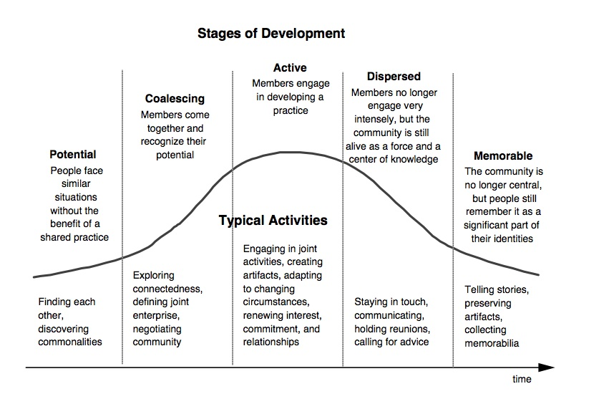
Figure 2: Typical activities of communities of practice at different stages of development.
Source: Etienne Wenger, in the “Systems Thinker” June 1998.

Adult learning principles and Communities of Practice

Communities of Practice are social learning environments so adult learning and educational delivery considerations presumably inform facilitation and design.

Adult learning principles highlight the need to have the right balance between open discussion and problem –solving to ensure engagement.

Adults are:
- Autonomous and self-directed
- Bring prior knowledge and experience
- Want relevant and practical material
- Goal-oriented
- Problem-oriented and want to apply what they have learnt
- Motivated by intrinsic and extrinsic factors
- Pressed for time
- Have different learning styles (i.e. visual, tactile, aural)

The learning stages of individuals need to be considered. Creating a learning environment is different to creating a decision-making environment.

The four individual learning states (adapted from various sources)

Conscious Incompetence
Challenge to self-esteem/some stress. Recognition of need to learn more.

Unconscious Incompetence
Don’t know what I don’t know – awaiting provocation.

Conscious Competence
Knowledge affirmed. Practicing and articulating knowledge to keep developing.

Unconscious Competence
Develop mastery by being challenged through sharing, showing or teaching others.
A successful CoP
According to Gilbert Probst and Stefano Borzillo’s review of 57 communities of practice within large European and American organisations (mainly large companies such as Oracle, PWC and Siemens, but also public sector organisations such as the World Bank and the UN); there are a number of common contributors to success. They are:
- Stick to strategic objectives
- Divide objectives into sub-topics
- Form governance committees with sponsors and COP leaders
- Have a CoP sponsor and CoP leader who are “best practice control agents”
- Regularly feed the CoP with external expertise
- Promote access to other intra-organisational and inter-organisational networks
- The CoP leader must have a driver and promoter role
- Overcome hierarchy-related pressures
- Provide the sponsor with measurable performance
- Illustrate results for CoP members

Their five reasons for failure are:
- The lack of a core group
- Low level of one-to-one interaction between members
- Rigidity of competences
- Lack of identification with the CoP
- Practice intangibility

Their six components for governance are therefore: objectives, sponsorship, leadership, boundary-spanning, risk-free environment and measurement.

Community development theory and communities of practice
A review of the theories underpinning community development, community organising, community action, social planning and action, community capacity building and community strengthening practices are beyond the scope of this paper, however the balance between a concern with social and economic development, the fostering and capacity of local co-operation and self-help and the use of expertise and methods drawn from outside a particular community (however defined) are worth extrapolating into this context.
To what extent would a CoP associated with ‘consumer-driven practices in the NDIS’ enhance wider systemic economic and social development, empower and build the capacity of service participants, whilst also itself exercising help –seeking behaviours and incorporating expertise and methods from elsewhere?
Clearly an effective CoP needs to enhance social learning among a group of adults, therefore all participants need to experience several of these cognitive states to maintain participation, and the community is built through shared insight and development.
First Nations people in Canada refer to Gramsci and the role and importance of ‘organic’ intellectuals in their cultural and historical context, and go on to use Etienne Wanger and Jean Lave models regarding CoP. The context for this approach to community leadership activity is highlighted.

“The majority of people living in North Central here in Regina are First Nations (Indian), and Metis. For over one hundred years and many generations their futures have been pre-determined. The dominant culture (White) has done its best to colonize these peoples into something that they are not, White. It is time to let Aboriginal cultures find their own way and future. So, any organization who tries to "clean up North Central" must ask themselves this, "Whose future do we want them to have? Theirs or ours? Showing this oppressed community that they can do it gives them dignity. Showing outside communities that they can do it gives them respect.” Source: Heart of the Nations Learning Community
Tony Vinson and Margot Rawsthorne’s principles of community efficacy may also be worth applying to this context. Also, their four principles recommended for utilisation in responding to disadvantaged locations (published in Jesuit Social Services/Catholic Social Services’ Dropping off The Edge 2015) are Persistence, Knowledge, Extra-communal resources and Community-level changes.

What is not a Community of Practice?
In a review of the coverage of ‘communities of practice’ in management literature, Enrique Murillo noted that “the literature reveals a large number of studies that rely on condensed or abridged definitions, lack a theory-grounded model, or mistake communities of practice with other social structures that somehow feature knowledge sharing, such as occupational communities, professional associations, epistemic cultures, or networks of practice”

Murillo went on to say, ”Researchers have accepted the concept as an enduring element in the knowledge-based view of the firm, but practitioners have mostly used it in fashionable management discourse, specifically as a knowledge management tool, resulting in numerous publications based on pragmatic interpretations of the concept.”

He also said, “Further confusion has been introduced into the literature by a number of competing designations for essentially the same social phenomenon or some aspect of it, including communities of knowing, strategic communities, knowledge networks, communities of coping and knowledge communities.”

The up-shot of this is that various social learning and development structures have been designated the title as ‘Community of Practice’ in various sectors, but the title is often applied in settings where expectations of deliverables on members of the group have reduced the creativity and social learning, energy has dissipated, and the structure is not sustainable. However, if there isn’t some sense of ‘burning platform’, people clearly won’t feel motivated to attend.

The extent to which urgent events motivate - or unduly stress - members of a group is articulated in discussion of response to climate change, world conflict and in emergency management literature. In reviewing “Internal Crisis as an Impediment to Futures Thinking” while the roll-out of the NDIS is hardly the same as the aftermath of the Fukushima earthquake and nuclear power emergency in 2011, an interesting theme in this article is that the self-esteem of the individual, and the organisation/institution in which one is placed, is challenged by impending or actual crisis. In order to conceive and secure positive things in the future, there needs to be enough sustenance of self-esteem and sense of hope for members to maintain their participation, at individual, organisational and industry level.

This suggests that difficult issues do need to be canvassed in order for innovative solutions to emerge. However, the tenor of discussion in an effective community of practice will need to be agreed beforehand to enable space for venting and release by participants if necessary, before moving to a hope-generating dynamic.

In summary, the following structures are unlikely to operate as a Community of Practice:
- Information-sharing network or forum – one-off or regular;
- Government policy consultation event;
- Governance arrangement for program delivery, collaborative or otherwise;
- Operational planning or management decision-making meeting.

An information science perspective

Social network theory considers people and their relationship with artefacts (e.g. information processing technology) and writers such as Nardi and others draw attention to the asymmetry of people with objects. The chart below indicates an orderly process that is widely used in project planning and program logic. The reality is of course more complex as social networks don’t operate in the logical, linear way of an information science project plan. The researchers assert, “the network is modelled as a graph, consisting of a set of nodes and edges, where each node represents a user and an edge represents a relationship between a pair of nodes However, social network theory blurs the boundaries of these ‘nodes’ or agents.”

In other words, a project plan and an actual community of practice will look and feel different, and the logic that is used to describe the model will require evaluation indicators that reflect both the efficiency and effectiveness of the modes as well as the relationships between the people.

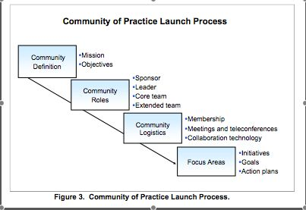
Figure 4: Community of practice launch process. Source: comments on “networks of people versus networks of artefacts” 1 January 2007.

How others have set up a Community of Practice

Closer to the health and community service sector, the Canadian Healthcare Education Commons (CHEC) has published resources to build an active online community

The following diagram shows a simple way to visualise the work required: it requires initiators to visualise the community, consider what is the compelling idea that will motivate the group to work together, agree who will be allowed to join, define the audience, add content that members will use and enjoy, and establish parameters for participation.
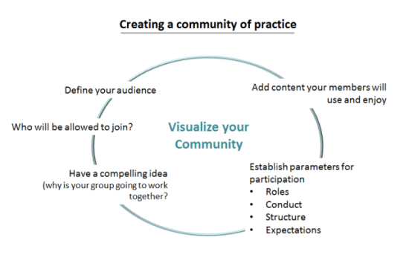.
Figure 5: Creating a community of practice. Source: Canadian Healthcare Education Commons (viewed November 2015).

There are numerous examples of communities of practice written up from within the higher education industry. The infographic below might be useful to consider, entitled the ‘helix of change’ - it offers a variety of roles for participants to consider for themselves.

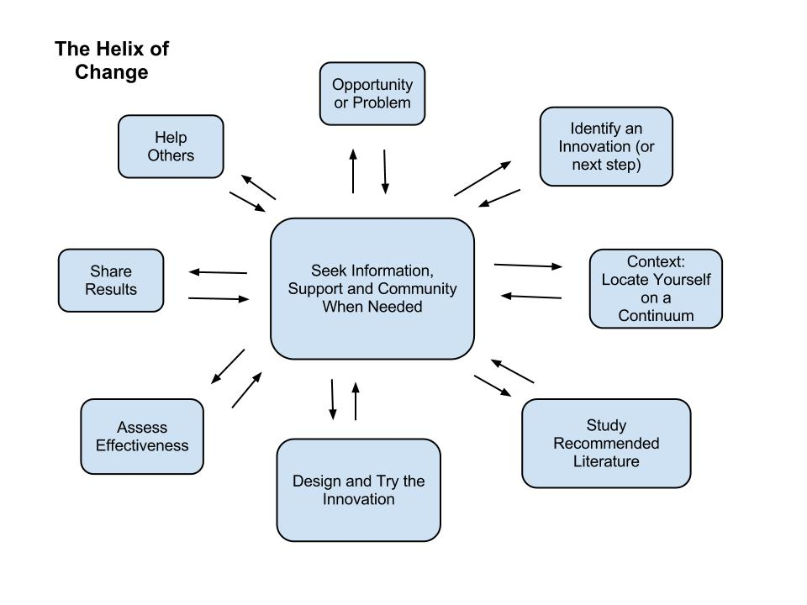
Figure 6: The Helix of Change. Source: Building communities of practice in higher education.

Another higher education example (below) has six articulated phases, adapted from Richard McDermott (a colleague of Etienne Wenger) in 2002. The authors of this step-by-step guide for designing and cultivating communities of practice note that “without conscious facilitation, momentum may be lost during the launch phase and the CoP may not achieve the critical mass needed to evolve into a sustainable entity”.
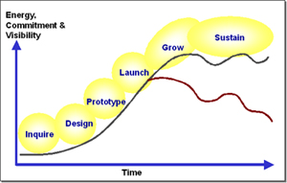
Figure 7: Lifecycle phases of a community of practice. Source community of practice design guide
The lifecycle phases include:
Inquire: Through a process of exploration and inquiry, identify the audience, purpose, goals, and vision for the community.
Design: Define the activities, technologies, group processes, and roles that will support the community’s goals.
Prototype: Pilot the community with a select group of key stakeholders to gain commitment, test assumptions, refine the strategy, and establish a success story.
Launch: Roll out the community to a broader audience over a period of time in ways that engage newcomers and deliver immediate benefits.
Grow: Engage members in collaborative learning and knowledge sharing activities, group projects, and networking events that meet individual, group, and organizational goals while creating an increasing cycle of participation and contribution.
Sustain: Cultivate and assess the knowledge and “products” created by the community to inform new strategies, goals, activities, roles, technologies, and business models for the future.

Outcomes from communities of practice
The higher education community of practice design guide mentioned above states that communities of practice are important because they:
- Connect people who might not otherwise have the opportunity to interact, either as frequently or at all.
- Provide a shared context for people to communicate and share information, stories, and personal experiences in a way that builds understanding and insight.
- Enable dialogue between people who come together to explore new possibilities, solve challenging problems, and create new, mutually beneficial opportunities.
- Stimulate learning by serving as a vehicle for authentic communication, mentoring, coaching, and self-reflection.
- Capture and diffuse existing knowledge to help people improve their practice by providing a forum to identify solutions to common problems and a process to collect and evaluate best practices.
- Introduce collaborative processes to groups and organizations as well as between organizations to encourage the free flow of ideas and exchange of information.
- Help people organize around purposeful actions that deliver tangible results.
- Generate new knowledge to help people transform their practice to accommodate changes in needs and technologies.
A key outcome mentioned under sustaining a CoP of this kind is “persistence of presence” and evidence that the community’s audience, purpose, goals and domain shift reflect the expectations and needs of members. Clearly, if the shared vision of an NDIS regional CoP is to drive client-centred care (or similar), an outcome for evaluation will be whether participants (and potentially non-participants) feel this is being advanced through the CoP.

6. Sustain
Cultivate and assess the learning, knowledge, and products created by the community to inform new strategies, goals, activities, roles, technologies, and business models for the future.
Key Questions to Explore | Supporting Activities
- What are the ongoing community processes and practices that will contribute to the liveliness and dynamism of the community and keep members engaged?  - How does the community support members across a wide range of roles?  - How are new potential community leaders (official and unofficial) going to be identified, chosen, developed, and supported by the community?  - How is persistent community “presence” maintained in the minds of the community members?  - To what extent is the community serving its intended audience and accomplishing its stated purpose and goals? How might it do a better job?  - How does the community demonstrate return on investment (ROI) for its sponsor(s)?  - From the perspective of each individual community member and from that of the community as a whole, what is the perceived return on participation?  - How should the knowledge and products created by the community be shared beyond the community? | - Provide opportunities in the community for members to play new roles, experiment with new community activities, and examine new technology features.  - Develop a support infrastructure including documentation, mentoring, and development as well as recognition programs for different roles.  - Ensure that procedures, practices, and the technology support structured data sharing.  - Identify opportunities for capturing new knowledge, including establishing new roles related to harvesting and creating best practices (e.g., “gardeners,” summarizers, synthesizers).  - Develop policies and processes for harvesting and sharing knowledge outside the community.  - Encourage publication of articles about the community and its projects.  - Test for “persistence of presence” by evaluating member and group activity reports as well as member focus groups and surveys.  - Review community audience, purpose, goals, and domain; watch for shifts in expectations and needs.

Figure 8: Example of exploratory questions and activities for a specific phase in the life cycle of a community of practice.

Online communities of practice

A common feature of the literature is the focus on social/online learning and online communities of practice. A typology of social forms for learning is shown in the example below.

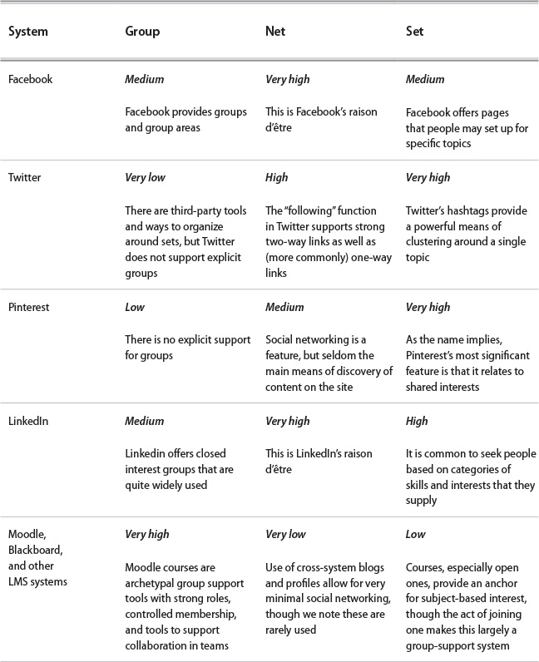 Figure 9: Support for social forms in some common social software.

APPENDIX 2: Examples of effective cross-sectoral networks

From Sarah Fordyce - NDS Network for Quality 2009-2010
The Network for Quality Project has three goals. The project is designed to give agencies opportunities to establish and sustain:

- Networks focused on leadership from experienced agencies to build capacity to implement the Quality Framework and prepare for independent monitoring.

- Networks that develop innovative and collaborative knowledge management strategies to support documentation of quality processes.

- Networks that focus on building organisational capacity in effective change management to engage staff of their agencies in implementing the Quality Framework and preparation for independent monitoring.

Project outcomes are that Disability Service Providers will be:

- More confident about their organisation’s capacity to meet Industry and Outcome Standards
- More confident about their organisation’s readiness for independent monitoring.
- Successful in implementing the Quality Framework and meeting independent monitoring requirements

Write-up is on the NDS website.

Examples of effective cross-sectoral forums with elements of ‘community of practice’

From Kathy Pompetti: Whittlesea Community Futures
- Convened by Council
- 30 orgs, plus metroaccess… 4 working groups/clusters and a fifth cluster - Disability Working Group (service providers only) plus
- Whittlesea Disability Network (cf DAC) with providers and community members

Also Hume Early Years Partnership
- Kim Barker is Whittlesea contact.
- Family Violence working group operates as an energised CoP

Also LLEN at Whittlesea
Team meets once per month to develop case studies and cross-learning (Kathy P sending contacts)

From Tony McBride: Refugee health network
Convened out of Foundation House. Evaluation indicated useful features are:
- Resourced – with 2 staff
- Respected honest broker that convenes the network
- Well chaired
- Diverse network members face common current issues
- Constantly shifting rules/policy frameworks from government
From Me’ad Assan:
- Yarra Drug and Health Forum (holds an event the first Monday of each Month)
- Health Literacy Meet up (jointly run by CoHealth and Health West)
- Electoral Regulation Research Network (ERRN)
- Victorian Refugee Health Network (second mention)

From Jan Black MAV - NE Melbourne local government NDIS roll-out coordination –
- Coordinated by Banyule Council, operates across different levels (Managers, Executives and at Council level). Contact is Shawn Nielsen.

From Cath McDonald - Strategic alliance on workforce – in Bendigo
Radius, Haven Homesafe, MIND. Also an accommodation alliance/back office concept -

Some suggestions of people/organisations/networks to invite in to forum(s)

1. Peaks
- MAV
All the Collaboration panel member orgs and relevant members: VICSERV; AFDO; COTA Vic; Carers Vic; VCOSS; ECCV.

- NE Melbourne
- Key Council contacts in the 5 local government areas (via the forum convened by Banyule Council)
- Community sector members of Whittlesea Community Futures (30 orgs with several working groups)

3. Bendigo/Northern
- Amicus Group Inc
- Radius Support Services
- Haven Housing
- Mind Australia
- Golden City Support Services
- Key Council contacts
- Bendigo Community Health
- Bendigo (Loddon-Mallee PCP)
- Murray Human Services (Echuca)
- Bendigo Access Employment
- Cobaw Community Health Service

4. Ballarat/Central Highlands
- Karden Disability Support Foundation
- McCallum Disability Services
- Scope Western Region
- Key Council contacts
- Grampians Community Health
- Ballarat Community Health

This definition of a community of practice is from Wenger, E., McDermott, R. & Snyder, W. M. (2002). Cultivating communities of practice: a guide to managing knowledge. Boston, MA: Harvard Business School.
Wenger, E., McDermott, R. & Snyder, W. M. (2002). Cultivating communities of practice: a guide to managing knowledge. Boston, MA: Harvard Business School.
Wenger, E. (1998). Communities of practice: learning, meaning and identity. Cambridge: Cambridge University Press.
Murillo, E. (2011). "Communities of practice in the business and organization studies literature" Information Research, 16(1) paper 464. [Available at http://InformationR.net/ir/16-1/paper464.html]
Wenger, E. (1998). Communities of practice: learning, meaning and identity. Cambridge: Cambridge University Press page 125-126
Hara, N. (2009). Communities of practice: fostering peer-to-peer learning and informal knowledge sharing in the workplace. Berlin: Springer-Verlag.
Hara, N. (2009). Communities of practice: fostering peer-to-peer learning and informal knowledge sharing in the workplace. Berlin: Springer-Verlag.
http://wenger-trayner.com/introduction-to-communities-of-practice/
http://wenger-trayner.com/introduction-to-communities-of-practice/ viewed 12/11/15
https://cdns3.trainingindustry.com/media/2068131/principlesofadultlearning_full.pdf
Probst, G. and Borzillo, S., Why communities of practice succeed and why they fail, European Management Journal (2008) 26, 335– 347 University of Glasgow 2008. http://herbsleb.org/SCALEpapers/probst-why-2008.pdf
http://heartofthenations.uregina.wikispaces.net/1+-+Early+Beginnings
Vinson T and Rawthorne M, Lifting Our Gaze: The Community Appraisal and Strengthening Framework, Commonground and Interdisciplinary Social Sciences, Sydney, 2013. Available to download from: http://www.amazon.com/Lifting-Our-Gaze-Community-Strengthening-ebook/dp/B00INIAMFO
http://www.dote.org.au/wordpress/wp-content/uploads/conclusions-and-recommendations.pdf
Murillo, 2011, op cit
Boland, R. & Tenkasi, R. (1995). Perspective making and perspective taking in communities of knowing. Organization Science, 6(4), 350-372
Stork, J. & Hill, P. (2000). Knowledge diffusion through "strategic communities". MIT Sloan Management Review, 41(2), 63-74.
Büchel, B. & Raub, S. (2002). Building knowledge-creating value networks. European Management Journal, 20(6), 587-596.
Korczynski, M. (2003). Communities of coping: collective emotional labour in service work. Organization, 10(1), 55-79.
Barrett, M., Cappleman, S., Shoib, G. & Walsham, G. (2004). Learning in knowledge communities: managing technology and context. European Management Journal, 22(1), 1-11.
Ryata Ono, of Aichi University, Internal Crisis as an Impediment to Futures Thinking in Journal of Future Studies, 20 (1):19-34, September 2015
Nardi, B., Editor. (1996). Context and Consciousness: Activity Theory and Human-Computer Interaction. Cambridge: MIT Press.
https://tihane.wordpress.com/2007/01/01/networks-of-people-versus-networks-of-people-and-artifacts/
https://tihane.wordpress.com/2007/01/01/networks-of-people-versus-networks-of-people-and-artifacts/
There are many helpful suggestions and considerations on the Canadian Healthcare Education Commons (CHEC) site https://chec-cesc.afmc.ca/wiki/references-and-resources-to-build-an-active-online-community-2089:
https://techknowtools.wordpress.com/2012/09/30/building-communities-of-practice-in-higher-ed/ by Dr Laura Pasquini, 30 September 2012, viewed November 2015
http://www.cacuss.ca/_Library/documents/CommOfPracticesGuide.pdf
http://www.cacuss.ca/_Library/documents/CommOfPracticesGuide.pdf This design guide is based on collective experiences of National Learning Infrastructure Initiative at EDUCAUSE (http://www.educause.edu/nlii) and a community it sponsored, the Bridging VCOP; the American Association for Higher Education. (http://www.aahe.org); and iCohere (http://www.icohere.com)
http://www.cacuss.ca/_Library/documents/CommOfPracticesGuide.pdf This design guide is based on collective experiences of National Learning Infrastructure Initiative at EDUCAUSE (http://www.educause.edu/nlii) and a community it sponsored, the Bridging VCOP; the American Association for Higher Education. (http://www.aahe.org); and iCohere (http://www.icohere.com)
http://www.cacuss.ca/_Library/documents/CommOfPracticesGuide.pdf as cited above
http://teachingcrowds.ca/discuss-the-chapters/chapter-3-a-typology-of-social-forms-for-learning

