Example 2 of a board finance dashboard

Finance summary for the eleven months ended 31 May 2018

Summary of sources of income and expenditures
Sources of Income | Percentage
Fundraising, donations and bequests | 42%
Government funding | 37%
NDIA NDIS and Other Fees | 13%
Product series | 3%
Other income | 5%

Expenditure | Percentage
Fundraising, donations and bequests | Approx. 72%
Government funding | Approx. 3%
NDIA NDIS and Other Fees | Approx. 2%
Product series | Approx. 23%
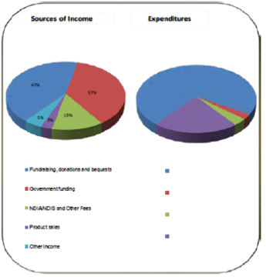

5 years revenue and expenses
Revenue | 2019# | 2018 | 2017 | 2016 | 2015
Fundraising, donations and bequests | 6,042 | 5,579 | 4,155 | 3,651 | 4,583
Government fundings | 5,248 | 4,785 | 5,845 | 6,441 | 6,077
Fees | 1,867 | 1,485 | 1,201 | 632 | -
Product sales | 422 | 382 | 498 | 989 | 1,283
Other Income | 671 | 1,486 | 1,428 | 785 | 1,367
Total Revenue | $14,251 | $13,718 | $13,127 | $12,498 | $13,310

Expenditure | 2019# | 2018 | 2017 | 2016 | 2015
Employee benefits | 9,670 | 9,391 | 9,643 | 8,033 | 6,809
Cost of sales | 333 | 295 | 331, | 699 | 943
Depreciation | 455 | 874 | 1,011 | 924 | 586
Other expenses | 2,908 | 3,006 | 3,831 | 3,466 | 2,965
Total  Expenditure | $13,366 | $13,566 | $14,816 | $13,122 | $11,383
Surplus (Defecit) | $885 | $152 | -$1,629 | -$624 | $2,007
# = Year-to date

Key performance indicators
Criteria | Target | Outcome
Staff satisfaction | >70% | 90%
Staff productivity | ≥80% | [blank]
Customer satisfaction | ≥70% | 93%
Client service hours (60,000 annual) | ≥55,000 | 53,391
Staff costs ratio | ≤70% | 74%
Corporate overhead  (net of earned revenue) | ≤15% | 18%
Total revenue growth – stretch target ($30M annual) | $25M | $14.2M

Bequests
Category | Value
Pipeline (future) | $1,398,375
Pipeline (Current) | $292,000
Actual | $3,433,000
Budget | $1,228,333
5 year average | $1,869,510

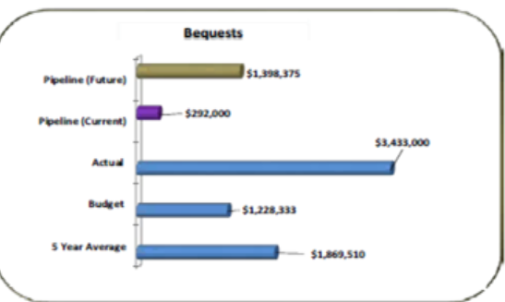

5 year financial position ($’000)
Accounts | 2019 | 2018 | 2017 | 2016 | 2015
Assets | 27,142 | 25,949 | 24,636 | 21,930 | 22,695
Liabilities | 5,578 | 4,468 | 3,307 | 3,734 | 3,875
Equity | 21,565 | 21,481 | 21,329 | 18,196 | 18,820

Operating results without excess bequest ($,000)
Accounts | Actual | Budget | Variance
Total revenue | 14,251 | 11,758 | 2,492
Less: Excess bequest over budget | -2,205 | 0 | -2,205
Revenue before excess bequest | 12,046 | 11,758 | 288
Total Expenditure | 13,366 | 13,231 | -135
Surplus / deficit before excess bequest | -1,320 | -1,473 | 153
End of document.

