Example 1 of a board finance dashboard

16 graphs make up the board finance dashboard

# Income

# This line graph titled income shows the income over 2017/18 using a blue line. The x axis is time over the year and the y axix is income in dollars in increments of $1,000,000. The income starts at approximately $30,000 for 2017/18 and steadily increases to approximately $5,000,000 over the year. The 2918/19 income is shown with a red line which is overlaying the blue line. The red line starts just above the blue and increases at a slightly faster rate to $2,000,000. The income line for 2018/2019 does not cover as much of the x axis as the previous year, indicating only approximately the 1st three months of data for the year.

# Surplus

This line graph shows the trend in surplus in dollars (y axis) over a year (x axis).  2017/18 is shown with a blue line and sporadically increases from $0 to around $200,000.  This is overlay with a red line for 2019/20 which shows a steady drop in surplus from $0 to negative $100,000 over about a 3 months period when the data for that year ceases.

# Income versus Budget Month

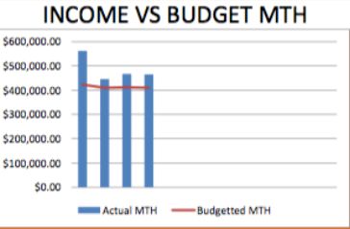

# Income versus Budget Year to Date

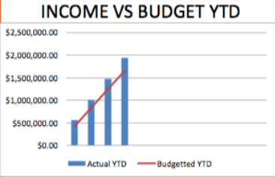

# Expenses

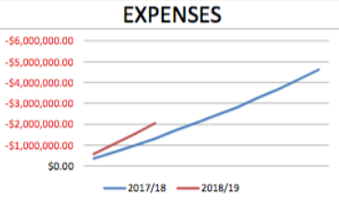

# Total Investments

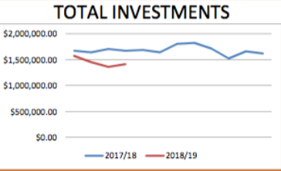

# Expenses versus budget month

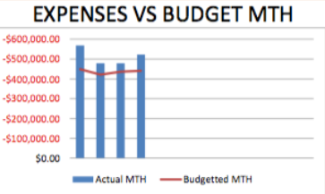  
Expenses versus budget year to date

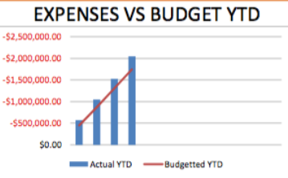

# Surplus to budget

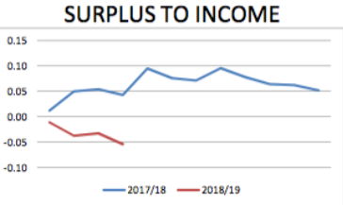

# Current

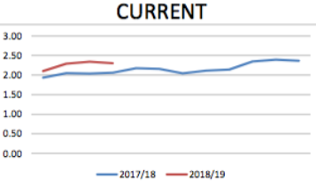

# Surplus versus budget month

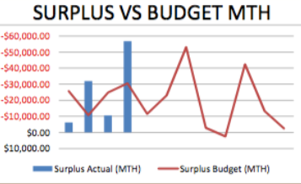

# Surplus versus budget year to date

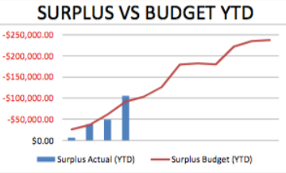

# Debt to equity

This graph shows a ratio of debt to equity (y axis) and a one year period (x axis).  A blue line indicates the change in ration of 2017/18 and a red line for the ratio for the corresponding months in 2018/19.  The red line only shows the first 4 months of that year and shows the ratio is sitting approx 0.3 below the previous year.

# Return on assets

This graph shows a trend in return on assets over a period of a year.  A blue line tracks 2017/18 for the whole year and shows a steady increase on return until the final month where there is a steep increase.  A red line shows the return on assets for the first 4 months of 2018/19 and shows a similar, but slightly faster increase in return than the previous year.

# Months of spending

This graph shows months of spending over a one year period (x axis) where the y label in unlabelled but increases from 0 to 35.0. A blue line shows that over 2017/18 there was a steady drop in relation to the y axis.  A similar, but slightly lower trend is evident for the first 4 months of 2018/19 which is represented by a red line.

# Accounts receivable

This bar graph shows a break down in accounts receivable.  4 bars a long the x axis represent the total value of accounts received for a month.  Each bar is broken down to show the ratio in a different colour for: AR- current, 1 AR 1-31 days, 2 AR 32-62, 3 AR 63-93 days and 4 AR- GT 93 days.

End of document.