Slide 1

UpSkill Summer Foundation

NDS Regional Disability Workforce Innovation Forum
Helen Jeisman, UpSkill Project Support Officer
Linda Hughes, UpSkill Lead

Slide 2

Acknowledgement of Country
I would like to acknowledge the Wurundjeri Woi Wurrung people of the Kulin Nation as the Traditional custodians of the lands and waterways in the area now known as Moreland where I am today; as well as the traditional owners of the lands on which you are all on today. I pay my respects to Elders past, present and emerging and I extend that respect to other Indigenous people who are present at this online event.
I would also like to acknowledge that this land – which we benefit from occupying – was stolen, and that sovereignty has never been ceded.

Slide 3

About the Summer Foundation
Our mission is to create, lead and demonstrate long-term sustainable systems change that stops young people being forced to live in aged care because there is nowhere else for them.
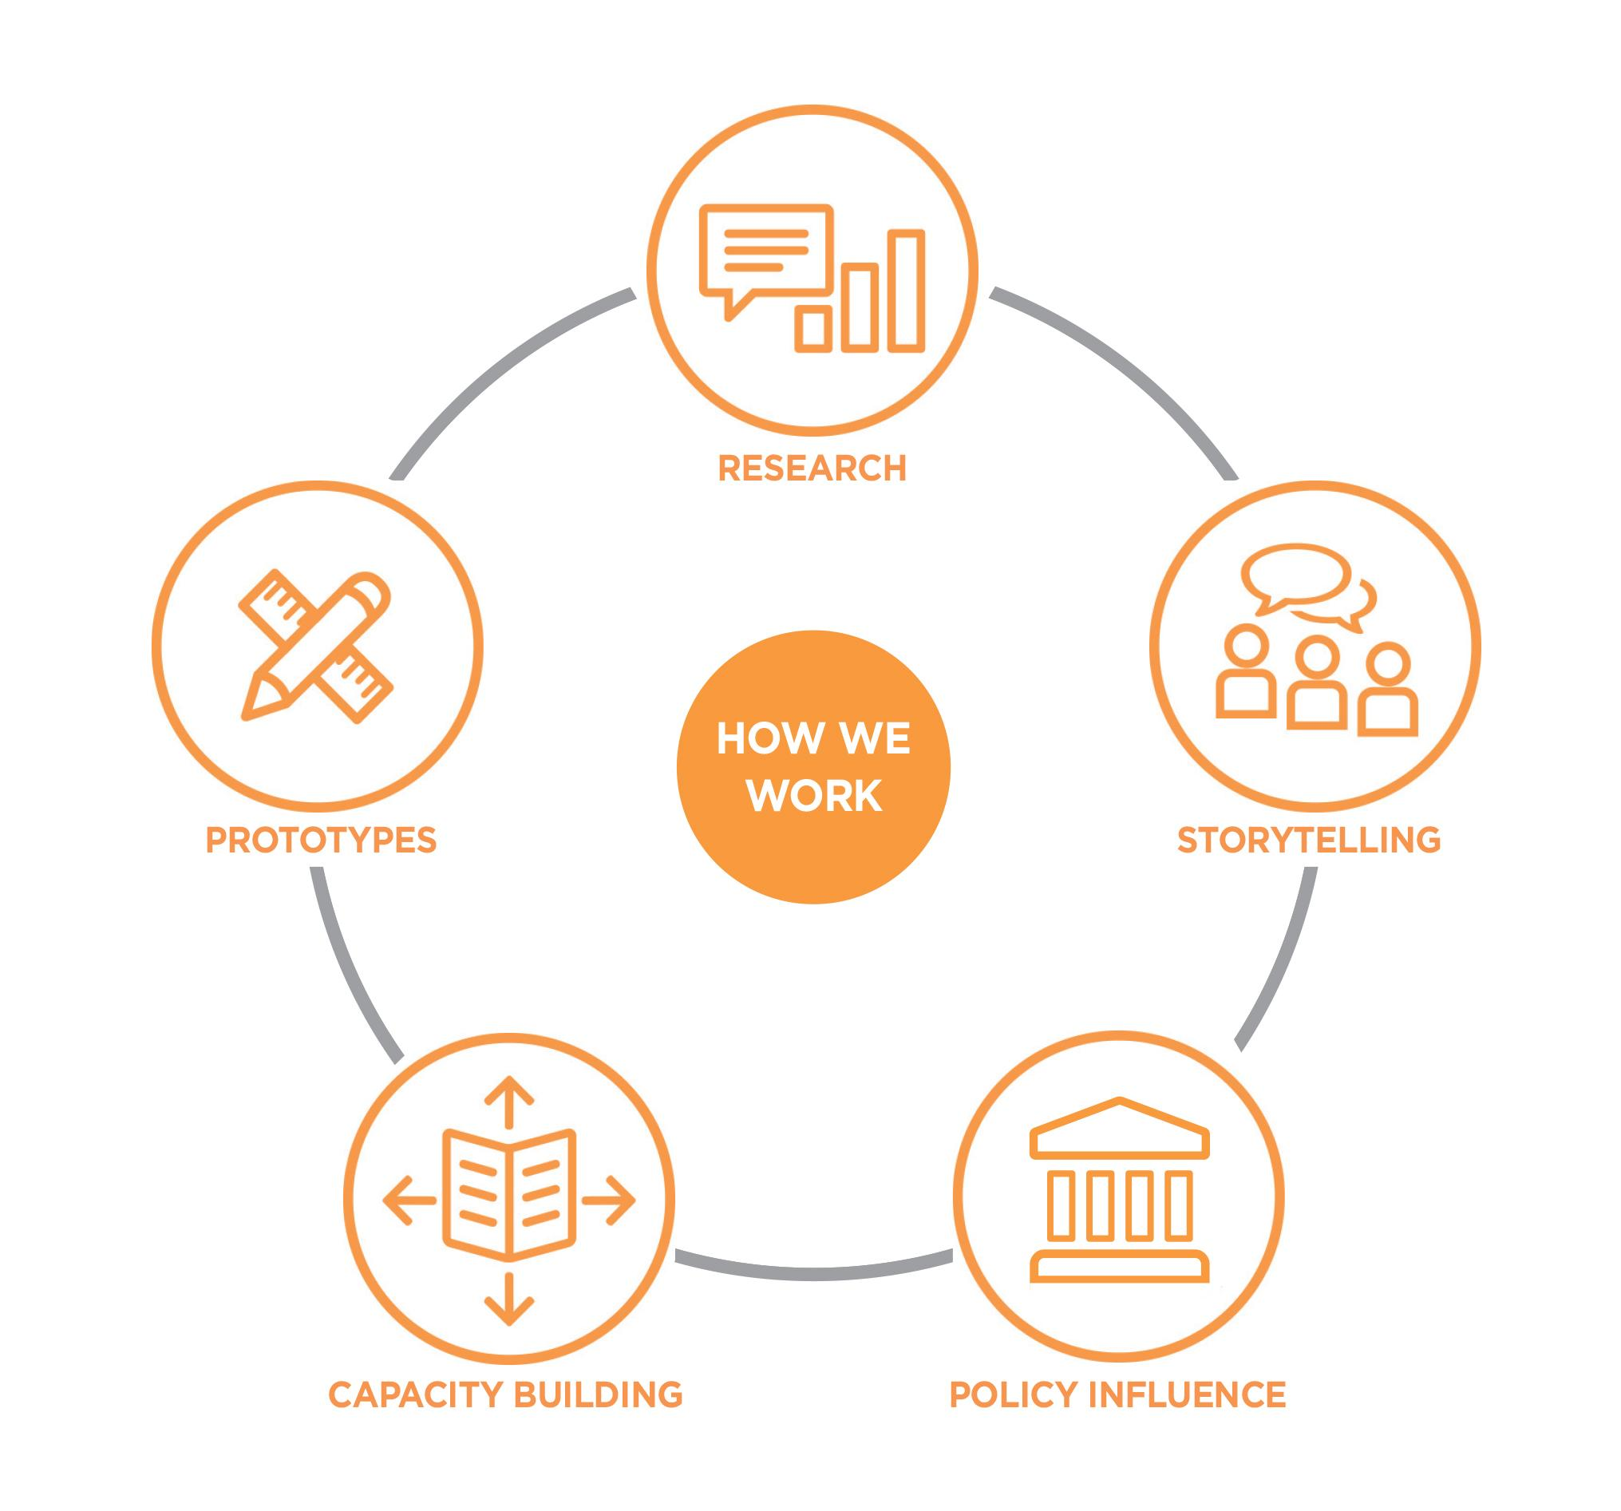

Slide 4

About UpSkill
UpSkill is a capacity building program for NDIS support coordinators and allied health professionals.
Our vision is that there is a workforce of NDIS professionals delivering quality services to empower people with disability to have independence, choice and control over their lives and the supports they choose to access.

Slide 5

The Opportunity VRRF
- Finding skilled and experienced support coordinators who can work with people with complex needs has been identified as a current challenge.
- The VRR grant allowed us the opportunity to increase the pool of skilled support coordinators in regional Victoria with sufficient competency to respond effectively to the diverse needs of people with disability.

Slide 6

Project Partners
- Centre for Culture, Ethnicity and Health
- AbleLink

Slide 7

What did we do?
Facilitated 16 workshops for a total of 160 support coordinators, allied health professionals and aged care providers across the Mallee and Goulburn regions on the following topics:
- Building your skills to work with people with complex needs.
- Evidence for Specialist Disability Accommodation (SDA) Outcomes.
- Supporting people residing in Residential Aged Care to benefit from the NDIS.
- Running a sustainable Support Coordination business (AbleLink).
- Working across cultures in the NDIS (CEH).

Slide 8

What did we do? (continued)
Developed a suite of free online resources to reinforce training topics including webinars:
- UpSkill Fundamentals.
- SDA Fundamentals (with complimentary flyers).
- Teach back, cultural beliefs of understanding and working with interpreters.
- What makes great support coordination, running a business, and working efficiently with templates and systems.
All webinars can be found on the Summer Foundations UpSkill Resources webpage.

Slide 9

What did we do? (continued)
Developed a suite of free online resources to reinforce training topics including four 30-minute podcasts:
- Talking ethnicity, culture and the NDIS
- Talking support coordination, what it takes to be a support coordinator and how to run a support coordination business.
- Talking how to capacity build for people with complex needs (in production at time of recording).
- Talking ILO, Independent Living Options (in production at time of recording).
All podcasts can be found on the Summer Foundations UpSkill Resources webpage

Slide 10

Training feedback
“Good knowledge and information resources from the team delivering the session. Appreciated the link with disability and people living in aged care facilities.” - Attendee of the Evidence for SDA Outcomes workshop
“All of the presenters were really engaging, and I felt it relevant to my practice.” – Attendee of Working across Cultures in the NDIS online workshop
“I enjoyed all parts of the course. Seeing support coordinators who have their own business and enjoying their role gave me more hope and confidence to start my new career. I need to say thank you for all detailed fresh knowledge and practical experiences you generously shared with us.” – Attendee of the Running a Sustainable Support Coordination Business online workshop

Slide 11

Challenges and learnings

COVID-19 impacts
- Delaying deliverables due to COVID-19 and converting face-to-face training to online.
- Engaging with a fatigued workforce during a period of high stress.

Networking with a regional workforce in an online context
- Markets are thin and collaborative relationships key to positive outcomes. Networking is difficult in an online format, and there will be a greater utilisation of break-out rooms in the future.

Engagement with an Aboriginal led organisation
- Engaging with ALOs with time-limited project funding.

Slide 12

Thank you
The Summer Foundation would like to thank the Department of Health and Human Services for their support as well as Victorian Regional Readiness grant managers - Rachel Eastoe and Brenton Hobbs. The Summer Foundation would also like to thank their NDS Disability Workforce Innovation Connector, Andrew Gibbs, as well as Dianne Hardy and En En See.

Slide 12

Contact
Helen Jeisman, Summer Foundation
Ph: 03 9894 7006
Email: upskill@summerfoundation.org.au

