Slide 1

Inclusion Team and Allied Health Project
PALS Inc: Providing All Living Supports

Slide 2
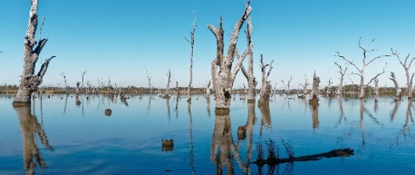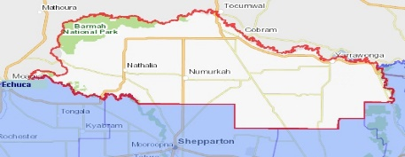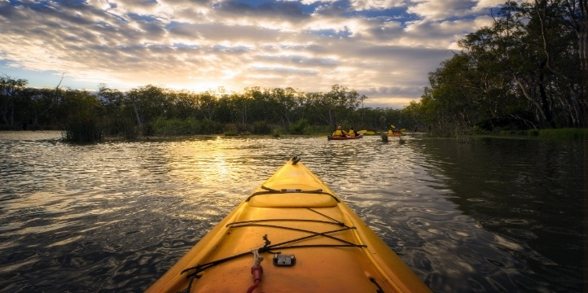

Slide 3

Customers and Staff
Customers: 134 total
- 65 Female (49 per cent)
- 69 Male (51 per cent)
Age:
- 26 are less than 25 years (19 per cent)
- 103 are aged between 26 and 66 years (77 per cent)
- Five are aged 66 years or older (1 per cent)
Staff: 85 total
- 75 Disability Support Workers
- 63 Female (84 per cent)
- 12 Male (16 per cent)
Age:
- Six are less than 25 years (8 per cent)
- 66 are aged between 26-66 years (88 per cent)
- Three are aged 66 years or older (4 per cent)

Slide 4

What was the issue/opportunity?
- Struggled to find workers with the right values, skills and attributes to meet increased demand.
- Wanted to increase workforce capacity and service offerings in line with our mission.
- There was evidence that self-directed teams were effective in delivering community services.
- Wanted to transform our organisation through a small pilot of a self-directed team - which we called an Inclusion Team.
- NDIS participants in our area were struggling to access timely allied health services.
- Wanted to improve access and partnerships with allied health.

Slide 5

About the project
- Literature Review
- Environmental Scan
- Advice and Training
- Values-Based Recruitment
- Organisational Framework
- Team Manual
- Quoting Tool
The Inclusion Team was made up of an Admin and Tech Guru, Roster Shaper, Onboarder, Community Influencer, Social Connector and Culture keeper all working together

Slide 6

Key learnings and next steps
- Use experts to extend your horizons, provide advice and support the change
- Use evidence-based approaches, where possible
- Organisational transformation is ‘a marathon - not a sprint’.
- Its’ success depends on creating good foundations, ensuring strong leadership & support and the right environment to introduce the change.
- Now we have the foundations we look forward to launching the Inclusion Team.

