Slide 1

Workforce Connect Project
Tamara Clark and Carolynne Frost
Victorian Regional Readiness Fund

Slide 2

Acknowledgement to Country
I acknowledge that I am presenting from the lands of the Yorta Yorta people.
I also acknowledge the Traditional Custodians of the various lands on which we all meet today and the Aboriginal and Torres Strait Islander people participating in this forum. I pay my respects to Elders past, present and emerging.

Slide 3

What inspired the VRRF grant application?
Shepparton Community Share
Our combined services support people with a disability, families, young people, and members of our community requiring a community health response.

Slide 4

What inspired the VRRF grant application?
Workforce Connect centres on:
- Informed and insightful leadership and governance
- A sustainable shared workforce, and
- A commitment to building and empowering a collective workforce through quality training, e-learning, as well as leaning on another for internal expertise.
To meet the goals of the Workforce Connect project, a Shared Workforce initiative was developed with a focus on building worker confidence, employment stability and career pathways through a shared workforce strategy and joint professional development.

Slide 5

What work was undertaken?
Investigating legal ramifications of a shared workforce
  - Fair Work Commission rules
  - Justice Connect providing pro-bono assistance regarding employment contract wording
Shared Workforce options:
  - On-hire staff through a labour hire agreement
  - Outside employment agreement, through signing a memorandum of understanding.

Slide 6

Shared Workforce resources
  - Templates: MoU, on-hire agreement, outside employment agreement and policy
  - Induction and Refresher training
  - Outside employment agreement, policy and register
  - Job advertisement, PD and Referee check templates
  - Interview question template and scenarios
  - Managing a casual workforce guidelines
  - Review of shift management software programs
  - Peer-to-peer mentoring and Leadership program
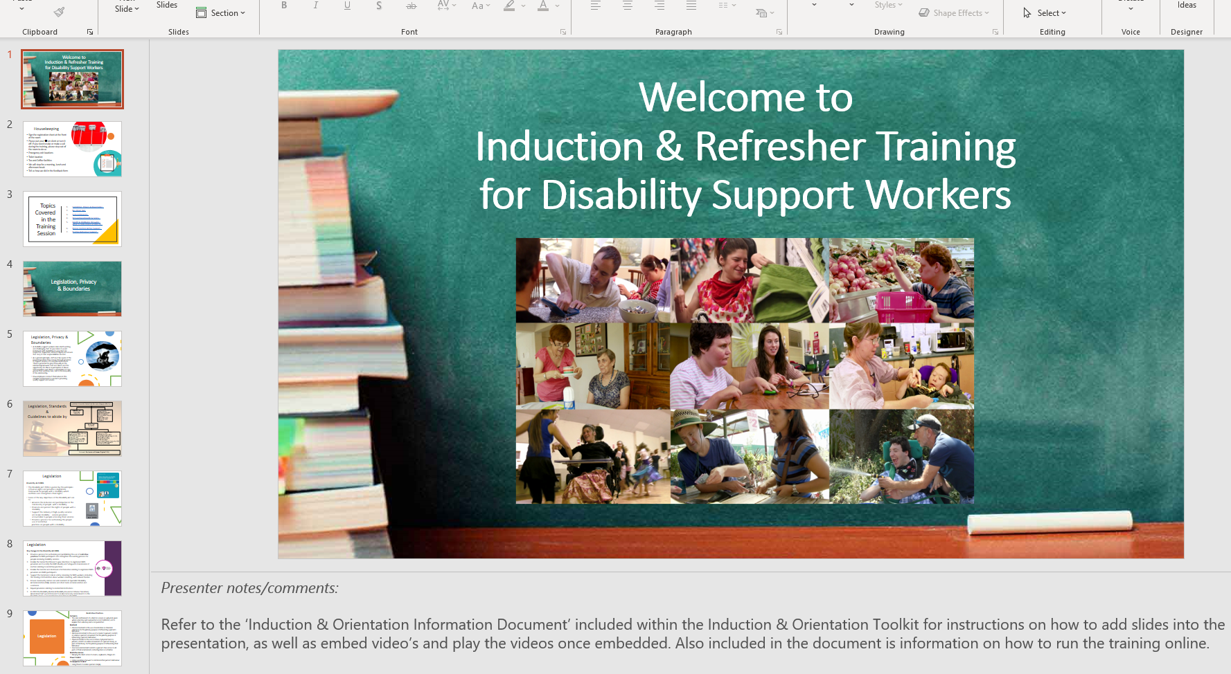

Slide 7

What did we learn?
  - Broader application across the community sector, not just for disability services.
  - Need to appreciate that there are similarities and gaps. Then come to the table with areas open to negotiation on and areas that are not.
  - There is the possibility of employees working more than 38 hours a week. This is where shift management software will be of use to organisations.
  - COVID restrictions meant that only limited documents could be tested.
  - The pool of experienced staff could potentially dry up and unskilled or inexperienced staff may need to be recruited, which could result in practice and safety issues. Therefore, detailed recruitment processes and inductions are going to be even more important in the future.

Slide 8

What came out of the project that will be useful to other organisations?
A toolkit of the resources including:
  - Setting up a shared workforce
  - Marketing and Advertising
  - Recruitment and On-boarding
  - Induction and Orientation
  - Students on Placement and Volunteers
  - Casual Workforce (including managing a casual pool)
  - Mentoring and Leadership.

Slide 9

Contact
Creation of a website is underway; in the meantime, I can be contacted directly for resources.
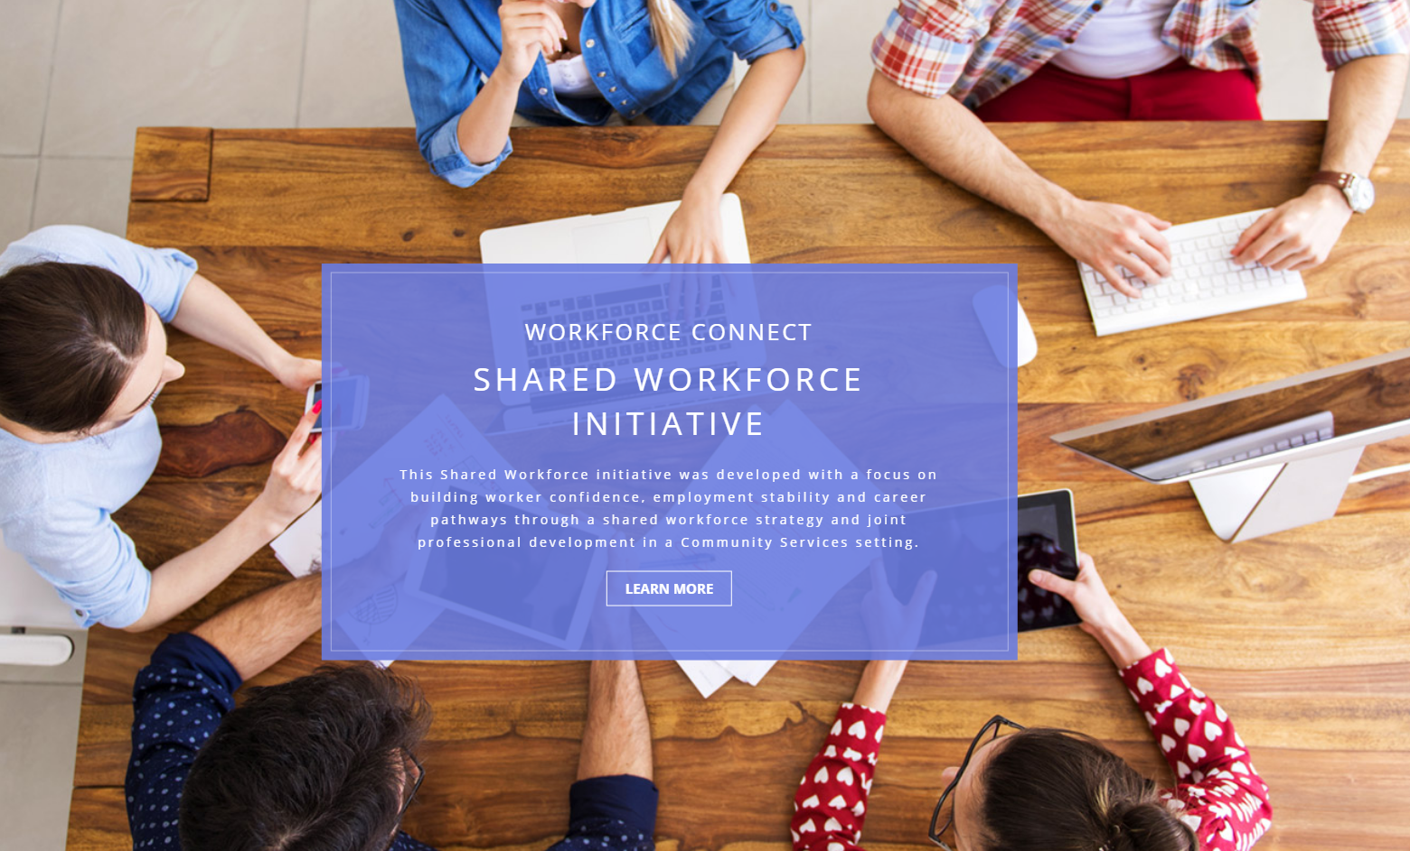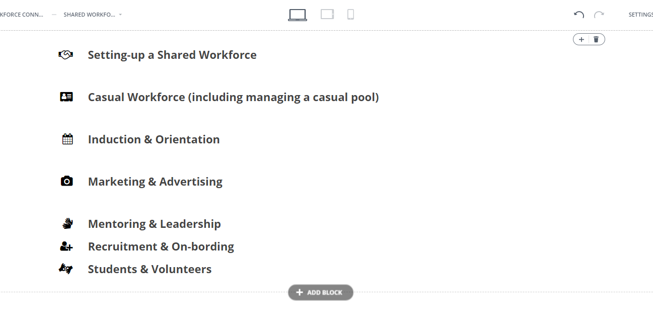

Slide 10
Thank you for taking the time to learn about our project.
We would like to thank Rachel and Brenton from VRRF, as well as Kathy Barakis our NDS Connector for this opportunity and their support with our project.
Tamara and Carolynne
Email: tamarac@connectgv.com.au
Email: carolynney@connectgv.com.au

