National Disability Services
WA Election Priorities 2021

Seven Priorities Online Overview
Build a strong and sustainable disability services sector

Invest in the economic and social inclusion of people with disability
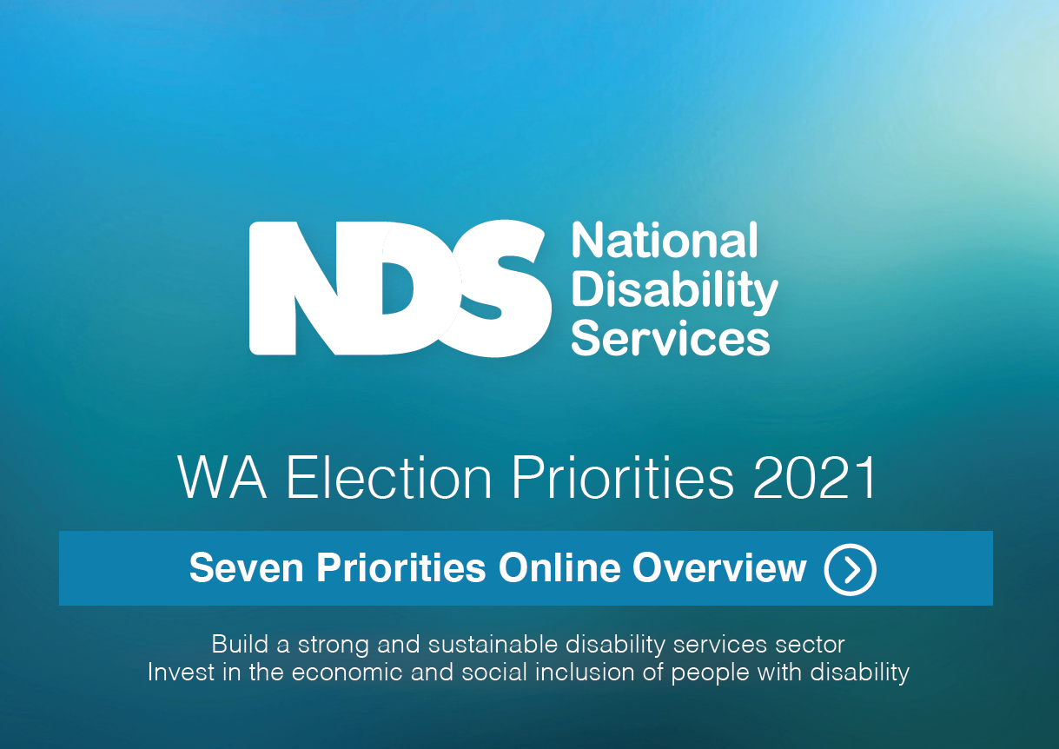

WA Election Priorities 2021
National Disability Services (NDS) in Western Australia is pleased to present our WA Election Priorities for the 13 March 2021 State Election.
NDS is the leading peak body for more than 1,000 disability service organisations across Australia. We also provide a strong voice for initiatives and services that support more than 411,500 people with disability in our State.
NDS through our members has identified seven priorities that will require strong commitment and funding by the future State Government to build a sustainable disability sector that provides quality supports as well as delivering great outcomes for people with disability across the community.
The disability sector is a growth industry and with new jobs and higher demand for services, presents great opportunities to provide economic stimulus while also building social capital and improving the everyday lives of people with disability.
Building and investing in a strong state disability ecosystem will help reboot the WA economy through jobs, training and business innovation, as well as improving the well-evidenced level of disadvantage of people with disability.
The incoming State Government is uniquely placed to significantly improve and promote the social and economic participation of people with disability in WA and build a strong sustainable disability services sector by committing funding to the priorities.
Video: Julie Waylen, NDS State Manager WA
WA Election Priorities 2021 Detail
Media Statement

WA Election Priorities 2021
Priority 1: A Minister for Disability Services and fund the 10 year State Disability Strategy
Priority 2 Maintain a fit for purpose Office of Disability
Priority 3 Invest in a Strong Disability Workforce and Quality Support Services
Priority 4 Guarantee Good Education, Training and Jobs
Priority 5 Roll out Disability Housing
Priority 6 Build Accessible Communities
Priority 7 Great Health and Justice Outcomes

Priority 1: A Minister for Disability Services and fund the 10 year State Disability Strategy
What we want:
- The incoming State Government is uniquely placed to provide strong stewardship, leadership and champion an inclusive society for West Australians with disability, a strong and viable disability sector and the delivery of quality support services.
- Continue with a dedicated Minister for Disability Services and an Office of Disability to oversee the effective implementation of the 10 year State Disability Strategy and its Action Plan. COVID-19 showed that the Minister with local oversight is a powerful agent for delivering strong and timely policy responses particularly in times of crisis.
- This important leadership and accountable governance mechanism will ensure WA maximises the State’s $4.3 billion investment to 2023-24 for the NDIS and essential State run disability services, particularly for those outside the scope of the NDIS.
- Fund the implementation of the 10 year State Disability Strategy and a comprehensive Action Plan. This should also include a comprehensive Disability COVID-19 Plan to better respond to the needs of people with disability to meet a future pandemic crisis.
- Strengthened proven existing governance structures including the Disability Services Board and the Ministerial Advisory Council on Disability (MACD).
- The continued development and support for a strong, sustainable and innovative disability services sector to provide quality supports for people with disability in Western Australia.
Video: Joan McKenna Kerr, NDS WA Chairperson, Autism Association of WA CEO

Priority 2: Maintain a fit for purpose Office of Disability
What we want:
- The incoming State Government maintain a fit for purpose Office of Disability.
- Ensure the Office of Disability is led by an accomplished senior executive with demonstrated disability experience and understanding of the WA disability sector and inclusion.
- Ensure the Office of Disability and Minister for Disability Services have direct oversight, control and accountability of the State Budget 2020-21 allocation of $4.3 billion over four years from 2020-21.
- The Office of Disability delivers a comprehensive Action Plan to support the 10 year State Disability Strategy with a whole-of-government approach with actions focused on increasing the economic and social participation of West Australians with disability.
- Ensure the Office of Disability collects data on critical unmet need to inform its decision making and ensure NDIS is delivering in the most critical of areas.
- Develop strong, accountable and transparent interfaces with mainstream agencies alongside the NDIS in WA.
- Provide last resort and emergency / crisis disability services. This should include developing a mechanism to monitor emerging thin markets (or potential for market failure) e.g. people with complex needs or rural/remote regions.

Strong State Government stewardship is critical
The incoming State Government is well placed to ensure it is the key steward and agent of the Western Australian disability ecosystem.
Good and decisive stewardship will be best achieved by continuing with a dedicated Minister for Disability Services and an Office of Disability which oversees the delivery of better social and economic community inclusion of all people with disability in WA, promoting and protecting their human rights and the continued development of a strong, sustainable and innovative disability services sector.
This recognises the State Government’s commitment to support more than 411,500 West Australians with disability, their families, carers, disability service organisations and the many thousands of workers that support them, as well as the $4.3 billion invested in disability services in WA.
It is important to prominently acknowledge the significant contribution of people with disability and that of the disability sector to the State’s economy, in terms of jobs and to its economic activity.
Investing in a strong and sustainable state disability ecosystem for all Western Australians with disability will help reboot the WA economy through jobs, training and business innovation, as well as improving the well evidenced significant level of disadvantage experienced by people with disability in our community.

Disability Ecosystem
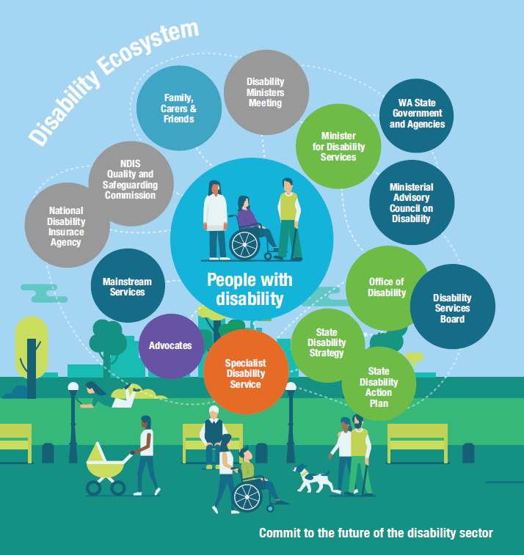
The “Disability Ecosystem” infographic above illustrates the components of the disability sector in Western Australia and how they interact like a living ecosystem.
A large, light blue circle is in the centre and titled People with disability.
Reading in a clockwise direction, there are 14 coloured circles surrounding the people with disability titled:
- Family, Carers and Friends
- Disability Ministers Meeting
- Minister for Disability Services
- WA State Government and Agencies
- Ministerial Advisory Council on Disability
- Office of Disability
- Disability Services Board
- State Disability Strategy
- State Disability Action Plan
- Specialist Disability Services
- Advocates
- Mainstream services
- National Disability Insurance Agency
- NDIS Quality and Safeguarding Commission

Priority 3: Invest in a Strong Disability Workforce and Quality Support Services
What we want:
- The incoming State Government must build a strong sustainable disability services sector through investment in workforce, service innovation and quality and safeguarding initiatives. A strong quality services sector and good providers are critical to delivering the promise of the NDIS to WA participants.
- Continue to support the Positive Behavior Support Practitioner project to ensure organisations have access to proficient practitioners to sit on restrictive practices panels.
- Develop an industry implementation plan for NDIS Worker Screening Checks.
- Roll out the NDS WA Skills Passport to reduce training duplication, expedite worker commencement and quality assure the workforce.
- Partner with NDS to identify initiatives to deliver service improvements arising from the Disability Royal Commission or any other inquiry that will strengthen service safety.
- Fund NDS for its systemic advocacy, policy work and sector building capacity work to build a strong sustainable disability sector. This will support NDS to facilitate the WA disability sector workforce to double in size, with 10,000 new jobs required by 2023 to meet demand for services.
- Support the TAFE network and NDS to work together to deliver tailored workforce pathways, including contemporary and targeted quality training for people with disability to help meet disability sector workforce demand.
- Implement a Workforce Exchange Demonstration project between regional and metropolitan WA.
- Sponsor traineeships, cadetships and graduate careers of people with disability across the WA public sector and create 50 internships for people with disability in varied industries.
Video: Frances Buchanan, WA Blue Sky CEO and Shane Birch, Owner, Shane’s Liquid Gold

Priority 4: Guarantee Good Education, Training and Jobs
What we want:
- The incoming State Government must commit to ensure people with disability have the education and skills they need to succeed and have meaningful inclusive employment and economic independence.
- Support and increase the number of teachers and education assistants and access to in-classroom support.
- The Department of Education and NDS partner to develop and deliver a program of anti-bullying strategies to support students with disability.
- Establish a Disability Education Training Program to improve inclusive education practices in schools for teachers and advice to students and families on available supports. Set up an Inclusive Schools Program requiring mandatory changes to how schools operate so they deliver inclusive learning environments. Establish a Pathways to Work Schools Partnership program for students.
- Continue to support the TAFE network and NDS to work together to create inclusive training and employment environments for students with disability and staff.
- Expand the NDS Building the Talent Pool project to 2025 and fund a state-wide educational campaign promoting the benefits of employing people with disability.
- Create 50 internships for people with disability in varied industries and sponsor traineeships, cadetships and graduate careers across the WA public sector.
- Continue to support Australian Disability Enterprises (ADE) through the Department of Finance Social Procurement ADE initiative that supports businesses that employ people with disability. The State Government should explore other opportunities to increase the employment of people with disability through the wider Government procurement process.
Video: Ben Aldridge, Managing Director, 30 Foot Drop

Priority 5: Roll out Disability Housing
What we want:
- People with disability must have good housing options and increased home ownership. The State Government must lead and collaborate with industry and provide incentives to fast track the delivery of disability friendly housing in WA.
- Top priority areas include:
  - Finalise and implement the State’s approach to NDIS Specialist Disability Accommodation.
  - The State Housing Strategy to provide clear line of sight between State Government responsibility and delivery of accessible and affordable housing for all people with disability.
  - Through the 10 year State Disability Strategy progressively require new housing to be built to a Silver Standard Universal Housing as minimum.
  - Increased focus on better use of existing disability housing stock, rather than solely on building new stock, including improved strategic asset management, use of matching services like Home Hub and transfer of management to community housing providers.
- Ensure minimum accessibility standards for residential dwellings as part of National Construction Code and ensure the Rental Tenancy Act provides minimum accessible standards / allow minor modifications.
- Better targeting of Keystart, the First Home Owners Grant, Building Grants and Housing Loan schemes to improve accessibility by people with disability and the rebate or removal of property transfer duties for people with disability.
- Provide industry incentives to housing developers, creating more affordable housing options across the community including targeted funding, use of government surplus land / planning scheme quotas as part of new developments.
- Set minimum inclusion targets for land and house developers - preferential access to land or housing for people with disability. Progressively move to a target of 10% of social housing to be allocated to people with disability (commensurate with rate per head of population).
- Partner with NDS, the housing sector and people with disability to design and develop pathways to access suitable housing, addressing long-term shortages in accessible and affordable disability housing, the lack of community disability housing and to ensure maintenance of existing housing through retrofitting is to an accessible standard.
- Develop a Ready Reckoner Disability Housing Information Package of disability housing products for people with disability, the housing industry sector and community.
- Invest in a significant housing industry awareness campaign to promote the construction of accessible housing as a future growth area.
- Commit to provide regional housing for disability workers to enable services to be established for people with disability in regional, rural and remote locations.
- Work with the real estate industry to include accessibility features for rentals and houses for sale and include accessibility as a filter on real estate websites.
Video: Sophie Keay, NDS Project Officer – Building the Talent Pool

Priority 6: Build Accessible Communities
What we want:
- Our communities must be designed so that everyone, including people with disability, can be valued and have opportunity to be active members as well as having access to the whole community.
- The incoming State Government must address the lower community participation of people with disability by ensuring accessible infrastructure standards and facilitating changes in community attitudes towards disability.
- The State Disability Strategy must deliver greater economic and social participation for people with disability so that they are involved in a full range of economic, recreational, social and cultural opportunities. This should aim to improve accessibility to community infrastructure, address transport shortcomings and promote inclusive tourism.
- Some key commitments NDS is seeking is to:
  - Provide NDS with long term funding surety through a five year agreement for ACROD and Companion Card delivered by NDS in WA and implement an expanded eligibility criteria for more than 100,000 ACROD parking permit holders.
  - Fund NDS to work with local government authorities and the community to expand the Changing Places network in WA to priority locations identified by people with disability.
  - Ensure the State Government’s Digital Blueprint platform will be shaped by people with disability – its connectivity and design must provide full digital inclusion, including access to online services and platforms, as well as the innovative technologies that support the delivery of important services such as health, education and judicial services.
  - Change planning regulations and policies to require increased accessibility of all State infrastructure and work towards ensuring all new commercial developments will be accessible.
  - Identify accessible infrastructure priorities in the Building METRONET/ HUB, Building Infrastructure and Driving Industry Development programs and ensure all upgrades of existing facilities to be done to an accessible standard. Schools and tourism works such as national parks, trails and camp sites whether new works, maintenance or refit should be a priority including those planned through regional recovery plans.
  - Work towards ensuring all tourism facilities and national parks are accessible.
  - Fund a range of initiatives to promote and improve access for people with disability to sport and recreation activities.
Video: Melissa Northcott, Disability advocate

Priority 7: Great Health and Justice Outcomes
What we want:
- The incoming State Government must provide focused investment to deliver better health outcomes by improving the coordination of health and disability services and investing in health and dental checks. It must ensure that people with disability are safe from violence, abuse, neglect and exploitation.
- Commit to comprehensive health and dental checks for people with significant disability funded through the Comprehensive Health Assessment program.
- Finalise a COVID-19 Plan for people with disability and sector workers to ensure people with disability have ongoing access to quality services whilst outbreaks remain a risk and are given priority access to a COVID-19 vaccine once it becomes available.
- Fund the Department of Health and NDS to design and implement a pool of metropolitan-based clinical staff that can be deployed at short notice to regional locations to support healthcare delivery to people with disability.
- Through the NDS and Health Department – “Ready to go home” project, develop a range of transitional care arrangements to facilitate timely discharge from hospital.
- Support NDS for sector-wide training for disability sector workers on diabetes insulin injection.
- Fund an integrated services demonstration project focused on people with complex needs and support for at-risk vulnerable people with disability.
- The State Government, NDS and the Insurance Commission of WA should continue to work with key stakeholders to fast-track the delivery of an optimal response to the National Injury Insurance Scheme.
- Improve continuity and integration of supports between health, mental health and disability services systems. Better connectivity, communication and interdisciplinary awareness between health and disability is critical.
- Support the Department of Justice (DoJ) and NDS to develop and implement the WA Disability Justice Blueprint in partnership with people with disability, their families and the sector.
- Support DoJ and NDS to work together to identify opportunities for demonstration projects to divert people with disability out of the justice system and develop strategies for their reintegration into the community.
- Continue to fund systemic advocacy for the disability sector, including NDS’s pivotal role in systemic advocacy for service provision improvements to strengthen the rights of people with disability and support services provided to them.
Video: Danielle Loizou-Lake, NDS Project Lead - Disability Health Projects

Disability Fast Facts
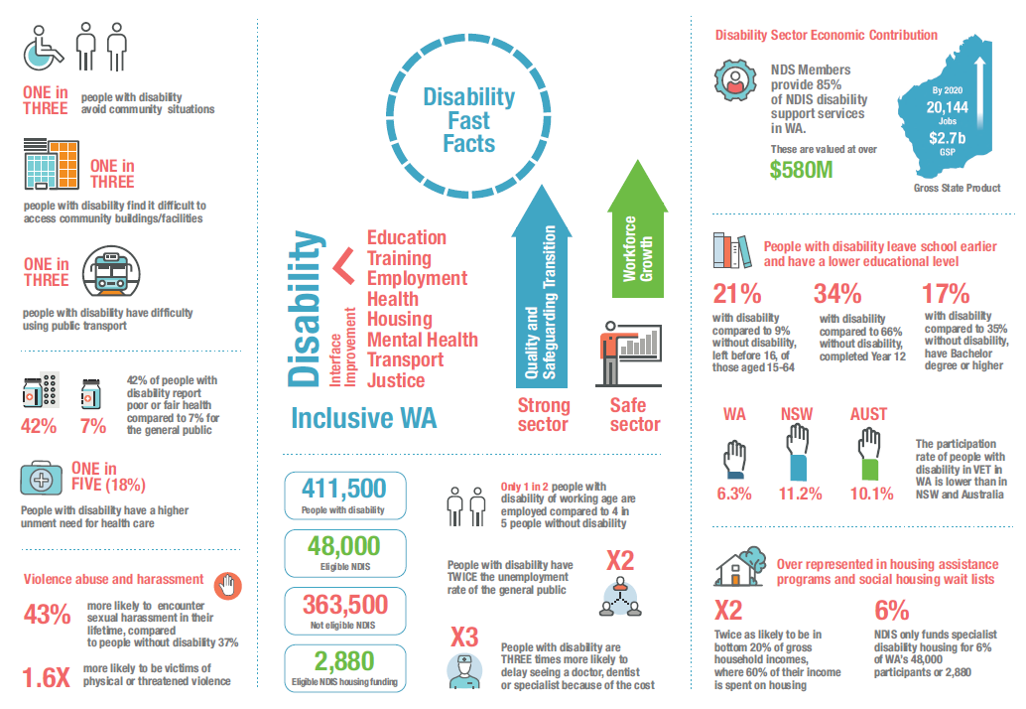
The “Disability Fast Facts” infographic above illustrates statistics related to disability in Western Australia. The statistics are divided into eight sections.
Section 1:
- One in three people with disability avoid community situations
- One in three people with disability find it difficult to access community buildings/facilities
- One in three people with disability have difficulty using public transport
Section 2:
- 42% of people with disability report poor or fair health compared to 7% for the general public
- One in five (18%) people with disability have a higher unment need for health care

Section 3: Violence abuse and harassment
- 43% more likely to encounter sexual harassment in their lifetime, compared to people without disability 37%
- 1.6 times more likely to be victims of physical or threatened violence
Section 4
One side of the section reads:
- Education
- Training
- Employment
- Health
- Housing
- Mental Health
- Transport
- Justice
An arrow labelled Interface Improvement points from those words to the word Disability.
The bottom of the section reads: Inclusive WA.
To the right, there are two arrows pointing up, labelled:
- Quality and Safeguarding transition
- Workforce Growth
The bottom of the section reads strong sector, safe sector.
Section 5
The left hand side of the section reads:
- People with disability: 411,500
- Eligible NDIS 48,000
- Not eligible NDIS: 363,500
- Eligible NDIS housing funding: 2,880
The right hand of the section reads:
- Only 1 in 2 people with disability of working age are employed compared to 4 in 5 people without disability
- People with disability have twice the unemployment rate of the general public
- People with disability are three times more likely to delay seeing a doctor, dentist or specialist because of the cost.
Section 6: Disability Sector Economic Contribution
NDS Members provide 85% of NDIS disability support services in WA. These are valued at over $580M
By 2020 20,144 jobs, $2.7b Gross State Product
Section 7
People with disability leave school earlier and have a lower educational level
- 21% with disability compared to 9% without disability, left before 16, of those aged 15-64
- 34% with disability compared to 66% without disability, completed Year 12
- 17% with disability compared to 35% without disability, have Bachelor degree or higher
The participation rate of people with disability in VET in WA (6.3%) is lower than in NSW (11.2%) and Australia (10.1%).
Section 8
Over represented in housing assistance programs and social housing wait lists
- Twice as likely to be in bottom 20% of gross household incomes, where 60% of their income is spent on housing
NDIS only funds specialist disability housing for 6% of WA’s 48,000 participants or 2,880

About NDS
National Disability Services (NDS) is Australia’s peak body for non-government disability service organisations representing over 1000 non-government organisations, which support people with a diverse range of disability.
In WA, NDS represents over 150 specialist disability services organisations that provide services to tens of thousands of people with disability, their families and carers in the State including metropolitan, rural and remote regions. Our members provide more than 85% of services to people with disability valued at more than $580 million. These range from home support, respite and therapy to community access, employment and more.

Contact:
Julie Waylen
State Manager WA
Telephone: 08 9208 9805
Email: julie.waylen@nds.org.au
NDS website: www.nds.org.au

