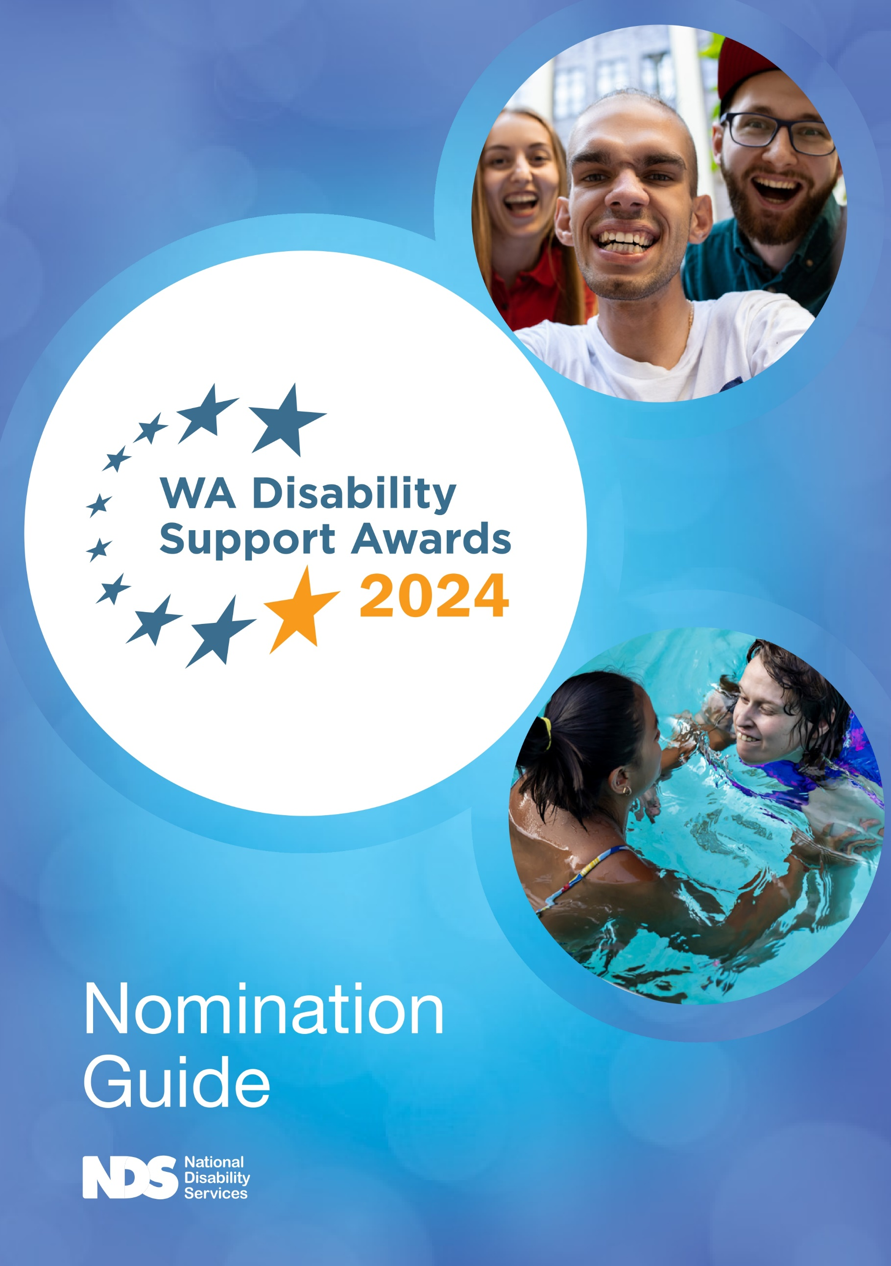

Contents

About the Awards .3
Award Categories 3
Key Dates 3
Preparing your nomination 4
Completing your nomination 4
Submitting your nomination 4
Award Catgories 5
Emerging Leader 5
Excellence in Home and Family Support 6
Innovation in Service Delivery 7
Excellence in Regional Support 8
Excellence in Rights Promotion 9
Excellence in Supporting Employment Outcomes 10
Excellence in Supporting Inclusion and Citizenship 11
About the Awards Ceremony ……………………………………………………………………… 12
Contact Information ………………………………………………………………… 12
Terms and Conditions 13

About the Awards

The WA Disability Support Awards celebrate the significant contribution of individual workers and teams who support people with disability to achieve their goals.

The Awards recognise and reward people who go beyond ordinary standards of service and provide the highest standard of individualised support to people with disability. The Awards also provide an opportunity to recognise excellence in leadership and innovation to continuously improve disability supports and create better outcomes.
The Awards highlight the important role of disability sector workers in providing high quality services that support people with disability exercise real choice and control. Award nominees demonstrate excellence and commitment in supporting people with disability.
A high-quality workforce that strengthens, safeguards and provides greater choice for people with disability is a vital part of building quality disability services throughout Western Australia. The Awards showcase the very best approaches and help the disability sector attract, recruit and retain a capable and committed workforce.
The Awards are open to individuals, teams, organisations or Boards in Western Australia supporting Western Australian people with disability.

Information about the Awards is available on the NDS WA Disability Support Awards webpage and you can also keep up to date with the Awards by liking us on Facebook at www.facebook.com/DSWAwards.

Award Categories

- Emerging Leader
- Excellence in Home and Family Support
- Innovation in Service Delivery
- Excellence in Regional Support
- Excellence in Rights Promotion
- Excellence in Supporting Employment Outcomes
- Excellence in Supporting Inclusion and Citizenship

Key Dates

Wednesday 18 October 2023
Nominations open

Friday 2 February 2024
Nominations close

18 May 2024
WA Disability Support Awards Gala Dinner

Preparing your nomination

- Gather relevant information and start building your nomination.
- Tell the story of what the individual or team does, and the significant impact they have had on your life, the life of your family member or a person(s) with disability.
- Use the questions which are provided for each award category in this Guide.
- Use real examples that can be easily understood.
- Avoid abbreviations, acronyms or language other people might not easily understand.
- If you make general claims about the person, for example “he has great patience and compassion”, “she has a can-do attitude”, or “he supports choice and control”, make sure you back them up with details and real examples.
- Do not assume that judges will already know about a particular project or program.
- NDS can provide advice to assist you to develop your nomination – please contact Michelle Crook at michelle.crook@nds.org.au or 9208 9812.

Completing your nomination

- Every nomination must be made or endorsed by a person with a disability or their family member or carer Where possible, nominations should also be supported by the organisation employing the Nominee.
- Decide on the most suitable Award Category – you can select more than one category.
- More information is provided in the “Award Categories” section of this Guide on what will be considered by the judges.
- Nominations may be submitted for either an individual, team, organisation or Board.
- For your nomination to be accepted, you must ensure you have permission from your nominee to be nominated. If you are nominating a team, all team members must agree to be nominated.
  - Confirmation from all nominators that they have read and agreed to the Terms and Conditions set out in this Nomination Guide.
  - Permission from your nominee and any other person who appears in the nomination for NDS and event sponsors to use any information (textual or photographic) included in the nomination for promotional purposes.
  - It is the responsibility of the nominator to advise NDS should any person mentioned in this nomination or supporting documents prefer to remain anonymous.
- Check the spelling of all names and email addresses, as this information will be used to contact nominees as well as on certificates and trophies.
- Ensure all your additional information supports and strengthens the nomination and is in an accessible format.

Submitting your nomination

To nominate, access the online nomination form. Supporting documentation (i.e. photographs, audio or video files, or PowerPoint presentations) must be submitted separate to your nomination.

Nominations close, 5pm AWST, 2 February 2024.

Award Categories

Emerging Leader

Leadership occurs across all levels of an organisation and this Award highlights emerging leaders. This Award is open to people employed in the disability sector with the exception of CEO’s and senior executives, who have newly demonstrated the capability, determination and vision needed to build the confidence and competency of people around them, influencing others to be the best they can be to deliver high quality support to people with disability.

Judging Criteria

- Are there clear examples of how the nominee has newly shown leadership skills including being accountable and effective?
- Is there clear evidence of, or examples where, the nominee has overcome obstacles, resolved problems, or lead innovation and creativity to better support the goals and aspirations of people with disability?
- Does the nomination provide evidence of excellence or best practice in leadership?
- How does the person or organisation make sure services and supports are planned and provided in ways that build on individual strengths? Do they maximise individual outcomes?
- What behaviours has the person shown that demonstrates best practice in an emerging leader?

Examples:

  - Driving the re-development or strengthening of existing services towards more flexible, personalised models of support.
  - Fostering creative mindsets, innovation and collaboration with peers and colleagues.
  - Providing support and mentoring to others in a rapidly changing environment; or
  - Promoting an open, inclusive culture that supports ownership, empowerment, and person-centred practice.

Some questions to help you tell the story:

  - How has the nominee used their leadership skills when supporting you or other people, or when working as part of a team, or when in the community?
  - How has the nominee been creative and resourceful in finding ways to improve internal processes for their team or department?
  - How did this improve the quality of services to you and/or people with disability? What were the impact or outcomes?
  - How has the nominee made sure services and supports are planned and provided in ways that build on individual strengths?
  - What behaviours has the nominee shown that demonstrate leadership capabilities?

Excellence in Home and Family Support

This Award is open to people who are employed in the disability sector as an individual support worker (or similar role) or a team of support workers and recognises their significant contribution to providing support that meets the needs of a person with disability at home. This can include supporting them to build their capacity and confidence, or to truly exercise control regarding how, where and with whom they wish to live. Nominations which recognise a worker or team that supports an individual with exceptionally complex support needs to lead the life they choose will be particularly well regarded.

Judging Criteria

- Is there clear evidence or examples of the significant positive impact the nominee had on the person with disability they support (including family and carers)?
- Is there clear evidence or examples of how the nominee assisted the person with disability they support to expand or enhance their home and family life in a meaningful way?
- Does the nomination provide clear examples of, or explain how the nominee demonstrated best practice or excellence in home and family support?
- Does the nomination provide examples of how the nominee built on a person’s strengths and supported their needs and life goals?
- How did the nominee support the person to make individual choices and be involved in making decisions about their supports?
- Were services provided in a way that suits the person, including, age, gender, culture, language, faith, sexual identity, and relationship status?

Examples:

  - Commitment to supporting a person with disability with complex needs to achieve specific personal goals;
  - Assisting a person receiving home support to connect with family, or broaden their networks;
  - Supporting a person with disability to further their independence, skills and confidence;
  - Supporting or building family capacity and resilience; or
  - Working alongside or supporting a family or person with disability during times of difficulty.

Some questions to help you tell the story:

  - What has changed for you or the person with disability because of this support?
  - How did the nominee build on a person’s strengths and support their needs and life goals?
  - What are you or the person with disability involved in now that is new, has been improved on, or made possible through the support of the nominee?
  - Why is this important to you or the person with disability?
  - How did the nominee support the person with disability to make individual choices and be involved in making decisions about their supports?
  - How were services provided in a way that suited the person with disability, including, age, gender, culture, language, faith, sexual identity, and relationship status.
  - What does the nominee do that demonstrates true excellence in home or family support?

Innovation in Service Delivery

This Award is open to any person, team, Disability Support Organisation or their Board, operating in the disability sector, who has developed new or innovative approaches to service delivery improving the life of a person, or people with disability, including those with complex or acquired disability.

The new approach has been trialed, tested and found to be a solution which has improved the outcome and / or adds value from the perspective of people with a disability. The innovation may be in relation to an approach, process, or system, and may have been prompted by feedback from people with disability, families or carers or be a result of a review or co-design with people with disability.

Judging Criteria

- Is there clear evidence of change in process, the nature of supports, or the way they are provided?
- Does the nomination provide evidence of deliberate effort to innovate and improve service quality?
- Is there evidence that the innovation results in significant improvements to individual outcomes for a person with a disability?
- What has changed for the person/ people concerned and why?
- What does the change mean for people with disability and the community?
- Can the innovation be extended to others’ advantage?
- Why is this innovation worthy of recognition and how does it impact on the person/s capacity and independence?

Examples:

  - New ways of supporting an individual that has significantly improved an aspect of their life or ability to achieve something with increased independence;
  - Changes to practice and how services are delivered that leads to better life outcomes or reduces reliance on formal supports and/or paid services;
  - New ways of involving people with disability, families and carers in decision making about services or improved communication that increases people’s choice and control in their daily life; or
  - An innovative use of technology that makes a significant difference in post- catastrophic injury rehabilitation, care and independence.

Some questions to help you tell the story:

  - What has the nominee done, or what are they doing, that is innovative?
  - What has changed for the person (or people) concerned and why?
  - How has the innovation had an impact on service quality or long-term outcomes for a person or people with disability?
  - Can the innovation be scaled up or extended to support other people with disability?
  - How has the innovation led to better life outcomes or reduced the person’s reliance on formal and/or paid supports?
  - What have people who have experienced the innovation said about its effectiveness or impact that makes you want to submit this nomination?
  - What does the change mean for people with disability and the community?
  - Why is this innovation worthy of recognition and how does it impact on the person’s capacity and independence?

Excellence in Regional Support

This Award is open to people who live and work in regional Western Australia and are employed in the disability sector, with the exception of CEO’s and senior executives, who provide direct support to people with disability living in regional or remote Western Australia. It recognises a person or team who have made a significant contribution to providing quality supports, services and opportunities to a person with disability living in regional Western Australia.

Eligible nominees for other awards who meet the above criteria will automatically be
entered in the Excellence in Regional Support category.

Judging Criteria

- Is there clear evidence or examples of the significant positive impact the nominee had on the person with disability they support (including families and carers)?
- Did the nominee harness the benefits of the regional context or overcome obstacles or resolve problems to better support the goals and aspirations of people with disability in regional areas of Western Australia?
- Does the nomination provide clear examples of, or explain how the nominee demonstrated best practice or excellence in delivering regional or remote supports?
- Does the nomination describe how people with disability in remote, rural, or regional settings achieved better outcomes?
- Is there evidence that explains why the support was important to the person with disability?
- Does the nomination describe supports that leverage the benefits of the regional context and/or overcame local and regional challenges to support service access and availability?

Examples:

  - Providing or developing services that are sensitive to the needs and culture of Aboriginal people with disability;
  - Working collaboratively with community groups, other sectors and other disability service organisations to develop services that support the inclusion of and improved quality of life of a person with disability who lives in regional or remote Western Australia; or
  - Innovative ways to engage people in their chosen community or in supports and services.

Some questions to help you tell the story:

  - How has the nominee been creative and resourceful in finding ways to overcome the challenges of accessing services in regional and remote areas?
  - What were the challenges in the regional setting and what did they do to overcome these?
  - Why was this important to you or the person with disability?
  - What did the nominee do that demonstrates true excellence in disability support?

Excellence in Rights Promotion

This Award is open to people who are employed in the disability sector as an individual support worker (or similar role) or advocate or a team of support workers or advocates and recognises a significant contribution to supporting and promoting the human rights of people with disability, to exercise choice and control in their lives and build their capacity to do so.

This can include assisting people with disability to understand their human rights, or opportunities and choices available to them, or to develop the skills to make independent decisions and self-advocate. Nominations that focus on the steps a person has taken to achieve their desired outcome will be favoured by the judging panel.

Judging Criteria

- Is there clear evidence or examples of the significant positive impact the nominee had on the person or people they support (including families and carers)?
- Is there clear evidence or examples of how the nominee supported people with disability to ensure their rights are respected and upheld or supported the person to build their capacity to self- advocate?
- Is there clear evidence of the steps undertaken to achieve the desired outcome?
- Is there clear examples of, or explain how the nominee demonstrated best practice or excellence in supporting choice, control and building capacity?
- How was respect, self-expression and decision making supported or facilitated?
- How were human rights and responsibilities enhanced/facilitated?
- How was equality and social inclusion achieved, and human rights upheld?
- How has individual resilience, responsibility and independence increased?
- Where improvements in services made and/or did communities become more inclusive because of the activity?

Examples:

  - Developing human rights or self-advocacy training for a person with disability, families and carers or support workers to support greater awareness of individual rights;
  - Taking effective action in support of a person with disability by enhancing their understanding of the implications of restrictive practices;
  - Advocating on behalf of or supporting a person with disability to develop self- advocacy skills; or
  - Providing support to a vulnerable person with disability to participate on an equal basis with others.

Some questions to help you tell the story:

  - How has the nominee promoted or supported your rights and what was the outcome for you? Why was this important to you or the person with disability?
  - How was respect, self-expression and decision making supported or facilitated?
  - What is the evidence of your rights being enhanced?
  - What equality or social inclusion has been achieved or rights upheld?
  - How did individual resilience, responsibility and independence increase?
  - What has been improved, or made possible through the support or advocacy of the nominee?

Excellence in Supporting Employment Outcomes

This Award is open to people who are employed in the disability sector as an individual support worker (or similar role) or a team of support workers providing direct support and recognises their significant contribution to supporting employment outcomes for a person with disability. This can include supporting them through the employment discovery phase, to secure meaningful and rewarding work, develop a micro-business, undertake work experience, or to develop the skills to work, find or keep a job.

Judging Criteria

- How does the support directly contribute to a person exploring, progressing or achieving employment goals?
- Is there clear evidence or examples of the significant positive impact the nominee had on the person with disability they support (including family and carers)?
- Is there clear evidence or examples of how the nominee assisted people they support to explore or achieve their employment goals? For example, to find and keep a job, to improve employment conditions, to develop job readiness skills, to develop a micro-business.
- Does the nomination provide clear examples of, or explain how, the nominee demonstrated best practice or excellence in improving employment outcomes?
- Is there evidence that the supports provided built on a person’s strengths, skills and abilities, and assisted the person to pursue rewarding employment outcomes?
- Does the nomination describe how and why the employment activity was meaningful for the person with disability?

Examples

  - Using strength-based personalised approaches to the employment of people with disability; Increasing employment opportunities for a person(s) with disability;
  - Working with employers to reduce barriers to employing people with disability;
  - Supporting a person with disability to build their skills and work towards employment; or
  - Supporting a person with disability with starting or sustaining a micro-business.

Some questions to help you tell the story:

  - What has the nominee done or what are they doing that demonstrates best practice in improving employment outcomes?
  - How has the nominee supported you or the person with disability with specific employment goals?
  - How have the supports provided built on a person’s strengths and interests?
  - What has been improved, or made possible, through the support of this nominee in terms of employment discovery, job readiness, finding satisfying work, overcoming barriers at work, or working for yourself?
  - How is the employment activity meaningful to you or the person with disability?
  - What has the nominee done, or what are they doing, that is different from other support workers?

Excellence in Supporting Inclusion and Citizenship

This Award is open to people who are employed in the disability sector as an individual support worker (or similar role) or a team of support workers and recognises their significant contribution to improving the community inclusion and citizenship of a person with disability. This can include supporting them to be an active member of the community, to exercise choice, to build skills, knowledge and experiences or strengthen family and cultural connections.

Judging Criteria

- Is there clear examples of the significant positive impact the nominee had on the person with disability they support (including family and carers)?
- Is there clear examples of how the nominee assisted people with disability they support to enhance their community involvement, strengthen family connections or more fully exercise their rights to participate in the community?
- Does the nomination provide clear examples of how the nominee demonstrated best practice or excellence in supporting inclusion and citizenship?
- How was the person supported to connect with their chosen communities reflecting their individual interests and preferences?
- Is there evidence of how the person was supported to make individual choices and be involved in making decisions about their supports?
- For an Aboriginal person or person from a culturally and linguistically diverse background, how was the support provided in a way that promotes community and cultural connection?

Examples:

  - Supporting a person with disability to have an active and valued role in an organisation, service, or community association;
  - Improving the accessibility of communication, information or facilities in the community in support of a person with disability;
  - Actions that ensure people with disability can access and participate in activities of their interest and choice; or
  - Supporting an Aboriginal person or person from a culturally and linguistically diverse background to access culturally appropriate community activities.

Some questions to help you tell the story:

  - How has the support assisted you to be actively included in the community?
  - How has the nominee had a positive impact on your life?
  - What are you involved in now that is new, has been improved by, or made possible through the support of this nominee?
  - How are you supported to connect with communities in a way that is respectful and reflects your individual interests and preferences?
  - How are you supported to make individual choices and be involved in making decisions about your supports?
  - Has the support provided promoted community and cultural connection for your Aboriginal or culturally diverse background?
  - What does the nominee do that demonstrates true excellence in supporting community inclusion and citizenship?

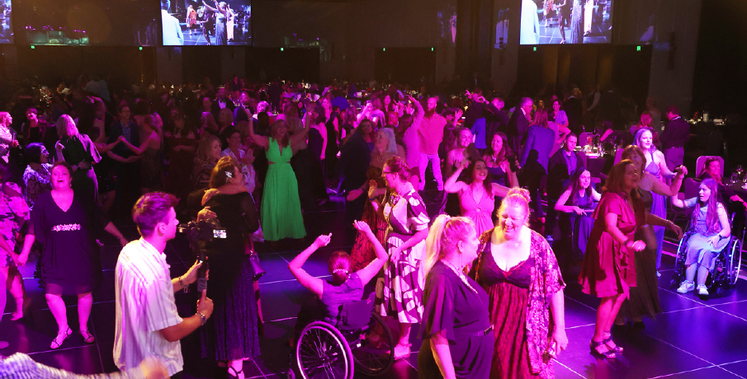

About the Awards Ceremony

Winners and finalists will be announced at a gala dinner on 18 May 2024 at Crown Perth.

Tickets for the gala dinner are available for purchase here.

Winners of each category will receive a cash prize of $2,000 and a trophy. Nominees should be aware that the prize monies for each award will remain the same, regardless of whether an individual, team, organisation or a Board wins the award.

Contact Information

If you have any questions or require assistance in completing a nomination, please contact Michelle Crook at NDS on 9208 9812 or michelle.crook@nds.org.au.

/ WA Disability Support Award

Terms and Conditions

- All information in the Nomination Form and the Nomination Guide forms part of the Terms and Conditions.
- Nominations can only be accepted for individuals, teams, organisations or Boards in Western Australia supporting Western Australian people with disability.
- All nominations must be endorsed by a person with a disability, their family or carer.
- All nominees will be contacted prior to the Gala Dinner, so please ensure you have the permission of your nominee to be nominated. If you are nominating a team, all team members must agree to be nominated. Nominations without nominee consent are ineligible.
- Incomplete Nomination Forms received will not be accepted and returned to the Nominator for completion with a fixed deadline.
- All nominations must be received by 5pm AWST, 2 February 2024. Late nominations, or amendments to a nomination, may only be accepted by NDS with prior written consent.
- All nominees must be employees paid for their work in the disability sector. They may only be nominated for the work undertaken in that role and may not be nominated for support provided in any voluntary capacity.
- A “support worker” is someone who provides direct supports to a person with disability and can be known by other job titles such as residential aide, recreation assistant, mentor, personal care worker, house care person, job coach, recovery coach, skills trainer, and others determined by NDS. For the purposes of the Awards, support coordinators are NOT the equivalent of a support worker.
- Department of Communities and National Disability Insurance Agency (NDIA) employees are NOT eligible for these awards.
- Nominees cannot nominate themselves, either as an individual or part of a team.
- Nominees may be nominated for more than one Award category. Eligible nominees who provide support to people living in regional or remote Western Australia will automatically be entered in the Excellence in Regional Support Award category.
- Nominees may only win one Award category.
- It is the responsibility of the Nominator to ensure that anyone who appears in any photos, videos or audio files has given permission for the materials to be included in the nomination.
- Photographs, videos and documents in support of a nomination will only be returned to the Nominator on request.
- NDS reserves the right to contact the Nominee and any other person who appears in the nomination to request consent for any information provided (textual, photographic or other) to be used for promotional purposes.
- Each Award category has a panel of judges who read and score nominations. The judges meet to discuss their scores and finalists and winners are determined.
- Individual and team nominations are judged solely on the information provided, and assessed on their own merit, independent of the nominee’s employer.

- Judges are required to declare any real or perceived conflict of interest and withdraw from assessing any nomination where they are associated in any way with the nominator, nominee or nominated program/project.
- The Judges’ decision is final. No correspondence or discussion will be entered in to.
- Details of winners and finalists will be published in media releases and promotional materials.
- Photographs taken by the official photographer at the Awards ceremony may be used for promotional purposes by NDS, disability sector organisations and event sponsors.
- The selection of nominees, finalists and winners reflects the nominations received and information available to NDS and the Judges at the time. NDS reserves the right to withdraw a nomination or Award if further information or the nominees’ conduct draws the National Disability Awards into disrepute.
- Nominators and/or nominees should notify NDS immediately if further information or conduct that may draw the National Disability Awards into disrepute occurs.

