Considering health, pain and communication in Positive Behaviour Support

Contents
Learning Outcomes from today 3
You’re not you when you’re feeling… 4
You’re not you when you’re feeling…(continued) 4
What the research tells us 4
Current research – health needs 5
Current research – specific risks 5
Concurrent Considerations – Mental health 6
Concurrent Considerations - Trauma 6
Intersection of physical health and behaviour 7
Meet ‘Lenny’ 7
Meet Robbie 8
Diagnostic Overshadowing 8
Tony Vardaro – Social Worker and Disability Health Network member. 9
Tools for assessment 10
Some tools for assessment 10
Specific assessment considerations 11
Planning guided by the BSP – QEII 12
Implementation – communication needs 12
Overcoming barriers to access 13
Implementation – health literacy 13
Quality of life and good practice 14
Know it works – quality of life 14
My role is…my role isn’t 15
Re-visiting ‘Lenny’ 15
Re-visiting ‘Robbie’ 15
Mapping to the PBS Capability Framework 17
A Quote and a reminder 17
Meet ‘Kim’ and ‘Penny’, actors from the Zero Tolerance films - Recognising Restrictive Practices 18
Resources for considering health, pain and communication in PBS 18
Resources for considering health, pain and communication in PBS (continued) 19
References 20
Contact details and acknowledgements 21

Learning Outcomes from today
- Understand the current research
- Health needs
- Intersection of Health, Well-being and Behaviour.
- Keeping a respectful, balanced approach
- Gain awareness of tools for assessment.
- Explore strategies you may include during planning
- including how the BSP-QEII can inform our practice
- Be familiar with resources to support implementation.
We'll also map our learning to the Convention on the Rights of People with Disability and the PBS Capability Framework.

You’re not you when you’re feeling…
Image shows a Snickers chocolate bar on a white background to invite participants to think about the Snickers advertisements, where we can be grouchy and annoyed when hungry.

You’re not you when you’re feeling…(continued)
Hungry, thirsty, dealing with a migraine, constipated, bloated, missed your medication, sore, heartburn is playing up, tired, giving up coffee, stomach ache, toothaches, achy, your knee hurts, exhausted, yuck.

What the research tells us
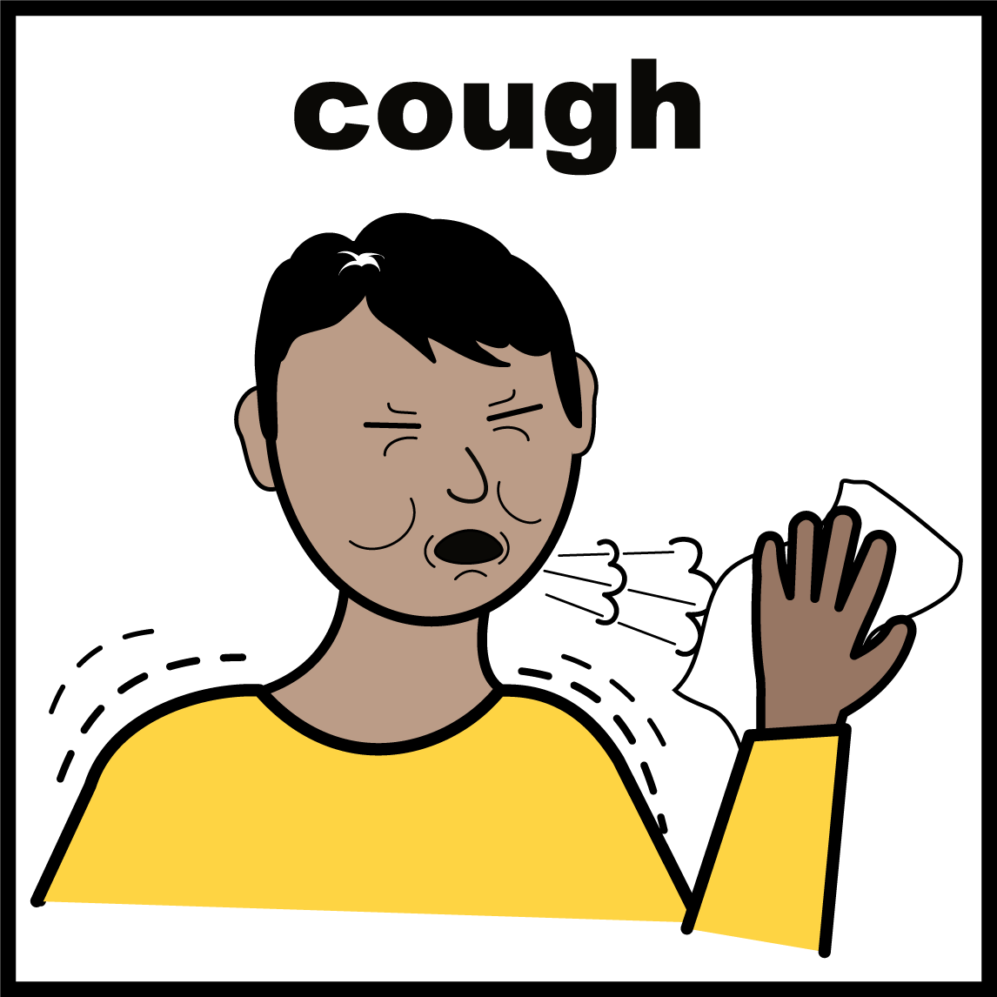
Simply having a cold is associated with reduced alertness and slower movement. We are also slower to take on new information and to remember things.
Reference - Smith, A.P. (2012). Effects of the common cold on mood, psychomotor performance, the encoding of new information, speed of working memory and semantic processing. Brain, Behavior, and Immunity. Accessed on November 4, 2020 at ScienceDirect website

Current research – health needs
"People with intellectual or cognitive disability often have more complex health needs and a higher mortality rate than the general population."
Reference - Office of the Public Advocate(Qld) (2016). Upholding the right to life and health. A review of the deaths in care of people with disability in Queensland: A systemic advocacy report. The State of Queensland (Department of Justice and Attorney-General)
42% of adults with disability rate their health as fair or poor. Compared to 7% of adults without disability.
Reference: AIHW web report, People with disability in Australia - health status

Current research – specific risks
People with disability, particularly an intellectual disability, are more likely to experience:
- Dental problems
- Epilepsy
- Chronic constipation
- Respiratory disease
- Gastro-oesophageal reflux disorder (GORD)

Concurrent Considerations – Mental health
There is a high prevalence of mental health problems for people with disability. These can co-occur with challenging behaviour, however a clear relationship between the two is not clear.
Reference - Bowring, D.L., Painter, J. and Hastings, R.P. (2019). Prevalence of Challenging Behavior in Adults with Intellectual Disabilities, Correlates, and Association with Mental Health. Current Developmental Disorders Reports 6 (p.173–181). doi.org/10.1007/s40474-019-00175-9

Concurrent Considerations - Trauma
“The possibility of trauma in the lives of all clients/patients/consumers is a central organising principle of trauma-informed care, practice and service provision. This is irrespective of the service provided, and of whether experience of trauma is known to exist in individual cases”
Reference - ASCA, 2012, p. 88, cited in Berry Street Report, ‘Taking Time, A Literature Review’ PDF.

Intersection of physical health and behaviour
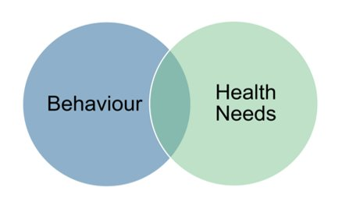
“Although behavioural change has been well documented as the first symptom of many serious health problems this can be overlooked”. (Evenhuis, 1997)

Meet ‘Lenny’
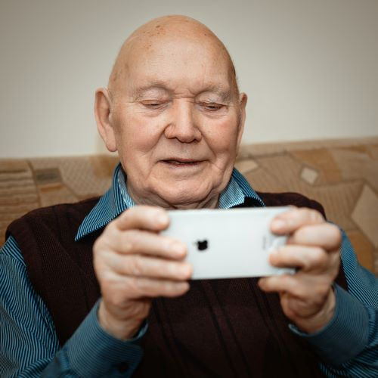
...a developing health problem might be viewed as just “being difficult.”
“He’s up at the toilet … I believe that it’s a boredom thing, not so much boredom because he does a lot of things but coupled with the short-term memory he forgets.”
Reference - Bowers B, Webber R, Bigby C. Health issues of older people with intellectual disability in group homes(†) Journal of Intellectual & Developmental Disability. 2014;39(3):261-269. DOI: 10.3109/13668250.2014.936083. Accessed at: Europe PMC website

Meet Robbie
...a developing health problem might be viewed as just “typical behaviour for that person”
Robbie hit out this week at staff, and last week as well.
When younger, Robbie had medication to prevent self harm and hitting out at others. The medication was stopped last year and things have been going really well, till now. We think it is just the same thing again. Anecdotal report.

Diagnostic Overshadowing
Diagnostic overshadowing occurs when a health professional makes the assumption that the behaviour of a person with learning disabilities is part of their disability without exploring other factors such as biological determinants.
Reference - Royal College of Nursing (2018) All you see isn't all there is: Looking beyond learning disability Bulletin.

Tony Vardaro – Social Worker and Disability Health Network member.
YouTube video: Tony Vardaro by Department of Health, Western Australia (2015)

Tools for assessment

General
- All functional assessments include a review of the person’s health.
- Is there a health plan?
- For adults – Comprehensive health assessment program(CHAP)
- Other health records?
- Is the person currently facing a significant health issue? What is the progress on this being attended to?
- What is the person’s health literacy – their understanding of the health issues they may be dealing with or awareness of healthy lifestyle choices?

Some tools for assessment
Peadiatric Pain Profile
Abbey Pain Scale PDF
Related tool - Intelligent Pain Assessment Tool | PainChek
St Oswald's Hospice | Distress and Discomfort Assessment Tool (DisDAT)
A screenshot of the DisDAT is then shown and discussed further in the recorded webinar.

Specific assessment considerations

Where there is chemical restraint
PRN (as needed medication),
- Does the checklist to provide PRN overlap with observations of physical discomfort for the participant?
- How is the person’s physical discomfort addressed?
Side effects
- Are these related to the health issues the person is experiencing?
- Consult with pharmacists regarding side effects.

Planning guided by the BSP – QEII
An extract of the Behaviour support plan quality evaluation tool, version two (BSP- QEII2) is shown.
Item | Quality Components of behaviour support plans | Evaluation guidelines and examples
5 | Environmental supports that addresses the triggers and setting events. | What changes need to be made to address the triggers and setting events (eg. system, communication, materials, interactions etc).  Other factors may also need to be considered. - Health, choice, routine, engagement.
6 | Replacement behaviour that meets the same function as behaviour of concern | Must specify replacement behaviour(s) that serve the same function as the behaviour of concern and must be easily performed.
7 | What strategies, tools or materials will be used to teach the replacement behaviour | Teaching strategies including at least one detail about how this will be done (eg. Materials, strategy, skill steps are described).

Implementation – communication needs
A YouTube video AAC - Introduction to Augmentative and Alternative Communication is discussed.
An example symbol of five fruit or vegetables a day is shown.
A screenshot of a resource bank called WidgetHealth and one example, a Health check social story is shown. Links are included on resources page below.

Overcoming barriers to access

Getting there
- extending appointment times
- calendars
- drive-by to prepare to go somewhere new

Successful appointments
- support providers with strategies around behavioural support planning for the best outcome
- waiting and/or modifying attendance
- provide brief behavioural information if needed
- supporting the presence of an advocate or someone the person trusts at appointments

Available information
- provide written information in an accessible format
- using visual aids when explaining procedures or results

Implementation – health literacy
A small selection of resources for the people you work with:
Health education for teenagers and adults from Centre for Developmental Disability Health Victoria, Monash University
Your Dental Health - Inclusion Melbourne
What Is Diabetes - Queensland Centre for Intellectual and Developmental Disability - University of Queensland
Easy Read Health Guides from the Council for Intellectual Disability [CID] a screen shot of one of these resources “Some signs of sickness’ is shown in the slide deck.

Quality of life and good practice
The Empowerment Circle [Accessible] builds on the work of Robert Schalock Quality of Life (QOL) domains and introduces additional life areas.

Know it works – quality of life

KINDL
A generic Health –Related QOL assessment for children and adolescents.

I-CAN
A supports needs assessment (training and certification required).

My role is…my role isn’t
“The disability services sector and disability professionals represent critical players in access to health care and continuity of health care for people with disability.”
Professor Julian Trollor, Statement to the Royal Commission into Violence, Abuse, Neglect and Exploitation of People with Disability PDF, page 46. Accessed on 15/12/2020 at Disability Royal Commission website

Re-visiting ‘Lenny’
‘Lenny’ was supported to go to an urologist.
Bowers B, Webber R, Bigby C. Health issues of older people with intellectual disability in group homes(†) Journal of Intellectual & Developmental Disability. 2014;39(3):261-269. DOI: 10.3109/13668250.2014.936083. Accessed at: Europe PMC website

Re-visiting ‘Robbie’
Robbie was supported to
- Keep using the communication board
- A page was added about pain and discomfort
- A social story about being active and healthy was shared with Robbie regularly

Robbie’s team was supported to
- Improve record keeping
- Be able to identify when Robbie’s health needed to be reviewed
- How to share the communication resources

Mapping to the PBS Capability Framework

Interim Response
BSP’s - identify any existing data that might provide insight into the situation
Providers - Provide support for immediate review by a medical professional if required

Functional Assessment
BSP’s - Understand the importance of obtaining baseline measures (QOL); identify antecedents of the behaviours of concern; consider physical or mental health problems, including the effect of medications and sleep.
Providers – Arrange medical reviews as required
Always discuss your practice with your supervisor to ensure best practice and meets standards.

A Quote and a reminder
“The inability to communicate pain verbally can be stressful and frightening for any individual”
Johnson, E, Bornman, J. and Tönsing, K.M. (2016). An exploration of pain-related vocabulary: implications for AAC use with children. Journal of Augmentative and Alternative Communication Volume 32, 4 (p249-260)

Meet ‘Kim’ and ‘Penny’, actors from the Zero Tolerance films - Recognising Restrictive Practices
A freeze frame from the film regarding physical restraint is shown. This pair of films is recommended to reinforce learning about health and behaviour. Links to these and other Zero Tolerance films and resources are on the resources page below.

Resources for considering health, pain and communication in PBS

Zero Tolerance
Zero Tolerance is an initiative led by NDS in partnership with the disability sector. Built around a national evidence-based framework, Zero Tolerance is a way for organisations to understand actions they can do to prevent and respond to abuse, neglect and violence of people with disability. Resources include Recognising Restrictive Practices and Trauma Informed Support can be found on the Zero Tolerance webpage.

Health education
- For teenagers and adults (Centre for Developmental Disability)
- For practitioners and supporters Healthcare & People with Intellectual Disability Course

Selection of Accessible Information
- What Is Diabetes - Queensland Centre for Intellectual and Developmental Disability - University of Queensland
- Your Dental Health - Inclusion Melbourne
- Health Archives | Council for Intellectual Disability
- Widgit Health website

Pain
- See slide ‘Some tools for assessment’ above
- Pain Australia Clinics, research and resources

Resources for considering health, pain and communication in PBS (continued)

Centre for Disability Research
Inclusive research paper: Being and Keeping Healthy PDF

Centre for Developmental Disability Health – GP education
Dr Paul Nguyen, General Practitioner and Medical Educator: Presentation - ACT Senior Practitioner Seminar Series

NDIS Quality and Safeguards Commission - various
- NDIS Worker Orientation Modules
- Compendium of Resources for Positive Behaviour Support | NDIS Quality and Safeguards Commission (tools shared in the Compendium are noted with an asterisk* in previous slides)
- Practice Alerts - Resources | NDIS Quality and Safeguards Commission

Disability and health video - moving away from the medical model of disability
YouTube video: Tony Vardaro, Department of Health, Western Australia (2015)

References
Adults Surviving Child Abuse (ASCA, 2012). Practice guidelines for treatment of complex trauma and trauma informed care and service delivery. Kirribilli, Australia: Adults Surviving Child Abuse. p. 88, cited in Berry Street Report ‘Taking Time Literature Review’ PDF
Australian Human Rights Commission (2020) Guidelines on the rights of people with disability in health and disability care during COVID-19. Retrieved from Australian Human Rights website
Australian Institute of Health and Welfare. (2020). People with disability in Australia. Retrieved from AIHW web report People with disability in Australia
Bauer A, Taggart L, Rasmussen J, Hatton C, Owen L, Knapp M. (2019) Access to health care for older people with intellectual disability: a modelling study to explore the cost-effectiveness of health checks. BMC Public Health. Jun;19(1) 706. doi:10.1186/s12889-019-6912-0. PMID: 31174506; PMCID: PMC6556058.
Bowring, D.L., Painter, J. and Hastings, R.P. (2019). Prevalence of Challenging Behavior in Adults with Intellectual Disabilities, Correlates, and Association with Mental Health. Current Developmental Disorders Reports 6 (p.173–181). doi.org/10.1007/s40474-019-00175-9
Disability Services Commissioner (2019) A review of disability service provision to people who have died 2018–19 PDF. Accessed on 4/11/2020
Evenhuis HM (1997). Medical aspects of ageing in a population with intellectual disability: III. Mobility, internal conditions and cancer. Journal of Intellectual Disability Research : JIDR. 1997 Feb;41 ( Pt 1):8-18. DOI: 10.1111/j.1365-2788.1997.tb00672.x.
Hunt, A., Goldman, A., Seers, K., Crichton, N., Mastroyannopoulou, K., Moffat, V., & Brady, M. (2004). Clinical validation of the paediatric pain profile. Developmental Medicine and Child Neurology, 46, 9-18. doi: 10.1017/S0012162204000039
Johnson, E, Bornman, J. and Tönsing, K.M.(2016). An exploration of pain-related vocabulary: implications for AAC use with children. Journal of Augmentative and Alternative Communication Volume 32,4 (p249-260)
Trollor, J. (2020) Statement to the Royal Commission into Violence, Abuse, Neglect and Exploitation of People with Disability PDF, p46. Accessed on 15/12/2020
Webber, L.S., Major, K., Condello, C., & Hancox, K. (2017). Providing positive behaviour support to improve a client’s quality of life, Learning Disability Practice, 20, 4, 36-41 [cited in Victoria Government (2019). Recognising and reducing mechanical restraint: Practice Guide Word

Contact details and acknowledgements
Thank you for watching this webinar. Wishing you good health and a productive week. For a recorded version of the webinar visit nds.org.au.
Presented by:
Sarah Nicoll
National Practice Lead – Zero Tolerance, NDS
sarah.nicoll@nds.org.au
With thanks to: NDS are pleased to be able to provide the Behaviour Support Practitioner workshops for free to the sector as part of a two-year grant from the NDIS Quality and Safeguards Commission.

