NDS & DHHS Webinar: Safer and Stronger – accessible slides

# Slide 1

## NDS: Safer and Stronger – Disability Services and COVID-19 webinar

### Friday 25th September 2020, 10:00am – 11:00am



# Slide 2

## Welcome and Introductions

Sarah Fordyce – Victorian State Manager (Acting), NDS

# Slide 3

## Agenda

* DHHS update – James MacIsaac, Executive Director Disability, Disability and Communities Branch, DHHS
* Public Health update – Professor John Catford - Senior Medical Adviser, DHHS
* NDIA update – Stephen Broadfoot, Branch Manager, Provider Engagement Branch
* WorkSafe update – Brianna Doolan, Project Officer WorkWell Program, WorkSafe
* Provider Perspective – Lynette McKeown, National Director, Quality and NDIS Residential, Able Australia
* Q&A – Facilitated by Sarah Fordyce,NDS

# Slide 4

## DHHS Update

James MacIsaac

Executive Director Disability, Disability and Communities Branch

Department of Health and Human Services

# Slide 5

## NDSV Safer and Stronger Webinar COVID-19 and Disability

Disability Update 11 September 2020

James MacIsaac, Executive Director, Disability

Department of Health and Human Services

Visit [DHHS website](http://www.dhhs.vic.gov.au/coronavirus)

COVID-19 hotline 1800 675 398

# Slide 6

## COVID-19 outbreaks in disability settings

As at 24 September, there are 11 active cases of COVID-19 in disability and community setting (including SRSs)

4 cases are in facility based settings

* 4 staff members and 0 residents / participants

7 cases are in community based settings (including SRSs)

* 6 staff members and 1 participant

A total of 5 facility based sites are currently affected

# Slide 7

## Day to day PPE requirements during the pandemic

**Disability residential services must have sufficient supply of:**

* PPE to meet the usual day to day requirements of everyday living. Day to day requirements will vary based on resident support needs.
* Single use surgical face-masks and eye protection for all staff to meet the current prevention requirements in response to the COVID-19 pandemic:
* Enough face masks to allow for a new mask at least every four hours
* Enough eye protection for each staff member to have their own – not shared
* Face-masks for residents to wear when they are out and about in the community (reusable or single use surgical)

**How many days of PPE should services store?**

Consider how often an order will be placed, and ensure that enough days of supply on hand to cover that period, the delivery delay and a safety margin

# Slide 8

## PPE Training

**Training in the use of PPE**

* Ensure staff know how to don and doff PPE safely and dispose of contaminated PPE
* Ensure that in ordering outbreak PPE, allowance is made for every staff member to utilise at least one set of PPE in a training exercise
* Face to face training and fit testing in PPE is recommended. NDS is working to support disability services to strengthen their relationships with local health services.  Some are available to support individual organisations. DHHS is working with NDS to support further face to face training options, and is also providing some directly through the IPC nurses [IPCON@dhhs.vic.gov.au](mailto:IPCON@dhhs.vic.gov.au)
* E-learning modules on COVIDSafe, PPE and Use of P2/N95 masks are available [here](https://health.evelearningex.com/)

# Slide 9

## PPE requirements in preparedness for outbreak

* When preparing for an outbreak in a residential service, providers should ensure each site has at least 2-3 days supply of outbreak PPE kits
* Check with your usual PPE supplier – is it sufficient to have 2-3 days stock to cover you until additional stock can be delivered? If not, order additional stock to cover the expected delivery period
* In addition to having outbreak PPE kits available at each residential site, you should also have 2 or 3 outbreak PPE kits available in a centrally located office, that can be quickly deployed to residential sites as a back up if needed
* For a 14-day outbreak, it is estimated that about six medium-sized boxes of PPE will be required. Consider storage requirements when planning and have your order ready to go

Advice about the types of PPE required when a client has COVID-19 or is a close contact is available at [PPE Community Service Providers Prevention](https://www.dhhs.vic.gov.au/ppe-community-service-providers-prevention-covid-19)

# Slide 10

## PPE Supply

Providers are expected to have sufficient PPE supply available through their usual suppliers. Always ensure that PPE is Therapeutic Goods Administration (TGA) approved.

* NDIS providers can claim the additional cost of PPE for support workers through the NDIS. Information is available at [Connecting and helping participants](https://www.ndis.gov.au/coronavirus/providers-coronavirus-covid-19/connecting-and-helping-participants#ppe)
* If PPE is not available through the provider’s usual supplier then approach other sources.
* Disability providers funded under the National Disability Insurance Agency (NDIA) have access to the National Medical Stockpile and can request PPE by emailing [NDISCOVIDPPE@health.gov.au](mailto:NDISCOVIDPPE@health.gov.au)
* Disability providers funded by DHHS and NDIS can request PPE via the department’s centrally managed inbox [CSPPE@dhhs.vic.gov.au](mailto:CSPPE@dhhs.vic.gov.au)

# Slide 11

## Recognising current PPE supply challenges

Health services and Infection Prevention and Control teams visiting services have reported **gaps in PPE** on site.  In some cases they have provided short term supply, or assisted by linking providers with local health services.

We are aware that some providers have had **issues accessing P2/N95 masks** in particular, and we urge providers not to purchase different masks or brands that are not TGA approved instead.

We are working with the sector to provide a **ready reckoner** that will help providers estimate how much PPE they need for **day to day infection prevention** during the pandemic, how much they need to have on hand in case of outbreak and how to plan ahead for **outbreak quantities**.

This will help providers to have good engagement with PPE suppliers and put in place these arrangements systematically and ahead of time. In the meantime we are working to provide further information about accessing PPE and working with the NDIA on the opportunity to facilitate a short term boost to supplies.

# Slide 12

## Worker mobility reduction payment initiative - update

COVID-19 Workplace Directions oblige **employers to restrict** worker mobility and **workers to declare** where they are working at more than one site.

Disability residential providers have made efforts to minimise the risk of COVID-19 cross infection by **cohorting workers** and **restructuring rosters**.

State and Commonwealth Governments have jointly funded the $15m Disability Worker Mobility Reduction Payment (DWMRP) initiative to further incentivise providers and workers to work at no more than two residential sites.

The initiative compensates **workers** for income lost as a result of reduced hours and **providers** for the additional costs associated with filling rosters**.**

NDIA and DHHS will **make payments** to NDIS/state funded providers respectively **through existing funding mechanisms/contracts**.

**For more information see** [**Disability worker mobility reduction factsheet**](https://www.dhhs.vic.gov.au/disability-worker-mobility-reduction-payment-factsheet-covid-19-doc)

# Slide 13

## Public Health Update

Professor John Catford

Senior Medical Adviser

DHHS

# Slide 14

## NDIA update

Stephen Broadfoot

Branch Manager for Provider Engagement

NDIA

# Slide 15

## WorkSafe update

Brianna Doolan

Project Officer, WorkWell Program

WorkSafe

# Slide 16

## WorkWell

Brianna Doolan

Project Officer, WorkWell Program

WorkSafe Victoria

# Slide 17

## WorkWell Program

**Toolkit**

**Mental Health Improvement Fund**

**Learning Networks**

**Leadership**

# Slide 18

## Work-related factors

**Work-related factors** are anything in the **design or management of work** that increases the risk of **work-related mental injury.** These are some common work-related risk factors:

* Low job control
* High and low job demands
* Poor support
* Poor workplace relationships
* Low role clarity
* Poor organisational change management
* Low recognition and reward
* Poor organisational justice
* Poor environmental conditions
* Remote and isolated work
* Violent or traumatic events

# Slide 19

## Work-related fatigue

* Consequence of work-related factor ‘high job demand’
* Current environment - Increased demand for healthcare and social assistance services during COVID. This increases the risk of work-related fatigue in some healthcare employees through the following:
* working additional shifts
* working longer shifts
* dealing with more intense workloads
* not getting adequate breaks
* 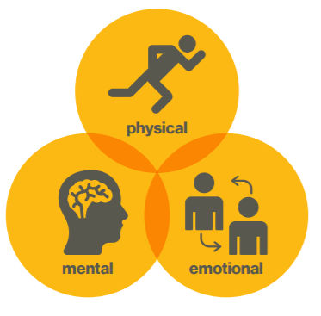

# Slide 20

## WorkWell Toolkit

[Video: Meet the WorkWell Toolkit](https://www.youtube.com/watch?v=ltGh4ipBDR8)

# Slide 21

## WorkWell Toolkit

The WorkWell Toolkit is a free online tool

* step by step approach
* help employers promote mental health and prevent mental injury
* access to tailored tools and information
* create an account to access practical resources such as;
* case studies
* policy examples
* videos
* tip sheets
* templates
* track your progress and share information

It is aimed at employers, focused on:

* Business owners
* Senior management
* Human Resources
* Occupational Health and Safety (OHS)
* Health and Wellbeing (H&WB)

Decorative image

# Slide 22

## Fatigue Action – WorkWell Toolkit

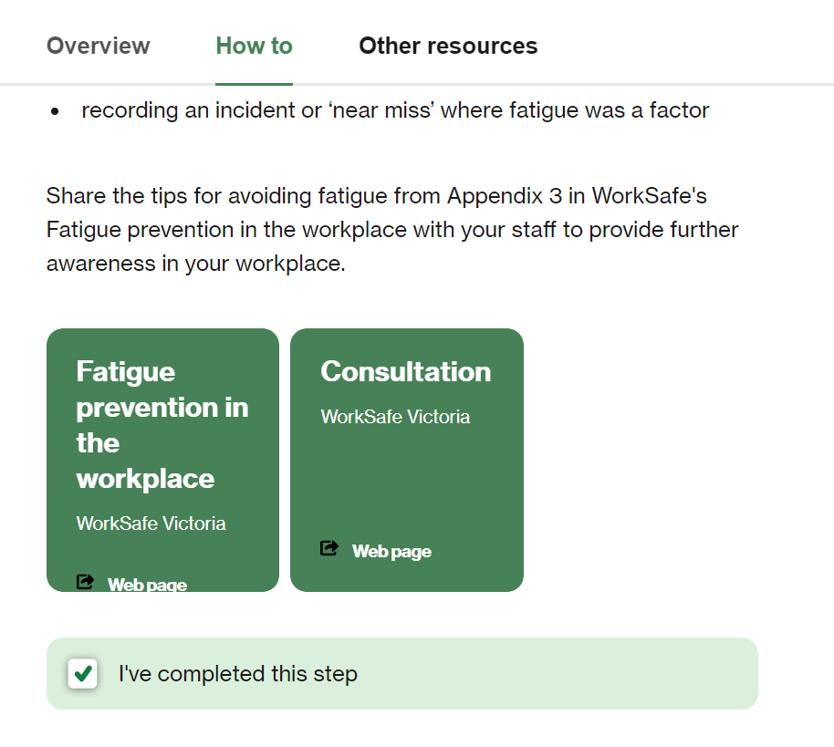

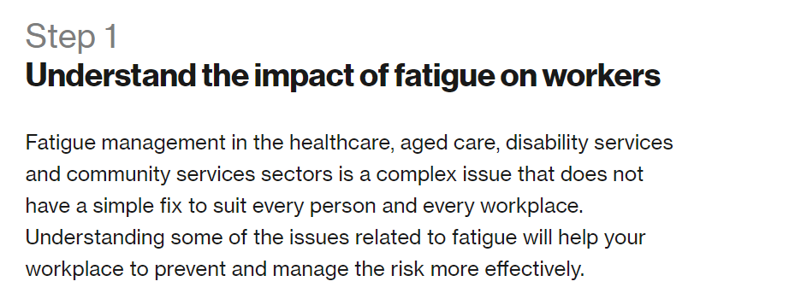

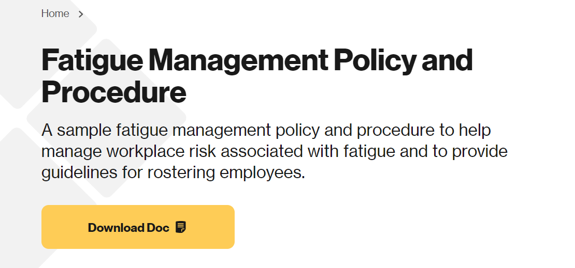

# Slide 23

## Coronavirus (COVID-19) Resources

* Managing coronavirus (COVID-19) risks: [Mental health at work risks](https://www.worksafe.vic.gov.au/managing-coronavirus-covid-19-risks-mental-health-work)
* Preventing and [managing the increased risk of employee fatigue](https://www.worksafe.vic.gov.au/preventing-and-managing-increased-risk-employee-fatigue-healthcare-during-coronavirus-covid-19) in healthcare during coronavirus (COVID-19)

# Slide 24

## Provider Perspective

Lynette McKeown

National Director, Quality and NDIS Residential

Able Australia

# Slide 25

## COVID Lessons Learned

Lynette McKeown

Able Australia

# Slide 26

## Case Study

* Client ‘cough’ à GP on-call à Admitted to hospital (1/9) à COVID + (3/9)
* COVID precautions within 1 hour @ Resi facility 1/9
* Four clients (close contacts) tested negative COVID
* Nine staff (close contacts) tested negative COVID
* One NDIS Residential home (staff work 1 site)
* Isolation space (staffed and ready for immediate stand-up) à not required
* 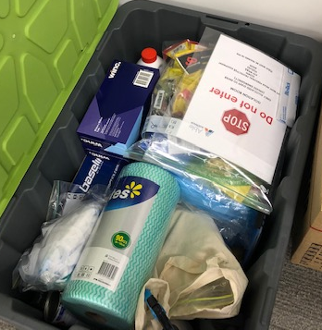

# Slide 27

## Incident Command Centre

Flow chart displays operations, logistics, planning, administration going up to Liaison Officer, Communications Officer and Incident Commander

# Slide 28

## Checklists

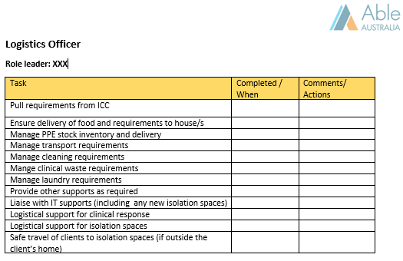

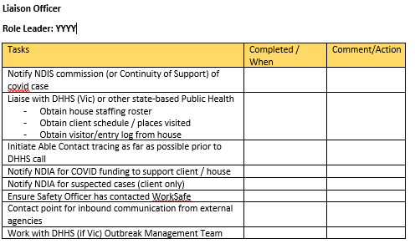

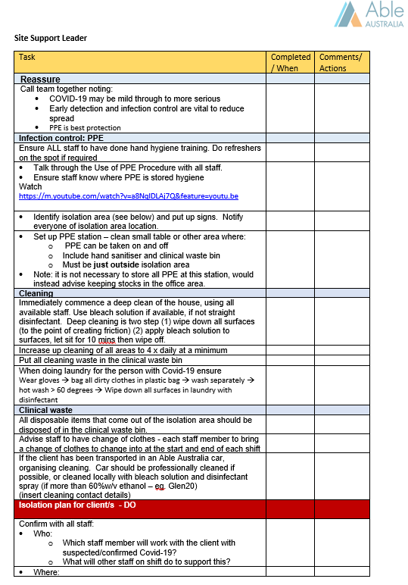

# Slide 29

## Site Support Team

**NOVICE**

**25 staff**

Volunteers / identified staff

(unsure, not confident, unskilled, willing)

Decorative image

**Weekly Sessions**

**(6-8 sessions)**

Team Building

Skill development PPE training

Education – e.g. infection control

**PROFICIENT**

**20 staff**

(confident, skilled, cohesive team)

‘well supported’

‘you did what you said you would do’

‘you gave us the tools and knowledge that we needed’

Decorative image

# Slide 30

## Response

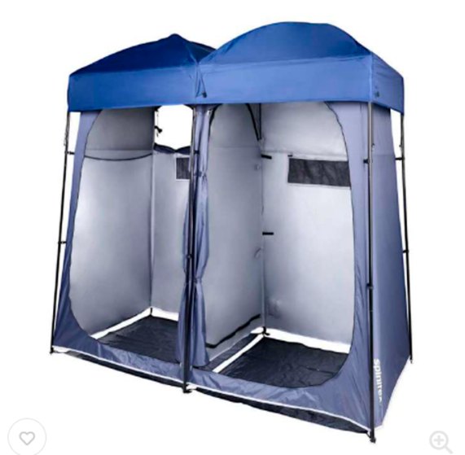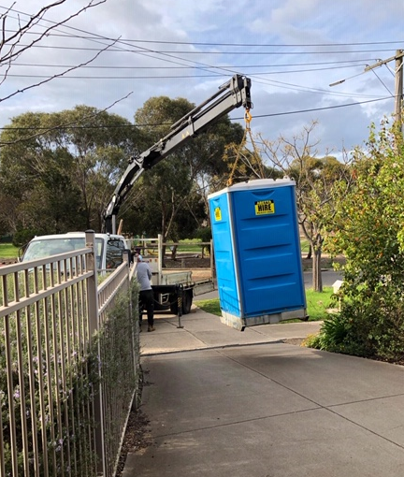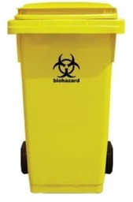

# Slide 31

## Storage

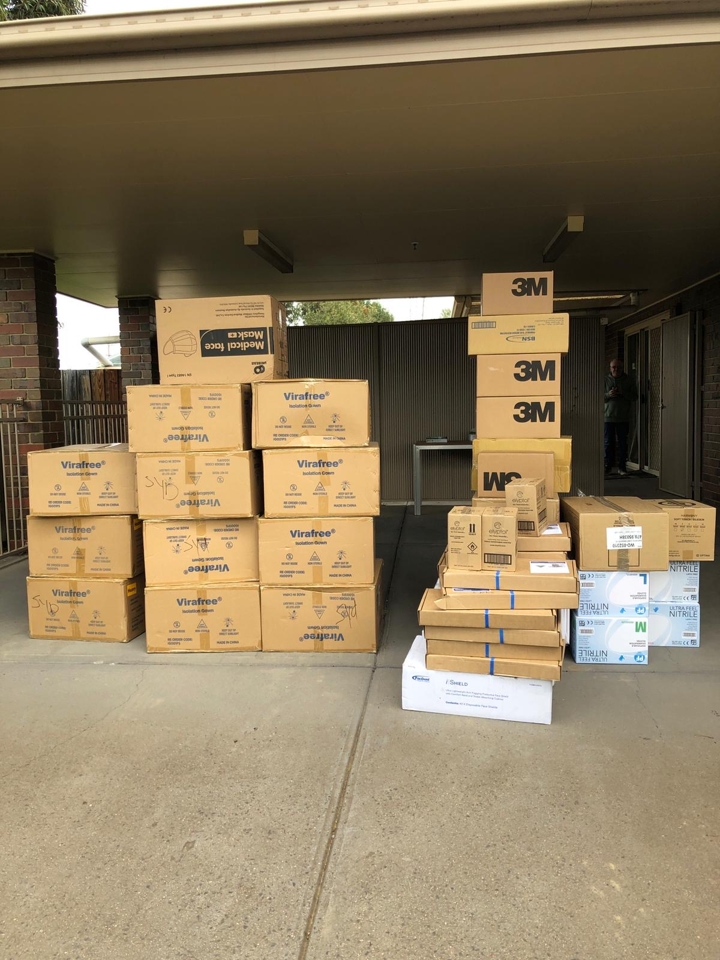

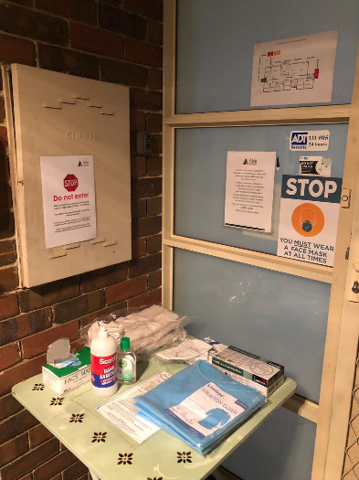

# boxes of gloves and bin

# Slide 36

## Royal Melbourne Hospital Staff

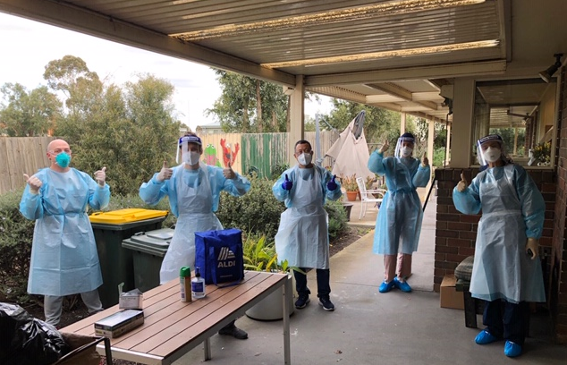



# Slide 37

## Partners

* Health Services
  + RMH immediate response – checked flows / cleaning support / food packs / N95 / refresher training
  + Clinical support
  + Acute (WH) à HITH planned (seamless transition of care)
* DHHS (DRRG + Public Health – Team 4)
  + Prevention Audits / Outbreak Team audit – isolation space
  + PPE supplied – immediate
  + Contacts – deep cleaning / clinical waste

# Slide 37

## Q&A

Questions from Q&A box and those submitted in advance to NDS

# Slide 37

## Thank you

Short survey – link in the chat box

[NDS Coronavirus Hub](https://www.nds.org.au/covid-19-hub) - [Victorian COVID-19 Response](https://www.nds.org.au/index.php/covid-19-hub/victorian-covid-19-response)

End of document.