National Disability Services State of the Disability Sector Report 2016
The concerns raised in this report are not about the NDIS as a destination or the imperative to improve employment outcomes for people with disability, but about how we get there – and whether the path we are on is the best route to the destination.

Contents
The State of Play – Page 3
- The local story: Northern Territory – Page 5
The state of the operating environment for disability services – Page 6
- The local story: Western Australia – Page 16
The state of the NDIS – Page 17
- The local story: South Australia – Page 20
- The local story: Tasmania – Page 21
The state of the broader policy environment – Page 22
The state of disability employment – Page 23
- The local story: Australian Capital Territory – Page 26
- The local story: Queensland – Page 27
The state of the workforce – Page 28
- The local story: Victoria – Page 32
Toward a future state – Page 33
- The local story: New South Wales – Page 35
NDIS transition arrangements – Page 36

The state of play
Over the past decade the disability services sector has been a leading proponent of reform. We campaigned for the National Disability Insurance Scheme (NDIS), applauding when in 2009the Prime Minister announced a Productivity Commission inquiry into disability support – the inquiry which 18 months later recommended the establishment of the NDIS.
Equally, the disability sector has long advocated for an expansion of employment opportunities for people with disability. We have repeatedly raised concerns about the low and static rate of disability employment and generated practical proposals of how that rate could be lifted. We are active participants in the current consultation process to reform Disability Employment Services.
The principles on which the NDIS is founded remain compelling and inspiring. Doubling the funding for disability support to rectify the chronic under-supply of services, choice and control for people with disability and their families, an insurance approach that focuses on early intervention and building the capacity of individuals and families and increased equity across Australia.
The concerns raised in this report are not about the NDIS as a destination or the imperative to improve employment outcomes for people with disability, but about how we get there – and whether the path we are on is the best route to the destination.
Expanding opportunities for people with disability in all domains of life is a vision shared across the disability sector. Achieving that vision requires a partnership between people with disability, families and carers, service providers and governments. It requires improvements across mainstream services and it requires a vibrant and sustainable disability services sector. This report focuses on the risks and the opportunities that lie before us if we want that vibrant and sustainable sector to achieve the vision we all share.
National Disability Services’ (NDS) 2016 Business Confidence Survey highlights the amount of change and growth required by the supply side to fulfil demand. Australia has over 2,000 disability service providers operating in the current market. They need resources, time and clarity about policy settings to successfully transition to the NDIS.
Traditional funding arrangements have allowed them little opportunity to build the required operating capital needed for an NDIS transition. As many of these service providers are not-for-profit, their capacity to access finance is also limited. When the inadequacy of key NDIS prices and the difficulty in recruiting and retaining staff are factored in, it is evident that there are significant constraints to growth in supply that present risks to NDIS transition.
New market entrants, including for-profits, can’t be relied on to bridge this supply gap. For-profits and not-for-profits operate in the same markets, pay the same salaries and on-costs and are equally affected by workforce constraints. New entrants of any type will have to invest to build assets and market share. Prices and profit margins must be sufficient to ensure they recover this new investment as well as provide for a strong long-run return. For-profit providers will likely demand a higher minimum rate of return than not-for-profit providers.
We cannot ignore the significant financial investment made by the more than 2,000 providers already operating. It makes good sense to fully leverage this investment. As they have been running very lean for many years, existing providers need short-term resources to adapt and improve service delivery. With effective support these organisations and their more than $16B in assets can be transitioned to become a strong source of supply for the NDIS. Without it these organisations and assets will be lost to the sector – further adding to the costs and risks of supply.
The NDIS cannot afford to lose existing providers’ knowledge of and commitment to current and future NDIS participants.
To ensure we have a robust, adaptable, high-quality and affordable market for the supply of disability services, the Australian Government should work with the disability services sector to develop an industry plan that outlines how providers will be supported to adapt and thrive. The expansion of life opportunities for people with disability promised by the NDIS cannot be delivered without a strong, sustainable and diverse disability services sector.
- Ken Baker, Chief Executive, National Disability Services

The local story: The Northern Territory
Tony Burns, CEO - HPA (Helping People Achieve)
The aim of HPA has always been to break down barriers in how people look at disability, advocating for inclusion and educating people.
The past 12 months have been huge for HPA. It became the first charity to win the Telstra Business Awards – a great achievement for both us and the sector.
One of our most innovative programs is our Work Ready program, which has been rolled out in two schools in the Northern Territory as a stepping stone from school to work. Students are given a 12 month partnership with HPA, where they are provided with extra tools to expand their skills. We’ve also had great results with products made by our supported employment enterprise. We’ve branched into trailer-building with Trailers 2000, making trailers for Bunnings. We are now their Number 1 distributor in Australia.
We are in the final stages of completing our new Community Hub. It’s for businesses, clients, families and carers to improve discussion, participation and community involvement. Partnerships are very important. We are working more closely with big companies here. There is more social responsibility now among such companies but there is still some disconnect, so we are bettering communication with them.
We are also working with the defence force and crucially we’re developing partnerships in remote areas of the Northern Territory.
The NDIS is a big change for us. We’ve been running workshops to better inform our clients. It’s about being at the forefront of positive change.
My key message for other providers is get back to the crux of why you do this. Being connected to your brand and knowing who you are and what you do is extremely important.

The state of the operating environment for disability services
The following data is produced from NDS’s fourth wave of the national business confidence survey of the disability sector. 549 disability service providers responded – 486 NDS members and63 non-members. More than half of respondents (53%) had income of less than $3M in 2015-16 and employed fewer than 50 staff. 80% of respondents were not-for-profit.

Demand is growing rapidly
71 per cent of service providers have reported increased demand for their services over the last year (compared with 61% in 2014) and 75% expect demand to increase further in 2016-17. While not all respondents are yet operating in the NDIS, its introduction is increasingly being felt across the sector.
Despite their expectations that demand will grow further, only 60% of organisations are planning to increase the scale and range of services they provide. This is down from 68% in 2015. Only half (53%) expect to be able to satisfy demand – as such the amount of unmet client need is expected to grow. Of the half of organisations that believe they will not be able to meet demand, only 13% expect client needs to be fully met by another organisation. Approximately one in five organisations (22%) believes that the clients they turn away will receive no service at all and 43% believe that other providers will only partially meet their needs.
Finding: Despite most providers reporting an increase in the range and scope of their services, 38% were unable to keep up with demand.
Although more than half of organisations have increased the scale and/or range of services provided in the last year, 60% reported comfort with keeping up with demand. 38% stated they were unable to meet demand.
Of organisations unable to meet demand, 10% reported that clients went without any service, over a third said the needs of clients were only partially met by other organisations and 14% stated clients’ needs had to be met (at least in part) by family or other supporters.

Clients are exercising choice
More than half (58%) of organisations providing services under the NDIS have had one or more clients leave them to go to an alternate provider. At this stage most clients appear to be moving to other existing not-for-profit providers (38%). There is also movement to new not-for-profit providers, sole practitioners (13%) and other for-profit providers (8%).

Graph: NDIS participants changing their provider: Where did they go?
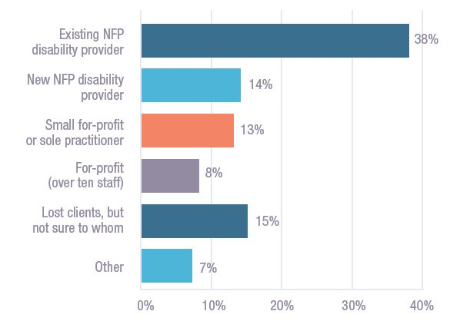
Reasons for moving service provider are varied. Some clients moved because a provider could not offer the desired service. Many reported that clients are leaving because they want a different kind of service or they chose to follow a particular frontline worker. Practical reasons like services being located closer to their home were also reported. Some report competitors using targeted advertising and special offers to attract clients.

The sector is responding to pricing levels and seeking alternate sources of income
Seventy per cent of organisations currently providing therapy services provided more service hours than the previous year. In contrast only 28%of providers operating a supported employment enterprise increased services. 31% increased interpretation/translation services and 42%increased in-home care. 10% of those providing assistive technology provided less services.
Fifteen per cent of services providing advocacy services for individual clients, 10% providing behavioural support and 13% providing respite services plan to either reduce or stop providing these services in the next year.
Thirty eight per cent of organisations are planning to introduce new services in the next year. Planning and coordination is the most popular for new services (8%) followed by assistance with new accommodation, travel and/or therapy services (6%).
Quotes:
“We can only break-even due to running five op-shops with volunteers ... The big risk is that there is not enough money for necessary longer-term investment and proper maintenance. The uncertainty around “how much we will be able to receive” once NDIS is implemented in our region means that the climate for any investment is too uncertain, because we cannot make a reliable business plan.”
“At this time, the income from non-government sources is subsidising the supply of services.”
Graph: Reported changes in service volumes by market segment over the last year
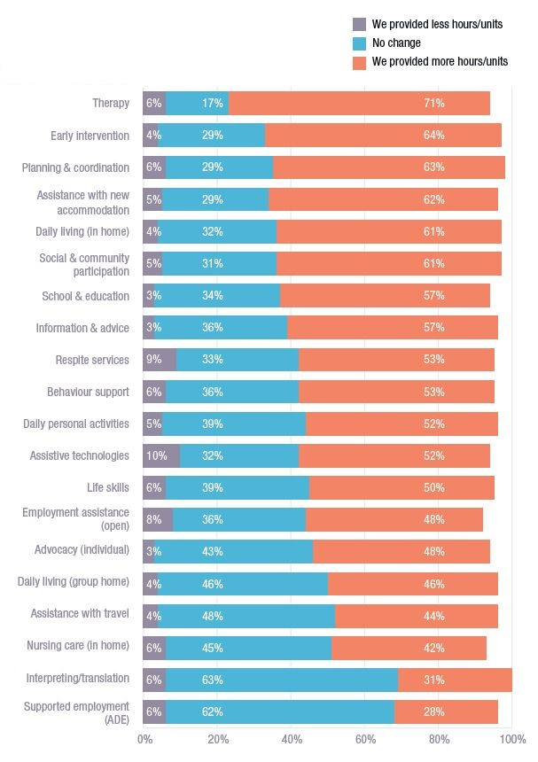
Graph: Intention to reduce or stop the supply of services
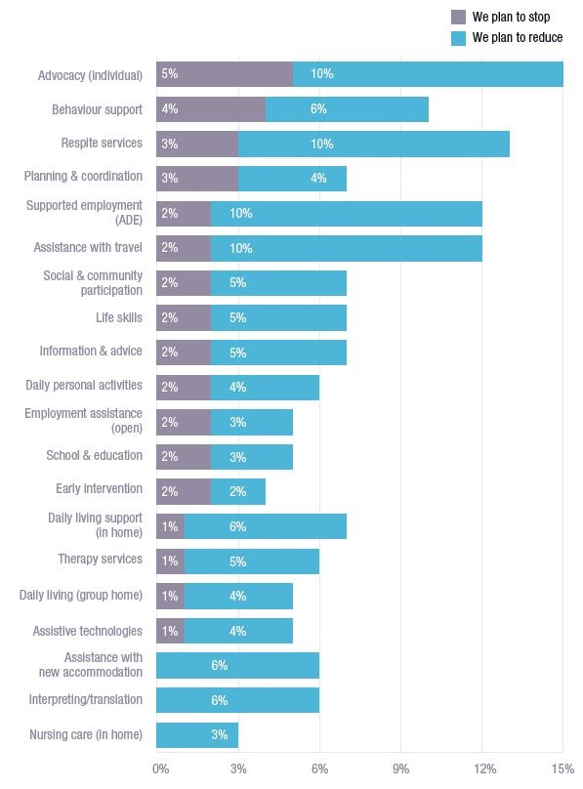
Less than half of respondents (43%) reported that all of their activities relate to the provision of disability services. The majority also provide services in areas of aged care, mental health and/or homelessness.
Nearly half (48%) report that they are entering new markets. Notably one in five (21%) are planning to begin providing services to aged care clients,17% are planning to provide community care services and 13% will offer mental health services.
The extent to which organisations are moving into new markets is related to their level of specialisation. Only a third (33%) of organisations specialising in disability services are planning to enter new markets in the next year, whereas 75% of those for which disability services is half or less of their business are planning to move into new markets.
Quote:
“The NDIA set pricing is insufficient to keep our service in financially stable condition.”

The strength of supply is variable
Just over half (55%) of all respondents reported making a profit, 20% broke even and a further 22% made a loss (the remainder did not know or were new entities). Of all organisations, only a third achieved a profit of 4% or more for the 2015-16 financial year.
Only 40% of organisations have budgeted to make a profit in 2016-17 and only 26% expect to achieve a profit of 4% or more. For-profit organisations were more likely to forecast a profit (58%); 23% expect to break-even with only 8% forecasting a loss. More than half (51%) of not-for-profits and 14%of for-profits that expect to make a profit in 2016-17 expect profits to be4% or less.
If this data is indicative of viability then service standards or prices must be altered for supply to be maintained. Low profit forecasts may be one of the reasons organisations are slowing their pace of growth.

The supply side is re-structuring in response to changes in the operating environment
Ninety per cent of providers agree or strongly agree that their organisation is actively working on its productivity. 79% say they have a clear strategy for the next year and 66% that they have a clear vision of where the organisation will be in three years.
Sixty per cent agree or strongly agree to being worried about their ability to adjust to changes resulting from the NDIS and 17% reported that their organisation is not focused on growth. This trend means demand must be met from other providers, again highlighting the impact of the NDIA’s pricing decisions on market supply.
The majority of organisations actively collaborate with others to advocate for individual clients or for the sector as a whole. Half have agreements in place with other organisations to refer or provide services to clients and a quarter share resources.
Graph: Working collaboratively and sharing resources
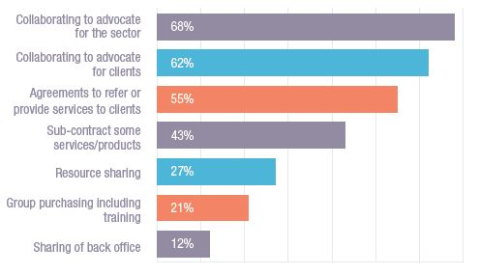
Forty one per cent of organisations have discussed the possibility of a merger. 14% have completed a merger within the past 12 months or are currently undertaking a merger. Of those discussing a merger, 12% said it was likely or very likely their organisation will merge in the next two years. 16% have discussed discontinuing the provision of disability services and 8% have discussed closing their organisation.

There is strong support for the NDIS but providers have concerns with the NDIA
Service providers feel left ‘outside the tent’ regarding decisions being made by the NDIA. Only 8% of respondents agreed that government is anticipating or responding well to the needs of organisations and just 13%stated the NDIA is working well with providers.
Less than one in five organisations (18%) agreed that ‘the NDIA has a high level of respect for current service providers’. In their comments, providers expressed views that the NDIA is dismissive of their years of experience in delivering disability services and does not recognise their commitment to the NDIS.
Many providers are worried that the NDIA’s low level of sector engagement will result in implementation errors.
Graph: Service providers’ opinions on the operating environment
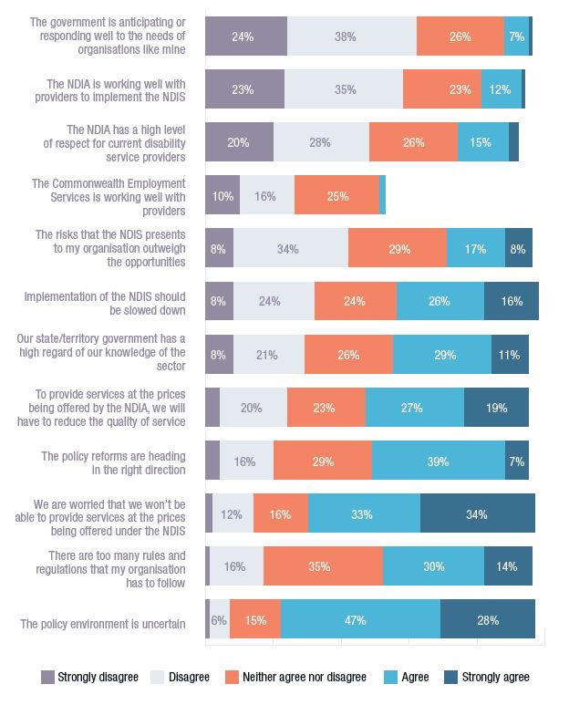
Quote:
“If the NDIA embraced the knowledge available from the sector ... and a clear understanding of the complexities involved in provision of services, a consistent and adequate approach to planning will result in better quality plans being provided.”

The message is clear – ensure that prices are aligned with the cost of supply
Effective pricing is critical. When asked to identify the one thing that would most impact on their capacity to supply services in the next year, by far the highest ranked was aligning prices with the actual cost of supply. Providers are also concerned they will not be able to provide services at the prices being offered under the NDIS (67%) and that they will have to reduce the quality of services in order to deliver at the current prices (46%).
Graph: Actions that would have the greatest impact on organisations’ capacity to deliver services in the next year
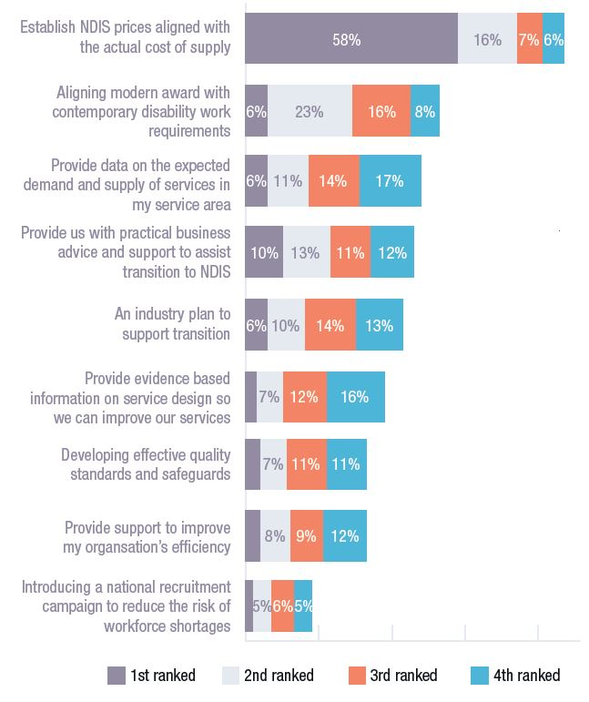

The local story: Western Australia
Marcus Stafford, CEO - MS Society WA
Our aims are simple, but focused. They are to increase services, the funding of research and the size of our property footprint for people with MS and other neurological conditions. We believe that the opportunities presented by the NDIS will help to facilitate that process.
The essence of the MSWA operating model is that it must be ‘customer-centric’. Whether dealing with our business, retail or disability customers, the same principle applies. Commercial thinking and creativity are encouraged in the workforce, creating a ‘can do’ culture.
In this model, both formal and informal processes apply for client interaction. These include informal forums and gatherings and a formalised structure within sub-committees of the Board.
While there has been some growth in government funding, our overwhelming funding source rests within MSWA’s commercial activities. These cover both business and retail segments. Gross revenue in this regard has grown by $20.6M in the last five years. This rapid growth has aligned with growth in all key areas of the organisation.
Member services in the last five years have grown by 70%.Client services have grown by 83%. MSWA’s contribution to research has grown by 120%.
As with our own aims, our message to others is simple – stay passionate and focused on mission, but embrace the marketplace. This world may be new to us, but it is steeped in history. The NDIS offers opportunities to increase revenue, reduce costs and lift productivity, quality and overall performance. This will in turn increase the “customer value proposition” for people with disability who we are here to serve.

The state of the NDIS

Experiences of NDIS transition
The complexity and intensity of scaling up from 30,000 NDIS participants(achieved over the three years of the NDIS trial) to 460,000 by mid-2019 is challenging governments, the NDIA, participants and families and service providers. Some of the systems and processes used during the trial were simply not suitable for this rapid growth and needed to be replaced or streamlined.
This past year service providers bore the brunt of substantial problems associated with the introduction of these new systems and processes. The myplace portal, introduced in July, interrupted payments to many organisations for the supports they provided over a two-month period.
The growth in planners and Local Area Coordinators, coupled with new planning pathways, has tested the tolerance of providers as they negotiate to have First Plans amended to include essential supports which were omitted.
An emerging problem is how the scheme will cope with registration applications from service providers. In recent months a backlog of thousands of applications has restricted providers from supporting participants. Given that many thousands more will be received as the NDIS transition continues, a streamlined registration process is urgently needed.
NDS has been in daily contact with the NDIA, both assisting providers with the problems they are experiencing and negotiating on substantial design and implementation issues. Communication from the NDIA has improved over the past few months. However a gap remains between the optimism of official updates and the experience of NDIS providers and participants.
NDS is particularly concerned about those service providers which have not yet provided NDIS supports. As they transition they will need to understand and respond to NDIS challenges immediately.

Reports flag transition challenges
Taken together, three recent reports by PwC, consultant Robyn Kruk and the Australian National Audit Office raise significant concerns about how well NDIS transition is occurring.
All reports flag the need for substantial improvements regarding how NDIS providers are consulted, assisted and informed. Failure to include service providers as co-design partners will compromise the creation of a market capable of meeting the demands of 460,000 participants. We need to see
government committed to understanding the on-the-ground experiences of the NDIS transition for service providers.
The important role of quality and safeguarding in this time was raised in the Australian National Audit Office’s report. The potential for workforce shortages, the emergence of new providers and a surge in demand for NDIS supports could challenge existing quality and safeguarding systems. Governments must prioritise finalising the national NDIS Quality and Safeguarding Framework and its supporting infrastructure and implementation arrangements.

NDIS prices
For the second consecutive year the NDIA has deferred the ‘step down’ to the so-called efficient price. This saw increases to the hourly price for one-to-one support by 3.9% in NSW, Victoria, Queensland and Tasmania and 1.9% in other states and territories. Remote and very remote loadings increased slightly to 18% and 23% and the monthly fee for financial intermediary services rose from $31.49 to $96.63 per month. Supported independent living prices in all areas were increased by 3.9%. Prices for most other supports increased by 2%. The announcement that prices were deregulated for participants who were self-managing their plans was welcomed.
Unfortunately progress on other important pricing matters stalled. Despite interest from the NDIA in participants with complex support needs, a higher price level has not been established. NDS continues to make the case for this higher price and has compiled evidence from providers to use in ongoing negotiations.
More work must be done to: increase one-to-one support prices; establish a mechanism for setting group prices; better reflect jurisdictional and geographical differences in prices; set prices that reflect complexity of support; improve the cancellation policy; and extend the deregulation of prices.
The Australian National Audit Office questions the NDIA’s dual role as funder or purchaser and price regulator and indicates that this conflict of interest ought to be examined. It proposes that whether the NDIA should have a role in price setting – or whether this important regulatory role should reside with an independent regulator – be investigated by the Productivity Commission in its review of scheme costs (which begins in July 2017 and reports by the end of that year).

Specialist Disability Accommodation prices
In June the NDIA released the Specialist Disability Accommodation (SDA) benchmark pricing for the land and build elements of SDA. This is the first time owners or renters of properties used for SDA can receive a payment from government to help cover the cost of providing the bricks and mortar.
While it is a welcome initiative, only around 6% of NDIS participants will be eligible for SDA payments. Considerable work is required across jurisdictions and government agencies that share housing responsibilities to improve the supply and diversity of accessible and affordable housing for people with disability.
Did you know?
The hourly price for one-to-one support increased by 3.9% in NSW, Victoria, Queensland and Tasmania and 1.9% in other states and territories.

The local story: South Australia
Wendy Warren, Chief Executive - EBL Disability Services
At EBL, we have a strong focus on continuous improvement and service innovation, particularly under the NDIS. We are developing systems for the scheme and are committed to social impact measurement and analysis. Last year, we travelled to Malaysia to share our social impacts for people with complex developmental disability.
We are working with sexual abuse prevention organisation Child Wise to ensure the safeguarding of children with disability is at the forefront of our work.
EBL is in a healthy position and is ready to enter an open market environment. We are ready to embrace the future.
We have grown from a $1.5M to a $10.5M business in just over four years and have managed to keep overheads to under 10% throughout this period.
In terms of collaboration, we are committed to helping other organisations succeed while supporting and broadening our own service offerings. To a degree, we have a culture of experimentation. We realise great innovation in our creative housing solutions and support for families to develop their own models. We do a lot of work to support families to be independent wherever they can be.
With regard to measurement of the impact on people’s lives, we have developed a framework that incorporates tailored dashboards for each person we support. By using real-time data, we are able to track the success of our practice.
We believe the pressure of the NDIS makes it important to “adjust, adjust, adjust.” Collaboration, experimentation and innovation are critical during this period of sector change. Pressure creates diamonds!

The local story: Tasmania
Natalie Rose, Manager, Advocacy and Engagement and Anthony Ozols, Manager, Positive Behaviour Support Li-Ve
Our work in Positive Behaviour Support is to reduce restrictive practices and create a culture of positive support. Li-Ve has always had a strong culture of person-centred thinking but we identified a gap as we didn’t have a framework around the monitoring and reviewing of restrictive practice.
We met with the Senior Practitioner to get an understanding of what we should be doing as an organisation. Following that we talked to our organisation about potential restrictive practices. Then we planned the best options to minimise the use of restrictive practice, better promote Positive Behaviour Support and best support our participants.
We created a database and as an organisation we’ve been able to have a lot more open conversations about current practices. As a result, some practices have changed and others have stopped.
We now have a Positive Behaviour Support Manager in our team, Anthony. He’s looking at opportunities for learning and developing skillsets as well as matching staff with people we support.
This experience has enabled staff to be very clear about their roles and when they need to seek direction. We also acknowledge the great resources available to our sector such as the Senior Practitioner we consulted with. Our advice would be, don’t shy away from these excellent resources.
Management and boards of organisations need to be across Positive Behaviour Support and restrictive practices, but it’s also extremely important that staff do the same since they are on the ground. Organisations need to allow their staff space to ask questions. There needs to be organisation-wide awareness to inform a holistic approach.

The state of the broader policy environment

Investment to reduce welfare dependence
The Australian Government is making $96M available for initiatives to decrease individuals’ reliance on welfare payments, reduce intergenerational welfare dependence and alleviate pressure on the social security budget. The Try, Test and Learn Fund will target carers under 25years of age, young parents 18 and under and students who move from a student payment to unemployment benefits.
NDS supports the introduction of the Fund, but cautions against using self-reliance as the sole measure of success. If exiting welfare support is achieved through employment, that is a good thing; but not if it is achieved through a means that impairs a person’s well-being (such as entering prison).

Numbers on DSP continue to shrink
Government policy (over several years) continues to drive a significant reduction in the number of Disability Support Pension (DSP) recipients. In June 2016 there were 782,891 recipients, a reduction of 48,703 recipients since January 2012 (the point at which revised Disability Impairment Tables were introduced).
Unfortunately, not enough of the people with disability who are leaving DSP or being denied access to the benefit are securing employment. The number of DSP recipients reporting wage earnings continues to decline, from 8.48% in June 2011 to 8.19% in June 2016. More effort must go into expanding employment opportunities for people with disability.

Renewed interest in the National Disability Strategy
At the September 2016 meeting of the Disability Reform Council all governments agreed to reinvigorate efforts regarding the National Disability Strategy. This renewed attention to ensure mainstream services are accessible for Australians with disability is welcome.
The newly formed National Disability and Carers Advisory Council will oversee the implementation of the 2010-20 Strategy and will report to the Disability Reform Council on progress. The last progress report was in 2014 and a plan for the next phase of the Strategy is due. A stronger performance and accountability framework – including annual reporting to parliaments – is needed.
Fact:
Over a four and a half period, there has been a reduction of 48,703 DSP recipients.

The state of disability employment

Open employment
A discussion paper outlining directions for the reform of Disability Employment Services (DES) was released in November 2016. It heralds: an expansion of participant choice; increased competition among providers and the elimination of market share; a single contract to replace Employment Support Service (ESS) and Disability Management Service(DMS) (with capacity to specialise); initiatives to stimulate employer demand for workers with disability; and a risk-based funding model that aligns rewards to providers with effort and outcomes.
Some features of the current program – such as star ratings and direct registration – will continue. The assessment and gateway process will be reviewed, but with a longer timeline than the other reforms which are likely to be finalised and announced in the 2017 Budget. The new program will commence in March 2018. A reference group (on which NDS is represented) has been established to help shape the reforms.
There are many design issues to work through and there is the critical matter of funding. According to the Productivity Commission’s Report on Government Services 2016, average government funding per DES user declined in real terms from $4,445 in 2009-10 to $3,657 in 2013-14. DES providers cannot continue to do more with less.
DES business reallocation has resulted in 10% of DES contracts across 59Employment Service Areas being reallocated, affecting 6% of participants who will be transferred to a higher performing provider. 81 contracts are being fully reallocated and four contracts partially reallocated. NDS remains sceptical about the net benefits of this exercise, given the disruption caused and the reforms now in gestation which are likely to abolish market share.
The government’s plans to tighten eligibility for Mobility Allowance (aligning it with NDIS eligibility) could disadvantage some DES participants. Mobility Allowance is a modest contribution to covering the cost of transport for a person in work or training or seeking work who would require substantial assistance to use public transport. The government plans to close Mobility Allowance in July 2020, having transferred funding to the NDIS. NDS’s evidence to a Senate Inquiry in November pointed out that some DES participants for whom access to public transport is an employment barrier will not be eligible for the NDIS.
Fact: Average government funding per DES user declined in real terms from $4,445 in 2009-10 to $3,657 in 2013-14.

Supported employment
Supported employment is a valid work choice for people with disability, but its public image is out-of-date. Through its new BuyAbility campaign, NDS intends to rebrand the supported employment model.
BuyAbility will market supported employment, increase procurement from supported employment enterprises and enable the sector to demonstrate its social and economic impact. BuyAbility will increase awareness of supported employment among jobseekers with disability, potential government and commercial customers, political leaders and local communities.
As part of the campaign, the BuyAbility Impact Tool will collect and present data demonstrating government savings and economic benefits from increased participation of people with disability in the workforce and measure the well-being of supported employees.

Legal and industrial challenges
The future of wage setting in supported employment remains unresolved, despite continuing discussions under the guidance of the Fair Work Commission.
In February 2016 the Business Services Wage Assessment Tool (BSWAT) was removed from the Supported Employment Services Award, but there are now moves by advocates and unions to remove other tools named in the award. These moves will be strongly resisted, particularly while the matter of a new wage assessment method is unresolved. A modified form of the Supported Wage System is being tested, but the outcomes as yet are inconclusive.
The complex matter of a wage assessment method won’t be resolved without consideration of two related issues: the income of supported employees, recognising that wages are a supplement to the DSP; and the affordability of increased wage costs.
A KPMG study (commissioned by NDS) clearly shows that supported employment enterprises do not have the financial capacity to absorb increased wage costs. A 40% increase in the wages of supported employees would push 84% of supported employment enterprises into deficit, causing closures and massive job losses.
Resolving the wages issue will require an increased subsidy from government. NDS has developed a proposal which would re-direct savings from DSP as a result of wages earnt by supported employees into a subsidy for supported employment organisations to fund increased wages. We believe this would preserve jobs, improve the income of supported employees and deliver net financial benefits to government (considering the cost of alternative disability supports).

Ticket to Work
Ticket to Work is a program designed to assist school students develop their work skills and readiness. Research shows that participation in work experience and employment during secondary school are among the most significant indicators of post-school success for young people with disability. A recent evaluation of Ticket to Work demonstrated positive results, with86% of participants in employment two to three years after leaving school.
Ticket to Work is delivered through a local network including schools, employment services, post-school providers and employers. There is an opportunity for this type of assistance to be provided through the Information, Linkages and Capacity Building (ILC) stream of the NDIS.

The local story: Australian Capital Territory
Hugh Packard, CEO - Valmar
Valmar started in Tumut in regional New South Wales – a town with a population of 7000, east of the ACT. As a result of the NDIS, Disability ACT moved out of direct service delivery and15 out of about 50 of their group houses in the ACT chose us to be their service provider.
The “transition phase” of the NDIS is presenting opportunities via a changing operating environment. For Valmar, reputation and word-of-mouth gained us this success.
Because of our commitment to relationships with people who use our services, we don’t use agency staff. We would rather pay existing part-time staff additional hours than employ people we don’t know.
It would be fair to say that for a variety of reasons some of the houses weren’t in great shape when we were chosen. Now, people have individualised plans, objectives and goals, and funds to support this. The NDIS has enabled more evolved decision-making, more independence and greater community participation.
Success as a service provider is about engagement on a human level, not gloss or the size of your organisation. The first challenge of the NDIS is to have people choose you! If you can genuinely deliver on the relationship, our experience is they will choose you.
It is hard work to become NDIS ready, though, adapting to all the changes – some of which are not immediately clear. There is a comprehensive body of work to be done by every organisation, which is different in each case. If I had a single piece of advice for others in the sector based on our experience, it would be, “Don’t wait!” Start making changes now.

The local story: Queensland
Karen Quaile, Director of Services – MS Queensland, Spark NeuroCare
Spark NeuroCare aims to bring together not-for-profits that support people with neurological conditions, acting as an alliance that actively supports that cohort. The central objective is improved quality of life for the people we support. We are working towards this through enhanced supports in the community and better outcomes such as the avoidance of hospital admissions and presentations.
This is the first time a group of not-for-profits have formally come together to do this kind of work.
To enable us to measure our effectiveness, we utilise the Australian Quality of Life 8D (AQoL-8D) assessment tool, based on the World Health Organisation’s tool. Over time, we will be able to ascertain the positive changes in the lives of our customers as a result of our service interventions. Other key effectiveness measures are Carer Strain Index, customer satisfaction surveys, reduction in the unnecessary presentations to hospital emergency departments and admissions to hospitals.
The strength of collaboration is the future for our sector. Individually, we are limited. Together, we have the strength and capacity to deliver holistic, high-quality services. It’s not easy – bringing organisations together is a challenge, but the outcomes make it worthwhile.
I’d also say the right staff is important. To deliver the best outcomes, staff require strong local networks and excellent listening skills. Something that’s absolutely fundamental is that services on the ground must employ locals to be effective. Each area has a different culture and history and that needs to be acknowledged in practice.

The state of the workforce

Sector workforce profile 2016
NDS’s Workforce Wizard now generates quarterly data on nearly 36,000workers in the disability sector Australia wide. Growth has been around 3%for the disability support workforce and 2% for the allied health workforce, suggesting organisations are growing steadily despite fears the sector will run out of workers.
Data from NDS’s 2016 Business Confidence Survey found a quarter of organisations employing speech pathologists or occupational therapists found them extremely difficult to recruit and a further third found them moderately difficult to recruit. Organisations have had trouble recruiting psychologists and other types of allied health professionals and difficulty retaining staff in these professions.
Fact: The rate of casual employment has remained steady 38% at around 38% of the workforce.
The rate of casual employment has remained steady at around 38% of the workforce, but many workers are anxious about casualization. Providers report difficulty in getting casual staff to team meetings and training. Casual workers have high turnover rates – roughly 8% per quarter, or over 30% per year compared to 20% per year for full-time and part-time staff.
Many state and territory governments are responding to concerns about disability workforce capacity and capability by funding workforce action plans and initiatives. Nationally the Australian Government has acted on an NDS recommendation by establishing a two year Innovative Workforce Fund which NDS will administer.
Graph: Changes in workforce in the 2016-17 financial year
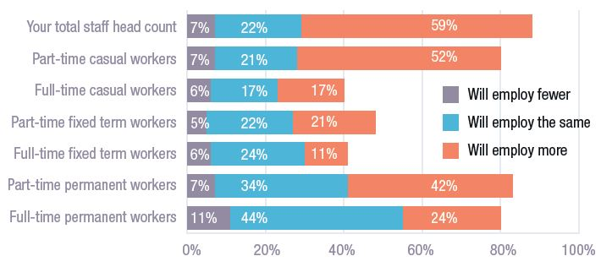

Service quality is at risk
Compared to the Australian labour force as a whole, jobs in disability are less likely to offer either a living wage or job security. Jobs in the disability sector are more likely to include fewer hours with the average at 22 hours per week. Across all industries the Australian average is 35 hours per week. A significant proportion of disability workers earn a living by combining two or more short-hours jobs together.
This can adversely affect the quality of service, with a worker’s commitment and focus split and their responsiveness to each individual employer constrained. For people with disability, being supported by the same person(s) tends to correlate with high-quality care.

Graph: Ease or difficulty in recruiting staff in the 2015-16 financial year
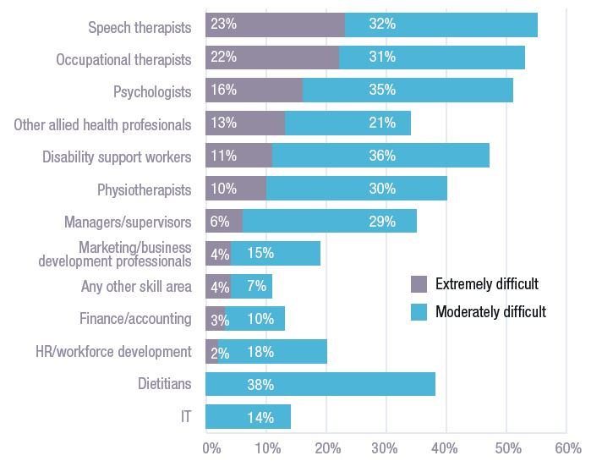

Changes under the NDIS
Individual purchasing under the NDIS encourages fragmentation rather than consolidation of hours. Many employers would argue that the combination of award rigidities and lean NDIS prices makes employing people casually and for short-hours jobs supporting specific clients the only financially viable option.
As a primary goal of the NDIS is to give people with disability greater ability to live their lives as they choose, the work to be performed may change on a daily or weekly basis. This makes rostering complex and less predictable. Many providers are finding that, in an already cost-constrained environment, they must devote more resources to administering cancellations and roster changes.
Graph: Intentions to recruit
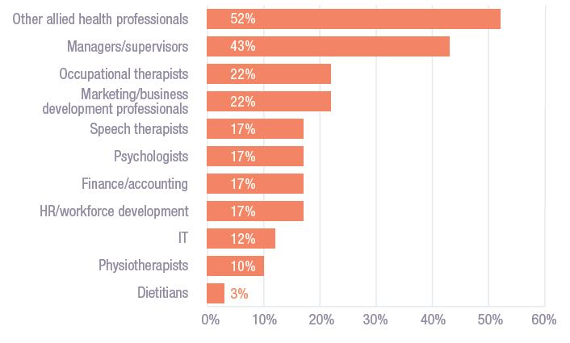

The review of the SCHADS Award
The current industrial award was created during a time when disability services were mainly delivered through state-funded programs. Recognising the changing environment, the Fair Work Commission’s Full Bench held special hearings in July and August to listen to evidence on how the NDIS is affecting working time arrangements.
NDS supported Jobs Australia and other employer bodies in arguing that there is now greater need for flexibility in days of the week, starting and finishing times and the ability to change shifts quickly where client needs change. NDS is firmly committed to an equitable and fair industrial relations system that supports a high-quality sector and provides attractive employment conditions for a growing workforce.
Changes proposed by employer parties during the award review have sought to discourage casualization by allowing minor flexibilities within permanent part-time employment. Employer parties explicitly rejected ‘zero hours’ contracts.
Although workplace bargaining theoretically offers the means for employers and workers to negotiate flexible local solutions that assist everyone, lean pricing is making this hard to achieve in practice.
Quotes:
“The biggest question for us is workforce. The talent war in the social and community services sector … over the past five years has already created shortages. The additional NDIS workforce requirements will need to come from somewhere and without a national strategy, the baseline remuneration and benefits that the NDIS will allow providers to offer, may not be enough to compete.”
“Meeting client demand is heavily reliant on the adequate supply of a suitable workforce which is becoming increasingly difficult to attain. The barriers to adequate workforce supply are dominated by low wages for support workers.”

The local story: Victoria
Julie Graham, Executive Director - Karingal
We have a big focus on listening to clients and getting better at supporting them individually. This has meant we’ve been able to provide them with access to more services in the community. In fact, we have built a community centre and our mainstream activities are running out of there.
The launch of our community centre has been a great step in innovation. It is more creative in terms of the ways people can get support in the community itself. We have also focused on sourcing local activities because of transport issues, especially in remote communities.
Clients and families are being engaged through regular forums where we meet with them. We also have supported accommodation meetings. These meet-ups allow us to see what’s working and what’s not and to deliver programs in a person-centred way. The clients are always included. We have also been working on the Community Inclusion Initiative with NDS.
In terms of the NDIS, we are looking at ways to use technology so we can have a more mobile workforce for both clients and providers. Technology is also essential for records, databases and tracking NDIS funding – and simply being more efficient. Online access is also crucial for access to training in regional and remote areas.
Our advice? Look for technological options that can save time and enable a more mobile workforce and seek activities in the local community for reduced reliance on public transport.
Talking to stakeholders is also crucial. Get really good at listening. Rather than saying, “Here are activities you can do,” say, “What do you want to do?” Clients will exercise choice and control.

Toward a future state
NDS and the disability services sector are committed to maintaining a leadership role in these reforms. To navigate our way to the right destination, we need to be guided by reference points. The following are essential:

Co-design
Increasingly, governments rely on the non-government sector to provide services. This is a sensible decision as the non-government sector is typically less bureaucratic, more innovative and more purpose-driven than the government sector. The ideal relationship between government and the disability sector is partnership, with each recognising the integrity and expertise of the other. The sector needs to recognise the pressures on government, while government recognises that reforms won’t work well holistically unless they work well for individual stakeholders, including the service providers that deliver those reforms. In the haste to implement the NDIS, the value of co-design has diminished. It must be restored. While co-design may add time to the development and testing phase of any initiative, it will almost always save time and stress in producing a smoother processor system when implemented. This is a key lesson from the launch of the NDIS myplace portal.

Practicality
The NDIS is based on laudable design principles and the NDIS Act rightly refers to the UN Convention on the Rights of Persons with Disabilities. But translating principles into practice requires a degree of pragmatism. While guided by principles, reformers also need to be practical. Given the pressures on the NDIS imposed by the pace and scale of implementation, pragmatism is needed at present more than ideological purity.

Pricing
The NDIS needs to be delivered within a $22B per annum budget, but it can’t be delivered on the current pricing. Inadequate pricing threatens to erode quality of service and generate market failure. No one wants this to happen. Similarly, it is not feasible to reform DES without expanding the funding per service user. While government needs to retain control over the total budget, it is poor at setting prices that reflect the diversity of circumstances in which services are provided. Either price deregulation or (in the interim) independent price determination is needed.

Planning
The sector cannot prepare for, or invest in, major change without a clear roadmap of the terrain ahead. While information is improving, parts of the NDIS are still unclear and there is no industry plan that spells out how the sector is going to get to the NDIS destination. A plan developed in partnership with the sector and backed by an investment strategy must be developed. When the reforms to disability employment take shape, they too should be accompanied by a sector transition plan.

Research
Planning is mere speculation unless it’s based on evidence. A substantial knowledge base is needed to inform decision-making in relation to the pioneering reforms in disability – whether NDIS or disability employment. NDS is building an Industry Barometer based on sound data and, together with leading universities and sector partners, we have proposed the establishment of a national disability research initiative. It would allow more efficient co-ordination of disability research activities, expertise and spending and better connection between existing funded projects. It would build the capacity and capability of research end users and facilitate system-wide innovation. The initiative would conduct evidence-based policy inquiry directed at pressing policy questions and build the capacity of people with disability to engage with research.
Quote:
“The NDIS is a wonderful initiative. Working with trusted service providers will only make the service better. This has been discouraged in the past to the detriment of the whole programme. A truly successful NDIS needs a team approach with all stakeholders contributing … Now is the time to innovate and think outside the box to make a truly fantastic NDIS for the people of Australia that have waited so long for this historic social reform.”

The local story: New South Wales
Anne Bryce, CEO and Fiona Miller, GM, My Pathway (CEO of On-Focus) Achieve Australia
As part of our strategic plan, Achieve Australia had an ambition to support regional organisations transition to the NDIS. A key concern for our board was that in some regional areas, service provision would be lost or decline in quality if organisations lacked the financial capacity to transition.
For On-Focus, the organisation realised the enormity of funding the transition to the NDIS. It faced significant financial challenges and feared the need to sell assets to continue to fund services. The options were to reduce standards, cut services or close. We embraced the opportunity to strengthen our balance sheet, start new systems and offer staff better conditions and career opportunities through a merger.
Achieve could offer On-Focus staff greater access to training and maintain or increase their pay and conditions. For clients, we could maintain the existing high level and quality of supports delivered by the local staff with local knowledge – all without selling assets and cutting programs.
Our philosophy in the merger was that one plus one had to equal greater than two. We were able to bring the significant learnings from Achieve in managing complex clients in accommodation supports to the Northern Rivers. On-Focus had invested heavily in developing a customer-focused approach to service delivery – now their service users also had specialist services previously unavailable in the Northern Rivers regions.
The success of our merger is based on an open and honest relationship between the two CEOs, a willingness to work through hard decisions together, a commitment to ensure the best for the people we support and the bravery to embrace the changes brought about by the merger.

NDIS transition arrangements by jurisdiction and data (as at 30 June 2016)

New South Wales – Trial period
2013-16
- Hunter trial (12,111 participants including Nepean)

New South Wales – Transition to full scheme
2015-16:
- Early transition Nepean – Children aged 0 to 17
2016-18:
- Transition to full scheme, geographical and client cohort

New South Wales – Full scheme
2018-20:
- Full scheme
- Estimated participation numbers at full scheme: 152,103

South Australia – Trial period
2013-16
- Statewide trial, children aged 0 to 14 (8,500 participants - trial and early transition)

South Australia – Transition to full scheme
2015-18:
- Transition to full scheme, age and geographical

South Australia – Full scheme
2018-20:
- Full scheme
- Estimated participation numbers at full scheme: 34,240

Victoria – Trial period
2013-16
- Barwon trial (5,102 participants)

Victoria – Transition to full scheme
2016-19:
- Transition to full scheme, geographical

Victoria – Full scheme
2019-20:
- Full scheme
- Estimated participation numbers at full scheme: 111,878

Tasmania – Trial period
2013-16
- Statewide trial, people aged 15 to 25 (1,125 participants)

Tasmania – Transition to full scheme
2016-19:
- Transition to full scheme, age and priority

Tasmania – Full scheme
2019-20:
- Full scheme
- Estimated participation numbers at full scheme: 11,121

ACT – Trial period
2014-17
- Territory-wide trial (5,075 participants) (See Notes: Note 1)

ACT – Transition to full scheme
2017-20:
- Transition to full scheme

ACT – Full scheme
- Estimated participation numbers at full scheme: 7,544

Northern Territory – Trial period
2013-16
- Barkly trial (149 participants)

Northern Territory – Transition to full scheme
2016-19:
- Transition to full scheme, age and priority

Northern Territory – Full scheme
2019-20:
- Full scheme
- Estimated participation numbers at full scheme: 6,808

Queensland – Transition to full scheme
2016-19:
- Transition to full scheme from July 2016, early transition from January 2016; Townsville, Charters Towers, Palm Island

Queensland – Full scheme
2019-20:
- Full scheme
- Estimated participation numbers at full scheme: 96,449

Western Australia – Transition to full scheme
2014-17:
- NDIS trial Perth Hills (See Notes: Note 2)
- WA NDIS

Western Australia – Full scheme
2017-20:
- Agreement on full scheme transition from July 2017 under negotiation (as at November 2016)
Notes:
- The Bilateral Agreement for NDIS launch between the Commonwealth and the ACT provides for all eligible ACT residents to have access to the scheme from 2016-17.
- In Western Australia, trials of two different models of disability service delivery are running parallel. The NDIS and WA NDIS trials are being evaluated and the outcomes will inform how disability services in Western Australia are provided in the future. In April 2016 the WA and Commonwealth governments announced the extension and expansion of the NDIS trials in WA. Existing trials were extended by 12 months to 30 June 2017. On 1 October2016 the WA NDIS trial was expanded to include three new local government areas, Armadale, Murray and Serpenline-Jarrahdale. From 1 January 2017 the NDIS trial will expand to include the local government areas of Bayswater, Bassendean, York, Chittering, Notham and Toodyay.
Data source: Based on ANAO analysis of: Heads of Agreement; Bilateral Agreements for the Transition to an NDIS.

State of the Sector report
Publisher
National Disability Services
Dr Ken Baker AM, Chief Executive, 02 6283 3200, ken.baker@nds.org.au
All rights reserved. No part of this publication may be reproduced, distributed or transmitted in any form without the prior written permission of the publisher.
Except in the case of brief quotations embodied in critical reviews and certain other non-commercial uses permitted by copyright law.
Media
Katherine McLellan, Director of Communications, 0408 175 564, katherine.mclellan@nds.org.au
About National Disability Services
National Disability Services is Australia’s peak body for non-government disability service organisations, representing more than 1,000 service providers. Collectively, NDS members operate several thousand services for Australians with all types of disability.
Acknowledgements
The 2016 Business Confidence Survey was undertaken by Professor David Gilchrist and Penny Knight from the Curtin University Not-for-profit Initiative. A full report of the Business Confidence Survey will be available in early 2017.
Thank you to our members who participated in our “Getting on with the job” case studies.
Thank you to the many people who have agreed to allow photographs of themselves to be used in various NDS publications.
This report was printed by a supported employment enterprise.
www.nds.org.au

