Pre-Budget Submission 2018-2019

Highlights

Executive Summary
On behalf of National Disability Services (NDS) WA members, we are pleased to present highlights of our 2018-19 Pre-Budget Submission (PBS).
The annual PBS is the policy centrepiece for State level disability advocacy. It highlights priorities and outlines a diverse range of measures required to improve the lives of people with disability and their families. NDS is committed to driving initiatives that address areas of critical need and pave the way for a comprehensive service system for people with disability in WA, based on entitlement, choice and control over their lives.
The State Government has provided strong support for previous PBS initiatives and, most importantly, recognised that the priority areas identified by NDS are also priorities of people with disability in WA. The community sector plays a pivotal role in the delivery of quality human services to Western Australians most in need. The focus of NDS in WA is to advance the social and economic inclusion of people with disability and build a strong and dynamic disability support market to support the successful implementation of the NDIS.
NDS WA’s PBS also identifies reform priorities that support the delivery of better outcomes for people with disability through better implementation of the National Disability Strategy.
Harnessing the opportunities and resolving the issues will require significant investment, resourcing and commitment to strengthen our community’s capacity to assist people with disability. Importantly, these approaches align with the McGowan Government’s Supporting Communities and Plan for Jobs election commitment policies. The prime consideration is to deliver quality social and economic outcomes for Western Australians in the key service areas of health, disability, justice, education and transport. The 2018-19 PBS provides recommendations for consideration by the State Government to best shape the delivery of higher-quality, more efficient services to people with disability in Western Australia. They reinforce a strong commitment to implement the National Disability Strategy and to ensure that the transition and continued implementation of the NDIS delivers on the promise of a better life for tens of thousands of Western Australians with disability and their families and carers.
NDS’s priority is to ensure that people with disability continue to get the support they need. Changes will be required to existing disability support systems, some significant. Our goal is to ensure a smooth transition for people with disability and support providers.
This year’s PBS is purposely framed around the State Government’s reform directions of the Service Priority Review (SPR).
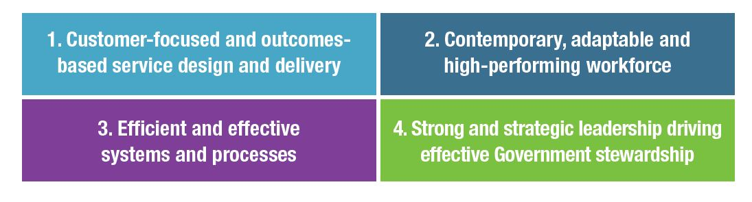

NDS WA Top Disability Service Priorities

Customer Focused and Outcomes-Based Service Design and Delivery

Deliver the NDIS in WA
Fund the WA Disability Services Industry Plan
- Resolve outstanding issues and shape the NDIS design and implementation
- Deliver a sustainable and quality NDIS
- Plan for the future NDIS market and strengthen market stewardship
- Promote integrated regional service delivery solutions
- Collaborate and partner with the WA disability sector in the co-design and
implementation of quality disability NDIS services.

Deliver the National Disability Strategy
Fund and develop the State Disability Strategy
- Implement an Outcomes Based Framework

Ensure full access and inclusion for people with disability
- Fully accessible education
- Creating job opportunities
- Improve Vocational Education and Training (VET) opportunities
- Safe and secure places to live
- Accessible and inclusive communities (including meeting the needs of regional communities)
- Equal access to rights, protection and justice (including the delivery of high quality safeguards and support)
- Better health and wellbeing outcomes

Contemporary, Adaptable and High-Performing Disability Workforce

Fund the WA Disability Services Industry Plan
- Build the disability sector’s capability and capacity
- Build a strong, capable workforce

Deliver Efficient and Effective Systems, Processes and Infrastructure

Reform of Government systems and processes that deliver better outcomes for disadvantaged and vulnerable communities including people with disability
- Build an overarching and more effective systems framework for human services
- Build the evidence base to support investment decisions
- Data integration and pooling
- Commit to reducing red tape and duplication, including streamlining procurement processes and reporting requirements
- Invest in NDIS ICT Infrastructure and integrated online portals between Government and not-for-profits
- Invest in collaborative disability service models that demonstrate service integration including the piloting of new approaches in targeted priority service areas in regional and remote parts of WA
- Develop more efficient use of Government facilities and co-location of services, particularly for regional communities

Strong and Effective Leadership to Drive Effective Government Stewardship

A State Government agency that oversees and delivers effective implementation of the National Disability Strategy and the NDIS
- Investment in strong Government stewardship
- Invest in an outcomes based framework with KPIs around service delivery, quality and efficiency
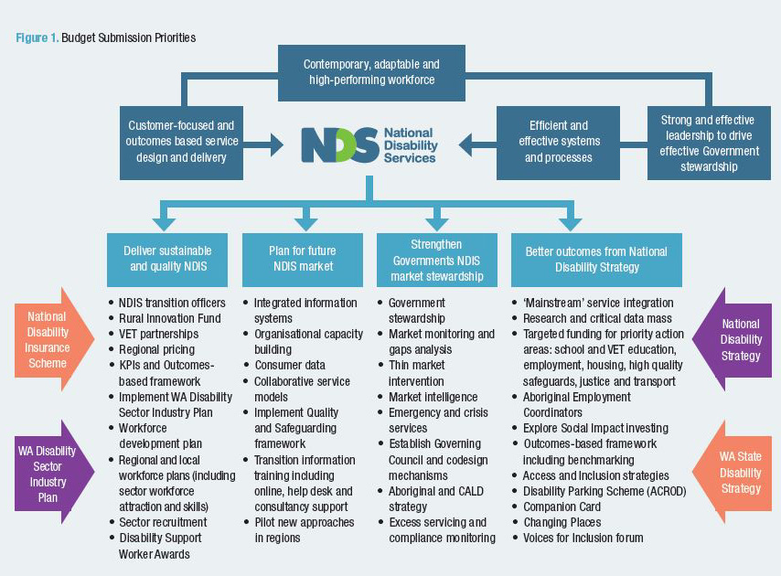

State Disability Strategy

This year’s PBS identifies four areas that require attention by the State Government.
- Deliver a sustainable NDIS
- Plan for the future NDIS
- Deliver better outcomes under the National Disability Strategy
- Strengthen Governments NDIS market stewardship
To achieve the best outcomes for people with disability and to provide high-quality community services, the State Government must:
- Provide leadership in driving cultural and systemic change to deliver innovative, high quality and long term sustainable services to Western Australian individuals and communities.
- Invest, as a critical first step, in developing a high level overarching State Disability Strategy (A Disability Roadmap) to deliver both the transition to the NDIS and better outcomes for people with disability from the National Disability Strategy.
A common vision embedded in a strategic plan for the delivery of disability services in Western Australia would support and strategically direct the work of the State Government and the sector. This should embody the principles of co-design and shared risk with the delivery of these services.
Effective reform needs to be jointly owned and driven by Government and the disability sector. A lack of commitment across government poses a significant risk where public servants may receive contradictory directions with their ultimate responsibility and accountability being to their Minister and the Cabinet. NDS welcomes the State Government’s SPR as a mechanism to deliver better and more integrated human services to Western Australians and reprioritise funding for existing programs that do not deliver good outcomes to Western Australians.

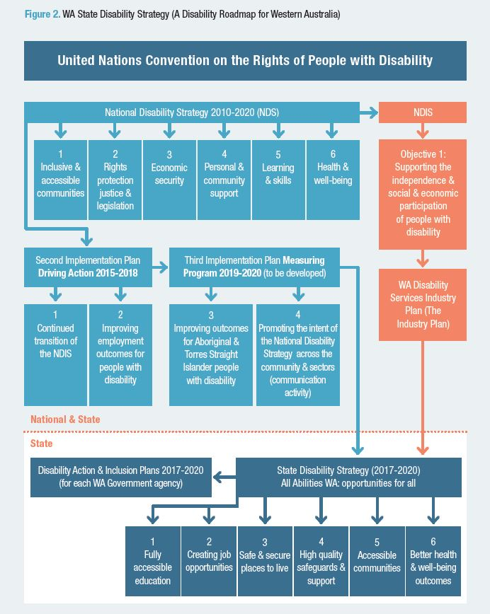

Deliver the NDIS in WA

The NDIS provides people with disability with real autonomy and decision making power to choose the services that best meet their individual circumstances.
Critical to realising the vision of the NDIS in WA is the growth of a dynamic, sustainable and values-driven disability sector. Without this, people with disability and their families will not have the choice and quality of support that the NDIS promises. The risks facing the disability sector are risks to the Scheme as a whole. They are substantial and require urgent mitigating action.
As the NDIS is implemented in WA, a key consideration must be whether the right services are in the right place at the right time and for the right price. This means delivering evidence-based, best-practice supports and services that are responsive to the preferences of people with disability and contribute to their quality of life and personal goals. NDS WA notes the tension between choice and control of services and what works, under what circumstances and at what cost, as well as the increasingly important market stewardship role of the State Government, particularly in relation to mitigating against market failure in small regional and remote communities.
The transition to the NDIS will need to be supported by adequate State Government investment and in particular the WA Disability Services Sector Industry Plan (The Industry Plan). The Plan provides a clear framework and pathway for the WA disability sector to ensure transition to full NDIS implementation in WA achieves the forecast levels of economic and jobs growth activity.
Our Industry Plan, a key feature of this year’s PBS, is the first of its kind for the WA disability sector. It proposes practical measures to reduce the avoidable pressure and risk – and so help secure the future of the NDIS. It considers the key drivers of the NDIS and forecasts the associated impacts on people with disability, disability service providers, Government, and broader industry stakeholders during the transition to a new operating environment.

What is the Industry Plan?

The Industry Plan includes:
- An NDIS snapshot of the experiences of all states and territories with the roll out of the NDIS and any transitional strategies implemented.
- A profile of the WA disability sector including an overview of its current strengths, limitations, opportunities and threats to its success; the current and future economic impact; and anticipated workforce growth.
- Three strategic themes recognising the need for comprehensive systemic and strategic planning to ensure the long-term social and economic gains of the NDIS are fortified.
- Seven strategies; 24 actions and initiatives to ensure the sector is well-prepared for the full implementation of the NDIS in WA.
- Recommended next steps: to successfully implement the Industry Plan.
The path to the NDIS in WA has been uncertain. NDS WA’s 2018-19 PBS calls on the State Government to commit to the funding and implementation of the Industry Plan to ensure a smooth NDIS transition, as well as build workforce capacity and deliver high quality disability services in all parts of our vast State.
The WA Industry Plan provides opportunities for NDS WA and the State Government to develop a strong, robust partnership to support the disability sector during this extensive period of change. Collaboration and cooperation between the sector and Government are vital in resolving outstanding design issues within the NDIS and developing the implementation strategy.
Building a strong and sustainable disability sector provides more choice for people with disability across WA, including people living in regional and remote areas.
The NDS WA 2018-19 PBS clearly articulates that the NDIS will stimulate significant economic and jobs growth for the State. However, this will require significant investment by the State Government in an Industry Plan to ensure this smooth transition and the delivery of high quality disability services in all parts of our vast State, as has been the case with other jurisdictions such as Victoria (a $36M investment over three years) and NSW ($30 million) to assist with sector NDIS readiness.
The implementation of the NDIS in other jurisdictions also offers valuable lessons about the need to involve Western Australians with disability, their families and carers and service providers in the design of the scheme and its implementation.
The Industry Plan will assist to address many NDIS implementation issues highlighted by the recent Productivity Commission report (released October 2017) calling for more investment in supporting infrastructure and market development as well as ensuring the NDIS delivers on its promise of choice, high quality services and plans that reflect the needs and goals of people with disability.

The NDIS will provide a significant opportunity for WA, with potential to trigger large-scale economic growth and job creation in the State. Industry Plan modelling identified that the total economic contribution of the disability sector in WA and the number of jobs generated by the sector will double over the next three years.
By 2020, the disability sector in WA is forecast to generate a total of $2.7 billion worth of economic activity in the State. This includes $1.8 billion in income and the equivalent of 20,144 direct and indirect full-time jobs. Metropolitan and regional areas are all expected to see significant growth.

Key Industry Plan Facts & Figures

Figure 3. Industry Plan economic and service projections

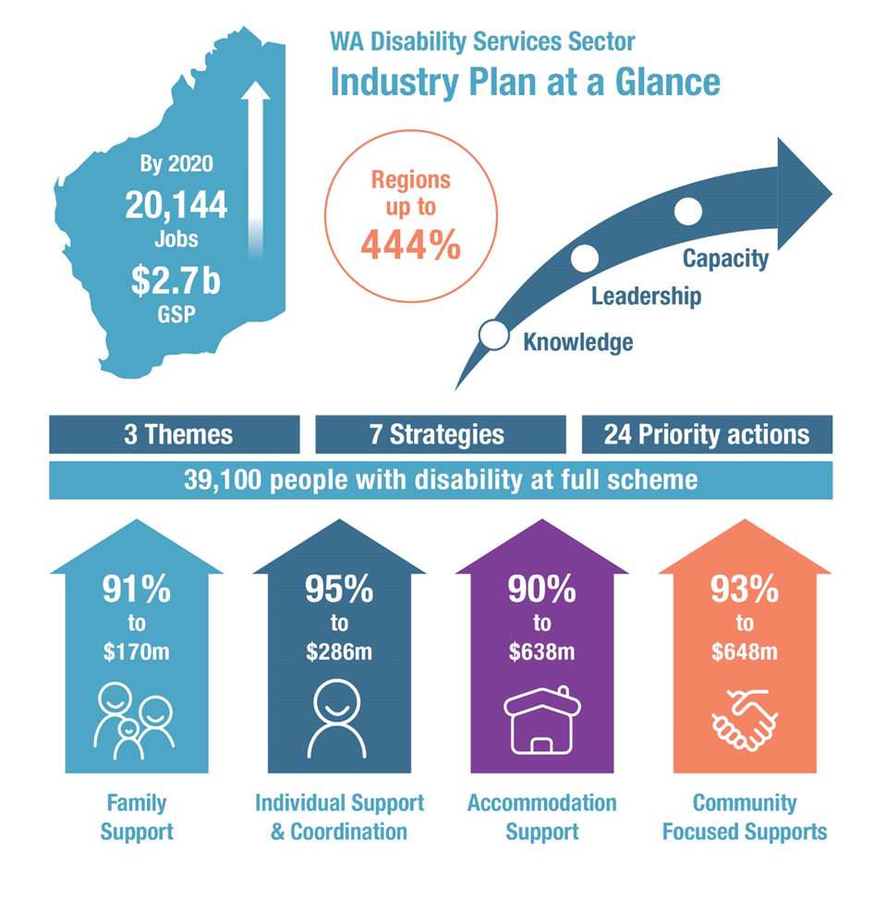

2020 Projections
- Significant economic growth
$2.7B contribution to the State’s economic activity (Gross State Product), up from
$1.4B in 2015-16
- Income growth
$1.8B in incomes, up from $941M in 2015-16
- Strong jobs growth
20,144 direct and indirect jobs, up from 10,507

Figure 4. WA Disability Services Sector Industry Plan on a Page.

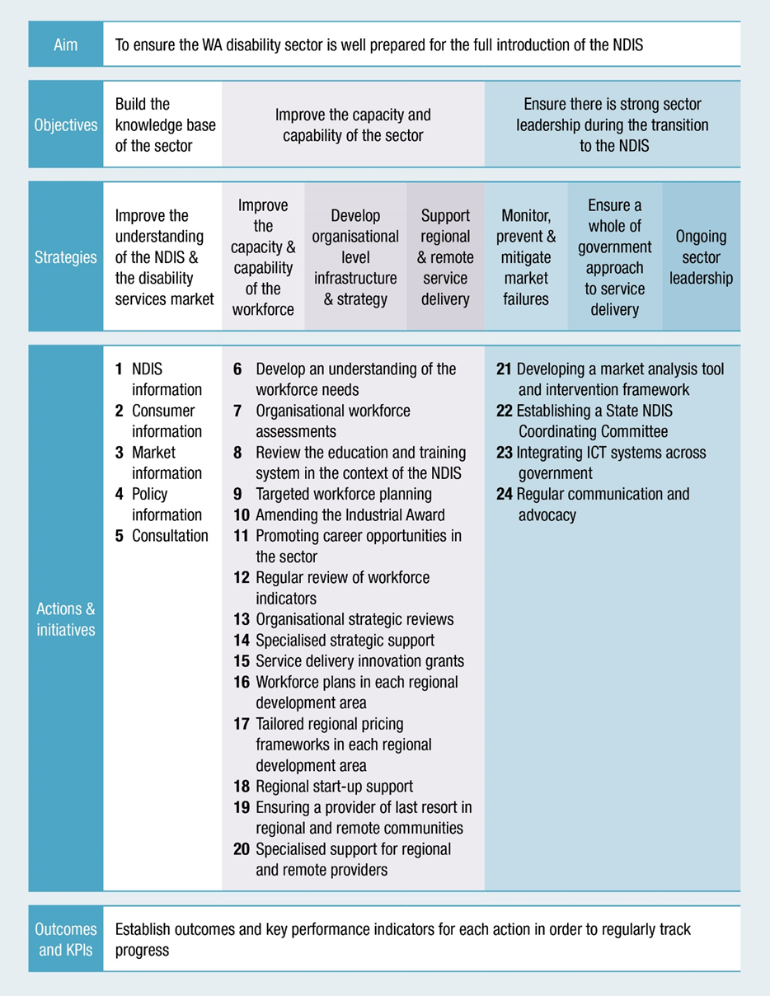

National Disability Strategy

The 2018-19 PBS puts the case that now, more than ever, it is imperative that the State Government remains highly aware of its obligations under the National Disability Strategy, as well as the important role of the interface with mainstream agencies alongside the NDIS transition in WA.
The State Government must continue to ensure full access and inclusion for people with disability in economic, cultural, social, civil and political life through increased participation effort to deliver on the outcomes of the National Disability Strategy. The NDIS only provides funding supports for individuals.
This will require a dedicated State minister responsible for disability in WA, a State agency with a mandate for economic/social inclusion and opportunities arising from the pending legislative review of the Disability Services Act 1993 (WA).
More than ever it is critical that the State Government continues to provide leadership in this specialised area of human services.
NDS shares the State Government’s focus on providing the highest standard of services and care for people with disability, and recognises that this is particularly important during the NDIS transition period. NDS and its members will continue to contribute to people’s lives by providing quality services and contribute to the broader community by helping the Government achieve the associated service delivery reforms.
In the next section, the 2018-19 PBS articulates strategies to deliver better outcomes in each of the following National Disability Strategy policy areas.

Deliver the National Disability Strategy
The 2018-19 PBS articulates strategies to deliver better outcomes in each of the National Disability Strategy policy areas outlined below. This should be part of the development (and funding of) a State Disability Strategy supported by the implementation of an overarching Outcomes Based Framework.
Key Strategies
- Fund and develop the State Disability Strategy
- Implement an Outcomes-Based Framework
- Fully-accessible education
- Improve Vocational Education and Training (VET) opportunities
- Create job opportunities
- Safe and secure places to live
- Accessible and inclusive communities (including meeting the needs of regional communities)
- Equal access to rights protection and justice (including the delivery of high quality safeguards and supports)
- Better health and wellbeing outcomes

Key National Disability Strategy Priorities
Fully Accessible Education
- Mandatory adherence with the National Education Standards as part of school registration
- Ensure the Australian Education Amendment Bill 2017 delivers improved adequate funding arrangements for children with disability
- Continue improving the data quality of Nationally Consistent Collection of Data on School Students with Disability (NCCD)
- Provide schools-based funding dependent on school progress towards disability action plans
- Educate school communities about disability inclusion and benchmark inclusive education
- Ensure all students with disability have access to education materials in alternative formats
- Ensure specialist advice and joint-planning between schools, families and Government
- Review adequacy of complaints process within Department of Education
Improving VET Opportunities and Creating Employment
- Lifting low and static workforce participation / employment rates of people with disability to build a strong, capable workforce and deliver a key priority of National Disability Strategy including public sector
- Public Service Commissioner encourage all Government agencies to demonstrate yearly increases in employment of people with disability, to be reported and tabled in Parliament
- State Government to set targets for employment of people with disability across
- WA State Public Sector and consider centrally-funded public sector traineeships
- State Training Board focus on lifting workforce participation of people with disability and ensure apprenticeships / traineeships build a strong capable workforce for full NDIS roll out
- Ensure NDIS plans are adequately funded for employment supports
- Complimentary public sector traineeship program for people with disability linked to training targets set by the State Training Board
- Use the NDS WA Plan to reshape the VET system and deliver skills needed for vital growth industries such as disability sector
- Vocational Education and Training in Schools (VETiS) programs to better align to pathways into skilled and priority occupations, including to adequately respond to the NDIS
- Invest in a comprehensive, well-implemented workforce plan to minimise skills shortages and support NDIS to 2020
- Improve VET traineeship pathways for people with disability by funding WA Ticket to Work, and projectABLE programs, Aboriginal employment coordinators and Government purchase of goods and services from Supported Employment Enterprises through BuyAbility
- Fund a research scoping study exploring low VET participation rates by people with disability
- Fund a pilot action research project to develop and trial strategies for a VET Centre of Excellence for people with disability
Secure and Safe Places to Live
- Whole-of-government housing policy with strategic growth plan developed in partnership with community and private housing and disability sectors
- Pursue more aggressive compliance with universal design in new developments
- Facilitate new housing through direct funding, use of Government land and planning schemes quotas
- Facilitate collaboration between State and local governments, developers, planners, providers, disability providers, families and banks
- Address housing affordability including First Home Owners Grant for people with disability and rebate/remove duties
- Explore Social Impact Investing to provide housing for people with disability
- Expand the WA Assisted Rental Pathways Pilot to build individual renter’s capacity to be self-sufficient in private rental market

Accessible and Inclusive Infrastructure, Transport, Recreation and Systems
- Ensure new commercial and retail properties meet minimum standards for access
- All new major retail developments of scale required to include a Changing Place facility
- Support improvements to Access to Premises Standards including better defining a role for Government and industry
- Ensure inclusivity of mainstream Government products and services, including accessibility and usability
- Support the WA Companion Card program to promote the right of people with disability to fair ticketing in digital ticketing systems
- Fund the development of a services directory application that provides place-based or service type information to aid individual decision-making and access to services
- Stronger commitment to ‘Whole Journey’ transport, beyond standards, to create door-to-door accessible public transport journeys
- Faster implementation (and modernisation) of the Transport Standards
- Ensure the State Government’s METRONET is inclusive of people with physical, sensory and other disabilities
- Ensure changes to Mobility Allowance resulting from NDIS do not restrict employment or community access opportunities
- Ensure sustainable supply of existing transport options provided by disability organisations
- Continue access to State-run taxi subsidy schemes for NDIS participants to support travel needs of people with significant disability
- Extend State-run taxi subsidy schemes to services such as Uber
- Investment by State and local governments to pilot improved use of local transport assets including potential ‘shared’ provider fleets
- Stronger fines and loss of demerits for misuse of Australian Disability Parking Scheme and amend ACROD legislation to allow prosecution for misuse of private property bays
- Extend Road Traffic Code 2000 parking concessions to State Government property so ACROD permit holders have extra time to complete business
- Support and resource NDS WA to develop an online ACROD permit application system
- Fund ‘Smart Permit’ for WA Australian Disability Parking Permits
- Progress the implementation of accessible and secret voting for people with disability
- State Government to extend KidSport and SilverSport programs, administered by Department of Local Government, Sport and Cultural Industries, to people with disability
Equal Rights and Justice
- Develop and implement a WA Disability Justice Plan
- Fund a specialist role to develop practical resources to assist disability service providers support people with disability get better access to criminal justice processes
- Expand the ChildFIRST team to extend their skills and include interviewing people with disability
- Recurrent funding for NDS in WA to continue to lead and provide practical support to the sector on individual safeguarding; quality systems and evaluation; roll out of complaints handling and management; human rights; and specialist Zero Tolerance position
- Invest in the co-design of comprehensive prevention education package for disability sector workforce and people with disability
- Implement consistent pre-employment screening practices for the WA disability services sector supporting the Government Clear Card initiative
- Commit to ensuring the Disability Justice Centre remains for vulnerable people unable to plead due to disability. Exploring capacity within disability services sector to provide more support to this group
Better Health and Wellbeing Outcomes
- Investment to equip healthcare professionals to recognise health disparities and provide high-quality health services to people with disability
- Invest in targeted health promotion initiatives
- A coordinated information platform for both health information and services for people with disability, families, carers and disability service providers
- Support targeted health literacy initiatives to build the capacity of people with disability to access, understand and use information that promotes and maintains good health. This includes using existing programs on obesity, diabetes, and oral health. There should also be consideration of non-government implementation
- Fund annual health checks for people with significant disability (e.g. Qld Comprehensive Health Assessment Program) and consider the roll out using non- government organisations in partnership with NDS
- Increase focus on disability within health networks to improve workforce knowledge and promote good practice such as WA Care Coordination Framework and related admission to discharge toolkits
- Greater commitment to support and resource the Disability Health Network, including prioritising WA Disability Health Framework recommendations for 2015-2025 for immediate action.

Disability Fast Facts

Education & Training
PWD have lower levels of educational attainment
- In WA, 30.9% of PWD (aged 15-64) completed year 12 compared to 58.3% of people without disability
- Many students have difficulties at school because of their disability
- In 2015, around 2 in 3 students with disability (64%), and 3 in 4 students with severe or profound limitation (76%), had difficulties at school because of their condition (Australia)
- WA has a lower VET participation rate for PWD, at 6.5%, compared to the national average of 9.5%

Employment
PWD are under-represented in WA’s workforce, have higher unemployment and lower participation rates
- PWD unemployment rate, 11.4% compared to 4.9% (2015)
- Participation rate, 57.8% compared to 83.6% (2015)
- State Public Sector, a low 1.9% (2017), below the Australian Public Service (3.6%), Westpac (12.1%) and Australian workforce (9.9%)
- More than 1 in 4 working-age PWD reported their employer as the source (27%), and around 1 in 6 reported work colleagues as the source (18%)

Housing
PWD spend more of their income on housing with many suffering housing affordability stress
- PWD are twice as likely to be in the bottom 20% of gross household incomes, where 60% of income is spent on rental housing
- PWD are over- represented in housing assistance programs and waiting lists for social housing
- NDIS only assists 6% of 460,000 participants. Unmet need for affordable, accessible and well located housing of over 100,000 NDIS participants by 2020
- Huge demand exists for similar housing from PWD not eligible for the NDIS
- Barriers to accessing suitable housing options for PWD include cost, (including high cost of modifying and retro-fitting housing), disadvantage or discrimination in competition for private rental properties, and a limited supply of universal ‘accessible’ housing

Access & Inclusion
PWD do not have equal ability to move easily around the community which is essential for their economic and social participation
- In 2015, of people aged 15-64 with disability:
- 1 in 3 did not go out as often as they would like, almost unchanged from 2003
- More than 1 in 4 found it difficult to access buildings or facilities in the community
- 2 in 5 avoided community situations because of their disability
- Almost one third of PWD in WA had difficulty in using public transport, 28.9% or 85,555

Safety

PWD experience higher rates of abuse and violence
- PWD requiring supports (those with restrictions in core activities) are
- 1.6 times more likely to have been victims of physical or threatened violence (16.9% compared to 10.3%)
- They are 1.7 times more likely to be victims of actual/ attempted break ins (13.7% compared to 8%)
- Women with disability have higher rates of abuse - particularly those with psychosocial disability (12%) and ‘other’ disability (9%) compared to people with disability at 5%

Safety

Why
- Processes fail to respond to individual reports
- Secondary protection measures to reduce future acts of violence, abuse or neglect are missed
- Lack of support to communicate and participate in all stages of the criminal justice process.
- Complaints processes are often inaccessible and ineffective
- Police, lawyers, judges and other staff do not always identify disability or respond adequately
- NDIS Quality and Safeguarding mechanisms provide protection for NDIS participants – only 10% of the disability population
- PWD in prison, do not have access to supports, adjustments and aids
- Aboriginal PWD, are over represented in the justice system with very high levels of unmet care needs

Health & Wellbeing
PWD have poorer health outcomes than the general population
- Higher prevalence of long-term health conditions and increased use of health services and hospitalisations
- PWD with severe or profound disability aged 15-64 years, are 10 times more likely to have check-ups with general practitioners at least once a month
- 3.5 times more likely to consult specialist doctors over a 12 month period
- 5 times more likely to consult both specialist doctors and health professionals in the same period
- 46% of PWD aged 15– 64 years report poor or fair health compared with 5% of the general population aged 15–64 years
- People aged under 65 years with severe or profound disability have a higher prevalence of long-term health conditions than people without disability
- 8% of people with severe or profound disability have mental health problems

Contact
Julie Waylen State Manager, WA Ph 08 9208 9805
Fax 08 9242 5044
julie.waylen@nds.org.au
www.nds.org.au
12 Lindsay Street Perth WA 6000
PO Box 184 Northbridge WA 6865
About NDS National Disability Services (NDS) is Australia’s peak body for non- government disability service organisations. In WA, NDS represents over 100 not-for-profit disability services organisations. It provides services to tens of thousands of people with disability, their families and carers in the state. Services range from home support, respite and therapy to community access, employment and more.
NDS and its members in WA are committed to providing high standards of care and supports and better outcomes for people with disability. It is well recognised that to do this, service providers will have to completely adjust their operations and way in which they provide

More detail about the Industry Plan can be found at: www.nds.org.au/resources/wa-disability-services-sector-industry-plan

