National Disability Services   
Pre-Budget Submission 2021-2023

Five Priorities   
Supporting over 500,000 West Australians with disability, their families, workers and organisations.

**Cover page featuring a photo of the outback, and a diagram of Western Australia with photos of different people.
**

# Pre-Budget Submission Priorities 2021-23

Priority 1 Invest in Workers in the Disability Sector and Quality Support Services

Priority 2 Protect the Integrity of the NDIS

Priority 3 Build a fit-for-purpose Office of Disability

Priority 4 Fund the State Disability Strategy

Priority 5 Build Accessible Communities and Participation

# Forward

National Disability Services (NDS) in Western Australia is pleased to present our Pre-Budget Submission (PBS) 2021-23, the annual policy centrepiece for state-level disability advocacy.

This submission provides a framework for consideration of key priorities by the State Government for both the 2021-22 State Budget (to be delivered in September 2021) and State Budget 2022-23 (scheduled for May 2022), given the short interval between both.

NDS is the peak body for more than 1000 disability service organisations across Australia. We also provide a strong voice for initiatives and services that support more than 411,500 people with disability in our State.

Through our members, NDS has identified five priorities that will require strong commitment and funding by the State Government to continue to build a sustainable disability sector that provides quality supports, as well as delivering great outcomes for people with disability across the community.

We firstly wish to acknowledge the sound commitment by the McGowan Government to people with disability and their families, disability sector workers and organisations in WA over the last four years and the significant progress that has been made to building a more Inclusive WA for people with disability.

This has been demonstrated through a range of initiatives introduced by the McGowan Government, many championed by NDS, including:

* The development of State Disability Strategy and an allocation of $5 million to support its outcomes and the initial Action Plan.
* The establishment of the Office of Disability.
* Investment of over $40 million in the Industry Transition Fund to assist service providers to transition to the NDIS.
* Funding for a range of disability workforce related initiatives including contributing to the development of the Disability Sector’s first Industry Plan.
* Investment to create job opportunities for people with disability through the Containers for Change initiative and increasing their employment representation in the public sector to five per cent by the end of 2025.
* Funding for a range of quality and safeguarding initiatives to support the transition to the NDIS.
* $6.7 million allocated in the March 2021 election commitments to drive disability access and employment as well as for individual and systemic disability advocacy in WA.
* Expand the Changing Places network throughout WA and more than $2 million to ensure community facilities and services are more accessible and inclusive for people with disability through investment in accessible parks and purpose built, all-terrain wheelchairs at beaches and in national parks so visitors with mobility issues can explore the great outdoors.
* A commitment to provide $500,000 over two years to boost microenterprise to support 100 people with disability to establish new businesses through start-up grants, mentoring and support.
* Funding to undertake commencing work to ensure ACROD parking bays are better monitored, and penalties are enforced for parking infringements and demerit point, including funding to support the ‘This Bay is Someone’s Day’ campaign.
* The recent expansion of the ACROD program to include people who are legally blind.
* Good investment to support disability workforce training including lower TAFE fees for the Local Skills Program, the NDIS Job Matching Service, Aging and Disability Job Ready Program and NDIS Skills Training Centres in Rockingham, Bunbury, Broome and Karratha.

We commend the State Government’s disability commitments and good work to improve the lives of people with disability, their families and the workers and organisations that support them.

We note that the WA economy continues to strongly recover from the enormous economic and social upheaval caused by the COVID-19 pandemic and this is also reflected in State Finances which are expected to deliver a significant upgrade of the revised 2020 Mid-Year Review budget surplus of $3.1 billion at February 2021.

NDS urges the State Government to invest in disability workers and the sector which is experiencing an environment of growing competition for workers as the sector competes with the booming resources sector and the aged care and health sectors. Our PBS 2021-23 prioritises the need for funding a range of disability workforce initiatives to help address the shortage of workers in our sector. In addition, it provides representation to the State Government to protect the integrity of the NDIS and WA’s $2.8 billion investment.

The WA disability sector continues to operate in a volatile and uncertain environment – the sector is undertaking significant work to ensure effective operations for NDIS, with all its implications and the additional costs to ensure alignment with the requirements of the NDIS Quality & Safeguarding Commission. In addition, there has also been high levels of anxiety for people with disability and their families regarding the proposed reforms to the NDIS.

NDS welcomes the rejection of the IA proposal at the Disability Ministers’ Meeting on 9 July 2021, agreeing to consult on any future amendments and work with the disability sector to codesign a model to improve equity in the NDIS as well as to share detailed data and evidence on the Scheme with other States and Territories to consider the implications of, and basis for, any future proposed changes. WA has great mechanisms in place for the sector to actively support this important work.

Apart from COVID-19, the bushfires and the transition to NDIS, there are now waiting-lists for services across the sector due to staff shortages and the competition for workers with other human services sectors and as the resources and construction sector heats up.

On top of this, NDS notes that the COVID Vaccine roll out has been severely delayed despite the high level of vulnerability of people with disability – around 2 per cent of people with disability have been vaccinated Australia wide and only one in five with disability support care fully vaccinated.

The impact of all these events and issues on people with disability, their families and the workers and organisations that support them has been significant.

There has never been a greater time for State Government leadership to champion people with disability, to improve their economic and social participation in our community as well as investing to build a strong disability services sector that provides a quality capable workforce.

Building and investing in our State Budget 2021-23 five priorities will strengthen the state disability ecosystem and further contribute to growing the WA economy through jobs, training and business innovation, as well as improving the well evidenced level of disadvantage of people with disability.

They provide great opportunity to provide economic stimulus while also building social capital, improving the everyday lives of people with disability and disability workers as well as building sustainable organisations that are such an important part of the fabric of WA community life.

NDS commends our PBS 2021-23 for your consideration.

Headshot of Joan McKenna Kerr.  
Joan McKenna Kerr

NDS WA Chairperson

Headshot of Julie Waylen.  
Julie Waylen

State Manager WA

# Key Priorities and Actions for State Budget 2021-23

# Overview

| **Priorities** | **Actions** |
| --- | --- |
|  |  |
| * Through boosted investment subsidies to support the workforce and initiatives that are focused on education and training, supporting targeted migration, and funding to ensure that the pay and conditions of the sector workforce support the long-term attraction and retention of its workers. * By reducing administrative barriers on disability support workers, to entering and staying in the disability sector and easing the burden of registration requirements on providers. * Focussing on co-design service improvements drawn from Government inquiries including the Disability Royal Commission in order to strengthen service quality safety. This includes investment in sector-wide capacity building initiatives and partnerships to further develop the ecosystem of innovation around disability. | 1. Funding of $1.8 million to implement the WA Disability Skills Passport over the next three years. This should include resourcing and promoting a portal or app which allows regional and remote workers to connect, share information, access resources, for training and provide a Hub to meet. There is capacity for the NDS Skills Passport and/or NDS member organisations to identify workers to participate. 2. Investing $225,000 in 2021-23 to update the WA Disability Industry Plan to build a worldleading disability workforce. 3. Funding to reduce the cost and fragmentation of NDIS Worker Screening Checks. We seek a provision of $3 million in the 2021-23 State Budget. 4. Funding to expand the NDS Positive Behaviour Support and Quality and Safeguarding projects to continue to improve service safety and quality and review its curriculum as well as meeting increased demand for workers across WA. 5. Attracting interstate and international workers through targeted migration policies focusing on ensuring the State Nominated Migration Program (SNMP) provides an avenue for disability support workers as the occupation does not appear on the relevant Commonwealth Government skilled migration occupation list. 6. Funding to subsidise audit and reporting costs which are not sufficiently provisioned for under the current NDIS Quality & Safeguarding requirements, especially for regional and Small to Medium Enterprise (SME) organisations. |
| 1. Protect the Integrity of NDIS | |
| * By focussing on negotiating with the Commonwealth Government on NDIS reforms to ensure positive outcomes for people with disability, whilst ensuring the sustainability of the sector over the longer-term. * This should be informed by the experience of NDIS participants and the disability sector which is responsible for the NDIS service implementation. Both are well-positioned to identify and highlight the key emerging trends and issues in WA regarding the Commonwealth Government’s planned changes to the NDIS. * The State Government, through the Office of Disability, must use this information databank to develop a strong position and sound policy platform to re-negotiate the next Bilateral Agreement with the Commonwealth in 2023. | 1. The State Government to request that the NDIA and the Commonwealth Government acknowledge the higher costs of delivering the NDIS in WA through an appropriately adjusted pricing regime including for SIL and also accommodating the higher costs associated with delivering services in regional WA. As a first step, NDS urges the State Government to seek commitment from the Commonwealth to initiate a review of WA economic market conditions and their impact on the cost of delivering supports services to NDIS participants in WA. This Review would align with Recommendation 6 of the WA Market Review. 2. Stronger State Government advocacy and intervention on NDIS operational challenges faced by participants and service providers by holding a review of the NDIS in WA to help inform the next Bilateral Agreement negotiations. This should focus on improving the sustainability of the sector by reducing levels of bureaucracy to improve efficiency and reduce provider costs. 3. Work with the Commonwealth Government‘s proposal to develop a better model for NDIS reform and ensure the WA sector and people with disability are actively involved. 4. Provide safety net funding and ensure the State’s role as provider of last resort. 5. Request that the Commonwealth Government implements a dedicated strategy to improve engagement between NDIA, the Quality & Safeguarding Commission and providers. |
| 1. Build a fit-for-purpose Office of Disability | |
| * The Office to provide expert and decisive leadership to oversee the delivery of better social and economic inclusion of people with disability in WA. This priority must include a strong focus on people with high and complex needs especially those who require 24-hour specialist support services. * The Office must be capably led, have budget oversight and accountability of Government funding, and supports effective disability services across the WA disability sector. * Focused on funding the implementation of the 10-year State Disability Strategy and its Action Plan. This should also include a comprehensive Disability COVID-19 Plan to better respond to the needs of people with disability to meet a future pandemic crisis. * The WA Strategy must deliver the State Government’s obligations under the National Disability Strategy and maximise the State’s investment in the NDIS including ensuring a strong interface with mainstream agencies alongside the NDIS in WA. * Build a data and information databank to monitor and support NDIS decision making and in particular for people with high and complex needs especially those requiring provision of 24-hour specialist support services. * Report on the achievements of the Strategy outcomes to measure success and table these in parliament annually | 1. State Budget 2021-23 must provide adequate funding to build a fit-for-purpose Office of Disability. The Office must report direct to the Director General and Minister for Disability Services, not be buried in layers of internal bureaucracy within the Department of Communities (DoC). 2. Ensure the Office and Minister have direct oversight, control and accountability of the State Budget 2020-21 allocation of $4.3 billion over four years from 2020-21. 3. Ensure it is led by an accomplished senior executive with demonstrated disability experience and understanding of the WA disability sector and inclusion. 4. Ensure the Office delivers comprehensive two-year Action Plans to support the implementation of a fully funded State Disability Strategy. 5. The Office must inform and together with WA State Treasury and the Department of Premier and Cabinet lead negotiations on the next Bilateral Agreement. 6. It must have a key role to collect data on critical unmet need and future demand to inform its decision making and ensure NDIS is delivering in the most urgent of areas. This is critical for people with high and complex needs and the provision of 24-hour specialist support services. The Office should work with people with disability, their families, and carers as well as disability service organisations to help build a data bank of information to provide an independent assessment of the current NDIS in WA to be used to inform the next Bilateral Agreement in 2023. 7. NDS seeks an allocation of financial support for the Office to oversee and support an initiative for people with high and complex needs and the provision of 24-hour specialist support services. 8. Develop strong, accountable and transparent interfaces with mainstream agencies alongside the NDIS in WA. |
| 1. Fund the State Disability Strategy | |
| * Fully fund the implementation of the State Disability Strategy and its Action Plans. This should also include a comprehensive Disability COVID-19 Plan to better respond to the needs of people with disability to meet a future pandemic crisis. * The Strategy must deliver the State Government’s obligations under the National Disability Strategy and maximise the State’s investment in the NDIS including ensuring a strong interface with mainstream agencies alongside the NDIS in WA. * Monitor and track achievements of the Strategy outcomes to measure success and table these in parliament annually. | 1. Fund the implementation of the State Disability Strategy and its Action Plans. 2. Report on the achievements of the State Disability Strategy including outcomes to measure success and to table these in parliament annually. 3. The Strategy must deliver the State Government’s obligations under the National Disability Strategy and maximise the State’s investment in the NDIS. This will include ensuring a strong interface with mainstream agencies alongside the NDIS in WA 4. The Strategy must inform negotiations on a new NDIS Bilateral Agreement by 2023. This should incorporate an NDIS Outcomes Framework and KPIs and include a strategy to build a sustainable innovative disability services sector, workforce and ecosystem to manage the risks and costs of market failure. 5. The Strategy to formalise the State Government’s role of provider of last resort and emergency disability services. Funding provisioned for State run disability services must include funding for the State Government to be the provider of emergency / crisis services where there is market failure, particularly in regional, rural and remote parts of WA. |
| 1. Build Accessible Communities and Participation | |
| * The State Government has a responsibility to improve the economic and social participation of Western Australians with disability which is embedded in the 10-year State Disability Strategy and in its commitment to deliver policy outcomes of the National Disability Strategy. * There is still significant progress that needs to be made on many fronts including building more accessible communities and in particular disability housing, improving the economic participation of people with disability through improving their training and employment opportunities and delivering better health and justice outcomes. | **Disability Housing**   1. Finalise and implement the State’s approach to Specialist Disability Accommodation in the NDIS. 2. A funded action plan in the State Housing Strategy to roll out disability housing including setting minimum accessibility standards for residential dwellings as part of National Construction Code and the Rental Tenancy Act. 3. Improve the access paths to housing options for people with disability by better targeting of Keystart, the First Homeowners Grant, Building Grants and Housing Loan schemes and the rebate or removal of property transfer duties for people with disability. 4. Targeted funding through industry incentives to housing developers to create more affordable housing options for people with disability such as including use of government surplus land / setting minimum planning scheme quotas as part of new developments should also be considered. 5. Funding the development of a Ready Reckoner Disability Housing Information Package of disability housing products for people with disability, the housing industry sector and community. 6. This should complement investment in a significant housing industry awareness campaign to promote the construction of accessible housing as a future growth area. 7. Commit to provide regional housing for disability workers to enable services to be established for people with disability in regional, rural and remote locations.   **Deliver Accessible Community Infrastructure**   1. Progressively implement a range of planning, regulatory and policy reforms across the State Budget 2021-23 forward estimates to significantly improve the accessibility of WA infrastructure and community facilities outlined in detail at Priority 5: Build Accessible Communities and Participation. 2. Invest in community campaigns to raise awareness of accessibility infrastructure requirements. 3. Commit to improving disability transport options for people with disability as well as access at train and bus stations. 4. Ensure that the State Government’s Digital Blueprint platform is funded so that its connectivity and design is fully digital inclusive and shaped by people with disability.   **ACROD and Companion Card**   1. Provide NDS with long term funding surety through a five year agreement for ACROD and Companion Card delivered by NDS in WA.   **Expand Changing Places**   1. Fund NDS to work with local government authorities and the community to expand the Changing Places network in WA to priority locations identified by people with disability. 2. Install Changing Places facilities at new key transport interchanges as part of METRONET. 3. The WA Government request that the Commonwealth Government’s current review of the Disability (Access to Premises – Building) Standards 2010 (the Premises Standards ensures that Changing Places become part of the suite of accessible facilities across Australia to provide people living with a disability with dignified and equitable access to buildings.   **Education**   1. Specific funding to support and increase the number of teachers and education assistants and access to in-classroom support. 2. Funding to develop and deliver a program of anti-bullying strategies to support students with disability. 3. Set up an Inclusive Schools Program requiring mandatory changes to how schools operate so they deliver inclusive learning environments. 4. Establish a Disability Education Training Program to improve inclusive education practices in schools for teachers and advice to students and families on available supports. 5. Fund a Pathways to Work Schools Partnership program for students.   **Employment**   1. Expand the NDS Building the Talent Pool project to 2025 and fund a state-wide educational campaign promoting the benefits of employing people with disability. 2. Create 50 internships for people with disability in varied industries and sponsor traineeships, cadetships and graduate careers across the WA public sector. 3. Continue to support Australian Disability Enterprises (ADE) through the Department of Finance Social Procurement ADE initiative with disability. 4. The State Government should explore other opportunities to increase the employment of people with disability through the wider Government procurement process.   **Better Health and Justice Outcomes**   1. Funding for comprehensive health and dental checks for people with significant disability funded through the Comprehensive Health Assessment program. 2. Through the NDS and Health Department – “Ready to go home” project, develop a range of disability transitional care arrangements to facilitate timely discharge from hospital 3. The Department of Health and NDS to design and implement a pool of metropolitan-based clinical staff that can be deployed at short notice to regional locations to support healthcare delivery to people with disability during pandemic and emergency situations. 4. Funding support to NDS for sector-wide training for disability sector workers on diabetes insulin injection. 5. Invest in accessible hospital equipment and accessible communications including access to Auslan interpreters and advocacy liaisons. 6. Provide accessibility training for medical practitioners and nurses. 7. Support the Department of Justice (DoJ) and NDS to develop and implement the WA Disability Justice Blueprint in partnership with people with disability, their families and the sector. 8. Continue to fund systemic advocacy for the disability sector, including NDS’s pivotal role in systemic advocacy for service provision improvements to strengthen the rights of people with disability and support services provided to them. |

# Disability Sector Priorities

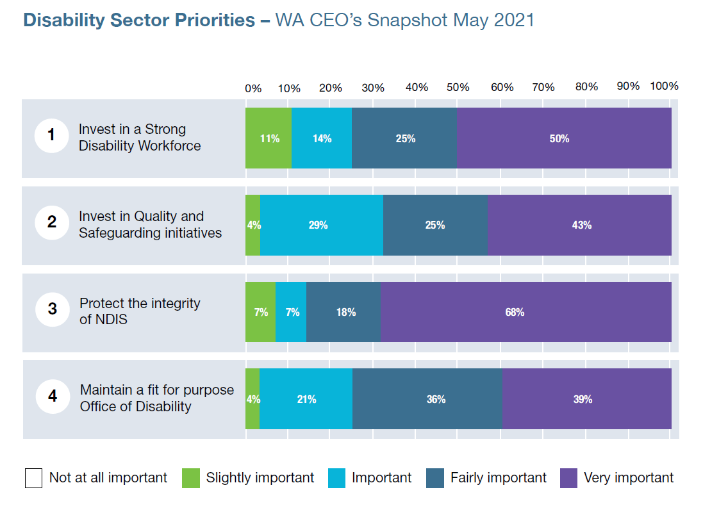

WA disability CEOs provided a snapshot in May 2021 that highlighted their main concerns with the implementation of the NDIS in WA. They indicated that Protecting the Integrity of the NDIS is one of their top priorities for actions they seek from the WA Government, with 93% stating that this was important to very important. Other high order priorities include Investing in Quality and Safeguarding initiatives (96%), Maintaining a fit for purpose Office of Disability (96%) and Investing in a Strong Disability Workforce.

# Priority 1: Invest in Workers in the Disability Sector and Quality Support Services

**Context**

To maximise the benefit of the NDIS, there must be priority and purposeful investment in a strong Disability Workforce and Quality Support Services in the 2021-23 State Budget.

Around 10,000 workers are already providing support to NDIS participants in WA but by 2023 the demand for workers will exceed 20,000. Organisations are currently experiencing very high FTE vacancy rates for workers – a snapshot conducted by NDS of the top ten largest disability service providers in WA shows that on average these organisations indicated a significant current FTE vacancy rate of around 12 per cent or more than 400 existing positions that need to be filled

The NDIS National Workforce Plan 2021-25 indicates Australia wide there are 3,750 unfilled vacancies now and an additional 83,000 NDIS workers expected to be required by 2024. WA is approximately 10 per cent of this data which indicates that workforce pressures are and will continue to be significant.

The NDIS workforce needs to have capacity to retain existing workers, improve productivity and innovation, attract new workers and improve quality. Existing workers need to be supported to grow in the NDIS.

NDS’s PBS 2021-23 is put forward in the context of significant disability workforce pressures resulting from WA having the lowest unemployment rate in the country, the effects of COVID 19 on migration and a mining and housing boom putting upward pressure on wages.

The projected impact of the current prevailing mining boom on state and sector wages, general costs and service delivery is largely yet to be quantified but we do know it is unprecedented in terms of the volume of resources being exported and its value – and potentially the flow on impact on the competition for labour in

our sector.

NDS WA understands there are key competitive pressures for labour experienced by disability service providers, especially in the context of the significance of the highly paid mining sector and that this is not abating.

There is also the added competition from other human services sectors – namely aged care and health – Governments are investing in these sectors which is impacting the supply of suitable workers for the disability sector. This exacerbates the already tight labour market in WA.

None of this is currently recognised by a NDIS pricing regime that largely does not account for WA significant cost differential relative to the other Australian jurisdictions.

We also know that Quality and Safeguarding and Worker Screening requirements are adding another layer of complexity and cost. High workforce retention is crucial for service continuity and reducing the burden to recruit replacement workers. Currently, the NDIS loses 15-18 per cent of its workforce to churn every year, losing workers almost twice as quickly the average Australian job.

**What we ask**

NDS seeks funding for the following key workforce initiatives in this year’s State Budget.

**Implementation of the NDS Skills Passport Platform**

A fully operational Disability Skills Passport is now in pilot. 1,100 workers from five community service organisations, Nulsen, Arch Recruitment, WA Blue Sky, Far North and Chorus will have skills passports holding verified information as part of the pilot phase. In addition to the benefits for workers, the data that is available at an organisational level will assist providers to plan their training, ensure compliances and reduce the administration related to onboarding.

An independent evaluation of the platform will be finalised in July 2021, and it is anticipated that the passport will be available broadly from September 2021.

The work of the NDIS Job Matching Service to identify skills in demand in the disability sector will be greatly enhanced through the wide adoption of the Skills Passport. This will provide an avenue for employers to search for workers with particular skills or attributes to reduce recruitment activity burnout. Skills Passport with Job Matching would help recruit workers seamlessly and would encourage new graduates to sign up to the passport. They can also be used by employers to identify students who have the right values/skills needed. A Skills Passport will assist family and individuals to navigate the supports available through the NDIS identifying workers with the skills they need.

We seek funding of $1.8 million over three years for the roll out of the NDS WA Skills Passport to reduce training duplication, expedite worker commencement and quality assure the workforce. Consideration should also be given to providing subsidies for small and medium sized organisations to adopt the Skills Passport. The Skills Passport can also facilitate the implementation of the NDIS Worker Screening Checks for WA.

NDS also strongly supports initiatives that better support remote disability workforces including their well-being and connectedness, even with workers from other providers, who understand the dynamic of working in regional WA. The State Government could readily resource and promote a portal or app which allows workers to connect, share information, access resources, for training and provide a Hub to meet at any time. There is also capacity for the NDS Skills Passport and/or NDS member organisations to identify workers to participate.

**Updated WA Disability Industry Plan**

Given the significant risk posed by growth in NDIS service demand that is already outpacing supply and impeding service quality and innovation and to progress the implementation of an informed and coordinated sector strategy, NDS seeks funding of $225,000 in 2021-23 for an updated WA disability industry plan.

A well-functioning NDIS workforce will improve the lives of people with disability and their families, create a sustainable disability support system and reduce the need for crisis expenditure in other West Australian sectors of health, justice and welfare.

The WA Disability Industry Plan will build a world-leading disability workforce that meets the needs of NDIS participants in WA and outlines and prioritise actions that the governments and the sector need to undertake.

This plan should, at the very least, include:

1. An industry workforce growth matrix. The disability sector in WA need an evidence base of current and future workforce requirements, and visibility of future development challenges to support service demand consistent with full scheme implementation and workforce planning outcomes indicated in WA’s 2020 – 2030 State Disability Strategy.
2. An environmental viability and sustainability scan and health check. An accurate representation of the current state and future outlook of the WA disability sector from both an organisation and participant sense, including its strengths, weaknesses, opportunities and threats.
3. A contemporary, evidence based, plan. The sector’s human resources are its greatest strength, we need to identify their current economic current contribution and its future potential under the NDIS at it evolves.

**NDIS Worker Screening Checks**

The introduction of the NDIS Worker Screening Checks is strongly supported. however, sector feedback indicates it is a significant cost barrier.

NDS requests the State Government give strong consideration to subsidising NDIS Worker Screening Checks to ensure all organisations can afford to implement this requirement in the absence of deficient NDIS pricing that is particularly challenging for small, medium and regional organisations.

We seek a provision of $3 million in the 2021-23 State Budget for the implementation of the NDIS Worker Screening Checks in WA.

**Continue to support the Positive Behaviour Support Practitioner project**

WA is the first state to offer training to increase and sustain the number of appropriately skilled Behaviour Support Practitioners.

The NDS Positive Behaviour Support Practitioner project ensures organisations have access to proficient practitioners to sit on restrictive practices panels. NDS has at end June 2021 supported

113 Positive Behaviour Support Practitioners (37 in regional WA and 76 in metropolitan WA) to be registered in WA through three 12-week training courses.

However, ongoing funding is required for an increase in the number of practitioners to provide expert clinical and best practice support and development to people with disability with complex needs, to assist the disability sector meet State and National requirements.

This should include funding for ongoing supervision support for practitioners and ensure organisations have, and can remunerate, proficient practitioners to sit on restrictive practices panels.

**Attracting interstate and international workers through targeted migration policies**

There should be a focus on ensuring the State Nominated Migration Program (SNMP) provides an avenue for disability support workers because the occupation does not appear on the relevant Commonwealth skilled migration occupation list.

NDS would like to see the State Government supporting labour agreements in WA, working with the Commonwealth Government, that establishes disability workers as a critical occupation to be considered in any future negotiations because the occupation is not currently available through the SNMP program. Labour agreements enable approved businesses to sponsor skilled overseas workers when there is a demonstrated need that cannot be met in the Australian labour market and where standard temporary or permanent visa programs are not available.

**State of the Sector WA – Workforce Recruitment and Retention Snapshot**

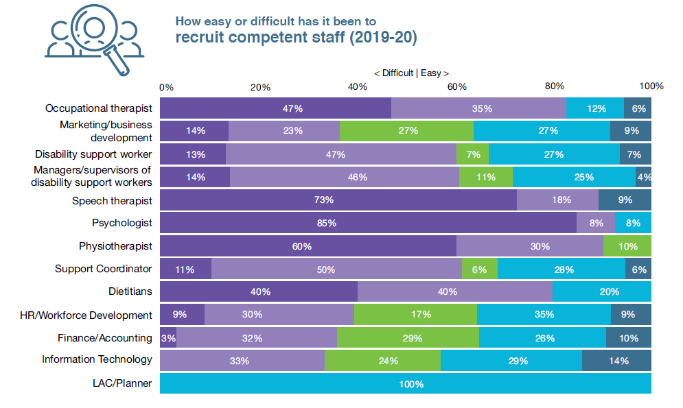

NDS’s Disability Sector Outlook – State of the Disability Sector Report (2020) for WA provides a snapshot of workforce recruitment and retention for the WA. Organisations were asked about the difficulty of recruiting staff. High-medium levels of difficulty were reported for Speech Therapists (91%), Disability Support Workers (60%), Psychologists (93%), Dietitians (80%), Physiotherapists (90%), Support Coordinators (61%) and Managers /supervisors of disability support workers (60%).

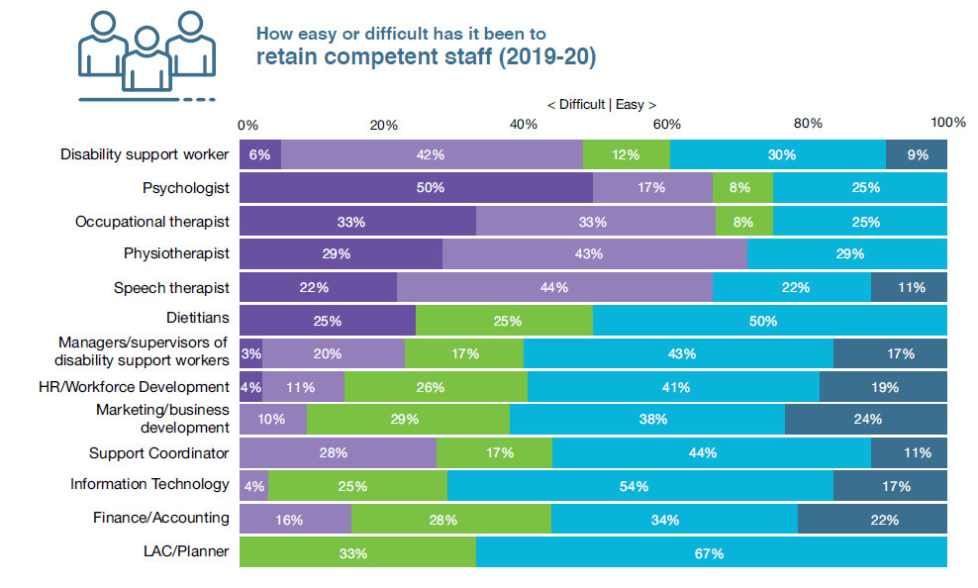

Organisations were also asked about the difficulty of retaining staff. High-medium levels of difficulty were reported for Speech Therapists (66%), Occupational Therapists (66%), Disability Support Workers (48%), Psychologists (67%), Dietitians (50%), Physiotherapists (72%) and Support Coordinators (28%).

# Priority 2: Protect the Integrity of the NDIS

**Context**

Current total budgeted expenditure on disability services is $4.3 billion (over four years from 2020-21). This includes the State Government’s commitment of $2.8 billion to be contributed to the NDIS over the forward estimates (2021-22 to 2023-24)

Of immediate concern is the state of play with the NDIS and its current failings. While Scheme administration sits with the Commonwealth Government, the State Government must protect its significant investment of $2.8 billion contribution to the NDIS over the forward estimates (2021-22 to 2023-24). This is not the NDIS we fought for and not the Scheme the State Government invested in.

While the NDIS has had a positive impact on many people’s lives, there is room for considerable improvement. The scheme is complex and constantly changing. It is hard to navigate. There are problems with fairness and consistency. While it is working well for some people, others are missing out.

A broad range of voices across the Australian and WA disability sectors share concerns around the implementation of the NDIS across jurisdictions - These include its inadequate pricing regime, the ineffectiveness of the NDIA to administer the Scheme on behalf of the State and Commonwealth Governments and most importantly, the current NDIS reform agenda of the Commonwealth Government that is largely motivated to re-engineer the Scheme to meet sustainability and overall Scheme budget parameters rather than providing a fit for purpose solution to remedy the many challenges with the NDIS.

WA disability CEOs have provided a snapshot that highlights their main concerns with the implementation of the NDIS in WA. They indicate that protecting the integrity of the NDIS is one of their top priorities for actions they seek from the WA Government.

* Almost 2 in 3 (62 per cent) report weak to very weak current financial sustainability.
* Over 2 in 3 (68 per cent) expect sector performance to deteriorate in the next year.
* Over 2 in 3 (72 per cent) expect organisational performance to deteriorate or stay the same in the next year.

Sector organisations report a challenging current NDIS working environment which is expected to deteriorate in the next year which is also reflected in the WA results from the NDS State of the Disability Sector Report 2020.

Budget 2021-23 must continue to acknowledge that WA disability organisations are facing an increasing demand for services in an environment of challenging NDIS pricing for WA participants. It is crucial that the State Government through the Office of Disability holds the Commonwealth Government to account on this expenditure and whether the promise of the NDIS is being delivered to the estimated 48,000 Western Australian participants that will be in the Scheme by 2023.

The following NDIS challenges continue to frustrate WA participants and disability service organisations.

**The NDIS market based approached** – This is focused on a centralised decision-making structure from Geelong that does not favour WA or our regions. This has resulted in an over administered and costly NDIS. Again, this demonstrates the importance of an independent and well-resourced State Office of Disability that can deliver local expertise and decisions responding quickly to the needs of all people with disability and their families in WA and better work in partnership with the NDIS

locally.

**Independent Assessment (IA) Panel** – NDS congratulates the State Government for supporting the Disability Ministers decision to reject the proposal to introduce mandatory independent assessments (IA) for the NDIS. The abandonment of this flawed proposal is a good first step so the Scheme delivers true choice and control for people with disability and enables them to access the services and supports they need.

We are therefore pleased that the Commonwealth government has agreed not to make any legislative changes to the Scheme and committed to consult on any future amendments as always should have been the case. The commitment to work with the disability sector to co-design a model to improve equity in the NDIS is also most welcome as is the request by States and Territories for evidence and necessary data from the Commonwealth to consider the implications of, and basis for, any future proposed changes.

We urge that the WA State Government along with all States and Territories Governments closely monitor that these commitments are followed through.

As we have highlighted previously, while Scheme administration sits with the Commonwealth Government, it is jointly governed by all jurisdictions and the WA State Government must protect its investment of $2.8 billion contribution to the NDIS over the forward estimates (2021-22 to 2023-24).

NDS in WA commits to continue to work with the McGowan Government, people with disability and their families and disability organisations and workers in our State so that the NDIS better supports the needs and experiences of participants.

**Inadequate NDIS pricing regime for WA** – The current NDIS pricing regime largely does not account for WA’s significant cost differential to deliver services across our vast State relative to the other Australian jurisdictions.

This pricing does not take account of the significant disability workforce pressures in WA resulting from one of the lowest unemployment rate in the country, the effects of COVID 19 on migration and a mining and housing boom putting upward pressure on wages.

We are keen to ensure the NDIS is sustainable, however it is also realistic in its price arrangements that reflect the WA conditions.

**Supported Independent Living (SIL) group homes issues** – SIL pricing remains a critical issue. A growing number of organisations express genuine concern about the sustainability of supports they provide for SIL participants, particularly those with high intensity and complex needs. WA organisations have indicated that the reduction in SIL funding is significant and may threaten the sustainability of some organisations and/or lead to a reduction and closure in some services. Information from the WA sector indicates that:

* Decreases in SIL funding packages ranging from 5-27 per cent and averaging around 7.8 per cent in the period 2019-20 to 2020-21. Over the last three months to June 2021, there has been a noticeable deterioration in this position with decreases in average SIL packages noted at 12-27 per cent for prominent SIL organisations.
* Some organisations are forecasting a $1m loss in 2021 under current SIL operating conditions. Participant funding decreases are having an immediate, direct, and significant financial impact on the organisations which are not sustainable in the long term.
* A trend that more residents and houses are unsustainable than sustainable. A majority of SIL houses are operating at a loss. A significant concern is an increasing number of unsustainable houses.
* NDS notes that the NDIA Quarterly Performance Dashboard at 31 March 2021 for WA shows that the rate of growth in annualised plan budgets have fallen by 2.5 per cent.
* Options to reduce losses significantly impact extra training of staff, life-skill activities for residents, drop in quality standards and delayed property maintenance and improvements.

**What we ask**

* The State Government should review the NDIS operational impact. State Government advocacy and intervention on operational NDIS challenges is required (e.g. local decision making powers to suit environmental context and legislative changes to better align policy and principles), implement an outcomes focussed evaluation and provide support to workers and organisations.
* Request that the NDIA and the Commonwealth Government acknowledge the higher costs of delivering the NDIS in WA through an appropriately adjusted pricing regime including for SIL.

WA is geographically one of the largest subnational jurisdictions in the world. This means that, when we consider the pricing of disability services, we need to take into consideration economic conditions and impacts at the very local level.

* This should reflect the higher cost of providing services in the WA economy and account for:
* the higher proportion of total income expended on employee expenses in WA, higher labour costs as a result of the impact of mining on the employment market that ensures that competition for workers is significant and which has recently escalated.
* that the low-paying disability services sector cannot compete for workforce capacity without competing in terms of the quality of jobs, and the competition for employees from other human services sector. The recent Commonwealth budget included significant funding increases in these two areas in response in part to findings related to the Aged Care Royal Commission. In terms of aged care, the Commonwealth has allocated an additional $17.7b, including funding for sustainability for aged care providers. In terms of mental health services, the same budget included an increase in funding of $2.3b, including funding for workforce growth needed to provide additional and extended services.
* Both of these budget initiatives will increase recruitment and retention pressure on the disability services sector which has also had costs increases as a result of the implementation of the quality framework amongst other cost increases.
* Costs associated with living in regional towns and communities are likely to compound this issue further, as attracting and retaining quality staff in disability service provision requires at the minimum a liveable wage, housing support and ideally a competitive remunerative package.

NDS urges the State Government to seek commitment from the Commonwealth to initiate a review of WA economic market conditions and their impact on the cost of delivering supports services to NDIS participants in WA.

This Review would align with Recommendation 6 of the WA Market Review which specified that the NDIA should work with the relevant Commonwealth and State/Territory Departments to monitor the economic conditions in WA (and Queensland and South Australia) with a view to making temporary adjustments to price, to proactively manage any potential impacts on the supply of disability goods and services from economic trends in those states that were contra cyclical to national trends.

* The State Government and the Commonwealth Government work to put in place mechanisms that are controlled locally in WA to improve engagement between NDIA, the Quality and Safeguarding Commission and disability organisations. This should include improved channels of consultation, more formal guidance from the NDIA (e.g., written guidelines), periodic forums involving organisations and the NDIA to resolve issues; and codesign and collaboration between organisations and the NDIA on specific issues (e.g., people with complex needs and compliance requirements).

# Disability Sector Outlook – WA CEO’s Snapshot May 2021

**Financial sustainability of the Sector today**

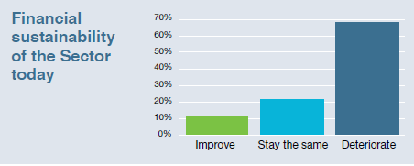

WA disability CEOs provided a snapshot in May 2021 that highlights their expectations around the financial sustainability of the disability sector, with over 2 in 3 (68 per cent) reporting they expect sector performance to deteriorate in the next year.

**Performance of organisation next year**

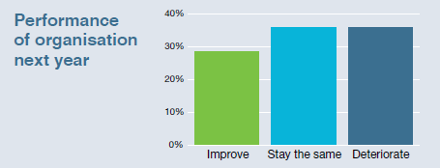

Over 2 in 3 (72 per cent) expect organisational performance to deteriorate or stay the same in the next year.

**Performance of the Sector next year**

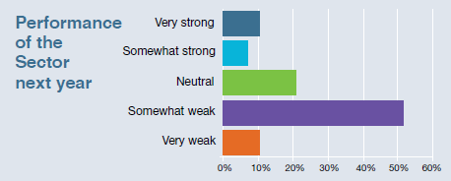

Nearly 2 in 3 (63 per cent) expect sector performance to be very weak of somewhat weak in the next year.

**Levels of services provided next year**

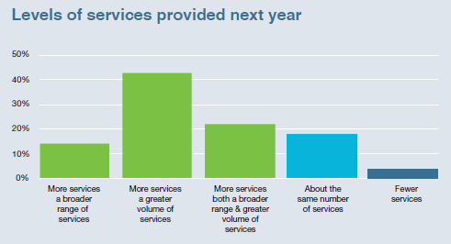

WA CEOs of disability organisations also indicated they expected that disability organisations would provide more services – a greater volume and broader range of services in the next year. Less than 3% indicated they expected fewer services to be provided.

**Levels of employment required next year**

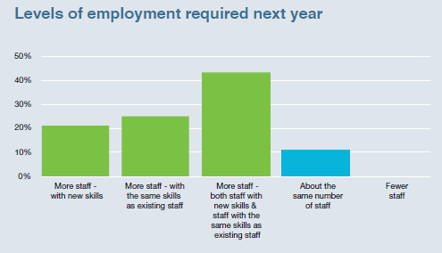

WA CEOs of disability organisations indicated they expected that the levels of employment next year would increase. About 43% reported that disability organisations will need more staff, both staff with new skills and staff with the same skills as existing staff provide more services, 25% reported organisations will require more staff with the same skills as existing staff, while about 21% reported they would require staff with new skills. Only 10% reported that their staff levels would not change and no CEO expected their organisation to employ fewer staff.

# Disability Sector Outlook – State of the Disability Sector Report 2020 (WA)

**The NDIA is working well with organisations**

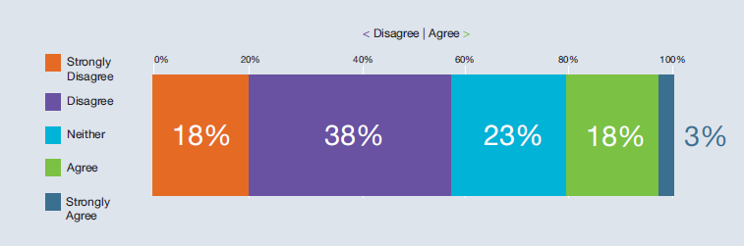

NDS’s Disability Sector Outlook – State of the Disability Sector Report (2020) for WA provides an insight into how the disability is travelling with the transition to the NDIS. The data indicates that:

56% of organisations reported they strongly disagree/disagree that NDIA is working well with organisations, with a further 23% neutral. Only 21% agreed or strongly agreed that the NDIA works well with organisations.

**The systems and processes in the NDIS are working well**

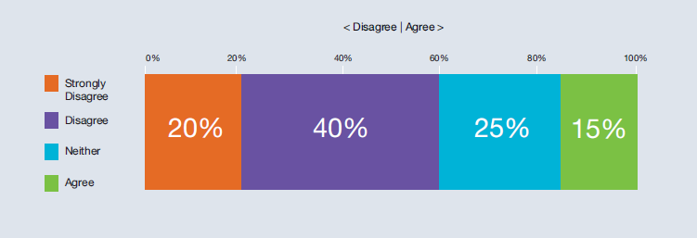

60% of organisations reported they strongly disagree/disagree that the systems and processes in the NDIS are working well with a further 25% neutral. Only 15% agreed or strongly agreed that NDIS systems and processes worked well.

**We are worried organisations won’t be able to provide NDIS services at current price**

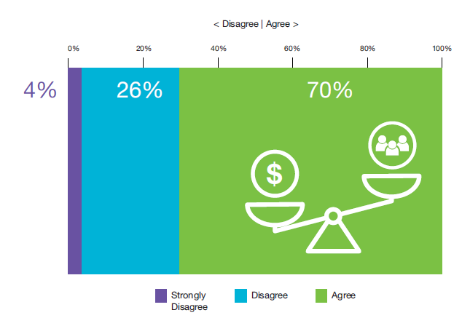

Overwhelmingly, 96% of organisations agree/strongly agree that they are worried organisations won’t be able to provide NDIS services at current prices.

**Over the last 12 months, have received requests for disability services that could not be provided**

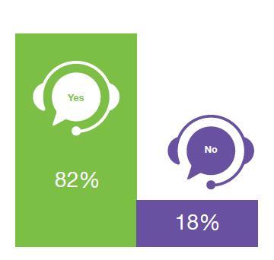

The vast majority (82%) of organisations indicated that over the last 12 months, they have received requests for disability services that could not be provided.

**There are too many unnecessary rules and regulations my organisation has to follow**

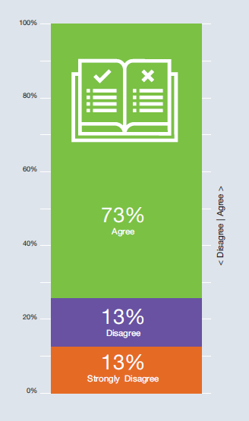

Nearly 3 in 4 organisations (73%) agreed/strongly agreed that there are too many unnecessary rules and regulations their organisation has to follow. Only 26% disagree/strongly disagree that this was the case.

**Helping people understand and navigate the scheme is taking us away from service provision**

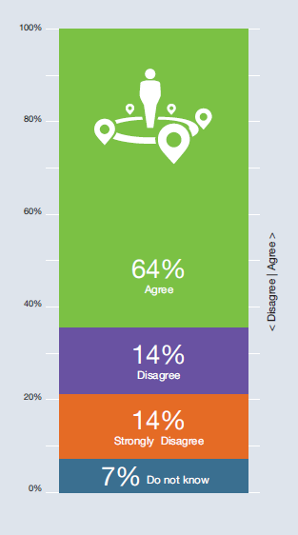

Nearly 2 in 3 organisations (64%) agreed/strongly agreed that helping people understand and navigate the scheme is taking organisations away from service provision. About 28% disagreed/strongly disagreed that this was the case.

# Priority 3: Build a fit-for-purpose Office of Disability

**Context**

The recommendations of the Functional Review into the operations of the DoC supported the establishment of the Office of Disability. The release of the full report of the Functional Review into the operations of the DoC and Disability Services would provide better context around the State Governments intentions for the role that the Office of Disability will play in overseeing the WA disability sector and Western Australians with disability.

We convey the importance that the Office be fit-for-purpose and well-resourced to support its responsibilities for the implementation the NDIS and a fully funded State Disability Strategy supported by detailed two-year Action Plans with milestone targets to be achieved. Both should continue to play a vital role to provide specialist expertise to ensuring people with disability have access to a good education, training and jobs, better health and justice outcomes, more affordable and accessible housing options, as well as steering the delivery of investment in a strong disability workforce.

This Office must have real grunt and be appropriately funded to manage its own budget and be led by an accomplished senior executive with demonstrated disability experience and understanding of the WA disability sector and inclusion.

These mechanisms will play a critical role to deliver a fair go for people living with disability, building economic and social inclusiveness as well as to help build a strong and viable disability sector workforce and delivering quality support services.

**What we ask**

* Provide adequate funding in the next State Budget 2021-23 to build a fit-for-purpose Office of Disability. Currently, no funding has been allocated to the Office and it must report direct to the Director General and Minister and not be buried in layers of internal bureaucracy within the Department of Communities.
* Ensure the Office of Disability is led by an accomplished senior executive with demonstrated disability experience and understanding of the WA disability sector and inclusion.
* Ensure the Office of Disability and Minister for Disability Services have direct oversight, control and accountability of the State Budget 2020-21 disability allocation of $4.3 billion over four years from 2020-21.
* Ensure the Office delivers a comprehensive Action Plan to support a fully funded 10-year State Disability Strategy with a whole-of-government approach with actions focused on increasing the economic and social participation of West Australians with disability.
* The Office must have an independent capacity to provide the State Government with information to assist in their negotiation of the next Bilateral Agreement between the State and Commonwealth Government which will commence in the next 12 months.
* It should work with people with disability, their families and carers as well as the disability service organisations to help build a data bank of information to provide an independent assessment of the status of the current NDIS in WA, to be used to inform the next Bilateral Agreement in 2023. The Office has a key role to collect data on critical unmet need and future demand to inform its decision making and ensure NDIS is delivering in the most urgent of areas. This is critical for people with high and complex needs and the provision of 24- hour specialist support services.
* NDS seeks an allocation of financial support for the Office to oversee and support an initiative for people with high and complex needs and the provision of 24-hour specialist support services.
* Be funded to develop strong, accountable and transparent interfaces with mainstream agencies alongside the NDIS in WA.
* Provide last resort and emergency / crisis disability services. The Office should act on behalf of the Western Australian Government as the provider of last resort. This should include developing a mechanism to monitor emerging thin markets (or potential for market failure) and is particularly important for people with complex needs or in rural/remote regions.

# The Office of Disability must guide strong State Government stewardship of the disability eco-system

The State Government has a responsibility to further progress the development of a strong state disability ecosystem to the benefit of over 411,000 Western Australians with disability. Around 48,000 are eligible for NDIS.

While NDS acknowledges the State Government’s implementation of its election commitment to continue with a dedicated Minister for Disability Services and an Office of Disability, State Budget 2021-23 must prominently acknowledge the many challenges faced by people with disability, the sector and its workers.

An adequately resourced Office of Disability must guide the State Government’s investment in a strong and sustainable state disability ecosystem for all Western Australians with disability. It will be critical to oversee the delivery of better social and economic community inclusion of all people with disability in WA, championing and protecting their human rights and the continued development of a strong, sustainable and innovative disability services sector.

This Office must carefully oversee the State Government’s investment in disability of $4.3 billion over four years of which $2.8 billion is the State’s contribution to the NDIS and make sure this is directed toward priority areas. This will also help to support the WA economy through jobs, training and innovation, as well as improving the well-evidenced level of disadvantage of people with disability, noting that the disability sector directly contributes a significant $2.7 billion to the State economy (with an indirect contribution much higher) and is projected to employ over 20,000 workers.

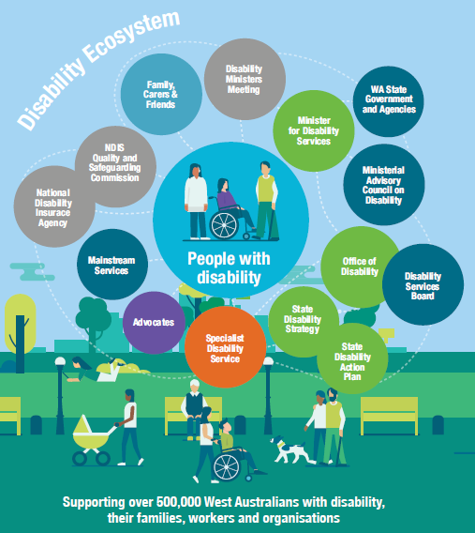

The **“Disability Ecosystem” infographic** above illustrates the components of the disability sector in Western Australia and how they interact like a living ecosystem.

A large, light blue circle is in the centre and titled People with disability.

Reading in a clockwise direction, there are 14 coloured circles surrounding the people with disability titled:

* Family, Carers and Friends
* Disability Ministers Meeting
* Minister for Disability Services
* WA State Government and Agencies
* Ministerial Advisory Council on Disability
* Office of Disability
* Disability Services Board
* State Disability Strategy
* State Disability Action Plan
* Specialist Disability Services
* Advocates
* Mainstream services
* National Disability Insurance Agency
* NDIS Quality and Safeguarding Commission

Supporting over 500,000 West Australians with disability, their families, workers and organisations

# Priority 4: Fund the State Disability Strategy

**Context**

We are very pleased with the State Government’s development of a State Disability Strategy, which has long been championed by NDS.

**What we ask**

* Fund the implementation of the State Disability Strategy and its Action Plan. This should also include a comprehensive Disability COVID-19 Plan to better respond to the needs of people with disability to meet a future pandemic crisis.
* Report on the achievements of the Strategy outcomes to measure success and table these in parliament annually.
* The Strategy must deliver the State Government’s obligations under the National Disability Strategy and maximise the State’s investment in the NDIS including ensuring a strong interface with mainstream agencies alongside the NDIS in WA.
* It must also inform negotiations on a new NDIS Bilateral Agreement by 2023 that incorporates an NDIS Outcomes Framework and KPIs. This should include a strategy to build a sustainable innovative disability workforce and services sector and to manage the risks and costs of market failure.
* The Strategy must formalise the State Government’s role of provider of last resort and emergency disability services. Funding provisioned for State run disability services must include funding for the State Government to be the provider of emergency / crisis services where there is market failure, particularly in regional, rural and remote parts of WA.

# People with disability in WA, disability workers and the sector

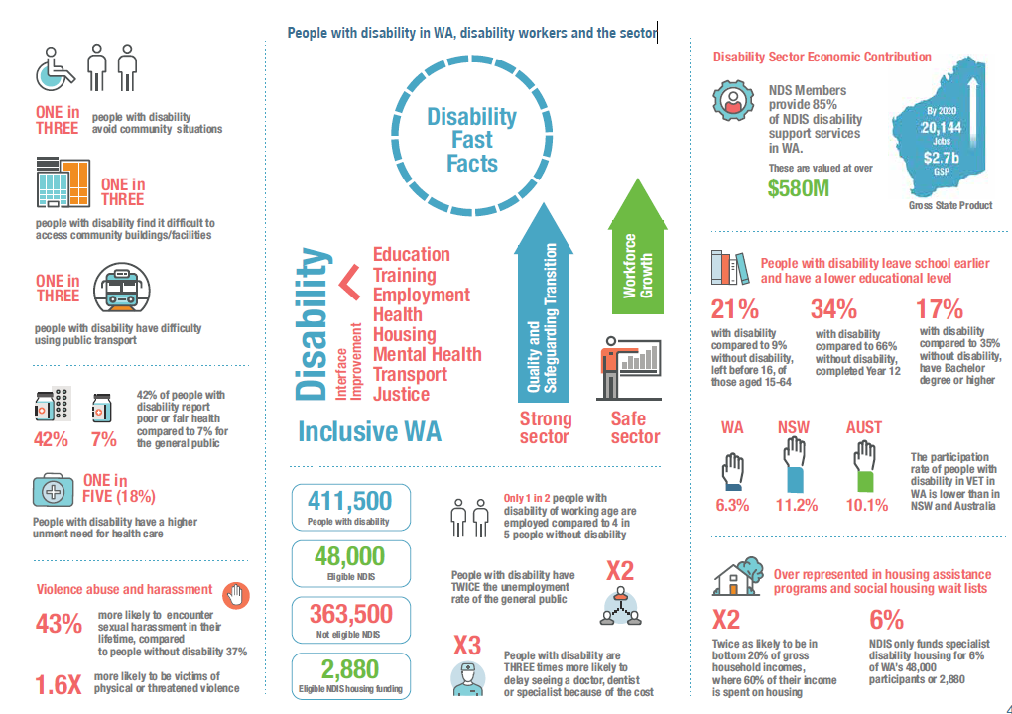

The **“Disability Fast Facts” infographic** above illustrates statistics related to disability in Western Australia. The statistics are divided into eight sections.

**Section 1:**

* One in three people with disability avoid community situations
* One in three people with disability find it difficult to access community buildings/facilities
* One in three people with disability have difficulty using public transport

**Section 2:**

* 42% of people with disability report poor or fair health compared to 7% for the general public
* One in five (18%) people with disability have a higher unment need for health care

**Section 3: Violence abuse and harassment**

* 43% more likely to encounter sexual harassment in their lifetime, compared to people without disability 37%
* 1.6 times more likely to be victims of physical or threatened violence

**Section 4**

One side of the section reads:

* Education
* Training
* Employment
* Health
* Housing
* Mental Health
* Transport
* Justice

An arrow labelled Interface Improvement points from those words to the word Disability.

The bottom of the section reads: Inclusive WA.

To the right, there are two arrows pointing up, labelled:

* Quality and Safeguarding transition
* Workforce Growth

The bottom of the section reads strong sector, safe sector.

**Section 5**

The left hand side of the section reads:

* People with disability: 411,500
* Eligible NDIS 48,000
* Not eligible NDIS: 363,500
* Eligible NDIS housing funding: 2,880

The right hand of the section reads:

* Only 1 in 2 people with disability of working age are employed compared to 4 in 5 people without disability
* People with disability have twice the unemployment rate of the general public
* People with disability are three times more likely to delay seeing a doctor, dentist or specialist because of the cost.

**Section 6: Disability Sector Economic Contribution**

NDS Members provide 85% of NDIS disability support services in WA. These are valued at over $580M

By 2020 20,144 jobs, $2.7b Gross State Product

**Section 7**

People with disability leave school earlier and have a lower educational level

* 21% with disability compared to 9% without disability, left before 16, of those aged 15-64
* 34% with disability compared to 66% without disability, completed Year 12
* 17% with disability compared to 35% without disability, have Bachelor degree or higher

The participation rate of people with disability in VET in WA (6.3%) is lower than in NSW (11.2%) and Australia (10.1%).

**Section 8**

Over represented in housing assistance programs and social housing wait lists

* Twice as likely to be in bottom 20% of gross household incomes, where 60% of their income is spent on housing

NDIS only funds specialist disability housing for 6% of WA’s 48,000 participants or 2,880

# Priority 5: Build Accessible Communities and Participation

**Context**

The State Government has a responsibility to improve the economic and social participation of Western Australians with disability which is embedded in the 10-year State Disability Strategy and also in its commitment to deliver policy outcomes of the National Disability Strategy.

There is still significant progress that needs to be made on many fronts including building more accessible communities, improving the economic participation of people with disability and in particular their training and employment and delivering better health and justice outcomes.

NDS highlights the following areas as an opportunity for State Budget 2021-23 to commence addressing.

**Disability Housing**

People with disability must have good housing options and increased home ownership. The State Government must lead and collaborate with industry and provide incentives to fast track the delivery of disability accessible housing in WA. NDS highlights the following top priority areas for action in this year’s State Budget.

**What we ask**

* Finalise and implement the State’s approach to Specialist Disability Accommodation in the NDIS.
* The State Housing Strategy to be funded to provide clear line of sight between State Government responsibility and delivery of accessible and affordable housing for all people with disability. It should include an action plan to roll out disability housing.
* Through the 10-year State Disability Strategy, progressively require all new housing to be built to a Liveable Design Housing Australia’s silver standard as a minimum. The State Government has made some progress with the building of accessible, inclusive and affordable accommodation for people with disability with a requirement for all new social housing homes through the Social Housing Economic Recovery Package to be built to a Liveable Design Housing Australia’s silver standard or higher to better support people with disability.
* Ensure minimum accessibility standards for residential dwellings as part of National Construction Code and ensure the Rental Tenancy Act provides minimum accessible standards / allow minor modifications.
* Increased focus on better use of existing disability housing stock, rather than solely on building new stock, including improved strategic asset management, use of matching services like Home Hub and transfer of management to disability and community housing providers.
* Better targeting of Keystart, the First Homeowners Grant, Building Grants and Housing Loan schemes to improve accessibility by people with disability and to families who act as guarantors, the rebate or removal of property transfer duties for people with disability.
* Provide industry incentives to housing developers, creating more affordable housing options across the community including targeted funding, use of government surplus land / planning scheme quotas as part of new developments.
* Set minimum inclusion targets for land and house developers - preferential access to land or housing for people with disability. Progressively move to a target of 10 per cent of social housing to be allocated to people with disability (commensurate with rate per head of population), as part of a action plan on disability housing.
* Partner with NDS, the housing sector and people with disability to design and develop pathways to access suitable housing, addressing long-term shortages in accessible and affordable disability housing, the lack of community disability housing and to ensure maintenance of existing housing through retrofitting is to an accessible standard.
* Develop a Ready Reckoner Disability Housing Information Package of disability housing products for people with disability, the housing industry sector and community to support housing exploration options.
* Invest in a significant housing industry awareness campaign to promote the construction of accessible housing as a future growth area.
* Commit to provide regional housing for disability workers to enable services to be established for people with disability in regional, rural and remote locations.
* Work with the real estate industry to include accessibility features for rentals and houses for sale and include accessibility as a filter on real estate websites.

**Accessible Communities and Infrastructure**

Our communities must be designed so that everyone, including people with disability, can be valued and have opportunity to be active members as well as having access to the whole community.

The State Budget 2021-23 must address the lower community participation of people with disability by ensuring accessible infrastructure standards and facilitating changes in community attitudes towards disability.

The State Disability Strategy must be funded to deliver greater economic and social participation for people with disability so that they are involved in a full range of economic, recreational, social and cultural opportunities. This should aim to improve accessibility to community infrastructure, address transport shortcomings and promote inclusive tourism and consider investment in the following:

**What we ask**

* Expand Disability Access and Inclusion Plans to include an eighth outcome reporting area (Achievement) for all State and local government agencies. The eighth outcome should highlight significant achievements in delivering access and inclusion across Government and meeting ongoing commitment to designated KPI.
* New public infrastructure to be co-designed through Inclusion Planning Committees to ensure accessibility for all people with disability.
* Change planning regulations and policies to require increased accessibility of all State infrastructure.
* Identify accessible infrastructure priorities in the Building METRONET/ HUB, Building Infrastructure and Driving Industry Development programs.
* Identify priority projects to improve accessibility of existing community infrastructure.
* Require the involvement of people with disability in public infrastructure procurement, planning and design processes.
* New public community infrastructure design to include people with disability. Upgrades of existing facilities to be done to an accessible standard. Schools and tourism works such as national parks, trails and camp sites whether new works, maintenance or refit should be a priority including those planned through regional recovery plans.
* Audit all publicly funded community infrastructure in WA to assess whether they meet accessibility standards with a requirement to move to full accessibility by 2030.
* Continue the current work towards ensuring all tourism facilities and national parks are accessible.
* Work towards ensuring all new commercial developments will be accessible. Provide incentives for commercial infrastructure to optimise community access for people with disability.
* The State Government’s Digital Blueprint platform to also be shaped by people with disability and disability service organisations – its connectivity and design must provide full digital inclusion, including access to online services and platforms, as well as the innovative technologies that support the delivery of important services such as health, education and judicial services.
* Invest in the provision of accessible plain English and Easy Read formatted information about the Western Australian disability ecosystem, mainstream and support services.
* Commit to improving disability access at train and bus stations and ensure footpaths and roads linking to transport hubs are maintained and unobstructed.
* Mandatory disability awareness training modules for all transport staff who engage with passengers with disability.
* Work with the commercial passenger vehicle industry to ensure availability of accessible taxis and ride share vehicles.
* Engage with the Public Transport Access Committee on accessibility issues in regional WA.
* Provide education for tourism operators and tourism improvement grants to support improved experiences for visitors with disability.
* Provide subsidies for tourism operators in WA to conduct access audits.
* Develop an online tourism platform which highlights accessible accommodation, facilities, activities and sites for tourists.
* Explore use of technologies in public transport to enhance the journey for people with a disability.
* Fund a demonstration project to showcase the benefits of point-to-point transport services for people with disability. Invest and promote a range of interactive sport inclusion programs e.g., good models are the Victorian WheelTalk, AFL Wheelchair, dsrKids and Cycle Power initiatives that are promoted through primary and secondary schools, universities, TAFEs, private colleges, private businesses and not-for-profit organisations.
* Provide advice / funding for recreational service providers to complete workplace modifications to improve access for people with disability to mainstream activities.

**ACROD, Companion Card and Changing Places**

There has been commendable investment in these three programs by the State Government over recent years.

The ACROD Parking Program currently supports Western Australians with significant mobility restrictions to access the community by providing permits for accessible ACROD parking bays. NDS administers ACROD which is subsidised by the WA State Government. ACROD has over 90,000 Australian Disability Permit holders across WA. In 2019, a new ACROD database has been developed and launched.

NDS welcomed the Minister for Disability Services’ announcement on 3 June 2021 of the expansion of the ACROD Parking Program eligibility criteria following a review and recommendations which highlighted the significant barriers for people whose ability to safely navigate a carpark is significantly restricted by a disability or medical condition.

The review found that people who were legally blind often experienced barriers when accessing the community, with the issue of safely navigating carparks consistently raised by individuals and support people.

Eligibility criteria for the 40-year-old program is being expanded and will now include those who are legally blind and people assisted by a guide dog.

The review also highlighted the need for more ACROD parking bays and recommended that strategies be developed to address this issue. The next phase of the ACROD Parking Program review will investigate options to increase the number of available ACROD parking bays in Western Australia and to minimise bay misuse.

Work being undertaken by NDS in WA, Department of Local Government, Sport and Cultural Industries such as the very successful community awareness campaign - This Bay is Someone’s Day - reduce the misuse of ACROD Parking bays in the community and improves their availability.

**Companion Card**

NDS also administers the WA Companion Card which has almost 17,000 cardholders (and 601 affiliated business participating) and is for people with a significant and permanent disability, who require attendant care support in order to participate at community venues and activities. It is anticipated the number of cardholders will continue to grow – NDS anticipates that around 20,000 Companion Cardholders with growing number of industry affiliates.

**What we ask**

* Provide NDS with long term funding surety through a five-year agreement for ACROD and Companion Card delivered by NDS in WA.

**Continue to Expand Changing Places**

NDS has long advocated for the funding of Changing Places across WA which provide suitable facilities for people who cannot use standard accessible toilets. We are pleased that the State Government committed $2 million in December 2020 to support the establishment of a network of Changing Places across WA with 32 established to date.

Changing Places is critical infrastructure that aims to improve access and inclusion for people who might not be able to fully participate in community life because of their bathroom needs. A free key to open Changing Places is currently available for WA Companion Card holders funded by the State Government of WA, with 6,588 MLAK keys issued to people with disability in WA to date. NDS seeks funding for further expansion of the Changing Places network in WA.

**What we ask**

* Fund NDS to work with local government authorities and the community to expand the Changing Places network in WA to priority locations identified by people with disability.
* Install Changing Places facilities at new key transport interchanges as part of METRONET.
* The WA Government request that the Commonwealth Government’s current review of the Disability (Access to Premises – Building) Standards 2010 (the Premises Standards) ensures that Changing Places become part of the suite of accessible facilities across Australia to provide people living with a disability with dignified and equitable access to buildings.

**Education and Employment**

People with disability have a right to a good education, training and jobs. The State Government must commit to ensure people with disability have the education and skills they need to succeed and have meaningful inclusive employment and economic independence. However, this is not the case – people with disability have significantly lower employment participation rates (including in the WA Public Sector), higher unemployment rates and are subjected to discrimination in schools and workplaces – factors which reduce their economic independence and income earning capacity.

We urge the State Government to provide funding through the State Disability Strategy to remedy this.

**What we ask**

**Education**

* Increase funding to support and increase the number of teachers and education assistants and access to in-classroom support.
* The Department of Education and NDS partner to develop and deliver a program of anti-bullying strategies to support students with disability.
* Establish a Disability Education Training Program to improve inclusive education practices in schools for teachers and advice to students and families on available supports.
* Set up an Inclusive Schools Program requiring mandatory changes to how schools operate so they deliver inclusive learning environments. Establish a Pathways to Work Schools Partnership program for students.

**Employment**

* The July 2021 WA Skills summit discussion should provide tailored education and employment solutions for people with disability to improve their employment outcomes.
* Create 50 internships for people with disability in varied industries and sponsor traineeships, cadetships and graduate careers across the WA public sector. Continue to support Australian Disability Enterprises (ADE) through the Department of Finance Social Procurement ADE initiative that supports businesses that employ people with disability. The State Government should explore other opportunities to increase the employment of people with disability through the wider Government procurement process.

**Great Health and Justice Outcomes**

The State Government must provide focused investment in this year’s State Budget to deliver better health and justice services for people with disability who have significantly poorer outcomes than the general population. People with disability are six times more likely to assess their health as poor or fair while only about 1 in 4 (24 per cent) of adults with disability experience good or excellent health care compared to about 2 in 3 (65 per cent) of people without disability.

Significant action is required to enhance the capacity of GPs and other primary health care services to respond to the needs of people with disability and ensure equitable health services. Nursing support for people with disability who also have health related needs is inconsistent in terms of access to nursing services, consumables and equipment. A particular concern is that some people with disability experience unduly long hospitals stays due to a breakdown in accommodation or delays in NDIS funding

**What we ask**

* Improve the coordination of health and disability services by investing in comprehensive health and dental checks for people with significant disability funded through the Comprehensive Health Assessment program.
* Through the NDS and Health Department – “Ready to go home” project, develop a range of transitional care arrangements to facilitate timely discharge from hospital.
* Finalise a WA COVID-19 Plan for people with disability and sector workers to ensure people with disability have ongoing access to quality services whilst outbreaks remain a risk and are given priority access to a COVID-19 vaccine once it becomes available.
* Fund the Department of Health and NDS to design and implement a pool of metropolitan-based clinical staff that can be deployed at short notice to regional locations to support healthcare delivery to people with disability.
* Support NDS for sector-wide training for disability sector workers on diabetes insulin injection.
* Invest in accessible hospital equipment such as hoists and accessible communications including access to Auslan interpreters and advocacy liaisons.
* Provide accessibility training for medical practitioners and nurses. Fund an integrated services demonstration project focused on people with complex needs and support for at-risk vulnerable people with disability.
* The State Government, NDS and the Insurance Commission of WA should continue to work with key stakeholders to fast track the delivery of an optimal response to the National Injury Insurance Scheme.
* Improve continuity and integration of supports between health, mental health and disability services systems. Better connectivity, communication and interdisciplinary awareness between health and disability is critical.
* Support the Department of Justice (DoJ) and NDS to develop and implement the WA Disability Justice Blueprint in partnership with people with disability, their families and the sector.
* Support DoJ and NDS to work together to identify opportunities for demonstration projects to divert people with disability out of the justice system and develop strategies for their reintegration into the community.
* Continue to fund systemic advocacy for the disability sector, including NDS’s pivotal role in systemic advocacy for service provision improvements to strengthen the rights of people with disability and support services provided to them. NDS’s 2020 State of the Sector report highlights that 76 per cent of disability organisations surveyed in WA indicate that there is insufficient advocacy for the people they support. This will provide certainty and the ability to plan for the long term so that the disability sector can adequately support Western Australians with disability and their families.

# About NDS

National Disability Services (NDS) is Australia’s peak body for non-government disability service organisations representing over 1000 non-government organisations, which support people with a diverse range of disability.

In WA, NDS represents over 150 specialist disability services organisations that provide services to tens of thousands of people with disability, their families and carers in the State including metropolitan, rural and remote regions. Our members provide more than 85 per cent of services to people with disability valued at more than $580 million. These range from home support, respite and therapy to community access, employment and more.



**Contact**

Julie Waylen

WA State Manager, National Disability Services

Telephone: 08 9208 9805

Email: julie.waylen@nds.org.au

[National Disability Services website](http://www.nds.org.au)