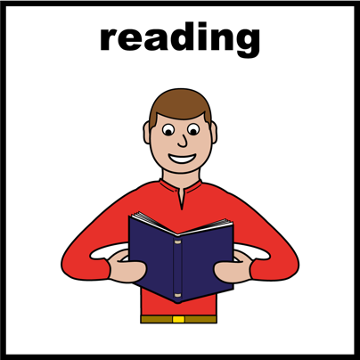
Tell us what would make mental health better for diverse communities.

Easy English

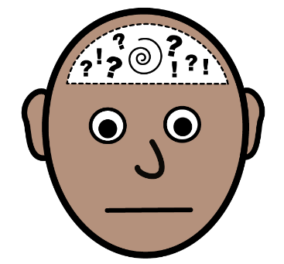
The Victorian Government is making a new plan for mental health supports.

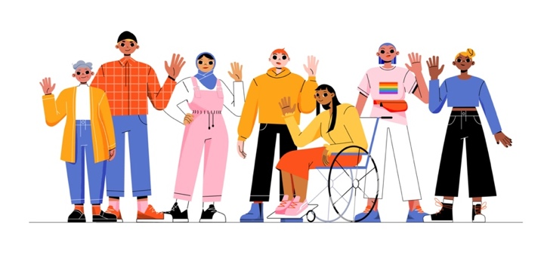

This plan is about people from diverse communities.

Your experience and ideas can help.

Acknowledgement of Country

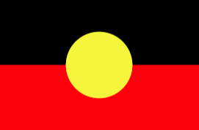
This flyer was made on Aboriginal land. We respect Aboriginal peoples

- History
- Culture
- Country
- Wisdom

Hard words

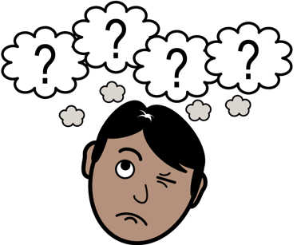
Some words in this flyer are in a different colour.

The green words are hard words.

We will tell you what the hard words mean.

Someone can help you read this flyer

You can ask someone to help you
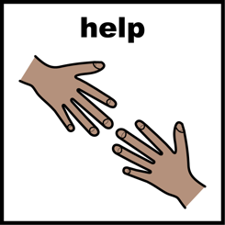
- read
- understand
- know what you need to know
- find out more
- ask questions.

Who wrote this flyer?

The Diverse Communities Team wrote this flyer.

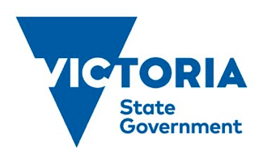
The Diverse Communities Team is part of the Victorian Government.

The Government makes decisions about some services and how to pay for them.

By diverse communities we mean

- People with disabilities.

- People who are lesbian, gay, bisexual, transgender, queer or intersex. This is sometimes called the ‘rainbow’ group.

- People from different cultures and countries.

About mental health
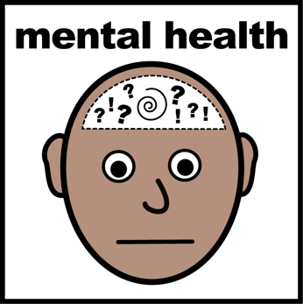

The Diverse Communities Team will make a plan to support good mental health.

Good mental health is when a person can

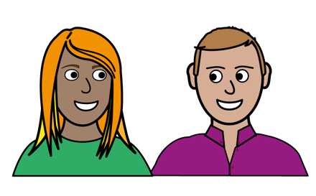
- do what they want to do
- cope with some stress
- work if they want to
- be part of their community

Poor mental health is when someone often has strong feelings that make daily life hard.

They could feel
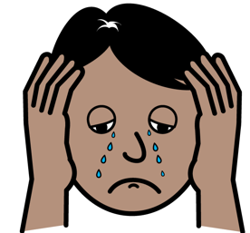
- sad
- hopeless
- nervous
- many feelings at once.

Poor mental health can also be when someone often has trouble with thinking or memories.

Poor mental health can happen for many different reasons.

It is normal to feel like this sometimes, but not to feel like this all the time.

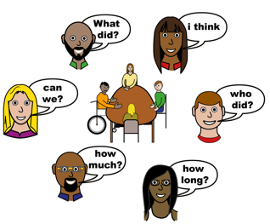
What are we doing?

The Diverse Communities Team wants to listen to people who

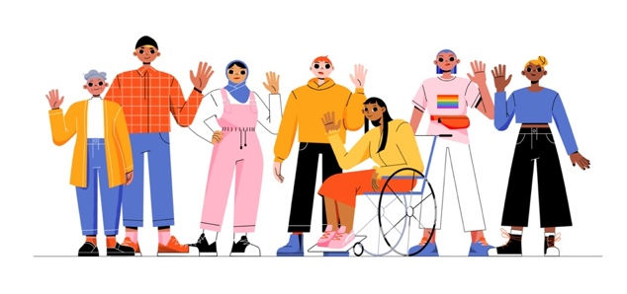

- are from diverse communities

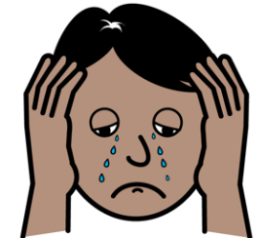

- have experience with poor mental health

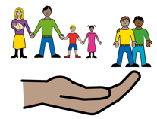

- have experience of being a family member, carer or supporter

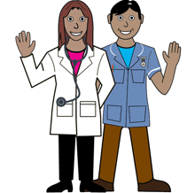
- work with diverse communities
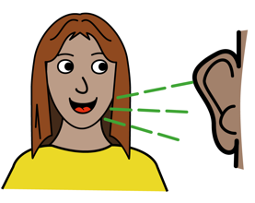
We want to hear your ideas about mental health.

If you want to talk to us about mental health, please read the rest of this flyer.

What we want you to do
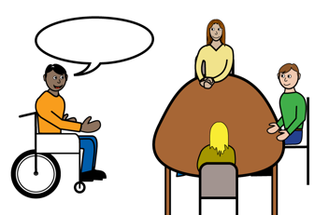
We want you to talk about mental health.

You can talk with
- the Diverse Communities Team
- other people who have ideas about mental health
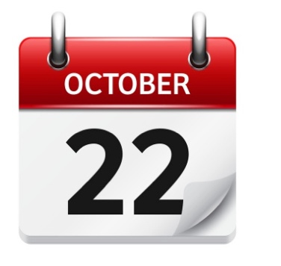

The talks will happen between 3 and 28 October 2022.

Most talks will happen online.

You will need a computer and internet.

A computer could be a laptop, desktop, tablet or smartphone.

The internet helps us talk to each other on our computers.

We will use Zoom.

Zoom is a computer program that helps us see and hear each other.

We might ask about:

- what good mental health means to you
- good support you want for your community
- your ideas to make mental health services better

Things that could help you join

You can bring a support person.

They can help you
- communicate
- feel comfortable.
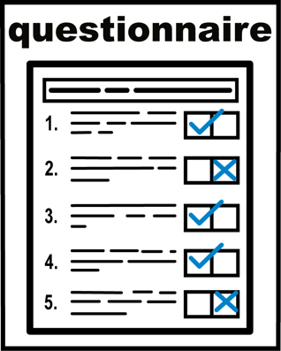

We will send you some questions a week before the session.

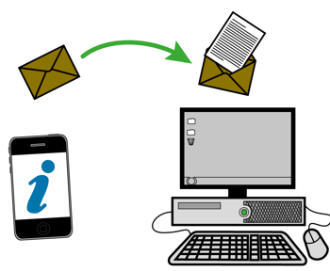
You do not need to pay to come to these talks.

If you have financial barriers email us on mhwd.diversity@health.vic.gov.au

Financial barriers could be:
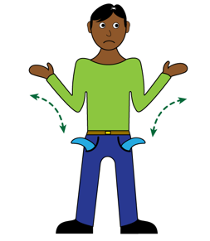
- you need to pay for your internet
- you need to pay a support person
- you will miss out on paid work

You can email us about things that could help you take part.

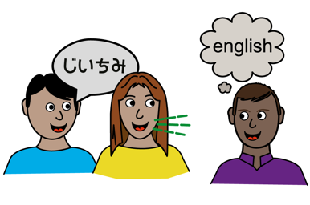
For example:
- someone who speaks your language
- closed-captioning

How can you find out more?

For more information, go to https://www.health.vic.gov.au/mental-health-wellbeing-reform/diverse-communities-mental-health-and-wellbeing-framework-and-blueprint
You can email the Diverse Communities team on mhwd.diversity@health.vic.gov.au.

Click this link to tell us you want to come tinyurl.com/yckwdvra

A list of talks you could join

This section has lots of information. You might ask someone to help you.

Who the talk is for |  | You may want to go to this talk if: | When the talk is
 | LGBTIQ+ community | You are from LGBTIQ+ communities or are a family member, carer or supporter of someone from these communities. | 1 – 3pm, 5 Oct  Online  6 - 8pm 18 Oct  In Melbourne
 | LGBTIQ+ sector and services | You are from a group or organisation that supports the mental health and wellbeing of LGBTIQ+ people. | 1:30 - 3:30pm, 18 Oct  In Melbourne
 | Culturally and linguistically diverse community | You are from culturally and linguistically diverse communities or are a family member, carer or supporter of someone from these communities. | 10am - 12pm, 11 Oct  Online  2 – 4 pm, 16 Oct  In Melbourne
 | Culturally and linguistically diverse sector and services | You are from a group or organisation that supports the mental health and wellbeing of culturally and linguistically diverse people. | 6 – 8pm, 19 Oct  In Melbourne
 | People with disability | You are a person with disability or are a family member, carer or supporter of someone with disability. | 6 - 8pm, 12 Oct  1 - 3pm, 13 Oct  Both online
 | Disability sector and services | You are from a group or organisation that supports the mental health and wellbeing of people with disability. | 1 - 3pm, 11 Oct  Online
 | Rural and regional | You are from, or work with, one or more diverse communities.  You have experience of mental health in rural or regional Victoria. | 3 - 5pm, 4 Oct  Online
 | Health services and practitioners | You work as a health practitioner in mainstream or cohort-specific services. This includes general health, allied health, community health, women’s health, etc. | 10am - 12pm, 4 Oct  10am - 12pm, 5 Oct  1 - 3pm, 12 Oct  All online
 | Open | You have any of the above experiences and are happy to be in a group with anyone. | 10am - 12pm, 13 Oct  Online  6 – 8pm, 17 Oct  In Melbourne

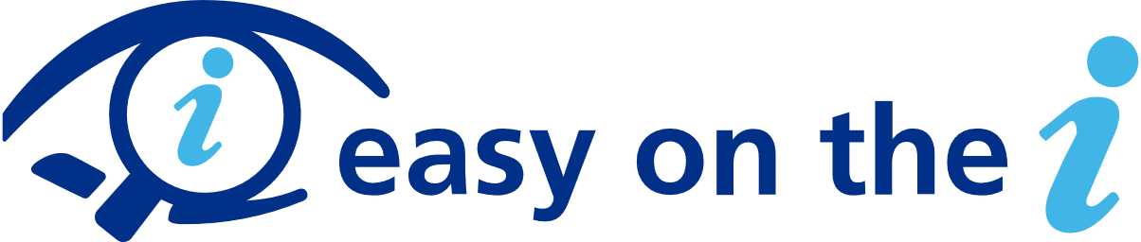
This document was created with ‘easy on the I’ images publicly available for download from Leeds and York Partnership at https://www.learningdisabilityservice-leeds.nhs.uk/easy-on-the-i/

