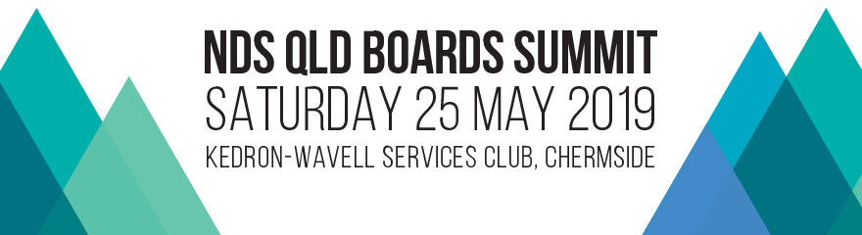

EVENT DETAILS

Date: Saturday, 25 May 2019
Venue: Kittyhawk Room, Kedron-Wavell Services Club, Chermside (Brisbane)
Time: 9.30am-4pm
Guests: CEO’s, board members and senior management of Queensland service provider organisations / Approximately 150 delegates to attend

As the NDIS is implemented across Australia the operating environment for disability service organisations and the sector landscape is rapidly changing. Boards and CEOs carry responsibility to adapt and innovate in galloping time and steer their organisations in the direction of success.

The NDS Qld Boards Summit will deliver a valuable program supporting boards and CEOs with insight, foresight and practical steps to ensure sustainable, quality services into the future.

SPONSORSHIP

Qld Boards Summit sponsor (maximum of 3) Cost: $1,500 (inc gst)

- Logo inclusion on the event webpage (with a link to your company’s website)
- Logo inclusion on event related printed advertising
- Logo inclusion on program
- Acknowledgement as a sponsor at the official opening
- Logo inclusion on event holding slides
- Networking opportunities with delegates
- 1 display table for you to promote your organisation’s products and services (during arrival, morning tea and lunch)
- 2 complimentary tickets to the Summit
- List of delegate names (subject to privacy legislation)

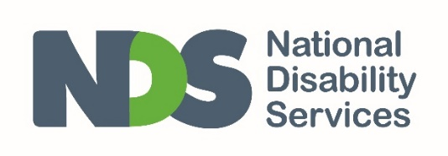
___________________________________________

For enquiries: contact Julie Walton on 02 9256 3115
or julie.walton@nds.org.au

