Marketing Governance Workbook
This workbook is designed to accompany the Marketing Governance Workshop delivered by Syneka Marketing.
Please complete this workbook during the Marketing Governance workshop.
1300 965 989
contact@synekamarketing.com.au
Syneka Marketing

What is Marketing Governance?
Marketing exists to create value, yet its failure to deliver can have fatal ramifications for business.
Marketing is both an internal and externally facing function. It needs to align internal aspects of an entity with its external market place.
Syneka Marketing has developed Marketing Governance using the five pillars of good governance:
- Strategic and marketing planning;
- Risk management;
- Financial management and reporting;
- Human resource planning and control; and
- Compliance and accountability systems.
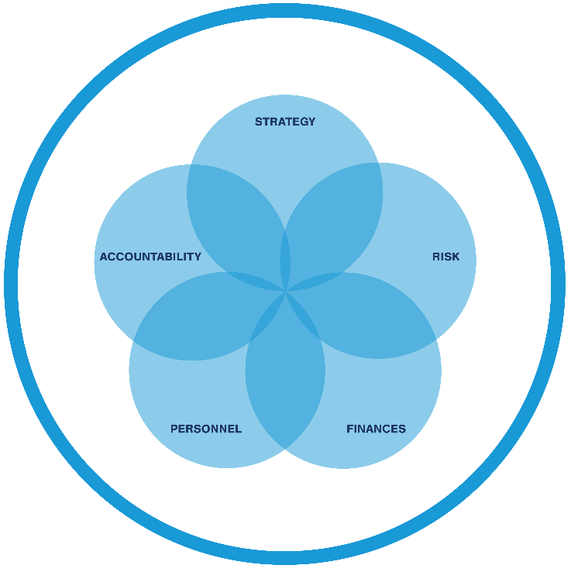
Marketing governance reinforces good governance by ensuring that marketing performs a strategic role, so it can fulfil its purpose of delivering value.

Your Name:

Your position

How do you define marketing?

How does your role involve marketing?

What is the role of marketing within your organisation?

What is the mission of your organisation?

What is the vision?

What are the aims of the current business plan?

Do you have a current strategic marketing plan?

What are your current marketing goals?

What strategies support this goal?

Is marketing consistent across the marketing mix?

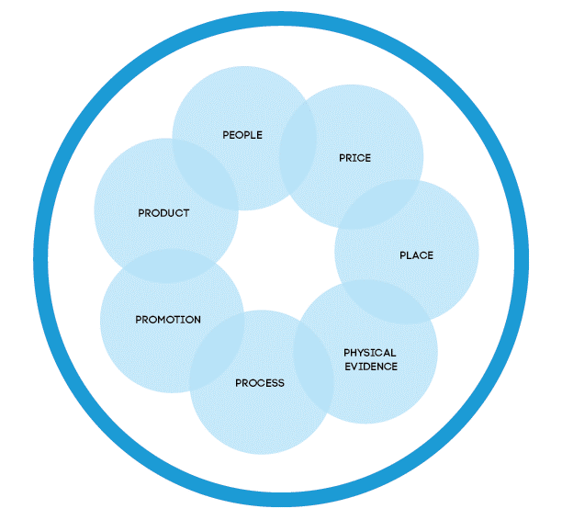

What areas are going well and why?

What areas could be improved and why?

Who are your current stakeholders?

What outcomes do they seek?

How are you currently measuring marketing performance?

What inconsistencies currently exist?

Do you undertake market research?

Are surveys undertaken on a consistent basis?

Are the results compared and evaluated?

What modifications have been made based on feedback?

Who is involved in the purchase decision and why are they involved?

What key messages are used?

How do these messages connect to stakeholders?

What gaps exist in your research?

What are market and industry conditions like?

What level of competition do you face?

Who are your direct competitors and why?

Who are your indirect competitors and why?

What alternatives exist?

How are competitors reacting?

What do you want to achieve over the next twelve months?

What do you want to achieve over the next three years?

What happens if this is not achieved?

What is your marketing budget?

What is the size of your marketing team?

How will you measure results?

What strategic risk exists in your organisation?

What compliance risk exists in your organisation?

What financial risk exists in your organisation?

What operational risk exists in your organisation?

What environmental risk exists in your organisation?

What reputational risk exists in your organisation?

What stakeholder risk exists in your organisation?

What service delivery risk exists in your organisation?

0 = lowest / 10 = highest
Risk | Severity (0 to 10) | Likelihood (0 to 10) | Cost/return

Why have the risks received these scores?

Eliminate and avoid, reduce, share or retain
Risk | How it will be managed? | What happens if it is not managed?

Do you have a defined marketing team?

What are the responsibilities of the marketing team?

What other marketing related roles exist in your organisation?

Who do these roles report to?

How many personnel have a marketing related role?

Who is responsible for the following? Are they internal or external?
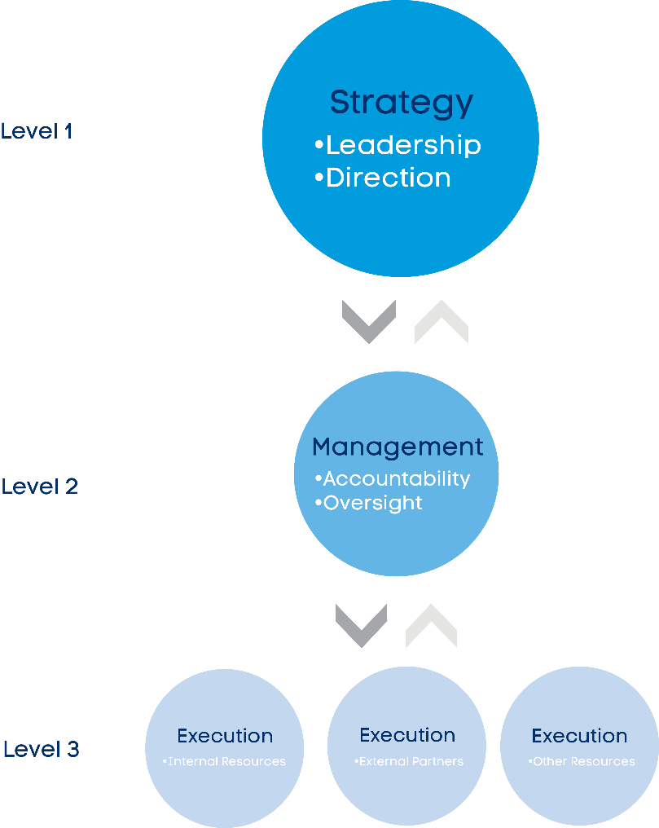
Level 1: Strategy – Leadership, Direction

Level 2: Management – Accountability, Oversight

Level 3: Execution – Internal resources, External partners, Other resources

What skills gaps currently exist?

What strengths currently exist?

How integrated is marketing across the organisation?

When did this work well?

When could it have been improved?

How is collaboration fostered?

What is the existing marketing budget?

What does this include?

What are the key campaign requirements?

Has marketing research been conducted?

Are resources allocated to evaluation?

What revenue is expected from the campaign?

What costs are required for the campaign?

What does success look like?

What activities will be undertaken, when and what resources are needed?
Activity | When | Resources needed

What are your core products/services and what value do they provide?

Where are they in terms of product lifecycle and why?

How are these products/services priced relative to competitors?

What pricing strategies are used and why?

What marketing actions are used during each phase of the decision making process (or customer journey)?
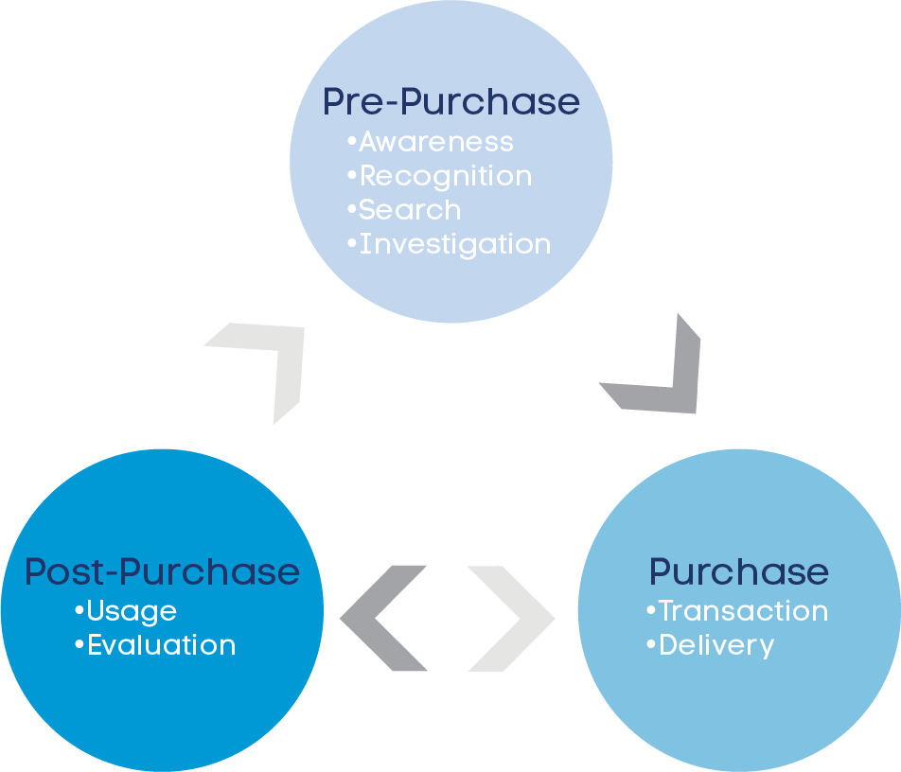
Pre-Purchase: Awareness, Recognition, Search, Investigation

Purchase: Transaction, Delivery

Post-Purchase: Usage, Evaluation

What does a typical sequence look like and how important is each step?
Pre-Purchase: Awareness, Recognition, Search, Investigation

Purchase: Transaction, Delivery

Post-Purchase: Usage, Evaluation

Who else is involved and how do they interact in the journey?
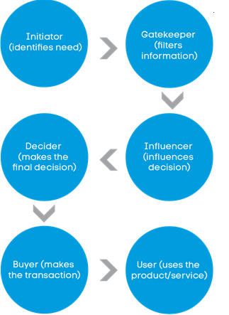
Initiator (identifies need)

Gatekeeper (filters information)

Influencer (influences decision)

Decider (makes the final decision)

Buyer (makes the transaction)

User (uses the product/service)

How important is each role for this purchase?

What activities are undertaken and how can they be measured?
Activity | Inputs | Outputs | Outcomes

How will these metrics be measured?

What gaps currently exist in measuring marketing performance?

What is required to fill these gaps?

General Notes

Syneka Marketing
Syneka Marketing is an independent agency and consultancy that exists to redefine marketing.
The leadership team of Syneka Marketing are accredited Certified Practising Marketers (CPM) as recognised through the Australian Marketing Institute (AMI).
The Syneka Marketing Governance Framework and its strategic expertise has been recognised through the Awards for Marketing Excellence.
The expertise at Syneka Marketing is sought through editorial coverage in Marketing Mag, The Age, Source Magazine, Third Sector, Inside Small Business, Radio 774, 3AW as well as key business and not-for-profit conferences.
Syneka Marketing's head office is based in Melbourne, with a client portfolio across Australia, as well as overseas.
The Certified Practising Marketer (CPM) is the peak professional benchmark for all marketers.
(Australian Marketing Institute)

