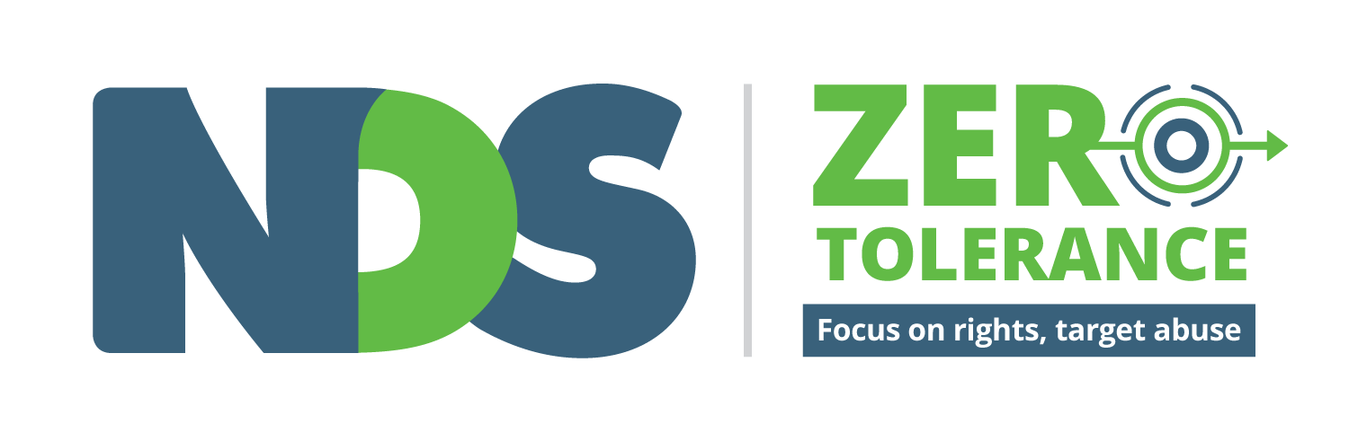

**Understanding Abuse**

**e-learning and resources**

**A guide for supervisors**

**Accessible version**

Acknowledgements

National Disability Services would like to acknowledge the funding from the Victorian Government which allowed the Understanding Abuse e-learning and resources to be developed.



We would also like to express our gratitude for the time, expertise and input provided by individuals and organisations in the development of the *Zero Tolerance* framework and more specifically those who helped inform this guide, including:

* Victorian Advocacy League for Individuals with Disability (VALID)
* NDS National Learning and Development
* Members of the Zero Tolerance Expert Reference Group
* Members of the Zero Tolerance Victorian Project Reference Group
* Participants of the ‘Speaking Up About Safety’ and ‘Understanding Abuse’ workshops
* Department of Health and Human Services
* Staff of the Office of the Disability Services Commissioner
* Staff of the Office of the Public Advocate
* Self Advocacy Resource Unit (SARU)
* Beyond Edge eLearning
* Silverpod Productions
* Actors and crew

‘Understanding Abuse’ resources have been funded by the Department of Health and Human Services and all intellectual property rights vests in NDS. No part of it may be reproduced without prior permission. Material which is reproduced from this publication must include an acknowledgement of the source. Prior permission should be sought from the relevant NDS office.

NDS acknowledges the following sources which have been utilised in the development of resources as per the permissions granted:

* National Disability Abuse and Neglect Hotline: <http://www.disabilityhotline.net.au/>
* Queensland Government: [Preventing and responding to abuse, neglect and exploitation](https://www.communities.qld.gov.au/disability/support-and-services/for-service-providers/preventing-and-responding-to-abuse-neglect-and-exploitation)
* Social Care Institute for Excellence: [Protecting Adults at Risk: Good Practice Guide](http://www.scie.org.uk/publications/adultsafeguardinglondon/files/sections/recognition-and-indicators-of-adult-abuse.pdf)

Disclaimer

The information provided in this guide is intended for general use only. It is not a definitive guide to the law and best practice, does not constitute formal advice, and does not take into consideration the particular circumstances and needs of your organisation.

Every effort has been made to ensure the accuracy and completeness of this document at the date of publication. NDS cannot be held responsible and extends no warranties as to the suitability of the information in this document for any particular purpose and for actions taken by third parties.

All stories used throughout this tool are fictional and are for educational purposes only.

NDS 2016

Understanding Abuse: A guide for supervisors

1. Introduction
   1. About this Guide
   2. About the Zero Tolerance initiative
   3. About this training
   4. What people with disability told us
   5. Your role as a supervisor
   6. About the e-learning and resources
   7. Learning objectives
   8. How to use this guide
2. Module 1: Understanding Abuse
3. Module 2: Power and Control
4. Module 3: Introducing the Empowerment Circle
5. Learning Bites
   * 1. Identity: Who I am and what I believe
     2. Emotional: How I feel
     3. Physical: My body, my health
     4. Relationships: The people in my life
     5. Material: My house and my things
     6. Financial: My money and my job
     7. Social: My life in my community
     8. Education: Things I have learned or want to learn
6. Further information, resources and support

About this guide

This guide is part of the NDS Zero Tolerance ‘*Understanding Abuse*’ training program.

It has been written for supervisors and practice managers to help implement the ‘Understanding Abuse’ program in your organisation.

Use this guide to work through the e-learning modules with your staff; as individuals and in teams.

Additional case studies and questions are provided to help explore specific topics or allow you to tailor the resources for use within your organisation. You are also encouraged to incorporate examples from your own workplace.

Links to further information and resources are provided throughout the guide. We encourage you use these links to get the most out of this training.

About the *Zero Tolerance* initiative

*Zero Tolerance* is an initiative led by NDS in partnership with the disability sector. It aims to assist disability service providers to understand, implement and improve practices which safeguard the rights of people they support.

Using a human rights approach, *Zero Tolerance* outlines strategies for service providers to improve prevention, early intervention and responses to abuse, neglect and violence experienced by people with disability.

Put simply, ***Zero Tolerance* means abuse is never OK**. It urges providers to focus on rights and target abuse to create safer, more empowering environments for people they support.

An expanding range of *Zero Tolerance* tools and resources for the disability sector is available to support safeguarding approaches for people with a disability. See the NDS website for more information: <https://www.nds.org.au/resources/zero-tolerance>

About the ‘Understanding Abuse’ program

The ‘Understanding Abuse’ training program is a critical component of *Zero Tolerance*. It builds on NDS’s [Online Human Rights Training program](https://www.carecareers.com.au/page/human-rights-course) to set out a rights-based approach to thinking about the causes of abuse and neglect, and how they can be prevented.

The program uses a combination of online videos and training tools, as well as downloadable worksheets for offline team work and personal reflection.

These resources should be considered in the context of the environment you work in and the people you support. They are to be used in conjunction with relevant legislation and policies.

‘Understanding Abuse’ is not intended to provide comprehensive advice for every situation. Rather the resources should be used as a conversation starter to prompt thinking about the best way to support people with disability. It is your responsibility, and the responsibility of your team, to keep the conversation going and to take action when action is needed.

‘Understanding Abuse’ resources

The ‘Understanding Abuse’ training program consists of three key components:

* Part 1: Understanding Abuse e-learning modules
* Part 2: Eight short video ‘Learning Bites’ with worksheets
* Part 3: A Guide for Supervisors

|  |  |
| --- | --- |
| **Topic** | **Resource** |
| **Part 1: Understanding Abuse eLearning** | |
| Module 1: Understanding Abuse | * 15 minute e-learning program * Downloadable worksheet for workers |
| Module 2: Power and Control | * 15 minute e-learning program * Downloadable worksheet for workers |
| Module 3: the Empowerment Circle | * 20 minute e-learning program * Downloadable worksheet for workers |

|  |  |
| --- | --- |
| **Part 2: Learning Bites** | |
| Learning Bite 1: Identity: Who I am and what I believe | * 5 minute online video * Downloadable worksheet for workers |
| Learning Bite 2: Emotional: How I feel | * 5 minute online video * Downloadable worksheet for workers |
| Learning Bite 3: Physical: My body, my health | * 5 minute online video * Downloadable worksheet for workers |
| Learning Bite 4: Relationships: The people in my life | * 5 minute online video * Downloadable worksheet for workers |
| Learning Bite 5: Material: My house and my things | * 5 minute online video * Downloadable worksheet for workers |
| Learning Bite 6: Financial: My money and my job | * 5 minute online video * Downloadable worksheet for workers |
| Learning Bite 7: Social: My life in my community | * 5 minute online video * Downloadable worksheet for workers |
| Learning Bite 8: Education: What I have learned and what I would like to learn | * 5 minute online video * Downloadable worksheet for workers |
| **Part 3: Guide for Supervisors** |  |

The e-learning modules can be completed on a PC or Mac, laptop, tablet or iPad. The ‘Learning Bites’ are online video clips that can be accessed on any device with an internet connection. The ‘Learning Bites’ are designed to generate personal reflection, conversation and action. They include filmed scenarios highlighting poor practice or abuse.

Each module and ‘Learning Bite’ is accompanied by a downloadable worksheet to be completed and discussed in the context of your organisation’s policies, procedures and work practices.

These resources have been designed to be used flexibly by organisations in a way that suits your needs. They can be used in order, in segments, all at once or over a longer period of time. There is no wrong way to use the resources. Examples include:

* as part of induction
* during ongoing staff training sessions
* as part of one-to-one supervision
* during staff meetings or team discussions
* in personal reflection
* in conversation with people with disability, families and carers

What people with disability told us

This ‘Understanding Abuse’ training program grew from conversations with people with disability, support workers, service providers and other people involved in work to prevent abuse, neglect, violence and exploitation of people with disability.

We heard that support workers were sometimes unsure about what abuse is, how to know if it’s happening and what to do next. We heard that people worry about speaking up about things they see or hear because they won’t be believed or it’s not important enough, or because they don’t want to cause problems.

Most importantly people with disability told us about safety, and what it means to feel safe and be safe. People told us that they want their service providers to:

* listen to people with disabilities
* respect people’s choices and decisions
* involve people with disability in planning their services
* make sure that staff can do their jobs properly
* give people real choice about things they can do
* get to know them as a person and be treated as an individual
* support contact with other services like the police or advocacy
* ensure respect for personal space and privacy
* offer choice about who people live with
* ensure support workers understand this is their home, not just a workplace

This told us that we need to think about safety across the whole of a person’s life, not just when very bad things happen. We need an approach which targets a good life for people with disability and supports them to feel safe, and which makes sure that support workers and organisations act quickly when poor practice occurs or bad things happen.

*“This is the guarantee I want: Our services can guarantee your safety and when that guarantee is broken we will act immediately to restore safety.”*

*Speaking up about Safety* participant

Your role as a supervisor

‘Understanding Abuse’ encourages workers to reflect on how their actions impact on the people they support. It seeks to show how workers can change their own work practices to eliminate poor practice, prevent abuse and empower the people they support.

As a supervisor, it is important to recognise that reflecting on and talking about what you are doing in daily work does not come naturally to everyone. It requires practice for this to become ingrained in the way people work as individuals and as a team. It also takes practice for supervisors and staff to talk about the things they are doing well.

It is your role to facilitate this practice, and to set expectations of your staff. Use these ‘Understanding Abuse’ resources to:

* reinforce a zero tolerance, human rights approach
* promote your organisation’s relevant values, policies and procedures
* share experiences of positive practice
* create opportunities for reflective practice amongst individuals and workers
* encourage workers to discuss safety and practice with the people they support
* seek a commitment from staff to call each other out on poor practice
* recognise and respond to emotional responses from staff if they occur
* increase responsiveness to complaints and feedback
* link to organisational and external processes for responding to abuse

In using these resources be sure to provide clear and accessible information to staff about incident reporting, file notes and other reporting requirements. Be clear with all that you expect every person to speak up when they see or hear something that is not right, or when someone is being supported in a way that is disempowering. Talk within your team about things you are doing well and how you can do better. Share ideas and resources. Do additional training in specific areas as required.

The ‘Understanding Abuse’ resources alone will not keep people safe from harm. However if used in the right way they will contribute to cultures that are more aware of and responsive to abuse, and a better focus on empowering people in their lives. See also: <https://www.nds.org.au/resources/zero-tolerance-supervision-and-safety>

Meet our characters:

 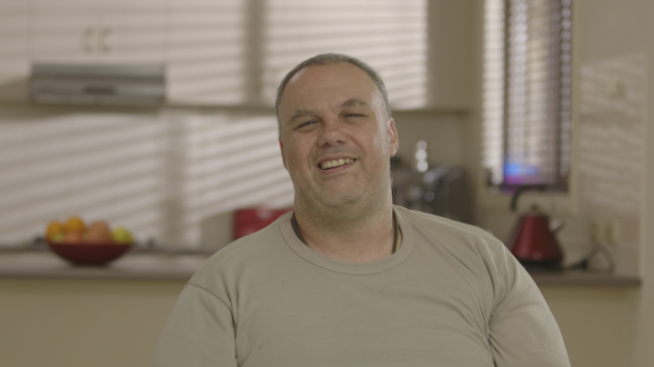

**Maggie: House Supervisor Tom**

 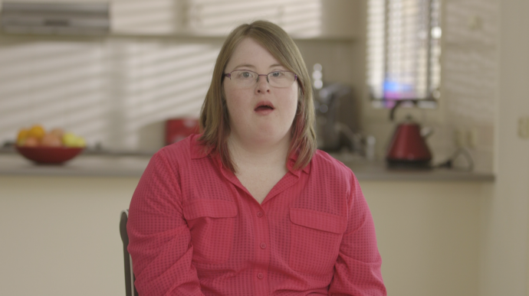

**Alex: Support worker Mylene**

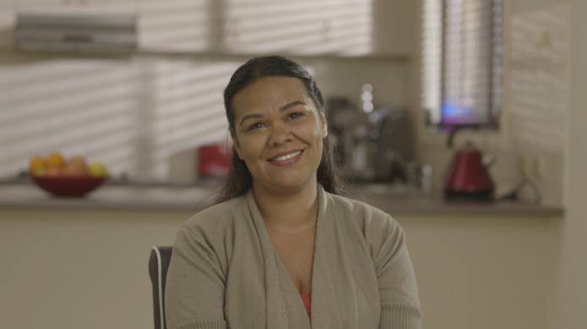 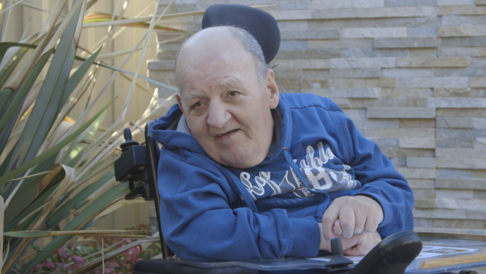

**Jo: Support Worker Kim**

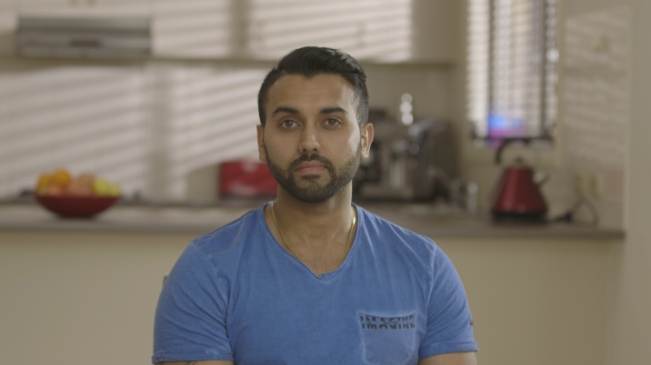 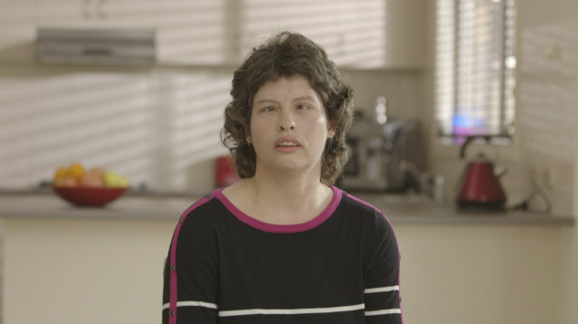

**Pradeep – Support Worker Kelly**

|  |  |
| --- | --- |
|  |  |

Module 1: Understanding Abuse

This module asks learners to see abuse and neglect as a violation of human rights. Learners are invited to commit to calling each other out on all instances of poor practice.

**In this scenario we see**

* Alex returning to work for training. The story is told from his point of view
* Mylene is disappointed because she didn’t get a job that she applied for
* Tom is distressed after being left alone in the sun. He is badly sunburnt
* Mylene is upset by a news story on the television about abuse in a group home where she used to live. The news story outlines how people with disability have historically experienced segregation, and lack of choice and control.
* Maggie reminds us that all people have human rights. Learners complete an activity
* Maggie explains that abuse can happen on purpose, by accident or because people didn’t know better.
* The team make a ‘zero tolerance commitment’ to call each other out on poor practice

**Key things to highlight**

* Human rights apply to all people. Abuse is a violation of human rights.
* The history of disability services provides helps us understand why abuse happens.
* Abuse can happen on purpose, by accident or because people didn’t know better.
* The impact of someone’s action is more important than the intent.
* Neglect can occur in all areas of a person’s life, not just physical.

**Resources and links:**

* United Nations [Convention on the Rights of Persons with Disabilities](http://www.un.org/disabilities/convention/conventionfull.shtml) (UNCRPD)
* NDS [Online Human Rights Training](https://www.carecareers.com.au/page/human-rights-course) for frontline workers and boards
* VALID [My Rights Training Program](http://www.valid.org.au/valid.htm)
* [Disability Rights](https://www.humanrights.gov.au/our-work/disability-rights) at the Australian Human Rights Commission website

Module 2: Power and Control

This module challenges support workers to recognise the power that they have, and the ways in which they have control over people they support in the course of their work.

**In this scenario we see**

* An animation about everyday experiences of power and disempowerment
* Alex exerting control over others without being aware that he was doing it, including:
  + imposing his own values on Mylene
  + making choices about what Mylene is allowed to eat
  + having low expectations of what Mylene is able to achieve
  + talking about Kim in a way that is disrespectful, disempowering and does not respect his privacy
* Alex taking time to reflect on his state of mind as he prepares to start a shift

**Key things to highlight**

* All people experience power and control in different ways in life
* Support workers have a lot of power in their role, even if they don’t realise it
* Support workers need to recognise ways they exert control over the people they support. What they do makes a difference; even the small things.
* Control can be overt and deliberate. Examples include patronising or mocking, intimidating, bullying or creating fear through words and actions.
* Control can also be less obvious, including not asking people their opinion or listening to them, ignoring a person’s choices and speaking for someone in public
* Staff need to think about their values and how they may affect the way they interact with others and provide support.
* Staff should think about their own emotions and how they might affect their work.
* H.A.L.T.S. (Hungry – Angry – Late – Tired – Sensitive) is a handy checklist to use before work each day (download workplace poster from the back of this guide)

**Resources and links**

* [Peer Connect](http://www.peerconnect.org.au/resources/peer-networks/): information on peer support networks across Australia
* *Supporting decision making* *guide* – [resources for people and staff](http://www.dhs.vic.gov.au/about-the-department/documents-and-resources/policies,-guidelines-and-legislation/supporting-decision-making-guide)
* *ADACAS* [*supporting decision making tools*](http://www.adacas.org.au/decision-support)

Module 3: Introducing the Empowerment Circle

This module introduces the Empowerment Circle, the eight life areas and the concepts of good, poor and abusive practice.

**In this scenario we see**

* The Empowerment Circle, with a person at the centre in a dark green circle
* Eight sections of the circle representing the areas of people’s lives: Physical; Emotional; Social; Identity; Material; Economic; Education; and Relationships.
* Three zones within the Circle:
  + **Green** for good or positive practice
  + **Orange** for poor or neglectful practice
  + **Red** for abusive or criminal practice
* Four human rights arrows reminding us that the closer we are to the middle, the more we are using and enjoying our rights
* A task where support workers identify scenarios as Green, Orange or Red

**Key things to highlight**

* All people have the same life areas with hopes, goals and ambitions
* The dark green circle is our target. It represents empowerment.
* The green area represents good or positive practice. Workers should always be operating in this zone. Even when people are working in this zone, they should be aiming for practice that gets them closer to the dark green centre.
* The orange area represents poor or neglectful practice. If workers are operating in this zone, they must take action. There is a blurred line between orange and green showing how easy it is to slip from one to another if we are not vigilant
* The red area represents abusive and criminal practice. There is a clear line between orange and red. This is because actions in this zone have significant consequences.
* You can find examples of Green, Orange and Red scenarios for each life area in the Learning Bites.

**Resources and links**

* A Good Life [resources](http://www.mychoicematters.org.au/resources/a-good-life/a-good-life) - My Choice Matters

Part 2: Learning Bites

The Learning Bites are short online video clips that can be accessed on any device with an internet connection. Each Learning Bite is accompanied by a downloadable worksheet to be completed and discussed in the context of your organisation’s policies, procedures and work practices. They include filmed scenarios highlighting poor practice or abuse, designed to generate personal reflection, conversation and action.

Each Learning Bite contains:

* a brief introduction to the life area with an animation
* people with disability and support workers reflecting on their own lives
* a scenario that demonstrates red or orange behaviour from support workers
* reflection questions for discussion
* an alternative scenario showing how the scene could have played out differently

The accompanying worksheets include:

* personal reflection exercises and questions about practice in the workplace
* a team discussion exercise
* checklists with examples of good practice, poor and neglectful practice and abusive or criminal practice
* space to add examples from your own workplace
* a commitment to take action

The Learning Bites can be used in a number of ways to suit your staff group, including:

* as a group, in a staff meeting or 30 minute training session
* as part of regular supervision
* targeted approach for staff requiring additional training in a specific area
* in response to specific needs of a person being supported

Each worksheet should be signed off by staff and you as their supervisor on completion.

Using the checklists

The checklists in the worksheets are intended to be used as a guide only. No list of examples can comprehensively cover every situation. Knowing a person, listening, observing and being responsive to their needs are the most effective safeguards.

The checklists contain four sections:

* **Green:** Includes examples of good practice. Good will look different for each person. Ask staff to consider this list in the context of the people they support and add their own examples.
* **Orange:** Examples range from practice that is not empowering to practice that is neglectful. Everything that is identified in this area requires attention and action.
* **Red:** Includes examples of abusive and criminal practice. Swift and appropriate action must be taken for anything identified in this column.
* **Signs and signals:** This includes signs and signals to be attentive to. Be mindful that no list is comprehensive, and that factors other than abuse or neglect may be responsible for these signs. Take appropriate action as required.

Appropriate actions will be determined according to your policies and procedures and in accordance with departmental incident reporting requirements. Make sure staff are aware of reporting or immediate response requirements for anything that is in the red zone, and set a clear expectation that they take action on anything in the orange zone.

Communication between staff in the form of file notes, incident reports, phone calls and staff meetings will also assist to identify when there are changes in mood or behaviour that may indicate that abuse is occurring. Avenues for action include:

* Speaking to supervisor and/or speak to another staff member
* Adding to staff meeting agenda for documented discussion and action
* Following your organisation’s complaints process, and taking action on ALL practice that is happening outside the green zone

**Ensure that the person is supported appropriately throughout this process**

IDENTITY: “Who I am and what I believe”

This is about supporting people to understand and express what it is that makes them who they are, and the things that are important to them. This includes their culture, religion, politics, sexuality and gender identity, sporting affiliations and personality traits. Supporting a person well in this area means getting to know them as an individual and supporting them to express what makes them unique with others

**In this scenario we see**

* Pradeep asks Tom to come to the table for dinner. Tom explains that it is still Lent, so he can’t eat meat or dairy. Pradeep says that Easter was last week but Tom explains that he means Greek Easter, which is still two weeks away.
* Pradeep tells Tom that no-one will know; Lent is over, and he doesn’t want to keep talking about it or messing around with food anymore.

**Key things to highlight**

* Pradeep should know that Tom is still in Lent. As someone who works with Tom regularly Pradeep should have an interest in and understanding of Tom’s culture and provide the right kind of support to Tom to express himself in this important life area
* Tom explains that he is in Lent and Pradeep still encourages him to eat meat
* Pradeep expresses annoyance that Tom is creating extra work for him

**Others things to discuss**

Ask staff to consider anything else that could be done better. Examples include:

* There is an expectation that everyone living in the house needs to eat the same thing at the same time
* Pradeep invited people to the table instead of Kelly, who prepared the meal

**How the scene could have played out (Scenario 2)**

* When Tom reminds Pradeep that Greek Easter is coming up, Pradeep suggests that Tom makes himself something else to eat.
* He talks to Tom about how he will celebrate and reminds him about making red eggs, as part of the celebration when Tom cooks Easter lunch for his family.

**Other scenarios for discussion**

* Kim is a Carlton supporter. His support worker follows Essendon, and only arranges trips to the footy when Essendon are playing
* Mylene joins a prayer group at her church. It is her turn to host the meeting but staff have told her it would be too disruptive to the house to have people over
* Kelly has expressed interest in having a girlfriend. Staff are told to change the subject if she brings it up

**Supporting staff**

Ensure staff can access and understand all relevant organisational policies, procedures, work practices and plans to support people to express their identity. Other areas to address might include:

* Exploring how values and expectations of support workers and family members may impact on people being able to express their identity and values
* Recognising tensions where family has strong opinions that run contrary to a person’s identity and views including threat of removal from service
* A commitment from leaders in the organisation about supporting each person as an individual, which is clearly communicated to staff, people with disability and families
* Education, training, awareness around culture, sexuality and gender identity
* Education and support for families and carers to support people with their identity
* Information and links to advocacy organisations including cultural support services
* Information about discrimination

**Think Diversity!**

* How might supporting someone to express their identity be different for someone from a non-English speaking background? Or an indigenous person? What about someone with complex communication needs?
* Is it different for men and women? Or someone who is gay, lesbian, bisexual or transgender? Explore these ideas with your staff.

**Useful resources and helpful links:**

* NDS Industry Development Fund – People, culture and communication project: <http://www.idfnsw.org.au/people-culture-and-communication-project>
* Intellectual disability and people from culturally and linguistically diverse backgrounds: [Resource Kit](http://communitydoor.org.au/service-delivery/disability/how-to-hear-me-a-resource-kit-for-working-with-people-with-intellectua-6)
* [Reachout.com](http://au.reachout.com/lgbtiq-support-services) – national LGBTIQ support services

EMOTIONAL: “How I feel”

This is about reflecting on your own emotions and the emotions of people you support. It means knowing the person and how they like to be supported when they are feeling good or bad.

**In this scenario we see**

Everyone is at the breakfast table. Alex is angrily serving pancakes. Jo arrives and remarks that it is late, and asks if everyone’s showered yet. Alex complains about Kim having made a mess in his bed. He tells Kim and Jo that it is disgusting. Jo remarks that this always happens on Alex’s shift. They laugh and leave the room together, leaving everyone who lives in the house sitting at the table in silence.

**Key things to highlight**

* Alex and Jo violate Kim’s (and others) privacy by discussing his personal care (including showering) in front of others
* Jo and Alex are focused on their own work tasks without regard for the feelings of the people involved
* Alex is visibly angry before Jo enters the room. His mood clearly impacts on the people at the table
* Alex belittles, humiliates and intimidates Kim
* Jo joins in laughing with Alex rather than calling him out on his poor behaviour

**Others things to discuss**

Ask staff to consider anything else that could be done better. Examples include:

* Alex is serving breakfast for people instead of people getting their own
* Jo talks to Alex instead of the people who live in the house

**How the scene could have played out (Scenario 2)**

* Alex asks Jo privately if she can assist him with Kim’s sheets
* They do not make a big deal or discuss it in front of others

**Other scenarios for discussion**

* Kelly experiences anxiety in large crowds and often requires PRN medication after going to the supermarket to do the weekly shopping. Staff accept this as normal.
* Tom is reluctant to leave a restaurant. When no one else is listening, staff swear at him and threaten to leave him there on his own
* Since she saw the news update about abuse in the house she lived in, Mylene has been talking a lot about what happened while she was there.
* When Kim is happy he makes loud, repetitive noises. Staff find it irritating so they discourage people from having too much fun with him

**Supporting staff**

Ensure staff can access and understand all relevant organisational policies, procedures, work practices and plans to respond to the emotions of people they support. Other areas to address might include:

* knowing what support can staff provide and who else in the person’s life could help
* what professional supports may be required and how staff can facilitate access
* how staff can empower the person to express and manage their emotions
* supporting people to communicate with important people in their life
* following positive behaviour support plans consistently
* supporting people to use any personalised communication aids to express feelings
* recognising that even friendly jokes and gentle teasing can be hurtful to some people who might not understand
* being clear that any intimidating or bullying actions or language will not be tolerated
* guidelines on appropriate communication with people they support and other staff
* making a list of communication that is not acceptable and a commitment to call each other out when people speak in a way that may be hurtful or inappropriate. Involve the people you support so that everyone is accountable.

Think Diversity!

* How might supporting someone to express their identity be different for someone from a non-English speaking background? Or an indigenous person? What about someone with complex communication needs?
* Is it different for men and women? Or someone who is gay, lesbian, bisexual or transgender? Explore these ideas with your staff.

Useful resources and helpful links

* BeyondBlue: <https://www.beyondblue.org.au/>
* Communication aids: <http://www.scopevic.org.au/communication-aids/>

PHYSICAL: “My body, my health”

This is about people’s physical health and safety. It is about understanding and respecting personal space. It is about providing the right support and information for each person to make choices about how to maintain their health in a way that works for them. It is about knowing what signs to look out for and take action on to make sure people feel safe and are safe from harm.

**In this scenario we see:**

Tom is in his room. Pradeep and Jo tell him that the bus is waiting and they are ready to go to the movies. Tom is lying on his bed with the doona draped over him. Pradeep enters and tells him to hurry up. Tom says he doesn’t want to go, and Pradeep tells him he is selfish. Pradeep pulls the doona off Tom, grabs him by the upper arm and drags him up and out of the room.

**Key things to highlight:**

* Pradeep grabs Tom and moves him forcefully and without his consent

**Others things to discuss**

Ask staff to consider anything else that could be done better. Examples include:

* Pradeep and Jo do not let Tom know it’s time to leave until the last minute
* Pradeep does not listen when Tom says he doesn’t want to go to the movie
* Pradeep enters Tom’s room without permission
* Pradeep removes Tom’s doona without permission

Ask them what they would do in this situation, and what options they have if someone chooses not to do something or go somewhere.

**How the scene could have played out (Scenario 2)**

* Jo discusses the movies with everyone the night before
* Jo speaks to Tom an hour earlier than they need to leave, gives him time to think about it, and offers support if required
* Maggie reminds the learner that this behaviour is never OK, even if it means missing out on going to the movies

**Other scenarios for discussion**

* Kim is pale and seems distressed. You are not sure what to do about it. Your shift is about to finish, so you send him to his day service and don’t say anything to his support staff there
* Tom keeps standing up while everyone is eating dinner. He won’t sit down even though you ask him repeatedly, so you push him down into his chair
* The hoist is kept in the storeroom, and you’re in a rush. It’s easier to lift Kim and not worry about his manual handling plan. You’ve done it lots of times before and it’s fine

**Supporting staff:**

Ensure staff can access and understand all relevant organisational policies, procedures, work practices and plans to support people respectfully, safely and healthily. Other areas to address might include:

**Consistent use of personal plans**

People may have a number of plans in place to support their health or mobility. These should be reviewed regularly and consistently followed by all staff, including

* Manual handling plan
* Epilepsy, asthma or diabetes plans
* Meal assistance plans and nutritional advice from a doctor or specialist

**Training and resources**

* Training about positive behaviour support and use of restrictive practices
* Training in medication administration, manual handling, and other specialised areas as needed (e.g. PEG feeding)

Think Diversity!

* How might supporting someone to express their identity be different for someone from a non-English speaking background? Or an indigenous person? What about someone with complex communication needs?
* Is it different for men and women? Or someone who is gay, lesbian, bisexual or transgender? Explore these ideas with your staff.

Useful resources and helpful links:

* Treat Me Right: Better Healthcare for People with Learning Disability ([UK resources](http://cddh.monash.org/assets/treat-me-right.pdf))
* Health and people with disability – NSW Department of Health [resources](http://yourhealthlink.health.nsw.gov.au/resource_type/carers-people-with-a-disability/)

RELATIONSHIPS: “The people in my life”

This is about supporting people in their relationships with others. This could be family, friends, or partners. It could be someone the person has known for a long time or someone they would like to know better. It is also about their relationship with support staff. It’s about people having control over who is in their life, how often they spend time together. It’s about supporting people to figure out what sorts of relationships they want, and to have the right information and support to stay safe in those relationships.

**In this scenario we see:**

Mylene and Jo are in Mylene’s room talking. Mylene shows Jo a photo of her boyfriend, Ryan, and tells Jo it is their anniversary. Mylene says that she would like Ryan to come and stay over. Jo explains that Mylene’s parents don’t want their relationship to get too serious, and that she doesn’t want to risk another run-in with Mylene’s mum. She suggests that Mylene have coffee with Ryan instead.

**Key things to highlight:**

* Jo automatically defers to the wishes of Mylene’s mother instead of Mylene
* Jo prioritises her own comfort over Mylene’s right to have a relationship
* Jo’s suggestion of having coffee with her boyfriend shows she thinks Mylene’s needs and desires are different from her own

**Others things to discuss**

* Ask staff to consider anything else they notice in the scenario that could be done better. Ask what they would do in this situation, and what else they would need to consider when supporting someone with relationships.

**How the scene could have played out (Scenario 2)**

* Jo listens to Mylene and tells her that she is an adult and it is her decision.
* Mylene tell us that Jo has helped her to speak to her mum about Ryan staying over, and helped her to go to the doctor for information and support

**Other scenarios for discussion**

* Kelly has told staff that she feels uncomfortable about one of the casual staff. She said that he came into her bedroom and watched her while she was getting dressed
* Kelly and Kim attend the same day service and often spend the whole day together
* Tom often expresses interest in buying pornographic magazines in the newsagency. Staff have told him he is not allowed to buy them.
* Kim has a regular video date with his girlfriend but it doesn’t happen when casual staff are working.

What might staff need to support people in this area?

Ensure staff can access and understand all relevant organisational policies, procedures, work practices and plans to support people in their relationships. Other areas include:

* Exploring how the values of support workers and family members may impact on people being able to express themselves in this area
* Guidance where families of people they support have strong (and/or contrary) opinions about the people you support
* Clear message from organisation management about the commitment to support each person as an individual in their relationships with others
* Education, training, awareness around sexuality and safe relationships
* Education and support for families and carers to recognise and support romantic and sexual relationships

Think Diversity!

* How might supporting someone to express their identity be different for someone from a non-English speaking background? Or an indigenous person? What about someone with complex communication needs?
* Is it different for men and women? Or someone who is gay, lesbian, bisexual or transgender? Explore these ideas with your staff.

Useful resources and helpful links:

* [Peer Connect](http://www.peerconnect.org.au/resources/peer-networks/): information on peer support networks across Australia
* Victorian State Government [Better health channel: Disability and Sexuality](https://www.betterhealth.vic.gov.au/health/conditionsandtreatments/intellectual-disability-and-sexuality)
* Living Safer Sexual Lives: <https://www.deakin.edu.au/health-social-development/disability-and-inclusion/lssl>

MATERIAL: “My house and my things”

This is about supporting people to feel ownership over their home and their things. It’s about people having a say about where they want to live and who they live with. It’s about respect for privacy and possessions. It’s about people being able to use their own things when they want to, and choose who to share things with.

**In this scenario we see:**

Kelly comes home and Jo is tidying up the lounge room. Jo has opened a package which arrived for Kelly. It was a new jumper from her sister. Jo tells Kelly she put the new jumper in her cupboard, and threw out her old one. Kelly takes the opened card from the empty box on the table and looks at it. She appears sad but thanks Jo anyway.

**Key things to highlight:**

* Jo has opened Kelly’s mail
* Jo has gone into Kelly’s room without permission
* Jo has thrown out one of Kelly’s jumpers without asking

**Other things to talk about:**

Ask staff to consider anything else that could be done better. Examples include:

* Jo does not stop tidying to talk to Kelly when she arrives home
* Jo is treating the house like her workplace rather than Kelly’s house
* Jo has prevented Kelly from making choices for herself
* Kelly feels like she needs to say “thank you” to Jo even though she is unhappy

**How the scene could have played out (Scenario 2)**

* Kelly comes home and there is a package waiting for her to open
* She opens it and is excited to find a jumper from her sister
* Jo gives Kelly privacy to open the package then comes over when Kelly tells her what it is. She shows genuine interest and excitement for Kelly.

**Other scenarios for discussion**

* Tom has been told by the doctor that he needs to lose weight. He likes to snack at night-time, so staff lock the cupboards and fridge after dinner
* Someone has been using Kelly’s iPad while she is out during the day. There is a now a crack in the screen and Kelly doesn’t know how it got there.
* Staff keep walking into Kim’s room without waiting because he can’t answer verbally.
* Mylene got a DVD box set for her birthday. A staff member took it home to watch thinking that Mylene wouldn’t notice.

What might staff need to support people in this area?

Ensure staff can access and understand all relevant organisational policies, procedures, work practices and plans regarding people’s property and privacy. Other areas include:

* Clear statement about supporting people in their own homes, and the need to prioritise the needs of the person over the needs of staff
* Clearly communicated expectations about respect for privacy and possessions
* Understanding that people have the right to choose who they do and do not like being around
* Understanding of their responsibilities in regard to restrictive practices (in relation to locking of doors and removal of possessions)

Think Diversity!

* How might supporting someone to express their identity be different for someone from a non-English speaking background? Or an indigenous person? What about someone with complex communication needs?
* Is it different for men and women? Or someone who is gay, lesbian, bisexual or transgender? Explore these ideas with your staff.

ECONOMIC: “My money, my job”

This is about providing support to people to understand, manage and spend their own money. This includes everyday budgeting and spending, involvement in decisions about major purchases, and saving. It is also about working and earning a wage, or getting money from other sources. Providing support in this area will look different for every person.

**In this scenario we see**

Kim, Mylene, Pradeep and Alex are meeting at a café. Pradeep and Alex haven’t seen each other for a while, and are pleased to catch up. Alex has forgotten his wallet. Pradeep tells him not to worry as he has Kim’s money. Kim points at a drink on his communication aid and Alex deliberately misinterprets him as offering to buy him a drink. Pradeep orders three drinks, to be paid for with Kim’s money.

**Key things to highlight**

* Kim does not have control of his own money. He never sees or touches it
* Pradeep treats Kim’s money as his own
* Kim does not order his drink or have any interaction with staff at the café
* Kim never sees or touches his money

**Other things to talk about**

Ask staff to consider anything else that could be done better. Examples include:

* Alex and Pradeep are catching up as though Kim and Mylene are not there
* Kim is excluded from the conversation except for Alex’s misinterpretation
* Mylene is excluded from the conversation entirely

**How the scene could have played out (Scenario 2)**

* Alex supports Kim to use his communication aid to choose what he would like to drink, then to take money from his wallet and use the correct communication aid
* He encourages Kim to call over the waitress, then stays out of the conversation while Kim orders and pays for his own drink
* Everyone is involved in the conversation

**Other scenarios**

* Kelly once spent all her money on magazines and did not have any left over for her regular weekly activities. Ever since staff give her program money to day service staff
* Kim does a weekly letterbox drop with Jo. If Jo is on leave, the other staff call up and cancel the letterbox drop for the period that she is away.
* Staff took Mylene to the bank to get a debit card. A staff member later used the card to withdraw $600 for herself to pay her rent. She planned to pay it back

What might staff need to support people in this area?

Ensure staff can access and understand all relevant organisational policies, procedures, work practices and plans regarding people being in control of their own money. Other areas include:

* Staff understand that financial processes should be used in a way that includes and makes sense to each person and maximises their financial independence
* Encourage staff to share ideas about creative ways to support people to manage their money with the maximum level of independence
* Provide examples of communication aids and picture-based budgeting systems
* Use person-centred active support rather than doing everything for someone
* Think about community inclusion and how supporting people with their money can lead to more interactions with people in the community

Think Diversity!

* How might supporting someone to express their identity be different for someone from a non-English speaking background? Or an indigenous person? What about someone with complex communication needs?
* Is it different for men and women? Or someone who is gay, lesbian, bisexual or transgender? Explore these ideas with your staff.

Resources and links

* Managing a Personal Budget [resources](http://www.mychoicematters.org.au/resources/planning-and-goals/managing-a-personal-budget): My Choice Matters
* Ticket to Work: [www.tickettowork.org.au](http://www.tickettowork.org.au)
* Australian Government Disability Employment Services: <https://employment.gov.au>
* Communication aids: <http://www.scopevic.org.au/communication-aids/>

SOCIAL: “My life in my community”

This is about supporting people to be part of a community in a way that is meaningful to them. It’s about fostering connections with other people with shared interests. It’s about providing support for people to connect with new people and old friends where they feel like they belong. It’s about being a citizen. It’s about making a contribution and being valued. Shared interests may include work, sport, music, politics, work, spirituality.

**In this scenario we see:**

Alex explains it has been a hectic morning, so he hasn’t got time to take Kim to his bird-watching group. Alex puts on a bird-watching DVD instead, and says he’ll be in the office. Kim appears distressed. Alex tells him when everyone else gets back at lunchtime they can all go to the park and watch seagulls.

**Key things to highlight**

* Kim was denied the opportunity to be part of his birdwatching community
* Everyone else in the house went out except for Kim
* As a treat, Kim will get to go to the park with his housemates

**Other things to talk about**

Ask staff to consider anything else that could be done better. Examples include:

* Alex is in Kim’s home but working in the office
* Alex does not acknowledge or support Kim’s feelings

**How the scene could have played out (Scenario 2)**

* Kim is at his bird watching group with Sandy, another member of the group. She supports him to use binoculars, mark off what he sees on his chart and take photos.
* Alex comes to pick Kim up and they talk about going out for lunch with the group the following week. Alex tells Kim he will help him load the photos they have taken onto the online bird watching forum when they get home.

**Other scenarios**

* Tom met a family friend who invited him to come along to the Greek Club on Tuesday nights. Staff thanked the friend but have not supported Tom to follow up
* Kim has an ‘All About Me’ book that he likes to take with him when he meets new people. It is kept in his bag, but has not been taken out for over a year
* The house has a rule that people contact their families on Saturdays, and no one is allowed to use the phone or internet on any other day
* One of the staff invited everyone to her birthday party. The venue was not wheelchair accessible so Kim stayed home.

**What might staff need to support people in this area?**

Ensure staff can access and understand all relevant organisational policies, procedures, work practices and plans regarding people being in control of their own money. Other areas include:

* Demonstrating ways that staff can facilitate a person’s interests and connection with others in the community by:
  + having lots of conversations with the person, alone and in a group
  + showing interest in things the person is interested in
  + encouraging the person to ask questions, not just answer them
  + supporting the person to feel confident and prepared to talk to others
  + linking people to groups and things that interest them
  + supporting people to try new things
  + being clear it’s OK for people to change their mind or not like something
* Ensure staff use communication aids that facilitate conversation with others including community request cards, personal communication dictionaries and social stories

Think Diversity!

* How might supporting someone to express their identity be different for someone from a non-English speaking background? Or an indigenous person? What about someone with complex communication needs?
* Is it different for men and women? Or someone who is gay, lesbian, bisexual or transgender? Explore these ideas with your staff.

Resources and links

* NDS Community Inclusion Initiative [fact sheets](https://www.nds.org.au/resources/all-resources/community-inclusion-initiative-factsheets) for service providers
* *Trying New Things* [resources](http://www.mychoicematters.org.au/resources/your-community/trying-new-things): My Choice Matters (NSW)
* ‘Supporting Inclusion’ [online learning program](http://supportinginclusion.weebly.com/): La Trobe University and UNSW
* Scope Communication Access [site and resources](http://www.scopevic.org.au/service/communication-access/)

EDUCATION: “Things I have learned or want to learn”

This is about providing support and information for people to learn new skills or knowledge. It might be about doing a course or going to TAFE or university. It might be about learning a new skill to be more independent. It could be learning for fun and to meet people. It’s about recognizing the importance of learning new things all through life and supporting people to be able to keep learning and growing if they want to.

**In this scenario we see**

Jo is cooking dinner at the stove while Tom stands on the other side of the bench. Tom asks Jo what she just put in the sauce, and asks if he can help. Jo tells him that she can’t make lasagne and watch him at the same time. Tom tells Jo that Pradeep lets him cook, and Jo tells Tom he can put his own cheese on at the table. Tom turns away, clearly upset.

**Key things to highlight**

* Jo does not support Tom’s clearly expressed interest in learning
* Jo appears to believe that Tom putting cheese on his meal is a reasonable alternative to cooking dinner

**Other things to talk about**

Ask staff to consider anything else that could be done better. Examples include:

* Jo is cooking dinner alone with no involvement from anyone who lives in the house
* There appears to be an unspoken rule that Tom can’t go into the kitchen while staff are cooking, or without permission. It is his kitchen and his house.
* Meal preparation is prioritised over active support.
* The inconsistent approach between staff to support people with meal preparation

**How the scene could have played out (Scenario 2)**

Jo remembers that it is Tom’s night to cook and apologises. She says that Pradeep told her about a delicious pasta sauce that Tom cooked. Tom gets the lasagne sheets from the cupboard. Jo tells Tom that she saw a cooking course advertised at the local TAFE, and asks him if he’s interested. He says yes, and they discuss what he would like to cook for an upcoming visit from his family.

**Other scenarios**

* Kim shows interest in using an iPad. A couple of staff try to help him but he has not shown much progress, so they decide it is too hard for him
* Mylene wants to catch the train to her new job. The office is on the way to Kim’s day service, so it is easier to drop her off each morning.
* Kelly has told everyone that she hates going to her day service, and often becomes tearful when she has to go. She has gone there for ten years. No effort has been made to identify or follow up alternatives
* Tom brings home a flyer for a self-advocacy course. Staff throw it in the bin

**What might staff need to support people in this area?**

Ensure staff can access and understand all relevant organisational policies, procedures, work practices and plans regarding access to information and opportunities to access education. Other areas include having an expectation that staff will:

* support people to learn new skills
* support people to access information and pursue learning opportunities
* recognise and act on boredom in a person they support
* support people to try new things that they are interested in or are good at
* ensure that life goals in plans are documented and outcomes measured

Providing opportunities for **training in** person centredactive support, task analysis and person-centred planning will also strengthen approaches.

Think Diversity!

* How might supporting someone to express their identity be different for someone from a non-English speaking background? Or an indigenous person? What about someone with complex communication needs?
* Is it different for men and women? Or someone who is gay, lesbian, bisexual or transgender? Explore these ideas with your staff.

Resources and links:

* *Every Moment has Potential* [resource](http://www.activesupportresource.net.au/): La Trobe University
* Person-Centred Planning resources: [www.helensandersonassociates.co.uk](http://www.helensandersonassociates.co.uk)
* *Trying New Things* [resources](http://www.mychoicematters.org.au/resources/your-community/trying-new-things): My Choice Matters (NSW)
* *My Learning Matters* [online tool](http://www.mychoicematters.org.au/resources/online-learning/my-learning-matters): My Choice Matters (NSW)

Technical information

#### Viewing Content

##### Content Format

|  |  |
| --- | --- |
| **Flash** | [Adobe Flash Player](http://www.adobe.com/go/getflash) 10.3 or later, and one of the following browsers:   * Windows: Internet Explorer 8 and later, Microsoft Edge (latest version), Google Chrome (latest version), Firefox (latest version) * Mac: Safari 7 and later, Google Chrome (latest version) |
| **HTML5** | * Windows: Google Chrome (latest version) * Mac: Safari 7 and later, Google Chrome (latest version) * Mobile: Safari in Apple iOS 7 and later, Google Chrome (latest version) in Android OS 4.1 and later |
| **Apple iOS** | [Articulate Mobile Player](http://itunes.apple.com/us/app/articulate-mobile-player/id505546381) in Apple iOS 7 or later on iPad |
| **Android OS** | [Articulate Mobile Player](https://play.google.com/store/apps/details?id=air.com.articulate.articulatemobileplayer) in Android OS 4.1 or later (optimized for tablets) |

##### Accessibility

|  |  |
| --- | --- |
| **Screen Reader** | [JAWS](http://www.freedomscientific.com/Products/Blindness/JAWS) 16 or later with Internet Explorer 11 or later (Flash output only) |
| **Section 508 Accessibility** | [Complies with applicable requirements](http://en-au.articulate.com/products/storyline-section-508.php) |
| **WCAG 2.0 Accessibility** | [Complies with applicable requirements](https://en-au.articulate.com/products/storyline-wcag.php) |

Further information, resources and support

**National Disability Services resources**

* Zero Tolerance webpage: <https://www.nds.org.au/resources/zero-tolerance>
  + Zero Tolerance Framework
  + ‘*Speaking Up About Safety*’ reports
  + Zero Tolerance Practice Advice series
* NDS Community Inclusion Initiative: <https://www.nds.org.au/resources/community-inclusion-initiative-factsheets>
* NDS Industry Development Fund: <http://www.idfnsw.org.au/person-centred-approaches-program>

**Other resources**

* ‘Supporting Inclusion’ [online learning program](http://supportinginclusion.weebly.com/): La Trobe University and UNSW
* *Every Moment has Potential* [resource](http://www.activesupportresource.net.au/): La Trobe University (active support)
* SCOPE Communication and Inclusion Resource Centre: [site and resources](http://www.scopevic.org.au/service/communication-access/)
* National Disability Abuse and Neglect Hotline: <http://www.disabilityhotline.net.au/>
* Queensland Government: Preventing and responding to abuse, neglect and exploitation: <https://www.communities.qld.gov.au/disability/support-and-services/for-service-providers/preventing-and-responding-to-abuse-neglect-and-exploitation>
* Social Care Institute for Excellence: Protecting adults at risk: Good practice guide:<http://www.scie.org.uk/publications/adultsafeguardinglondon/files/sections/recognition-and-indicators-of-adult-abuse.pdf>

**Contacts**

* National Disability Abuse and Neglect Hotline: 1800 880 052 <http://www.disabilityhotline.net.au/>
* Disability Services Commissioner: 1800 677 342. <http://www.odsc.vic.gov.au/>
* Office of the Public Advocate: 03 9603 9500. <http://www.publicadvocate.vic.gov.au/>
* Sexual Assault Crisis Line: 1800 806 292. <http://www.sacl.com.au/>
* VALID (Victorian Advocacy League for Individuals with a Disability): 03 9416 4003. <http://www.valid.org.au/valid.htm>
* My Choice Matters: [www.mychoicematters.org.au](http://www.mychoicematters.org.au)
* NSW Council for Intellectual Disability: [www.nswcid.org.au](http://www.nswcid.org.au)

Checklist for completion of Learning

Use this checklist to keep track of which Modules and Learning Bites have been completed successfully. Do not sign off on any section until you are satisfied that the learner is effectively implementing the learning in their work. If you are unsure, provide them with extra case studies from the guide or real-life examples from your workplace.

**Name: _________________________ Supervisor name: ______________________**

|  |  |  |  |
| --- | --- | --- | --- |
| **Topic** | **Downloadable worksheet** | **Contribution to group discussion** | **Conversation with person you support** |
| **Part 1: Understanding Abuse eLearning** | |  |  |
| Module 1: Understanding Abuse |  |  |  |
| Module 2: Power and Control |  |  |  |
| Module 3: the Empowerment Circle |  |  |  |

|  |  |  |  |
| --- | --- | --- | --- |
| **Part 2: Learning Bites** | |  |  |
| Learning Bite 1: Identity: Who I am and what I believe |  |  |  |
| Learning Bite 2: Emotional: How I feel |  |  |  |
| Learning Bite 3: Physical: My body, my health |  |  |  |
| Learning Bite 4: Relationships: The people in my life |  |  |  |
| Learning Bite 5: Material: My house and my things |  |  |  |
| Learning Bite 6: Financial: My money and my job |  |  |  |
| Learning Bite 7: Social: My life in my community |  |  |  |
| Learning Bite 8: Education: What I have learned/want to learn |  |  |  |

 **Staff signature and date: Supervisor signature and date:**