Purpose at Work
National Disability Services

Right on Board: Governing and Managing for Human Rights, Quality and Safeguarding
A Capacity Building Program for Disability Service Providers

Purpose at Work, in partnership with National Disability Services, presents Right on Board: a capacity building program for Boards and Executive Teams of disability service providers on human rights, quality and safeguarding.
Right on Board answers the need as highlighted by the Disability Royal Commission for greater awareness of the United Nations Convention on the Rights of Persons with Disabilities, as well as the strengthened governance and management of quality and safeguarding.
Get Right on Board
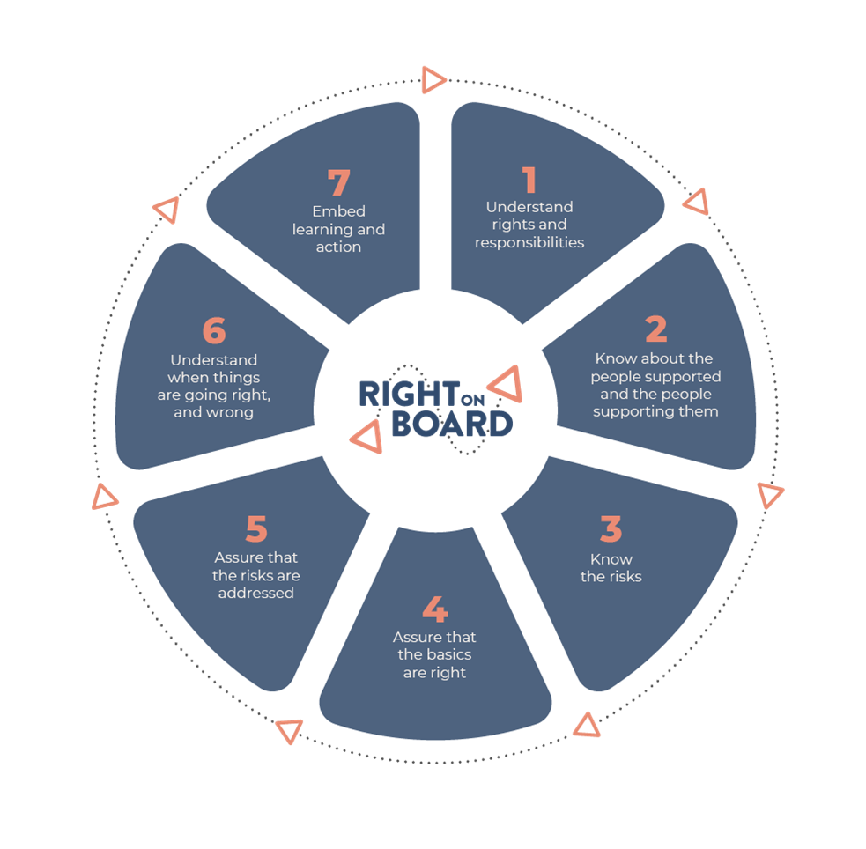
Your Board and Executive Team will gain a deeper understanding of:
the human rights approach and the legislative context, including key provisions of the UN Convention that affect service design and delivery;
the key concepts around quality and safeguarding impacting the entire sector, as well as the key challenges for your own organisation;
the potential areas for strengthening your risk management practice;
the adequacy of your current governance and management arrangements for human rights, quality and safeguarding.
As a result, your organisation will have a better understanding of the standards that people using disability services should expect and will be better prepared for responding to the Royal Commission and its likely recommendations.

The Right on Board program
Purpose at Work offers Right on Board in two formats.
Option A: In-house workshop. This includes:
- an intake interview with the CEO or delegate
- delivery of the workshop, and
- a comprehensive workbook for each participant.
NDS members: $5100 + GST all inclusive; non-members: $7650 + GST all inclusive.
The workshop can be delivered in-person or online. If delivered in person, there are no additional costs for travel. If delivered online, it is usually delivered with two presenters plus technical support, to ensure the best possible experience for participants.

Option B: The Full Program. This includes:
- Interviews with key informants: the CEO, the COO, the Executive responsible for quality, and the Chair of the Board’s Quality & Safeguarding Committee (however these roles are titled in your organisation)
- Desktop review of say 20 to 30 key organisational documents, from the perspective of human rights, quality and safeguarding
- A written report from the interviews and desktop review on what the organisation does well, with recommendations on what might be improved
- Delivery of the workshop, tailored to the unique circumstances of your organisation,
- A comprehensive workbook
- Post-workshop implementation assistance (of up to half a day).
NDS members: $14,000 + GST + expenses; non-members: $17,500 + GST + expenses.
The workshop can be delivered in-person or online. If delivered online, it is usually delivered with two presenters plus technical support, to ensure the best possible experience for participants.
Supplementary services are available on request and will be quoted for separately, e.g. developing policies, risk appetite statements, and Key Performance Indicators; consulting on implementation; or observing a meeting of the Quality and Safeguarding Sub-Committee of the Board.

Our consultants
Alan Hough, PhD, FGIA, MAICD, combines expertise in governance with extensive practical knowledge of quality and safeguarding in disability service provision. He has presented at the NDS Victoria and Queensland Boards Summits. Together with Professor Christine Bigby, Alan is co-editor of Disability in Practice: Safeguarding Quality Service Delivery to be published by Palgrave in 2023.
Gilbert Kruidenier, MSc Organisational Culture and Change, has wide-ranging consulting experience and has been engaged with NDS in the ACT and Victoria, on topics such as strategy, change, workforce and governance. Gilbert has been a speaker at the NDS Victoria State Conference and is the author of the NDS interactive resource Fundamentals for Boards.
Alex Carbonetti has twenty years' experience in the disability sector. She consults with disability service providers to develop quality systems and contemporary, person-centred practice to meet the requirements of the Practice Standards. Alex has been a quality auditor for eight years and conducts quality audits across a number of standards including the NDIS Practice Standards.

Terms
The workbook is supplied in electronic format, for copying and distribution by the client. If you prefer, we can arrange photocopying and collation at cost.

Questions?
Contact us to secure your booking by emailing Alan Hough alan@purposeatwork.com.au or phone 0407 132 848.

