 | 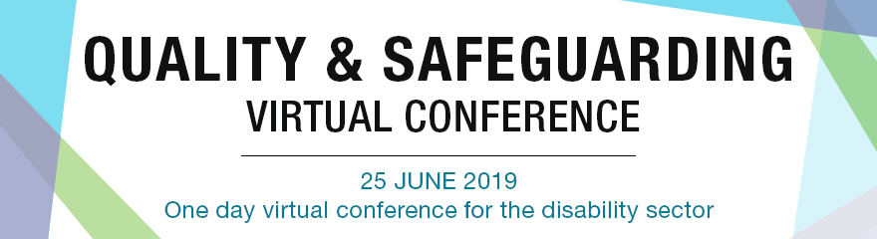
Time | Description | Speaker/s
9.00 AM | Welcome to Country | Aunty Norma
9.10 AM | Welcome from the Acting CEO | David Moody (CEO, NDS)
9.20 | Making the most of your virtual conference experience | NDS/NDP Team

Morning Keynote Sessions
9:30 AM | Panel - What lessons can we learn from the Aged Care Royal Commission | Emma Turner (Russell Kennedy),  Pat Sparrow  (ACSA),  John Carrigan and Annette Glenister (NDS)
 | The Australian Government has called a Royal Commission into Violence, Abuse, Neglect and Exploitation of People with Disability. This is going to frame the discussion and delivery of disability services for the next five years. Hear from a panel of expert speakers about the experience of other sectors of a Royal Commission and about what disability service providers need to do to prepare.
10:30 AM | Psychology and the Neuroscience of 'Mental Fitness' | Kate McKenna (Next Evolution Performance)
 | Our belief is that everyone can be a high performer with the right tools and focus. Building resilience, or ‘mental fitness’, is a major topic in the world today and is essential for the continually changing market and the world all businesses and industries face. This has never been more prevalent than in your industry today.
Morning Concurrent Sessions
11.30 AM | The NDIS Practice Standard Audit process:  The Certification Audit Experience: A providers perspective | Catherine Kearney  (Sunnyfield)
 | This session is an interview with a provider that has recently completed stage 1 and 2 of their Certification audit against the NDIS Practice Standards Core Module and associated Supplementary Modules. The interview delves into the experience and provides tips for providers yet to commence the recertification audit.
11:30 AM | NDIS Quality and Safeguarding Basics:  So you’ve got your Certificate of Registration: What Next? | John Carrigan (NDS)
 | Transitioning into jurisdiction of the NDIS Commission on 1 July and wondering what that involves? This presentation will answer your questions.
12:30 PM | The NDIS Practice Standard Audit process:  The Certification Audit Experience: An auditors perspective | Sharon Floyd  (Engels Floyd Associates)
 | This presentation shares learnings and practical tips from EFA's support to NDIS providers, and importantly training of all NDIS quality auditors. It demystifies some of the complexities/ambiguities about the key stages in the NDIS audit and registration process. It also shares some insights into trends into non-conformances arising during the audit process.
12:30 AM | Safeguarding: Lessons on Rebuilding. | Adrian Marshall and Luana Atger (Lifestyle Solutions)
 | Join us as we explain the exciting positive changes underway at Lifestyle Solutions, to reshape our organisation and keep people safe.
1:30 PM | The NDIS Practice Standards and Framework:  Tools and resources to support the sector | Jenny Klause and Edwina Pickering  (NDS)
 | This session introduces three new companion resources released by NDS this month. These guides will assist leadership teams to examine and determine their required processes and practices for operating in the NDIS quality and safeguards environment.
1:30 PM | Quality and Safeguarding in context:  Delivering Quality Services in a Rural Context | Fiona Phips (Royal Far West)
 | How one organisation attempts to stay true to the principles of Best Practice and Evidence based theory through the delivery of therapy via technology.
Afternoon Keynote Session
2:30 PM | Creating Positive Cultures – NDS Zero Tolerance Initiative | Dave Relf and Liz Collier (NDS)
 | The NDS Zero Tolerance initiative assists disability service providers to understand, implement and improve practices which safeguard the rights of people they support. As part of this initiative, NDS has recently launched a new series of Positive Cultures films to encourage conversations within organisations about creating cultures where every person feels valued, listened to and safe to speak up.
Afternoon Concurrent Sessions
3:30 PM | Worker Screening - implications for HR managers | Karen Stace (NDS)
 | This session will cover the important elements involved in implementing NDIS Worker Screening Checks in your organisation. Drawing on the information available in the NDIS Worker Screening Check Rules, the Intergovernmental Agreement and how we think the state and territory based processes might look, we will identify the steps that organisations should be taking to prepare for the implementation of worker screening checks and the implications for your recruiting and induction processes.
3:30 PM | Quality and Safeguarding in context:  Restrictive Practice and Behaviour Support | Peter Conway and Angela Koelink  (FACS NSW)
 | Restrictive practices take away a person with disabilities’ rights or freedom. This session presented by NSW Family and Community Services explains there are rules for NDIS providers when implementing restrictive practices such as seclusion, chemical restraint, mechanical restraint, physical restraint and environmental restraint.

Evening Concurrent Sessions
4:30 PM | Quality and Safeguards for Small Business | Chantelle Robards (The Business Centre)
 | This presentation will cover the basics of the new NDIS registration process and provide some tips for how to navigate it. You will learn about important timelines, compliance pathways and how to develop confidence in completing the process.
4:30 PM | Quality and Safeguarding for leaders: Is your current risk management strategy adequate. | Mark Saunderson and Diana Borgmeyer (Gallagher)
 | This session will provide insights on the challenges, options and the program of change required to enable organisations to develop and implement fit for purpose risk and governance frameworks that support Boards and Executives manage their strategic and operational risks. This includes managing inherent sector complexities such as; balancing duty of care and safety obligations with the right of participants to choice and dignity of risk. The session will also provide learnings from the Aged Care Royal Commission and implications for the design and operation of risk management frameworks from the disability sector royal commission.
Evening Keynote Session
5.30PM | Quality and Safeguarding for Leaders:  Quality and Safeguarding for Boards and CEO’s | Dr Alan Hough  (Purpose at Work)
 | In this presentation, Alan uses case studies and regulator reports to identify the major threats to the safety of people with disability when receiving services. After considering how organisations can respond to the challenge of providing quality and safe supports, the role of boards of directors in promoting quality and safeguarding is examined. Finally, the presentation considers the responsibilities of directors as “key personnel” under the NDIS Act, and the governance requirements of the NDIS Practice Standards.
6.30PM | NDS Team Thank you | NDS/NDP Team
Thank you for joining us for another NDS virtual conference!
Audience: All

