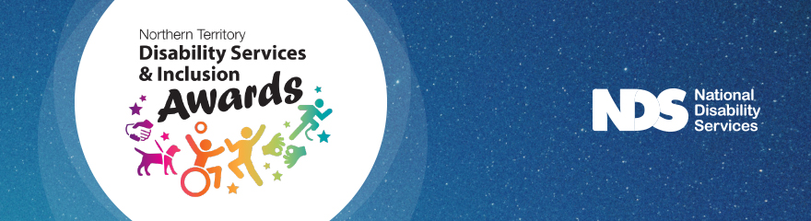

Terms and Conditions

Northern Territory Disability Services and Inclusion Awards 2021 People’s Choice Awards

The Competition
- The Northern Territory Government, in collaboration with National Disability Services, proudly present the 2021 Northern Territory Disability Services and Inclusion Awards (the Awards).
- The Awards recognise exceptional individuals, businesses, organisations, government departments and programs working in the disability sector that demonstrate outstanding commitment to improving the lives of people with disability.
Definitions
- The Northern Territory (NT) Disability Services and Inclusion Awards 2021 ‘People’s Choice’ Award competition is conducted by National Disability Services (NDS), ABN 52 008 445 485, 33 Thesiger Court, Deakin ACT 2600.
- “Competition” and “Awards” means the Northern Territory Disability Services and Inclusion Awards 2021 ‘People’s Choice’ Award.
Eligibility Requirements
- To be eligible for a nomination in the NT Disability Services and Inclusion Awards 2021, the Nominees must:
  - Be a current resident of the Northern Territory or be a business or service located in the Northern Territory;
  - Agree to be nominated and understand that the information provided in the nomination form (with the exception of contact details) may be used for publicity and promotional purposes;
  - The person being nominated (the Nominee) must have worked in the nominated service for a minimum period of six (6) months.
How to Enter a Nomination
- The competition commences on 20 August 2021. The competition closes on 29 September 2021 at 17.00 ACST. NDS reserves the right to amend the competition dates at any time.
- The Nominator must complete the Nomination Form either on-line or following the instructions on the form.
- Nominations must be submitted by the above deadline or they will be excluded from the Competition.
- NDS will not be responsible for any nominations that cannot be uploaded to the Competition Website.
- Files must be uploaded in one of the following file formats: PNG, JPG, JPEG, PDF, TIF.
- Files to be uploaded must be high resolution to allow reproduction in printed format, as well as display on social media platforms (minimum of 5MB, maximum of 15MB). Low resolution images may be excluded from the Competition.
- Files must have a minimum image resolution of 300 dpi and minimum size of 3000 pixels.
- NDS takes no responsibility for any Entries that are lost, delayed or misdirected.
How to Vote in the People’s Choice Award
- As a voter, there is no entry fee and no purchase necessary to enter this competition.
- Voting is open to all ages.
- Voting is open to Members and non-members of NDS, their employees and the general public.
- You can vote for one individual and one organisation/team.
Judging
- A panel of judges appointed in the sole discretion of NDS will assess the nominations.
- The judging panel will determine the winner of the Grand Prize and the Runner-up Prize.
- The judging panel will select the top 10 Entries (excluding the winners of the Grand Prize and Runner-up Prize) to be eligible for the People’s Choice Award. The top 10 Entries selected will be put to an online public vote on the Competition Website for a period of time determined by NDS, which is expected to be from 11 October 2021 to 2 November 2021 at 17.00 ACST.
- Each nomination will be judged on the basis of its adherence to the competition challenge to recognise exceptional individuals, businesses, organisations, government departments and programs working in the disability sector that demonstrate outstanding commitment to improving the lives of people with disability in the NT.
- The decision of the judges will be final and no correspondence will be entered into.
- If for any reason this promotion is not capable of running as planned, including but not limited to tampering, unauthorised intervention, fraud or any other causes beyond the control of NDS, which corrupt or affect the administration security, fairness or integrity or proper conduct of this promotion, NDS reserves the right in its sole discretion to disqualify any individual who tampers with the entry process, and/or cancel the awarding of the prize.
- NDS shall not be liable for any loss or damage whatsoever which is suffered, (including but not limited to) direct or consequential loss or for any personal injury suffered or sustained in connection with any prize, except for any liability which cannot be excluded by law.
- Two winners will be announced in the Northern Territory Disability Services and Inclusion Awards 2021 People’s Choice Awards, the individual with the highest votes and the organisation/team with the highest votes.
Prizes
- The Northern Territory Disability Services and Inclusion Awards 2021 People’s Choice Award includes two x $500 bursary payments.
- NDS has no responsibility for dividing prizes amongst participants.
- Winners will be announced during the event and on the Northern Territory Disability Services and Inclusion Awards Facebook page on 6 November 2021 and available on the awards Winners page on NDS’s website shortly after the event.
- This is not a game of chance and chance plays no part in selecting the winner.
- A selection of Entries (if they are of sufficient quality and relevance) may be used by NDS in its promotional and other activities as stated in these Competition Terms and Conditions.
Personal Information
- Any personal information provided to NDS by a Nominee shall only be used for the purposes of the competition.
- The Nominee and Nominator consents to NDS publishing their full name and town of residence or photo for any purpose relating to this Competition.
- The Nominator must ensure that any personal information they include in their nomination or provide in connection with this Competition has been provided with the consent of the individuals concerned for use in this Competition as contemplated in these Competition Terms and Conditions.
- All Entrants are entitled to access, cancel, oppose and rectify the details of their personal data (such as names, addresses, etc) contained in their nomination by sending a request by email to confs@nds.org.au.
- Further information relating to NDS’s Privacy Policy, which tells you how NDS use any personal information we may collect about you by entering this competition.
Contact NDS
- For any questions concerning the submission process or the Competition process please contact the Competition Administrator at confs@nds.org.au.

