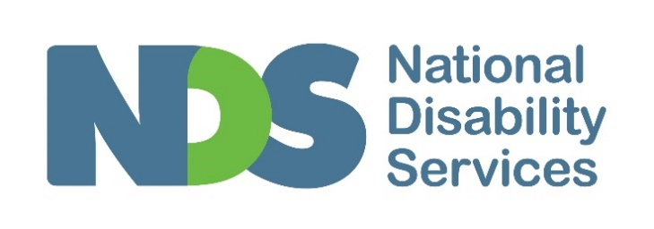

Submission: Aligning regulation across aged care, disability support and veterans’ affairs, December 2021

Introduction
NDS supports the direction and goals of the Regulatory Alignment Across the Care and Support Sector initiative. There is no justification for not having the same protections and expectations of quality and safety for participants and consumers; age should be irrelevant to these matters.
Each of the following proposals holds potential to improve supports and streamline processes for providers working in more than one of these sectors and, ideally, improve outcomes for participants and consumers:
- Incorporating a human rights-based approach
- Reduced duplication through cross-sector Worker Screening Checks
- Development of common core and sector-specific supplementary standards
- Single point monitoring (report once, use often)
At the outset, NDS would like to highlight the enormous challenges disability service providers have faced as the National Disability Insurance Scheme (NDIS) was progressively implemented since 2013. Block funding in advance was replaced by payment in arrears for supports delivered, finance systems had to be overhauled, the cultures of organisations had to focus on ensuring participant choice and control occurred in every interaction, and service agreements between participants and providers had to be developed and kept up to date.
And even though the scheme has now reached ‘full implementation’, participants and providers are continuing to have to adjust to new policies, procedures and processes.
Findings from NDS’s Annual Market Survey have just been released. An overwhelming 81 per cent of respondents agreed or strongly agreed that the NDIS policy environment is uncertain, compared to 69 per cent in 2020. This sentiment was uniform across different sized organisations and not-for-profit and for-profit providers. Typical comments included:
“the environment is too uncertain to determine strategic direction” and “the operating [environment] is very uncertain and we need further long-term clarity’”
“additional requirements and increased employee wages/super are not being matched by increasing NDIS prices”; and “constant changes to the price guide creates additional finance/admin work which is not paid for within the prices”
The change in this measure over time can be seen in the graph below. Constant changes in NDIS policies and procedures make the operating environment for providers difficult.
Figure 2 The NDIS policy environment is uncertain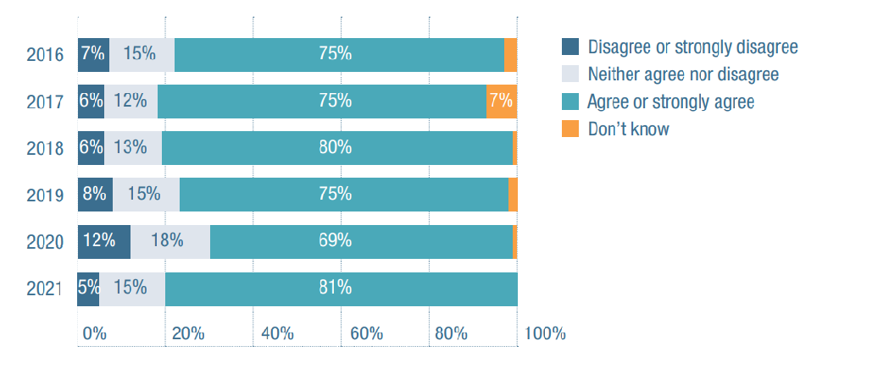
2016
Disagree or strongly disagree: 7 per cent
Neither agree nor disagree: 15 per cent
Agree or strongly agree: 75 per cent
Don’t know: 3 per cent
2017
Disagree or strongly disagree: 6 per cent
Neither agree nor disagree: 12 per cent
Agree or strongly agree: 75 per cent
Don’t know: 7 per cent
2018
Disagree or strongly disagree: 6 per cent
Neither agree nor disagree: 13 per cent
Agree or strongly agree: 80 per cent
Don’t know: 1 per cent
2019
Disagree or strongly disagree: 8 per cent
Neither agree nor disagree: 15 per cent
Agree or strongly agree: 75 per cent
Don’t know: 2 per cent
2020
Disagree or strongly disagree: 12 per cent
Neither agree nor disagree: 18 per cent
Agree or strongly agree: 69 per cent
Don’t know: 1 per cent
2021
Disagree or strongly disagree: 5 per cent
Neither agree nor disagree: 15 per cent
Agree or strongly agree: 81 per cent
Don’t know: 0 per cent
Overlaying these challenges, has been the introduction of a new regulator for the sector, the NDIS Quality and Safeguards Commission. The creation of one regulator for the disability sector across Australia is a welcome development but has required enormous work by providers to implement. New requirements are still to be introduced, generating new compliance activities for providers.
The figure below (2) (also taken from the NDS State of the Disability Sector Report) shows how providers are currently feeling about the implementation of the new regulations. The results are not particularly surprising—given the regulator is relatively new—but they do show a sector that is still working to embed the new regulations and compliance activities.
Taken together, disability service providers are still experiencing significant and ongoing changes to policies and procedures—generated by both the NDIA and the NDIS Commission—even though the NDIS has reached full implementation. The effort and cost of responding to constant changes are substantial.
NDS requests that the work taken to design the NDIS Quality and Safeguards Framework be used as the platform for this initiative to align regulations across the care and support sectors. Build on this relatively new regulation for disability providers rather than start again and disrupt the gains that have been made in improving the quality and safety of the supports delivered to NDIS participants.
Figure 12 Quality and Safeguarding Framework is leading to good outcomes for participants
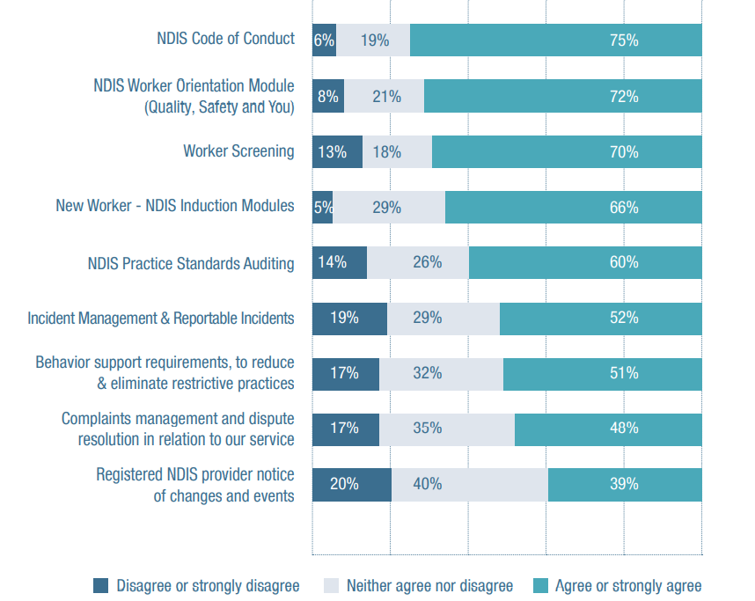
NDIS Code of conduct
Disagree or strongly disagree: 6per cent
Neither agree nor disagree: 19per cent
Agree or strongly agree: 75per cent
NDIS worker orientation module (Quality, Safety and You)
Disagree or strongly disagree: 8per cent
Neither agree nor disagree: 21per cent
Agree or strongly agree: 75per cent
Worker screening
Disagree or strongly disagree: 13per cent
Neither agree nor disagree: 18per cent
Agree or strongly agree: 70per cent
New worker – NDIS Induction modules
Disagree or strongly disagree: 5per cent
Neither agree nor disagree: 29per cent
Agree or strongly agree: 52per cent
NDIS Practice Standards Auditing
Disagree or strongly disagree: 14per cent
Neither agree nor disagree: 26per cent
Agree or strongly agree: 60per cent
Incident management and reportable incidents
Disagree or strongly disagree: 19 per cent
Neither agree nor disagree: 29 per cent
Agree or strongly agree: 52 per cent
Behaviour support requirements, to reduce and eliminate restrictive practices
Disagree or strongly disagree: 17 per cent
Neither agree nor disagree: 32 per cent
Agree or strongly agree: 51 per cent
Complaints management and dispute resolution in relation to our service
Disagree or strongly disagree: 17per cent
Neither agree nor disagree: 35 per cent
Agree or strongly agree: 48 per cent
Registered NDIS provide notice of changes and events
Disagree or strongly disagree: 20per cent
Neither agree nor disagree: 40per cent
Agree or strongly agree: 39per cent

Additional comments
After eight years of operating within the NDIS, disability service providers are seeking a stable operational and regulatory environment. Alignment activities need to minimal, be fast-tracked, follow a co-design model, and take the opportunity to streamline compliance requirements (without compromising quality or safety).
The regulatory requirements within the disability sector offer critical safeguards for people with disability; they must not be lost through aligning the care and support sectors. Human rights must be core to what is developed, along with maximising the choice and control of those receiving supports or services.
NDS strongly supports the reduced duplication offered in the Governments’ commitment to aligning worker screening but implementation delays need to be remedied. Providers have struggled with processing delays for the current NDIS Worker Screening Check (which is undertaken by state and territory governments), at times losing potential staff before they have been able to commence.
A weakness with existing arrangements is that workers who fail to meet NDIS Worker Screening Check requirements, are terminated, or leave prior to finalising investigations, can easily work elsewhere in the care and support sector. A strength of aligning the regulation across these sectors would be to close this loophole.
NDS is concerned that some workers supporting NDIS participants can do so without obtaining a Worker Clearance Check. This must be remedied as any alignment of regulations is implemented.
NDS supports the concept of developing a core set of standards, to be used alongside supplementary standards, across the sectors. Where refinements are made, consistent plain language and clear expectations can ease the burden of uncertainty for providers. Similarly, a centralised provider registration process or elements of registration would be beneficial to cross-sector providers.
To support the actual introduction of a core set of standards, NDS would need to see that any changes to the existing core standards are not onerous for disability service providers to implement.
The costs of regulatory compliance are high and not adequately covered by current funding models. NDS has raised with this issue, amongst others, in a submission to the NDIA Annual Pricing Review. The shortfalls are critical to consider in the context of regulatory alignment. We cannot dismiss the impact given the cost of compliance is leading some providers to question whether they should be registered.
Single point monitoring certainly holds potential for some reduction in this load and cost for cross-sector providers. It also has the potential to become confusing. Designing a new system must include clear protocols for cross-agency follow-up, timely triaging of information, and consistency of expectations. AI support to provide the efficiency and consistency within systems might be considered.
NDS acknowledges the work of the taskforce in seeking to cater for differences when implementing cross-sector alignment. Within the residential aged care sector, a star ratings system is under development. NDS would have significant concerns about the use of a star rating system within the disability sector. Put simply a rating system for only some providers—those who are registered but not those that are unregistered—would be divisive and not give a comprehensive picture to inform decision making by participants.
The care and support sector face ongoing challenges to attract and retain staff in most roles. Standardised accredited training that relates to the common core standards can have the benefit of enhancing service provision and increasing a cross-sector workforce. Subsidising quality training can increase the appeal of working in the care and support sectors.
The current consultation also seeks opinions on medium to longer-term activities. NDS asks that the process of aligning care and support regulation also consider future alignment with other sectors (such as out-of-home care which is regulated by state and territory governments). This would further reduce duplication and compliance costs.

References
2021 State of the Disability Sector Report (National Disability Services), Figure 3: We are worried we won’t be able to provide NDIS services at current pricing, nds.org.au
2021 State of the Disability Sector Report (National Disability Services), Figure 12: Quality and Safeguarding Framework is leading to good outcomes for participants, nds.org.au
Contact:
Laurie Leigh
Interim Chief Executive Officer
National Disability Services
P: 02 9256 3109
M: 0437 107 851
E: laurie.leigh@nds.org.au
National Disability Services is the peak industry body for non-government disability services. It represents service providers across Australia in their work to deliver high-quality supports and life opportunities for people with disability. Its Australia-wide membership includes more than 1200 non-government organisations which support people with all forms of disability. Its members collectively provide the full range of disability services—from accommodation support, respite, and therapy to community access and employment. NDS provides information and networking opportunities to its members and policy advice to State, Territory and Federal governments.

