State of the Disability Sector Report 2020

[Cover page]

A global pandemic. A paucity of workers. Problematic processes and not-quite-right pricing. It’s been a difficult year for the disability sector. But it’s also been a year which has brought out our best.

# Cover art

Artist name: Amy Pitcher Nanyi

Place of birth: Yarralin Station

Language / clan group: Gurindji / Warlpiri

Skin name: Nanyi

Dreaming designs: kungungyjurl (fire dreaming), jurrapinang (kangaroo dreaming), ngapa (freshwater dreaming).

Amy Pitcher Nanyi is a Gurindji woman who was born on Yarralin Station in 1978 and grew up in Lajamanu and Kalkarindji.

Since 2016, Amy has lived in Katherine in the Northern Territory and produced many works in the dot-painting style of Warlpiri and Gurindji artists. Amy has worked and exhibited in the Warnayaka Aboriginal Art Gallery, Lajamanu and Karungkarni Art and Culture Centre, Kalkarindji, producing paintings that reflects her dreaming designs and lived experiences. In 2021, Amy is scheduled to hold her first solo exhibition in Katherine at the Godinymayin Yijard Rivers Arts and Culture Centre.

## About the painting

Title: Water (ngupa)

This painting depicts digging sticks used by the ladies accessing the many layers of earth to reach safe water.

Materials: Watercolour on paper

The cover art image painted by artist Amy Pitcher Nanya


# Contents

The state of play 4

The way forward 6

The state of the operating environment 8

Case Study: Australian Capital Territory 47

Case Study: New South Wales 50

The state of the NDIS 53

Case Study: Northern Territory 57

Case Study: Queensland 59

The state of disability employment 62

The state of the workforce 71

Case Study: South Australia 82

Case Study: Western Australia 85

The state of the Royal Commission 87

Case Study: Victoria 89

Case Study: Tasmania 92

The state of the broader policy environment 94

# The state of play

Considering the year that’s been, Australia’s disability service providers seem to be in a reasonable state of health, although many were assisted through JobKeeper. But the sector is still operating well-short of full strength.

That’s the key take-out from this year’s Annual Market Survey, NDS’s annual check- up of Australia’s disability service providers and the sector in which they operate. While the bottom line is that around one third of providers still did not make a profit, 2019-20 was a year of progress for a sector which has long struggled to just remain viable.

Despite the unexpected disruption of COVID-19 and ongoing tension concerning NDIS pricing and processes, 67 per cent of Survey respondents reported making a profit in the last financial year (compared to 54 per cent in 2019) and 66 per cent advised they were ‘actively growing’ their business. Fewer providers are looking to merge, and just six per cent are considering getting out of the sector (down from 11 per cent this time last year).

With COVID-19, the bushfires and Australia’s first recession in three decades, this year has been a huge challenge for the sector – but one that providers have risen to.

Over the year, providers have had to evacuate entire regions, adapt to physical distancing, track down scarce personal protective equipment (PPE) and master complex new protocols. A lot of services that were once performed face-to-face are now being delivered online.

Forty-two per cent of Survey respondents believe they were well-supported by the Federal Government during emergency events. JobKeeper stood out for many providers, while others lamented their difficulties in accessing PPE, or the way in which sector-specific financial assistance was administered.

It’s important to add that, if Australians with disability are to have their needs met, it’s not enough to just help providers survive; we need an NDIS and a disability policy framework that allows them to thrive.

According to the Survey, no less than 69 per cent of providers had to turn away requests for services in 2020 because they did not have capacity to provide them. Most continue to be focused on delivering already existing programs, as opposed to adding new ones. And – despite the modest increase in sector- wide profits – the concern remains that 50 per cent of very small providers are just breaking even or actually making a loss at a time when we are continuing to face challenges in terms of ‘market gaps’ and ensuring that people with disability have choice and control in the services they access.

The NDIS will soon have 500,000 participants and, according to some estimates, the disability workforce will need to double in size in the next three years just to keep pace with increasing demand.

In short, the sector needs more workers, and those already in it need more incentives to stay. The fact the sector needs workers is positive news in a recession, yet providers still report significant challenges in attracting and retaining a workforce across many vital job types.

It is also the case that far too many people with disability still cannot find employment.

DES reforms remain problematic and the new ‘Supports in Employment’ pricing model for Disability Enterprises remains largely untested.

Given this, better government support in setting procurement targets from social enterprises would help to drive employment opportunities for people with disability.

The NDIA continues to implement Scheme administration improvements, significantly reducing payment delays to providers, yet only 17 per cent of Survey respondents were satisfied with NDIS systems and processes, and nearly two in three thought there were too many rules and regulations.

Deeper consultation relating to implementation, as well as policy design and review, would assist in this regard and NDS remains committed to consultation and co- design processes which ensure the NDIS and the wider suite of disability policies work as intended.

# The way forward

## Increased level of genuine consultation

The input of stakeholders should be heeded more readily in the development and implementation of policy and pricing reforms so as to drive better outcomes and avoid unintended consequences for participants and disability service providers.

## A concentrated focus on employment

The Agency’s target of 30 per cent of NDIS participants with disability of working age being in employment by 2023 should be supported by making improvements to the DES program and NDIS Participant Employment Strategy, maintaining a pragmatic approach to the implementation of the new ‘Supports in Employment’ pricing, and implementing targets for government procurement through social enterprises.

## NDIS price models that reflect true costs

Pricing and price models that are based on realistic assumptions, following service sector input and consultation.

## Extended school leaver supports

Open the School Leaver Employment Supports (SLES) to students from Year 10 to improve their employment prospects and ensure young people with disability are getting access to this support at the same time as their peers without disability.

## Implementation of the National Workforce Plan

Action to urgently address workforce shortages, including behaviour support specialists and Allied Health roles, must be implemented to ensure thin markets and Plan underutilisation are addressed, and timely quality supports are available nationally.

## Broader account manager support for service providers

A greater proportion of providers should be given access to account manager support.

## Reduced administrative burden

A reduction in the amount of red tape and complexity involved in streamlining processes, particularly relating to employment supports, Supported Independent Living and groups.

## An Industry Reference Group to test useability

A group for the NDIA to test process and price changes, including testing IT system changes.

## Ongoing market stewardship and greater links between the NDIA and NDIS Commission

Maintain vigilance for market gaps and greater collaboration between the Agency and the Commission to identify and safeguard vulnerable participants.

## A focus on mental health

Continued improvements in NDIS and other mainstream supports for people with psychological disability.

## Action on Royal Commission findings

Proactively address issues raised through the Disability Royal Commission to improve safeguards across the sector and within mainstream supports.

## A viable National Disability Strategy which is funded appropriately

A new Strategy should drive concrete action by all governments to deliver improvements for people with disability in critical areas, including housing, education, health and justice.

# The state of the operating environment

## About the Annual Market Survey

This data is produced from the eighth wave of NDS’s Annual Market Survey, analysed by the University of New South Wales in partnership with NDS.

## Who responded to the Survey?

A total of 410 disability service providers responded to this wave of the Survey. Sixteen per cent had an income of less than $1M, 25 per cent between $1M and $5M, 35 per cent between $5M and $20M, 13 per cent more than $20M but less than $50M, and 11 per cent had an income of more than $50M. Five per cent were sole traders. Eighty per cent of respondents were not-for-profit organisations and 13 per cent for-profit organisations.

Ninety-five per cent of respondents were registered to provide services under the NDIS and were providing services at the time.

## 2020 – an unprecedented year

2020 can only be described as an unprecedented year for the disability sector. Many organisations started the year responding to catastrophic bushfires that prompted evacuations and disruption to service provision. From late February, Australia started responding to the threat of COVID-19 and, as case numbers increased, States and Territories enforced stay-at-home measures and border closures. Disability service providers moved quickly to adapt to physical-distancing, protective-equipment and quarantine protocols.

Government responses to COVID-19 were introduced over time and included substantial JobKeeper payments for organisations experiencing a significant drop in revenue, and the ‘boosting cash flow support’ initiative for small and medium-sized organisations. The NDIA offered a one-month advance payment to providers supporting NDIS participants, along with a 10 per cent increase in some NDIS price caps, amendments to the cancellation policy and the ability for providers to charge for PPE if operating in COVID-19 ‘hot spots’.

In the face of these unprecedented circumstances, the sector has shown remarkable resilience and the ability to change and adapt to meet the recent emergency events. Nearly all respondents indicated they were able to respond well to recent emergency events, however their attitudes toward Government support were more divided. While 42 per cent of responding organisations agreed they had been well- supported during emergency events, 38 per cent disagreed with the statement.

### Figure 1: Attitudes towards recent emergency events

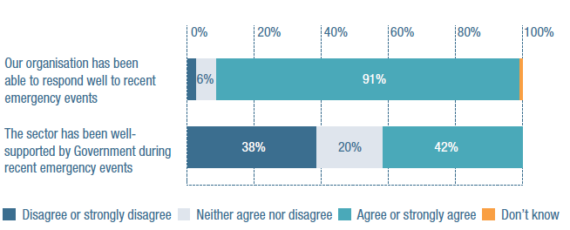

**Our organisation has been able to respond well to recent emergency events**

Disagree or strongly disagree: 2%

Neither agree nor disagree: 6%

Agree or strongly agree: 91%

Don’t know: 1%

**The sector has been well-supported by Government during recent events**

Disagree or strongly disagree: 38%

Neither agree nor disagree: 20%

Agree or strongly agree: 42%

The experience of government support was not felt equally. A significantly higher proportion of organisations that were classified as ‘large’ indicated they had not been well-supported (53 per cent) compared to medium, small, or very small organisations (38 per cent, 26 per cent, and 32 per cent, respectively).

A substantial number of providers called for a more coordinated and concerted response from government to help NDIS participants and organisations through the pandemic. They felt some responses came too late and were too piecemeal to be effective – putting providers and people with disability at risk of infection.

“JobKeeper has been a game changer but actions targeting the disability sector have been too-little-too-late or non-existent. Removal of the 10% loading was disgraceful and failed to take into account the actual increased cost of service delivery in a social distancing context.”

Others were more positive about the support they received:

“The operating environment has been difficult, especially with the negative impact COVID-19 has had on operations. The JobKeeper initiative has been a blessing for our organisation.”

The provision of PPE attracted a number of comments and criticisms. Two recent surveys included the topic of PPE. The Social Policy Research Centre, University of New South Wales (UNSW) study surveyed 2,341 disability support workers during March. Amongst other things, it found there was a lack of PPE available to disability support workers at the start of the pandemic. The Centre for Research Excellence in Disability and Health, University of Melbourne, conducted an online survey during May and June of 357 disability support workers. Ninety per cent of the disability workforce that was surveyed were unable to practice physical distancing at work, 25 per cent had had no PPE training and close to 70 per cent wanted more. In terms of PPE supply, close to 40 per cent were purchasing materials such as masks and gloves themselves. Although the Annual Market Survey did not specifically ask about PPE, this issue did feature in the commentary:

“Although the government was slow to respond to the needs of the disability sector with the current COVID-19 pandemic, their financial contributions and eventual PPE stocks kept our organisation viable to continue providing supports to our participants under the NDIS. The NDIS measures put in place with COVID-19 were also good for providers, but some caused concern for participants. These measures were taken away too quickly, particularly considering the pandemic isn’t over yet.”

Two themes that emerged strongly in past Annual Market Surveys – undue administrative burden and the amount of policy change occurring in the NDIS – remain of concern. In previous years, the sector reported it was carrying an unfunded administrative burden associated with compliance and assisting participants with navigating the complexity of NDIS systems. In 2020, these issues converged with the pandemic to create an even more difficult operating environment, with frequent changes to pricing and new rules regarding COVID-19 coming on top of this existing administrative burden.

“The responses to the pandemic have been limited to either amendments to pricing, which imposed an administrative burden on both the participant and the provider which was unnecessary, or additional requirements imposed by the commission on only registered providers. In terms of the administrative burden, the extension of the cancellation period to 10 days required agreement prior to implementation. Further, the new cancellation period increased the likelihood of non-disclosure of illness or, worse, the suspension of service merely to avoid the new conditions. Requiring a participant to fund PPE for workers in relation to COVID-19 was simply odd when it’s the provider’s responsibility to ensure safety. It has taken nearly five months and significant issues in the community sector for common sense to prevail.”

Victoria has been disproportionately impacted by the COVID-19 pandemic but this has not shown in the results. Respondents from Victorian organisations did not indicate any variance regarding their own organisation’s preparedness for emergencies or view of the government response compared with the rest of the country.

## Business confidence falls

The pressures and economic uncertainties associated with COVID-19 have influenced perceptions of operating conditions over the last 12 months. The 2019 Annual Market Survey reported a return in business confidence after several years of disruption. In the 2020 survey, provider attitudes were significantly different compared to previous years: 61 per cent of respondents believe that operating conditions in the disability sector have worsened in the last 12 months (compared to 38 per cent in 2019).

### Figure 2: Over the last 12 months, do you believe that the overall operating conditions of the disability sector have changed?

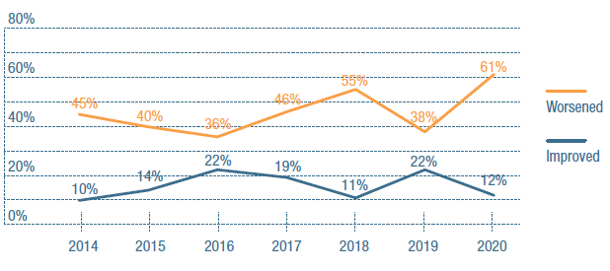

**2014**

Worsened: 45%

Improved: 10%

**2015**

Worsened: 40%

Improved: 14%

**2016**

Worsened: 36%

Improved: 22%

**2017**

Worsened: 46%

Improved: 19%

**2018**

Worsened: 55%

Improved: 11%

**2019**

Worsened: 38%

Improved: 22%

**2020**

Worsened: 61%

Improved: 12%

The change in perceived operating conditions in the wider Australian economy was even starker: 74 per cent of respondents believe that conditions have worsened in the last 12 months, compared to 29 per cent in 2019. These perceptions are merited: Australia entered its first recession in 29 years in 2020.

“This is currently an uncertain environment, mainly due to the economic and business downturn through the pandemic. Also, the changes throughout the NDIS system will impact on our organisation.”

### Figure 3: Over the last 12 months, do you believe that the overall operating conditions of the wider Australian economy have changed?

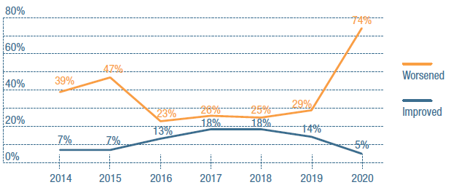

**2014**

Worsened: 39%

Improved: 7%

**2015**

Worsened: 47%

Improved: 7%

**2016**

Worsened: 23%

Improved: 13%

**2017**

Worsened: 26%

Improved: 18%

**2018**

Worsened: 25%

Improved: 18%

**2019**

Worsened: 29%

Improved: 14%

**2020**

Worsened: 74%

Improved: 5%

“Have not added any [new services]. We have therapy in our strategic plan, but do not have the capacity to provide additional or new services now with the downturn in the economy.”

## Financial struggles continue

While there was a significant increase in the proportion of organisations which reported making a profit in the last financial year (67 per cent compared to 54 per cent in 2019), the bottom line is that 31 per cent will only break-even – or, indeed, make a loss.

While the survey did not explicitly ask about the impact of government stimulus measures on overall positions for the 2019-20 financial year, it is evident from these results (and providers’ financial statements) that these measures have had a positive net effect for the sector.

A greater proportion of medium and large organisations reported making a profit in the last financial year (76 per cent and 71 per cent, respectively) compared to small and very small organisations. This is broadly reflective of previous trends. It remains the case that 50 per cent of very small organisations are either breaking even or making a loss in their business. As one respondent from a small organisation stated:

“We are currently funding our disability services from our reserves and other services. We either have to grow or exit. Currently considering whether to remain in this sector. We are only able to do this because we are a charity and this aligns with our purpose. If we were a for-profit provider, we would probably have exited by now.”

### Figure 4: In its most recent full financial year, did this organisation make a loss, break-even or make a profit (surplus) in regard to its disability services?

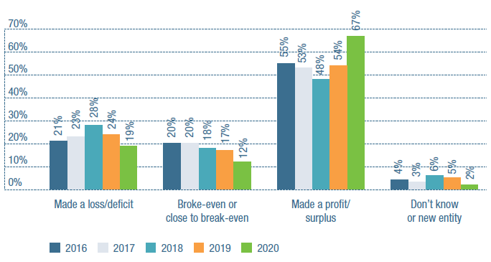

**Made a loss/deficit**

2016: 21%

2017: 23%

2018: 28%

2019: 24%

2020: 19%

**Broke even or close to break-even**

2016: 20%

2017: 20%

2018: 18%

2019: 17%

2020: 12%

**Made a profit/surplus**

2016: 55%

2017: 53%

2018: 48%

2019: 54%

2020: 67%

**Don't know or new entity**

2016: 4%

2017: 3%

2018: 6%

2019: 5%

2020: 2%

Just under half (49 per cent) of organisations that responded reported profits exceeding a notional 0.9 per cent CPI growth between 2019 and 2020 (ABS, 2020).

### Figure 5: In the most recent financial year, did your organisation make a loss, break-even, or make a profit?

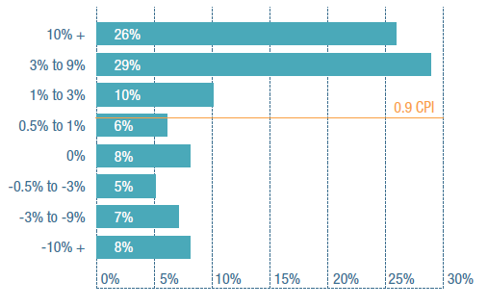

**10% +**: 26%

**3% to 9%**: 29%

**1% to 3%**: 10%

[CPI = 0.9]

**0.5% to 1%**: 6%

**0%**: 8%

**-0.5% to -3%**: 5%

**-3% to -9%**: 7%

**-10%+**: 8%

### Figure 6 Do you expect your organisation will make a loss (deficit), break-even or make a profit (surplus) on its disability services in this current financial year?

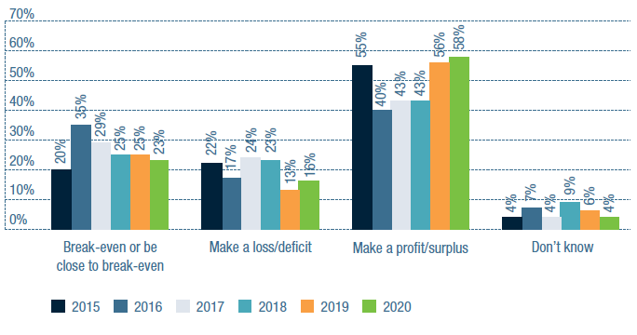

**Break-even or close to break-even**

2015: 20%

2016: 35%

2017: 29%

2018: 25%

2019: 25%

2020: 23%

**Make a loss/deficit**

2015: 22%

2016: 17%

2017: 24%

2018: 23%

2019: 13%

2020: 16%

**Make a profit/surplus**

2015: 55%

2016: 40%

2017: 43%

2018: 43%

2019: 56%

2020: 58%

**Don’t know**

2015: 4%

2016: 7%

2017: 4%

2018: 9%

2019: 6%

2020: 4%

Looking forward, more than half of organisations (58 per cent) expect to make a profit in 2020-21. Sixteen per cent predicted their organisation will make a loss, but in general, the Survey trends suggest that the sector is feeling more financially secure. Changes to economic stimulus packages (such as JobSeeker and JobKeeper) may impact performance in the next financial year, however, as the country continues to manage its response to the pandemic.

“COVID-19 closure periods and reduced services due to reduction of face-to-face opportunities have impacted in 2020 and will continue into 2021 financial years.”

## Organisation strategies focus on productivity and growth

There continue to be significant differences in strategy depending on the size of organisations. There are significant increases in the number of organisations that report they are actively focusing on improving their productivity and have a clear three-year vision for their organisation.

### Table 1: Overall organisation strategy – agree or strongly agree with the following statements

| Organisation Strategy | 2018 | 2019 | 2020 |
| --- | --- | --- | --- |
| We are actively working on improving our productivity | 84% | 92% | 95% |
| We are considering getting out of the disability sector | 16% | 11% | 6% |
| We will stay in the disability sector but are not focused on growth | 26% | 25% | 23% |
| We are actively growing our organisation | 60% | 65% | 66% |
| We have a clear vision of where we will be in three years from now | 54% | 61% | 67% |
| We are worried about our ability to adjust to changes resulting from changes in the policy environment | 58% | 53% | 56% |

Disability organisations, for the most part, are focused on strategies to deliver growth. Nearly all responding organisations in 2020 (95 per cent) said they are actively working on improving their productivity. This attitude was particularly seen in medium and large organisations (97 per cent and 100 per cent respectively indicated that this was the case).

Seventy per cent of medium and 75 per cent of large organisations also said they are actively growing their organisation. Very small organisations were more likely to indicate that, while they plan on staying in the disability sector, 40 per cent are not focussed on growth.

For respondents who indicated they may or were actively growing their organisation, this is primarily going to be achieved through increasing their client base, as well as increasing the size of their workforce and the range of services they offer. Merging with, or taking management ownership of, another organisation was less likely to be part of their plans.

### Figure 7: In what ways are you planning on actively growing your organisation?

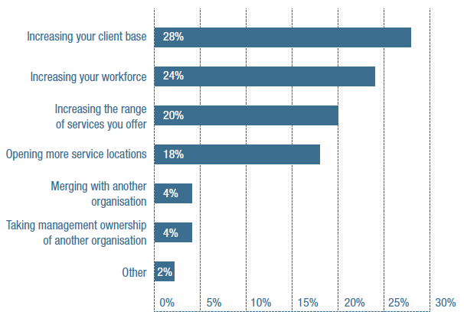

Increasing your client base: 28%

Increasing your workforce: 24%

Increasing the range of services you offer: 20%

Opening more service locations: 18%

Merging with another organisation: 4%

Taking management ownership of another organisation: 4%

Other: 2%

Compared to the previous year, there were no significant changes in concern about the impact of a changing policy environment. Some 56 per cent of respondents indicated that they are concerned about their organisation’s ability to adjust to the impact of policy changes.

The number of organisations considering leaving the disability sector continues to decrease, a significant reduction from 16 per cent of organisations in 2018 compared to six per cent in 2020.

## Changes in service provision

The impact of COVID-19 became more apparent when respondents were asked to indicate changes in service volume over the last 12 months. Services that provided community participation or social activities were most impacted, most likely due to physical distancing requirements and, in some cases, shut-down of non-essential services.

A greater proportion of organisations indicated they provided less participation in community, social and civic activities, group and centre based activities, innovative community participation, and assistance in personal activities, compared to previous years.

### Figure 8 Change in service provision – previous 12 months

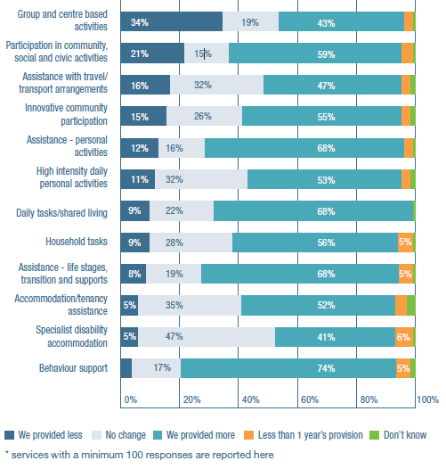

**Group and centre based activities**

We provided less: 34%

No change: 19%

We provided more: 43%

Less than 1 year’s provision: 3%

Don’t know: 1%

**Participation in community, social and civic activities**

We provided less: 21%

No change: 15%

We provided more: 59%

Less than 1 year’s provision: 4%

Don’t know: 1%

**Assistance with travel/ transport arrangements**

We provided less: 16%

No change: 32%

We provided more: 47%

Less than 1 year’s provision: 3%

Don’t know: 2%

**Innovative community participation**

We provided less: 15%

No change: 26%

We provided more: 55%

Less than 1 year’s provision: 3%

Don’t know: 2%

**Assistance – personal activities**

We provided less: 12%

No change: 16%

We provided more: 68%

Less than 1 year’s provision: 3%

Don’t know: 1%

**High intensity daily personal activities**

We provided less: 11%

No change: 32%

We provided more: 53%

Less than 1 year’s provision: 3%

Don’t know: 2%

**Daily tasks/shared living**

We provided less: 9%

No change: 22%

We provided more: 68%

Less than 1 year’s provision: 0%

Don’t know: 1%

**Household tasks**

We provided less: 9%

No change: 28%

We provided more: 56%

Less than 1 year’s provision: 5%

Don’t know: 1%

**Assistance - life stages, transition and supports**

We provided less: 8%

No change: 19%

We provided more: 68%

Less than 1 year’s provision: 5%

Don’t know: 1%

**Accommodation/tenancy assistance**

We provided less: 5%

No change: 35%

We provided more: 52%

Less than 1 year’s provision: 4%

Don’t know: 3%

**Specialist disability accommodation**

We provided less: 5%

No change: 47%

We provided more: 41%

Less than 1 year’s provision: 6%

Don’t know: 1%

**Behaviour support**

We provided less: 3%

No change: 17%

We provided more: 74%

Less than 1 year’s provision: 5%

Don’t know: 2%

*services with a minimum 100 responses are reported here

In planning for the next 12 months, 76 per cent of organisations offering therapeutic support indicated they planned to increase their volume of services. Sixty-nine per cent of services offering behaviour support and 74 per cent of organisations currently providing daily tasks/ shared living services indicated they also plan to increase their volume of services.

As was the case in the 2019 Survey, assistance with travel and transport arrangements was identified as a service that would either be stopped or reduced in the next 12 months by 13 per cent of organisations which are currently offering these services. Eleven per cent of plan management providers plan on stopping or reducing their services.

### Figure 9: In the next 12 months, do you plan to stop providing, reduce or increase the volume of services or make no changes to your services?

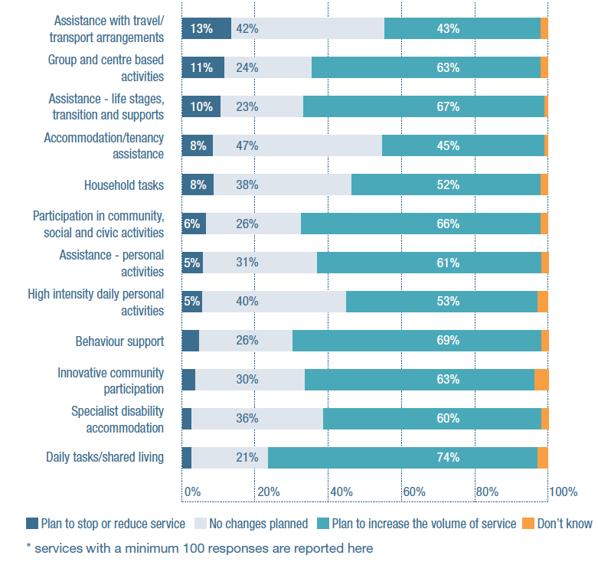

**Assistance with travel/transport arrangements**

Plan to stop or reduce service: 13%

No changes planned: 42%

Plan to increase the volume of service: 43%

Don’t know: 2%

**Group and centre based activities**

Plan to stop or reduce service: 11%

No changes planned: 24%

Plan to increase the volume of service: 63%

Don’t know: 2%

**Assistance – life stages, transition and supports**

Plan to stop or reduce service: 10%

No changes planned: 23%

Plan to increase the volume of service: 67%

Don’t know: 1%

**Accommodation/tenancy assistance**

Plan to stop or reduce service: 8%

No changes planned: 47%

Plan to increase the volume of service: 45%

Don’t know: 1%

**Household tasks**

Plan to stop or reduce service: 8%

No changes planned: 38%

Plan to increase the volume of service: 52%

Don’t know: 2%

**Participation in community, social and civic activities**

Plan to stop or reduce service: 6%

No changes planned: 26%

Plan to increase the volume of service: 66%

Don’t know: 2%

**Assistance – personal activities**

Plan to stop or reduce service: 5%

No changes planned: 31%

Plan to increase the volume of service: 61%

Don’t know: 2%

**High intensity daily personal activities**

Plan to stop or reduce service: 5%

No changes planned: 40%

Plan to increase the volume of service: 53%

Don’t know: 3%

**Behaviour support**

Plan to stop or reduce service: 4%

No changes planned: 26%

Plan to increase the volume of service: 69%

Don’t know: 2%

**Innovative community participation**

Plan to stop or reduce service: 3%

No changes planned: 30%

Plan to increase the volume of service: 63%

Don’t know: 4%

**Specialist disability accommodation**

Plan to stop or reduce service: 2%

No changes planned: 36%

Plan to increase the volume of service: 60%

Don’t know: 2%

**Daily tasks/shared living**

Plan to stop or reduce service: 2%

No changes planned: 21%

Plan to increase the volume of service: 74%

Don’t know: 3%

*services with a minimum 100 responses are reported here

There has been a steady and significant increase in the proportion of providers who indicated they have received requests for services they have not been able to provide in the last 12 months. For most of the providers who had to turn away requests in 2020, this was because they did not have capacity (69 per cent), they did not provide the requested service (51 per cent), or the client’s plan would not cover the requested services (47 per cent).

### Figure 10 Organisations which have received requests for disability services and not been able to provide those services

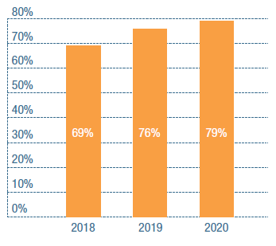

2018: 69%

2019: 76%

2020: 79%

Organisations continue to be focused on increased capacity to deliver existing programs, rather than adding new services. Six per cent of organisations indicated they are planning on introducing therapeutic supports in the next 12 months, and five per cent plan on offering behaviour support. Both of these results were significantly higher than was the case in previous years. Intentions to add other service types in the next 12 months were minimal.

## Workforce development and ICT remain the key priorities for improvement

Looking forward, organisations continue to report a focus on improving their HR strategy and workforce planning. Half of responding organisations identified this as an area for improvement, a significant increase from 37 per cent of respondents in the 2019 survey.

Interestingly, HR, ICT and Finance areas were less difficult to recruit to than frontline or Allied Health staff. Although 33 per cent of respondents found it difficult to recruit HR staff and 28 per cent found the same with ICT staff, this was a slight improvement on 2019. Likewise, back office functions such as HR and ICT generally found it easier to retain staff, whereas had more difficulty with the retention of frontline roles.

Other priority areas – information, communications and technology, and costing and pricing – were also identified by significantly more organisations as capability priorities compared to previous years.

Looking across five waves of the Survey, it is apparent that HR strategy, costing and pricing, and technology remain consistent priorities for the sector. In the 2020 Survey, organisations were asked whether records management and emergency management plans were areas requiring improvement.

Only 17 per cent of organisations identified records management, and six per cent selected emergency management plans as priorities. It is possible that providers did not select emergency management plans due to needing to adapt and utilise their plans already in 2020; however, it may also have been considered a low priority issue for some providers.

### Table 2: Organisational improvements for the next 12 months

| 2016 | 2017 | 2018 | 2019 | 2020 |
| --- | --- | --- | --- | --- |
| 1. Costing and pricing | 1. Costing and pricing | 1. Information, communications and technology strategy | 1. HR strategy and workforce planning | 1. HR strategy and workforce planning |
| 2. Information, communications and technology strategy | 2. Marketing practice | 2. Costing and pricing | 2. Information, communications and technology strategy | 2. Information, communications and technology |
| 3. Marketing practice | 3. HR strategy and workforce planning | 3. HR strategy and workforce planning | 3. Employee learning and development | 3. Costing and pricing |

In 2020, there was a significant increase in almost all business capability areas that were selected as priorities by responding organisations. Employee learning and development, data reporting and use, and risk management and compliance were all identified by significantly more respondents as priority areas for the next 12 months. Financial processes and controls, and quality and safeguards were the least commonly selected capability areas.

## The sector’s relationship with the NDIA

Despite a turbulent year, respondents in the 2020 Annual Market Survey indicated that relations between the disability sector and Government may be improving, albeit from a low base.

A significantly larger proportion of respondents (26 per cent) agreed that the NDIA is working well with providers, compared to previous years (19 per cent and 15 per cent in 2019 and 2018, respectively).

Perceptions of the NDIS policy environment also appear to be improving. Sixty-nine per cent of respondents indicated that the policy environment is uncertain in 2020, compared to 75 per cent in 2019 and 80 per cent in 2018.

### Figure 11: Policy and reform

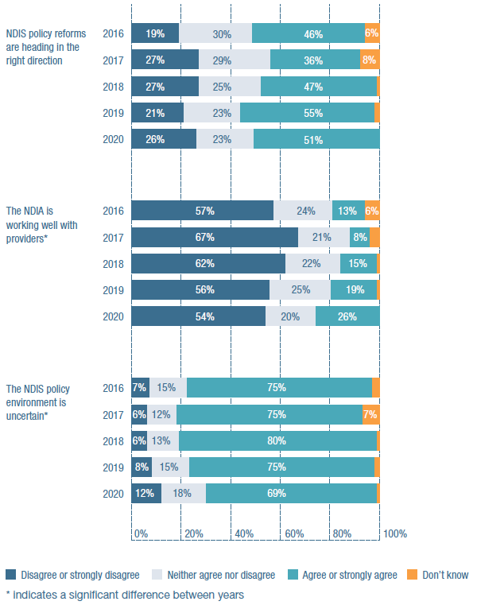

**NDIS policy reforms are heading in the right direction**

**2016**

Disagree or strongly disagree: 19%

Neither agree nor disagree: 30%

Agree nor strongly agree: 46%

Don’t know: 6%

**2017**

Disagree or strongly disagree: 27%

Neither agree nor disagree: 29%

Agree nor strongly agree: 36%

Don’t know: 8%

**2018**

Disagree or strongly disagree: 27%

Neither agree nor disagree: 25%

Agree nor strongly agree: 47%

Don’t know: 1%

**2019**

Disagree or strongly disagree: 21%

Neither agree nor disagree: 23%

Agree nor strongly agree: 55%

Don’t know: 2%

**2020**

Disagree or strongly disagree: 26%

Neither agree nor disagree: 23%

Agree nor strongly agree: 51%

Don’t know: 0%

**The NDIA is working well with providers\***

**2016**

Disagree or strongly disagree: 57%

Neither agree nor disagree: 24%

Agree nor strongly agree: 13%

Don’t know: 6%

**2017**

Disagree or strongly disagree: 67%

Neither agree nor disagree: 21%

Agree nor strongly agree: 8%

Don’t know: 4%

**2018**

Disagree or strongly disagree: 62%

Neither agree nor disagree: 22%

Agree nor strongly agree: 15%

Don’t know: 1%

**2019**

Disagree or strongly disagree: 56%

Neither agree nor disagree: 25%

Agree nor strongly agree: 19%

Don’t know: 1%

**2020**

Disagree or strongly disagree: 54%

Neither agree nor disagree: 20%

Agree nor strongly agree: 26%

Don’t know: 0%

**The NDIS policy environment is uncertain\***

**2016**

Disagree or strongly disagree: 7%

Neither agree nor disagree: 15%

Agree nor strongly agree: 75%

Don’t know: 3%

**2017**

Disagree or strongly disagree: 6%

Neither agree nor disagree: 12%

Agree nor strongly agree: 75%

Don’t know: 7%

**2018**

Disagree or strongly disagree: 6%

Neither agree nor disagree: 13%

Agree nor strongly agree: 80%

Don’t know: 1%

**2019**

Disagree or strongly disagree: 8%

Neither agree nor disagree: 15%

Agree nor strongly agree: 75%

Don’t know: 2%

**2020**

Disagree or strongly disagree: 12%

Neither agree nor disagree: 18%

Agree nor strongly agree: 69%

Don’t know: 1%

*indicates a significant difference between years

Overall, half of the respondents felt that NDIS policy reforms are heading in the right direction (51 per cent). This figure is slightly lower than the 55 per cent of respondents who agreed with this statement in 2019, however the change was not significant. Overall, there appears to be a gradual increase (off a very low base) in satisfaction with NDIS systems and processes: while only 17 per cent of respondents agreed systems and processes were working well in 2020, this represented significantly higher levels of satisfaction compared to previous years (13 per cent agreed in 2019, 10 per cent in 2018).

Concerns about pricing and administrative burdens remain: 57 per cent of respondents said they are worried about their ability to provide NDIS services at their current prices. Nearly two in three organisations (63 per cent) said there are too many rules and regulations. This was a significant increase compared to previous years.

“I think the question on whether we will be able to sustain services under NDIS pricing is too broad a question. Some services are OK and others are not, e.g. community support.”

“The constant changes in NDIS processes and pricing make it incredibly difficult to operate. Also the uncertainty of all the changes makes it impossible to budget appropriately and to respond to services needed for people with disability.”

“While the Agency seems genuine about addressing provider concerns, pricing pressure remains an ongoing issue for the provision of services and delivery of positive customer outcomes.”

Confusing or insufficiently detailed announcements hamper efforts to implement these changes.

### Figure 12: Administration burden

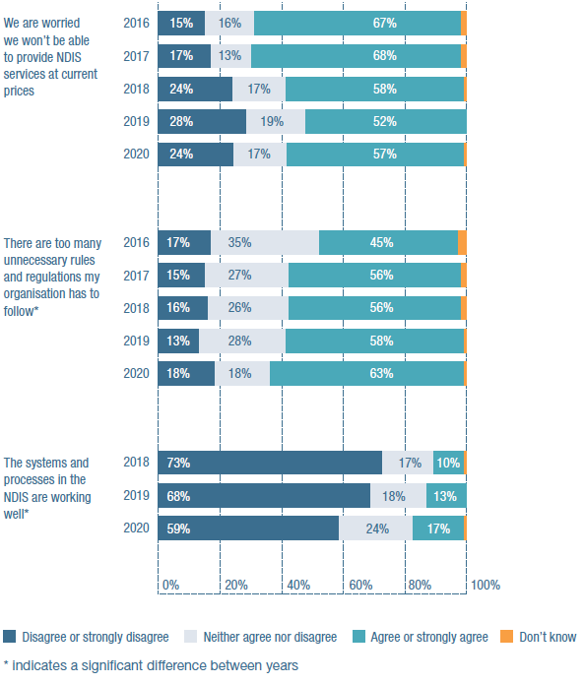

**We are worried we won’t be able to provide NDIS services at current prices**

**2016**

Disagree or strongly disagree: 15%

Neither agree nor disagree: 16%

Agree nor strongly agree: 67%

Don’t know: 2%

**2017**

Disagree or strongly disagree: 17%

Neither agree nor disagree: 13%

Agree nor strongly agree: 68%

Don’t know: 2%

**2018**

Disagree or strongly disagree: 24%

Neither agree nor disagree: 17%

Agree nor strongly agree: 58%

Don’t know: 1%

**2019**

Disagree or strongly disagree: 28%

Neither agree nor disagree: 19%

Agree nor strongly agree: 52%

Don’t know: 0%

**2020**

Disagree or strongly disagree: 24%

Neither agree nor disagree: 17%

Agree nor strongly agree: 57%

Don’t know: 1%

**There are too many unnecessary rules and regulations my organisation has to follow\***

**2016**

Disagree or strongly disagree: 17%

Neither agree nor disagree: 35%

Agree nor strongly agree: 45%

Don’t know: 3%

**2017**

Disagree or strongly disagree: 15%

Neither agree nor disagree: 27%

Agree nor strongly agree: 56%

Don’t know: 2%

**2018**

Disagree or strongly disagree: 16%

Neither agree nor disagree: 26%

Agree nor strongly agree: 56%

Don’t know: 2%

**2019**

Disagree or strongly disagree: 13%

Neither agree nor disagree: 28%

Agree nor strongly agree: 58%

Don’t know: 1%

**2020**

Disagree or strongly disagree: 18%

Neither agree nor disagree: 18%

Agree nor strongly agree: 63%

Don’t know: 1%

**The systems and processes in the NDIS are working well\***

**2018**

Disagree or strongly disagree: 73%

Neither agree nor disagree: 17%

Agree nor strongly agree: 10%

Don’t know: 1%

**2019**

Disagree or strongly disagree: 68%

Neither agree nor disagree: 18%

Agree nor strongly agree: 13%

Don’t know: 0%

**2020**

Disagree or strongly disagree: 59%

Neither agree nor disagree: 24%

Agree nor strongly agree: 17%

Don’t know: 1%

*indicates a significant difference between years

Providers continue to be concerned about the lack of access to advocacy. Only 20 per cent believe there is sufficient advocacy for the people they support.

“The independent advocacy sector continues to be vastly under-funded by all levels of government, which greatly affects its ability to reach out to people with disability and their family to provided much-needed independent advocacy assistance.”

### Figure 13: There is sufficient advocacy for the people we support

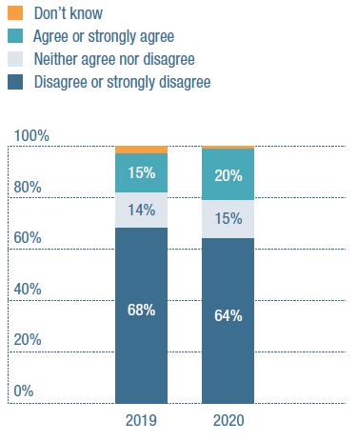

**2019**

Disagree or strongly disagree: 68%

Neither agree nor disagree: 14%

Agree nor strongly agree: 15%

Don’t know: 3%

**2020**

Disagree or strongly disagree: 64%

Neither agree nor disagree: 15%

Agree nor strongly agree: 20%

Don’t know: 1%

As was also noted in the 2019 Annual Market Survey, providers see a link between the lack of investment in advocacy and the growing role they play in this space. Over three- quarters of respondents (78 per cent) said that helping clients understand and navigate the scheme was taking them away from service provision. Additional administrative burdens appear to be impacting organisations differently.

Fewer very small organisations reported that helping clients navigate the system was taking them away from service provision; these organisations may be more likely to be offering single services, such as plan management, compared to larger organisations.

### Figure 14: Helping people understand and navigate the scheme is taking us away from service provision*

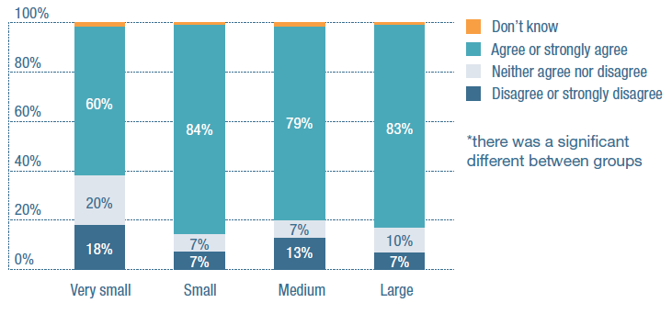

**Very Small**

Disagree or strongly disagree: 18%

Neither agree nor disagree: 20%

Agree nor strongly agree: 60%

Don’t know: 2%

**Small**

Disagree or strongly disagree: 7%

Neither agree nor disagree: 7%

Agree nor strongly agree: 84%

Don’t know: 1%

**Medium**

Disagree or strongly disagree: 13%

Neither agree nor disagree: 7%

Agree nor strongly agree: 79%

Don’t know: 2%

**Large**

Disagree or strongly disagree: 7%

Neither agree nor disagree: 10%

Agree nor strongly agree: 83%

Don’t know: 1%

*there was a significant different between groups

As in previous years, providers argued that reforms aimed at making things easier were often making operating conditions more difficult on the ground:

“Multiple changes to the pricing schedule take up an inordinate amount of administrative time. Every time the NDIA does something to ‘make things easier’ for providers to lodge payment claims, they actually make it harder.”

“NDIS is still complex and transactional, which significantly adds to our cost to service. Working with NDIS continues to be difficult. This has been further demonstrated in the rollout of pricing for supported employment being nothing like they said it would be during the consultation period.”

The 2019 Survey introduced questions about provider interactions with Early Childhood Early Intervention (ECEI) partners and Local Area Coordinators (LACs). Not surprisingly, providers still largely appear to be unaware or ambivalent about the impact of ECEI partners – the majority of respondents (73 per cent) indicated they either did not know about whether partners are working well in the community or did not have strong attitudes either way. Negative attitudes towards LACs appear to be persisting: half of respondents (50 per cent) indicated that LACS were not working well.

## The sector’s relationship with the NDIS Commission

There continues to be diversity in provider attitudes towards the Quality and Safeguarding Commission and the Framework. Half of respondents (50 per cent) said they are confident that the Framework will improve the quality of services and outcomes, which was a significantly higher percentage compared to previous Surveys. However, attitudes towards the Commission and its relationship with providers appear to remain ambivalent. Only 29 per cent of respondents said the Commission is working well with providers; 33 per cent indicated this was not the case.

Analysis of when the Commission commenced to exercise its jurisdiction across different states and territories indicated there was no significant difference in attitude based on how long the Commission had been operating.

The findings indicate there is confusion and uncertainty around the Commission’s audit and compliance requirements, reflected in the quantitative findings. There has been a statistically significant increase in the number of providers feeling that there are too many rules and regulations to navigate. Provider concerns were not with the substantive content of material provided, or the approach taken by the Commission, but rather with a lack of clarity in how to navigate it.

These findings indicate there is work to be done to assist providers to navigate, and ensure they are compliant with, the Quality and Safeguarding Commission Framework and systems.

“I really feel there is little synergy in the work that the NDIA is doing and the outcomes that the Quality and Safeguard Commission are striving to achieve. When we talk training and competency to the NDIA, the standard response back is... that is a business decision you need to make... you will need to prioritise what is important to your business. What is currently delivered cannot be compromised. The level of training provided is now what just meets safeguard expectations. It is not above and beyond and training that invokes innovation.”

“NDIS Q&S Commission is taking too long to respond to accreditation and certification and issuing very problematic certificates.”

## Larger organisations lead merger discussions

There is a continuing downward trend in the proportion of organisations that are discussing or currently undertaking mergers with other organisations. Similar to findings in the 2019 report, discussions of mergers, and the completion of mergers, are dominated by large organisations. Greater proportions of small organisations reported discussing winding up or closing their organisation in the last 12 months.

### Figure 15: Merger and market exit strategies

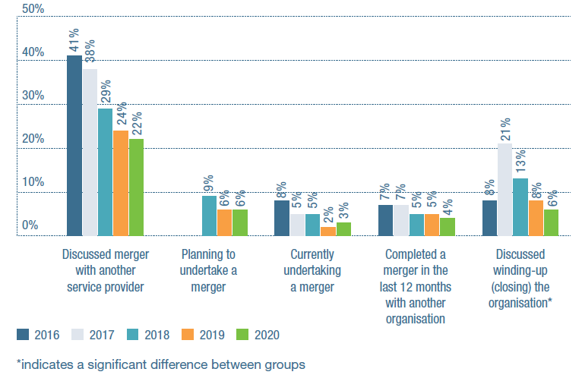

**Discussed merger with another service provider**

2016: 41%

2017: 38%

2018: 29%

2019: 24%

2020: 22%

**Planning to undertake a merger**

2018: 9%

2019: 6%

2020: 6%

**Currently undertaking a merger**

2016: 8%

2017: 5%

2018: 5%

2019: 2%

2020: 3%

**Completed a merger in the last 12 months with another organisation**

2016: 7%

2017: 7%

2018: 5%

2019: 5%

2020: 4%

**Discussed winding-up (closing) the organisation\***

2016: 8%

2017: 21%

2018: 13%

2019: 8%

2020: 6%

*indicates a significant difference between groups

### Figure 16: Merger plans by organisation size

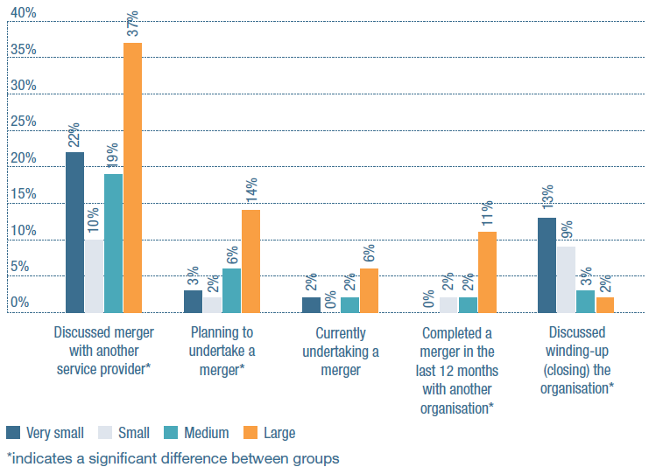

**Discussed merger with another service provider\***

Very small: 22%

Small: 10%

Medium: 19%

Large: 37%

**Planning to undertake a merger\***

Very small: 3%

Small: 2%

Medium: 6%

Large: 14%

**Currently undertaking a merger**

Very small: 2%

Small: 0%

Medium: 2%

Large: 6%

**Completed a merger in the last 12 months with another organisation\***

Very small: 0%

Small: 2%

Medium: 2%

Large: 11%

**Discussed winding-up (closing) the organisation\***

Very small: 13%

Small: 9%

Medium: 3%

Large: 2%

*indicates a significant difference between groups

Collaboration activities in the sector still appear to be focused on joint advocacy efforts. There has been a significant decrease over time in the proportion of organisations that report having resource-sharing arrangements in place, however in 2020 a significantly larger proportion of organisations reported having agreements or MOUs with other organisations.

As noted in the 2019 report, collaboration activities vary depending on organisation size. A greater number of very small organisations (31 per cent) reported outsourcing back office functions compared to large organisations (seven per cent). Medium and large organisations were more likely to indicate they had agreements or MOUs with other organisations, and collaborated with other providers in advocacy.

Volunteer patterns also have shifted significantly in the last 12 months – a likely consequence of COVID-19 but also, possibly, an indication of the preferences of people with disability as consumers of services. One in three organisations reported they had fewer volunteers in 2020 compared to 14 per cent in 2019. This was likely a result of non-essential services closing and physical distancing requirements. However, the proportion of organisations that reported using volunteers increased from 47 per cent in 2019 to 58 per cent in 2020.

## Conclusions

In meeting the challenges of this financial year, the disability sector in Australia has shown itself to be resilient, innovative and resourceful. The operating environment has impacted different organisations in different ways. The challenges will likely continue well into 2021 and potentially beyond, as the Australian economy recovers from the impact of the pandemic and the country braces itself for another bushfire season and potential pandemic outbreaks, pending a vaccine.

JobKeeper will hopefully help some eligible organisations remain viable, although the Federal Government has so far only budgeted for it to continue until 31 March 2021. A disability sector which can continue to adapt, change and deliver high-quality services will be a sector that will ultimately benefit the people we are here to serve.

## Research contact

For further information about the Annual Market Survey, please contact:

**Associate Professor Gemma Carey**

Centre for Social Impact, UNSW

[gemma.carey@unsw.edu.au](mailto:gemma.carey@unsw.edu.au)

**Philippa Angley**

Head of Policy, NDS

[phillippa.angley@nds.org.au](mailto:phillippa.angley@nds.org.au)

# Case Study: Australian Capital Territory

## Leanne Heald, Woden Community Services

**Tell us about Woden.**

We’re a regional community organisation which offers services through all walks of life, from children’s services all the way to aged care. We have quite a broad suite of mental health services, and specialise in psychosocial disability, which is where a person’s mental illness affects their social connections. We look at how we can help these people better connect to their community, build more friendships, develop more skills, or get a qualification or a job, those types of things.

**What has been your proudest achievement?**

In 2017, we brought our two NDIS programs together – one had been working with people with psychosocial disability, the other with participants with an intellectual or physical disability. Our teams now work very collaboratively, so that’s been a really big achievement for us.

**What does an average day look like?**

Well, I’m going to say that it’s never dull. We work with participants from all walks of life. I’m involved in the day-to-day activities, working on how we can best support a participant. Other times, I’m working on how we can keep the program viable.

**Is there much room for innovation?**

Oh, absolutely. We’ve already had to be innovative. Disability programs and mental health programs were all block-funded previously, so we’ve had to be able to try and offer similar supports to participants under a different funding model.

In the future, I would like to see us spread our wings and offer a really comprehensive suite of services under NDIS that specifically focuses on our expertise in psychosocial disability.

The biggest thing I would like to see is more groups. When people come together in groups, they’re connecting with their communities, they’re working on skills, they’re building friendships, they’re developing confidence.

So it would be great to see more of that happen in the sector, particularly in the psychosocial space, but the current NDIS funding model is causing us to question if we can even afford to keep groups running in the first place.

**Why did you get into the disability sector?**

I love seeing people empowered to live their best life. Every single person in the world has potential, it’s just about providing them with all the tools that they need to reach it. It is about finding meaningful opportunities for people to really connect with their community and get what they want out of life, rather than just slotting someone somewhere because it’s easy.

**What’s surprised you most?**

Probably the NDIS funding model, particularly when it comes to groups. There is just so much evidence and information on how powerful they are, and I’m surprised that the funding model hasn’t been able to reflect that.

**What’s impressed you most?**

The way how when you get a good plan – when the planner has heard what you’ve said, when the funding is appropriate – it really can change people’s lives. And that’s why we all do this job: because we see people change. In the nearly five years that I’ve been working in the NDIS space, I have seen participants get jobs, build really strong friendships, become roommates, get their licenses, start studying, get scholarships … I’ve seen that people can and do reach their full potential when the plan provides the appropriate funding.

## Key issues

### 1. NDIS Price Guide

Fundamental changes to the NDIS Price Guide, imposed with little consideration of implementation issues, are creating uncertainty and stress for disability service providers. These changes are driving up unfunded operational costs, particularly in the areas of modifying established support structures and models and adapting IT systems to align with new NDIS pricing and claims systems.

### 2. Clarity from governments

The introduction of the NDIS meant that funding contract relationships with State and Territory governments ended. An unintended consequence is that now, in the midst of a pandemic, there aren’t effective communication channels for delivering health advice to disability services. Disability service providers find it harder to make confident decisions about how to best keep people with disability safe, along with those who support them.

### 3. Positive Behaviour Support plan confusion

Conflicting information on positive behaviour support plans from the ACT Government, the NDIS Commission and the NDIA have had a particularly concerning impact in the ACT due to the lack of available behaviour support specialists. As a result, delays occur to positive behaviour plans development.

Providers are also at risk of high penalties when they have little or no control over the funding for positive behaviour support plans and the availability of behaviour support specialists.

## ACT sector stats

9,230 NDIS plans approved

184% of bilateral estimate

4.2% of NDIS participants are Indigenous

10.8% are culturally and linguistically diverse

# Case Study: New South Wales

## Poppy Malone, Head of Community, Hireup

**Tell us about Hireup.**

Hireup is Australia’s largest online platform that connects people with disability to local disability support workers who fit their needs and share their interests. We are an NDIS- registered provider, harnessing the power of technology to enable people to find, book, and manage their own supports in the one place.

**What has been your proudest achievement?**

The last six months have really blown me away. Not only the way our HQ team has had to adjust to a new way of working but also seeing the incredible resilience and innovation that has come from the Hireup community during the pandemic. We’ve all been working and connecting in brand new ways, and solving big and small problems that no-one ever saw coming. It truly has been amazing to be part of!

**What does an average day look like?**

Generally, it is a mix of working with the individuals and teams I am responsible for and then a fair bit of working internally with the business on various projects and trying to bring a ‘Sector and Markets’ lens.

**Is there much room for innovation? Do you think an average day will look different in five or ten years?**

Absolutely! Things like online/remote supports we imagined would happen at some stage but, you know, six months ago we never would have expected that a large proportion of our community would be having online supports on a daily basis in 2020. It’s amazing to see how a pandemic can create new spaces to try and test new things. We even launched a new business which enables disability service providers to join the Hireup platform to find and connect with Hireup support workers for their business. This has been really great to see happen in such a short period of time.

In five years, our sector will be far more digitally enabled. Humans will still be at the heart of it, but I hope we will all be able to focus on the things we can have true impact around and leave the tech to streamline and make our work more effective and efficient. I think we will also see new service offerings, specialisations and new players coming into the disability sector. All I really know is that it will look and feel quite different.

**What’s surprised you most about the sector?**

Probably speed. I’m a bit of an impatient person, so I’m always surprised by how slowly some things in this sector can move. But probably the whole world surprises me on that! In relation to COVID-19, everyone, including government, has moved quickly. Let’s hope it has set a new standard.

**What’s impressed you most?**

The wonderful people that work in this sector, they’re really why I still work here. I just can’t think of too many other sectors that just have so many great people with so many great intentions and values.

**If you could change one thing, what would it be?**

The disability support workforce is a crucial part of making the NDIS work, and making people’s lives as seamless as possible, but we never seem to look at that workforce in a holistic kind of way. COVID-19 has really highlighted the need to be having a deeper understanding of our workforce.

## Key issues

### 1. Process issues

Providers are reporting inadequate funding in NDIS participant plans for behaviour support assessments, a lack of access to experienced behaviour support practitioners and problems adapting to the reporting requirements under the NDIS Q&S Framework.

### 2. Housing

The impact of leasing arrangements for properties owned by the NSW Government but operated by the non-government sector continues to concern providers, as does the current absence of a whole-of-NSW- Government plan to support good housing outcomes for people with disability across the housing spectrum.

### 3. Mainstream interfaces

With the National Disability Strategy, the NSW Disability Inclusion Act and the Disability Inclusion Action Plan all due for review, attention has been focussed on how people who are not NDIS participants access the supports that they need. The sector is keen to see measurable strategies implemented across all mainstream systems that facilitate inclusion of all people with disability in NSW.

## NSW sector stats

139,499 NDIS plans approved

98% of bilateral estimate

7.3% of NDIS participants are Indigenous

10.4% are culturally and linguistically diverse

# The state of the NDIS

While the NDIS is now available all across Australia, it does not always work equally well. The Scheme’s problems tend to be especially pronounced in regional and remote areas, where the utilisation of participants’ plans remains disturbingly low.

To address this inconsistency – and the cost pressures evident everywhere – the NDIA is continuing to review the Scheme and implement a number of changes.

## Implementing the Tune Review

The Government has endorsed all 29 recommendations made in David Tune’s review of the NDIS Act, and we expect to see most of them acted upon in the coming year.

The recommendations included a number of legislative amendments that would need to be passed by the Federal Parliament, and initiatives designed to improve delivery of NDIS supports in remote communities.

A number of recommendations are tied up in the Participant Service Implementation Plan, and are expected to come into effect over 2021-22. The Government’s promise to implement a Participant Service Guarantee will involve setting strict timeframes around the four key steps in the NDIS process, along with expectations of higher standards of service.

In August, the Government announced that, while it was legislating a Participant Service Charter during 2021, it would report against it from the June 2020 Quarterly Report. This is welcome news for participants.

## Independent assessment

2021 will see the scheduled introduction of independent assessment, a new planning- process requirement that will likely have long-term effects. New applicants will be first to undergo independent, NDIS-funded assessments of their support needs, but from later in the year, such assessments will also be required for NDIS participants who:

* are approaching a new life stage
* have had a change of circumstances
* request a plan review
* have stable supports and would like a longer plan; or
* have supported independent living supports in their plan.

NDS is urging the NDIA to re-evaluate – and if necessary, refine – the independent assessment processes to give people greater confidence that they give an accurate and fair picture of a participant’s support needs. If a new process is being introduced, let’s be sure that it improves planning and funding processes, and ensures decisions are made equitably and fairly.

## Sustainability

Now that we are at ‘full Scheme,’ information about NDIS’s long-term sustainability is a lot easier to come by. Agency documents articulate their concerns about the costs of Supported Independent Living, the number of young participants entering the Scheme and the growth in the size of packages.

The Agency’s primary focus is on what is described as the large and growing cost of Supported Independent Living, which is currently increasing by about 19 per cent every year. Providers all over the country are experiencing the pain of the NDIA’s measures to rein this expenditure in through both tighter price caps and new processes that remove quotes for the provision of support.

Second: the number of young children who are entering the Scheme is significantly higher than projected when the Scheme was established. NDS believes that any measures taken to limit this number must be very fully and carefully justified, and not deny children the opportunity to develop to their full potential.

Third: the growth in the size of the average funding package is continuing to outpace the estimated effects of inflation and ageing.

## Prices

The NDIA believes it now has prices set close to where they need to be, and that participants will benefit from recent pricing policy measures designed to give them a greater degree of control. These measures aim to ensure that participants:

* only pay for what they receive
* have more information about what they are being charged for
* have a greater role in approvals and claims; and
* have better information about payments that have been made.

Unfortunately, these measures increase administration costs for providers.

This year has also seen the Agency extend the range of supports that are underpinned by the Disability Support Worker Cost Model.

It also introduced a new method for pricing group supports that will see participants share the cost of the direct support they receive and be billed separately for non-face-to-face supports.

While some providers have been given a grace period before these changes are introduced, many others are experiencing them now and reporting that they will render group supports unviable.

As noted above, the primary target of the NDIA’s current cost containment is supported independent living. NDS has responded to two discussion papers and is negotiating SIL prices with the NDIA’s pricing team. We are also in discussions about SIL processes and how they can be improved.

On a more positive note, NDS was pleased – after many years of negotiation – to see the NDIA finally allow providers to charge for the cost of business-related travel (including the use of a vehicle).

## NDIS Quality and Safeguards Commission under the spotlight

The NDIS Quality and Safeguards Commission regulates service providers across Australia.

The horrific death of Ann Marie Smith, an NDIS participant from Adelaide, has certainly put a spotlight on those services, as well as raising questions about the quality and safeguarding responsibilities of both NDIA and the Commission.

Both the SA Government and the NDIS Commission held inquiries into her death. A further investigation into the operations of the Commission itself is being conducted by the Joint Standing Committee on the NDIS.

For our part, NDS was shocked by Ann Marie’s death and what it revealed about systems designed to serve her. We urge governments to address the systemic flaws which saw her inhumane treatment be so tragically missed.

## How NDS is taking action

* Obtaining information from SIL providers to inform negotiations with the NDIA.
* Providing a voice to providers on the pricing of group supports (social and community participation, SIL and supported employment).
* Negotiating on the inadequacy of prices for participants with complex support needs.
* Identifying problems with the Disability Support Worker Cost Model and urging the NDIA to adjust it.
* Highlighting implementation challenges to the Joint Standing Committee on the NDIS.
* Operating the NDS Helpdesk to answer members’ questions.
* Keeping abreast of NDIS Commission requirements and informing members about changes.
* Assisting members to support staff working with restrictive practices.
* Keeping members informed of NDIS policy changes and negotiating on required amendments.
* Responding to all government inquiries into the NDIS as a means to influence policy issues.
* Delivering the Essential Briefing series and other state-based activities to keep providers up-to-date on NDIS policies and operational issues.

# Case Study: Northern Territory

## Peter Kay, CEO, CASA Services

**Tell us about CASA Services**

People with disability who identify as Aboriginal or Torres Strait Islanders (ATSI) and live in remote areas sometimes need to move to places that have more significant clinical supports. CASA looks to provide them with the supports they need to ‘return to country’ and reconnect with their cultures, lands and communities.

It’s not just ATSI, though – we actually work with people with disability from a wide range of backgrounds. Our major work involves providing accommodation and helping to develop life skills.

**What has been your proudest achievement?**

I think we understand local conditions pretty well. You know, it’s a remote area. There’s not much around for many thousands of kilometres, which can make things very challenging, but I think we’ve got a good sense of what local people need, after all these years.

It’s still very easy to make mistakes if you’re not across the local cultures, though. So, as an extreme example, if somebody happened to die, there will be big questions around who you should contact, who can or can’t visit – just who can or can’t associate with each other in general.

There might be family relationships, or family experiences that you’re just not aware of, that you still need to take into consideration. It’s not simple, by any means.

**What does an average day look like?**

I think of my role as creating a vision and an overall direction, and then delegating out to my managers who then delegate to their teams. My job is really about constantly trimming the sails and nudging things in the right direction. I try not to interfere too much in the day-to-day stuff, because otherwise what’s the point of having quality managers?

**Is there much room for innovation? Do you think an average day will look different in five or ten years?**

Well, it’s certainly changed dramatically in the last five or so years. The sector just doesn’t look anything like it used to. When you think about how people used to have so little individual choice, and weren’t allowed to do what they wanted so much of the time, the landscape is totally different now.

Change doesn’t always go down too well but the NDIS has been really good for us. You don’t hear that too often – most people complain – but we were really restricted and constrained in the past, and it’s allowed us a lot more freedom.

**If you could change one thing about NDIS, what would it be?**

I started off in the UK, and when I see how things have gone in the industry there – when I see the growth of all those national and international companies and the way they all seem so profit-driven – I see danger signs, really, because individual choice can easily get subsumed by profit.

So I think we should be cautious about becoming too much of a transactional model, you know – we don’t want to be like a Medicare-type system, where you have to fit into this or that box.

It’s always the people who’ve got the least clout, the least support, the least ability or the least resources who end up suffering the most.

## Key issues

### 1. Remote Service delivery

The Northern Territory is vast and sparsely populated, with one per cent of the population spread over 17 per cent of Australia’s landmass. Plan utilisation is very low. Distances make the delivery of even basic services to remote and very remote areas difficult. Thin markets and the lack of economies of scale continue to make it difficult to attract providers to deliver the required supports.

### 2. Workforce shortages

Attracting and retaining suitable workers remains a challenge throughout the Territory. Participants often find themselves on long waitlists. Workers need to have strong cross-cultural skills to work with support participants who are from Aboriginal and Torres Strait Islander and culturally and linguistically diverse backgrounds.

### 3. Housing

There is an estimated current shortfall of 9,000 social and affordable houses in the NT (City Futures Research Centre, UNSW, 2018). New housing is often released in small parcels, and falls well short of demand. There is a serious shortage of purpose-built accommodation for people with disabilities.

## NT sector stats

3,907 NDIS plans approved

60% of bilateral estimate

49.3% of NDIS participants are Indigenous

25.6% are culturally and linguistically diverse

# Case Study: Queensland

## Brett Casey, CEO, Deaf Services

**Tell us about Deaf Services**

We provide a range of services to the deaf and hard-of-hearing community, from the cradle to the grave. We focus on a ‘whole of life’ service, so we deal with community members of all ages.

We see ourselves as a conduit that community members can use at any point in their life to access the services and support they happen to need at any given time. We don’t expect the entire deaf community to come to us. We just are a resource for when they need to access any of the services and supports that we provide.

**What are you most proud of?**

There are just so many things to be proud of within this organisation. One example that comes to mind is the 2011 Brisbane floods. When they started, we only had live captioning during the press conferences on TV, which was not always reliable.

We successfully pushed to have an interpreter stand alongside the Premier during her press conferences, and since that point, it has become best practice across the country during a natural disaster.

**Is there much room for innovation?**

It’s part of our DNA at Deaf Services to innovate – and we’ve been doing it for quite a while now.

For example, about five years ago we established an on-demand video remote interpreting service that provides interpreters within 20 minutes of request, which also means that people who live in rural and remote areas can now access interpreters. So if you live in Mt. Isa, where there are no physical interpreters on the ground, you can still access an interpreter who may live in Brisbane via video link. This has become a common practice through COVID-19, with more providers establishing and offering this modality of service, but we’ve been investing in these sorts of platforms for a while.

**Can you tell us a bit about your background and how you got into this?**

I like to think I come at things from a social justice point of view – and obviously I’m a deaf person myself, so I have lived experience with deafness, and the issues and barriers involved. That definitely helps me lead change across the community.

**What impresses you about the sector?**

I think the sector itself has shifted, and become more willing to really understand the experience of people with disability, and design services that cater for that experience, rather than the old model of saying ‘here’s a service, take it and be thankful’.

Now people have the opportunity with the NDIS to decide ‘I want this type of service, I don’t want that type of service. If you can’t provide a certain type of service for me, I can find it elsewhere.’

I think that’s a positive shift and it means that a lot of service providers are making sure that their service is designed for and by the community that they work with.

**And the growth in modern technology makes you optimistic about finding those ways?**

Yes, definitely.

Once you start seeing the benefits of modern technology, you’re not relying on friends and family members for your supports. You can access interpreters sooner and quicker or book doctor’s appointments more easily and independently. Technology has changed the way we live and has definitely changed the focus of the deaf community.

## Key issues

### 1. Access

Access to the NDIS in Queensland continues to be slower than expected, with many locations and population groups lacking knowledge and assistance to enter the Scheme.

### 2. NDIS Pricing

New and existing State legislation has cost implications for Queensland disability service providers not recognised in the NDIS Price Guide. (For example, the continuation of state restrictive practice authorisation, the Human Rights Act and Portable Long Service Leave Scheme.)

The result is that NDIS pricing still does not reflect the operational costs of Queensland’s regional and remote providers and the thin markets that they serve.

### 3. A diverse and skilled workforce

To deliver on the NDIS, Queensland needs a diverse and dispersed workforce. Strategies that attract workers and provide pathways across age groups, genders and cultures will be especially critical.

Queensland providers are struggling with the tension of delivering a quality service within the framework of the price guide while simultaneously providing ongoing training, professional development and appropriate staff supervision.

## QLD sector stats

81,729 NDIS plans approved

90% of bilateral estimate

9.1% of NDIS participants are Indigenous

5.5% are culturally and linguistically diverse

# The state of disability employment

Employment is an aspiration of most Australians of working age. Yet people with disability are not afforded the same employment opportunities.

## A year of unprecedented labour market shocks

As of 30 May 2020, only 24 per cent of NDIS participants were in paid employment – a figure well short of the 30 per cent by 2023 that policy-makers are targeting.

And as the pandemic continues to disrupt workplaces, there is a real chance this figure will go down, rather than up, by the time you read next year’s report. With Australia’s unemployment rate already higher than it’s been in three decades, competition for jobs will be fierce in 2021, and people with disability will be at a significant disadvantage.

That’s why helping people with disability find sustainable work is more important than ever. We believe the Disability Employment Services (DES) program and the NDIS Participant Employment Strategy have both become even more important. Increased funding for Information Linkages and Capacity grants targeting employment would also be welcome.

NDS would also like to see more transition supports for young people with disability, along with greater access to vocational education and training opportunities (including the JobTrainer program).

## DES and ADE policy and reforms still not working

Perceptions of operating conditions amongst DES and Australian Disability Enterprises (ADEs) have not shifted substantially across the last three waves of the Survey. In 2020, only 18 per cent of DES organisations said that policy reforms are heading in the right direction. Similarly, DES organisations do not think that DES reforms (introduced July 2018) have improved operating conditions – 66 per cent of DES organisations said this had not been the case, and 68 per cent said the reforms had not reduced the overall administrative burden on their organisation.

DES providers strongly indicated that compliance and reporting obligations are increasing, which diverts resources from service provision. In March, DSS introduced welcome temporary COVID-19 measures that allowed providers more flexibility.

However, increases in evidence requirements for Ongoing Support, access to education placements and the work required to meet audit obligations have all added to the reporting burden. Access to timely and accurate data remains a concern for providers, especially given the unprecedented labour market shocks since March 2020.

### Figure 17: DES policy and reform

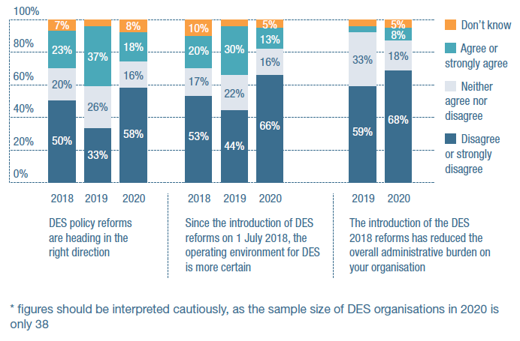

**DES policy reforms are heading in the right direction**

**2018**

Disagree or strongly disagree: 50%

Neither agree nor disagree: 20%

Agree nor strongly agree: 23%

Don’t know: 7%

**2019**

Disagree or strongly disagree: 33%

Neither agree nor disagree: 26%

Agree nor strongly agree: 37%

Don’t know: 4%

**2020**

Disagree or strongly disagree: 58%

Neither agree nor disagree: 16%

Agree nor strongly agree: 18%

Don’t know: 8%

**Since the introduction of DES reforms on 1 July 2018, the operating environment for DES is more certain**

**2018**

Disagree or strongly disagree: 53%

Neither agree nor disagree: 17%

Agree nor strongly agree: 20%

Don’t know: 10%

**2019**

Disagree or strongly disagree: 44%

Neither agree nor disagree: 22%

Agree nor strongly agree: 30%

Don’t know: 4%

**2020**

Disagree or strongly disagree: 66%

Neither agree nor disagree: 16%

Agree nor strongly agree: 13%

Don’t know: 5%

**The introduction of the DES 2018 reforms has reduced the overall administrative burden on your organisation**

**2019**

Disagree or strongly disagree: 59%

Neither agree nor disagree: 33%

Agree nor strongly agree: 4%

Don’t know: 4%

**2020**

Disagree or strongly disagree: 68%

Neither agree nor disagree: 18%

Agree nor strongly agree: 8%

Don’t know: 5%

*figures should be interpreted cautiously, as the sample size of DES organisations in 2020 is only 38

Supported employers’ responses to the new NDIS pricing have been mixed. The Survey indicates that more providers agree than disagree that the pricing will allow them to support NDIS participants in employment. However, this sentiment needs to be monitored. Communication from the NDIA on the roll-out of the pricing has been less than ideal due to difficulties arising from COVID-19 and important preparatory work on the impact of the pricing was delayed well-past 1 July. NDS will continue to work closely with providers and the NDIA to ensure the ongoing transition to the new pricing is as smooth as possible.

Of the 76 ADE organisations that took part in the Survey, 26 per cent said that policy reforms impacting ADEs were heading in the right direction – a significant increase, off a low base, on both the 2018 and 2019 Surveys (15 per cent in 2018 and 12 per cent in 2019). However, 62 per cent disagreed or strongly disagreed with the statement that the current operating environment for ADEs was more certain. Thirty-eight per cent of ADEs said the new pricing arrangements meant they were able to provide the required support for individuals; as a new item added to the 2020 Survey, it will be of interest to follow the longer-term impacts of the pricing arrangement on future support and operations.

The NDIA introduced the ‘Supports in Employment’ pricing on 1 July 2020. The new pricing framework aligns employment support funding to NDIS Community Participation rates.

The pricing is designed to reflect the frequency and intensity of supports received by employees, set out in a ‘typical pattern of support’. While the pricing has been welcomed by many NDS members, large group settings will receive a lower price rate if there are a low number of supervisors to supported employees.

The pricing will drive further evolution of the supported employment model and see it delivered across a wider range of mainstream settings. For example, the pricing may allow more registered NDIS providers to offer social enterprise models in which NDIS participants gain ongoing employment among a diverse workforce.

NDS will be focused on how this new framework affects jobs opportunities for NDIS participants, as well as the general financial viability of disability enterprises. We will work with members and the NDIA to refine the pricing and ensure resources are available to assist providers to claim the support pricing on a consistent basis.

### Figure 18: ADE policy and reform

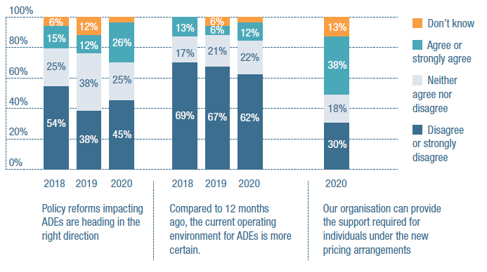

**Policy reforms impacting ADEs are heading in the right direction**

**2018**

Disagree or strongly disagree: 54%

Neither agree nor disagree: 25%

Agree nor strongly agree: 15%

Don’t know: 6%

**2019**

Disagree or strongly disagree: 38%

Neither agree nor disagree: 38%

Agree nor strongly agree: 12%

Don’t know: 12%

**2020**

Disagree or strongly disagree: 45%

Neither agree nor disagree: 25%

Agree nor strongly agree: 26%

Don’t know: 4%

**Compared to 12 months ago, the current operating environment for ADEs is more certain**

**2018**

Disagree or strongly disagree: 69%

Neither agree nor disagree: 17%

Agree nor strongly agree: 13%

Don’t know: 0%

**2019**

Disagree or strongly disagree: 67%

Neither agree nor disagree: 21%

Agree nor strongly agree: 6%

Don’t know: 6%

**2020**

Disagree or strongly disagree: 62%

Neither agree nor disagree: 22%

Agree nor strongly agree: 12%

Don’t know: 4%

**Our organisation can provide the support required for individuals under the new pricing arrangements**

**2020**

Disagree or strongly disagree: 30%

Neither agree nor disagree: 18%

Agree nor strongly agree: 38%

Don’t know: 13%

## Wage-setting arrangements in supported employment remain unclear

At the time of writing, proposed changes to the Supported Employment Services Award are still being challenged in the Federal Court. The changes would see a supported employee’s wage be determined by their work value and output – both of which would be assessed independently. (The plan would be to slowly phase out existing wage assessment tools, and develop more precise ones, once the changes come into effect in 2022.)

The changes would also see the Award’s current classification structure completely overhauled, with two new grades introduced for employees with disability.

NDS is involved in planning for a trial of the wage-setting framework, which has been delayed. Unfortunately, the current court action will cause more uncertainty for supported employment providers during what is already a time of unprecedented economic upheaval.

## Disability Employment Services

The DES program is operating in some of most challenging labour market conditions Australia has seen since Federation. NDS maintains that, in light of these extraordinary circumstances, additional initiatives to assist jobseekers may soon be required.

A review in 2020 by the Boston Consulting Group identified several ways in which the program could quickly become more effective. These included:

* simplifying the current DES contract by reducing its size, scope and level of prescriptiveness and retaining recent reductions in reporting and compliance
* revising the Star Ratings performance framework
* recognising education outcomes if a qualification is gained in a Priority Industry, is of at least six months’ duration and has a work-experience component
* redefining an employment outcome to reflect the ABS definition and remove benchmark hours; and
* automatically assigning level 4 DES funding to eligible school leavers and SLES participants.

We believe that DES and NDIS guidelines should be reviewed to better facilitate mainstream employment and create a separate DES stream for people with more severe disability who are eligible for the NDIS and/or DSP.

A review should address the competing objectives of job preparation, job placement, mainstream labour market employment and the specific employment and career goals of people with disability.

Lastly, we strongly support freeing up access to vocational education and training.

## How NDS is taking action

Throughout 2020, NDS consulted members on a vision for supported employment. We worked closely with stakeholders and the NDIA on the supported employment pricing framework. NDS believes any participant wanting to work should receive the support they need to gain employment.

Throughout out the year, we lodged submissions with:

* the Boston Consulting Group for its review of the DES Program
* the Australian National Audit Office on DSS’s administration of the DES contract; and
* the Australian Government on the Ticket to Work initiative.

Above all else, we have seized every opportunity to highlight the benefits of supported employment and the ways it can be built around people’s interests and skills.

# The state of the workforce

## The challenge of COVID-19

COVID-19 has brought significant disruption to what was already a difficult time for the disability workforce. Along with economic upheaval, the pandemic’s particular challenges have included the inavailability of PPE and the cancellation of many community activities and in-home services. Ever-changing safety requirements have also required a great deal of flexibility on the part of both providers and the people they employ.

All of which may help to explain why many providers still struggled to recruit and retain workers. The challenge of recruiting and retaining competent staff is not getting any easier, despite the fact that NDIS is now being rolled out across the country (noting that implementation of the NDIS Quality and Safeguarding Framework in WA has been delayed until December 2020).

## Recruitment

As in previous years, respondents were asked to rate how easy or difficult it had been to recruit or retain staff in particular roles. When recruiting staff, respondents have found it more difficult to recruit for frontline support worker and allied health roles, than for administrative roles.

Eighty-seven per cent of respondents found it moderately or extremely difficult to fill psychologist roles, 86 per cent for occupational therapists, 83 per cent for speech therapists, and 76 per cent for physiotherapists. These were the roles with the highest proportion of difficult to recruit responses.

The roles reporting the lowest proportion of difficult to recruit were finance (25 per cent), IT (28 per cent), HR (33 per cent), and marketing (34 per cent).

Compared with last year, the percentage of providers reporting difficulty recruiting for some particular roles showed a marked reduction: 58 per cent reported difficulty in recruiting dieticians in 2020, down from 69 per cent in 2019; LACs or planners (44 per cent in 2020 from 54 per cent), managers or supervisors of support workers (55 per cent in 2020 from 64 per cent), and marketing (34 per cent in 2020 from 43 per cent).

### Table 3: Difficulty recruiting support workers, Allied Health workers and administration staff

| Occupation | 2020 Percentage of respondents that answered “extremely or moderately difficult” to recruit |
| --- | --- |
| Psychologist | 87% |
| Occupational therapist | 86% |
| Speech therapist | 83% |
| Physiotherapist | 76% |
| Disability support worker | 59% |
| Dietitians | 58% |
| Managers/supervisors of disability support workers | 55% |
| Support Coordinator | 53% |
| LAC/Planner | 44% |
| Marketing/business development | 34% |
| HR/Workforce Development | 33% |
| Information Technology | 28% |
| Finance/Accounting | 25% |

## Retention

As in previous years, respondents reported it is easier to retain staff than to recruit them.

For example, the roles where the proportion of difficult to retain responses was highest were speech therapists (49 per cent), occupational therapists (48 per cent), psychologists (48 per cent), disability support workers (40 per cent), and physiotherapists (39 per cent). Retaining staff in Finance, IT, Marketing and HR was easier than in roles working directly with people with disability.

With respect to the retention of staff in some roles, there were pronounced reductions over the past year for: dieticians (26 per cent in 2020 from 45 per cent in 2019); marketing people (13 per cent from 24 per cent); and physiotherapists (39 per cent from 43 per cent).

Greater difficulty retaining disability support workers was also reported (40 per cent in 2020 from 34 per cent in 2019).

### Table 4: Difficulty retaining support workers, Allied Health workers and administration staff

| Occupation | 2020 Percentage of respondents that answered “extremely or moderately difficult” to retain |
| --- | --- |
| Speech therapist | 49% |
| Psychologist | 48% |
| Occupational therapist | 48% |
| Disability support worker | 40% |
| Physiotherapist | 39% |
| LAC/Planner | 36% |
| Support Coordinator | 27% |
| Dietitian | 26% |
| Managers/supervisors of disability support workers | 25% |
| HR/Workforce Development | 17% |
| Marketing/Business development | 13% |
| Information Technology | 13% |
| Finance/Accounting | 12% |

## Employment type

NDS’s Workforce Census survey registered a distinct shift towards permanent employment throughout the sector in the latter half of 2019, continuing the trend noted in the previous six-month period. Permanent employees account for 62 per cent of the latest sample, the highest level since data collection started in 2015.

The move towards permanent employment has been attributed to consolidation, following a period of comparative volatility during the NDIS roll-out (a period when casual employment was much more common). The Fair Work Commission’s March 2020 ruling on paying both casual loadings and penalty rates undoubtedly helped to drive this trend.

What the data does not tell us is the impact of JobKeeper payments or of workers being unable to move between providers (to avoid the situation of cross infection), especially in Victoria.

### Figure 19: Type of employment (per cent)

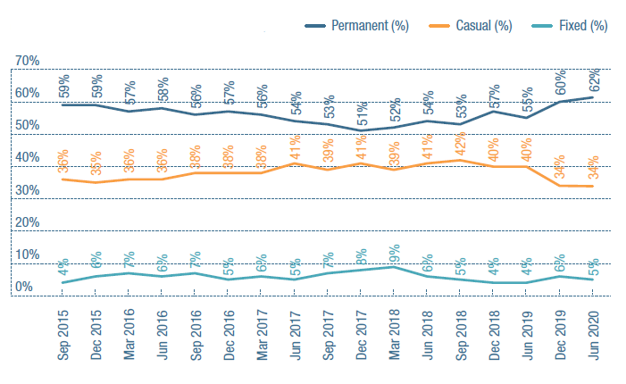

**Sep 2015**

Permanent: 59%

Casual: 36%

Fixed: 4%

**Dec 2015**

Permanent: 59%

Casual: 35%

Fixed 6%

**Mar 2016**

Permanent: 57%

Casual: 36%

Fixed: 7%

**Jun 2016**

Permanent: 58%

Casual: 36%

Fixed: 6%

**Sep 2016**

Permanent: 56%

Casual: 38%

Fixed: 7%

**Dec 2016**

Permanent: 57%

Casual: 38%

Fixed: 5%

**Mar 2017**

Permanent: 56%

Casual: 38%

Fixed: 6%

**Jun 2017**

Permanent: 54%

Casual: 41%

Fixed: 5%

**Sep 2017**

Permanent: 53%

Casual: 39%

Fixed: 7%

**Dec 2017**

Permanent: 51%

Casual: 41%

Fixed: 8%

**Mar 2018**

Permanent: 52%

Casual: 39%

Fixed: 9%

**Jun 2018**

Permanent: 54%

Casual: 41%

Fixed: 6%

**Sep 2018**

Permanent: 53%

Casual: 42%

Fixed: 5%

**Dec 2018**

Permanent: 57%

Casual: 40%

Fixed: 4%

**Jun 2019**

Permanent: 55%

Casual: 40%

Fixed: 4%

**Dec 2019**

Permanent: 60%

Casual: 34%

Fixed: 6%

**Jun 2020**

Permanent: 62%

Casual: 34%

Fixed: 5%

### Figure 20: Full-time permanent and part-time work: employment share (per cent)

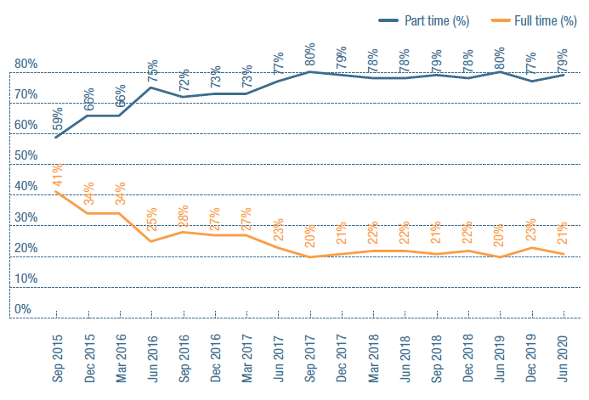

**Sep 2015**

Full time: 41%

Part time: 59%

**Dec 2015**

Full time: 34%

Part time: 66%

**Mar 2016**

Full time: 34%

Part time: 66%

**Jun 2016**

Full time: 25%

Part time: 75%

**Sep 2016**

Full time: 28%

Part time: 72%

**Dec 2016**

Full time: 27%

Part time: 73%

**Mar 2017**

Full time: 27%

Part time: 73%

**Jun 2017**

Full time: 23%

Part time: 77%

**Sep 2017**

Full time: 20%

Part time: 80%

**Dec 2017**

Full time: 21%

Part time: 79%

**Mar 2018**

Full time: 22%

Part time: 78%

**Jun 2018**

Full time: 22%

Part time: 78%

**Sep 2018**

Full time: 21%

Part time: 79%

**Dec 2018**

Full time: 22%

Part time: 78%

**Jun 2019**

Full time: 20%

Part time: 80%

**Dec 2019**

Full time: 23%

Part time: 77%

**Jun 2020**

Full time: 21%

Part time: 79%

## Modern award review

Throughout 2019 and 2020, NDS participated in the Fair Work Commission’s review of the SCHADS Award.

The Commission conducted formal hearings during July and October 2019 and March 2020. NDS participated in the hearings and made several written submissions. In September 2019, an initial decision was handed down. While it rejected some union proposals, it also provided for significant changes to the overtime provisions applying to casual employees, which came into effect in July 2020.

A significant number of issues remain unresolved, however, many of them related to working-time arrangements. Some of the more contentious include minimum engagement, broken-shift and travel-time arrangements, rostering and overtime for part- time employees.

## Quotes from providers

“Allied Health professionals are almost impossible to find in, or entice to, rural areas. The provision of accessible Allied Health services in rural areas is an extremely serious issue that needs to be addressed, as participants in rural areas are highly disadvantaged in accessing these services.”

“We are putting workers with lower qualifications in high-risk roles for minimum income. We aren’t able to retain staff as they’re wanting more permanent opportunities, as well as the opportunity for growth. We are always recruiting for support workers to keep up with the demand and the turnover in staff.”

“We have difficulty recruiting competent DSWs. There is a great demand for their services from individuals and organisations. We pay above the Award.”

“There is a great need to develop a bilingual workforce to provide services to CALD people with a disability, and their carers and families, to meet their cultural, linguistic and religious needs.”

“We’ve recruited throughout COVID-19 and been able to attract a lot of talent from corporate sectors.”

## How NDS is taking action

In 2020, NDS engaged an external industrial relations expert to represent our members throughout the SCHADS Award review proceedings. We also continued to:

* collect and analyse workforce data through the NDS Workforce Census survey
* provide a one-stop-shop of disability workforce tools and resources on the NDS Workforce Hub
* offer peer mentoring and professional development opportunities
* host online workforce conferences and seminars; and
* offer sector-specific career advice and recruitment tools through carecareers.com.au.

# Case Study: South Australia

## Liz Cohen, CEO, Cara

**Tell us about Cara**

We’re a leading South Australian disability organisation, employing more than 1,000 staff. Essentially, we’re all about providing person- centred, active support. That means doing things ‘with’ people, rather than ‘for’ or ‘to’ them. That means working alongside people and offering them our support as they cook, shop, garden, and spend time with family and friends.

**What does an average day look like?**

As Chief Executive, my role is to bring our community together in order to achieve our strategic direction. To that end, a typical day for me can mean meeting with our customers and their representatives, our Executive and staff, or touching base with external stakeholders such as Government and other disability organisations – all in order to build a better Cara that delivers high quality services for our customers

**Is there much room for innovation? Do you think an average day will look different in five or ten years?**

There’s a great deal of opportunity for innovation in the disability sector.

We see technology as an avenue for our customers to achieve things they may never have thought possible. Of all areas of our business, this is the one that may have the greatest impact on everyone’s lives.

**Why did you get into the disability sector?**

My sliding door moment was in 1987 when I was working as a teacher in Nhulunbuy in the NT. I taught a young blind student who brought a whole new perspective to my life and shaped my values and view of the world.

After working with her, I realised my passion was to support people with disability in education and life.

It’s definitely the most rewarding work I could ever have imagined being involved in.

**What’s surprised you most?**

I continue to be amazed by what our customers achieve every day. Many of them are doing things that they never would have thought possible a few years ago.

One, who we work alongside in Supported Independent Living, is a passionate sailor. When he was born, his family was told that he wouldn’t live to see 20. He is now in his late sixties and has competed at international competitions in accessible sailing.

Another customer, from Port Lincoln, was part of the local Tunarama Festival and the first entrant with disability. She won the fundraising and people’s choice awards.

**What have been some of the major challenges in recent times?**

Navigating the impacts of the COVID-19 pandemic has been particularly challenging for us, as it has been for just about everyone in the sector and the wider business community. However, we were proactive early, taking a careful and considered approach to all that we do has enabled us to provide our customers and staff with a safe environment.

On another level, the disability workforce is expected to double in size in the next few years and providers across the sector are definitely feeling pressure to secure quality staff.

## Key issues

### 1. The death of Ann Marie Smith

The circumstances around the tragic death of Anne Marie Smith left an indelible mark on the disability sector in 2020. The tragedy underscored the importance of a strong and robust national regulatory framework underpinned by legislation to protect all NDIS participants.

There has been, and will be, a lot said about the systemic and other failures that occurred in the lead-up to Ms Smith’s untimely death. But, as a community and sector, the onus falls heavily on us to ensure that people receive nothing short of high-quality disability services.

### 2. Thin markets and early childhood early intervention

Thin markets continue to persist in South Australia, especially outside of metropolitan and regional centres.

Also of concern is the lack of early childhood early intervention services being delivered into remote communities such as the Anangu Pitjantjatjara Yankunytjatjara Lands.

The NDIS must ensure it is delivering for all South Australians, not just those who live in convenient locations.

### 3. Quality audits

Many South Australian providers have completed their stage two quality audits but remain frustrated by the lack of local auditors and the inconsistency in the auditing processes.

Providers are also unable to track their progress towards certification, with some waiting months for process finalisation.

## SA sector stats

39,091 NDIS plans approved

121% of bilateral estimate

5.6% of NDIS participants are Indigenous

7.5% are culturally and linguistically diverse

# Case Study: Western Australia

## Robert Holmes, CEO, Enable

**Tell us about Enable**

Enable is the largest regionally based disability provider in WA. We provide in-home and in-community support, as well as a therapy service arm.

**What has been your proudest achievement?**

The development of Enable WA from a very small, locally focussed group to an organisation that now encompasses the southwest of the state, and beyond, is a major achievement that I feel pretty proud of.

**What does an average day look like?**

For me, there’s never an average day. Apart from the usual requirements of any CEO, like meetings and emails and so on, my days vary greatly. I enjoy the variety that comes from connecting with so many different colleagues, clients and families. It keeps me focussed and engaged.

**Is there much room for innovation?**

I think there is always room for innovation. We have completely upgraded our IT systems in recent years, and substantially changed our service delivery models and management structures as a way of keeping pace with change. Creating all these self-managed teams within a hub model has been an exciting development too.

COVID-19 has given all of us a pretty big foretaste of probable changes to the ways we all work. What exactly those changes will be is open to conjecture but it’s clear that technology will play a major role.

But even without COVID-19, organisations should always be looking for continuous improvement and that alone should be enough to change how we operate.

**What do you think are some of the major opportunities awaiting the sector, in general?**

The greatest opportunity is the advancement of technology. It will help people with disability to live more independent lives and it will help organisations to become a lot more efficient and just generally provide better supports.

I also think we’re seeing the development of a much more understanding and inclusive community in general. That will hopefully mean greater access, and therefore greater opportunities, for people with disability.

There’s also more recognition of the economic value that the sector provides in Australia, rather than just the social value, which I tend to find very encouraging.

**What’s surprised you most?**

The scope of change in the sector, and its complexity, coupled with the variety of the opportunities available, if you’re minded to take them.

**If you could change one thing, what would it be?**

I’d love to change the inflexible and overly complex IR system that we have, especially the SCHADS Award which in my view impedes service delivery rather than assisting it. We need to create a balanced employment Award that responds to the needs of the sector whilst protecting the employee.

**What have been some of the major challenges in recent times?**

I’ll give you four, if I may! One, COVID-19 and everything associated with it. Two, the implementation of the NDIS. Three, the quality and safeguards requirements. And four, the IR system.

## Key issues

### 1. Maximising the benefits of the NDIS

NDS continues to advocate for Scheme implementation to be informed by local conditions. This is particularly important for regional, rural and remote communities who may have limited access to disability services.

The State Government recently announced a further $14m to support the sector for NDIS transition in WA.

### 2. Office of Disability and State Government Stewardship

NDS supports the establishment of an Office of Disability to champion the rights of people with disability. It will provide strategic leadership and expertise across the Department of Communities, the WA Government and the disability sector. The Office will be critical to resolving NDIS transition issues in WA, such as gaps between mainstream services and the NDIS.

### 3. More time to transition to the NDIS Quality and Safeguarding Commission

In May 2020, the WA and Federal Governments agreed to provide more time for WA’s transition to the NDIS Quality and Safeguards Commission (to 1 December 2020). This decision has allowed service providers in WA to focus on critical support issues for people with disability during the COVID-19 recovery period.

## WA sector stats

35,423 NDIS plans approved

92% of bilateral estimate

6.8% of NDIS participants are Indigenous

8.5% are culturally and linguistically diverse

# The state of the Royal Commission

Even the Royal Commission wasn’t immune to the impact of COVID-19.

With in-person events suspended after just a single hearing in February, the Commission turned its focus to issues papers. Six papers were released throughout the course of year, covering topics such as restrictive practices, emergency response, employment, and rights and attitudes. NDS responded to each.

Thankfully, hearings were able to resume in August, with one or two held each month to December. They gathered evidence from a wide array of witnesses, including providers, people with disability and several senior Government and Agency representatives.

In May, some providers received notices to produce information. The scope of these requests was broad-ranging and the level of detail they required quite extensive. During an NDS ‘Essential Briefing’ in August, some NDS members noted that the process of producing this information involved significant costs, while others welcomed the opportunity to appraise their services and potentially invest in better management systems.

The Interim Report, released in October, covered the first 15 months of the Commission’s work to 31 July 2020, including its hearings on education, group homes and healthcare for people with cognitive disability. While the report doesn’t include recommendations, it contains numerous lessons for providers. The Commission emphasises the need for true choice to be facilitated for people with disability, for access to the community and for complaints to be responded to appropriately. It notes it will hold hearings on employment and day services, and that it will continue to examine restrictive practices and group homes. Based on questions Commissioners have asked to date, it appears significant policy reform is on the table.

Meanwhile, NDS continued to help members keep across, prepare for and contribute to this once-in-a-generation opportunity for reform. Throughout the year, we expanded our expert panel, added resources to our Royal Commission hub and released summaries of each day of hearings. We also hosted regular events to keep our members appraised of developments, and provide them with a sense of what may lie ahead.

With the Royal Commission’s schedule indicating that hearings will focus on service providers in 2021, and the possibility of an extension of the Final Report to 2023, providers are encouraged to review the way they are supporting people and consider improvements that could be made.

## How NDS is taking action

* Contributing to the Royal Commission by providing submissions in response to issues papers.
* Providing up-to-date summaries and analyses of Commission hearings and reports via news updates, newsletters, webinars and other material.
* Supporting providers to prepare for, and respond to, the Commission by expanding the number and types of expert panellists on the NDS Royal Commission Hub.
* Promoting our range of Zero Tolerance resources to help prevent violence, abuse, neglect and exploitation of people with disability.

# Case Study: Victoria

## Anne-Maree Davis, CEO, Amicus

**Tell us about Amicus**

Amicus delivers services to people with disability and vulnerable children across central and northern Victoria. The services that we offer are individualised, tailored and flexible – we call it a ‘one person at a time’ approach.

Basically, we believe that services are more successful when they are personalised, and focussed on fulfilling each individual’s individual goals.

**What does an average day look like?**

Is there such a thing as an average day? In Victoria at the moment, each day is very focussed on our COVID-19 response and making sure that our participants and staff can all remain COVID-free. That basically means that a lot of us are spending a lot of time alone and online, rushing from one Zoom meeting to another.

But outside of that, when you deliver a truly personalised service, no two days are ever the same. There are always new opportunities to navigate and new challenges to overcome.

**Is there much room for innovation?**

I think that it will be very interesting to see the long-term effects of COVID-19 and how they might impact the communities in which we work, and change the ways we connect and engage with each other. All organisations in our sector have had to pivot pretty quickly to respond to the evolving COVID-19 situation in their respective state or territory, and for some this has involved delivering services virtually. Will we all go back to the way things were? I’m not sure about that.

**Why did you get into the disability sector?**

I’ve always been pretty passionate about human rights and equality.

I started out as a nurse in an aged care setting at a time when adults with disability were routinely being admitted into aged care when their ageing carer required nursing home care. It was a truly distressing experience but it certainly spurred my interest in undertaking study to try and find different solutions.

**What’s surprised you most?**

I am not sure if this counts as surprising or just disappointing but I found the lack of prioritisation for our sector when it came to necessary and required PPE during COVID-19 a real eye-opener, and I know I am not alone in this.

**If you could change one thing, what would it be?**

Only one thing? Then it would have to be a world that embraced equality and inclusion!

As an example of this in recent times, we have been seeing an increasing number of children with disability go into special education rather than regular schools. We know that children who have mainstream education tend to have greater opportunities for inclusion throughout life, so I believe we need to work to reverse this trend.

**What have been some of the major challenges in recent times?**

Without a doubt, 2020 will be remembered for the impact that COVID-19 has had across the globe and for all of the challenges it presented for our sector when it came to maintaining continuity of operations.

Apart from that, there are still significant issues with the NDIS and the rollout of the NDIS Quality and Safeguards Framework that need to be addressed. And for many organisations like Amicus, growth and demand for services has also presented challenges, particularly when it comes to accessing a skilled workforce.

## Key issues

### 1. COVID-19 and worker mobility

COVID-19 has challenged existing workforce arrangements. In an effort to reduce worker mobility, many residential services have rejigged their rosters and deployment of staff. We welcomed the joint State and Federal Government announcement of a funded Worker Mobility Scheme to support restrictions in disability residential services with a ‘one worker to two sites’ cap.

### 2. PPE: Supply and funding

The pandemic left disability services scrambling to access sufficient PPE, with many turning to the NDS Coronavirus hub, the national stockpile, the Victorian Government or supply chains established by fellow providers. Providers experienced difficulty obtaining a sufficient and timely supply, especially when the Victorian Government increased the required levels of PPE in August 2020. There has also been widespread concern with the model of expense reimbursement. Following strong sector advocacy, the NDIA responded with an amended PPE funding process.

### 3. Business continuity and adapting to ‘COVID-19 normal’

Due to the extraordinary efforts of many people, the potential for further COVID-19 outbreaks has been reduced. Focus is now shifting from emergency response to operating in a ‘COVID-normal’ environment. Higher levels of infection control and adherence to social distancing requirements is required. At the same time, organisations need to respond to the withdrawal of JobKeeper payments and changing NDIA group and SIL prices. All of this results in a very challenging business environment.

## Vic sector stats

116,683 NDIS plans approved

111% of bilateral estimate

2.8% of NDIS participants are Indigenous

11.4% are culturally and linguistically diverse

# Case Study: Tasmania

## Allyson Warrington, CEO, Community Based Support

**Tell us about CBS**

CBS supports people who have a disability to live the lives they choose while living in their own homes for as long as possible. The support we provide is tailored to individual needs. It’s about finding the solutions that best suit the person.

**What has been your proudest achievement?**

In this topsy-turvy year, I’m proud of the way that our CBS team has managed to implement a new client management system, and really pivot all our services, in order to support clients who are dealing with the isolation of COVID-19.

**What does an average day look like?**

Depending on each client’s needs, our support workers can sometimes start their days as early as 6am and finish as late as midnight. The individual supports they provide can include anything from in-home care and daily exercise routines, to shopping and social outings.

**Is there much room for innovation?**

Absolutely! If we don’t innovate we will be left behind, that’s for sure. I am definitely a person who looks at ways to innovate and to create efficiencies. In the future, I’d like to see us streamline more of our office processes, remove duplications, create less paperwork, and just generally make interaction easier between ourselves and our clients, with a focus on high-quality service delivery and safety.

Our clients are definitely keeping up with all the latest technological advancements so we need to get ahead of the curve.

In five or ten years, we may still be providing the same general type of supports, but how we provide them, what tools we use, our focus on quality and safety, and how we back it all up with office support, data capture and outcome reporting should all be much more efficient, which will free up more time for client interactions.

**What excites you about the future?**

Working in disability means having the opportunity to profoundly impact someone’s life. The opportunities are endless.

**What’s surprised you most?**

The growth in the sector has surprised me. I think it’s probably surprised everyone.

I definitely see that rate of growth reflected in our own client intakes and in NDIS participant numbers more generally.

**What’s impressed you most?**

Our staff. They are often put in very challenging situations but every day they continue to turn up to work with a smile on their face and a genuine desire to make a big difference.

**If you could change one thing, what would it be?**

Funding. There are situations where the funding participants receive is simply not enough to deliver the support required.

**What have been some of the major challenges in recent times?**

COVID-19 has been challenging to navigate. We’ve been in daily contact with our teams in the office and the field.

## Key issues

### 1. NDIS and mainstream interface

The introduction of the NDIS disrupted relationships, processes and protocols that had been developed over many years. Collaboration between disability and other service systems was impacted.

The COVID-19 pandemic caused further disruption. At the interface between the NDIS and systems such as health, housing, transport, justice and child safety, we are seeing more carers and people with disability caught between contested funding responsibilities.

### 2. Workforce challenges

Tasmanian providers still struggle to attract and retain staff. With adequate investment, the disability sector can help drive employment and economic growth in Tasmania.

### 3. Preparedness for COVID-19

The disability sector in Tasmania needs to be prepared for a potential second wave of COVID-19. The response from Government departments needs to be swift and disability-specific.

## Tas sector stats

9,752 NDIS plans approved:

92% of bilateral estimate

8.2% of NDIS participants are Indigenous

3.1% are culturally and linguistically diverse

# The state of the broader policy environment

The sheer size of the NDIS – and the effort required to implement and refine it – means that it tends to dominate the bulk of policy discussion. There are plenty of disability- related reforms going on outside the NDIS however, though some of these have stalled under COVID-19.

## More DSP recipients and workforce participation continues to decline

The number of Disability Support Pension (DSP) recipients has been rising for the first time in six years. Some 752,191 people claimed the pension in the year leading up to 30 March, a 0.6 per cent increase on the year before.

On the other hand, the number of DSP recipients who earn a wage continued to fall. This decline will be difficult to turn around, not least because the March data did not factor in COVID-19 and the economic damage that it has since caused. High unemployment may well compromise the NDIA’s commitment to increasing the proportion of NDIS participants in employment to 30 per cent in the next three years.

At this critical time, NDS believes it is vital that the Government addresses disincentives to employment for DSP recipients, and puts jobs at the centre of NDIS plans for all participants of working age.

## Disability Strategy delayed

It is disappointing that yet another year has passed with little progress on a new National Disability Strategy. While consultations were conducted in the latter part of 2020, a draft Strategy is still to be released.

The review of the National Arts and Disability Strategy has also stalled, in part due to COVID-19. We hope this important work will recommence soon. A substantial number of people with disability (including NDIS participants) are able to derive income from their art work, but many of them need assistance to do so.

## National Disability Agreement not in sight

Early in 2019, the Productivity Commission released its findings on the National Disability Agreement (NDA) – a high-level document that defines the responsibilities of the federal, State and Territory governments in relation to disability services.

In those findings, the Commission recommended the development of a new NDA: one which establishes a single, strengthened national performance reporting framework, and requires outcomes to be tabled in Parliament every two years and published regularly.

We believe that such an NDA is urgently needed. Without it, there is little incentive to solve the problems at the interface between the NDIS and governments. A well-constructed, national performance reporting framework could help drive greater accountability for priorities in the National Disability Strategy.

## Review of the Disability Standards for Education

In 2020, NDS responded to the review of the Disability Standards for Education, noting our disappointment with its lack of progress. A common story prevails: the Government has a framework for improving the education of children with disability but does not have mechanisms to drive accountability and progress.

The Disability Royal Commission has given families a voice on how education systems are failing their children. Perhaps it will help to drive the reforms that so many children clearly require.

## How NDS is taking action

* Contributing to the development of the next National Disability Strategy, and its outcomes measurement.
* Responding to policy reviews of interest to the sector.
* Engaging with disability advocates to support issues of concern to people with disability.
* Informing governments on interface problems between the NDIS and mainstream services.

# Back cover page

**Publisher**

National Disability Services

**David Moody**

CEO

03 8341 4343

[david.moody@nds.org.au](mailto:david.moody@nds.org.au)

All rights reserved. No part of this publication may be reproduced, distributed or transmitted in any form without the prior written permission of the publisher. Except in the case of brief quotations embodied in critical reviews and certain other non-commercial uses permitted by copyright law.

## About National Disability Services

National Disability Services is Australia’s peak body for non-government disability service organisations, representing over 1000 service providers. Collectively, NDS members operate several thousand services for Australians with all types of disability.

## Acknowledgements

The 2020 Annual Market Survey was carried out by the Centre for Social Impact at the University of New South Wales.

**Associate Professor Gemma Carey**

Research Director

Centre for Social Impact, UNSW gemma.carey@unsw.edu.au

**Dr Megan Weier**

Research Fellow

Centre for Social Impact, UNSW www.csi.edu.au

Thank you to members who participated in our case studies.

National Disability Services acknowledges the Traditional Owners and Custodians across the lands in which we live and work and we pay our respects to Elders both past and present.