National Disability Services Submission

NDIS Review – Have your Say

NDIS Independent Review Panel

About National Disability Services
National Disability Services (NDS) is Australia's peak body for non-government disability service organisations, representing more than 1000 non-government service providers. Collectively, NDS members operate several thousand services for Australians with all types of disability. NDS provides information and networking opportunities to its members and policy advice to State, Territory and Commonwealth governments. We have a diverse and vibrant membership, comprised of small, medium and larger service providers, supporting thousands of people with disability. Our members collectively provide a full range of disability services, from supported independent living and specialist disability accommodation, respite and therapy, to community access and employment. NDS is committed to improving the disability service system to ensure it better supports people with disability, their families and carers, as well as supports building a more inclusive community.

Contents
About National Disability Services 1
Contents 1
About this submission 2
NDS’s State of the Disability Sector Report 2
The Pulse Survey 9
What areas of the NDIS work well for your participants and organisation? 11
What areas of the NDIS need to be improved to work better for your participants and organisation? 13
What do you think would be a 'quick win' to address inefficiencies or waste in the NDIS that would benefit participants and the sector? 16
What are disability leaders saying? 19
A note about ‘quick wins’ 20
Relevant Issues 20
Regulation and registration 20
Pricing 21
Working together 23
Conclusion 26
Attached 28

About this submission
NDS welcomes the opportunity to provide this early submission to the National Disability Insurance Scheme (NDIS) Review. The Independent Review Panel is seeking feedback to inform the findings of the NDIS Review and this submission will explore the questions outlined in the ‘Have your say’ survey:
- What are your three main problems or concerns with the NDIS?
- How do these three main problems affect you and/or others?
- What do you think are possible solutions to those problems?
- What parts of the NDIS are working well for you?

NDS’s State of the Disability Sector Report
NDS’s State of the Disability Sector report is based on data collected from disability service providers and has been running for 9 years. Conducted in partnership with the Centre for Disability Research and Policy at the University of Sydney, the 2022 report is based on responses from 364 providers from every state and territory, from sole traders to large multi-state organisations, delivering a wide range of services. The latest data was collected in across August and September 2022 (shortly before the NDIS Review was officially launched).
The 2022 Report identifies a number of issues that are useful to consider in the context of the NDIS Review. A key theme from the 2022 Report that characterises the experience of providers delivering NDIS services is the impact that unclear and constantly evolving operational processes and procedures have on the capacity of the sector to provide high quality supports that meet the needs of NDIS participants.
As with previous years, the effectiveness of the National Disability Insurance Agency’s (NDIA’s) approach to working with providers continues to be an issue. While this has improved compared to previous years, the working relationship between providers and the NDIA is poor. Two thirds of respondents (64 per cent) disagreed or strongly disagreed that the NDIA is working well with providers (and only 11 per cent believe that they are working well).

Figure 1: Perception of the NDIS environment - the NDIA is working well with providers
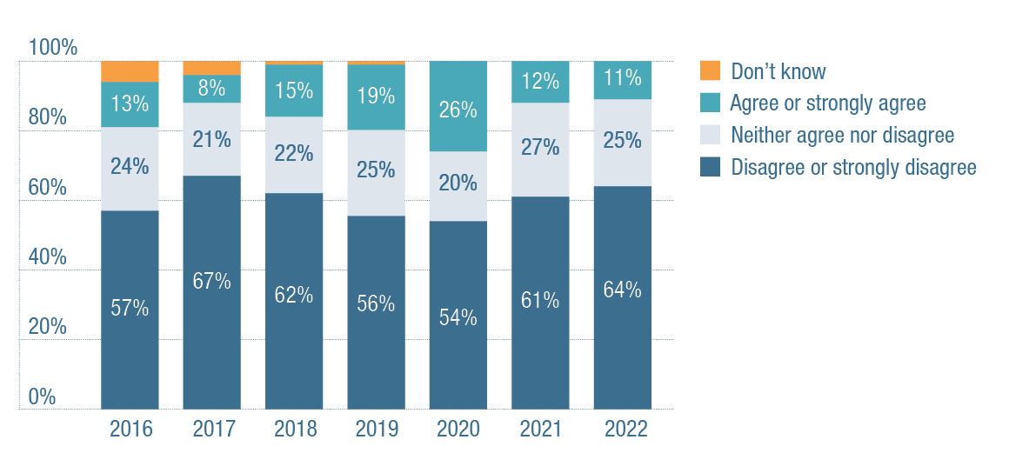
 | 2016 | 2017 | 2018 | 2019 | 2020 | 2021 | 2022
Don’t know | Less than 10 per cent | Less than 10 per cent | Less than 5 per cent | Less than 5 per cent | 0 per cent | 0 per cent | 0 per cent
Agree or strongly agree | 13 per cent | 8 per cent | 15 per cent | 19 per cent | 26 per cent | 12 per cent | 11 per cent
Neither agree nor disagree | 24 per cent | 21 per cent | 22 per cent | 25 per cent | 20 per cent | 27 per cent | 25 per cent
Disagree or strongly disagree | 57 per cent | 67 per cent | 62 per cent | 56 per cent | 54 per cent | 61 per cent | 64 per cent
Providers continue to be concerned about the policy environment with some improvement compared to previous years. In 2022, 79 per cent thought that the NDIS policy environment was uncertain.
Figure 2: Perception of the NDIS environment - the NDIS policy environment is uncertain
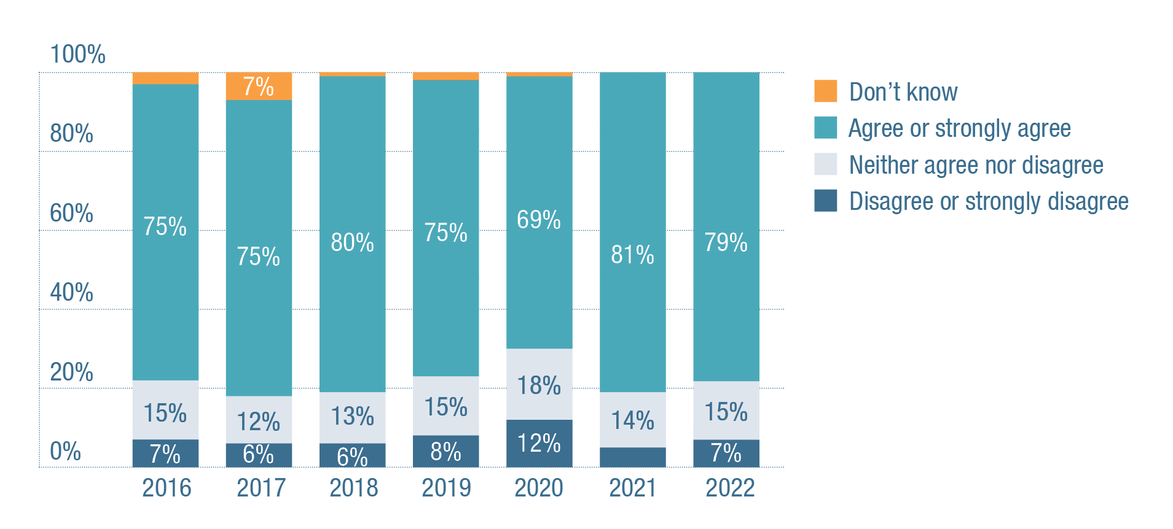
 | 2016 | 2017 | 2018 | 2019 | 2020 | 2021 | 2022
Don’t know | Less than 10 per cent | Less than 10 per cent | Less than 5 per cent | Less than 5 per cent | Less than 5 per cent | 0 per cent | 0 per cent
Agree or strongly agree | 75 per cent | 75 per cent | 80 per cent | 75 per cent | 69 per cent | 81 per cent | 79 per cent
Neither agree nor disagree | 15 per cent | 12 per cent | 13 per cent | 15 per cent | 18 per cent | 14 per cent | 15 per cent
Disagree or strongly disagree | 7 per cent | 6 per cent | 6 per cent | 8 per cent | 12 per cent | Less than 10 per cent | 7 per cent
‘The lack of consistency from the NDIA when we call about issues for clarification is poor. The rules change and the lack of information or reasoning is not clear for many of the participants we support. It is felt that NDIA has made changes and informed providers and expected us to communicate the changes to participants and families, leaving us open to the backlash when the changes are not our decision.’
Vic small not-for-profit, 2022 NDS State of the Disability Sector Report
Overall, the number of respondents who ‘agreed’ or ‘strongly agreed’ that ‘the risks that the NDIS presents to my organisation outweigh the opportunities’ sat at 30 per cent (roughly the same as the previous three years). Alarmingly few organisations plan to deliver new types of services in the year to come, even though many were unable to meet the demand for services over the course of the last 12 months, often due to a shortage of workers.
Providers reported that unfunded activity, such as helping people understand and navigate the Scheme, was distracting from direct service provision (together with a related concern that there was insufficient advocacy for NDIS participants). 73 per cent thought that there is not sufficient advocacy for the people they support; only 14 per cent agreed. Respondents agree that helping people understand and navigate the Scheme is taking them away from service delivery.
Figure 3: Perception of the NDIS environment – helping people understand and navigate the Scheme is taking us away from service provision
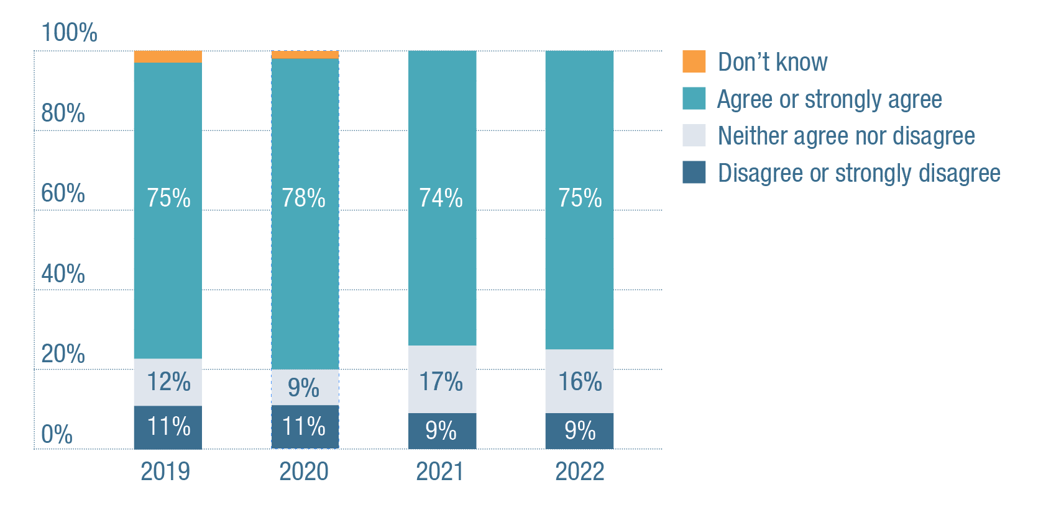
 | 2019 | 2020 | 2021 | 2022
Don’t know | Less than 10 per cent | Less than 5 per cent | 0 per cent | 0 per cent
Agree or strongly agree | 75 per cent | 78 per cent | 74 per cent | 75 per cent
Neither agree nor disagree | 12 per cent | 9 per cent | 17 per cent | 16 per cent
Disagree or strongly disagree | 11 per cent | 11 per cent | 9 per cent | 9 per cent
As indicated providers are willing to assist people to understand and engage with the NDIS however this comes at a cost which is unfunded and places addition pressure on providers already struggling to meet demand and deeply concerned about the ongoing viability.
More generally the report indicates that there is a sense of real and growing optimism about the new federal government’s NDIS reforms. High levels of pessimism in 2021 have turned into greater optimism that NDIS policy reforms are heading in the right direction in 2022. Up from 25 per cent last year (the lowest level ever recorded), 43 per cent of respondents agreed or strongly agreed that NDIS policy reforms were heading in the right direction. However, seen over a longer period, the 2022 results are returning to pre-pandemic levels, which have not been higher than 55 per cent between 2016 and 2021.
‘We are looking forward to a change in direction from Minister Shorten – however, it is still early days.’
Tas large not-for-profit, 2022 NDS State of the Disability Sector Report
‘I am hopeful things will improve under the new government – early indications are positive, but I fear operationalising good intent will take time.’
Vic large not-for-profit, 2022 NDS State of the Disability Sector Report
Figure 4: Perception of the NDIS environment – NDIS policy reforms are heading in the right direction
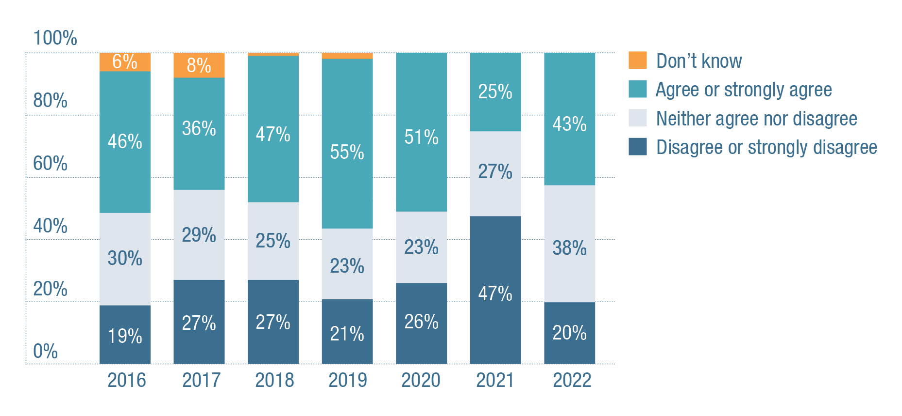
 | 2016 | 2017 | 2018 | 2019 | 2020 | 2021 | 2022
Don’t know | 6 per cent | 8 per cent | Less than 5 per cent | Less than 5 per cent | 0 per cent | 0 per cent | 0 per cent
Agree or strongly agree | 46 per cent | 36 per cent | 47 per cent | 55 per cent | 51 per cent | 25 per cent | 43 per cent
Neither agree nor disagree | 30 per cent | 29 per cent | 25 per cent | 23 per cent | 23 per cent | 27 per cent | 38 per cent
Disagree or strongly disagree | 19 per cent | 27 per cent | 27 per cent | 21 per cent | 26 per cent | 47 per cent | 20 per cent
Finally, this year the report identified that while the disability sector wants and needs more reform, it is also suffering from change fatigue. Far too many leaders have spent far too much time dealing with never-ending NDIS changes. And far too many disability workers feel exhausted by the challenge of constantly learning new systems and the complex administrative sagas that each tend to involve.
In the context of the current NDIS Review these results present both challenges but also opportunities. The survey points to clear areas where improvements can be made, in processes, communication and establishing a more positive relationship with the NDIA. Providers are facing the future with a sense of optimism about changes to come however at the same time are ‘change fatigued.’ Implementation of outcomes from the NDIS Review will need to be both incremental and considered.

The Pulse Survey
To inform NDS’s preliminary work on the NDIS Review, NDS released a Pulse Survey to gather the early views of members. The Survey was released into the field for a 10-day period from 9 November to 20 November 2022.
137 validated responses were received.
The following tables provide an overview of who responded to the survey.
Type of organisation | # | %
For Profit | 31 | 23%
Not for Profit | 90 | 66%
Social Enterprise | 10 | 7%
Not stated | 6 | 4%
Total | 137 | 100%

size of ORGANisation | # | %
I am a Sole Trader | 3 | 2%
Less than 50 People | 40 | 29%
Between 50 - 199 people | 46 | 34%
Between 200 - 999 people | 37 | 27%
More Than 1,000 people | 6 | 4%
Not stated | 5 | 4%
Total | 137 | 100%

Income | # | %
Less than $1 million | 25 | 18%
$1 million to less than $5 million | 29 | 21%
$5 million to less than $20 million | 47 | 34%
More than $20 million | 30 | 22%
Not stated | 6 | 4%
Total | 137 | 100%

Location | # | %
ACT | 5 | 4%
NSW | 37 | 27%
NT | 3 | 2%
QLD | 12 | 9%
SA | 15 | 11%
TAS | 4 | 3%
VIC | 40 | 29%
WA | 18 | 13%
Not stated | 3 | 2%
Total | 137 | 100%
The survey asked three simple questions:
- What areas of the NDIS work well for your participants and organisation?
- What areas of the NDIS need to be improved to work better for your participants and organisation?
- What do you think would be a 'quick win' to address inefficiencies or waste in the NDIS that would benefit participants and the sector?
Respondents were asked to enter a free text response of less than 150 words. The results along with quotes from those responding are explored below.

What areas of the NDIS work well for your participants and organisation?
When asked what was currently working well for the participants that they were supporting and for their organisations, respondents provided a range of views. These have been summarised below.
Scheme
Choice and control for participants was highlighted frequently by respondents as working well, which has enabled individualised services that meet a participant's unique needs. The philosophy and guiding principles of the NDIS has been successful in linking participants to their community through the application of flexible and individualised funding. Respondents also highlighted the positive impact of the standardisation of processes and systems and improved representation of people with disability on the NDIS Board.
“The NDIS concept itself is a good one and when everything works as it should it changes lives. A long overdue response to the needs of people living with disability”
Supports
“For some individuals, the NDIS has opened up new and exciting opportunities in their chosen communities”
Respondents suggest access to specialised supports and services has improved for people with disability because of the NDIS, including access to therapy and equipment needs, employment supports, support coordination, group supports and day programs, funding for behaviour support practitioners and overall, better supports available for people in remote areas. Longer term plans, when approved, are working well in addition to planning for participants with stable needs.
“When budgets are stable and can be predicted into the foreseeable future, participants and their providers settle into a pattern of support and enjoy productive relationships and outcomes”
Providers
Cooperation between providers to support participants to get the best outcome for people with disability was raised by respondents as working well, in addition to the ability to navigate the NDIS and other support systems. Some respondents expressed that a national approach to compliance and oversight through the NDIS Quality and Safeguards Commission (NDIS Commission) has worked well, while others noted that efficiency in payment and claiming processes through the NDIA have improved. Access to COVID payments and supports were also viewed positively.
“Generally speaking, our participants have been able to access a whole range of more diverse supports under the scheme which has improved their quality of life. The scheme has also forced providers to think beyond the areas of supports they previously provided to focus more on the needs and choices of participants”
Key areas of the NDIS that work well for participants and organisations identified were:
- Choice and control for participants
- Flexible and individualised funding
- Longer term plans (when approved)
- Philosophy and guiding principles of the NDIS
- Access to specialised supports and services.

What areas of the NDIS need to be improved to work better for your participants and organisation?
Providers responding to the survey were also asked what needed to improve for the NDIS to work better for the participants that they support and for their organisations. The key areas identified are summarised below.
Scheme
The survey revealed that respondents do not feel that the NDIS provides appropriate funding and supports to marginalised groups, e.g., participants with psychosocial disability, First Nations and culturally and linguistically diverse people with disability. Respondents identified that NDIA staff need more training to provide consistent advice to participants and providers, and Planners and Partners in the Community need skills to understand real support needs and assist in advocating for participants’ needs more effectively.
“Supports need to be outcome focused with appropriate training opportunities and accountability measures embedded into support provision”
Respondents frequently stated that the Scheme is too complex and should be simplified and more predictable for providers and participants alike. Several areas for improvement were highlighted including that participants and providers should each have a single point of contact with the NDIS; transparency in tribunal process; improved response times from the NDIA; turnaround of AAT requests; and ensuring external review outcomes (including AAT) lead to changes in practice and decision making.
Most importantly, respondents called out the need for greater consistency in decision making across the Scheme. Specifically, respondents highlighted that there needs to be better consistency in planning decisions (particularly Specialist Disability Accommodation and Supported Independent Living) and uniform interpretation of NDIS eligibility, application of reasonable and necessary supports, operational policies and practices within the NDIA to ensure transparency and accountably in decision making. Respondents raised that imbalances in funding packages need to be addressed and plan approval and review processes need to be faster, more consistent and with greater participant consultation, including participants having the opportunity to review their draft plan and provide feedback before the plan is 'approved'.
“Transparency, relevant guiding information in terms of changes to policy and practice by the NDIA. The shifts in practices from the Agency around plans, funding, assessments have been ad hoc. The is a lack of policy direction, guidelines and consistency. Additionally, there has been little transparency and engagement with participants and their support networks leaving providers to fill this space. It is difficult to run an organisation sustainably if the goalposts are constantly shifting, there is no connection between quality and compliance regulation and plan/funding decisions”
Supports
“Implementing draft plans would be a quick win, as was recommended from the Tune review. During the planning process, if a draft plan is made available to be discussed, it could improve planning outcomes and lead to less internal and external reviews. Any blaring omissions or mistakes can be rectified and discussed in the planning meeting”
Respondents were clear that supports and funding should be outcomes focussed and appropriate training and accountability measures should be embedded into support provision. More structure and transparency are needed for participants and providers around the management of funds and increased flexibility would allow providers to work in a culturally safe way. Respondents identified the need for increased supports for people to navigate the NDIS, understand planning processes and engage effectively with the provider market. Better support for participants (particularly those experiencing intersectionality) with underutilised plans to ensure funding meets their needs was also noted as an improvement.
The need for longer term supports and plans was highlighted by several respondents, including the increased need for support coordination to improve efficiencies and consistency in decision making. Greater inclusion and alignment of employment outcomes for people with disability was identified as an improvement opportunity for the Scheme, enabling organisations to provide better supports for participants into employment that reflects good practice.
“The imbalance of funding packages needs to be addressed. While uniform slide rule calculations are not suited, packages based on outcome deliverables would assist those that want more from their plan”
Providers
“Pricing that takes in to account the true cost of service delivery, which include training and development of direct support staff, and adequate leadership and supervision ratios. Pricing also needs to take in to account the extremely high cost of compliance and safeguarding of clients”
For the NDIS to improve, respondents raised several issues including pricing, workforce shortages, instances of overcharging, fraud and unnecessary and duplicative compliance processes that makes it difficult to continue to operate efficiently and effectively. Respondents call for the NDIA to consider providers' expert recommendations and assessments with some commenting that even when reports are commissioned by the NDIA, the recommendations are ignored.
While there is general support for greater mechanisms to safeguard participants and improve service quality, there was an overwhelming call for a more even playing field between requirements for registered and non-registered providers, and for this to be addressed swiftly and more consistently. Providers are also concerned that workers who they have ceased employing due to either performance or other concerns are able to provide supports as unregistered providers with little checking or oversight.
“Unregistered providers are increasingly a concern. Many unregistered providers who have been encouraged to leave registered providers return to the industry as unregistered sole traders where they can bounce between participants. They can claim the same as a registered provider without the overheads, accountability and responsibility of registered providers”
Finally, respondents want the NDIS to consider funding for training and/or free access to accredited training to assist organisations with professional development for the workforce.
Key areas of the NDIS that need to be improved to work better for participants and organisations identified were:
- NDIS pricing does not reflect the true cost of doing business
- Market sustainability (regional/remote areas, workforce shortages etc.)
- Timely and consistent advice to participants and providers
- Plan approval and review processes
- Even the playing field between unregistered and registered providers

What do you think would be a 'quick win' to address inefficiencies or waste in the NDIS that would benefit participants and the sector?
Finally, respondents were asked to identify ‘quick wins’ with a particular focus on inefficiencies and areas of waste in the NDIS that are impacting on the participants that they support and their organisation. Responses can be broadly grouped under the following themes:
Planning that makes sense
“Recognise that people need different types of support - one size does not fit all”
Respondents were clear that participants need more support to implement their plans and understand and navigate the NDIS system effectively. Longer plans that are indexed in line with pricing changes, but are reviewed only when necessary, could be introduced for a number of participants. This will enable providers to focus on outcomes, return on investment, and provide incentives for innovative service delivery.
“Implementation of a navigator function to support community with access requests and connection to provider market. Not everyone receives support coordination. Also to connect people with disability who do not require the NDIS to mainstream services.”
Improvements need to be made to the planning process by ensuring that there is a transparency and accountability for decision-making, better communication and review options for how plans are managed to ensure that these are effective, providing increased support for self-managing participants.
Flexible funding was highlighted as an improvement that would make a significant and positive difference in the implementation of the Scheme. Flexibility in budgets across all categories will support capacity building for participants and increase providers’ ability to respond to participants in crisis or at risk of crisis. However, it is vital that this is underpinned by fair pricing, which reflects costs of doing business. Respondents raised the difficultly of continuing to deliver quality supports to participants with complex needs without funding to support team meetings, training and coaching for support workers to provide appropriate safeguards for violence, abuse, neglect and exploitation.
Respondents emphasised the increased need for better support to link participants to mainstream services and this needs to be considered in the context of the needs of rural/remote/very remote participants including support to maintain a market. In addition to this, the NDIS needs to consider better housing support for participants not eligible for Specialist Disability Accommodation and improve utilisation of existing vacancies across the sector.
Quick and effective issues resolution
Respondents highlighted several improvement areas that will result in improved services and supports for people with disability, these included a provider point of contact which would enable organisations to have questions answered and small issues resolved in timely fashion. Increased localised decision making was important to respondents of the survey with improvements to be made to complaints and dispute resolution processes. Respondents would like to see adequate NDIA staffing levels, experience and skills and the Agency working responsively and proactively, including with Aboriginal and Torres Strait Islander communities and providers.
“When issues arise with plans/claims organisations need a person (not just a call centre) within NDIA that they can contact who we have a relationship with, who has authority to solve problems that can assist us. Similarly, participants need an actual person they connect with to resolve problems. Ideally, organisations and participants would connect with the same individual at the NDIA to resolve issues efficiently”
Simplified processes aimed at reducing red tape and administrative burden for all
Respondents to the survey highlighted the need for an effective targeted payment assurance process, streamlined claiming processes, and the reduction of red tape and duplicative reporting between the NDIS Commission and state and territory based systems. This is particularly an issue with the reporting required related to restrictive practices. It is also essential to ensure that Coordination of Supports works effectively (allocation, training and skills, adequate provision in plans).
“Cut the bureaucracy and time delays people and service providers suffer at the hands of the NDIS, fund managers and others. Find a more proactive way to support registered providers so that they have access to and speedy resolutions for queries and to ensure funding is paid on a timely basis”
Key resolutions to address inefficiencies or waste in the NDIS that would benefit participants and the sector identified were:
- Longer indexed plans with reviews only when required
- Increased transparency and communication related to planning decisions
- Systems that enable minor issues to be resolved at point of contact
- Target areas of waste and inefficiency (e.g.: targeted payment assurance; reduce duplicative reporting/red tape)
- Simplify and improve claiming and plan management options for participants and providers.

What are disability leaders saying?
NDS also took advantage of the opportunity to use key areas raised in the Pulse Survey to gather the views of disability sector leaders attending our CEO’s Meeting on
28 November 2022 across three questions. The following data represent the views of those in the room.
What areas of the NDIS work well for your participants and organisation? (245)
- Choice and control for participants (44)
- Flexible and individualised funding (50)
- Longer term plans (when approved) (92)
- Philosophy and guiding principles of the NDIS (33)
- Access to specialised supports and services (26)
What areas of the NDIS need to be improved to work better for your participants and organisation? (262)
- NDIS pricing does not reflect the true cost of doing business (139)
- Market sustainability (regional/remote areas, workforce shortages etc.) (9)
- Timely and consistent advice to participants and providers (16)
- Plan approval and review processes (32)
- Even the playing field between unregistered and registered providers (66)
What do you think would be a ‘quick win’ to address inefficiencies or waste in the NDIS that would benefit participants and the sector? (250)
- Longer indexed plans with reviews only when required (94)
- Increased transparency and communication related to planning decisions (27)
- Systems that enable minor issues to be resolved at point of contact (e.g., provider ‘hotline’) (45)
- Target areas of waste and inefficiency (e.g., targeted payment assurance; reduce duplicative reporting/red tape) (44)
- Simplify and improve claiming and plan management options for participants and providers (40)

A note about ‘quick wins’
NDS members have identified key areas for the Independent Review Panel that will positively impact the inefficiencies and areas of waste in the NDIS. While these have been labelled as ‘quick wins,’ it is important to note that some of these issues are longstanding issues and will not be fixed overnight. Even ‘obvious’ solutions and strategies identified through the NDIS Review will still need well considered responses that are codesigned with participants, providers and other stakeholders.

Relevant Issues

Regulation and registration
As indicated in both the State of the Disability Sector report and the pulse survey, providers are concerned about the effectiveness of the current Quality and Safeguarding Framework in supporting and driving safe and quality services for NDIS participants. The sector has been pleased to see some engagement from the NDIS Commission on the issue of registered and unregistered providers. This issue is likely to require a nuanced approach based on the relative risks of the supports being provided with higher levels of oversight required for supports such as personal care and accommodation. However, NDS believes that at a minimum all workers in risk assessed roles should require a NDIS Worker Screening. Providers are also keen to see a regulatory approach that balances compliance and auditing with educative and developmental approaches that support good practice and innovation.
Work that has already commenced to better align regulation and reduce duplication across the care and support sectors is welcome and holds promise in reducing red tape and duplicative reporting. The first reforms saw changes to aged care legislation to recognise NDIS Worker Screening clearances. Other proposals on the table include the development of common core and sector specific supplementary service standards and single point monitoring (report once, use often). Such proposals have merit in a sector that has been required to adjust to ongoing changes in policies, procedures and processes. Alignment activities need to be minimal and fast-tracked, follow a codesign model, and take every opportunity to streamline compliance requirements without compromising quality or safety.
The NDIS Review includes a focus on the Quality and Safeguarding Framework and the role of regulation. This will provide a critical opportunity for the sector to give feedback on how quality and safeguarding mechanisms can continue to be improved.

Pricing
NDS members have called for a NDIS that delivers on its vision by establishing fair and transparent pricing mechanisms that are fit for purpose and support positive participant outcomes. While the recent increase to the pricing of some support categories was very welcome, the underlying hourly rate still does not adequately reflect the large amount of administration required to operate under the Scheme. Inadequate NDIS prices pose a risk not only to individual disability service providers, but to the Scheme as a whole. Concerningly, NDS’s 2022 State of the Disability Sector Report reflected a sector less confident than ever in its capacity to operate within current NDIS pricing and funding approaches, with 59 per cent of providers concerned they cannot continue to provide NDIS services at current prices. This is even more the case in remote and very remote areas and other thin markets where cost pressures are more intense. Along with regulation and red tape, prices are seen are as one of the biggest inhibitors of innovation.
“Inadequate pricing remains a major concern. While the recent increase to the pricing of some support categories was very welcome, the underlying hourly rate still does not adequately reflect the large amount of administration required to operate under the Scheme. Inadequate NDIS prices pose a risk not only to individual disability service providers, but to the Scheme as a whole”
Koomarri (Australian Capital Territory) 2022 NDS State of the Disability Sector Report
Decisions to not index price limits for plan management, level 2 and 3 support coordination and therapy and psychology supports are making it increasingly difficult to deliver these supports. These price settings also fail to recognise the specialisations required for NDIS therapists and could drive a more medicalised, clinic-based approach to delivery. The decision to streamline the pricing of high-intensity supports is one that the sector supported. However, the removal of the previous level 3 high intensity supports from the 2022-2023 Pricing Arrangements and Price Limits was met with dismay. This is likely to leave some participants with very complex support needs without the level of support that they need.
‘Following the release of June’s price guide for 2022-2023, many providers have expressed their concerns around the sustainability of their services due to inadequate NDIA pricing systems. Current concerns in these areas have focused on lack of indexation for support coordination and plan management and therapy prices. Another issue has been the removal of Level 3 high intensity supports, which has left providers questioning how they can provide adequate services”
Selectability (Queensland) 2022 NDS State of the Disability Sector Report
Regular NDS polling indicates that economic viability is a major concern for disability service providers, with many members facing challenging budget situations. Day services are experiencing challenges with the shift to the new pricing model, and reports of some participants who have chosen not to return to services after the pandemic lockdowns.
A mechanism like the Independent Health and Aged Care Pricing Authority (IHACPA) that supports responsive pricing with the aim of achieving sustainable and efficient services is required. Current arrangements that have prices set by the NDIA involve a conflict of interest. The NDIA should be trying to ensure there is a vibrant market for high-quality supports, but it also has a strong agenda on constraining costs, as evidenced by the public debate on the sustainability of the NDIS.
In passing the legislation to enable the IHACPA, government recognised the importance of an independent assessment of costs and the provision of costing and pricing advice on aged care. Prices for NDIS supports should also be determined by an independent body.
NDS members believe that a new NDIS price setting body outside of the Agency will allow welcomed transparency for service providers, participants and taxpayers to contribute to how prices decisions are made, increase the emphasis of service quality, and plan for eventual NDIS price deregulation.
For a complex system to effectively operate in a market-based approach, it is reliant on informed and capable consumers. In the case of the NDIS, participants struggle to have sufficient information and capacity to be able to make informed choices to drive a market-based approach and for some participants with more complex needs or for providers that operate in remote and very remote areas. The individualised approach of the NDIS can lead to fragmentation of the system and services, and to poorer outcomes.
Other ways of commissioning supports for participants in thin markets should be considered. These approaches need to be nuanced, account for the unique characteristics of the ‘market’ and support the sustainability of ongoing support provision rather than a one-off, short-term intervention that solves an immediate issue but does not create longer term outcomes. Where these approaches are aimed at supporting remote communities, the approach needs to be co-designed with the community and the impact of any commissioning process on the community ‘support ecosystem’ considered.

Working together
NDS’s submission to the National Disability Insurance Scheme Amendment (Participant Service Guarantee and Other Measures) Bill 2021 supported the amendment to the principles proposed but requested a critical addition: that the important role that service providers have in delivering the supports purchased by participants should be acknowledged by including them as a partner in co-design activities undertaken by the NDIS. Too often, provider implications are not considered in decisions and policies of the NDIA to the detriment of both participant choice and the efficient and effective operation of the Scheme. Including providers and utilising their experience (accrued over many years) in co-design activities will deliver better outcomes for participants, families, and carers, the NDIA, as well as providers.
Providers should be specifically named in co-design processes as they bring pragmatic and practical expertise in the delivery and design of services, which is essential to delivering a system that works. Providers are unique in the experience that they bring to the table to design service systems that operate effectively and efficiently.
The current ‘inform’ engagement approach is one-way. Authentic co-design is the most effective engagement methodology to seek expertise of stakeholders and understand experiences from a variety of perspectives, to find and test solutions, and to manage competing values or priorities.
Effective and transparent communication with people with disability, advocates, providers, and the community is critically important when planning, designing, and implementing improvements and changes to the Scheme. To date untimely, poor, confusing and at times conflicting communication has been a hallmark of NDIS implementation. If an effective communication infrastructure is not established, then even good news and positive reforms will not deliver the desired outcomes.
Providers play a key role in communicating with participants and their families and can assist in translating information for them, however, this can only occur when there is transparency. Providers and participants speak of internal NDIA ‘unwritten/hidden rules’ which impact planning decisions and outcomes for participants.
A recent example includes changes to the ways in which Supported Independent Living (SIL) funding was allocated across 2021, where with no consultation or clear communication to participants or providers, participants support levels were downgraded from complex to standard. In many cases this change occurred overnight. A survey conducted by NDS in September 2021 revealed that over half (58 per cent) of responding organisations indicated that downgrades from higher intensity to standard support occurred for 20 per cent or more of their SIL participants. Further, providers reported that communication related to these significant changes was poor, with many indicating that they received no direct communication about this change for participants that they were supporting. In considering the impact of this type of decision it is important to note that most SIL supports are shared with other residents. Any change to one participant’s plan will have an impact on the support provided to other participants living in the same property.
To positively influence the implementation, performance, governance, administration, expenditure, of the NDIS, changes need to be well thought out, with an examination of potential implications, while enabling innovation through an action-learning approach.
Planning and Processes
NDS members have been clear on the need for ongoing transparency regarding the NDIA's processes to make funding decisions to assist in effective plan implementation by service providers. The current ‘cookie-cutter approach’ to plans, seems to focus on the sustainability of the Scheme to the detriment of the choice and control of participants. The confidence and capacity of participants is systematically challenged. Concepts such as ‘reasonable and necessary’ by their very nature are subjective and open to interpretation, yet this is the lynchpin of funding decisions. As noted in the Tune Review, participants and providers continue to report a lack of clarity as to how reasonable and necessary is defined and the evidence required to support planning.
The current system fails to provide the conditions to enable it to flourish. It is hard to escape the conclusion that the pricing arrangements in place now, together with a general sense of policy (and economic) uncertainty, makes it extremely difficult for providers to think far ahead – let alone plan for, and invest in, the future. Nearly half of respondents (48 per cent) in NDS’ State of the Disability Sector report survey agreed or strongly agreed that their boards and leadership teams were finding it difficult to develop strategies and set a direction in the current policy and operating environment. To put it simply, it is hard to move forward when you spend so much time and effort on simply staying afloat. This is a problem because the bar is rising all the time. Participants and their families expect services to improve every year – and, indeed, this is what they deserve.
Often reference is made to the market and providers, but there is insufficient focus on the provider experience of interacting with the current NDIA system which is administratively burdensome and costly, full of inefficiencies and waste, inappropriately complex and not assisting the delivery of efficient outcomes for participants. Consequently, for the effective implementation, performance and administration of the NDIS, it is essential to examine providers’ experience of the system and its impact on their ability to innovate and deliver new services and supports.

Conclusion
While representing a small subsection of providers, the pulse survey provides some valuable insights into areas where the NDIS could be improved across the short, medium and long term. These views have also resonated more broadly in the daily and ongoing engagement that NDS has with the sector. Snapshot polling conducted across a range of our engagement activities echoes the areas identified through the pulse survey: regulation and registration, pricing and its impact on financial sustainability and the impact of duplicative and unnecessarily complex and administratively burdensome processes.
Providers have emphasised that the NDIS Review needs to focus on planning that makes sense, quick and effective issues resolution and simplified processes aimed at reducing red tape and administrative burden for all. For these issues to be effectively addressed, suggested improvements include:
- longer indexed plans with reviews only when required.
- increased transparency and communication related to planning decisions.
- systems that enable minor issues to be resolved at point of contact (e.g., provider 'hotline')’
- target areas of waste and inefficiency (e.g., targeted payment assurance; reduce duplicative reporting/red tape).
- and the simplification of claiming and plan management options for participants and providers.
The co-design of solutions and improved processes is important for restoring trust in the Scheme. It is vital that all policies are developed in consultation with a diverse range of people with disability, peak bodies and other stakeholder groups.
As illustrated in this submission many of the issues identified by the sector are longstanding. Similarly, many of the strategies to address these issues are not new. NDIS providers and participants report a history of change that is poorly managed and that results in a range of unintended consequences.
For recommendations arising from the NDIS Review to be implemented successfully it will be critical to examine the factors that have led to previous reforms failing to achieve the desired outcomes. This will include exploring and naming those barriers in all parts of the system that have inhibited and are likely to impact successful implementation. This will require frank and at times difficult conversations to ensure that they are identified, understood and addressed.
NDS and its members welcome the opportunity of the NDIS Review and look forward to working with the Independent Review Panel to achieve a NDIS which is vibrant, innovative and delivers the right supports to people with disability to meet the original intent of the Scheme. Even despite justified frustrations and grappling with a history of poor implementation of NDIS reforms, the sector continues to have faith in the NDIS, and stands ready to fully engage with and play a role in shaping and implementing future reforms.
Contact: Laurie Leigh
CEO
National Disability Services
laurie.leigh@nds.org.au
December 2022

Attached
- NDS submission to the SDA Price Review
- NDS submission to the Jobs and Skills Summit Employment White Paper
- NDS submission to the Australian National Audit Office (ANAO): NDIA’s management of assistance with daily life supports
- NDS State of the Disability Sector report 2022

References

National Disability Services (2022) Victoria, State of the Disability Sector 2022, accessed 1 December 2022, https://www.nds.org.au/about/state-of-the-disability-sector-report
National Disability Services (2022) Victoria, State of the Disability Sector 2022, accessed 1 December 2022, https://www.nds.org.au/about/state-of-the-disability-sector-report
National Disability Services (2022) Victoria, State of the Disability Sector 2022, accessed 1 December 2022, https://www.nds.org.au/about/state-of-the-disability-sector-report
National Disability Services (2022) Victoria, State of the Disability Sector 2022, accessed 1 December 2022, https://www.nds.org.au/about/state-of-the-disability-sector-report
National Disability Services (2022) Victoria, State of the Disability Sector 2022, accessed 20 December 2022, https://www.nds.org.au/about/state-of-the-disability-sector-report
National Disability Services (2022) Victoria, State of the Disability Sector 2022, accessed 20 December 2022, https://www.nds.org.au/about/state-of-the-disability-sector-report
National Disability Services (2022) Victoria, State of the Disability Sector 2022, accessed 1 December 2022, https://www.nds.org.au/about/state-of-the-disability-sector-report
Aruma Submission to the Joint Standing Committee on the National Disability Insurance Scheme inquiry into the Capability and Culture of the NDIA accessed 10 November 2022 https://www.aph.gov.au/Parliamentary_Business/Committees/Joint/National_Disability_Insurance_Scheme/CapabilityandCulture/Submissions
National Disability Services (2021) Victoria, Supported Independent Living Survey Results, http://www.nds.org.au/index.php/policy-library/supported-independent-living-survey-results-2021, accessed 9 December 2022
Tune, D (2019), Review of the National Disability Insurance Scheme Act 2013; Removing Red Tape and Implementing the NDIS Participant Service Guarantee

