NDS Emerging Leaders Program

BSB40520 – Certificate IV in Leadership and Management
Duration: 40 weeks

Program Overview

NDS has partnered with Australasian Leadership Academy (ALA) to support the rapid advancement of frontline and mid-level managers in the disability sector. ALA is a National Registered Training Organisation (RTO 41012).

During a thought provoking 10-to-12-month journey, participants enhance their own understanding of leadership and engage in a powerful, shared learning experience.

The program is guided by Australasian Leadership Academy’s Program Managers, Facilitators, Assessors and Mentors, and aims to set a new standard in the provision of work-based, outcome-driven management development. Program modules have been aligned to the NDS Disability Capability Framework.

The program is broken into five themes, each containing two to three modules each. Upon completion of the eLearning content for each module, participants are assigned a “Research Tasks & Workplace Application” activity providing opportunity to apply the learning on the job.

Each month the program work gives participants an easily digestible amount of information that won't overload or impact on your work life. This allows participants to better retain and transfer the knowledge of each module into the workplace as well as throughout the remainder of the program.

Additionally, participants are required to complete a workplace business improvement initiative which runs across the duration of the program. This key activity is supported by scheduled mentoring sessions.

The “Research Tasks & Workplace Application” activities provide time to reflect on the content and your own thought processes, experiences, and work habits enabling deeper affective and cognitive connections with the content, which contributes to long-term application of the principles that are covered.
.

Program Facilitator and Delivery

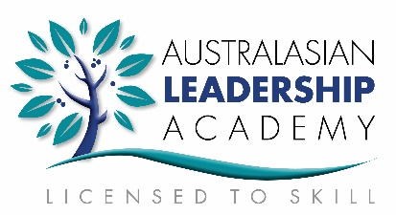
This is a nationally recognised qualification delivered by ALA, is delivered via ALA’s online Training Portal and can be completed at the participants own pace.

Recommended timelines and milestones are provided to keep learners on track. Learners have access to facilitators and mentors throughout the period in addition to two formal phone/web based mentoring sessions.

As this program is a blended eLearning program, access to a computer and internet is required.

What will I learn?

You will learn how to communicate effectively as a workplace leader, implement an operational plan, promote innovation, lead effective workplace relationships and teams, and implement customer service strategies.

Proficiency in managing projects and developing work priorities will be taught as well as skills for planning and completing your own work on time and on schedule.

Training Investment

$3,300 per participant discounted rate for NDS members (Non-members costs RRP $3,500).

This fee includes all course materials, assessments and 12 months access to global eLearning content. (GST exempt)

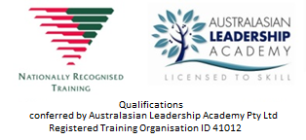

ALA Landing Page Link to Register - https://training.australasianleadership.com/nds
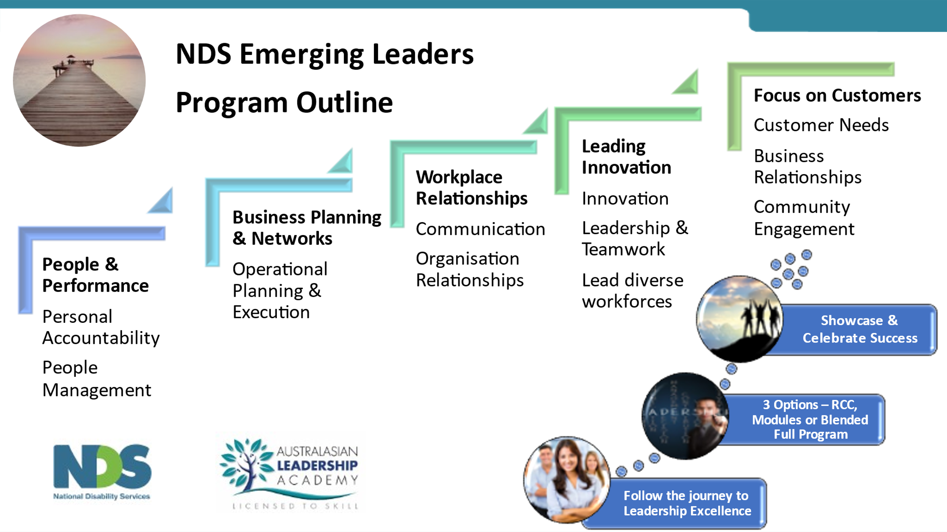

The Topics / Themes were aligned to some specific capabilities the NDIS Capability Framework: in particular competencies for Supervision and Frontline Management and General & Advanced Support Work - by those responsible for coaching, coordinating, supervising, celebrating diversity and developing others, including:

Model and reinforce values in organisational culture and practice
Support and model a culture that promotes the principles of the NDIS, such as upholding rights, celebrating diversity and respecting the voice of those with lived experience.
Promote quality through consistent good practice
Set clear expectations of what best practice looks like, provide access to support and coaching, and develop worker awareness and capabilities to deliver quality supports and services.
Communicate effectively
Support me to express myself and adjust your communication style to suit me
Build trusted relationships
Develop and maintain relationships with me, and those who are important to me, based on mutual trust and respect.
Work collaboratively
Recognise the roles and expertise of others who support me, and work with us as a team.

For more information, contact National Learning & Development team at learnanddevelop@nds.org.au

NDS Emerging Leaders Program Structure - Program outline
Module name | Unit of Competence |  | Due Dates Week
Part 1 - Workplace Business Improvement - Submit Project Decision Making & Overview  First 1:1 mentoring session |  |  | Week 2
THEME 1 – People & performance
Personal Accountability | BSBPEF402 Develop personal work priorities |  | Week 8
People Management | BSBLDR411 Demonstrate leadership in the workplace
THEME 2 – Business planning & networks
Operational Planning & Execution | BSBOPS402 Coordinate business operational plans |  | Week 12
Part 2 – Workplace Business Improvement – Submit your Project / Operational Plan  Second 1:1 mentoring session |  |  | Week 14
THEME 3 – Workplace relationships
Communication | BSBLDR412 Communicate effectively as a workplace leader |  | Week 18
 | BSBXCM401 Apply communication strategies in the workplace
Organisation Relationships | BSBLDR413 Lead effective workplace relationships
THEME 4 – Leading & innovation
Innovation | BSBSTR401 Promote innovation in team environments |  | Week 24
Leadership & Teamwork | BSBLDR414 Lead team effectiveness
 | BSBXTW401 Lead and facilitate a team
 | BSBLDR521 Lead the development of diverse workforces
THEME 5 – Focus on customers
Customer Relationships | BSBOPS404 Implement customer service strategies
Community Engagement | BSBTWK401 Build and maintain business relationships
Part 3 – Workplace Evidence & Validation:  - Workplace Business Improvement – Submit Final Report  - Workplace Evidence – Submit 3rd Party Report, Evidence Summary & Evidence Portfolio  - Checklist & Candidate Declaration – Check & complete declaration |  | Week 36
Final Steps & Assessment: Assessor Verification  Competency Conversation |  | Week 40

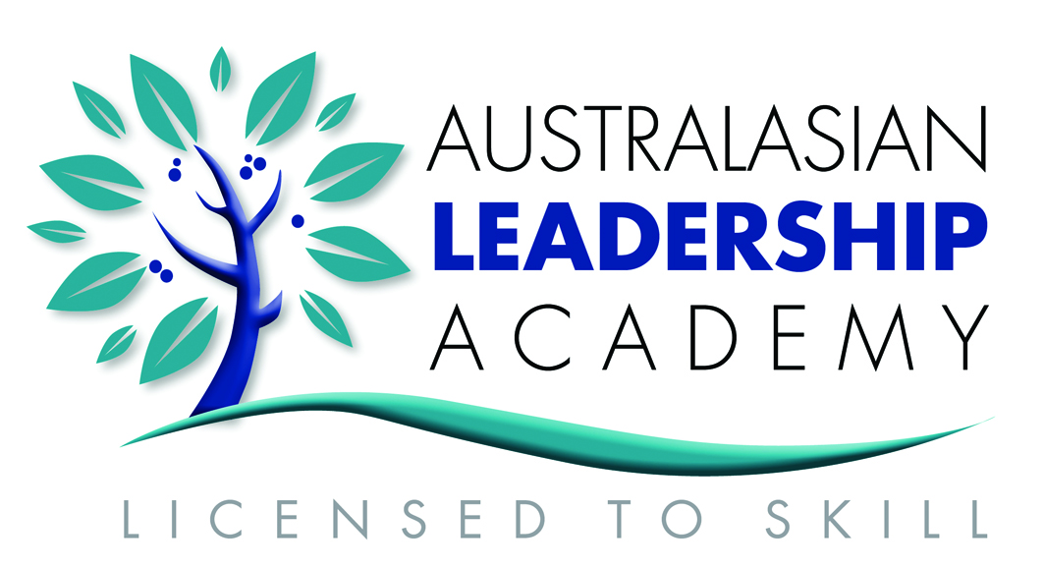
Australasian Leadership Academy
Ph 1800 997 304 | Mb +61 439 876 901
www.australasianleadership.com | info@australasianleadership.com
Registered Training Organisation - RTO ID # 41012

Registered Training Organisation - RTO ID # 41012

